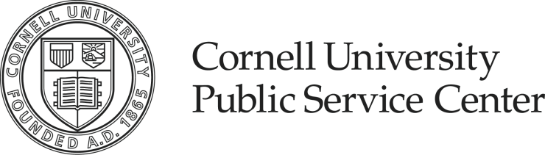 |  | 200 Barnes Hall  Ithaca, NY 14853-1601  t. 607.255.1148  f. 607.255.9550  cupsc@cornell.edu
Student Organization Affiliation Form
Affiliation with the Cornell Public Service Center is intended to create a community among student organizations engaged in diverse service, civic, and social justice efforts, and to share resources and learning experiences which will enhance students and community capacities for positive change. To promote the community building, effective and efficient delivery of service, and positive personal interactions, the Cornell Public Service Center provides a physical space, educational and training resources, and workspace for students to conduct their business. The resources and expectations briefly outlined below are consistent with the Cornell Public Service Center guiding philosophy – to address community challenges in collaborating, mutually beneficial, effective, and ethical ways.

Affiliation Benefits

- Access to the leadership development training series
- Access to evaluation tools for program assessment
- Access to staff consultant regarding resources for the group as well as organizational development
- Access to the Cornell Public Service Center, including assigned common student space, a mailbox, and limited meeting space
- Use of Cornell Public Service Center equipment including vans (if eligible), photocopier, fax machine, computers, printers, and phones, depending upon eligibility
- Authorized use of Cornell Public Service Center email lists, flyer distribution, and other publicity opportunities
- Table at Cornell Public Service Center events and open houses for recruiting
- Access and networking opportunities for interaction with alumni, faculty and community members
- Access to PSC community networks and partnerships
- Priority access to various awards and grants available through PSC

Student organization responsibilities

- Obtain a faculty and/or staff advisor independent of the Public Service Center (PSC)
- Adhere to Cornell Public Service Center’s policies and guidelines
- Participate in the PSC Leadership Training Series
- Attend all required PSC events such as the PSC Fall Retreat and end of academic year celebration
- Acknowledge partnership with the PSC in all publicity and media statements
- Submit media information and clippings relating to your group to PSC
- Conduct service in an appropriate manner, without the influence of drugs or alcohol
- Use appropriate language and exhibit appropriate manners and behavior when conducting business on and off campus
- Do not develop personal relationships with clients or community partners during the term of service
- Submit progress and annual report to PSC
- Complete the working agreement/contract with PSC

APPLICATION (Please complete the following application. Use separate sheet of paper)

Official name of group
- Aguaclara Student Project Team

Purpose and mission of the group
Aguaclara is a project in Civil and Environmental Engineering at Cornell University that is improving drinking water quality through innovative research, knowledge transfer, open source engineering and design of sustainable, replicable water treatment systems.

Financial accounting status – specify all accounts

Sample budget from Tamara project:

Tamara Project total Budget | $74,144
Population served | 3,500 people
Cost per person | $21.18

Budget breakdown:
Construction materials and unskilled labor | $23,104
Local engineering costs | $20,448
Material transportation costs | $13,375
Direct project travel/administration expenses | $6,040
Community contribution (labor, sand, gravel, wood) | $6,007
Training, educational and community materials | $2,620
Two months chemical supply | $2,550
Total expenses | $74,144

Funding sources (attach your most recent annual budget)
Donors, primarily the San Juan Foundation, have supported every aspect of the Aguaclara project.

Leadership information, organizational structure, and list of current board members
Organizational Structure:
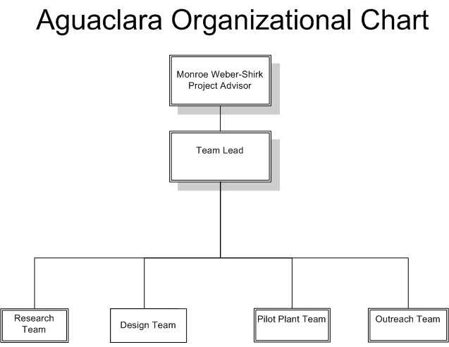
Program Director and Associate Professor at Cornell University, Monroe Weber-Shirk leads the multidisciplinary project team in its efforts to expand the knowledge base of sustainable water treatment technologies. His experiences living and working in Honduras during his early years cultivated the connections that led to our partnerships with APP and IRWA. Aguaclara is a result of a realization of his and our capacity to meet the needs of affordable and sustainable community water treatment.

About 40 students support the research, design, and outreach activities of Aguaclara through service learning. We have seven laboratory-based research groups and one computational research group investigating and refining water treatment technologies. The design team works to create the unit process and hydraulic algorithms, as well as to evaluate different plant layouts. One PhD, ten Masters of Engineering, and two Masters of Science students are dedicated to the project. For undergraduates who do not already have Aguaclara as a focus for their thesis or M.Eng Project, the course can be retaken as many times as they wish. Most students who join the team continue to contribute for many semesters. Student groups visit the plants to see how better to adapt research to the local needs. After graduation students have the opportunity to apply for an internship in Honduras.

Interns live and work in Honduras as direct employees of our Regional Partner, APPRegional Partners work with Aguaclara-Cornell and individual communities in every Aguaclara project.

Mission and purpose of your group as it relates to the mission of the PSC
Dr. Weber-Shirk identified a significant global challenge that was not being met. He developed a solution in the form Aguaclara which relies on open source engineering, that strengthens communities, and that capitalizes on the inventive capabilities of university students. He helped students identify the technology gaps that were preventing the dissemination of municipal scale water treatment plants and then guided the students to invent new technologies and to create new mechanisms for sharing those technologies with the global community. Many of the Aguaclara innovations have already been adopted for practical use. The vertical flow flocculators, shallow sedimentation tank designs, and flow controllers are in use in three of the Aguaclara water treatment plants that together serve approximately 11,000 people. The water treatment plant at Ojojona was the first plant that incorporated many of the Aguaclara innovations. The next facilities at Tamara and Marcala were improved with the addition of a roof and building enclosure to make the plants easy to operate in the rain, to protect the plastic components from sunlight, and to provide security.

Group’s goals and objectives for the coming year and strategy in meeting them
We anticipate a very high demand for robust, energy efficient, water treatment technologies given the combination of a large and unmet need for safe drinking water, the increased demand due to population growth and urbanization, and the need to replace aging infrastructure. AguaClara team is committed to open source engineering—making technology designs freely available thus reducing the traditionally-large engineering cost of construction and easily accessible online—as one tool to help disseminate the technology. To meet our goal of eventually providing the designs for 1,000 water treatment plants per year, we are developing a design tool that will make it possible to deliver customized, detailed designs to partner organizations over the internet.

The designs are developed based on a combination of fundamental fluid mechanics and ongoing research, for hydraulic flocculators that are economical to construct. In addition, the AguaClara team has invented a gravity-powered flow control module that delivers a constant flow rate and that is adjusted simply by raising or lowering a flexible tube. Although the AguaClara design process is sophisticated, the resulting designs are simple and use components that can easily be repaired and replaced by plant operators.

Group evaluation and/or assessment plan
For individual plants success is recorded by the operators’ logs, where they record the turbidity of the influent and most importantly effluent waters. In the future we hope to gather health statistics to create a concrete correlation between cleaner effluent and fewer cases of diarrhea in the community. This could prove unrealistic because it depends on the records attained before we are introduced to the communities. Therefore, we base our assumption of improved health on the feedback from the individuals in the community who receive the treated water.

We measure our overarching success by the number of people we reach. With the construction of our next plant in Cuatro Comunidades, we would reach 15,000 people. Our goal is to double that in the upcoming year.

Our future success will be measured by our spread to other Latin American countries and ultimately other continents. We plan to spend the next several years working exclusively with APP while we optimize the design of the treatment plants and while we provide APP with training so they can eventually build the plants without our assistance. There are many thousands of communities throughout Latin America that have untreated surface water and thus there is an excellent opportunity to continue building AguaClara facilities. We anticipate establishing new partnerships with organizations in other regions that also have inadequately treated surface waters used as drinking water. Our long term goal is to spread this technology globally.

Incorporation of community input and feedback in the organization
Our current partner is Agua Para el Pueblo (APP), a Honduran non-governmental organization. Regional Partners are organizations of engineers and technicians who take the lead role in choosing communities based on water quality deficiencies and, equally importantly, on community assets such as organization, ability to maintain qualified operators, and financing purchase of chlorine and aluminum sulfate. They are responsible for the development of the structural elements of designs, oversight of construction, operation of the plant for 3-6 months (to demonstrate that the technology is effective), training operators, transferring ownership of the plant to the local municipality or water board and monitoring, reviewing, and following up on continued performance. Feedback gained from the performance of the plants is used to direct the research agendas. Our ability to scale up will depend on the development of strategic partnerships who can implement our technology.

Communities in the towns benefit most directly from safer water to drink, eat, and clean with. Added benefits are the creation of new jobs such as a fontanero, or a plant operator. Aguaclara is proactive in involving the employment of women at the water treatment plants.

Communities at home are enriched by the outreach done at Cornell to teach children and adults about water treatment through demonstrations given at local schools, youth organizations, professional conferences, and alumni reunions.

Attach past evaluations and/or impact statements
AguaClara has already proven to be successful at treating turbid surface water on the municipal scale. Working with Agua Para el Pueblo, AguaClara has designed water treatment plants that are working effectively and providing safe, clean water to 2000 people in Ojojona, and 3500 people in Tamara (sponsored by Rotary and the Sanjuan Fund). Our largest design to date is a 2000 L/min plant in Marcala (sponsored by IRWA with construction supervision by IRWA and ADEC and serving 5400 people).

Specify methods and types of training provided to volunteers in the group
Students get grounding in the project through Aguaclara Civil and Environmental Engineering course taught by Monroe Weber-Shirk. As part of the course various teach-in sessions are organized for internal updates and discussion on different Project tasks. Aguaclara student team also organizes a trip to Honduras during winter break to educate students on project implementation and give them a better understanding of the ground realities in Honduras. Majority of the other training activities are on the job and are task dependent.

Faculty/staff advisor

Name/Title/E-mail: Monroe Weber-Shirk/ Lecturer Sr, Research Associate/ mw24@cornell.edu
Academic/non-academic department: Civil and Environmental Engineering Department
Phone/Address: 607-255-8445/ 115 Hollister Hall
Role of the faculty/staff advisor within your organization: Professor Weber-Shirk supervises the project. Advices student on various technical and functional issues and teaches the Aguaclara CEE Student Project team course each semester. He is also involved in fund raising related activities and is very instrumental in organizing the Honduras Service Learning Trip during winter break.
Attach a letter of support from faculty advisor

Only relevant signatures (print name and obtain signature)

______________________________ ______________________ _____________
Student Contact Person (print name) (signature) Date

_______________________________ ______________________ _____________
Student Contact Person (print name) (signature) Date

_______________________________ ______________________ _____________
Faculty/Staff Advisor Person (print name) (signature) Date

Please return completed application to Susan Duan, Student Manager of Center Program Specialists, Cornell Public Service Center, 200 Barnes Hall. www.psc.cornell.edu or e-mail cupsc@cornell.edu

