

AGUACLARA
DEMO PLANT
MANUAL

Fall 2009

AguaClara Demo Plant Manual

Table of Contents
Set-Up Instructions…………………………………………………………………………………………….. | 2
Operation…………………………………………………………………………………………………………… | 6
Take-Down………………………………………………………………………..................................... | 7
Packing………………………………………………………………………………………………………………… | 7

Set-Up Instructions

- Place wooden base firmly on a flat sturdy surface.
- Attach the short white tube to the top of the wooden base.
- Place the section labeled “Mid Section” (with Clay and Alum jars attached) on top of the short white tube.
- Place the section labeled “Top Section” on top of the “Mid Section” tube.
- Make sure the structure is secure and aligned.

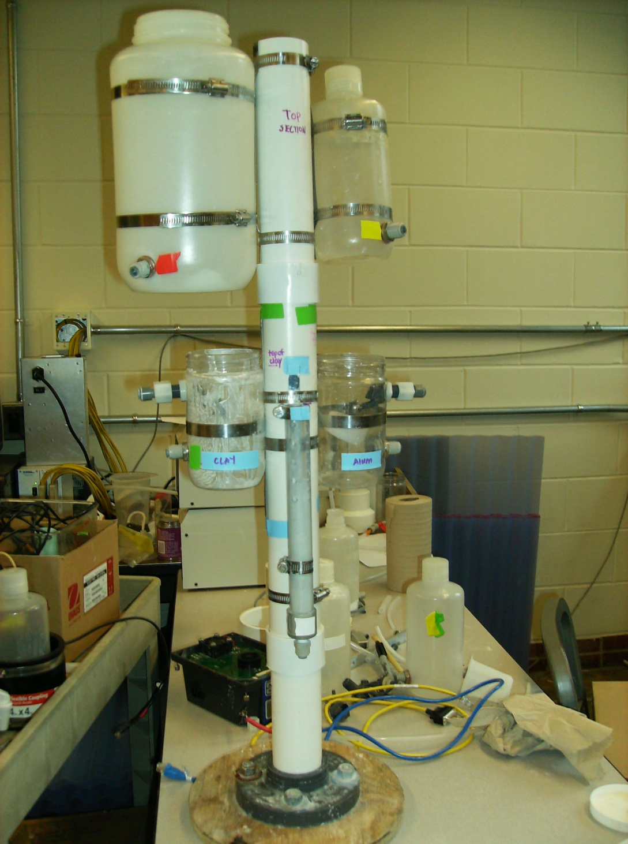

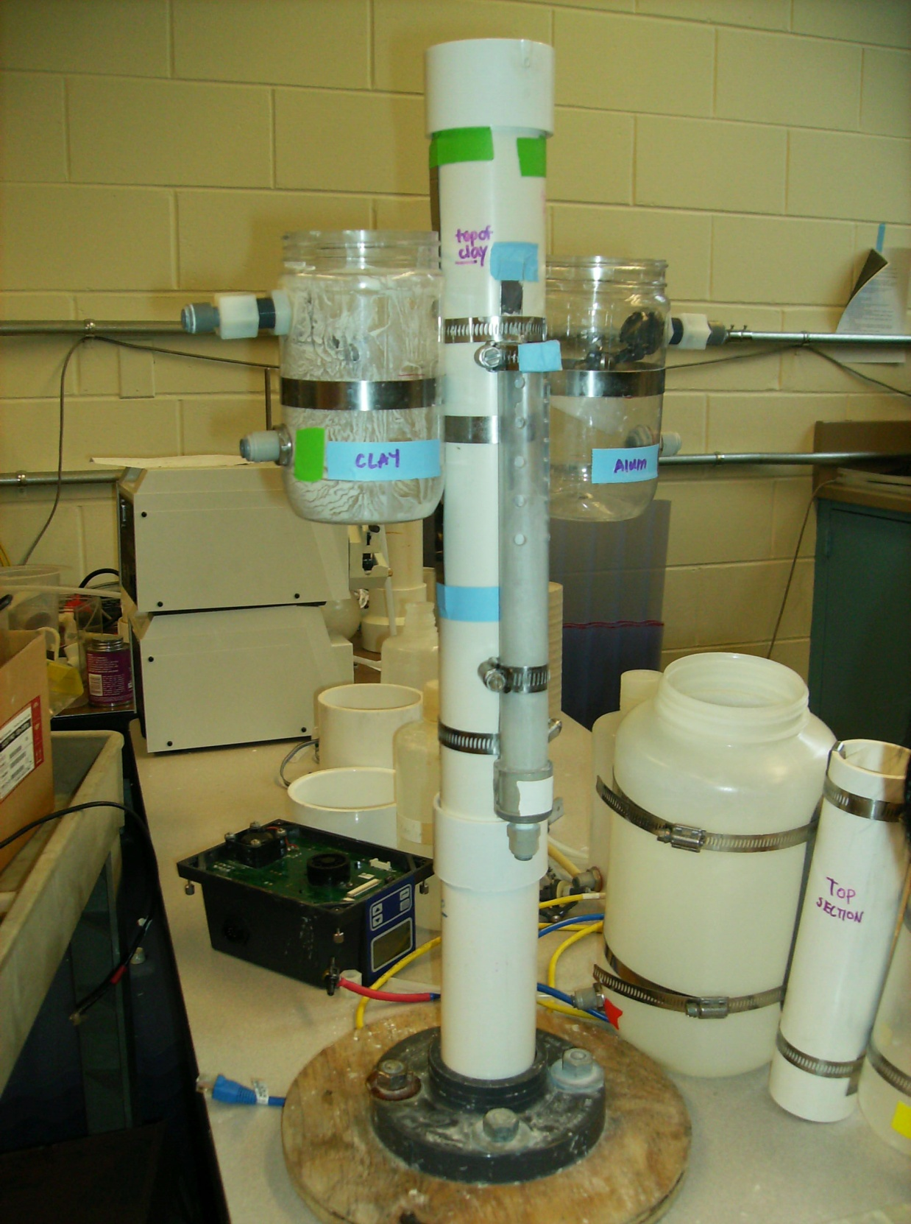

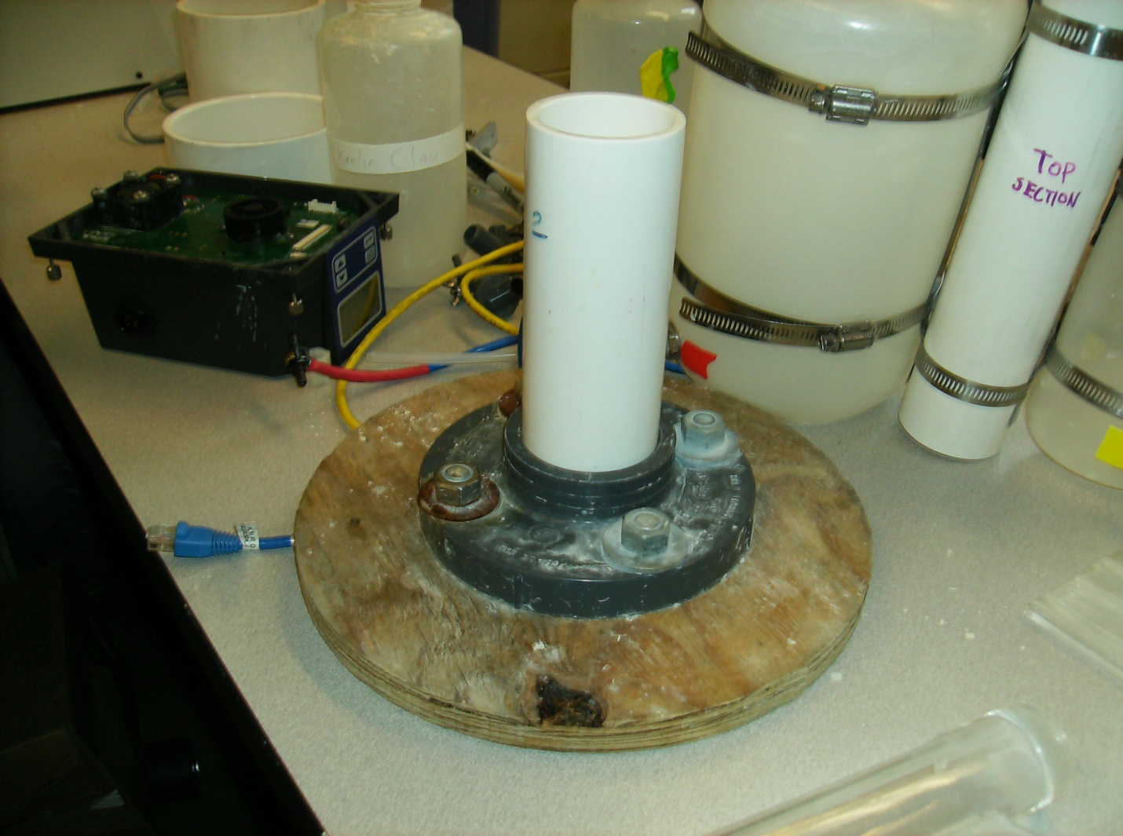

- Connect the tubes and valves with their respective jars and bottles by matching up the colors. Push the tubes in firmly; you will feel a ‘snap’ when the tubes are in their valves correctly.
  - Long red tube red clay stock solution jar.
  - Green tube the green clay solution float valve jar
  - Yellow tube yellow alum stock solution bottle
  - Clear skinny tube clear alum solution float valve jar
  - White tube white rapid-mix cylinder
*Note that one end of the white tube is not connected to anything yet
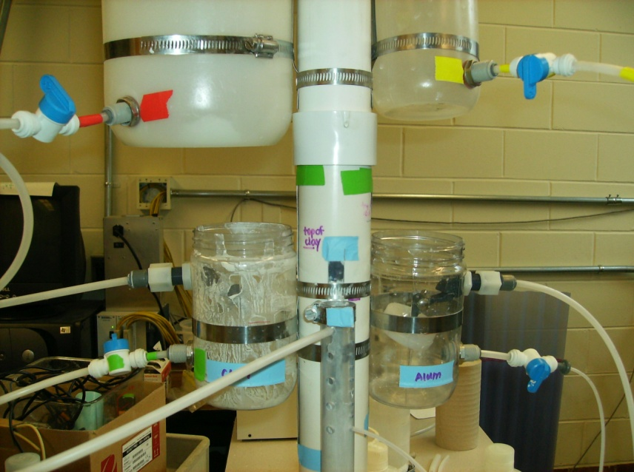

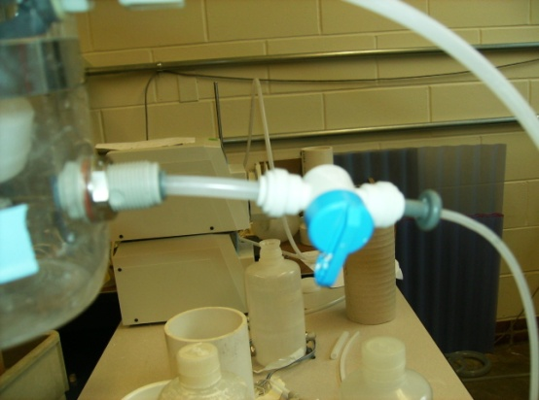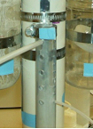The end of the tubes going into the rapid-mix cylinder can go in any hole you please, but if placed in the lower holes you won’t have to wait as long for flocs to form during presentations, since the flow rates will be the highest. Be sure that the valves are closed until you are completely set up.

Valve is closed.
- Set up the flocculator and the sedimentation tank.
- To make them stand up, place the three stands around their cylindrical bases, one on each end and one in-between the two pieces.
- One of the stands has only one screw in it and should be placed on the outflow side of the sedimentation tank to have the best stability.
- Place the flocculator to the left of the tank and connect the two at their bottom tubes.
- 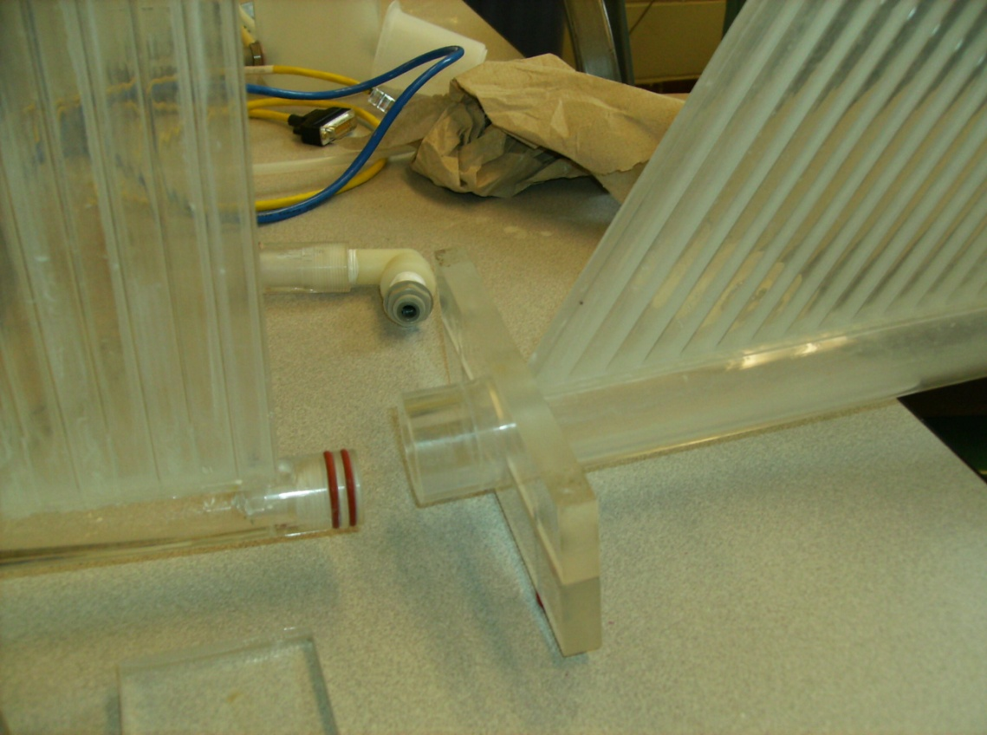Make sure that the sedimentation tank is upright be ensuring that the bottom end facing away from the flocculator is sealed and the top end facing away from the flocculator has an opening.

- Fill the flocculation and sedimentation sections with water. If you wait until after set-up is complete the flocculator and sedimentation tank will have a hard time filling up. It also saves time during presentations.
- 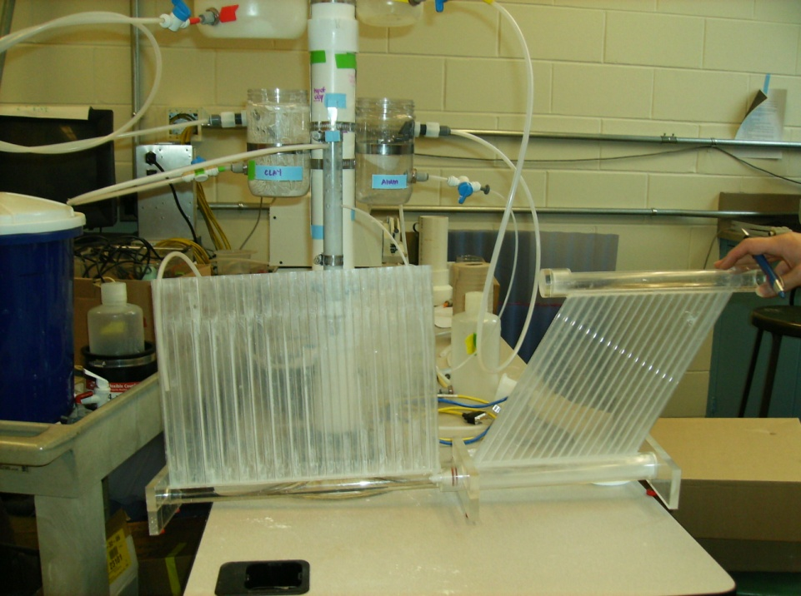Place the other end of the white tube into the baffles of the flocculator, making sure that this end of the white tube is lower in height that the inlet to the white tube before the valve.
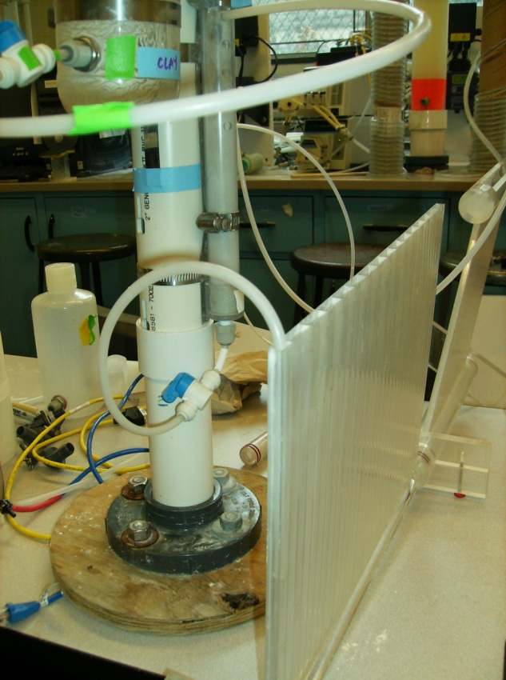

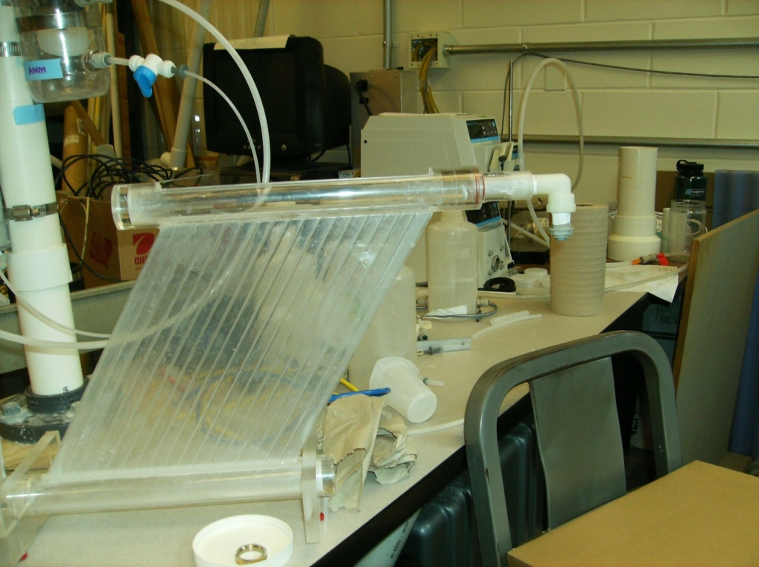
- Connect the end piece to the top open end of the sedimentation tank.

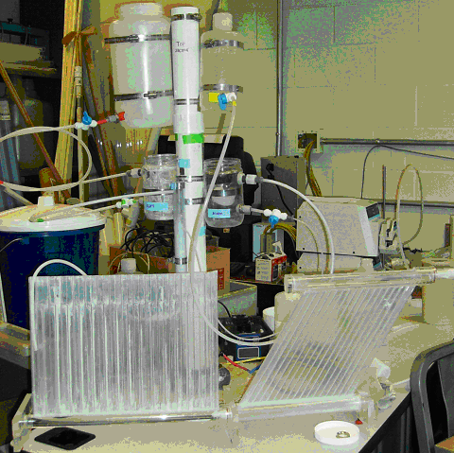
- The final set-up should look something like this:

Operation

- Put enough water and clay into the clay stock solution jar for the water to look cloudy. Stir to suspend clay particles. Repeat this step as necessary throughout the presentation.
- Fill the alum stock bottle halfway and add ¼ teaspoon of alum and stir until the alum has dissolved.
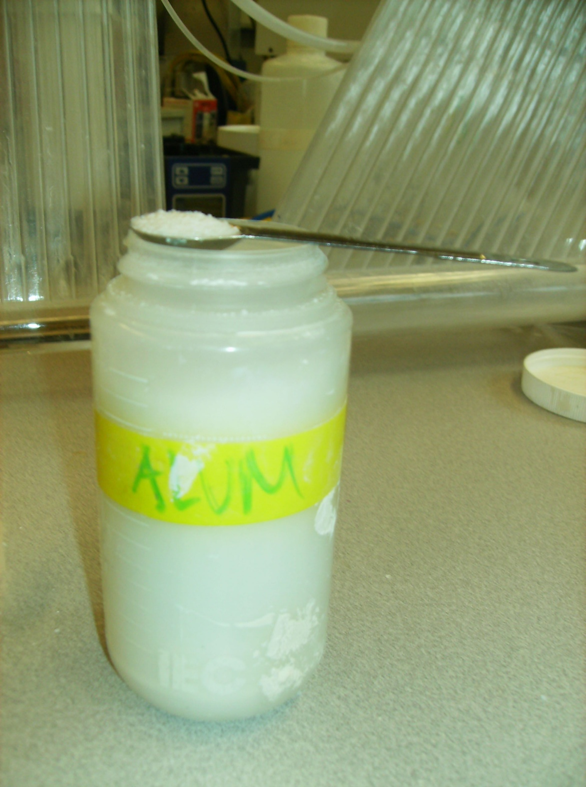

- Place a bucket under the outlet of the sedimentation tank to collect treated water.
- Check that the outflow tubes from the float control jars are in the rapid-mix holes that you want them to be in.
- Open all valves by turning blue knobs.
- Check for leaks and fix them by tightening connections (push tube in further) or by strategically placing sponges to collect spilled water.
- Wait for flocs to form!

Take-Down

- Close all valves.
- Dump water from flocculator, sedimentation tank, clay stock solution jar, clay float valve jar, and bucket into sink.
- Try to conserve as much alum as possible; pour alum from the alum float valve jar back into the alum stock solution bottle.
- Rinse all components to avoid dried-on clay hindering future presentations.
- Dry with paper towels

Packing Instructions

- Place wooden base and short white tube in the bottom of suitcase.
- Put in middle section and top section.
- Place flocculator and sedimentation tank on top.
- Place tubing and small parts into suitcase pockets.
*Packing the suitcase back up is truly an artform… but it gets easier with practice.




