Linear flow controller design
August 17, 2011

Screw mounting aluminum U-channel to wall

Screw mounting aluminum U-channel to wall
Aluminum U-channel
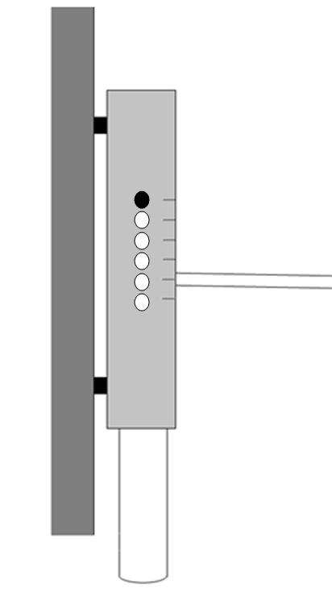
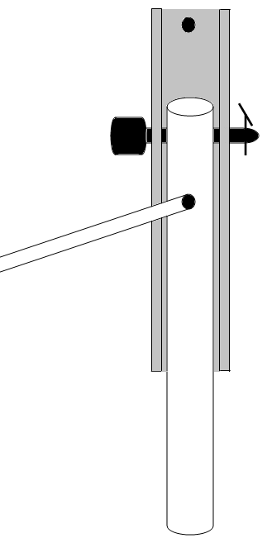
Small diameter tube
Drop tube
Profile view
Front view
Wall
Barbed fitting
Scale (mg/L)
Holes to set chlorine flow rate
Pin

