-
We need your help now to create an online design tool to allow users across the globe to access AguaClara sustainable water treatment plant designs thus reducing the engineering cost of municipally treated water. What is the task? To interface between MathCAD and AutoCAD using Active X!

Requirements:

Experience programming with Labview

Time commitment of 10 hours per week

Need an MEng design project?
This could count!

-

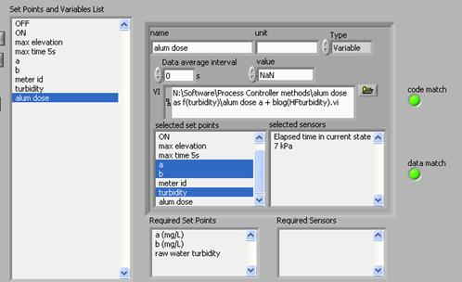

Want to get involved?

To Join:
Email ajd47@cornell.edu
Enroll in CEE 4550 or CEE 5051

For more information:
Visit aguaclara.cee.cornell.edu
Email mw24@cornell.edu



