CASA-SEVILLA GENERAL HEALTH & SAFETY EMERGENCY PROTOCOL (SPRING 2026)

An emergency is a situation where the health, safety and well-being of a student are in immediate danger. Emergencies can occur on the individual or group level. CASA-Sevilla on-site staff is responsible for supporting the safety and well-being of all program participants. To that end, that person or group of people will do whatever is necessary and possible in a crisis to protect students. This responsibility may, at times, appear to conflict with the values or respect for the student's individual autonomy and independence. In matters relating to personal safety, the authority of the governing body (e.g. Cornell’s International Travel Health and Safety Team, the U.S. State Department, Program Director, Embassy, national policy) will supersede the individual wishes of students.

- Health and Safety Emergency Protocol

- Threat to life, limb, or eye — call an ambulance! The local emergency number is:112.

- If victim of a crime, if safe to do so, contact the local police to report the incident and get immediate help. The local emergency number is: 112.

- If victim of a sexual assault you can call 900 200 999, a 24/7 anonymous and confidential service providing immediate information, advice, and assistance. If you need medical assistance, it is important that you go to Hospital de la Mujer (Hospital Universitario Virgen del Rocío): https://www.hospitaluvrocio.es within the 72 hours after the assault.

- For any type of emergency or if you need help and don’t know what to do:
  - Cornell students can contact International SOS for assistance at 1-215-942-8478, online or via the mobile app, and reference membership number: 11BSCA827281
  - Vanderbilt students can contact Vanderbilt Incident Response for Travel (VIRT) for assistance at +1 615-322-2745 or virt@vanderbilt.edu

- In the event of a natural disaster:
  - At the beginning of the semester, you must activate Civil Protection alerts on your mobile phone to receive information about any hazardous event in Spain.
  - Stay informed about the weather conditions on the National Meteorological Institute's website.
    - If there’s a risk of flooding, avoid road trips and stay away from rivers and swamps
  - If there's a blackout and your wifi connection fails, stay calm and walk home (do not use public transport).
    - If you're stuck in an elevator, call 112
    - If the power outage lasts more than 12 hours, the Center will reopen the next day to serve as a meeting and information point
  - Contact your parents/loved ones to let them know your status as soon as you can.
  - Contact CASA-Sevilla Director via WhatsApp/phone call at +34 650028920, or email eva@sevilla.casa.education to let them know your status as soon as you can.

- In the event of terrorism or a violent uprising
  - Shelter in a safe place and monitor the advice of local authorities.
  - For U.S. Citizens, the DoS will notify and advise you (first by email) if you enrolled through STEP, the Smart Traveler Enrollment Program. Non-U.S. citizens can also sign up to receive travel alerts and advisories by email but will not have access to the same emergency services. It is advisable to check with your own Embassy for similar programs.
  - Contact your parents/loved ones to let them know your status.
  - Contact CASA-Sevilla Director via WhatsApp/phone call at +34 650028920, or email eva@sevilla.casa.education to let them know your status.

- CASA-Sevilla emergency contact information

CASA-SEVILLA EMERGENCY CONTACTS – AY 2025-2026
During local business hours (Monday – Friday, 9 AM CET – 5 PM CET)
Director | Eva Infante | eva@sevilla.casa.education  011-34-954 227157
Outside local business hours (24/7)
Director | Eva Infante | eva@sevilla.casa.education  011-34-650 028 920 (cell)
During program-sponsored excursions and cultural visits
Coordinator | Ike Zwaan | 34-622-695-833 (cell)

- External emergency resources and contact groups

- US Embassy: https://es.usembassy.gov/embassy-consulates/madrid/ Emergency phone outside business hours: # 915872200
- Seville Consular Agency: sevillecons@state.gov / Phone # 954218751
- Local emergency services phone # 112
- National police phone # 091
- Theft reporting phone # 902102112
- Sanitas urgencias médicas 24h: Phone # 91 752 2901
- Hospital de la Mujer (Hospital Universitario Virgen del Rocío) is the reference for sexual aggressions https://www.hospitaluvrocio.es Phone # 955 012218 / 955 012219
- AMUVI (Counseling for Sexual Aggressions): amuvi@amuvi.org
- Unison Health (Onsite and Online Counseling Provider): https://www.unison-health.com/

- Relevant program policy and documents

- CASA-Sevilla Protocol for Housing Conflict Resolution
- CASA Code of Student Conduct

SANITAS: INSTRUCCIONES DE USO

Se puede pedir cita médica por los siguientes medios:
Web: https://www.sanitas.es/
- Médicos y centros
- Cuadro médico Sanitas
- Se elige la especialidad y lugar. De acceso directo son los médicos especialistas, psicología y podología. Para el resto de especialidades necesitas la prescripción de un doctor (fisioterapia, pruebas...)

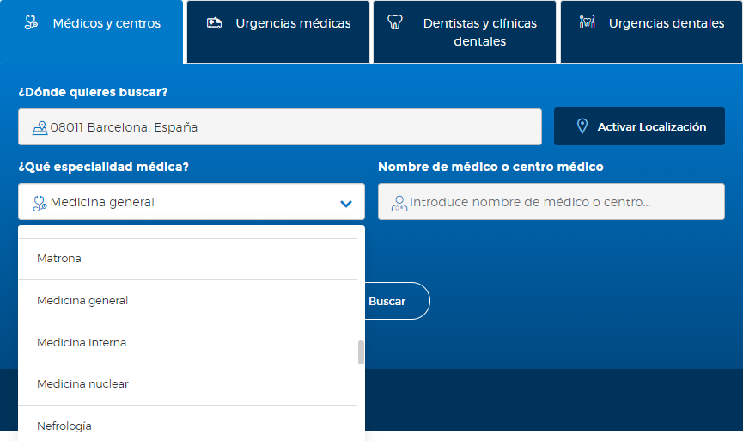

Pulsa "Buscar" y aparecerá esta pantalla
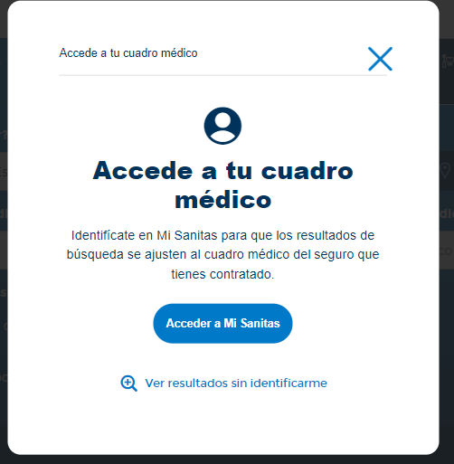

- Selecciona la opción "ver resultados sin identificarme" para hacerlo más rápido
- Por defecto la web busca a los profesionales a un radio de 25 km (se puede poner menos)

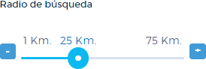

- Otro filtro es el idioma, se puede elegir que hablen inglés, aunque es posible que no todos tengan fluidez

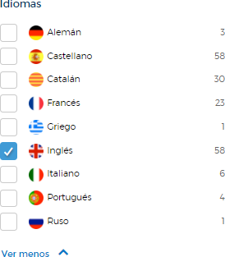

- Del listado que aparece elige el que más te convenga

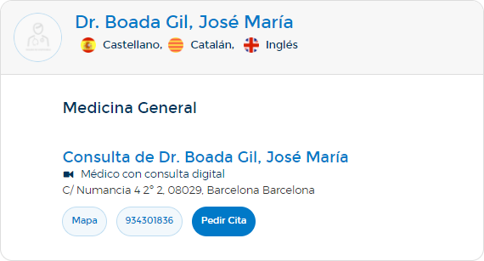

En algunos, como este caso, aparecerá la opción "pedir cita". Son aquellos para los que se puede solicitar hora sin tener que llamar porque están vinculados al sistema web. Cuando no aparezca esta opción tendrás que llamar por teléfono para reservar cita.

APP: Mi Sanitas
Se siguen prácticamente los mismos pasos, pero debes estar registrad@ en la app con un número de teléfono español ya que te enviarán un SMS para la confirmación del registro. No sirve un número de teléfono americano.
Para registrarte sigue los siguientes pasos:

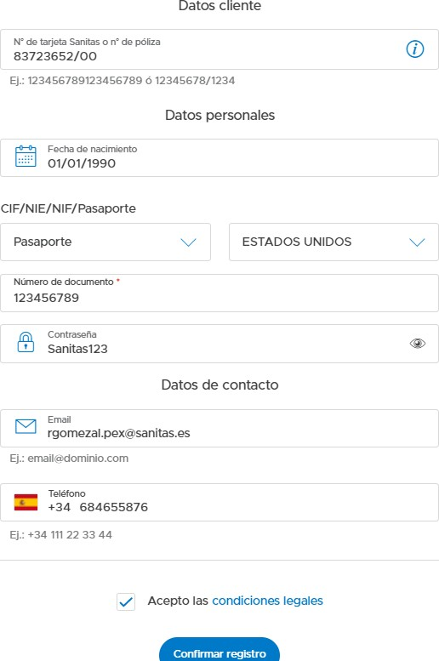

  - Introduce el número de tu tarjeta (que será 83723652/XX y después de la barra el número que corresponda)
  - La contraseña deberá tener un mínimo de 8 caracteres: números, letras y al menos una en mayúsculas.
  - Tu correo el electrónico

  - Número de teléfono español
  - Validar la casilla "acepto condiciones legales” y confirmar registro
  - A continuación, aparece la misma pantalla para que confirmes otra vez los datos o modifiques los que no estén correctos

Por teléfono:

Puedes pedir cita llamando a los números de teléfono que aparecen en el listado a través de internet. No se dan citas por WhatsApp ni por correo electrónico.

PARA EMERGENCIAS:
- Llamar a Sanitas urgencias médicas 24h: 91 752 2901
- O buscar a través de la web. Se recomienda ponerse en contacto con el hospital antes de acudir para confirmar que se encuentre el médico especialista

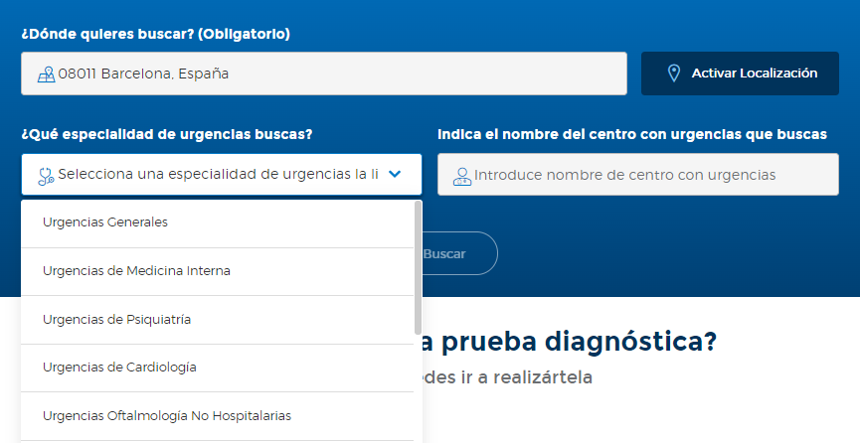

Para cualquier duda contactar con:
Ruth Gómez Álvarez
T 985 205 802 / 684 655 876
E rgomezal.pex@sanitas.es

