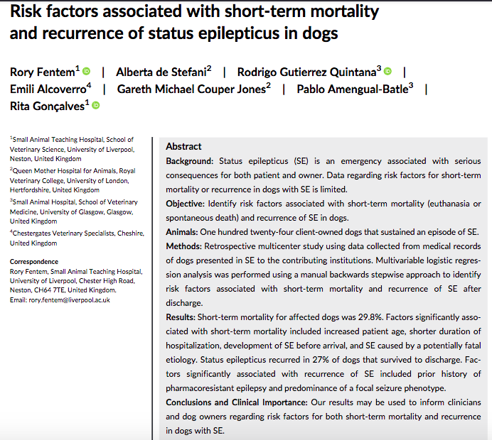

Introduction
- Status epilepticus (SE) definition: one seizure of >/= 5 minutes duration or </= 2 discrete seizures between which there is incomplete recovery of consciousness
  - Can occur for any reason a seizure could (i.e. idiopathic vs. neoplastic vs. metabolic vs. other)
- Increased duration of SE is associated with decreased likelihood of emergent treatment efficacy and permanent neurologic and other morbidity
- Risk factors for recurrent of SE in humans: < 4 years of age, female sex, lack of response to first-line SE treatment, remote symptomatic (i.e. head trauma, stroke) and progressive (i.e. neurodegenerative) etiologies
Material and Methods
- Retrospective
- Dogs from 3 teaching hospitals that had SE within 2004-2017
- Inclusion criteria: SE resulted in hospitalization, experienced sustained SE while in hospital, medical records available for review
- Data
  - Age
  - Sex
  - Breed
  - Neuter status
  - Weight
  - Clinical and neurologic exams at admission
  - Age of first seizure
  - Previously experienced SE
  - Preexisting comorbidities
  - History of pharmacoresistant epilepsy
  - Focal vs. generalized seizures
  - Duration of first SE
  - Duration of hospitalization
  - Insured vs. not insured
  - Survival to discharge
  - Neurologic status at discharge
  - Recurrence following discharge
  - Medications used to treat, method (CRI vs. not), response to medication
  - Underlying causes
    - Etiology = considered fatal if it could cause death regardless of SE
- Statistics
  - Assessed for normality with Shapiro-Wilk test most data not normally distributed
    - Descriptive statistics (medians and interquartile ranges) were therefore used
  - Univariate logistic regression
    - If a variable was associated, it was considered for inclusion in a multivariable model
Results
- 15.3% developed first SE while hospitalized vs. 84.7% who experienced SE before hospital admission
- First seizure manifestation in 43.6%
- 40.3%: idiopathic epilepsy, 37%: structural disease (inflammatory > neoplasia > cerebrovascular = TBI = hydrocephalus), 22.6%: reactive seizures (hepatic encephalopathy, other metabolic disease, hypoglycemia, intoxication)
- 33.9% of dogs were already receiving AEDs prior to SE
- At the time of discharge:
  - 28.4%: ataxia or proprioceptive deficits
  - 17.3%: paresis
  - 39.5%: obtunded
  - 17.3%: visual deficits
  - 1.2%: residual nystagmus
  - 3.7%: circling
- Short-term mortality:
  - 70.2% survived to discharge
  - 21.8% euthanized
  - 8% spontaneously died
  - Univariate analysis showed association with short-term mortality
    - Age
    - Seizure etiology
    - Duration of hospitalization
    - Potentially fatal etiology
    - SE as first seizure episode
    - Present of SE before admission – decreased short-term mortality
    - Administration of Propofol
    - Poor initial response to benzodiazepines
    - Use of a CRI
  - Multivariate analysis:
    - Increasing patient age
    - Shorter duration of hospitalization
    - SE before arrival
    - SE of fatal etiology
- Recurrence of SE: 27%
  - Univariate associations: previous seizure history, SE as first seizure event, hx of pharmacoresistant seizures, participating center, type of seizure
  - Multivariate associations: pharmacoresistant epilepsy, type of seizure
    - Focal seizure more likely to recur
  - Onset: 2-12 months after discharge
Discussion
- Results are dissimilar to human studies due to euthanasia
  - “Fatal etiologist” may also carry worse prognosis/perceived prognoses and result in more euthanasias
- Older age is associated w/ worse prognosis
  - Suspect due to Os worrying more about prognosis and QOL
- Unsure why SE before presentation is associated with decreased likelihood of short-term mortality
- Focal seizures are generally harder to treat which may be why they recur more frequently than generalized
- ~30% of dogs w/ idiopathic epilepsy have drug-resistant epilepsy
  - Consistent with human data, but mechanism is not clear
- SE is most likely to recur shortly after first episode: 50% within first 2 months
  - Treatment perseverance and O expectations are important to set up with this in mind
- Limitations: retrospective, so quality and completeness of medical records

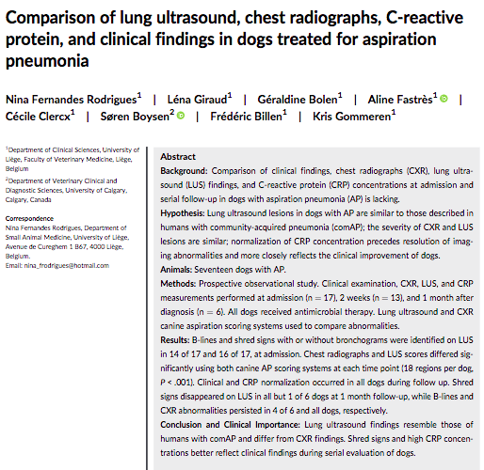
Introduction
- Differentiating aspiration pneumonia (AP) from sterile pneumonitis requires cytology and culture of lower airway secretions, which is rarely performed
- Community-acquired pneumonia (ComAP) in people is any pneumonia that is acquired outside of hospital setting
- AP and ComAP are both treated with antimicrobials
- ComAP treatment duration (usu. 7-10d) is based on clinical improvement and acute phase protein (APP) kinetics
  - Clinical improvement precedes radiographic resolution -> CXR not recommended to direct treatment duration
- Treatment duration is not well-established in dogs
  - 3-6 wk ABx
  - 10-14d recheck CXR
  - C-reactive protein (CRP) is a reliable APP to monitor treatment response to bacterial pneumonia
- Lung ultrasound (LUS) = comparable sensitivity and specificity to CXR in people
  - Tissue sign: entire width of lung lobe affected
  - Shred sign: partial
- Goal of study: describe LUS lesions in dogs with AP and compare serial LUS evaluation to other current diagnostics (CXR and CRP)
  - Hypotheses: LUS and CXR = similar; CRP normalization occurs before imaging resolution
Material and Methods
- Prospective observational
- Enrolled if: presumptive dx of AP based on history, clinical findings, CR, and increased CRP
- Excluded if: AP within the previous 30 days, ABx for > 5d before admission, concomitant lung disease
- 3-view CXR, LUS, and CRP @ T0 (after stabilization), T1 (2 wk after dx) and T2 (6 mo after dx)
  - CXR: interpreted by board certified radiologist
    - Split into 9 regions grossly corresponding to LUS regions
  - LUS: performed by internal medicine resident
    - 3-second video @ ICS 4, 6, and 8 in dorsal, middle, and ventral thorax = 9 regions total
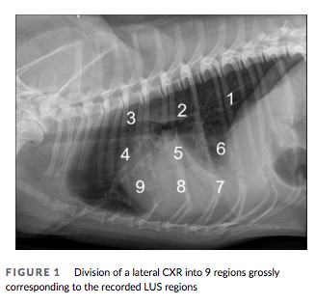

- Scoring systems
  - Canine aspiration pneumonia score: LUS-CAPS and CXR- CAPS
  - Simplified canine aspiration pneumonia score: LUS-sCAPS and CXR-sCAPS
  - CXR scoring based on CXR AP classification previously described
  - LUS were arbitrarily created by the authors
- CRP upper reference range = 9 mg/L
- Dogs = hospitalized and managed by clinicians’ discretion; Clavamox ~ 22 mg/kg x 4-6 wk per current recommendations
- Resolution of AP: 2 days of no clinical signs observed by O + unremarkable PE
- CAPS and sCAPS were calculated across all regions (n=18) for each time point and both CXR and LUS
  - Reported as overall median and interquartile range (IQR)
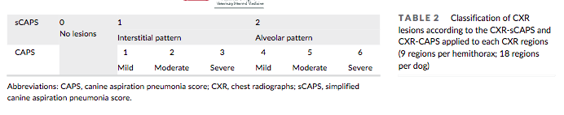
  - Compared T0, T1, and T2 LUS-CAPS vs. CXR-CAPS and LUS-sCAPS and CXR-sCAPS with Wilcoxon signed-rank tests
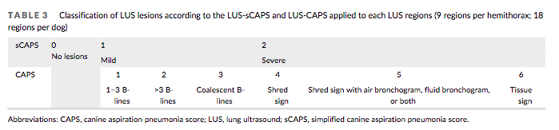
- CRP
  - Compared between T0 and T1 with Wilcoxon signed-rank test
  - Compared among T0, T1, and T2 with Friedman tests with post-hoc Nemenyi’s for multiple comparison
Results
- PE
  - T0: all had at least 1 abnormal PE finding
  - T1 and T2: all had complete resolution of clinical findings associated w/ AP
- CXR
  - T0: all dogs had localized alveolar pattern
  - T0 and T1 CXR-CAPS and CXR-sCAPS = significantly different
  - Interstitial pattern developed in follow-up
- LUS
  - T0: 16/17 dogs had shred sign
    - 12 airbronchograms
    - 4 fluid bronchograms
  - T2: 1 shred sign persisted despite not having associated clinical signs at T1 or T2
  - Most severe lesions: R ventral hemithorax
  - T0 and T1 LUS CAPS and LUS-sCAPS and LUS-CAPS = significantly different
  - T0 and T2 LUS CAPS and LUS-sCAPS and LUS-CAPS = significantly different
    - Not different between T1 and T2
- CRP
  - Median T0 = 137; T1 = 5; T2 = 5
  - All normal at T2
  - Significant difference between CRP at T0 and T1 and T0 and T2, but not T1 and T2
- Comparison of clinical, CXR, and LUS findings
  - CXR-CAPS/sCAPS were higher than LUS-CAPS/sCAPS scores at all times
    - More dogs had alveolar pattern on CXR than lung consolidation of LUS
    - Interstitial pattern on CXR and absence of LUS lesions were most common findings at all time points
Discussion
- Most frequent abnormalities with LUS at T0 were increase B-lines, shred signs, airbronchograms, fluid bronchograms
  - All consolidations resolved over time except in 1 dog
    - B-lines still present in 35% and 24% of regions at T1 and T2, respectively
  - Identifying ventral LUS consolidation = supportive evidence of diagnosis of AP
    - Further studies comparing LUS of AP vs. other disease = required to determine true sensitivity and specificity
- CXR findings: mostly in R ventral hemithorax
  - Severe lesions (i.e. alveolar pattern) improved at T0, T1, T2 (41%, 13%, 11%)
    - However, still present when pt was clinically normal at T2
  - Subtler lesions (i.e. interstitial pattern) persisted overtime
    - 74% and 82% of regions still had mild lesions at T1 and T2, respectively
  - Complete resolution never achieved
- Comparing CXR and LUS showed fair agreement between the 2 modalities
  - Significant differences at all times points
  - Possibilities of why this is include:
    - Atelectasis (neither modality requires long period of recumbency)
    - Lack of precise landmarks for each modality
    - Parenchymal lesions may be more detectable on CXR and missed on LUS
      - However, CXR carry risk of superimposition
    - No inter-observer LUS repeatability was tested
- Would a less complex scoring system yield similar info?
  - The two systems cannot be compared, but both showed similar changes overtime
  - OK to use either system as long as you are consistent with which you choose
- CRP: reliable APP to monitor treatment response in bacterial pneumonia in dogs
- Short-term resolution of lung consolidations has been documented in people at short-term follow-up but incomplete resolution in veterinary patients seen here
- Limitations
  - AP not diagnosed with culture
  - Small sample size which decreased with follow-up
- Conclusions
  - Dogs with AP have similar lesions as those in humans with ComAP
  - Significant differences between CXR and LUS CAPS and sCAPS
  - Resolution of lung consolidations on LUS and normalization of CRP concentrations are the monotirng tools that most closely follow clinical findings compatible with AP
  - sCAPS might be preferred over CAPS: easier to apply but still allows resolution of lung consolidations to be followed serially over time
  - Further studies comparing CRP, LUS, and clinical findings are required to determine optimal ABx discontinuation in dogs with AP

