July/Aug 2021

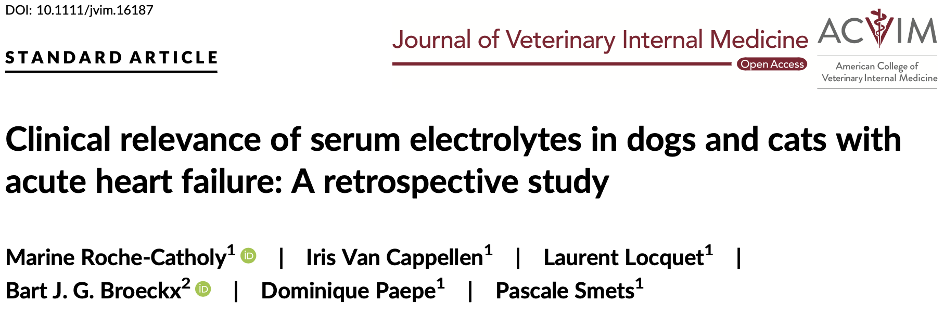

Introduction:
- Activation of the Renin-angiotensin-aldosterone (RAAS) and arginine vasopressin (AVS) system occurs in CHF and subsequent diuretic therapy
- Hyponatremia and hypochloremia is a known negative prognostic indicator in humans with CHF
  - Hyponatremia has bene documented as negative prognostic indicator in dogs
- The unique role of Cl (AKA it is not just the anion linked to Na) has recently been debated
- Goals of study:
  - Document -lyte abnormalities present at admission
  - Document relationship between diuretic dose and lyte concentrations
  - Document -lyte concentration in predictive prognostication of hospitalization length and survival time
Materials & Methods:
- Retrospective study
- Small animals (46 dogs, 34 cats) with first episode of CHF (both right and left) documented by imaging study (TXR + echo OR POCUS)
  - Previous diagnosis of cardiac disease (no previous CHF) and/or administration of cardiac meds were not exclusionary
  - Animals with neoplasia, other systemic disease that would impact survival or those undergoing interventional/surgical procedures were excluded
- -Lytes (Na, Cl and K) were classified as “hypo”, “normo” or “hyper”
  - Wilocxon rank sum sum test used to determine if furosemide administration prior to hospitalization impacted -lytes (Cl)
- Doses of furosemide were recorded at hospital discharge and at end-stage disease
  - Data from animals receiving other loop diuretics (torsemide) were not included in this analysis
Results:
- Hypochloremia was the most commonly diagnosed -lyte derangement (24% of cases)
  - Similar pattern in furosemide naïve animals
    - Furosemide naïve dogs had significantly higher Cl compared to previously treated dogs
- No correlation between admission -lytes and duration of hospitalization nor survival time
  - Included corrected Cl
- Significant negative association of admission Cl on total dose of furosemide (mg/kg/d) prescribed at discharge and at end-stage (dogs only)
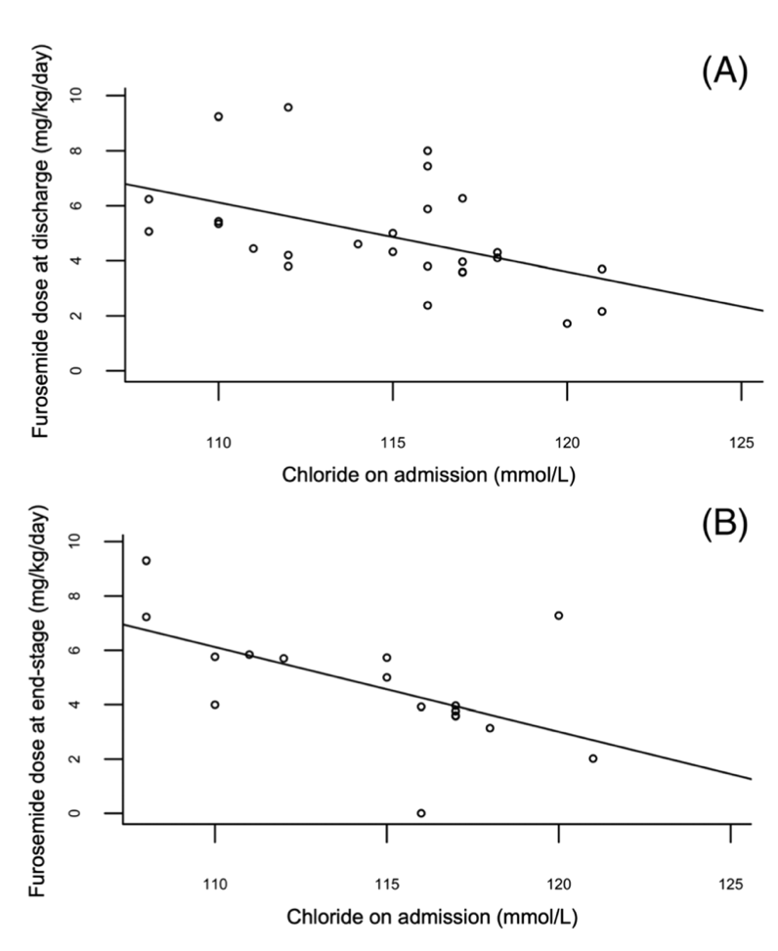
  - Cl level remained significant when Spearman rank correlation was used to assess correlation in furosemide-naïve dogs
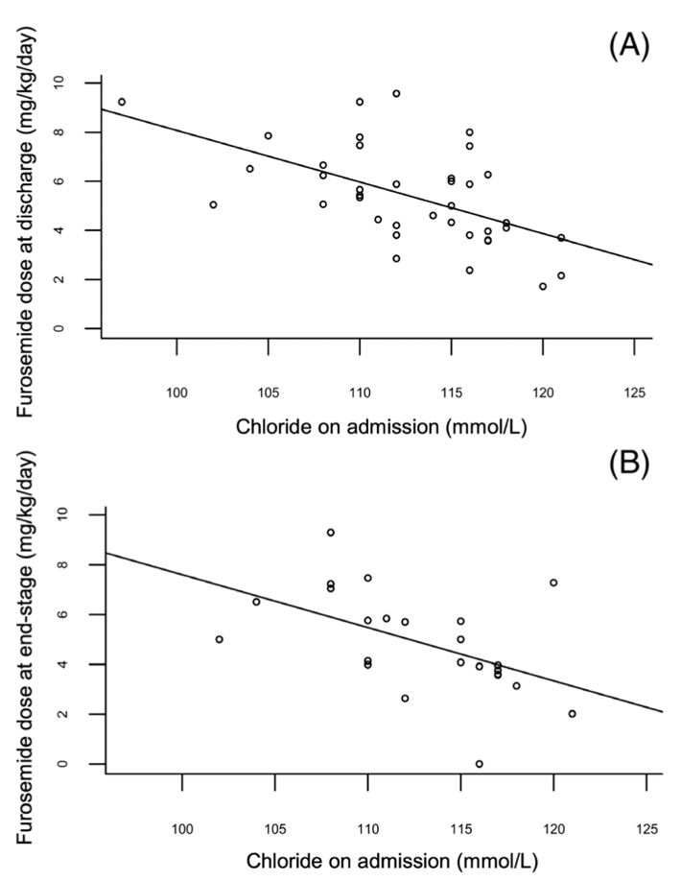

Discussion:
- Though still the most common documented electrolyte abnormality in acute CHF
  - The incidence of hypochloremia was more common in small animal veterinary patients than in humans
- The presence of hypochloremia could be used by clinicians as a prognostic indicator for disease severity and/or impaired response to diuretic therapy
  - Higher doses of diuretics associated with less favorable outcome in humans
    - No differences in outcome documented in this study
- Exact pathophys of diuretic resistance and/or hypochloremia still under investigation in people and veterinary species
  - Excess Angiotensin II vs altered acid/base status vs other
- Lack of statistically significant differences of duration of hospitalization (both species) and prognosis/diuretic doses in cats could be due to small sample size

Sept/Oct 2021

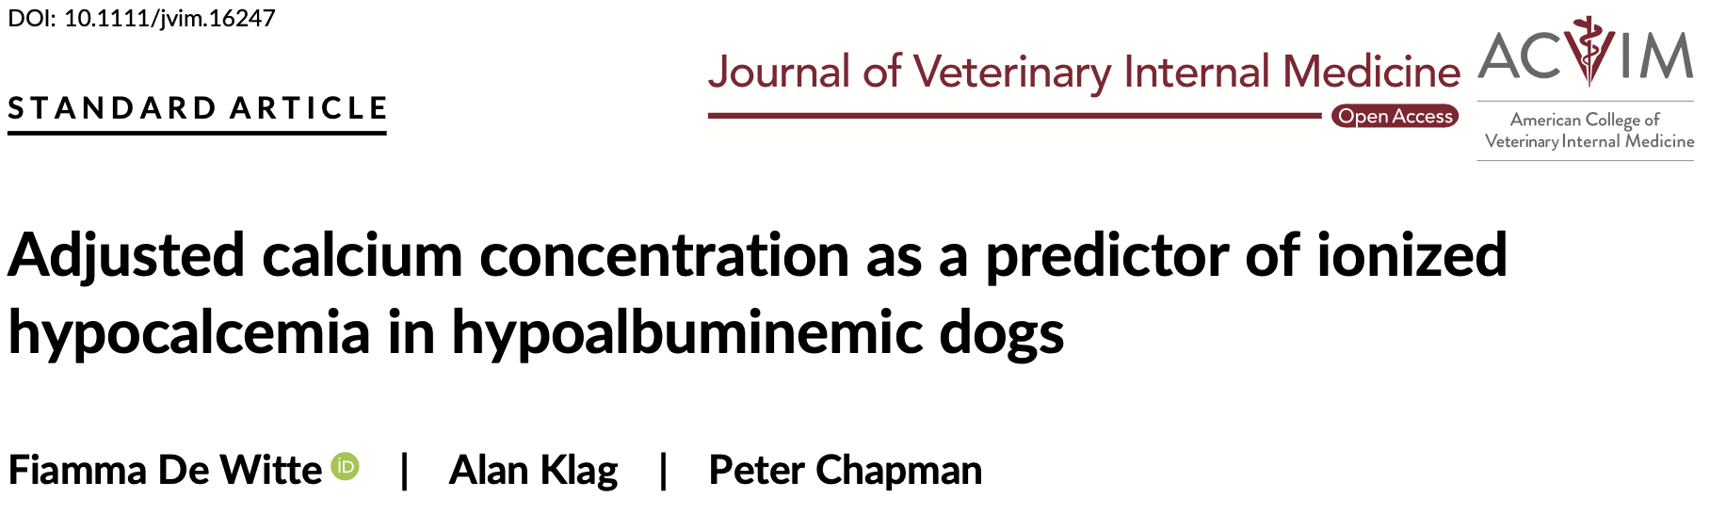

Introduction
- Calcium exists in 3 forms in the body:
Serum total calcium (tCa) exists in 3 fractions: protein-bound (mostly
to albumin), ionized calcium (iCa), and complexed calcium. In clinically
normal dogs, these fractions account for approximately 55%, 35%,
and 10%, respectively.
  - Protein (albumin) bound: 55%
  - Ionized (iCa): 35%
  - Complexed: 10%
- Exact proportions are affected by concentrations of anions (albumin, phosphates) and pH
- Only iCa and complexed calcium are biologically active
- Majority of routine chemistry analyzers only measure total calcium (tCa)
  - Previously published formulas adjust tCa for protein levels to determine if degree of hypo tCa is appropriate/expected
  - Formula to predict presence of hypo iCa may be helpful in clinical scenarios where phosphorous is normal
    - PLE: Low albumin with normal Phos
Materials and Methods
- Retrospective review study of 262 dogs from 2 different hospitals with documented iCa, tCa, Phosphorous and albumin within same 24h
  - Hypoalbuminemia (<2.5g/L)
  - Normal phosphorous (<5mg/dL)
- Adjusted calcium (aCa) level was calculated with below formula:
  - Total calcium [tCa] (mg/dL) – [serum albumin] (mg/dL) + 3.5g/dL
- Specificity, sensitivity, PPV and NPV of aCa for ionized hypocalcemia calculated
  - Degree of ionized hypocalcemia stratified as: Any (<1.13mmol/L) and severe (<1.02mmol/L)
  - Also stratified based on severity of hypoalbuminemia (mild/moderate (2-2.5g/dL) vs severe (<2.0g/dL))
- Receiver operator curves (ROCs) for tCa and aCa were created and AUC used to predict the two levels of hypo iCa
  - Plot of true positive rate (sensitivity) against false positive rates (specificity) at different thresholds
- Youdon method used to determine the performance of each tCa and aCa at predicting the above levels of iCa
  - J= [True positive/ (true positives + false negative)] + [True negative/ (true negative + false positive)] -1
    - AKA: Sensitivity + specificity -1
  - Value ranges from 0 (same number of positive tests with each process) to 1 (no false positive/negative results)
    - Values with same J have same proportion of misclassified results
Results:
- The ideal cutoffs for tCa and aCa to detect any ionized hypocalcemia were 8.3mg/dL and 9.9mg/dL
- The ideal cutoff for tCa and aCa to detect moderate ionized hypocalcemia were 7.0mg/dL and 9.4mg/dL
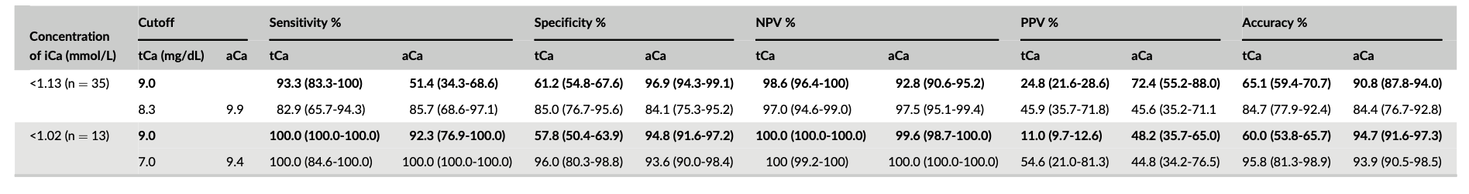
- In dogs that were stratified based on severity of hypoalbuminemia
  - Dogs with mild/moderate hypoalbuminemia (2-2.5g/dL), tCa cutoffs of 8.5mg/dL and 8.2mg/dL were ideal to detect any and moderate hypo iCa respectively
  - In dogs with severe hypoalbuminemia (<2.0g/dL), tCa cutoffs of 7.6mg/dL and 7.0mg/dL were ideal to detect any and moderate hypo iCa respectively
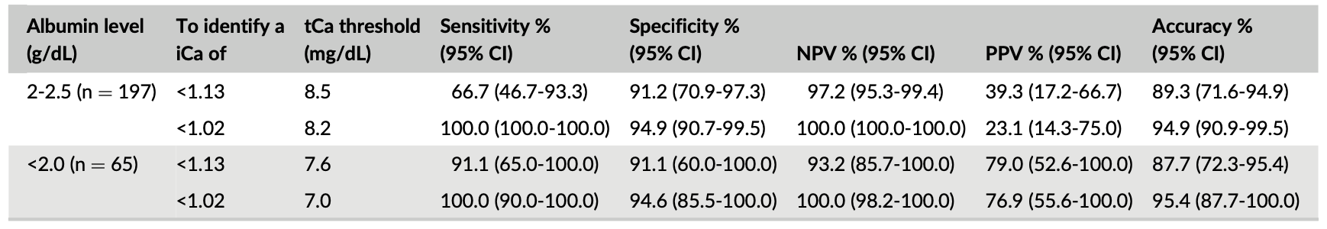
- When using lab reference range, aCa had a higher specificity, PPV, and accuracy for predicting ionized hypoCa compared to tCa

Discussion:
- aCa can be used as a good screening test, as dog with a low aCa are more likely to have a moderate hypo iCa.
  - Presence of a low aCa should prompt clinical investigation/measurement of iCa
- Results of this study differ from previous studies which have documented that low accuracy for aCa at predicting hypo iCa
  - Previous studies used a more heterogenous population and which were not controlled for P levels

