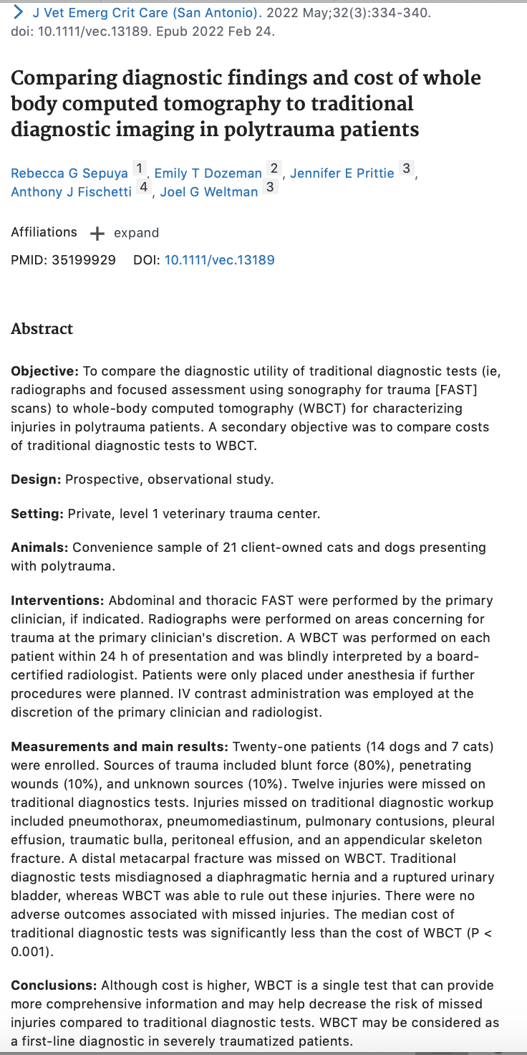
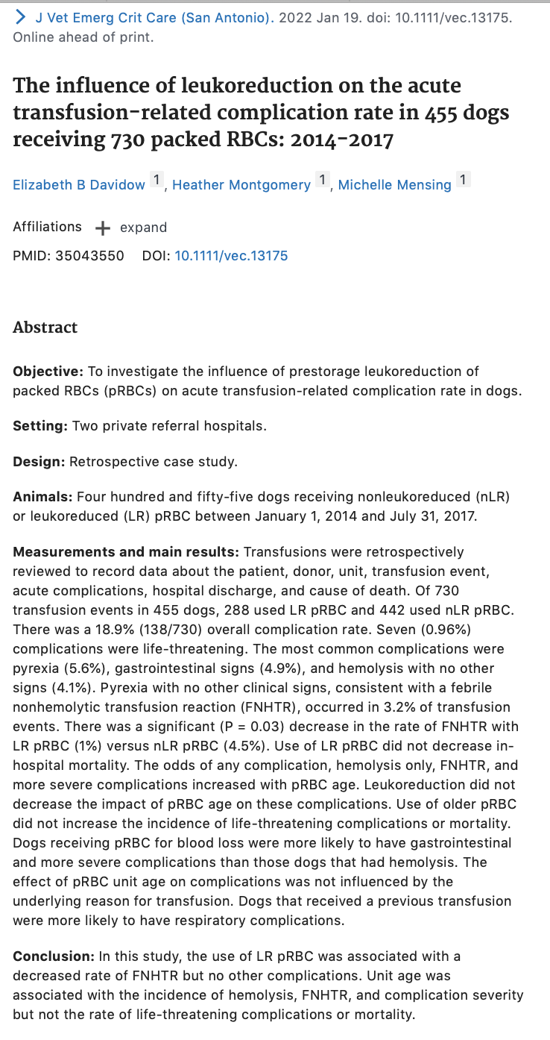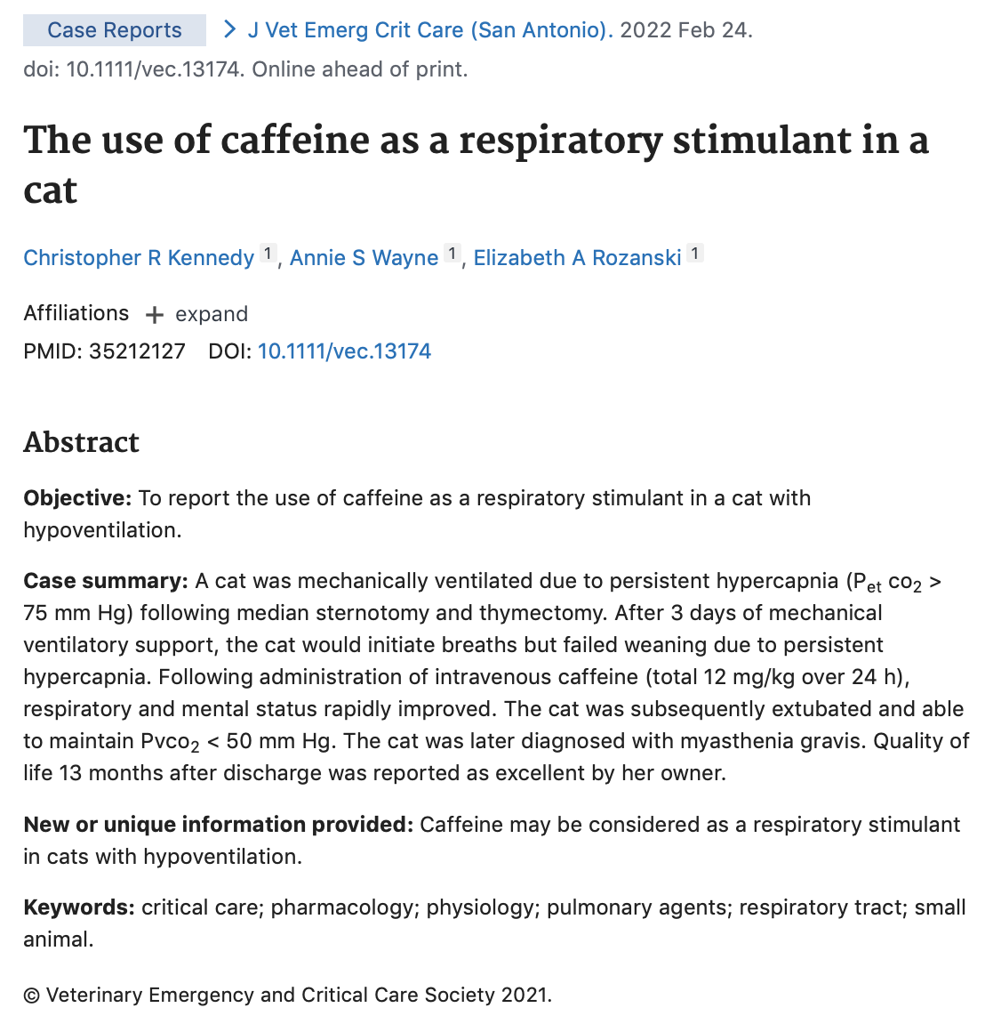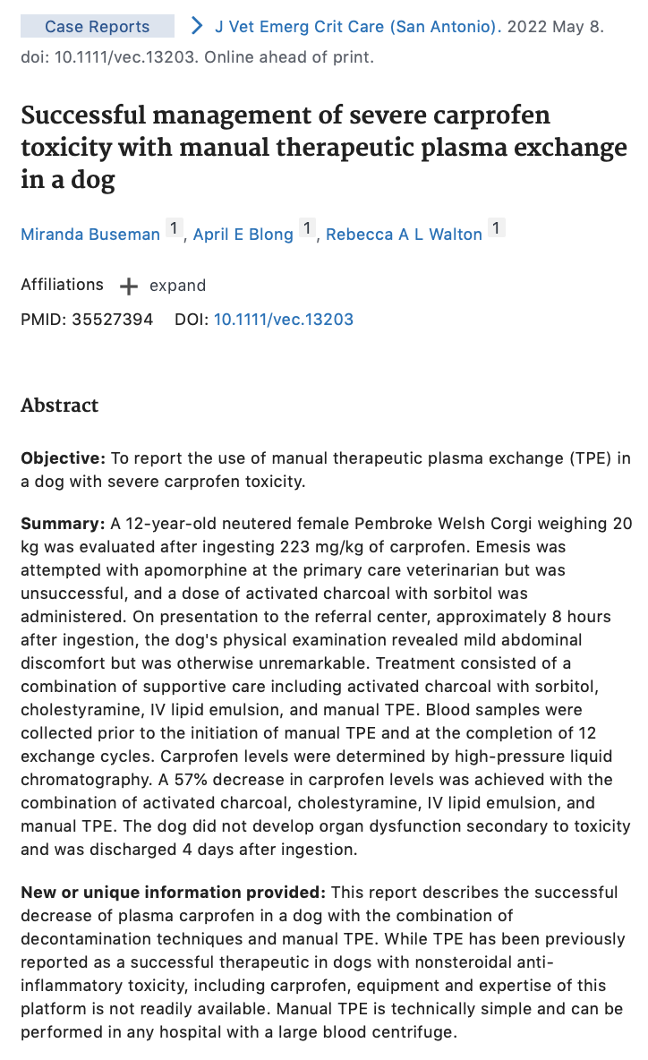
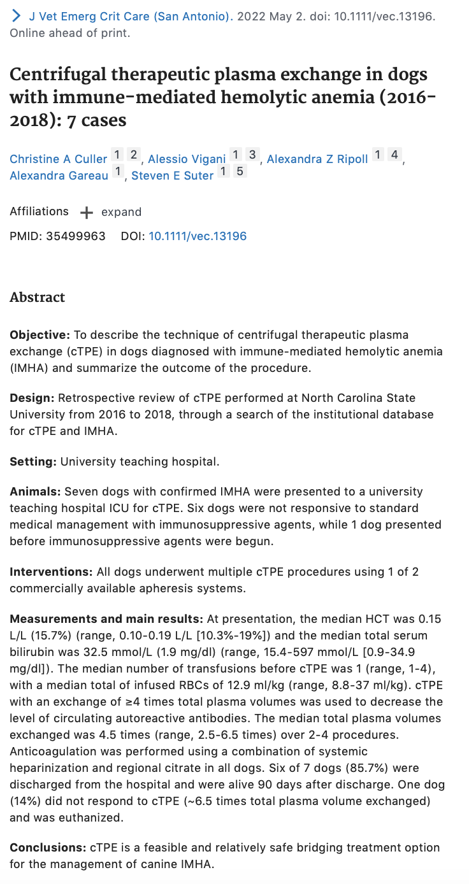
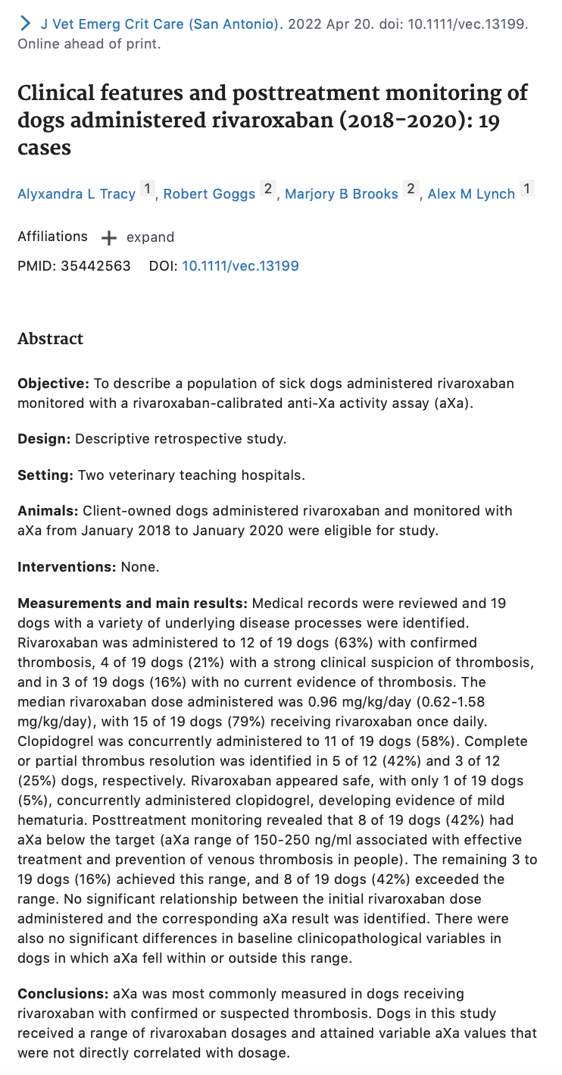
■ Summarized introduction
Rivaroxaban has a recommended dose of 1-2 mg/kg/day, and has a variable biological effect. Biological activity can be measured with anti-Xa activity assay. Human patients receiving this for VTE and thromboprophylaxis have aXa within 150-250 ng/ml. This study describes a population of sick dogs administered rivaroxaban and monitored with aXa, describing reason for admin, aXa values, evidence of thrombus resolution, complications and outcome.
■ Very brief materials & methods
Jan 2018-Jan 2020 retrospective study for dogs that had at least 1 rivaroxaban calibrated aXa and NC State and Cornell. Recorded signalment, CBC, chem, diagnostic imaging, TEG, PT/PTT, fibrinogen, D dimer, antithrombin, rivaroxaban dose and frequency, other antithrombotic meds, reason for admin, confirmed thrombosis/strong clinical suspicion of thrombosis/no current suspicion of thrombosis, any dose adjustments, serial imaging of thrombi, adverse effects, necropsy results, survival to discharge, cause of death. Confirmed thrombus: US or CT visualization. Strong clinical suspicion: PE, clinicopathological, diagnostic imaging results in absence of thrombus visualization. No current suspicion of thrombosis: disease associated with hypercoagulability.
Blood samples obtained from dogs 2-4 hours after rivaroxaban admin for aXa levels.
Continuous data compared with Kruskal-Wallis or Mann-Whitney test. Categorical data compared with Fisher’s exact. Pearson’s correlation coefficient calculated for relationship with dose and aXa result (0 is no correlation).
■ Summarized results
19 dogs total, median age 8.5 years, 10 females, 9 males, median weight 13.5 kg, 13 breeds. Rivaroxaban given to 12/19 (63%) with confirmed thrombosis, 4/19 (21%) strong suspicion, 3/19 (16%) no evidence of thrombosis. Thrombosis arterial in 7/19 (37%), venous in 63% of dogs (none with concurrent arterial and venous). Conditions treated include suspicion of PTE, acute neuro signs in dog with endocarditis, IMHA, acute panc, septic peritonitis. Unfractionated heparin used in 26% of dogs prior to rivaroxaban with 12 hour washout period. Clopidogrel used in 58% of dogs.
CBC: anemia, neutrophilia, leukocytosis. Chem: hypoalbuminemia, inc ALP, inc ALT. Inc D dimer, hyperfibrinogenemia, prolonged PTT. PT in 14 dogs, all normal. TEG in 3 dogs, 2 were hypercoagulable (G value).
Median dose of rivaroxaban 0.96 mg/kg/day (0.62-1.58 range). Once daily admin in 79%, BID in 21%. 42% of dogs had aXa below human therapy range, 16% in range, 42% above range. No diff in doses given to dogs below, in, or above range. Linear regression did not identify relationship b/w dose and aXa. No diff in CBC or chem variables in relationship to aXa range. Initial dose of rivaroxaban adjusted in 47% of dogs, 4 of 9 in response to aXa result.
4 dogs had second aXa measured. 2 initially below range, 2 above range. 2 with initial low range -> 1 achieved range, 1 remained below. 2 with initial high range-> lower result but both remained above.
Single adverse bleeding event (rivaroxaban 0.8 mg/kg/day and clopidogrel 1.5 mg/kg/day): hematuria. Initial aXa was 614 ng/ml (H).
12 dogs with confirmed thrombosis on imaging. 42% complete thrombus resolution, 25% partial resolution, 33% no change in 4 weeks. No diff in aXa in the 4 dogs without clot resolution.
8 dogs below aXa range: 25% evidence of thrombus resolution, 63% smaller thrombi, rest no change.
None of the 3 dogs without evidence of thrombosis at time of starting rivaroxaban developed any thrombosis at 6 week followup.
15 dogs (79%) survived to discharge. 4 dogs euthanized.
■ Summarized discussion
Dogs had variable aXa levels not directly correlated with dosage but rivaroxaban appeared safe and well tolerated with 1 minor bleeding event in dog getting rivaroxaban and clopidogrel.
Most dogs with confirmed thrombosis had complete or partial clot resolution but unclear if rivaroxaban is associated.
Dose adjustment in response to human therapeutic aXa levels for heparin anticoagulants has been assoc with improved outcome in dogs with IMHA treated with unfractionated heparin.
Small number of dogs in study achieved range of 150-250 ng/ml (16%), equal number above and below range. 67% of dogs with visible thrombosis had complete or partial clot resolution on subsequent imaging. Maybe not aXa activity? Maybe endogenous fibrinolysis and reductions in thrombophilicity. Clopidogrel was also administered to over half the dogs in study (58%). Peak aXa maybe less important than trough values or duration of action.
Consistency in timing of dosing and blood sampling strongly advised.
Rivaroxaban is not meant to be split per manufacturer, so effect of splitting tabs is unknown. Crushing tabs in people did not differ from whole pills, so this may be a reasonable method for smaller doses.
42% had aXa above 250 ng/ml, but only 1 mild bleeding event. 64% of dogs also had prolonged baseline PTT prior to starting rivaroxaban likely due to consumption (thrombus formation).
Anticoagulants generally recommended for VTE (clots mainly RBCs and fibrin) but platelets play a role in thrombin generation, so dual therapy (platelet inhibition and anticoagulant) has a synergistic effect.

Limitations: small and retrospective study with heterogenous patient population with variety of underlying diseases. Medications usually given by owners, reliability of dosing cannot be known. Serial aXa uncommon. Some received unfractionated heparin prior to rivaroxaban.

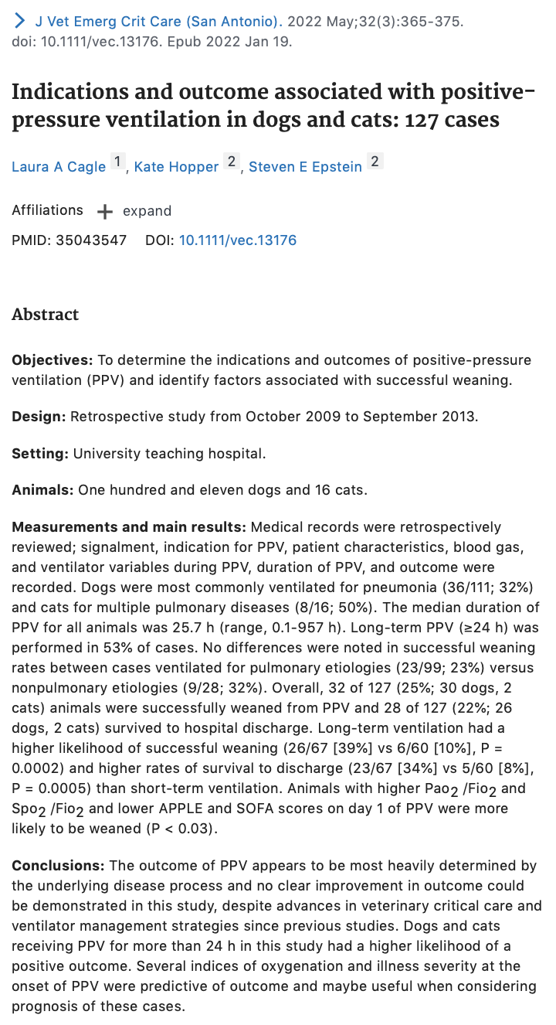
■ Summarized introduction
Only 4 studies on PPV in veterinary ICU, three between 1990-2001. Purpose of this study is to determine indications and outcomes of PPV in dogs and cats at university teaching hospital. Secondary goal: identify factors associated with successful weaning and survival to discharge.
■ Very brief materials & methods
Medical records from October 1, 2009 to September 30, 2013. Data collected include: primary disease diagnosis, arterial or venous blood gas 6 hours prior to initiation of PPV, SPO2. P/F, S/F ratios calculated. Indication for PPV classified in 2 groups: pulmonary disease or nonpulmonary disease group. Pulmonary disease group included patients with hypoxemia (P/F ratio </= 300 or S/F </= 315 despite oxygen therapy or severe signs of resp distress attributable to pulmonary dz). Nonpulmonary group included those with severe hypoventilation (PaCO2 >/= 60, inadequate respiratory efforts, apnea) without evidence of pulmonary disease as determined by CXR or P/F ratio >300.
Illness severity scores determined if enough data: SOFA, APPLE.
PPV period data: anesthetic protocol, ETT v trach, vent settings, art or venous blood gas, pulse ox values, duration of PPV, outcome. Data collected at initial stabilization on PPV, average throughout PPV, and last recorded value prior to weaning.
Long term PPV defined as =/>24 hours of ventilation. Successful weaning defined as being disconnected from vent for =/>24 hours.
Rate of successful weaning compared for indications for PPV, dz processes, brachy v non-brachy, duration of PPV, oxygenation status, mortality scores, species
■ Summarized results
127 animals (111 dogs, 16 cats) received PPV out of 56,936 animals presented to hospital. Brachycephalics made up 23% of dogs in study.
Dogs required PPV for pulm dz in 78% of cases, 22% for nonpulmonary dz. Pulm dz: pneumonia (61%), post cardiopulmonary resuscitation (14%), cardiogenic pulm edema (13%), ARDS (13%). Non-pulm dz: intracranial dz (42%), cervical myelopathy (21%). ETT in all dogs, 7 had temporary trach.
Cats required PPV for pulm dz in 75% of cases, 25% for nonpulm dz. Pulm dz: pneumonia (42%), cardiogenic pulm edema (33%), ARDS (33%). Nonpulm dz: intracranial dz (50%, 2 of 4). ETTs placed in all cats, 1 had temporary trach.
All animals initially started in pressure assist/control mode. Vent settings at initial stabilization significantly diff for those with and without pulm dz. Pulm dz: higher PEEP with median of 7 cm H20 (2-14cm), higher mean airway pressure with median of 12 cm H20 (3-24), lower TV with median of 9 ml/kg (4-23) and higher RR with median of 24/min (10-100).
CPAP is the most common mode prior to successful weaning (66%), with SIMV at 22%. Settings prior to successful weaning had median PEEP of 4 (1-5cm H20), TV 9 (2-17 ml/kg) FIO2 0.4 (0.25-0.45), pressure support vent of 5 (2-11 cm H20).
Median duration of PPV 25.7 hours (0.1-957h). Short term vent in 47% of cases (median duration 8.8 hrs); long term vent in 53% (median duration 59 hrs). Animals with pulm dz had no difference in median duration of PPV 31 hrs (0.1-957 hrs) versus without pulm dz (20hrs; 3.3-508 hrs)
Median oxygenation index 5.6 (1.3-60), median oxygen saturation index 4.7 (0.7-72).
Animals in long term PPV group more likely to be weaned and survive to discharge than short term PPV group. Pulm dz animals more likely to be weaned and survive to discharge in long term PPV than short term group. Non pulm dz animals not more likely.
25% of animals were successfully weaned from PPV (30 dogs, 2 cats). 22% (26 dogs, 2 cats) survived to discharge. In animals with pulm dz, 22% successfully weaned (all survived to discharge). In animals without pulm dz, 32% successfully weaned (5/8 dogs and 1/1 cat survived to discharge).
No attempt at weaning in 61% of animals (of these, 81% were euthanized, 19% CPA). Weaning was unsuccessful in 13% (of these, 82% euthanized, 18% CPA). Causes of weaning failure: tachypnea, hypoxemia, CV instability.
No difference in likelihood of weaning b/w animals with or w/o pulm dz. Brachyceph dogs more likely to be weaned. Animals with or w/o pulm dz had similar rates of survival to discharge.
P/F and S/F ratios were associated with likelihood of successful weaning at all time points.
SOFA and APPLE scores significantly higher in pulm dz group. Lower illness severity scores at onset of PPV were associated with successful weaning.
■ Summarized discussion
Animals received PPV for pulm dz more frequently than nonpulm dz. Pneumonia is the most common pulm dz in both dogs and cats; intracranial dz most common in both species.
ETT infrequently, mostly to facilitate weaning.
Pressure assist/controlled ventilation was the primary mode in the study. Vent settings reflect pulm mechanics associated with lung dz. Weaning most commonly performed by transition to vent modes with greater degree of spontaneous breathing.
Duration of PPV ranged from 0.1 to 957 hours (in human ARDS patients, range is 6-26 days). Weaning rate was 27% in dogs, 12.5% in cats.
Overall survival to discharge for all dogs 23%, dogs ventilated for =/> 24 hours was 37%.
No difference in weaning or survival rates of animals with pulm dz compared to those w/o pulm dz. May be due to the types of diseases included in the non-pulm dz group: post CPA, intracranial neoplasia, cerebellar herniation.
Dogs with pneumonia had higher likelihood of survival in long term PPV group and no animals that received <24 hours of PPV were weaned.
Brachycephalics had higher likelihood of weaning.
Post-cardiopulmonary resuscitation had lower weaning rate (none weaned from vent).
Oxygenation index and oxygen saturation index during PPV were associated with likelihood of weaning.
Both APPLE and SOFA scores associated with successful weaning.

