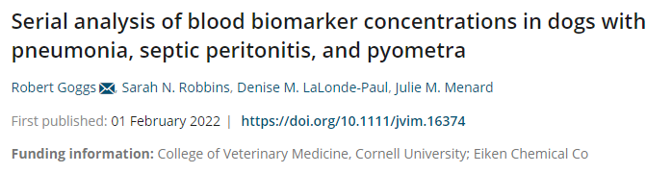
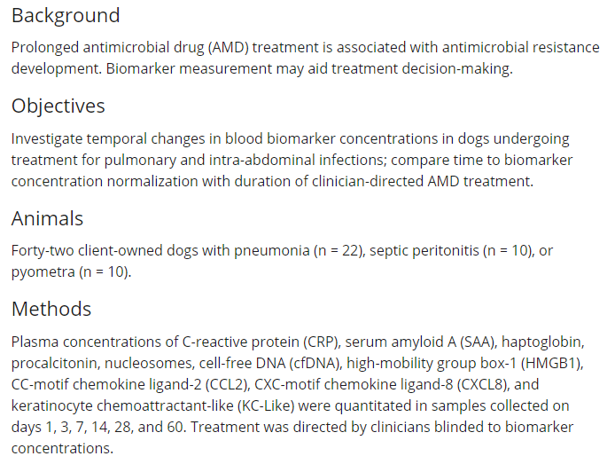
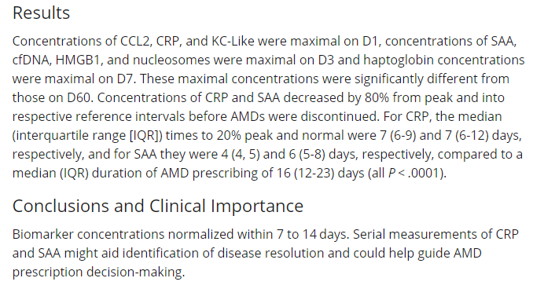
Summary:
Intro: Sepsis in dogs with pyometra, pneumonia and peritonitis carries a high mortality rate (30- 64%). Early recognition is important as well as appropriate antimicrobial drugs (AMD). This lead to resistance. Research in humans shows that shorter courses of AMDs can be used without worsening outcomes but now more research is needed in duration of treatment for dogs. In humans biomarkers measurements are used to guide treatment length. C reactive protein and procalcitonin are examples. Aim of the study was to compare temporal changes in biomarkers. They hypothesize that biomarkers would decrease with treatment, stop AMD at normal levels and decrease earlier in patients with surgical intervention to control infection.
Materials and Methods: Prospective observational cohort study of client owned dogs admitted for pneumonia, septic peritonitis and pyometra based on CXR, positive bacterial culture and surgical confirmation. Normalization of biomarkers was when they were withing the RI or decreased 20% of peak concentration. Blood samples were collected at study entry then 3,7,14,28 and 60. Along with VBG, CBC/chem and APPLEfast scores.
Results: 42 dogs enrolled, 22 with pneumonia, 10 with SP and 10 with pyometra. 41 dogs survived to discharge. 35 dogs survived to day 60. Median duration of AMD treatment was 16 days. Median of 3 antibiotics from 2 classes. Potentiated beta lactams and fluoroquinolones were the most common. CBC and chemistry showed changes in leukocytes, albumin and BUN/create had normalized in all by D60, except 2 dogs with high creats. Concentration of CRP and PCT were maximal on day, SAA on day 3 and haptoglobin on day 7. Cytokines varied greatly and biomarkers associated with neutrophil extracellular trap formation (NETosis) were highest on D3. CRP and SAA normalized at D7 much earlier than the antibiotic course (16 days).
Discussion: Markers highest on D1 or D3 and decreased over time with normal values by D14 except haptoglobin (D60) which is a minor APP. Biomarkers were normal or 20% of peak much earlier than discontinuation of AMDs in all groups (PCT 9 days vs SAA 10-12 days). Biomarkers did not decrease earlier in patients with surgical intervention. However there was no group of dogs treated surgically then without AMDs for ethical purposes. Human studies would suggest that stopping AMDs when the biomarkers normalize is safe and there is not a higher risk of recurrent infection. When compared to CBC results neutrophils were still elevated at D14 compared to D60 so CBC is not a good substitute for biomarkers. PCT was comparable to previous reports but lower severity illness scores may make it hard to correlate in this study. Cytokine CCL2 were above RI on D1 and below on D7. Limitations: lower APPLEFAST scores in this study compared to other similar studies, conclusions may not be able to be extrapolated to other diseases, cannot be certain that all dogs had bacterial infections,

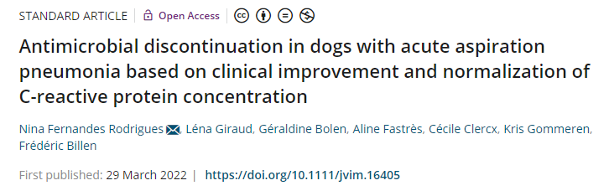
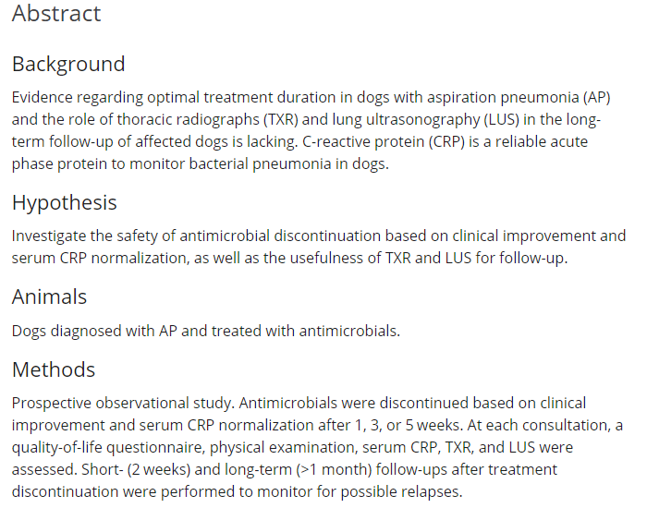
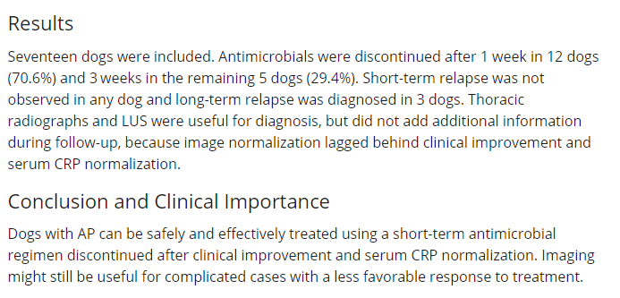
Summary:
Intro: CRP is a reliable APP that can be used to serially monitor response to treatment in dogs with AP. Can also be used to de-escalate therapy. Serial imaging was also assessed using TFAST especially since CXR lag behind resolution of AP. Current guidelines recommend treatment for 3-6 weeks or 1-2 weeks post resolution of clinical signs or CXR. Aim was to determine safety of antibiotic discontinuation as well as usefulness of CXR and LUS.
Materials and methods: Prospective observational. Dogs diagnosed with AP between January 2020 and June 2021. Based on CXR, CRP, clinical signs and history. At diagnosis and each recheck (1 week initially then every 2 weeks) TXR, LUS, CRP and PE were performed. Owners filled out a QOL survey. Imaging was reviewed by a BR radiologist. TXR were classified as resolved, improving, stable or worsening. LUS was evaluated by 9 windows for >3 B lines, coalescing B lines, shred sign, fluid bronchogram or pleural effusion. Treatment was discontinued if there was a normal PE and CRP and QOL survey was decreased by 25%. Relapse was defined as clinical signs, changes to PE, increased CRP but imaging was not included to determine if relapse occurred. If relapse occurred short term antibiotics were instituted. All dogs were hospitalized for 24 hours, went home with Clavamox and Enforfloxacin was added if concern for sepsis.
Results: 17 dogs, 14/17 had a history of vomiting, 2/17 with regurgitation and 1/17 had laryngeal paralysis. Main complaints were lethargy and tachypnea. Common PE findings were abnormal respiratory pattern, pyrexia, and increased lung sounds. Thoracic radiographs showed ventral alveolar pattern in bilateral or unilateral lung lobes with the cranial lung lobes and right middle the most affected. Two dogs has pleural effusion, 1 had megaesophagus and 2 had bronchiectasis. On admission LUS showed coalescing B lines and shred sign in all dogs. Changes matched signs on CXR. Median CRP was 82.8 mg/L at diagnosis and decreased to 6.0 mg/L. Five dogs has mild persistent elevation that was gone at 3 weeks. Treatment was discontinued in 1 week in 70.6% of dogs and 3 weeks in 29.4% in dogs. PE was normal in all dogs at all follow up appointments. TXR were rechecked at 1 and 3 weeks. Lesions were present in 88% of dogs at 1 week on TXR and 71% of dogs at week on LUS. Week 1 LUS lesions decreased in all dogs. LUS signs were persistent in 4 dogs that received 3 weeks of antibiotics. Short term follow up was not needed past 5 weeks. Long term follow up was performed in 10/17 dogs 1 month after antibiotics were discontinued, only 3 dogs relapsed. Two of the relapsed dogs followed up and both had bronchiectasis on the previous CXR- both had a CT and one was consistent with AP. Remaining 7 dogs had follow up by phone and all were doing except one dog with focal MG that relapsed and was treated with the rDVM.
Discussion: Antibiotics can be stopped safely based on PE and normal CRP concentration. No dogs needed > 3 weeks of antibiotics. QOL score not validated but only found changes in dogs that had relapsed. 17% complication rate similar to previous study, but with shorter duration of treatment. The 3 dogs that has relapse were likely due to other underlying disease processes. Limitations: no airway sampling and CRP is non specific.

