Downloading and Installing Ares Blacklight addon

Open up zip file. Copy zip file from “downloads” file
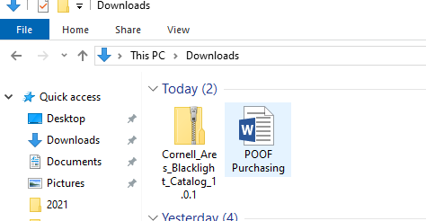

Copy the zipped file into documents, Ares, addons. Right click on zipped file and choose extract all.
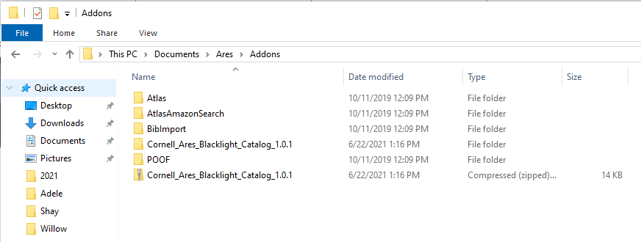

Open Ares client. Choose System and Manage Addons.
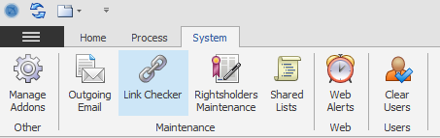

Confirm that the Blacklight Addon is listed in your addons.
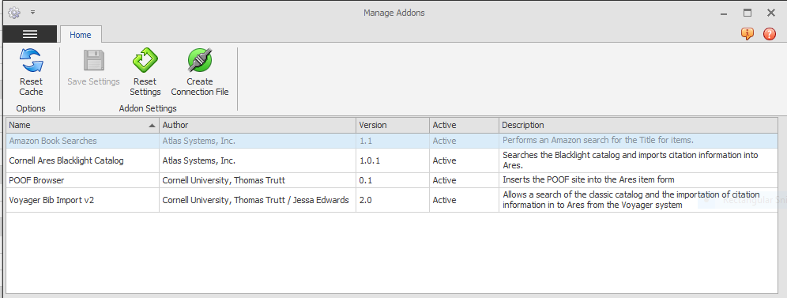
The addon will work very similarly to the Voyager Import addon except you will be able to import from Blacklight. You will also be able to search articles.

