FOLIO temporary procedure for Receiving

Receiving titles that have a slightly different title than that at the point of order:
If you have a purchase order number or a POL number begin there
- Open the Orders app and search by PO number or POL number: If you don’t have a PO number or POL number search by ISBN etc. to find the correct record.
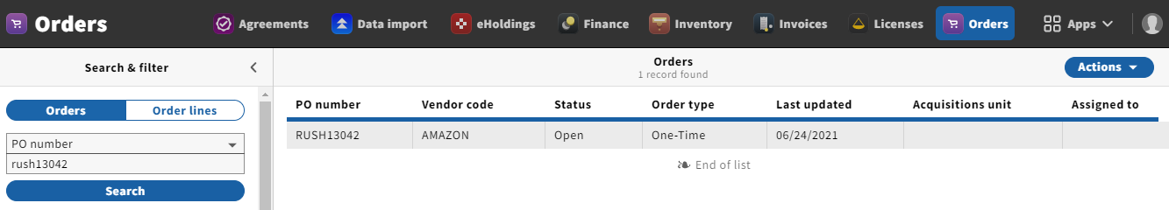
- Click on the PO number to open this in the right hand pane. Scroll down to the PO lines and click on the title you are receiving

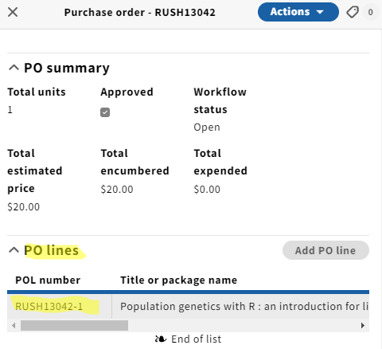

- This will bring you to the POL details
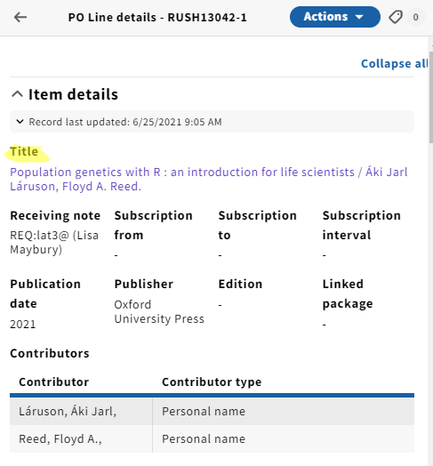
- Click on the title (this is a hot link that will take you to the Inventory app)
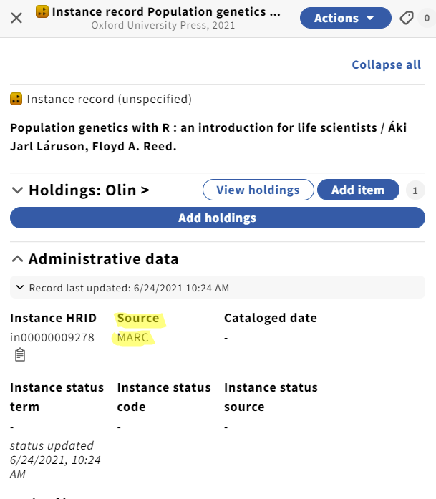

- Click on Actions → Edit in quickMarc (this is only available when your Source is “MARC”). If your Source is “FOLIO” you will update your title going to Actions → Edit.
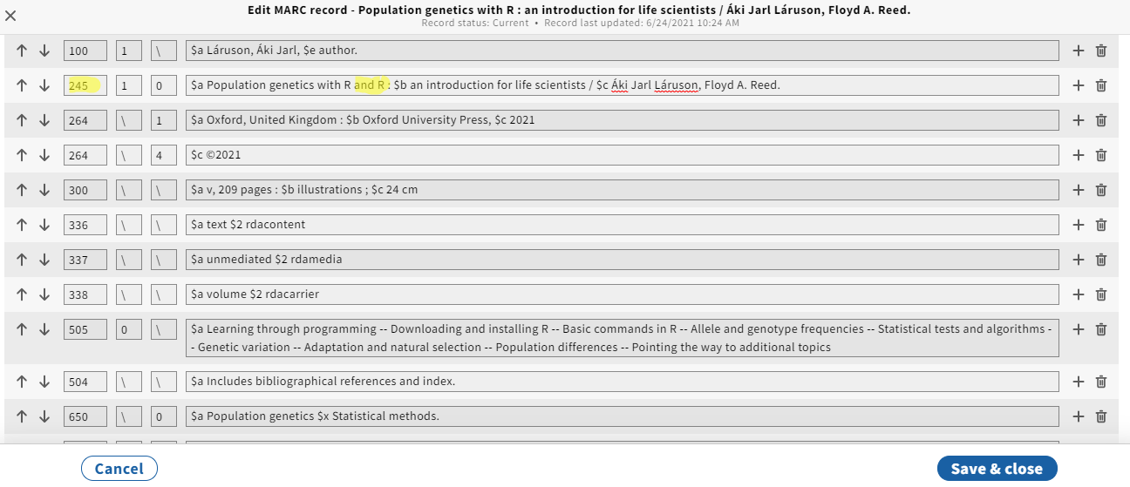
- After making the update to the title using “Edit in quickMarc” click “Save and close”
- Another option would be to search OCLC and overlay the Instance record using single record import
- Return to the title in the Orders app
- Unopen the purchase order (from the PO click Actions → unopen) Note: only people with Acq3 permissions can unopen and re-open an order.
- Click on the PO line you need to update
- Click Actions → Edit
Update the title as it is in Inventory (it is VERY important to use “Title look-up”. If you don’t, you will end up creating a duplicate record, which then cannot be deleted)”
- ):
- Change “Create inventory” to None
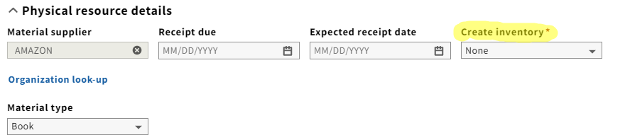
- Save and open order
Now your title in Inventory and your POL should match without creating a new instance record.

- From the POL, click on Actions → Receive which will take you to the Receiving app:
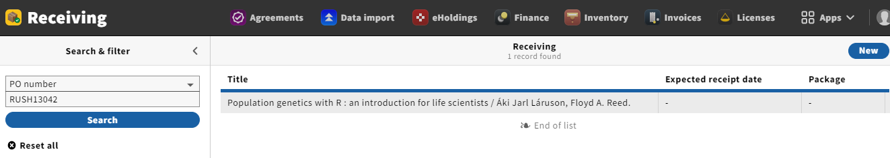

- Click on the title to open this in the right hand pane and receive your title:
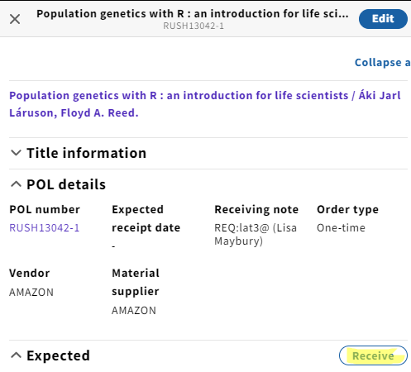
- Check the box to receive and add your barcode:
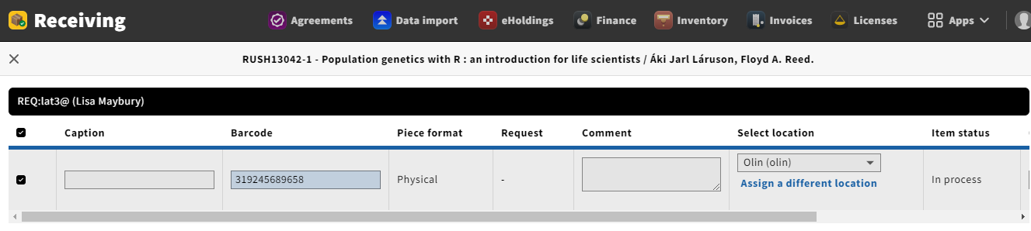


- After you click “Receive” you will be brought back to your original “Receiving” pane.
- Click on the title that is a hot link to the Inventory app to double check all is well!

