FOLIO temporary procedure for Ordering

RUSH ordering:

- Search the Inventory app to determine the order is not a duplicate

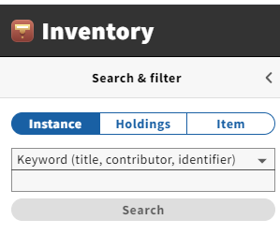
- Open OCLC and search the title you want to order. When you find the correct record copy the OCLC #

- Return to Inventory and import the record by using single record import from OCLC by clicking on the Actions → Import (you will get the following pop-up) Add the OCLC # into the box below and click import

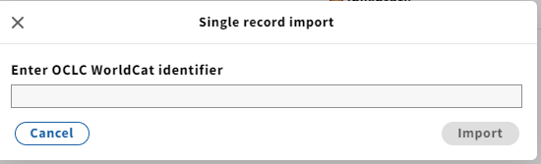

- You will now see your instance record populated in the right hand pane
- Open the Orders app

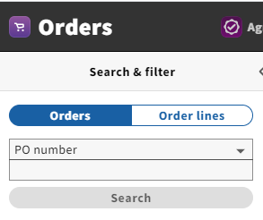

- Click on Actions → New and fill in all mandatory and necessary fields (if a template is available use the template to save time):

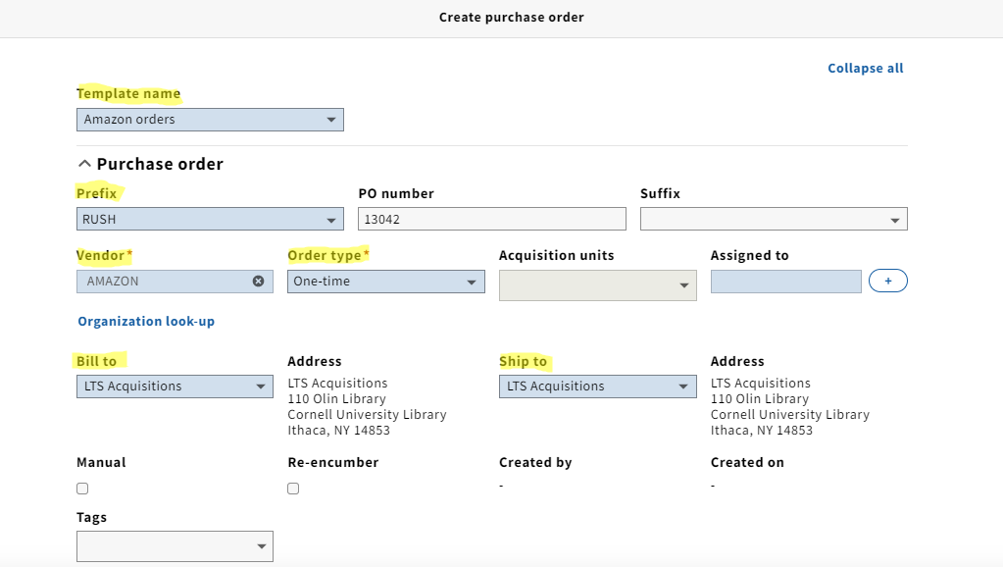

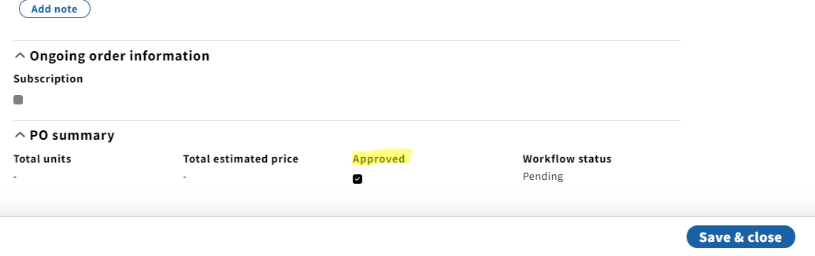

- After you click Save & close you will see your Purchase order in the right hand pane where you will scroll down to PO lines and add your PO line with the title that you imported from OCLC:

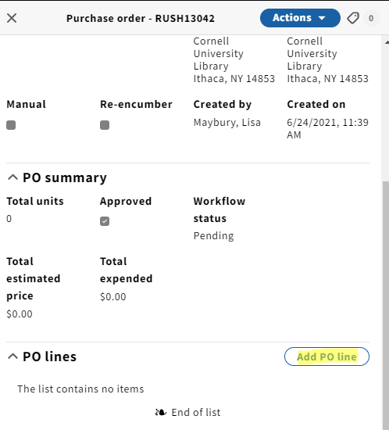
- Click on “Title look-up” and search the title that you brought in from OCLC (all fields that pertain to the title will populate) ADD your requester information in the “Receiving note” field and the “Requester” field and be sure to check the RUSH box:

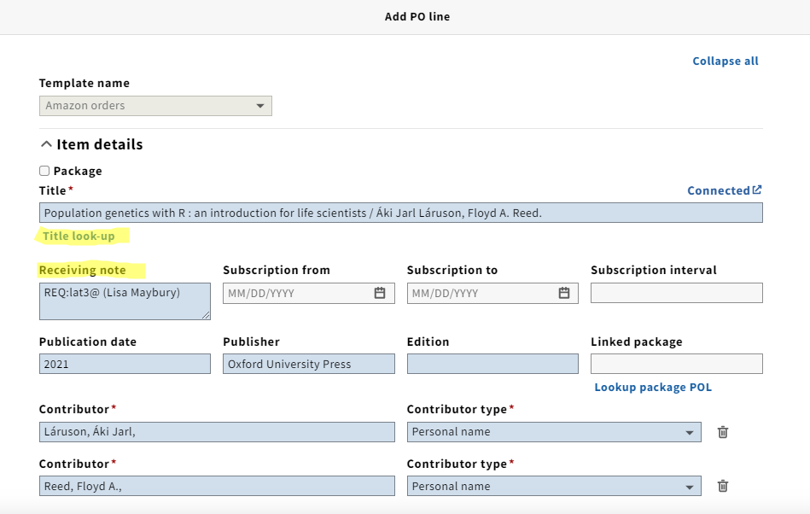
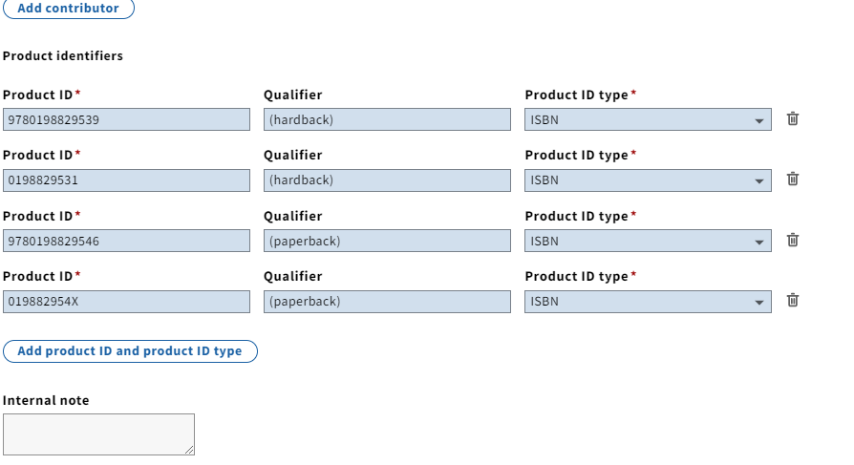
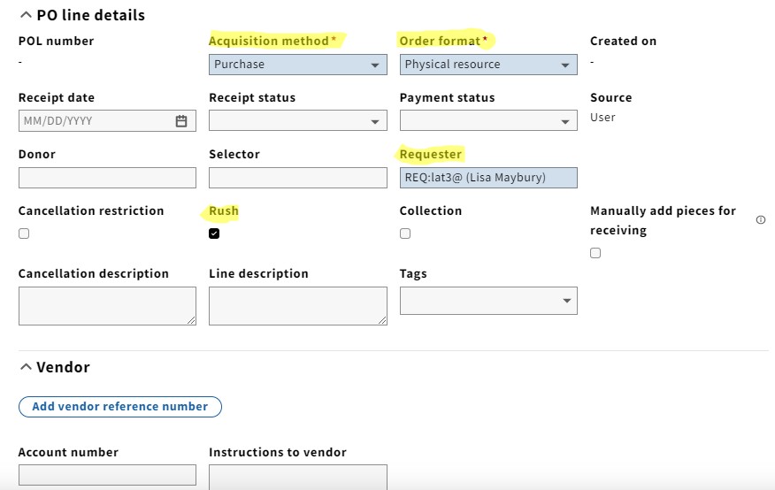
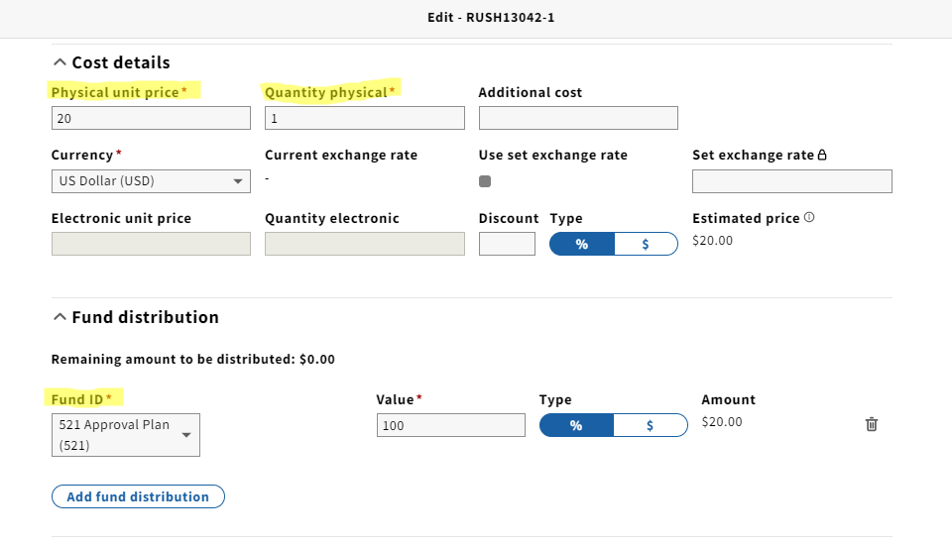
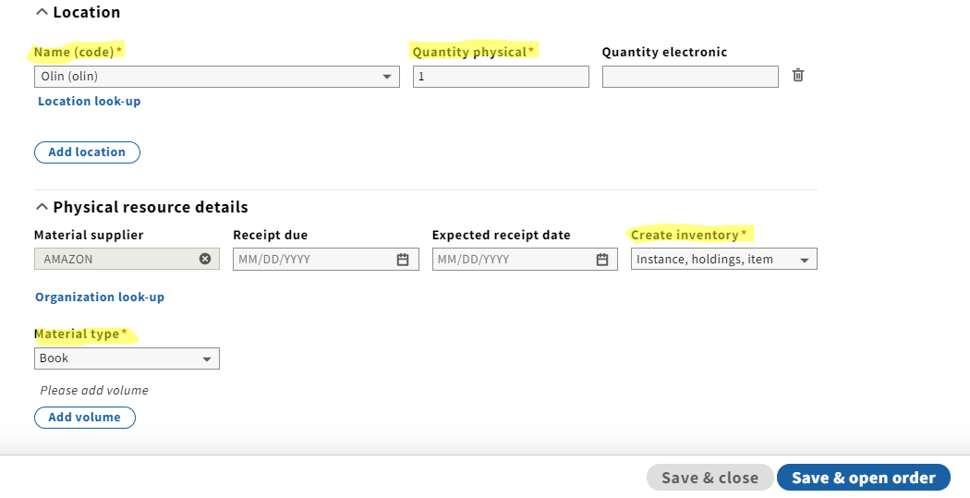

- After you “Save & open order” go to Actions → Receive. This will take you to the Receiving app.

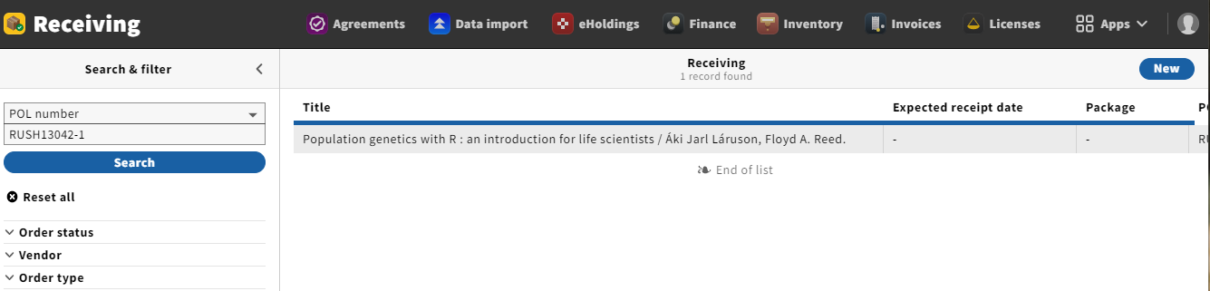

- Click on the title. This will open in the right hand pane and you will click “Edit” in the upper right hand corner

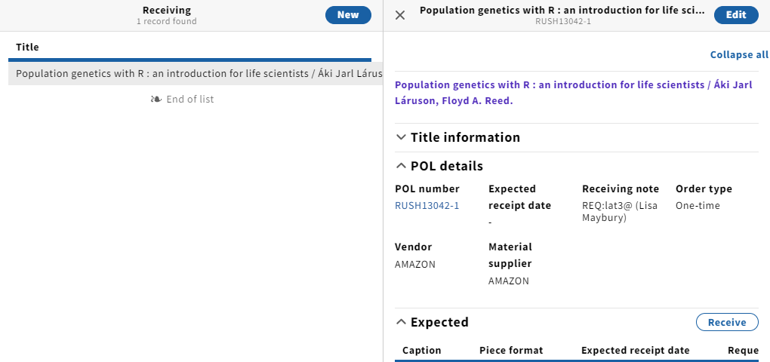

- Scroll down to the bottom and check the box for “Must acknowledge receiving note” and “Save & close”:

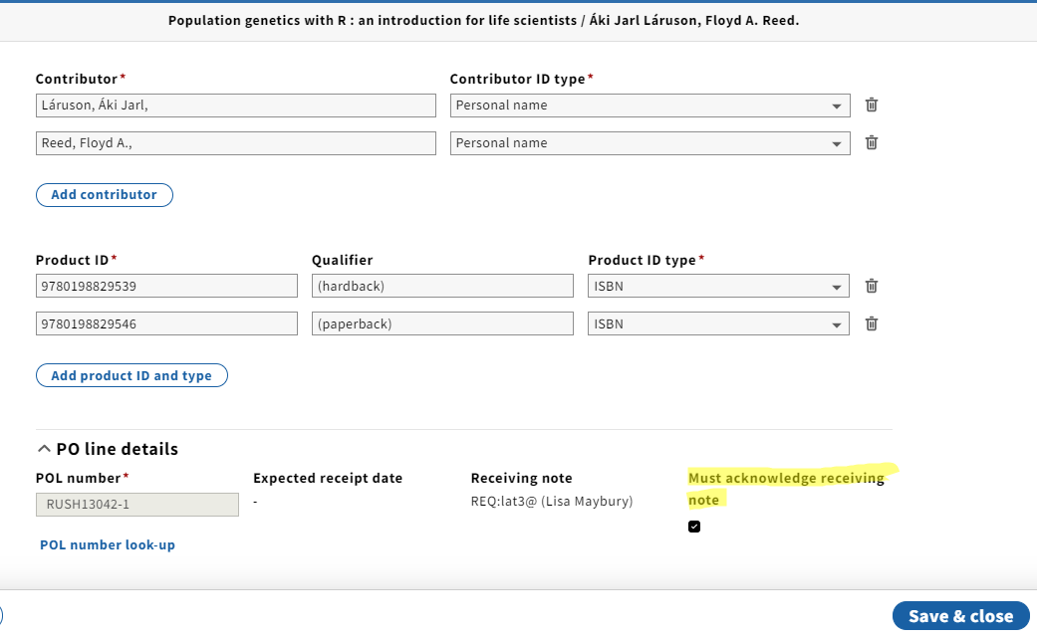

- Now when this RUSH order is received the following pop-up will appear at the point of receiving:

