Immunology – Tizard’s– Chapters 2 through 9
innate immune system is activated when the body senses that it is under attack. Recognizes alarm signals generated by two pathways: by invading microorganisms (exogenous signals) or by dead and dying cells (endogenous signals).
- Exogenous signals consist of molecules produced by microbial invaders. Collectively, these are called pathogen-associated molecular patterns (PAMPs).
- Endogenous signals consist of molecules released from damaged, dead, or dying cells. These are collectively called damage-associated molecular patterns (DAMPs).
Together, the DAMPs and PAMPs are recognized by pattern recognition receptors (PRRs) on sentinel cells located throughout the body. Once recognized, they activate the innate immune system.

Pathogen-Associated Molecular Patterns
- The body uses receptors that can bind and respond to abundant, essential molecules that are common to many different microorganisms
- Soluble receptors also circulate in the bloodstream. Examples of PRRs include the toll-like receptors (TLRs), the retinoic acid-inducible gene (RIG)-1-like receptors (RLRs), nucleotide-binding oligomerization domain (NOD)-like receptors (NLRs), and the C-type lectin receptors (CLRs).

Toll-like Receptors
- Most are located on cell surfaces, responsible for recognizing extracellular invaders. Other TLRs are located within the cells, responsible for detecting intracellular invaders such as viruses. TLRs are a critical first line of defense against bacterial, viral, and fungal invaders
- Expressed by many different cell types: expressed on sentinel cells located on or near the surface of the body. Sentinel cells (macrophages, mast cells, and dendritic cells, as well the epithelial cells)
- TLRs are transmembrane glycoprotein receptors.
- Mammals possess 10 or 12 different functional TLRs
  - Cell surface TLRs (TLR1, 2, 4, 5, 6, and 11) mainly recognize bacterial and fungal proteins, lipoproteins, and lipopolysaccharides.
  - Intracellular TLRs (TLR3, 7, 8, 9, and 10), recognize viral and bacterial nucleic acids.
- When a PAMP binds to its corresponding TLR, signals are passed to the cell. Multiprotein signaling complexes are formed, signal transduction cascades are initiated, and as a result, proinflammatory molecules are produced by the cell.
- All TLRs except TLR3 use an adaptor protein called MyD88 to activate three major transcription factors, nuclear factor kappa-B (NF-κB), MAP kinase (MAPK), and IRF3. NF-κB and MAPK activate the genes for three major proteins: IL-1, IL-6 and TNF-α.
  - The proteins regulate the activities of cells involved in the defense of the body. The cytokines are produced as inactive precursors and then activated by an enzyme called caspase-1.
    - The production of caspase-1 is triggered by a protein complex called an inflammasome. Caspases are proteolytic enzymes that play key roles in the initiation of inflammation. Many are activated by signals generated by TLRs.
    - Caspase-1 is most important because it acts on the inactive precursors to generate active cytokines. These cytokines trigger the next phase of the inflammatory response.
- TLRs also begin the process of “turning on” the adaptive immune system. For example, stimulation of TLR4 makes macrophages and their close relatives, the dendritic cells, produce cytokines that are potent stimulators of immune cells TLRs are also expressed on the bone marrow stem cells that are the source of leukocytes.

RIG-1-like Receptors
Retinoic acid inducible gene (RIG)-like receptors (RLRs) are another family of PRRs expressed within the cytosol. They recognize viral dsRNA.

NOD-like Receptors
Nucleotide-binding oligomerization domain (NOD)-like receptors (NLRs) are a family of PRRs recognizes bacterial peptidoglycans, whereas NOD2 recognizes muramyl dipeptide and serves as a general sensor of intracellular bacteria.

C-type Lectin Receptors
Lectins are proteins that bind carbohydrates. The C-type lectins require Ca2+ for this binding, recognize the carbohydrates on bacteria, fungi, and some viruses.

PAMPS
- conserved molecular structures (or patterns) that occur in a diverse range of potential microbial invaders. Examples:
  - Bacterial LPS: LPS links to MD-2 (myeloid differentiation factor-2), LPS-binding protein (LBP), and CD14.
  - Bacterial Peptidoglycans: Several PRRs can recognize these peptidoglycans, including some TLRs, NODs, and CD14.
  - Bacterial DNA
  - Viral Nucleic Acids

DAMPS or alarmins
- molecules that escape from dead, dying, and damaged tissues.
- may be released when cells die (intracellular) or generated when connective tissue is damaged (extracellular). Others may be produced by stimulated sentinel cells.
- Some of these have potent antimicrobial properties. Others may recruit and activate cells
- One of the most important intracellular DAMPs is called high mobility group box protein-1 (HMGB1).
  - Normally binds DNA molecules and ensures that they fold correctly. However, HMGB1 is also a potent trigger of inflammation.
  - secreted by macrophages that have been activated by lipopolysaccharides or cytokines such as IFN-γ. HMGB1 also escapes from broken cells. HMGB1 binds to both TLR2 and TLR4 and so sustains and prolongs inflammation.
  - Administration of HMGB1 to animals causes fever, weight loss, anorexia, acute lung injury, arthritis, and even death. HMGB1 plays a role in tissue repair because it stimulates the growth of new blood vessels.
  - It also has potent antimicrobial activity.

Soluble Pattern-Recognition Receptors
- many soluble PRRs can also bind PAMPs.
- Three extracellular lectin families, P-, S-, and C-type lectins, are involved in innate immunity.
- P-type lectins are also called pentraxins: Formed by five protein subunits arranged in a ring. Two are important acute-phase proteins: C-reactive protein (CRP) and serum amyloid P (SAP)
- They are acute phase proteins.
- Pentraxins have multiple biological functions:
  - Activation of complement and stimulation of leukocytes.
  - They bind to microbial carbohydrates such as LPS in a calcium-dependent manner and activate the classical complement pathway by interacting with C1q.
  - Interact with neutrophils, monocyte-macrophages, and NK cells and augment their activities.

Sentinel Cells
- Cells whose primary function it is to recognize and respond to invading microbes are called sentinel cells.
- scattered throughout the body
- Equipped with multiple, diverse PRRs, so they can detect and then respond rapidly to both PAMPs and DAMPs.
Macrophages: The most important sentinel cells. They can capture, kill, and destroy microbial invaders.
Dendritic Cells: The second major population of sentinel cells, they possess long, thin cytoplasmic processes called dendrites. They are a heterogeneous population of cells, many of which are closely related to, or derived from, macrophages.
Mast Cells: key role in allergies, they also trigger inflammation in conventional situations.

Proinflammatory and Antimicrobial Mediators

- Macrophages, dendritic cells, and mast cells are activated when PAMPs or DAMPs bind to their PRRs. As a result, they synthesize and secrete molecules that trigger inflammation, inhibit microbial growth, and initiate the first steps in adaptive immunity.

Cytokines
- When exposed to PAMPs, sentinel cell secretion of three major cytokines.
TNF-α:
- produced by sentinel cells in response to TLR stimulation.
- First cytokine to be produced
- TNF-α can also be produced by stimulated endothelial cells, T cells, B cells, and fibroblasts.
- Triggers the release of chemokines and cytokines from nearby cells and promotes the adherence, migration, attraction, and activation of leukocytes.
- Later, TNF-α facilitates the transition from innate to adaptive immunity by enhancing antigen presentation and T cell activation.
- Essential mediator of inflammation because in combination with IL-1 it triggers changes in the vascular endothelial cells that line small blood vessels.
- Local increase in TNF-α causes the classic signs of inflammation
- Circulating TNF-α can depress cardiac output, induce microvascular thrombosis, and cause capillary leakage.
- TNF-α acts on neutrophils enhance their ability to kill microbes. It attracts neutrophils damage and increases their adherence to vascular endothelium.
- Stimulates macrophage phagocytosis and oxidant production.
- Amplifies and prolongs inflammation by promoting macrophage synthesis of other mediators such as NOX2 and COX-2, and it also activates mast cells.
- Induces macrophages to increase its own synthesis together with that of IL-1.
- Can kill some tumor cells and virus-infected cells.
- In high doses, TNF-α may cause septic shock.
- Two TNF receptors:
  - TNFR1 is found on most cells, can bind both soluble and cell associated TNF
  - TNFR2 restricted to the cells of the immune system and responds only to cell-associated TNF

IL-1:
- Produced by sentinel cells when stimulated through CD14 and TLR4.
- 2 types: IL-1α and IL-1β. IL-1β is produced more than IL-1α, and whereas IL-1β is secreted, IL-1α remains attached to the cell. Therefore, IL-1α only acts on cells in direct contact with the Macrophage. IL-1β acts on nearby cells to initiate and amplify inflammation. Thus it acts on vascular endothelial cells to make them adhesive for neutrophils.
- IL-1 also acts on other macrophages to stimulate their synthesis of NOS2 and COX-2.
- During severe infections, IL-1β in association with TNF-α, is responsible for sickness behavior.
  - Acts on the brain to cause fever, lethargy, malaise, and lack of appetite. It acts on muscle cells to mobilize amino acids, causing pain and fatigue. On liver cells to induce the production of acute-phase proteins
- IL-1 receptors: CD121a and CD121b
- IL-1 activity is also regulated by IL-1 receptor antagonist (IL-1RA), regulator of IL-1 activity and inflammation. It reduces mortality in septic shock and graft-versus-host disease.

IL-6:
- Produced by macrophages, T cells, and mast cells. Its production is triggered by bacterial endotoxins, IL-1, and TNF-α.
- Affects both inflammation and adaptive immunity
- Major mediator of the acute phase reaction and of septic shock regulates the transition from a neutrophil-dominated process early in inflammation to a macrophage-dominated process later.

Chemokines
- They coordinate the migration of cells and dictate the course of many inflammatory and immune responses.
- Produced by sentinel cells
- CXCL8 (or IL-8) produced by macrophages or mast cells.
  - attracts and activates neutrophils, releasing their granule contents and stimulating their respiratory burst
- Play a major role in infections and inflammation in domestic animal species. They regulate immune cell trafficking.

Inflammatory Mediators
- Vasoactive molecules from sentinel cells such as macrophages and mast cells; from leukocytes such as neutrophils, basophils, and platelets; or from damaged tissue cells.
Vasoactive Amines
- histamine - Two major types of histamine receptor, H1 and H2, are expressed on nerve cells, smooth muscle cells, endothelial cells, neutrophils, eosinophils, monocytes, dendritic cells, and T and B cells.
  - When it binds to H1 receptors, stimulates endothelial cells to produce nitric oxide. At the same time, histamine causes blood vessel leakage, leading to fluid escape into tissues and local edema.
  - Upregulates TLR expression on sentinel cells
- Serotonin: found in the mast cells. Causes a vasoconstriction that results in a rise in blood pressure. Little effect on vascular permeability
Vasoactive Peptides
- generated by proteolysis of inactive precursors.
- C3a and C5a: also called anaphylatoxins, promote histamine release from mast cells.
- C5a is also a potent attractant for neutrophils and monocytes.
- Kallikreins (released by mast cells): act on kininogens to generate small vasoactive peptides called kinins (bradykinin): increase vascular permeability, stimulate neutrophils and trigger pain receptors, and they may have defensin-like antimicrobial activity.
  - Neuropeptides such as substance P and neurokinin produced by sensory nerves also cause pain and trigger vasodilation and increased permeability.
Vasoactive Lipids : leukotrienes and prostaglandins
- When tissues are damaged or sentinel cells stimulated, their phospholipases act on cell wall phospholipids to produce arachidonic acid.
- Four leukotrienes play a central role in inflammation by promoting leukocyte recruitment, survival, and activation.
- LTB4: neutrophil attractant and activator produced by neutrophils, macrophages, and mast cells. Also stimulates eosinophil chemotaxis
- Leukotrienes C4, D4, and E4: increase vascular permeability and collectively cause slow smooth muscle contraction.
- proinflammatory prostaglandins: PGE2, PGF2, the thromboxanes (TxA2, PGA2), and the prostacyclins (PGI2). Although prostaglandins can be generated by most nucleated cells, the prostacyclins are produced by vascular endothelial cells and the thromboxanes by platelets.

Antimicrobial Molecules
Peptides:
- Produced by neuts and macrophages. Close to 50 types.
- The hydrophobic regions can insert themselves into the lipid-rich membranes of bacteria, whereas the other regions can form channel-like pores or simply cover the membrane. This results in membrane disruption and microbial death.
- Defensins are typical antimicrobial peptides
- All defensins can kill or inactivate some bacteria, fungi, or enveloped viruses
- Other types of peptides: cathelicidins, asserprocidins and granulysins.
Lysozyme
- The enzyme lysozyme cleaves the bond between N-acetyl muraminic acid and N-acetyl glucosamine and destroys cell wall peptidoglycans in Gram-positive bacteria.

Neutrophils
- Predominant blood leukocyte.
- Formed by bone marrow stem cells at a rate of about 8 million per minute in normal humans
- Migrate to the bloodstream and about 12 hours later move into the tissues.
- ½ life 1 day on dogs. Circulating neutrophils account for only 1% to 2% of the total population. The vast majority are sequestered in capillaries within the liver, spleen, lungs, and bone marrow.
- During bacterial infections, the numbers of circulating neuts may increase 10-fold as the stored cells are released from the bone marrow and other organs.
- Their production is regulated by a cytokine called granulocyte colony-stimulating factor (G-CSF)
- The production of G-CSF is regulated by their rate of apoptosis.
- Thus dying neuts are removed by macrophages. These macrophages produce IL-23 that promotes IL-17 production by lymphocytes. IL-17 stimulates G-CSF production and stem cell activity.
- When LPS or DAMPs reach the capillary endothelium, they stimulate the cells to express a glycoprotein called P-selectin (CD62P) on their surface.
- P-selectin is normally stored in cytoplasmic granules but can move to the cell Surface. P-selectin can bind a protein called L-selectin (CD62L) on the surface of passing neuts; then neuts gradually slow, roll along the endothelial cell surface as they lose speed, and eventually come to a complete stop.
- As neuts roll along the endothelial surface, the second stage of adhesion occurs. Platelet-activating factor (PAF), secreted by the endothelial cells, triggers the rolling neutrophils to express an adhesive protein called CD11a/CD18 or leukocyte function–associated antigen-1 (LFA-1).
- LFA-1 is an integrin that binds to an intercellular adhesion molecule-1 (ICAM-1 or CD54) on the endothelial cells; binding brings the neut to a complete stop and attaches it firmly to the vessel wall despite the shearing force of the blood flow.
- Adherent neuts also secrete small amounts of elastase. The elastase removes CD43 (leukosialin), an antiadhesive protein, from the neutrophil surface, permitting the cells to bind even more strongly.
- After several hours, endothelial cells activated by IL-1, IL-23, TNF-α express the strongly adhesive E-selectin (CD62E).
- IL-1 and IL-23 also induce endothelial cells to produce the chemokine CXCL8, and this attracts still more neuts. TNF-α stimulates endothelial cells to secrete IL-1. It also promotes vasodilation, procoagulant activity, and thrombosis and increases the expression of adhesion proteins and chemotactic molecules.
- Neuts themselves increase vascular permeability and open gaps between endothelial cells secrete the chemokines
- After binding to blood vessel walls and coming to a complete stop, neutrophils emigrate into the surrounding tissues under the influence of chemoattractants

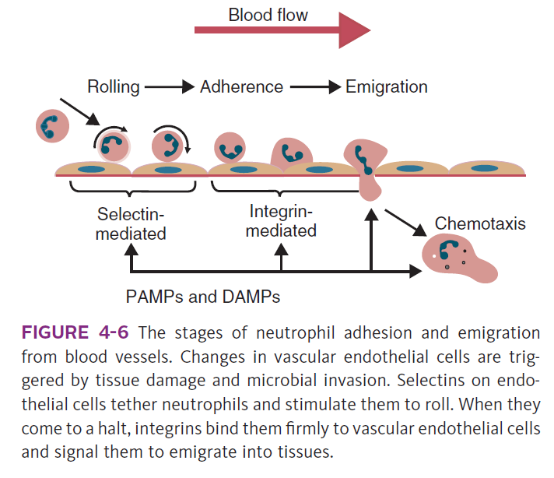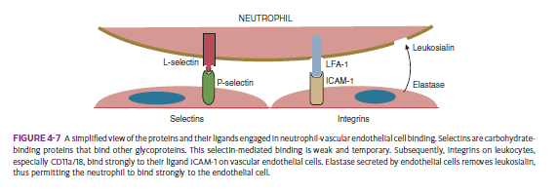

Phagocytosis
Steps:
- Activation
- Chemotaxis: chemoattractants diffuse from sites of microbial invasion and form a concentration gradient.
- Adherence and Opsonization
- Once a neutrophil encounters a bacterium, it must “catch” it.
- The electrostatic charge on the bacteria must be neutralized by coating them with positively charged molecules.
- Molecules that coat bacteria and promote phagocytosis are called opsonins.
- Antibodies, by far the most effective opsonins. They coat bacteria, bind them to receptors on phagocytic cells, and trigger their ingestion.
- Antibody receptor–mediated phagocytosis (or type I phagocytosis) is triggered by the binding of antibody-coated bacteria to receptors on the neutrophil
- Ingestion
- When a neutrophil meets a bacterium, the lamellipod flows over and around the organism, and binding occurs between opsonins on the organism and receptors on the neutrophil Surface
- Destruction
- two distinct processes.
1) The Respiratory Burst: Within seconds of binding a bacterium, neutrophils increase their oxygen consumption nearly 100-fold. This results from activation of a cell surface enzyme complex called NADPH oxidase (NOX).
  - The subcomponents of the NOX complex are separated in resting cells, but when a neutrophil encounters TNF-α, the NOX complex is assembled and activated.
  - Activated NOX converts NADPH to NADP+ with the release of electrons. A molecule of oxygen accepts a donated electron, generating a superoxide anion
  - The two superoxide anions interact spontaneously to generate one molecule of H2O2 under the influence of the enzyme superoxide dismutase: The hydrogen peroxide is converted to bactericidal compounds through the action of myeloperoxidase.
  - Myeloperoxidase catalyzes the reaction between hydrogen peroxide and intracellular halide ions (Cl−, Br−, I−, or SCN−) to produce hypohalides.
    - As long as H2O2 is supplied (neutrophils can generate H2O2 for up to 3 hours after triggering), myeloperoxidase will generate HOCl. HOCl kills bacteria by unfolding and aggregating their proteins and oxidizing their lipids, and it enhances the bactericidal activities of the lysosomal enzymes.
- Lytic Enzymes: Once a bacterium is ingested by a neutrophil, lysosomes migrate through the cytoplasm, fuse with the maturing phagosome, and release their enzymes.
  - The rise in ionic strength within phagosomes releases elastase and cathepsin G from their sulfated proteoglycan matrix
  - Other lysosomal enzymes include lysozyme, proteases, acid hydrolases, and myeloperoxidase. The enzymes that accumulate in phagosomes can digest bacterial walls and kill most microorganisms

Macrophages
- detect and kill invading microorganisms, but when stimulated, they also secrete a mixture of cytokines that promote both innate and adaptive immune responses
- Control inflammation
- function and structure are highly variable
- Immature macrophages circulate in the bloodstream, called monocytes. When monocytes emigrate into tissues, they become macrophages.
  - Macrophages are found in connective tissue, called histiocytes; those found lining the sinusoids of the liver are called Kupffer cells; those in the brain are microglia. The macrophages in the alveoli of the lungs are called alveolar macrophages
- Develop from common myeloid stem cells in the bone marrow. During monocyte development, the myeloid stem cells give rise in sequence to monoblasts, promonocytes, and eventually to monocytes, all under the influence of cytokines called colony-stimulating factors.
- Monocytes enter the bloodstream and circulate for about 3 days before entering tissues and developing into macrophages. They form about 5% of the total leukocyte population in blood.
- long-lived cells, replacing themselves at a rate of about 1% per day unless activated by inflammation or tissue damage
- Macrophages express many different PRRs and readily detect and respond to invading bacteria and viruses.
- Functions:
- They respond by producing complex cytokine mixtures. The most important of these are interleukin-1 (IL-1), IL-6, IL-12, IL-18, and tumor necrosis factor-α
- recognize tissue damage, promote the recruitment of neutrophils, and regulate the processes by which neutrophils recruit monocytes.
- Promote neutrophil emigration from blood vessels. The release of HMGB1 and other damage- DAMPs from damaged tissues stimulates resident macrophages to produce TNF-α and IL-6
- Phagocytosis: Adherence and rolling are triggered by selectin binding, and the cells are brought to a gradual halt by integrins binding to ligands on vascular endothelial cells.
  - They bind to endothelial cell intracellular adhesion molecule 1 (ICAM-1), using β2-integrins and then emigrate into the tissues. Within the tissues these cells are called macrophages.
  - These macrophages are attracted not only by bacterial products and complement components such as C5a but also by DAMPs from damaged cells and tissues. Once neutrophils have emigrated into tissues, they also attract macrophages.
  - Activated neutrophils and endothelial cells produce monocyte chemoattractant protein-1 (CCL2) under the influence of IL-6.
  - Phagocytosis by macrophages is similar to the process in neutrophils. They destroy bacteria by both oxidative and nonoxidative mechanisms.
  - Release collagenases and elastases that destroy nearby connective tissue. They release plasminogen activator that generates plasmin, another potent protease. Thus the can “soften up” the local connective tissue matrix and permit more effective penetration of the damaged tissue.
  - Macrophages phagocytose both apoptotic neutrophils and their exosomes.

Activation
- Although macrophages are potent phagocytes, their activities may be greatly enhanced by PAMPs such as lipopolysaccharides, CpG DNA, microbial carbohydrates, and heat-shock proteins as well as many DAMPs.
- TNF-α and IL-12, activate a population of lymphocytes called natural killer (NK) cells. The NK cells in turn secrete interferon-γ (IFN-γ), which activates macrophages still further.
Receptors:
- different receptors on their surface. All are glycoproteins. Some are PRRs. Many receptors for opsonins.
Fate of Foreign Material
- Once ingested, the bacteria are removed by the macrophages (Kupffer cells) that line the sinusoids of the liver. The process occurs in two stages. Bacteria are first phagocytosed by blood neutrophils.
- These neutrophils are then ingested and destroyed by the Kupffer cells. The spleen also filters blood. It is a more effective filter than the liver, but since it is much smaller, it traps much less material.
- Splenic macrophages have antibody receptors (CD64) so that particles opsonized with antibody are preferentially removed in the spleen.
- In contrast, phagocytic cells in the liver express CD35, a receptor for C3, the third component of complement, so that particles opsonized by C3 are preferentially removed in the liver.
- Removal of organisms from the bloodstream is greatly enhanced if they are opsonized by specific antibodies.

Recovery from Inflammation
- as inflammation progresses, macrophages change their Properties these M1 macrophages eventually convert to M2 cells and develop antiinflammatory properties. Thus the same cell can act in a proinflammatory manner at the beginning of an infection but switch to antiinflammatory activities once the infection is overcome.
- Inflammation is also resolved by an active process mediated by several polyunsaturated fatty acid–derived lipids related to the leukotrienes. Two of these, resolvin E1 and protectin D1, activate inflammation resolution programs.
- Produced by endothelial cells, they promote phagocyte removal by regulating phagocyte infiltration and promoting macrophage ingestion of apoptotic neutrophils. removal of the chemoattractants CCL3 and CCL5.
  - These chemokines are also destroyed by tissue metalloproteases. Apoptotic neutrophils exercise negative feedback by releasing lactoferrin that suppresses neutrophil recruitment.
  - Dying neutrophils attract scavengers. Thus phagocytosis of apoptotic neutrophils by macrophages triggers the release of vascular endothelial growth factor (VEGF) that is crucial for revascularization and wound repair.
- M2 cells secrete SLP1, a serine protease inhibitor that inhibits the release of elastase and oxidants by TNF-α-stimulated neutrophils and inhibits the activity of the elastase.
- Even in normal healthy animals, many cells die every day and must be promptly removed. This is the function of macrophages. This interaction operates through the adhesion protein CD3 1. Thus CD31 on a neutrophil binds to CD31 on a macrophage. If the neutrophil is healthy, it sends a signal to the macrophage, causing it to disengage.
- By secreting IL-1β, macrophages attract and activate fibroblasts. These fibroblasts enter the damaged area and secrete collagen. Collagen is then remodeled over several weeks or months as the tissue returns to normal.
  - The reduced oxygen tension in dead tissues stimulates macrophages to secrete cytokines such as VEGF that promote the growth of new blood vessels.
- The final result of this healing process depends on the effectiveness of the inflammatory response. If the cause is rapidly and completely removed, healing will follow uneventfully.
- The chronic inflammatory lesion that develops around this foreign material is called a granuloma.
- The chronically activated M2 cells within these granulomas secrete IL-1, which stimulates collagen deposition by fibroblasts and eventually “walls off” the lesion from the rest of the body.

Systemic Responses to Inflammation
Sickness Behavior
- PAMPs bind to PRRs of phagocytic cells stimulate the production of IL-1β, IL-6, and TNF-α. All three of these cytokines signal to the brain (LPS) and TLR4 can also trigger these vagal signals.
- They trigger fever, nausea, and other sickness responses in the brain. Microglial cells express TLR4, whereas neurons express TNF receptors.
- modify behavior and alter pain perception.
- IL-1, IL-6, and TNF-α all trigger changes in body temperature. They induce the expression of cyclooxygenase-2 (COX-2) in the hypothalamus that results in prostaglandin production, which causes the body’s thermostatic set-point to rise.
  - vasoconstriction and increase heat production by shivering, thus raising their body temperature until it reaches the new set-point.
- Benefits of higher body temp:
  - enhances transendothelial neutrophil migration and chemotaxis and increases neutrophil accumulation within tissues.
  - Accelerates caspase-dependent neutrophil apoptosis.
  - Cause dendritic cells to mature
  - Enhance the circulation of lymphocytes
  - Promote the secretion of IL-2.
  - Enhance the survival of T cells by inhibiting their apoptosis.
- In addition to causing a fever, inflammatory cytokines, especially IL-1, promote the release of sleep-inducing molecules in the brain.
  - Increased lethargy is commonly associated with a fever and may, by reducing the energy demands of an animal, increase the efficiency of defense and repair mechanisms. IL-1 also suppresses the hunger centers of the brain and induces the loss of appetite
- IL-1, IL-6, and TNF-α have long been known to cause septic shock and sickness behavior, these three molecules induce HMGB1 release from macrophages several hours after initiation of sickness. It enters secretory lysosomes and is then released slowly from the cells.
  - HMGB1 has been implicated in food aversion and weight loss by its actions on the hypothalamicpituitaryaxis. It mediates endotoxin lethality, arthritis, and macrophage activation
Metabolic Changes
- IL-1, IL-6, and TNF-α act on skeletal muscle to increase protein catabolism and release amino acids. Although this eventually results in muscle wastage, the newly available amino acids are available for increased antibody and cytokine synthesis.
Acute-Phase Proteins
- IL-1β, TNF-α, and especially IL-6, liver hepatocytes increase protein synthesis and secretion.
- Increase begins about 90 minutes after injury or systemic inflammation and subsides within 48 hours. About 30 acute-phase proteins PRRs, complement components, clotting molecules, protease inhibitors, and ironbinding proteins.
Soluble Pattern-Recognition Receptors
- C-reactive protein (CRP) is the major acute-phase protein produced in rabbits, hamsters, and dogs and is important in pigs.
- Promotes the phagocytosis and removal of damaged, dying, or dead cells in addition to microorganisms. CRP can bind to bacterial polysaccharides and glycolipids and to damaged cells, where it activates the classical complement pathway.
- Anti-inflammatory role: inhibits neutrophil superoxide production and degranulation and blocks platelet aggregation.
- May promote healing by reducing damage and enhancing the repair of damaged tissue.
Iron-Binding Molecules
- Iron concentrations within animal tissues are normally very low. Mammalian blood has just 10−26 M free iron since almost all available iron is bound to proteins. These iron-binding proteins include transferrin, lactoferrin, hepcidin, siderocalin, haptoglobin, and ferritin.
- When bacteria invade the body, intestinal iron absorption ceases.
- Liver cells secrete transferrin and haptoglobin, and there is increased incorporation of iron into the liver. Haptoglobin is a major acute-phase protein in cats.
  - Haptoglobin binds iron molecules and makes them unavailable to invading bacteria, thus inhibiting bacterial proliferation and invasion.
- Lactoferrin binds free iron and makes it unavailable to the bacteria.
- Serum amyloid A (SAA), major acute-phase protein in cats functions of SAA are unclear, but it binds to TLR2 and may also be an endogenous TLR4 agonist. This leads to the production of multiple inflammatory cytokines.
  - SAA also recruits lymphocytes to inflammatory sites and induces enzymes that degrade the extracellular matrix. It is also a chemoattractant for neutrophils, monocytes, and T cells.

Systemic Inflammatory Response Syndrome – when shit goes wrong
- After massive tissue damage, excessive amounts of cytokines, HMGB1, mitochondrial components, and oxidants may escape into the bloodstream and trigger a lethal form of shock known as systemic inflammatory response syndrome (SIRS).
- Released DAMPs may activate large numbers of sentinel cells and as a result generate very large quantities of inflammatory mediators. The most important of these are TNF-α, IFN-γ, CXCL8, and IL-6. These cytokines in turn trigger the activation of additional T cells and the release of additional cytokines, leading to even more cell destruction.
- This “cytokine storm” may result in severe illness and even death.

Bacterial Septic Shock
- Severe infections, however, may cause excessive triggering of TLRs leading to a massive and uncontrolled release of HMGB1. Other cytokines involved are TNF-α and IL-1β, with IFN-γ, IL-6,
- These cytokines stimulate expression of nitric oxide synthase 2 (NOS2), leading to an increase in serum nitric oxide, and of COX-2, leading to prostaglandin and leukotriene synthesis.
- This vastly excessive cytokine production leads to severe acidosis, fever, lactate release in tissues, an uncontrollable drop in blood pressure, elevation of plasma catecholamines, and eventually renal, hepatic, and lung injury and death.
- Tissue damage, severe systemic inflammation, and the release of damaged cell fragments all act to raise blood levels of TF, a key initiator of coagulation.
- Vascular endothelial cell apoptosis may trigger their detachment from the basement membrane.
- The cytokines activate vascular endothelial cells so that procoagulant activity is enhanced, leading to blood clotting.
- The nitric oxide causes vasodilation and a drop in blood pressure. The prostaglandins and leukotrienes cause increases in vascular permeability.
- This combination results in enhanced coagulation. Simultaneous downregulation of anticoagulant systems occurs as a result of reduced antithrombin synthesis (it is a “negative” acute-phase protein), whereas fibrinolysis is reduced owing to increased synthesis of inhibitors of plasminogen activator.

- MODS: end stage of severe septic shock, characterized by hypotension, insufficient tissue perfusion, uncontrollable bleeding, and organ failure caused by hypoxia, tissue acidosis, tissue necrosis, and severe local metabolic disturbances. The severe bleeding is due to disseminated intravascular coagulation.

Innate Immunity: The Complement System
- major innate defense system.
- main role is to protect against infections, regulate inflammatory processes, remove damaged or altered cells, send “danger” signals to the body, and regulate adaptive immune responses.
- Complement proteins are activated through pathways that cause some molecules to bind covalently (and hence irreversibly) to the surface of invading microbes. Once bound, these proteins can destroy the invaders.
- The complement system is inactive in healthy, uninfected animals. It is activated by either pathogen PAMPs or by antigen-bound antibodies.
- Sets of inactive proteins that are activated in a stepwise manner.
- Three major steps are involved. First, the complement system must be activated. Second, a key protein called C3b must be generated. Third, a terminal complement complex is assembled through an amplification pathway.
- All steps carefully regulated.
- The first step, can occur by three different mechanisms, referred to as the alternative, the lectin, and the classical pathways.
  - The alternative and lectin pathways are activated directly by microbial carbohydrates
  - The classical pathway, in contrast, is an evolutionary recent pathway activated when antibodies bind to the surface of an organism and thus works only in association with adaptive immune responses.
Complement Proteins
- The 30 or more proteins that form the complement system - either labeled numerically with the prefix C or designated by letters.
- Some are found free in serum, whereas others are cell-surface receptors.
- Account for about 5% to 10% of the proteins in serum

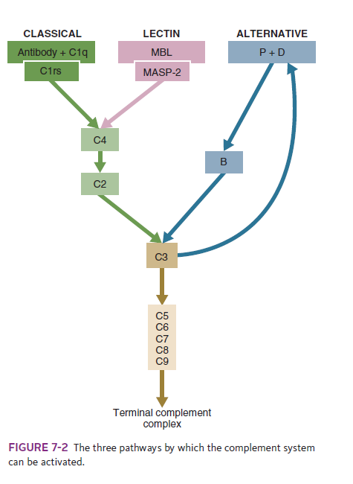

Activation Pathways
The Alternative Pathway
- triggered when microbial cell walls interact with complement components in the bloodstream.
- key component of innate immunity.
- The most important complement protein is called C3.
  - C3: disulfide-linked heterodimer with α and β chains.
  - synthesized by liver cells and macrophages
  - highly reactive thioester side chain, that, when activated binds to the surface of microbes and marks them for destruction.
  - The activation of the C3 thioester must be carefully regulated to ensure that it does not bind to normal tissues.
- In healthy normal animals, C3 breaks down slowly but spontaneously into two fragments called C3a and C3b.
- This opens up the C3b molecule to expose the thioester group.
- The thioester then generates a carbonyl group that binds the C3b irreversibly to carbohydrates and proteins on nearby cell surfaces.
- The breakdown of C3 also exposes binding sites for a protein called factor H. When factor H binds to these sites, a protease called factor I degrades the C3b, blocking further activity and generating two fragments, iC3b and C3c. iC3b binds receptors found on circulating leukocytes.
- It stimulates these cells to engulf pathogens and activate inflammatory cells. The final breakdown product of C3, C3dg, targets pathogens to surface receptors on B cells and so promotes antibody production
- When factor H interacts with normal cells, glycoproteins rich in sialic acid and other neutral or anionic polysaccharides enhance its binding to C3b, factor I is activated, and the C3b is destroyed.
- In a healthy individual, therefore, factors H and I destroy C3b as fast as it is generated.
  - bacterial cell walls lack sialic acid. When C3b is deposited on these surfaces, factor H cannot bind, factor I is inactivated, and the bound C3b therefore persists.
  - In this case, the opening of C3b on an activating surface exposes a binding site for another complement protein called factor B.
  - As a result, a complex called C3bB is formed. The bound factor B is then cleaved by a protease called factor D, releasing a soluble fragment called Ba and leaving C3bBb attached to the bacteria.
  - This bound C3bBb is a protease whose preferred substrate is C3. (It is therefore called the alternative C3 convertase.) Factor D can only act on factor B after it has bound to C3b but not before. This constraint is called substrate.
- Modulation of this pathway: it occurs at several points in the complement pathways.
  - It ensures that the activities of enzymes such as factor D are confined to the correct molecules.
  - The alternative C3 convertase, C3bBb, can act on C3 to generate more C3b. C3bBb is, however, very unstable, with a half-life of only 5 minutes. If another protein, called factor P (or properdin), binds to the complex, it forms C3bBbP with a half-life of 30 minutes. Since C3b thus serves to generate more C3bBbP, the net effect of all this is that a positive loop is generated where increasing amounts of C3b are produced and irreversibly bound to the surface of the invading organism.
- the alternative complement pathway accounts for 80% to 90% of all complement activated even if initially triggered by the classical or lectin pathway.

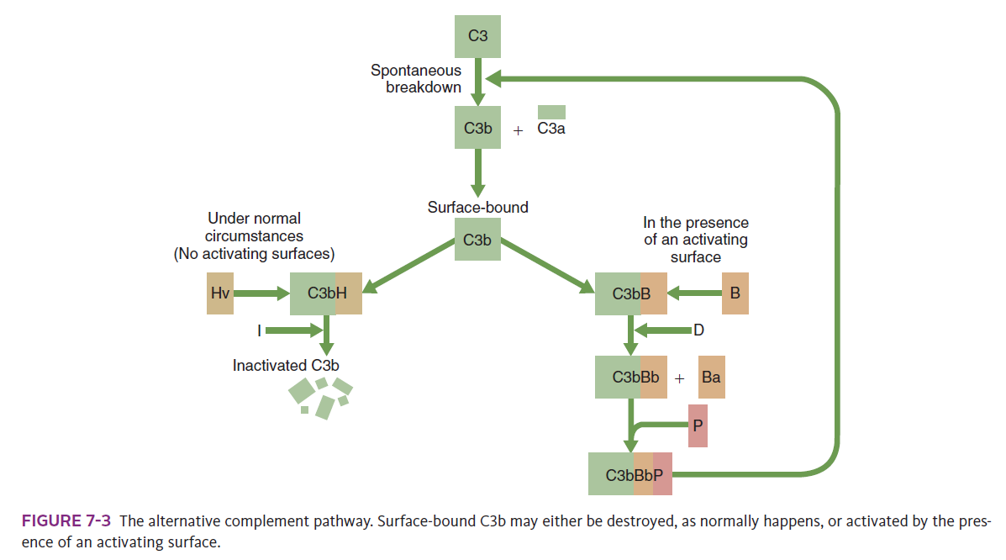
The Lectin Pathway
- involves the use of soluble pattern-recognition molecules that recognize microbial carbohydrates.
- These lectins bind to microbes and then activate proteases that activate complement.
- This is an innate pathway triggered simply by the presence of bacterial PAMPs
- These activating lectins include mannose-binding lectin (MBL) and the ficolins. MBL can attach to bacteria, fungi, parasitic protozoa, and viruses by binding to mannose or N-acetylglucosamine on microbial cell walls.
- It does not bind to mammalian glycoproteins. Once bound, MBL activates a serum protease called MASP-2.
- Activated MASP-2 acts on C4, splitting it into C4a and C4b. This exposes a thioester group on the C4b that generates a reactive carbonyl group that covalently attaches the C4b to the microbial surface. Another complement component, C2, then binds to C4b to form a complex, C4b2. The bound C2 is then cleaved by MASP-2 to generate C4b2b
- Cell-bound C4b2b is a protease that splits C3 to generate C3a and C3b and exposes the thioester group on the C3b. The activation of C3b by C4b2b is a major step because each C4b2b complex can generate as many as 200 C3b molecules.
- newly formed C3b will bind to nearby microbes. The bound C3b then binds C5 and cleaves it to C5a and C5b. The complement pathway then can proceed to completion and the killing of the organism by terminal complement complexes.
- The MBL–MASP-2 pathway is ancient

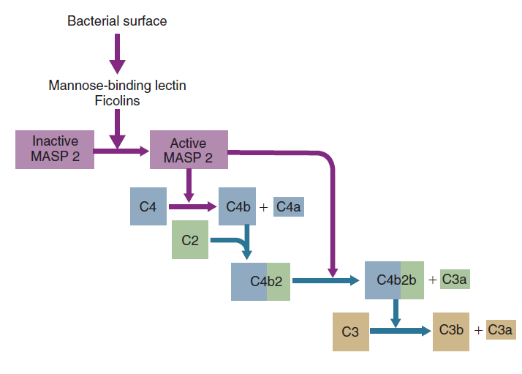

The Classical Pathway
- Triggered by clusters of antibody molecules on the surface of a foreign organism
- Associated with adaptive immune responses.

- Cannot be triggered until antibodies are made, which may occur as late as 7 to 10 days after infection.
- When antibody molecules bind an antigen they expose active sites on their Fc regions. If several antibody molecules are clustered on the surface of an organism, the multiple exposed active sites can collectively trigger classical complement pathway activation.
- first component: C1 - consists of three proteins (C1q, C1r, C1s) bound together by calcium.
- Two molecules of C1r and two of C1s form a structure located between the C1q strands.
  - C1q is activated when at least two of its strands bind to complement-activating sites on clustered antibody molecules.
  - Binding to antibodies causes a conformational change in C1q that is transmitted to C1r. As a result, C1r exposes an active proteolytic site that acts on C1s to convert that molecule to an active enzyme.
- Single, antigen-bound molecules of immunoglobulin M (IgM) or paired, antigen-bound molecules of IgG are needed to activate C1
- Thus IgG is much less efficient than IgM in activating the classical pathway.
- Activated C1s cleaves C4 into C4a and C4b. C2 then binds to C4b to form C4b2.
- Activated C1s then splits the bound C2, generating a small peptide fragment C2a and active C4b2b. C1s cannot act on soluble C2; the C2 must first be bound to C4b before it can be cleaved (another example of substrate modulation).
- Active C4b2b is a potent protease that cleaves C3 and is therefore called classical C3 convertase. C3b generated in this way binds and activates C5. Subsequent reactions lead to formation of the terminal complement complex and microbial killing.
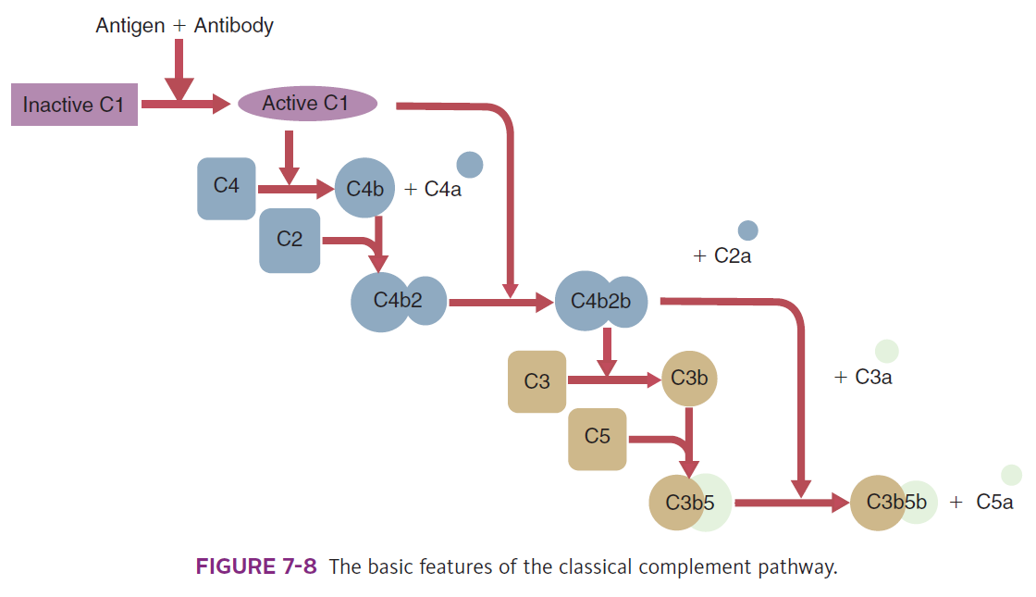

The Amplification Pathway
- All surface-bound C3 convertases, regardless of their origin, can induce the next step in complement activation
- Once C5 binds to C3b, substrate modulation occurs, and the C5 can be cleaved by C3bBb. The convertases cleave C5 (195 kDa) into a small fragment called C5a (15 kDa), leaving a large fragment C5b attached to the C3b.
- This cleavage also exposes a site on C5b that can bind two new proteins, C6 and C7, to form a multimolecular complex called C5b67. The C5b67 complex can then insert into the microbial cell membrane.
- Once inserted in the surface of an organism, the complex binds a molecule of C8. Twelve to 18 C9 molecules then aggregate with the C5b678 complex to form a tubular structure called the terminal complement complex (TCC), also called the membrane attack complex (MAC).
- The TCC inserts into microbial cell membranes and punches a hole in the invader. If sufficient TCCs are formed on an organism, it will be killed by osmotic lysis.
  - Much more important than TCC-mediated lysis are the potent proinflammatory effects of the small released peptides: C3a and C5a: degranulate mast cells and stimulate platelets to release the vasoactive molecules histamine and serotonin.
    - Both trigger inflammation through their cell surface receptors (C3aR and C5aR).
    - They are powerful chemoattractants for neutrophils and macrophages. They increase vascular permeability, causing lysosomal enzyme release from neutrophils and thromboxane release from macrophages.
    - C3a is an efficient killer of E. coli, Pseudomonas aeruginosa, Enterococcus faecalis, and Streptococcus pyogenes.
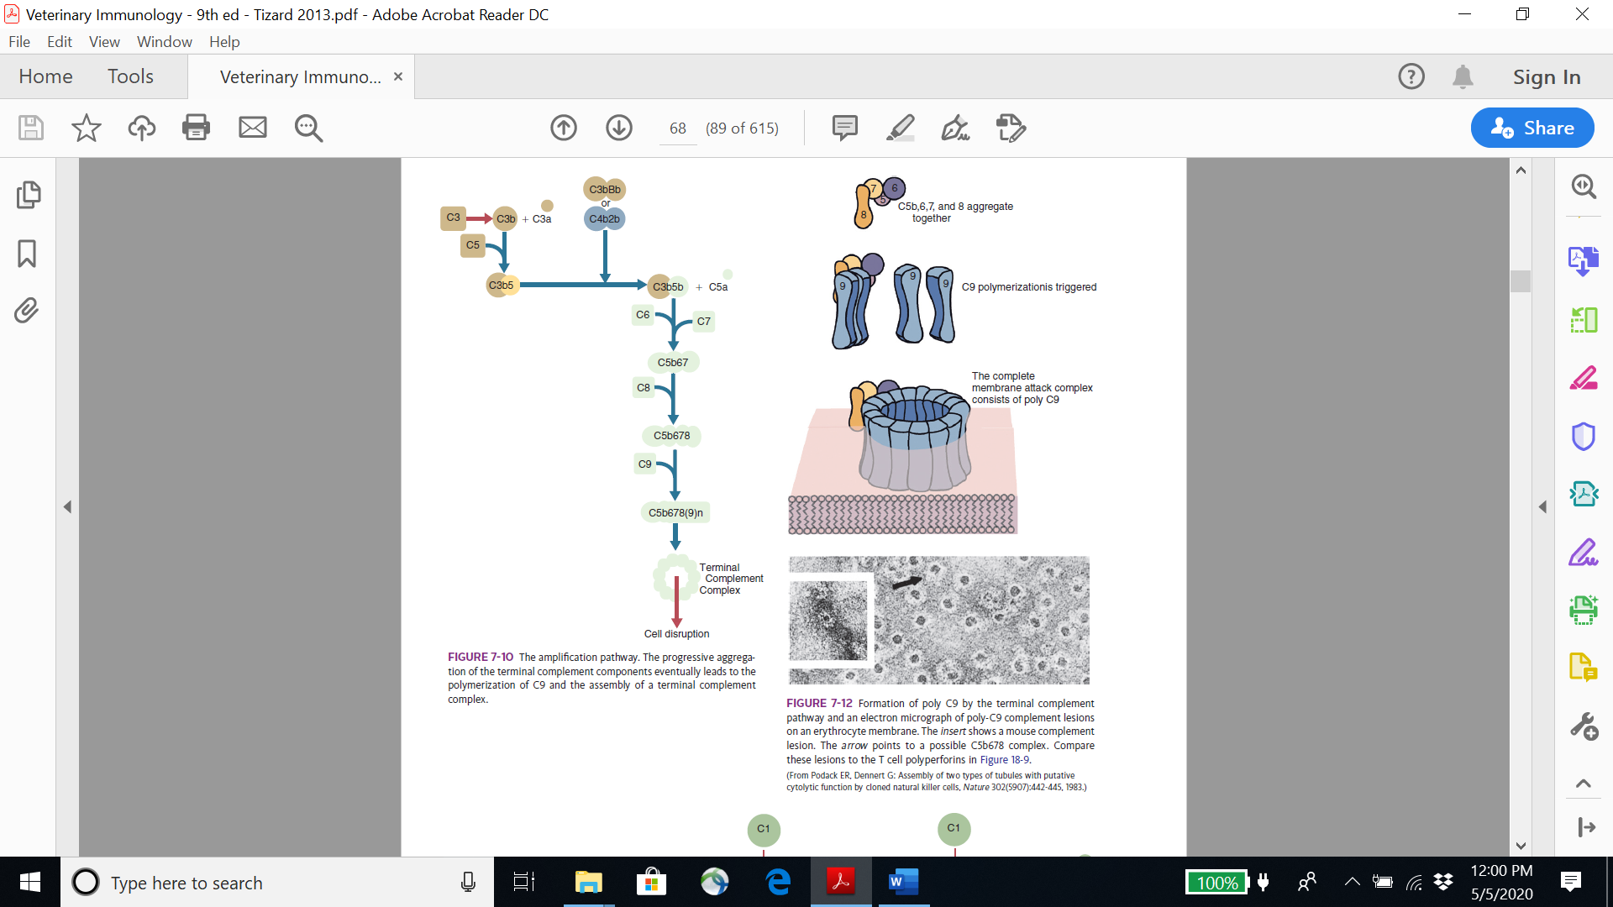
Regulation of Complement Activation
- The most important regulator of the classical pathway is C1-inactivator (C1-INH), a glycoprotein that inhibits several proteases in the classical and lectin pathways. C1-INH blocks the activities of active C1r and C1s.
Complement Receptors
- Five receptors for C3 – Cr1 to Cr5

Other Consequences of Complement Activation
- Opsonization: C3b and C4b bound covalently to a microbial surface - effective opsonins.
- Inflammation C3a and C5a, enhance TLR-induced production of TNF-α, IL-1β, and IL-6.
- Blood Coagulation The complement system enhances blood coagulation and inhibits fibrinolysis.
- Chemotaxis The complement system is a major contributor to acute inflammation.

Cell Signaling: Cytokines and Their Receptors
Properties of Cytokines
- Short-lived proteins
- Highly diverse structures and receptors
- Can act locally and/or systemically
- Pleiotropic: affect many different cells
- Redundant: exhibit biologically overlapping functions
- Carefully regulated
- Toxic in high doses

- The interleukins, for example, are cytokines that mediate signaling between lymphocytes and other leukocytes.
- Interferons are cytokines produced in response to virus infection or immune stimulation. They interfere with viral RNA and protein synthesis and so have antiviral activity
  - Three types of interferon.
    - Type I interferons are a diverse family, the most important of which are interferon-α (IFN-α) and IFN-β.
    - Type II interferon, called IFN-γ.
    - Three type III interferons (IFN–λ) have been identified.
- TNFs secreted by macrophages and T cells. They can kill tumor cells. Key mediator of acute inflammation.
Functions
- produced in response to many different stimuli such as antigens acting through the T cell or B cell antigen receptors; antigen-antibody complexes acting through antibody receptors (FcR); PAMPs such as lipopolysaccharides acting through TLRs
Cytokine Receptors
- These receptors consist of at least two functional units, one for ligand binding and one for signal transduction channel-linked receptors, which act as transmitter-gated ion channels.
- Thus the receptor itself is a channel, and binding of its ligand opens that channel, allowing ions to pass through it. Channel-linked receptors are found in inflammatory and immune cells, but their roles are unclear.
- A second class of receptor consists of proteins that also act as tyrosine kinases. These are typically growth factor and cytokine receptors. In these cases, binding of the ligand to two adjacent receptors forms an active dimer.
- When the ligand binds to the extracellular domain, the receptor chains dimerize so that the two tyrosine kinases are brought together and activate each other.
- These kinases phosphorylate tyrosine residues on other proteins or even the receptor itself (autophosphorylation). Since many of these other proteins are also tyrosine kinases, phosphorylation also converts them to an active state. In this way a cascade of expanding phosphorylations develops within the cell

- Phosphorylation triggers changes in cellular activities. Many cytokines and other immunological signals operate through this type of receptor.
- A related class of receptor consists of proteins that are not themselves tyrosine kinases but can activate tyrosine kinases associated with the receptors.
- Examples of tyrosine kinase–linked receptors include the T cell antigen receptor (TCR) and the B cell antigen receptor large class of receptors are coupled to membrane-bound guanosine triphosphate (GTP)–binding proteins, called Gproteins.
- G-proteins act as chemical switches and so control many different cellular processes. When the receptor is inactive, they bind guanosine diphosphate (GDP). When bound to their ligand they exchange the GDP for GTP.
- The activated G-protein then activates other substrates, resulting in a biological response.
- The GTP is rapidly hydrolyzed to GDP so that the G-protein is then turned off.
- The targets of G-proteins include ion channels, enzymes such as adenylate cyclase, phospholipase C, and some protein kinases.
- When activated by a G-protein, phospholipase C splits the membrane-bound lipid, phosphatidylinositol 4,5-bisphosphate (PIP2), into two messenger molecules, inositol trisphosphate and diacylglycerol.
- Inositol trisphosphate binds to intracellular receptors releasing Ca2+ from internal stores and increases the concentration of intracellular Ca2+.
- These calcium ions can activate many different proteins. The diacylglycerol remains in the plasma membrane and along with calcium activates an enzyme called protein kinase C.
- Immunological receptors that employ G-proteins include the receptors for C5a, chemokine receptors, leukotriene receptors, and the platelet-activating factor receptor.

Cytokine Regulation
- Cytokine signaling is regulated in three major ways: by changes in receptor expression, by specific binding proteins, and by cytokines that exert opposite effects.
- Some cytokine receptors act as decoys. They bind cytokines but do not transmit signals.
- Perhaps the most important way by which cytokine function is regulated is through the opposing effects of different cytokines.
  - i.e: IL-4 stimulates B cells to switch to IgE production, whereas IFN-γ suppresses IgE production. Likewise IL-10 inhibits the activities of many other cytokines

Signal Transduction
- Cytokines are agonists for their cell surface receptors. Once a cytokine binds its receptor, the receptor transmits a signal to the cell to modify its behavior.
- This conversion of an extracellular signal into a series of intracellular events is called signal transduction.
- The key components of signal transduction include binding of an agonist to its receptor, possibly clustering of receptor chains, activation of kinases by the receptor, secondary activation of second messengers, generation of new transcription factors, and gene activation leading to altered protein synthesis and cell behavior
Transduction Pathways
- Although there are many different signal transduction pathways, three play key roles in the immune system.
- These involve the generation of the transcription factors: NF-κB, NF-AT, and JAK-STAT.

