VESTIBULAR DISEASE, TBI, NEOPLASIA – NEURO BR 7/28/2020
Vestibular disease
- Vestibular system: responsible for maintaining balance, body posture, and eye position
- Functions in close coordination with cerebellum
- Peripheral component - located in the inner ear
- Central nervous system component – brainstem and cerebellum
- Cerebral cortex (incorporates extraocular muscles), spinal cord, and cerebellum receive peripheral sensory inputs from the vestibular system
Anatomy / nerve pathways
- CN VIII (vestibulocochlear) is the only CN that does not leave the skull
- Peripheral vestibular system contains the vestibular organs - the utricle, saccule, and three semi- circular canals; contained within the bony and membranous labyrinths of the inner ear
- Endolymph movement within these organs causes deflection of specialized hair cells activation of the vestibular component of the CN VIII
  - Detects static or kinetic positional signals
- CN VIII leaves the petrous temporal bone via the internal acoustic meatus (also with CN VII)
- Vestibular axons enter the brainstem and travel in several different pathways projections sent to the spinal cord, brainstem, and cerebellum

- Majority will synapse on the ipsilateral vestibular nuclei in the medulla oblongata (at the level of the cerebellar peduncle and trapezoid body)
- Small number of axons will bypass the vestibular nuclei and ascend into the cerebellum via the caudal cerebellar peduncle
- There are four vestibular nuclei on either side of the brain stem axons from these nuclei project to the spinal cord (vestibulospinal tracts) and rostrally within the brainstem (medial longitudinal fasciculus)
  - Fibers that descend the spinal cord mainly influence limb extensor tone and inhibition of flexor muscles on the ipsilateral side and coordinate the limbs, neck, and trunk
  - Fibers in the medial longitudinal fasciculus terminate within the nuclei of CN III, IV, and VI influences eye position relative to the head in space; responsible for the oculocephalic reflex
- Ascending information to the cerebrum (involving synapse in thalamic relay nuclei) provide conscious awareness of the body's position in space
- Vomiting center within the reticular formation of the medulla receives afferent input motion sickness

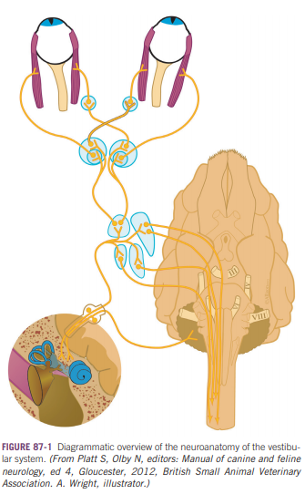
Clinical Signs
- Unilateral vestibular disease – asymmetric signs, often toward the side of the disease
- Most common clinical signs: head tilt, nystagmus, and vestibular ataxia
Loss of equilibrium
- Head tilt – present with central or peripheral vestibular disease
  - Toward side of lesion with peripheral disease
    - Bilateral peripheral vestibular – no head tilt; characteristic side-to-side head movement is seen instead
  - Toward either side with central disease
    - Head tilt often is accompanied by ipsilateral cerebellar signs, paresis, and proprioceptive deficits
    - Opposite to the side of the lesion = paradoxical can be seen with lesions of the flocculonodular lobe of the cerebellum or the supramedullary part of the caudal cerebellar peduncle sparing of the vestibular nuclei in the rostral medulla
- Pathologic nystagmus
  - Sign of altered vestibular input to the neurons that innervate the extraocular eye muscles
  - Fast phase away from the damaged side; slow phase toward the affected side
  - Nature of movement (horizontal, vertical, or rotary) is dependent on which semicircular canal is affected
    - Vertical semicircular canals cancel each other out horizontal or rotary nystagmus is seen with peripheral vestibular disease (usually components of both)
  - Eyelids may be seen to contract at a rate corresponding to that of the nystagmus
  - May disappear with chronicity of the underlying lesion (peripheral disease)
  - Vertical nystagmus implies a central vestibular lesion but it is not definitive localizing sign
  - Induced positional nystagmus – more common with central disease
  - Bilateral vestibular disease – no pathologic nystagmus
- Strabismus
  - Often present
  - Ventrolateral on the ipsilateral side
  - May be positional (dorsiflexion of neck) or spontaneous
- Wide-based stance and may lean or drift toward the side of a lesion
  - Ipsilateral reduction in extensor tone and contralateral hypertonicity causes “push” - leaning, falling, and circling toward the side of the lesion
  - Falling may occur when the animal shakes its head if there is aural irritation
Peripheral Vestibular Signs
- Should have normal mentation may be disoriented or anxious after a peracute onset of signs
- CN VII commonly involved (close association of nerves) may see facial paresis, paralysis or spasm
- Horner’s syndrome (miosis, ptosis, enophthalmos, protrusion of the third eyelid) of the ipsilateral eye may be present with either middle or inner ear disease (vagosympathetic trunk synapses in the cranial cervical ganglion deep to the tympanic bulla)
- Nystagmus is usually not positional with peripheral vestibular disease
- Resting nystagmus and veering or leaning to one side are significantly more common
- Resting nystagmus rate of ≥ 66 BPM are significantly more likely to have peripheral vestibular disease (median rate = 90 BPM), compared with those with central vestibular disease (median rate = 0 BPM)
- Orlandi BMC Vet Res 2020
  - MRI performed in all patients with PVD, no abnormalities in 45% (65% with idiopathic PVD had no MRI abnormalities; if seen there was contrast enhancement of CN VII and VIII)
  - 55% had concurrent facial nerve paralysis
  - Idiopathic in 68% of cases; 26% otitis media/interna, 7% hypothyroid
  - Increasing age was significantly more likely to be idiopathic than otitis media
  - 52% had persistent neuro deficits (head tilt, facial paresis, ataxia)
  - 18% recurrence in 12 months
  - Previous episodes of vestibular dysfunction was associated with increased chance of resolution of clinical signs; contrast enhancement of CN VII/VIII was associated with a decreased chance of resolution of signs
Bilateral peripheral disease
- Uncommon presentation; seen more frequently in cats than in dogs
- Mentation should be normal but may be disoriented
- Typically appear crouched and remain close to the ground ataxia is more symmetrical and patients may fall and list to either side; often exhibit characteristic wide head excursions from side to side
- Results in complete loss of vestibular function = no head tilt, no pathological OR physiological nystagmus
Central Vestibular Signs
- Central vestibular syndrome suggests damage to the brainstem
  - Is not present in patients with inner ear disease unless there has been extension of the inner ear disease into the brainstem (otitis media, otitis interna, neoplasia)
- Often have ipsilateral proprioceptive deficits due to concurrent disturbance of the ascending proprioceptive pathways located in the brainstem
  - Larger lesions or multifocal lesions may cause an asymmetric tetraparesis
  - Strongest sign of central disease proprioceptive pathways do not come into contact with the peripheral vestibular system
- Altered mentation
  - Reticular activating system (RAS) facilitates the alertness and awakeness damage to this area may cause disorientation, stupor, or comatose state
- Other cranial nerve dysfunction
  - Ipsilateral facial hypalgesia, atrophy of the masticatory muscles, reduced jaw tone, facial paralysis, tongue weakness, and loss of the swallow or gag reflex
- Severe central vestibular dysfunction underlying disease may cause decerebellate posturing (opisthotonus with thoracic limb extension, normal mentation, flexion of the pelvic limbs) with vertical nystagmus
  - May be confused with seizure activity
  - Dorsiflexion of the neck sometimes elicits this posture
- PE/neuro exam is efficient at identifying lesions in central vestibular system, but less for peripheral (Bongartz et al JSAP 2020)
  - 62 dogs NAL on PE was central, 31 peripheral MRI: 68 dogs dx with central lesion, 25 peripheral
    - 61/62 NAL central on PE had central lesion on MRI (98.4%)
    - 24/31 NAL peripheral on PE had peripheral lesion on MRI (77.4%)
- Cats with evident MRI lesions location of the imaged lesions agreed with the clinical classification of vestibular dysfunction 95% of cases (Negrin 2010 JFMS)
  - 52% had signs of central vestibular dysfunction (CVD) multifocal disease in 43% (inflammatory conditions #1 – infectious, intracranial extension of otitis interna, FIP, toxo); neoplasia 30%; vascular disease (10%)
  - 48% had signs of peripheral vestibular dysfunction -- idiopathic vestibular syndrome in 43% and otitis media/interna 43%
Paradoxical Vestibular Signs
- Caused by a lesion impacting on the cerebellopontine angle (flocculonodular lobes of the cerebellum, caudal cerebellar peduncles, rostral and medial vestibular nuclei in the medulla)
- Subset of central vestibular disease
- Cerebellum’s influence on the vestibular system is largely inhibitory lesions in this location cause vestibular release that is interpreted as a contralateral deficit (greater facilitation of the extensors on the ipsilateral side and facilitation of the contralateral flexors = body will lean away from the side of the lesion and the head tilt will be in the opposite direction)
  - Right sided paradoxical vestibular lesions result in clinical signs consistent with a lesion on the left (head tilt, listing, leaning, falling away from lesion; nystagmus with fast phase TOWARD side of lesion)
- Additional CN deficits (CN V-XII) and postural reaction deficits will be ipsilateral to the lesion (opposite head tilt and nystagmus); cerebellar ataxia

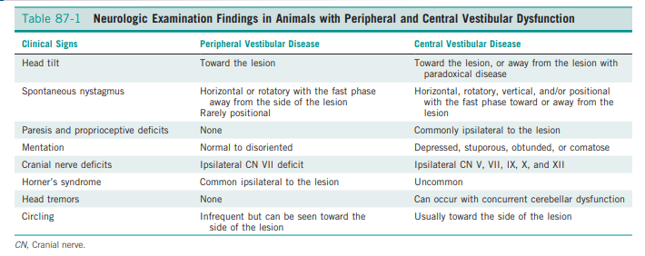

Common Causes of Vestibular Disease
Peripheral Vestibular Disease
- Otitis media/interna
  - Most common cause of peripheral vestibular disease in dogs
  - Extension of otitis externa across the tympanic membrane, from the nasopharynx via the Eustachian tube, or hematogenously
  - May have concurrent CN VII deficits and/or Horner’s syndrome due to the close anatomical relationship of these structures
  - Common pathogens: staphylococcus spp, pseudomonas aeruginosa, beta-hemolytic streptococcus, proteus spp, E. coli; cryptococcus neoformans in cat
  - Treatment: combination of cleansing and flushing the ear, topical medications, and systemic antibiotics for at least 6–8 weeks
    - Empirical antibiotics may include amoxicillin/clavulanic acid, cephalosporins, or fluoroquinolones
    - Relapsing otitis media/interna / intracranial extension: TECA-BU
- Nasopharyngeal polyps
  - Most common benign pharyngeal and external ear canal masses diagnosed in cats
  - Typically young cats presenting with vestibular signs + chronic upper respiratory, pharyngeal, or ear infections
  - Traction can be used to remove most polyps; recurrence rate ~ 30%
  - Cases with significant middle ear involvement or recurrent ventral bulla osteotomy
    - Lower recurrence rate but a higher rate of complications
- Toxins
  - Peripheral vestibular disease and hearing loss can be associated with ototoxic drugs: aminoglycosides, cisplatin, loop diuretics, chlorhexidine, erythromycin, chloramphenicol, and minocycline
  - Vestibular signs have been reported in cats after ingestion of five-lined skunks in the south-eastern US
- Hypothyroidism
  - Can be peripheral or central
  - Peripheral – may be accompanied by CN VII dysfunction
  - Syndrome is poorly understood; may be secondary to myxomatous compression of the nerves
- Idiopathic / Old Dog
  - Median age = 12.5 years (dogs)
  - Cats: more frequent in outdoor cats, not restricted to geriatric age, higher incidence in the late summer and early fall
  - Diagnosis of exclusion
  - Syndrome may result from abnormalities with the endolymphatic fluid of the inner ear structures, a mild intoxication of the vestibular system, or autoimmune disease
  - Improvement seen in 3–5 days, resolution occurring over 2–4 weeks; may have a residual head tilt and/ or mild ataxia
  - Can relapse
- Idiopathic polyneuropathy impacting CN VIII and VII
  - Reported in cats and dogs
- Neoplasia
  - Can arise from or invade the tympanic bulla
  - Common primary aural neoplasias: squamous cell carcinoma, sebaceous gland adenocarcinoma, and ceruminous gland adenocarcinoma; middle ear angiocentric/angioinvasive T-cell LSA; cholesteatomas - benign masses arising in the middle ear
  - Patients with more advanced disease, vestibular signs or pain on opening of the mouth may have a more guarded prognosis
Central Vestibular Disease
- Strokes / vascular events
  - Transient ischemic attacks and ischemic or hemorrhagic strokes are common
  - TIAs: temporary vascular disruption results in short-term neurological signs (less than 24 hours)
    - Can be recurring
  - Strokes within the rostral cerebellar artery or the thalamus result in central signs
  - Patients present with a peracute, non-progressive onset of central (or paradoxical) vestibular signs
  - Diagnosis can be made based on typical MRI findings of ischemia or hemorrhage
  - Screen for hypertension, underlying cardiac or renal disease, coagulopathies, hypothyroidism, hyperadrenocorticism, neoplasia
    - Greyhounds and spaniels may be predisposed to strokes
  - Can make a functional recovery with adequate supportive care and time
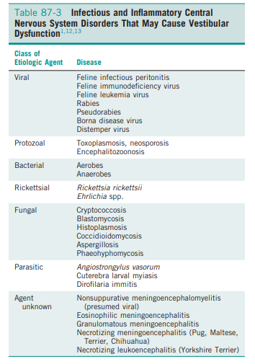
- Meningoencephalitis
  - Viral: canine distemper virus, FIP, rabies
  - Bacterial: otogenic infections, septic meningitis, penetrating trauma
  - Rickettsial: RMSF, ehrlichiosis
  - Protozoal: neosporosis, toxo
  - Fungal: cryptococcosis, blastomycosis, aspergillosis, coccidioidomycosis, pheohyphomycosis, fusariosis, histoplasmosis
- Metronidazole toxicity
  - Noted at doses higher than 60 mg/kg/day
  - Individual sensitivity, hepatic insufficiency, chronic administration may contribute to toxicity at lower doses
  - Signs: head tilt, nystagmus (typically vertical), ataxia, paresis, tremors; cats - disorientation, seizures, blindness
  - Tx: supportive care, drug withdrawal; diazepam (0.5 mg/kg IV, then 0.5 mg/kg orally every 8 hours for 3 days) has been associated with a more rapid recovery
- Hypothyroidism
  - Pathogenesis is not well understood
  - Hyperlipidemia and associated atherosclerosis, increased blood viscosity, and thromboembolic events have been postulated
- Thiamine (vitamin B1) deficiencies
  - Vestibular signs + bilateral mydriasis, blindness, and seizures
  - Associated with fish diets high in thiaminase, prolonged anorexia, and incorrectly formulated diets
  - Characteristic lesions within the midbrain and brainstem resolves with thiamine supplementation
- Neoplasia
  - Common primary intracranial neoplasias include meningiomas, astrocytomas, oligodendrogliomas, choroid plexus tumors, and primary central nervous system lymphosarcoma
  - Metastatic neoplasia: HSA (#1), LSA, carcinoma
  - Boxers, Bostons, golden retrievers, French bulldogs, and rat terriers - increased risk of primary intracranial neoplasia
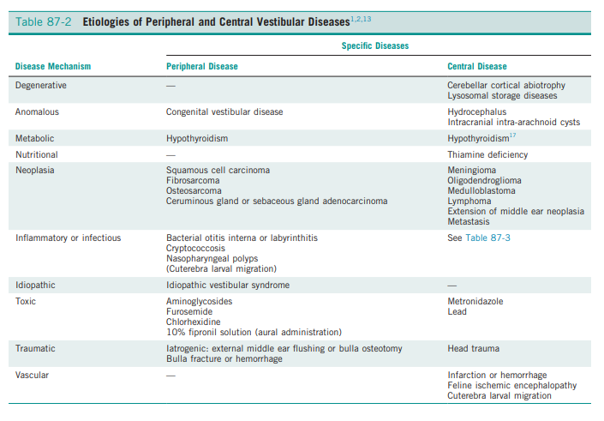
Diagnosis
- Neuro exam – determine central >> peripheral
- Hematology, chemistry, thyroid function analysis, urinalysis with culture and susceptibility, thoracic radiographs, and abdominal ultrasonography or radiographs should be analyzed in all cases of acute vestibular dysfunction to evaluate the patient for multisystemic or concurrent disease
Peripheral
- Otoscopic examination but intact tympanic membrane does not r/o otitis media/interna
  - Tympanum should be examined for color, texture, and integrity -- usually dark gray or brown in cases of otitis
- Myringotomy can be performed to obtain samples for cytology, C&S
- Radiographs of tympanic bulla
- CT or MRI may be indicated to evaluate the inner ear, and r/o intracranial extension, neoplasia, nasopharyngeal polyps, foreign bodies
Central
- CT evaluation for animals with central vestibular diseases may be less helpful because of artifact from petrous temporal bones surrounding the medulla
- MRI – improved soft tissue contrast; allows for better assessment of neoplastic and inflammatory conditions
- CSF analysis – cytology, antibody titers, PCR for infectious antigens
  - Preferable to obtain advanced imaging studies of the brain before performing CSF tap, especially if a caudal fossa lesion is suspected
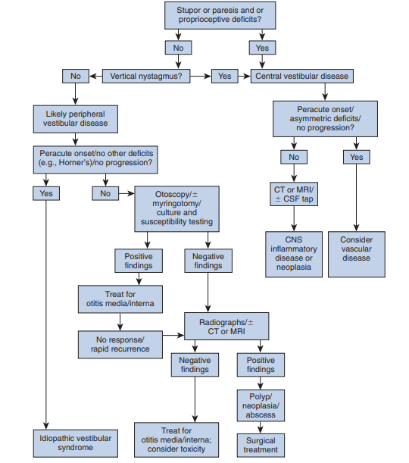

Treatment and prognosis
- Damaged vestibular system can compensate over time with central reprogramming of eye movements and postural responses and reliance on visual and other sensory input that replaces lost vestibular input
- Prognosis for a functional recovery can be good depending on underlying cause
- Residual signs are always possible
- Recurrences can occur at times of stress, recurrent disease, or after anesthesia
- Cats: neurolocalization (central), older age and male gender -- more likely to die (Negrin 2010 JFMS)
- Supportive care:
  - IVF, feeding tubes until the patient can self-maintain
  - Relief from motion sickness may result by suppressing the activity of the vestibular nuclei
    - Diphenhydramine, dimenhydrinate, and meclizine – maybe some anticholinergic effects on vestibular nuclei (work better in humans)
  - Antinausea/vomiting
    - Maropitant -- NK1 receptor antagonist, prevents binding of substance P in the emetic center

TRAUMATIC BRAIN INJURY
- Causes: motor vehicle accidents, animal interactions, falls from heights, blunt trauma, gunshot wounds, and malicious human activity
Pathophysiology
Primary injury
- Immediate, direct damage to brain parenchyma or intracranial structures that occurs at time of impact; out of control of clinician
- Function of the force of impact -- acceleratory and deceleratory forces of both the impacting object and the intracranial contents will affect overall tissue damage
- Types of injury:
  - Concussion: brief loss of consciousness, not associated with an underlying histopathologic lesion
  - Contusion: parenchymal hemorrhage and edema; clinical signs can range from mild to severe
    - Can occur in the brain directly under the site of impact = “coup” lesion
    - Opposite hemisphere = “contrecoup” lesions
    - Both – as a result of displacement of the brain within the skull
    - Unconsciousness for more than several minutes is most consistent with contusion
  - Laceration: most severe; physical disruption of the brain parenchyma
  - Hematomas:
    - Axial hematomas = within the brain parenchyma
    - Extraaxial hematomas = in the subarachnoid, subdural, and epidural spaces causes compression of the brain leading to severe localizing signs or diffuse neurologic dysfunction
      - Occurs in up to 10% of animals with mild head injury, > 80% of dogs and cats with severe head injury
  - Diffuse axonal injury
Secondary injury
- Occurs hours to days after trauma
- Complex series of biochemical events resulting in and perpetuating brain-tissue damage, neuronal cell death, increase in ICP, compromise of BBB
  - Glutamate accumulation, influx of Na+ and Ca2+ intracellularly, free radical production, inflammatory mediator release, loss of autoregulation
Phys/pathyophys
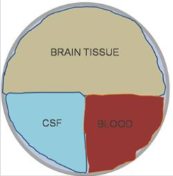
ICP and Autoregulation
- Monroe–Kellie doctrine
  - Cranial vault is a rigid, defined space, with a fixed volume -- composed of the brain, CSF, blood, and mass lesion (if present)
    - Normally in equilibrium
  - An increase in the volume of any of these results in a compensatory decrease in one or more of the others
    - If not, an increase in ICP will occur – can lead to ischemia
- Normal ICP is 5-12mmHg
- CPP = MAP – ICP; CPP is driving force of blood into the calvarium
- Increases in ICP combined with decreases in MAP results in decreased CPP and CBF

- Cerebral blood flow is a function of CPP and cerebrovascular resistance
- The normal brain is capable of maintaining constant CBF via autoregulation at MAP b/w 50 to 150 mmHg
  - MAP rises vasoconstriction in the brain
  - MAP falls vasodilation in the brain
  - Autoregulation refers to the direct responsiveness of brain vasculature to PaCO2 elevated PaCO2 levels cause cerebral vasodilation; decreased PaCO2 levels cause cerebral vasoconstriction
  - In TBI autoregulation may be lost -- CBF more dependent on CPP ischemic injury can occur with even small decreases in MAP
Cushing’s reflex
- Severe, acute increased ICP may result in the CNS ischemic response
  - Decreased cerebral blood flow as a result of increased ICP results in elevations in CO2 sensed locally at the vasomotor center causes an increase in sympathetic tone / catecholamine release systemic vasoconstriction and increased CO increase in MAP to attempt to increase CPP stimulates baroreceptors in the aortic and carotid sinuses vagally induced, reflex bradycardia signifies life-threatening intracranial hypertension
  - Catecholamine release also may result in cardiac arrhythmias due to myocardial ischemia = “brain-heart syndrome”

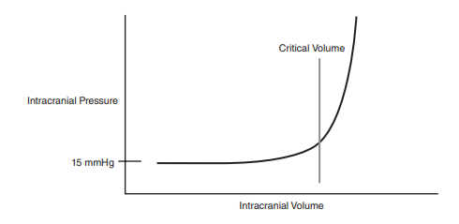
Secondary Injury - neuronal cell death pathophys
Excitatory NTs
- After TBI massive release of excitatory NTs (glutamate) causes influx of Na and Ca into neurons cellular swelling (cytoxic edema) and depolarization occurs further release of excitatory NTs causes further increase in Ca levels
  - Influx of Ca overwhelms mechanisms for removal severe intracellular damage due to enzyme activation (AA cascade via phospholipase A2 activation and xanthine oxidase pathway) ultimately neuronal cell death
- Massive release of NTs causes excessive metabolic activity results in depletion of ATP cell death (influx of Na and Ca into neurons as above)
ROS
- Several factors favor the production of ROS: hypoperfusion/ischemia, local tissue acidosis, increased intracellular Ca, AA metabolites, activated neutrophils
- Fe2+ is a vital cofactor in the xanthine oxidase pathway free radicals (OH – and SO) generated via the Fenton reaction
  - Brain tissue is rich in Fe2+ and hemorrhage also provides a source of iron
- Catecholamines contribute to the production of free radicals (directly and indirectly)
- ROS produced can oxidize lipids, proteins, DNA brain is lipid-rich = very susceptible to oxidative injury neuronal injury
Nitric oxide
- Vasodilatory effects (increases ICP)
- Participation in free radical reactions (ONOO-)
Inflammation
- Marked increase in inflammatory cytokine release due to infiltration and accumulation of inflammatory cells
- Inflammatory mediators perpetuate secondary injury via:
  - Inducing NO production excessive vasodilation, loss of autoregulation
  - Triggering influx of more inflammatory cells
  - Activating the arachidonic acid and coagulation cascades
  - Disrupting the BBB
- Some mediators may also have neuroprotective effects
*The result of these secondary processes is increased ICP*
Systemic effects on secondary brain injury
- May compromise CPP
- Systemically: hypoxemia, hypotension, hypercapnia, hypocapnia, hyperglycemia, hypoglycemia, acid–base and electrolyte disturbance, hyperthermia, and systemic inflammation potentiate injury
- Hypoxemia and hypercarbia:
  - Increases in PaCO2 concentration can lead to cerebral vasodilation and increased intracranial blood volume, worsening ICP
  - Hypocapnia caused by hyperventilation can lead to cerebral vasoconstriction, decreasing cerebral blood flow and leading to cerebral ischemia
- Hypovolemic shock can decrease CPP, increase PaCO2 and lead to increased ICP – aggressively treat to maintain MAP of 80 to 100 mm Hg
Physical exam
- Examine and treat ABCs first
  - Often concurrent injuries
  - Consider neurogenic pulmonary edema CNS overstimulation of sympatho‐adrenal activity marked peripheral vasoconstriction and increased venous return to heart systemic hypertension leads to markedly elevated LV afterload and diminished stroke volume blood accumulates in the pulmonary circulation resulting in pulmonary capillary hypertension edema
    - Resolves in hours to days
- Initial neuro exam: focus on the level of consciousness, posture, PLR, ocular position, motor response, breathing pattern
  - Shock can impact neuro status; reduced level of consciousness and PLR
  - More detailed neuro exam can be performed once stabilizing therapy has been instituted
- Modified Glasgow Coma Scale
  - Objectively evaluate the neurological status of dogs after TBI
  - Monitor progression of neurologic deficits, effects of therapies, assess overall prognosis
  - 3 categories: level of consciousness, motor activity, brainstem reflexes
  - Score 1-6 each section; 1= severe dysfunction (score range 3-18; 3 being worst)
  - Demonstrated to sigmoidally correlate with the probability of survival
    - Higher scores correlate with better prognosis
    - Score of 8 associated with a 50% likelihood of survival in the first 48 hours after TBI in dogs (Platt JVIM 2001)
      - Higher score, better prognosis
    - MGCS is better predictor of survival when compared to the Animal Trauma Triage Score and multiple clinicopathologic parameters, with a MGCS of <11 having a Se of 84% and Sp of 73% for predicting non-survival to hospital discharge (Sharma JVECC 2015)
- Repeated neurological assessment is recommended every 30–60 minutes after initial presentation and after interventions are made
- Best used as objective measure of progression than prognostic indicator

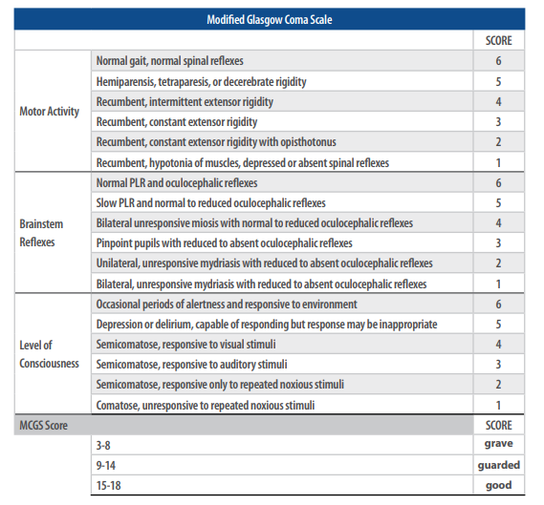
- Level of consciousness is most reliable measure of impaired cerebral function (RAS, cerebral cortex) coma – bilateral or global abnormalities or brainstem injury = guarded prognosis
- Decerebrate posture = damage to RAS/midbrain grave prognosis
- Neuro-ophtho exam – assesses brainstem reflexes (PLR – rostral brainstem, optic chiasm, optic nerves, retinae assessed)
  - Miotic pupils = diffuse forebrain injury
  - Progression to mydriasis = brain herniation
    - Transtentorial herniation compresses CN III interrupts PSNS input to the eye mydriasis
  - Fixed, unresponsive and midrange pupils = cerebellar herniation
Diagnostics
- Blood work
  - PCV/TS assess for hemorrhage
  - BG to assess the severity of injury
  - Blood gas to assess ventilation, perfusion, and acid-base status
  - Lytes, lactate, renal values, and markers of hepatic damage etc
  - Avoid jugular venipuncture - can increase in ICP
- Monitoring of the CV system – maintain adequate tissue perfusion
  - MAP at or above 80 mmHg in order to maintain CPP
  - Doppler: maintain above 100 mmHg
  - HR should be assessed when hypertension (MAP > 120 mmHg or systolic > 140 mmHg) is present – Cushing’s reflex
- Oxygenation/ventilation
  - SpO2 > 94%; PaO2 > 80mmHg
  - PvCO2 40-45mmHg
- CT is the preferred; superior to MRI for assessing bone and areas of acute hemorrhage or edema
  - Faster, less expensive
  - Should be considered in patients with moderate to severe neurologic abnormalities on presentation, lateralizing signs, failure to improve significantly within the first few days, or those with an acute deterioration in neurologic status
  - MRI can detect subtle parenchymal damage which may have prognostic utility
Treatment
Extracranial Therapy
- Airway, breathing, and circulation should be evaluated and addressed if necessary
  - Treat hypoxemia and hypercapnia (O2, intubation, ventilation)
    - Recommend against oxygen cage; frequent monitoring needed
    - Nasal cannulas can cause sneezing, struggling, anxiety which can increased ICP
    - If ventilating, do not go below PaCO2 30mmHg vasoconstriction, brain ischemia
  - Volume resuscitation goals should be aggressive – MAP of 80 to 100 mmHg
    - NaCl 0.9% is the best initial choice contains the smallest amount of free water = least likely to contribute to cerebral edema
    - Synthetic colloid resuscitation as needed
      - For hydrated patients with evidence of hypovolemia and increased ICP - combo colloid and HTS solution is recommended
    - If not responding to volume resuscitation, start vasopressors

Intracranial therapy
- Hyperosmotic agents: Na and mannitol have near-perfect exclusion by the BBB making HTS and mannitol extremely effective for addressing increased ICP
  - Mannitol (sugar alcohol) – osmotic diuretic
    - Recommended as a first-line treatment for intracranial hypertension in human medicine
      - Shown to decrease ICP, increase CPP and CBF
    - 0.5-1.5g/kg over 20 min
    - MOA: blood viscosity is reduced due to plasma expansion reflex vasoconstriction of brain vasculature ICP decreases due to decreased CBV but CBF is maintained; reduction of CSF production; scavenging free-radicals; osmotically drawing extravascular edema fluid into the intravascular space
    - Positive effects (reflex vasoconstriction and decreased blood viscosity) can be seen within minutes of administration and lasts to 75min
    - 15 to 30 minutes – osmotic effects predominate, can last 1.5 to 6 hours
    - NOT recommended for prophylactic use in patients with TBI unless there is concern for elevations in ICP effectiveness is related to the degree of intracranial hypertension and its effect decreases as the cumulative dose increases
    - Should be followed by fluids to avoid hypovolemia; don’t use in hypovolemic patients
    - May induce AKI if serum osmolarity exceeds 320 mOsm/L serial measurement of serum osmolality may be useful in patients receiving repeated doses
    - May accumulate in extravascular compartment and cause edema if in circulation for prolonged periods of time (reverse osmotic shift) repeated boluses rather than CRI recommended
  - Hypertonic saline (7-7.8%)
    - Rapid rise in osmolarity that promotes transcapillary shift of fluid (interstitial, intracellular) volume expansion; reduce brain water/ICP
    - Has vasoregulatory effects, immunomodulatory effect by reducing adhesion of neutrophils to microvasculature - decreasing inflammatory response, decrease excitotoxicity by reuptake of glutamate into intracellular space, positive inotropic effects, and reduces endothelial swelling (increasing vessel diameter and improving CBF, O2 delivery)
    - 4mL/kg 7.5% HTS over 2-5 min
    - Na is redistributed within the body and reabsorbed in the kidneys = hypotension is a less likely sequela than with mannitol
    - Preferable in hypovolemic patients
  - Several metanalyses, no clear winner. Limited by different strengths of HTS and mannitol (+/- glycerol)
    - (Gu Neurosurg Rev 2018): Comparisons indicate that they were close in improving function outcome, reducing intracranial pressure, and mortality. Results do not lend a specific recommendation for first-line treatment but HTS may be preferred for refractory intracranial hypertension
    - Cochran review 2019: HTS no better than mannitol
- Pilot study (Ballocco JVECC 2019) looking at mannitol 18% an HTS 3% in 3 cases of natural TBI (MGCS <8 after hemodynamic stabilization and MRI findings suggestive of increased ICP)
  - Patients received direct ICP and CPP monitoring – 1 patient did not respond to HTS, 1 did transiently with HTS, 1 had improvement with ICP and CCP but then had rebound increases after mannitol
- Decreasing Cerebral Blood Volume
  - Elevating head by 15–30° reduces cerebral blood volume decreases ICP and increases CPP without affecting cerebral oxygenation
  - Slant board should be used to avoid bending of the neck and occlusion of the jugular veins
  - Short-term hyperventilation to a PaCO2 of 25 to 35 mmHg may be used to reduce CBV and ICP longer term hyperventilation is not recommended
Ancillary treatment
- Analgesia
  - Avoids transient increases in ICP caused by pain and agitation
  - Opioids preferred because of their ease of reversal and relative safety
  - CRI over bolus administration recommended
  - Ketamine noncompetitively inhibits the NMDA receptor may have neuroprotective properties against ischemic and glutamate-induced injury in addition to its cardiovascular and respiratory-sparing properties
    - Recent studies have failed to demonstrate that ketamine results in the ICP increases typically reported in the older literature
  - Alpha 2-agonist (metomidine) has been documented to have no effect on ICP in anesthetized dogs use cautiously as to not cause reduction in CO from bradycardia
- Glycemic control
  - HyperBG associated with increased mortality and worse neuro outcomes in humans and experimentally induced head trauma in animals
    - intensive glycemic control with insulin has not been found to reduce mortality
  - HyperBG is result of sympatho-adrenal response – reflection of severity of injury
    - Degree of hyperBG associated with severity of injury in dogs/cats but not to outcome (Syring JAVMA 2001)
  - HyperBG can potentiate neurologic injury by increased free radical production, excitatory NT release, cerebral edema and acidosis
- Corticosteroids
  - Can cause iatrogenic hyperBG
  - CRASH trial showed that high dose corticosteroid treatment was associated with worse outcomes at 2 weeks and 6 months after injury in humans with TBI
  - The Brain Trauma Foundation recommends against steroids in patients with TBI
- Furosemide
  - Not recommended as sole agent as volume depletion and systemic hypotension can occur leading to decreased CPP
  - The Brain Trauma Foundation guidelines do not recommend the administration of furosemide in combination with mannitol
  - Should be reserved for those patients in whom it is indicated for reasons other than cerebral edema (i.e. pulmonary edema or oligoanuric renal failure)
- Seizure treatment/prophylaxis
  - Post-TBI seizures are common in people – similar in vet med seizure rates of 6.8-10% in dogs
    - 6.6% of the dogs with TBI developed seizures and the risk of seizures increased with severity of TBI; 14.3% of the dogs with skull fractures developed seizures; 15.5% of the dogs with epilepsy had a history of prior head injury; 14% developed seizures within the first week of injury (Steinmetz Epilepsia 2013)
    - 3.5% of dogs with head trauma developed in-hospital seizures, 6.8% of dogs with head trauma developed seizures after hospital discharge; 10% of dogs with TBI had in-hospital seizures. HBC or acceleration/deceleration injury were more likely to develop seizures in hospital (Friedenberg JAVMA 2012)
    - 10% of dogs with TBI developed recurrent seizures (Beltran JVIM 2014)
    - Cats: no cats with mild or moderate TBI developed seizures within 2 years, though CI was 0 to 5.6% (Grohmann JAVMA 2012)
  - Posttraumatic seizures are classified as immediate (within 24 hours of injury), early (24 hours to 7 days after injury), or late/delayed (greater than 7 days after injury)
  - Seizures increase secondary brain injury by increasing cerebral metabolic demand, ICP, and excitatory NTs
  - Prophylactic AED has not been shown to reduce development of late seizures in humans
  - AED therapy is indicated in seizing patients to reduce secondary brain injury
  - Prophylactic AEDs are recommended for 7 days post-TBI in humans; no recommendation in veterinary medicine
  - If risk factors for seizures are present it is reasonable to consider prophylactic AED therapy for the first 7 days after injury; Keppra may be preferred
- Decreasing cerebral metabolic rate
  - Increased cerebral metabolic rate (secondary to excitotoxicity and inflammation after head injury) can lead to cerebral ischemia and cellular swelling increasing ICP
  - Barbiturate coma – rarely used, second line therapy in refractory intracranial hypertension in humans (pentobarbital)
  - Therapeutic hypothermia
    - Hypothermia decreases basal and cerebral metabolism, prevents apoptosis and necrosis, decreases cerebral edema formation and disruption of the BBB by decreasing release of excitotoxic NTs and production of proinflammatory cytokines, seizure activity is also reduced
      - Targeting temperatures of 32–35 °C
      - Avoid shivering through the use of benzos and GA can increase body temperature and increase metabolic demands
      - Mechanical ventilation is mandatory
    - Single case report in the vet literature to treat refractory seizures in a dog after TBI (Hayes JVECC 2009)
    - Initially in human medicine a study in 1997 showed better neuro outcomes at 3 and 6 months in patients with TBI cooled to 33C for 24 hours (Marion NEJM) – later larger clinical trials did not find improvement in neuro function (NABIS:H I & II) in patients treated with therapeutic hypothermia
    - 2009 Cochrane review - authors concluded that patients treated with hypothermia had better results in terms of mortality and neurologic outcomes. HOWEVER this association was statistically significant only in studies with poor methodological quality
    - Eurotherm3235 RCT (2018) - In participants following TBI and with an ICP of > 20 mmHg, titrated therapeutic hypothermia (32-25C) successfully reduced ICP but led to a higher mortality rate and worse functional outcome. Study stopped early.
    - HOPES trial – ongoing, evaluating therapeutic hypothermia with decompressive surgery to limit reperfusion injury
    - Factors for difficulty finding positive or consistent results: level of cooling, duration of cooling, when to implement cooling (early vs late and what “phase” of injury to target), when to rewarm and how fast, heterogeneous TBI population
    - Not currently recommended by Brain Trauma Foundation
- Decompressive Craniectomy
  - Indicated for evacuation of extraaxial hematomas
    - Considered rare in vet med
  - DECRA trial (human) revealed surgical decompression reduced ICP and length of ICU stay, but was associated with more unfavorable outcomes (death, vegetative state or severe disability) however post hoc analysis accounting for potentially more severe injury with the decompression group showed no difference in unfavorable outcomes between surgery and medical management.
  - RESCUEicp trial (human) - at 6 months the decompressive craniotomy group had lower mortality however surgery was found to be associated with higher rates of vegetative state, higher lower severe disability (dependent on others at home) and upper severe disability (independent at home) than medical management
  - Should not be employed as primary management but does have utility for those cases that remain refractory to medical management
- Transanemic acid
  - CRASH-3 trial: TXA is safe in patients with TBI; treatment within 3 hours reduces head injury related death
    - Inclusion criteria was (GCS <13 or evidence of intracranial hemorrhage on CT); exclusion GCS of 3 or dilated unreactive pupils
  - Benefit from tranexamic acid was seen in subgroup analysis of patients with less severe injury (GCS 9-15 or patients with bilateral reactive pupils). In patients with more severe injury, tranexamic acid did not have an effect.
- Supportive Care
  - Dry, clean bedding, frequent turning, range of motion, bladder care, ocular care, and nutrition
  - Hypermetabolic sates have been documented and early feeding is recommended
  - GI protectants (PPI, H2 antagonists, anti vomiting, sucralfate) and promotility drugs recommended
Prognosis
- Difficult to predict after TBI
- Younger animals, particularly kittens, can make remarkable recoveries despite severe dysfunction immediately after trauma
- Client education on persistent or permanent neurologic deficits necessary
- Complications: coagulopathies, pneumonia, sepsis, diabetes insipidus, seizures/delayed seizures from glial scar
- Level of consciousness, presence or absence of brain-stem reflexes, age and general physical status, and presence and extent of other concurrent injuries may affect prognosis
- MGCS score of 8 = 50% chance of survival at 48 hours (Platt JVIM 2001)
- MGCS score ≤11 on admission was 84% Se and 73% Sp for predicting nonsurvival; MGCS score ≥15 predicted 100% survival; probability curve for MGCS score showed a 43% probability of nonsurvival at a score of 8 and a 54% probability of nonsurvival at a score of 7 (Sharma JVECC 2015)
- ATT score ≥7 on admission was 85% Se and 64% Sp for predicting nonsurvival; ATT score of 7 showed a 33% probability of nonsurvival and score of 9 showed 51% probability of nonsurvival (Sharma JVECC 2015)
- Hyperglycemia has been associated with more severe injury but has not been validated as an independent predictor of outcome (Syring JAVMA 2001)
- Patients that require intubation and the administration of HTS are less likely to survive (Sharma JVECC 2015)
- Prognostic value of MRI
  - Cats: parenchymal injury associated with poorer outcome especially if bilateral or multifocal; mass effect and caudal transtenortial herniation associated with poor outcome; poor prognosis associated with soft tissues injury to head (peripharyngeal, orbital trauma) (Caine JFMS 2019)
  - Dogs: 66% had abnormal MRI findings; MRI grade (I-VI) was negatively correlated with MGCS. A significant negative correlation of MRI grade, degree of midline shift, and percentage of intraparenchymal lesions with follow-up scores (3, 6, 24 months). Follow-up scores (0-4; telephone consult with owner, vet, both) were significantly lower in dogs that had brain herniation or skull fractures. The possibility of having seizures was associated with higher percentage of intraparenchymal lesions and 10% developed post traumatic epilepsy (Beltran JVIM 2014)
  - Midline shift and ventricular obliteration are poor prognostic indicators (Platt JVIM 2007)

NEOPLASIA

- Commonly encountered
- Primary brain tumors originating from:
  - Parenchymal tissue: glial cells and neurons
  - Cells of the outer and inner lining of the brain: meninges, ependyma
  - Vascular: choroid plexus
- Pathologic effects:
  - Primary effect: encroach upon and/or invade brain tissue
  - Secondary effects: peritumoral edema, inflammation, obstructive hydrocephalus, hemorrhage

Primary brain tumors

- Meningioma most commonly reported tumor in cats and dogs
- Gliomas (astrocytoma, oligodendroglioma) frequently reported in dogs, occasionally in cats
- Others: primary CNS LSA, neurobastoma, primary CNS histiocytic sarcoma, ependymoma, and vascular hamartoma
- Recent study on primary vs disseminated histiocytic sarcoma showed (Toyoda JVIM 2020)
  - Predisposition in Bernese Mountain Dogs, Golden Retrievers, Rottweilers, Corgis, Shelties
  - Corgis and Shelties -- predominantly primary tumors; Rottweilers -- exclusively disseminated tumors
  - Marked CSF inflammation in primary rather than disseminated HS; neoplastic cells were detected in CSF of 52% of affected dogs; increased neutrophil to lymphocyte ratios were seen in all groups but not among tumor subtypes
  - Definitive (any combo of surgery, RT, CCNU) versus palliative treatment (pred, AEs) had significantly longer survival times but overall prognosis is poor (MST for all dogs was 4 days; definitive tx MST 42d, palliative MST 5d for primary HS; definitive MST 27d, palliative MST 4d for disseminated HS)

Demographics
- Dogs/cats typically middle-aged to older (5yo +), majority being greater than 9yo
- Dolichocephalic dog breeds (German Shepherd dogs, Collies) = meningiomas
- Brachycephalic breeds (Boxers, Boston Terriers) = gliomas
- Golden Retrievers and Boxers predisposed to developing primary brain tumors
  - Golden = meningiomas, choroid plexus tumors
  - Boxer = gliomas
- Predilection for male cats to develop meningiomas, no breed disposition
- Cats: meningioma, LSA, glial cell tumors most common (Tomek JFMS 2006) + pituitary tumors (Troxel JVIM 2003)
- Younger felines more likely to have LSA than meningioma (Tomek JFMS 2006)

Presenting signs:
- Variable; reflective of the location and the secondary effects (edema, hemorrhage)
- Seizures most common in dogs (50% of cases)
- Cats: incidence of seizure activity was 23% - most commonly with gliomas (26.7%) and LSA (26.3%); meningioma (15%) (Tomek JFMS 2006)
- Lethargy, inappetence, anorexia, BEHAVIOR CHANGE (cats)

Location, location, location
- Cerebral tumors are more common than tumors of the brain stem or cerebellum
- Half of canine primary brain tumors occupy more than one anatomic region of the brain can lead to false conclusion that patient has multifocal disease
  - 23% of dogs with primary brain tumors had concurrent, unrelated neoplasia (pulmonary carcinoma, hemangiosarcoma) mostly involving the thoracic or abdominal cavity important to importance of screening (CXR, AUS) prior to advanced diagnostics and definitive therapy for the brain tumor
- Cerebral and diencephalic tumors: seizure activity, behavior changes, circling, headpressing, visual deficits, and hemi-inattention syndrome
  - CP deficits and neck pain common
- Brainstem tumors: alterations of consciousness, dysfunction of cranial nerves (not CN I or II), and gait/proprioceptive abnormalities
- Cerebellar tumors: ataxia, dysmetria, intention tremors, vestibular abnormalities, and menace reaction deficits with normal vision

Onset
- Signs occur slowly and insidiously over time (especially with meningiomas); subtle behavior changes over time (months to years) often attributed to “old age”
- Also can have subacute to acute development of neurologic dysfunction -- sudden exhaustion of brain compensatory mechanisms, or hemorrhage or acute obstructive hydrocephalus due to the tumor

Diagnosis
- Brain tumor should be highly suspected in:
  - Elderly dog or cat with slowly progressive signs of brain dysfunction
  - Recent onset of seizure activity after 5 yrs of age, especially if there is a breed predisposition (Golden Retriever)
    - Depending upon the location and size of the tumor may appear normal be normal interictally
- Definitive diagnosis – brain biopsy
- Confident tentative diagnosis made by MRI / CT (MRI preferred)
- Before MRI – basic bloodwork, CXR, AUS
- Utility of CSF evaluation is controversial – often abnormal but WBC and protein levels are variable and nonspecific

Treatment
- Supportive and definitive treatment

Supportive
- Alleviation of the secondary effects of the tumor
- Anti-inflammatory doses of oral prednisone (0.5 mg/kg, q 12 hrs) -- decrease ICP by relieving tumor-associated brain edema and decreasing CSF production
- Seizures – start AEs
  - Phenobarbital in dogs with rostral forebrain tumors may cause profound sedation -- zonisamide, levetiracetam less sedating and may be better option
- Supportive therapy should be initiated whether or not definitive therapy is elected

Definitive
- Reduce tumor volume, remove -- surgical removal/debulking, megavoltage radiation and oral chemotherapy
- Feline meningiomas – tend to “peel away” from normal brain tissue at surgery and can be relatively easily removed en masse
- Canine meningiomas are often located over the cerebral cortical surface and are surgically accessible but are more frequently encountered in the cerebellar and brain-stem regions are frequently
  - Less predictable in terms of ease of surgical removal
  - Several histologic subtypes; 1/3 are invasive
  - May be radiation sensitive – combo of surgery and RT often pursued
- Chemotherapy -- traditionally regarded as ineffective due to the poor ability of most drugs to cross the BBB (even when disturbed by the presence of a tumor)
  - Reports of lomustine (CCNU) and carmustine (BCNU) for canine gliomas -- highly lipid-soluble alkylating agents that can cross the BBB
  - Lomustine treated dogs had longer survival (MST 138 days) than those treated supportively (MST 35 days) (Moirano Vet Comp Oncol 2018)
- RT may also be an effective treatment for cats with non-resectable masses and can relieve neurologic signs and improve tumor control (meningiomas, pituitary tumors, choroid plexus tumor, glioma) (Korner JFMS 2019)
  - 95% had neurologic improvement after RT
  - Median progression-free survival was 510 days; overall MST was 515 days

Prognosis
- Supportive therapy alone = poor
  - Most will die or be euthanized due to worsening neurologic dysfunction within 1–6 mos of initial presentation
  - Tumor location significantly impacts survival time
    - Dogs with supratentorial masses NST 178 days; infratentorial MST 28 days
- Long-term survival in cats with meningiomas -- good to excellent with surgical removal
  - MST post-op 18 to 58 mos depending on study; subtypes can impact survival time
  - Tumor recurrence estimated to be 20 - 25% (often at original location)
- Definitive treatment of canine meningiomas more guarded
  - More aggressive than feline meningiomas which tend to be benign
  - MST post-op 4.6 - 6.6 mos
  - RT as sole therapy MST 5 and 9 mos

Secondary brain tumors
- Metastatic neoplasia, tumors that affect the brain by local extension
  - Metastatic neoplasia: mammary, pulmonary, and prostatic carcinoma, HSA, malignant melanoma, LSA
  - Extension: nasal / frontal sinus carcinoma (adenocarcinoma, SCC), calvarial tumors (OSA, chondrosarcoma), pituitary tumors (pituitary macroadenomas), NST (CN V)
  - More common than primary neoplasia (Snyder JVIM 2008)
- Dogs: HSA (29%), pituitary tumors (25%), LSA (12%), metastatic carcinoma (12%), invasive nasal tumors (6%) (Snyder JVIM 2008)
  - Most in cerebrum – mentation changes
- Cats: multicentric LSA and pituitary tumors
- Similar to primary neoplasms: tumors encroach upon/invade brain tissue, cause secondary effects such as hemorrhage, inflammation, and obstructive hydrocephalus
- Metastatic lesions commonly found elsewhere in the body (lungs, kidney, heart) (Snyder JVIM 2008)

Demographics
- Primarily encountered in middle-aged to older dogs and cats
- Medium-sized to large-breed dolichocephalic dogs prone to developing nasal/frontal sinus carcinomas and calvarial tumors
- Small and brachycephalic breeds of dogs more likely to develop pituitary macroadenomas

Clinical signs
- Dependent on location within the brain and degree of secondary effects
- Secondary brain tumors more often associated with the rapid development of neurologic dysfunction
- May exhibit clinical signs related to primary neoplasm -- collapse due to hemorrhage from HAS, epistaxis, skull deformity from nasal carcinoma, signs of forebrain dysfunction (obtundation, inappetence, lethargy) from pituitary macrotumors
  - Pituitary mass: abnormal mentation, gait, CN abnormalities, postural abnormalities, abnormal CP, pain/hyperesthesia (Menchetti Vet Q 2019)
  - Case report of narcolepsy-cataplexy in a Dachshund with pituitary macroadenoma (Schmid JVIM 2017)

Diagnosis
- Definitive diagnosis – biopsy
- Extra neural tumors may be suggestive of metastasis however older animals can have multiple different neoplasms occurring at the same time
- Nasal/frontal sinus carcinomas tend to cause bony destruction – CT/MRI can confirm evidence of invasion into the cranial cavity and be used for treatment planning
- Clinical signs + endocrine testing for pituitary macroadenomas + mass in the region of the pituitary on CT/MRI
- Tentative diagnosis of a CN V-associated NST invading the calvarium is based upon typical clinical signs of CN V dysfunction, clinical evidence of brain-stem involvement, and visualizing an intracranial mass on CT/MRI

Treatment
- Supportive treatment: same as for primary (anti-inflammatory prednisone and AEs if indicated)
- Definitive: surgery and radiation therapy
  - Rarely attempted due to the poor prognosis
  - Pituitary adenomas are radiation sensitive – MST 1-2 years in dogs, 17mo in cats
    - Hypophysectomy (transsphenoidal surgical approach) -- primarily intended as treatment for hyperadrenocorticism rather than treatment for large pituitary tumors causing signs of encephalopathy

