Strong Ion Approach to Acid-Base Disorders – DiBartola’s Ch. 13
Working through Acid-base disturbances:
- Henderson-Hasselbalch equation (1916)
- Base Excess concept (1960)
- Calculation of the anion gap (1970s)
- Introduction of the strong ion approach
- Simplified strong ion approach
- Development of the strong ion gap concept
Two main goals of acid-base assessment are to identify and quantify the magnitude of an acid-base disturbance and to determine the mechanism for the acid-base disturbance by identifying changes in variables that independently alter acid-base balance.
- An independent factor is one that influences a system from the outside and cannot be affected by changes within the system or by changes in other independent variables.

Plasma pH was proposed to be determined by two independent factors:
- pCO2
- net strong ion charge
  - equivalent to the strong ion difference or the difference in charge between fully dissociated strong cations and anions in plasma.
But then an additional variable (total plasma concentration of nonvolatile weak buffers (like albumin, globulins, and phosphate)) was proposed by Stewart. He believed that it also exerted an independent effect on plasma pH.
- pH = respiratory (pCO2) component + metabolic component [(SID) or (NaK, CaMg, Cl, lactate, keotacids, SO4)] + total plasma concentration of nonvolatile weak buffers (albumin, globulins, phosphate)

pCO2:
- Carbon dioxide tension can be changed by alveolar ventilation
- Approximately 50% of the daily variability of bicarbonate in normal dogs can be attributed to changes in pCO2 alone. The dependent nature of the relationship between bicarbonate and pCO2 is best appreciated by the rearrangement of the Henderson-Hasselbach equation where HCO3 = S x pCO2 x 10 (pH-pK1a)
  - pK1a is the negative logarithm of the apparent dissociation constant for carbonic acid (H2CO3) in plasma
  - S is the solubility of CO2 in plasma
  - When you consider that the plasma pH is vigorously defended by animals to maintain a homeostatic environment, and because values for pK1a and S are fixed at constant temperature and ionic strength, the dependence of HCO3 on pCO2 is seen.
- Measurement of arterial pCO2 (paCO2) provides the clinician with direct information about the adequacy of alveolar ventilation because PaCO2 is inversely proportional to the alveolar ventilation.
  - An increase in PaCO2 or respiratory acidosis is caused by and synonymous with hypoventilation
  - A decrease in PaCO2 or respiratory alkalosis is caused by and synonymous with hyperventilation.
Strong Ion Difference (SID)
- Simple ions in plasma can be divided into two main types: non-buffer ions (strong ions or strong electrolytes) and buffer ions
  - Strong ions are fully dissociated at physiologic pH and therefore exert no buffering effect. They do exert an electrical effect because the sum of completely dissociated cations does not equal the sum of completely dissociated anions. This is termed the strong ion difference (coined by Stewart). Because strong ions do not participate in chemical reactions in plasma at physiologic pH, they act as a collective positive unit of charge (SID).
  - The most important strong ions in plasma are:
    - Na, K
    - Ca, Mg
    - Cl
    - Lactate
    - B-hydroxybutyrate
    - Acetoacetate
    - Sulfate
  - The influence of strong ions on pH and bicarbonate can always be summarized in terms of SID. Changes in SID of a magnitude capable of altering acid-base balance usually occur as a result of increasing concentrations of Na, Cl, sulfates organic anions, or by decreasing concentrations of Na or Cl.
  - An increase in SID by decreasing Cl or increasing Na will cause a strong ion metabolic alkalosis, whereas a decrease in SID by decreasing Na or increasing Cl, sulfate, or organic anions, will cause a strong ion metabolic acidosis.

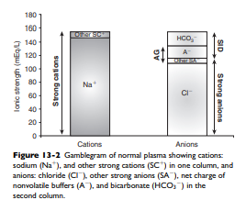

(Atot) or Total plasma concentration of nonvolatile weak buffers:
- In contrast to strong ions, buffer ions are derived from plasma weak acids and bases that are not fully dissociated at physiologic pH.
- The conventional dissociation reaction for a weak acid (HA) and its conjugated base (A-) pair is HA <->H+A. At equilibrium, an apparent dissociation constant (Ka) can be calculated.
- For a weak acid to act as an effective buffer, its pKa (negative logarithm of the weak acid dissociation constant Ka) lies within the range of pH +/- 1.5. Because normal plasma pH is approximately 7.4, substances with a pKa between 5.9 and 8.4 can act as buffers.
- The main nonvolatile plasma buffers act as weak acids at physiologic pH (phosphate, imidazole groups on plasma proteins). Also known as the non-bicarbonate buffer system, they form a closed system containing a fixed quantity of buffer.
- The non-bicarbonate buffer system consists of a diverse and heterogenous group of plasma buffers that can be modeled as a single buffer pair (HA and A). An assumption in Stewart’s strong ion model is that HA and A do not take part in plasma reactions that result in the net destruction or creation of HA or A.
- The great advantage of Stewart’s strong ion approach is that it provides a mechanistic view as to why pH is changing and fully integrates electrolyte and acid-base physiology. This approach states the pH is a function of eight factors. The Henderson-Hasselbalch equation states the pH is a function of four factors, whereas Constable’s simplified strong ion equation states that pH is a function of six factors.
- Because clinically important acid-base derangements result from changes in pCO2, SID, or Atot, the strong ion approach distinguishes six primary acid-base disturbances (respiratory, strong ion, or nonvolatile buffer ion acidosis and alkalosis) as opposed to the traditional 4 (respiratory/metabolic acidosis/alkalosis) from the Henderson-Hasselbach.

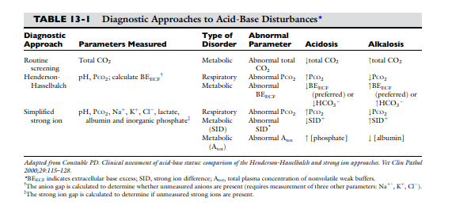
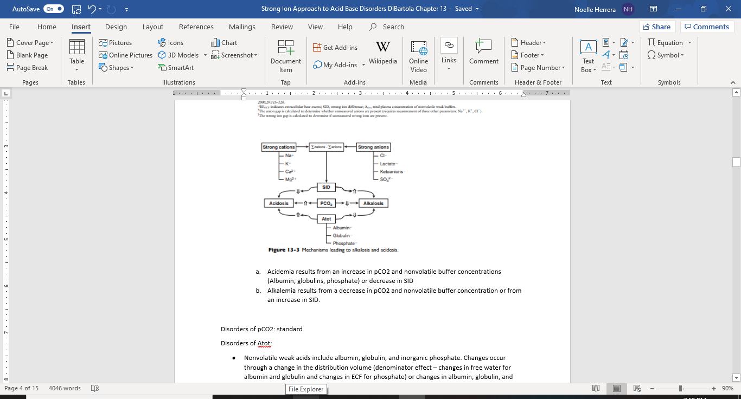
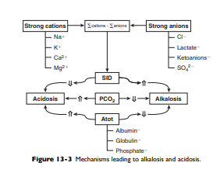

  - Acidemia results from an increase in pCO2 and nonvolatile buffer concentrations (Albumin, globulins, phosphate) or decrease in SID
  - Alkalemia results from a decrease in pCO2 and nonvolatile buffer concentration or from an increase in SID.

Disorders of pCO2: standard
Disorders of SID:
- Changes in SID are usually recognized as changes in bicarbonate, base excess, sodium, or chloride.
- The change in SID from normal is equivalent to the change in bicarbonate or base excess from normal whenever the plasma concentrations of nonvolatile buffer ions (albumin, globulins, and phosphate) are normal.
- The difference in sodium and chloride provides a clinically valuable index of SID, particularly in animals that do not have hyperlactatemia.
- A decrease in SID results in a strong ion metabolic acidosis whereas an increase in SID results in a strong ion metabolic alkalosis. There are three general mechanisms by which SID can change:
  - Increase in strong anions relative to strong cations
  - Decrease in strong anions relative to strong cations
  - Change in the free water content of plasma (change in ECF) with no change in strong anions relative to strong cations.
- SID alkalosis:
  - There are three general mechanisms by which SID can increase, leading to metabolic alkalosis
    - Increase in sodium
    - Decrease in chloride
    - Decrease in plasma free water (dehydration)
  - Strong cations other than sodium are tightly regulated, and changes of a magnitude that could affect SID clinically either are not compatible with life or do not occur. Conversely, chloride is the only strong anion present in sufficient enough concentration to cause an increase in SID when its concentration is decreased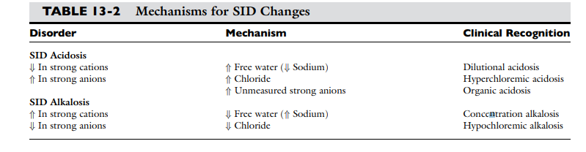
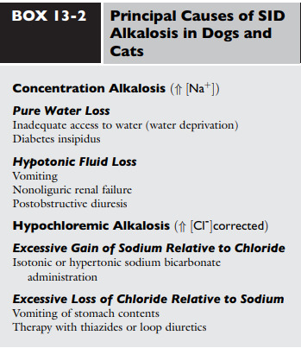
  - Concentration Alkalosis:

    - Concentration alkalosis develops whenever a deficit of free water in plasma occurs
      - recognized clinically by the presence of hypernatremia or hyperalbuminemia.
    - Solely decreasing the content of water increases the plasma concentration of all strong cations and strong anions and thus increases SID.
      - This decrease in water content also increases Atot, but the increase in SID has a greater effect on pH.
      - A decrease in ECF alone will not alter acid-base status because such a decrease in volume does not change any of the independent variables and therefore cannot change acid-base status.
      - However, if the decrease in ECF volume is associated with a relatively greater loss of free water as in DI or hypotonic fluid loss (diarrhea, vomiting, osmotic diuresis), then an acid-base change (concentration alkalosis) will result because of the increase in SID.
    - Hypernatremia and increased SID also can be associated with sodium gain in animals with cushings or in those treated with isotonic or hypertonic sodium bicarbonate because the effective SID of sodium bicarbonate solutions is high, whereas animals treated with isotonic or hypertonic sodium chloride will have hypernatremia and decreased SID because the effective SID of sodium chloride solutions is 0 mEq/L.
    - Therapy for concentration alkalosis should be directed at treating the underlying cause responsible for the change in sodium. If necessary, sodium and osmolality should be corrected.
  - Hypochloremic alkalosis:
    - If there is no change in the water content of plasma, plasma sodium will be normal.
    - Other strong cations (Mg, Ca, K) are regulated for other reasons than acid-base and their concentrations never change enough to affect SID.
    - Therefore, when water content is normal, SID changes only as a result of changes in strong anions.
    - If sodium remains constant, decrease in chloride can increase SID (hypochloremic alkalosis).
    - Primary decrease in chloride unrelated to increases in plasma water content are recognized by the presence of a low corrected chloride concentration.
    - Hypochloremic alkalosis may be caused by an excessive loss of chloride relative to sodium or by administration of substances containing more sodium than chloride as compared with normal ECF composition.
      - Excessive loss of chloride relative to sodium as compared with normal ECF composition can occur in the urine after administration of diuretics that cause chloride wasting (furosemide) or when the fluid lost has a low or negative SID as in the case of vomiting of stomach contents.
      - Administration of substances containing more sodium than chloride (sodium bicarbonate) also increases SID, causing metabolic alkalosis.
    - Cushings and hyperaldosteronisms are generally chloride resistant in that this hypochloremic alkalosis does not response to chloride administration alone. These diseases cause sodium retention by activating the type 1 renal mineralocorticoid receptors.
      - Administration of desoxycorticosterone acetate (DOCA) twice daily in sodium-supplemented dogs caused a significant increase in sodium and bicarbonate with no changes in chloride.
      - When sodium bicarbonate was added to the diet instead of sodium chloride, sodium and bicarbonate increased but chloride decreased.
      - Approximately 30% of cushinoid dogs have mild hypernatremia.
      - The low chloride that occurs in the presence of high mineralo or glucocorticoid concentrations is likely responsible for the mild metabolic alkalosis observed in these patients.
      - The lack of response to sodium chloride can be explained by a resetting of the regulatory mechanism and associated increased urinary loss of chloride.
      - Thus in so called chloride-resistant metabolic alkalosis, something (such as excess mineralocorticoid activity) prevents chloride retention and consequently SID cannot not be lowered by chloride administration.
    - Normal therapy for chloride-responsive hypochloremic alkalosis is directed at correcting SID with a solution containing chloride (0.9% saline, LRS, K-Cl supplemented fluids).
      - In cases in which expansion of extracellular volume is desired, intravenous infusion of 0.9% NaCl is the treatment of choice.
- SID Acidosis:
  - There are three general mechanisms by which SID decreases resulting in a SID metabolic acidosis:
  - Decrease in sodium:
    - Dilutional acidosis occurs when there is an excess of water in plasma and is recognized clinically by the presence of hyponatremia.
    - Increasing the water content of plasma decreases the concentration of all strong cations and anions and thus SID. The increase in water content also decreases Atot but the decrease in SID has a greater effect on pH.
    - An increase in ECF volume alone will not alter acid-base status because such an increase in volume does not change any of the independent variables. However, if the increase in ECF volume is associated with a relatively greater addition of free water, then an acid-base change (dilutional acidosis) will result primarily because of the decrease in SID.
    - Large increase in free water are needed to cause a big difference in SID. In dogs and cats, it is estimated that a decrease in sodium by 20mEq/L is associated with a 5mEq/L decrease in base excess.
    - Associated with congestive heart failure, hypoadrenocorticism, third space loss of sodium, and hypotonic fluid administration. However, hyponatremia in dogs is most commonly caused by GI losses of sodium.
    - Therapy should be directed at the underlying cause of the decreased sodium, and if necessary fixing sodium and osmolality.
  - Increase in chloride
    - Hyperchloremic acidosis caused by an increase in chloride that decreases SID
    - Caused by:
      - Chloride retention (early renal failure, renal tubular acidosis)
      - Excessive loss of sodium relative to chloride (diarrhea)
      - Administration of substances containing more chloride than sodium as compared with normal ECF (0.9% NaCl)
    - Treatment is aimed at underling process
      - Careful attention should be given to plasma pH, and sodium bicarbonate can be administrated whenever plasma pH is less than 7.2 because it has a high effective SID.
  - Increased concentration of other strong anions (Organic acidosis)
    - L-lactate (lactatic acidosis, pKa 3.9)
    - B-hydroxybutryate (DKA, pKa 4.4)
    - Sulfate (uremic acidosis)
    - Citrate (pKa 4.3)
    - Acetoacetate (pHa 3.6)
    - Exogenous organic anions (salicylate, glycolate from ethylene glycol poisoning)
    - These strong anions decrease SID
    - pKa values of these ions are at least 3 pH units lower than normal. At a pH of 7.4, the concentrations of their dissociated forms are at least 1000 times greater than the concentrations of the nondissociated forms.
      - This means that one molecule of lactic acid at a pH of 7.4 is equivalent to 3200 molecules of lactate. These organic acids are completely dissociated within the range of pH of bodily fluids and consequently behave as strong ions.
    - Accumulation of some inorganic strong anions (ie sulfates in renal failure) will resemble organic acidosis because these substances decrease SID
    - Treatment is directed at stabilizing the patient and treating the primary disorder.
      - Sodium bicarbonate may help patients in renal failure with acidosis but its efficacy remains controversial in patients with lactic acidosis or ketoacidosis because the sodium bicarbonate causes subsequent metabolism of the accumulated organic anions and further increases bicarbonate potentially leading to excessive alkalinization.
        - The thought behind sodium bicarbonate in patients with renal failure is: increase in plasma sodium concentration leading to an increase in plasma SID (strong ion alkalosis); expansion of the extracellular fluid volume which is the distribution space for phosphorous; and increased urine production. The combined effects of these changes lead to a decrease in plasma phosphorous concentration.

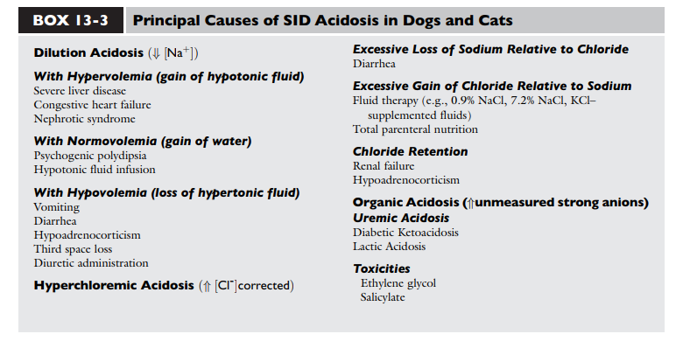

Disorders of Atot:
- Nonvolatile weak acids include albumin, globulin, and inorganic phosphate. Changes occur through a change in the distribution volume (denominator effect – changes in free water for albumin and globulin and changes in ECF for phosphate) or changes in albumin, globulin, and phosphate themselves (numerator effect).
- The contribution of proteins to Atot has been determined in vitro for dogs.
  - The net protein charge of canine plasma at pH 7.4 is approximately 16mEq/L, equivalent to 0.25mEq/g of total protein or 0.42mEq/g of albumin.
  - The overall effect of a 1-g/dL increase in total protein concentration is a decrease in pH of 0.047.
  - For cats, the overall effect of a 1-g/dL increase in total protein concentration is a decrease in pH of 0.093.
- The contribution of phosphate can be estimated by first converting phosphate concentration to mmol/L and then multiplying by its valence.
  - One millimole (atomic weight in mgs) of phosphate has 31mg of elemental phosphorous.
  - Thus the phosphate concentration in mg/dL can be converted to mmol/L by dividing by 3.1.
- Hypoalbuminemia:
  - Tends to increase pH and cause metabolic alkalosis.
    - Phosphate is the second most important component of Atot and normally is present in plasma at a low concentration therefore hypophosphatemia is not a clinically important cause of a nonvolatile buffer ion metabolic alkalosis.
    - A 1-g/dL decrease in albumin concentration is associated with an increase in pH of 0.093 in cats and 0.047 in dogs.
    - The increase in pH secondary to hypoalbuminemia should result in ventilatory compensation (hypoventilation) or a decrease in SID
      - Because plasma pH is vigorously defended and any deviation in pH from the optimal range for a given core temperature will be energetically inefficient.
  - Hypoproteinemic alkalosis is a common finding in critically ill patients.
    - Hypoalbuminemia complicates identification of an increased unmeasured anion (lactate, ketones) because hypoproteinemia not only increases pH but also decreases anion gap.
    - Calculation of the strong ion difference is recommended in patients that are hypoproteinemic as this will not be affected.
    - Treatment of hypoproteinemic metabolic alkalosis should be directed at the underlying cause and the decreased colloid oncotic pressure.
- Hyperphosphatemia:
  - When severe, it can cause a metabolic acidosis.
  - The most important cause is renal failure.
  - Treatment of hyperphosphatemic acidosis should be directed at the underlying cause.
    - Sodium bicarbonate can be used as an adjunctive because the increase in plasma sodium concentration results in an increase in plasma SID (strong ion alkalosis) expansion of the ECF (which is the distribution space for phosphorous) and increased urine production. The combined effect of these changes is to decrease plasma phosphorous concentration.
- Principle causes of nonvolatile ion (Atot) Acid-Base Abnormalities:
  - Decreased Atot or alkalosis:
    - Hypoalbuminemia:
      - Decreased production: chronic liver disease, acute phase response to inflammation, malnutrition and starvation
      - Extracorpreal loss: PLE, PLN
      - Sequestration: inflammatory effusions, vasculitis
  - Increased Atot or acidemia:
    - Hyperalbuminemia: water deprivation
    - Hyperphosphatemia:
      - Translocation: tumor cell lysis, tissue trauma or rhabdomyolysis
      - Increased intake: phosphate-containing enemas, intravenous phosphate
      - Decreased loss: renal failure, urethral obstruction, uroabdomen

Clinical approach to Strong Ions:
- Three simplified approaches have been developed to allow the clinical use of Stewart’s strong ion approach:
  - Effective SID model (Stewart Figge methodology)
    - Unmeasured strong ions are estimated by subtracting the effective SID (approximation of the real SID) from the apparent SID (which is calculated by adding Na, K, Mg, Ca, Cl)
    - Was developed using protein behavior based on human albumin and has not been tested in dogs or cats
    - Calculating the effective SID is not simple and clinically impractical. Less accurate in human plasma than calculating the SID using Constable’s simplified strong ion equation.
  - Base excess approach (Fencl-Stewart algorithm)
    - Base excess has been used to asses changes in the metabolic component because SID is synonymous with buffer base. It is a measurement of the deviation of buffer base (and therefore SID) from normal values, assuming nonvolatile buffer ion concentrations (albumin, phosphate, globulin) are normal.
    - Blood gas analyzers use the van Slyke equation to calculate BE from measured values of pH, pCO2, and hemoglobin concentration. Moreover, these are using human blood values.
    - Been used for many years in the clinical setting. This approach attempts to take into account the effect that changes in sodium (dilutional acidosis and concentration alkalosis), chloride (hypochloremic alkalosis and hyperchloremic acidosis), phosphate (hyperphosphatemic acidosis) and plasma protein (hypoproteinemic alkalosis and hyperporteinemic acidosis) concentrations exert of plasma pH, purportedly facilitating identification and quantification of unmeasured strong ions (organic acidosis) in plasma.
      - Values less than -5mmol/L are suggestive of an increase in unmeasured strong anions.
      - Formulas to estimate changes in BE resulting from changes in SID and Atot are presented here:

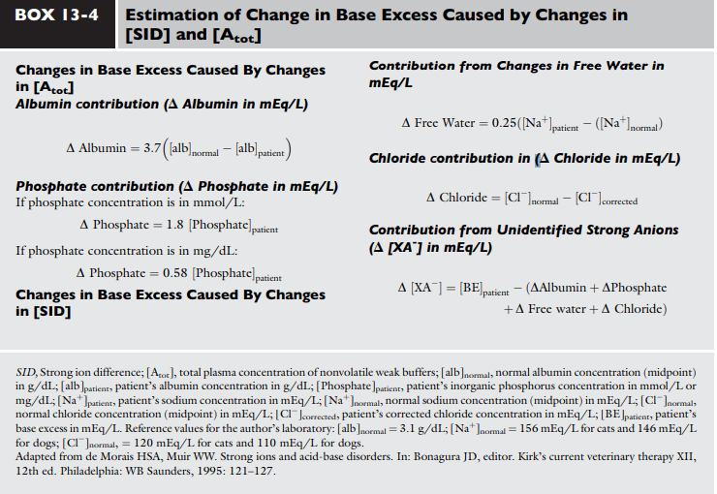
        - This BE algorithm lacks controlled clinical studies in dogs and cats and the influence of protein on BE is based on human albumin.
  - Simplified strong ion equation (Constable):
    - This assumes that plasma ions act as strong ions, volatile buffer ions (bicarbonate), or nonvolatile buffer ions (A-). Therefore plasma contains three types of charged entities:
      - SID
      - HCO3-
      - A-
      - Law of electroneutrality means SID+ = HCO3- - A-.
    - Unlike Stewart’s strong ion equation, the simplified strong ion equation uses hydrogen ion activity (pH) instead of concentration, provides a practical experimental model for determining species-specific values for Ka and Atot (CO2 tonometry of plasma), and simplifies to the Henderson-Hasselbalch equation when applied to aqueous nonprotein solutions (where Atot = 0meQ/L and SID =HCO3).
    - The simplified strong ion model also explains many of the anomalies of the Henderson-Hasselbach equation.
      - It explains why the apparent values for pK1’ in plasma is dependent on pH, protein concentration, and sodium concentration and also provides a mechanistic explanation for the temperature dependence of plasma pH.
    - The simplified strong ion model shares two disadvantages of the Stewart’s strong ion model:
      - 1. Difficulty in accurately determining SID
      - 2. Mathematical complexity when compared with the traditional Henderson-Haselbalch equation.
        - Unlikely to take over for the Henderson-Hasselbach equation because in the latter two of the three unknowns can be measured accurately and easily in plasma whereas only two of the four unknowns in the simplified strong ion approach can be measured easily and accurately. However in mechanistic experimental studies, the simplified strong ion model is preferred because it conveys on a fundamental level the mechanisms underlying acid-base disturbances.
    - Studied in dogs >> cats
Strong Ion Gap:
- The Strong Ion Gap concept is a modification of the simplified strong ion equation that overcomes the algebraic complexity.
- SIG is the difference in charge between all unmeasured strong anions and all unmeasured strong cations. Because there are more strong cations than anions, normal SIG is positive.
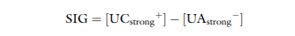
  - Unmeasured strong cations is the sum of ionized calcium and magnesium.
  - Unmeasured strong anions is the sum of ketoanions, lactate, sulfate.
  - Most important strong cations in plasma are Na and K whereas the most important strong anion is Cl. Thus SIG can be defined in its simplest form when only these three strong ions are measured: SIG = Na+K-Cl = UCstrong – UAstrong.
    - UCstrong is the sum of all strong cations besides Na and K
    - UAstrong is the sum of all strong anions other than Cl.
    - Electroneutrality must be maintained in plasma the excess of positive charges from the SIG is balanced by the negative charges of HCO3 and the nonvolatile buffers (A-).

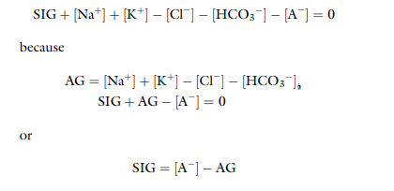
  - Based on this relationship, the SIG has been simplified so as to allow an estimation based on Atot (Sum of A- and its weak acid pair (HA)) and AG.
    - Albumin is used to estimate Atot in the SID simplified because albumin is the most important buffer in plasma.
    - At a normal plasma pH of 7.4, SIG simplified can be calculated form the albumin concentration in g/dL in dogs as:
      - SIG simplified = (alb x4.9) -AG
      - In cats at a normal pH of 7.35, = (alb x 7.4) – AG
    - An increase in umeasured strong anions is suspected whenever SID simplified is less than 5mEq/L.
    - Patients with hyperphosphatemia should have the AG corrected AG phosphate adjusted = AG + (2.52 – 0.58 x (phosphate)) before calculating the SIG.
    - SIG simplified offers a more accurate approach to identifying unmeasured strong ions in plasma than does the AG.
      - SIG simplified estimates the difference between unmeasured strong cations and anions
      - AG provides an estimate of the difference between unmeasured cations and anions (including strong ions and nonvolatile buffer ions such as albumin, globulins, and phosphate).
      - Therefore, a change in SIG simplified provides a more specific method for detecting a change in unmeasured strong ions (such as lactate) than does a change in AG.
    - The SIG simplified has not be adequately tested in dogs and cats but its derivation is sound.
    - It remains to be seen whether SIG or SIG simplified provides a more clinically useful tool for quantifying unidentified strong anions than the corrected AG, which corrects the AG for changes in plasma albumin concentration by assigning the net change assigned to albumin at physiologic pH (7.4) nad the deviation in albumin concentration from its normal value of 3.8 for the dog and 3.3 for the cat.
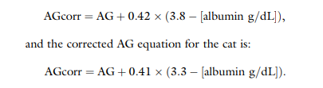

Conclusion to Ch. 13:
- The traditional Henderson-Hasselbach equation for the evaluation of acid-base status using pH, pCO2, and HCO3 has several clinically relevant limitations:
  - Does not give a complete assessment of the sources of pathophysiologic changes in the metabolic component (HCO3)
  - May lead to the conclusion that changes in electrolytes are only secondarily relative to acid-base status
  - Does not recognize changes in pH caused by changes in protein or inorganic phosphate concentrations
- The strong ion model makes the relationship between electrolytes and acid-base status becomes clear and it becomes apparent that they should no longer be viewed as separate entities. However, it is more time consuming and therefore may be less convenient in daily practice. This is most true in patients with normal albumin and phosphate concentrations, in which the H-H and an estimation of unmeasured anions works well as a first approximation of a more complex system and is therefore the preferred method.

