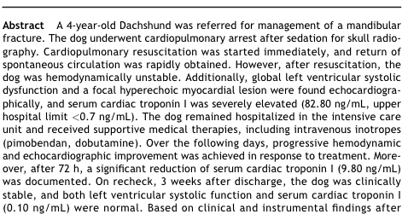
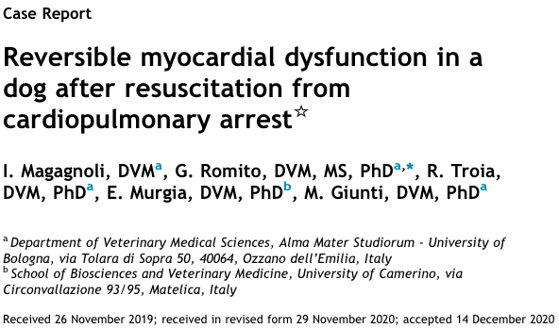

Introduction
- No indications of cardiovascular or respiratory compromise/disease prior to general anesthesia aside from mild hypertension, suspect secondary to anxiety
- Premedicated with appropriate doses: Methadone 0.1 mg/kg IV, Dexmedetomidine 1 mcg/kg IV sinus bradycardia on ECG CPA ROSC within 4 minutes
  - Compressions, intubated, Naloxone, Atipamezole, fluid bolus, and low dose Epi administered
- Echo, 30 min post-CPR: global left ventricular systolic dysfunction (FS 20%, normal 30-49%) and a focal hyperechoic myocardial area within the LVFW.
- Cardiac Troponin, post-CPR: severely elevated (82.8 ng/mL, normal < 0.7)
- DDX: postresuscitation myocardial dysfunction (PRMD) vs. SIRS vs. residual response to drugs
- Day 3 post-arrest:
  - Hyperechoic region still present
  - LV systolic function improved/normal (FS 37%)
  - Successfully able to disconitnue all inotropic support
- Week 3 post-arrest:
  - LV FS 43% (WNL)
  - Hyperechoic region still present
  - Serum cTnI normal (0.10 ng/mL)
- Unchanged for the next 2 months

Conclusions
- PRMD = a form of “myocardial stunning secondary to a period of global myocardial ischemia resulting from total circulatory arrest followed by resuscitation”, involving proposed mechanisms:
  - Tissue hypoxia
  - Mitochondrial oxidative phosphorylation abnormalities
  - Reperfusion injury
  - Cytokines
  - Excessive catecholamine release
- Usually transient dysfunction which peaks a few hours after ROSC and normalizes within 48-72 hours
- Severity of myocardial dysfunction depends on duration and extent of myocardial ischemia and reperfusion injury
  - Complete recovery if cardiac arrest < 7.5 min
  - Irreversible cardiovascular and neurologic damage if >/= 12.5 min arrested
- No major interventions required to establish complete recovery, although IV Pimobendan is recommended (inotropic, vasodilatory)—currently only licensed for single use
  - Used concurrently with Dobutamine here, so uncertain which/if either had a greater beneficial effect

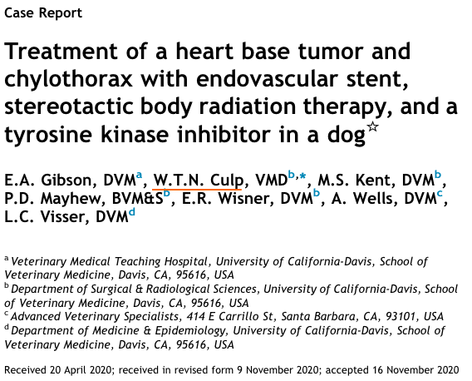
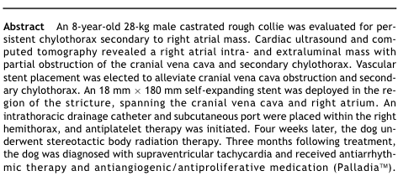
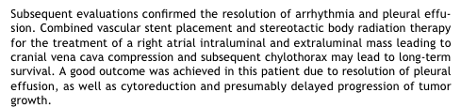
Introduction
- Right atrial mass => recurrent chylothorax due to partial cranial vena caval obstruction
- When chylothorax first diagnosed:
  - Echo WNL
  - CT showed partial torsion of L cranial lung lobe, but no heart mass => thoracotomy and lung lobectom
- 3 wk post-op: persistent pleural effusion
  - Echo: 40 mm RA mass causing a cranial vena cava inflow obstruction
  - Cytology of fluid = suppurative + chyle
  - C & S of fluid = non-hemolytic E. coli, susceptible to Clavamox
  - CT: 4 cm x 2.5 cm x 3 cm mass
- Stenting procedure through jugular vein
- Followed by stereotactic beam radiation therapy (SBRT) 1 month later + Toceranib (Palladia)
- Resolved pleural effusion for 4 mo following SBRT and 5 mo following stent
  - SVT developed, suspect secondary to long term radiation effect

Conclusions
- Tumor’s response to SBRT + Palladia suggests it was a chemodectoma
  - This protocol resulted in tumor shrinkage and good outcome
- Other cases of stenting along has demonstrated outcomes of 4-10 months without pleural effusion recurrence
- Clopidogrel post-op recommendend
- Longterm radiation effect: supraventricular tachycardia 3 mo later

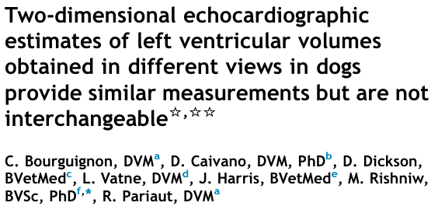
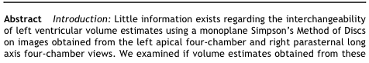
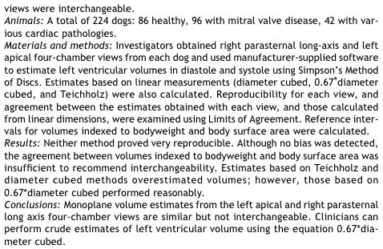
Introduction
- LV linear dimensions are used to estimate the size of the LV lumen
  - Veterinary studies in healthy dogs have shown these volumes do not agree well with LV volumes measured by 3D echo, CT, or MRI
  - Important when determine LV volume overload: uses LV volume and body weight/body surface area
  - Linear extrapolations don’t correlate well when an animal has LV disease
- Simpson’s Method of Discs: uses 2D echo to assess LV volume
  - Monoplane measurement from R parasternal long axis view and L apical 4-chamber view (not biplane due to patient conformation, but biplane is standard in people)
- Healthy breed-specific studies have shown these methods (two Simpson’s methods) agree, are interchangeable, and low variability
  - Not much info regarding the utility in dogs with cardiac diseases or other breeds

Conclusion
- Measurements obtained by different views show no bias but are not interchangeable because of relatively poor reproducibility
  - Offered similar measurements, but did not agree enough
  - Neither offered consistently smaller or larger LV volume estimates
    - Larger volumes had larger differences than smaller volumes
    - Limits of agreement are substantial, especially in diastole
    - Reference intervals are marginally tighter for the R parasternal vs. L apical views
  - Suggests they provide similar estimates of LV volumes due to there being no fixed of proportional bias
- Compared to Simpson’s, the Teichholz method and a unidimensional volume estimate (= diameter cubed) overestimated the LV volume, especially at higher volumes
  - Unidimensional volume estimate of 0.67 X D³ showed agreement with Simpson’s in both views
- Clinicians should use the same Simpson’s method for monitoring individual cases, but obtain similar results with either method

