Sepsis:
Sepsis 2 definition: SIRS + infection – not very specific, casting wide net, focused mostly on inflammatory excess.
- SIRS: systemic inflammatory response syndrome, Two or more of:
  - Temperature <100.6 >102.6
  - Heart rate >120/min
  - Respiratory rate >40/min
  - White blood cell count >16 000 x10^3 or <6000 x10^3 or >3% immature bands
- Severe sepsis: sepsis with 1 or more of following: hypotension, organ dysfunction, hypoperfusion (hyperlactatemia, oliguria)
- Septic shock: despite adequate intravascular fluid resuscitation, persistent hypotension and acute circulatory failure
- MODS (multiple organ dysfunction syndrome): physiologic derangements of at least 2 major organ systems associated with SIRS
Sepsis 3 definition: now recognized to involve both early activation of pro and anti-inflammatory responses as well as major modifications in nonimmunologic pathways involving aberrant or dysregulated host response affecting cardiovascular, neuronal, autonomic, metabolic, and coagulation and organ dysfunction (removing the previous “severe sepsis” distinction)
- Using SIRS criteria and SOFA (sequential organ failure assessment)
- Organ dysfunction acute change in total SOFA score $≥$2
- qSOFA (quick SOFA) alteration in mentation, hypotension, elevated resp rate
- Septic shock with persistent hypotension requiring vasopressors to maintain MAP $≥$65 and serum lactate >2mmol/L. In people, hospital mortality >40%

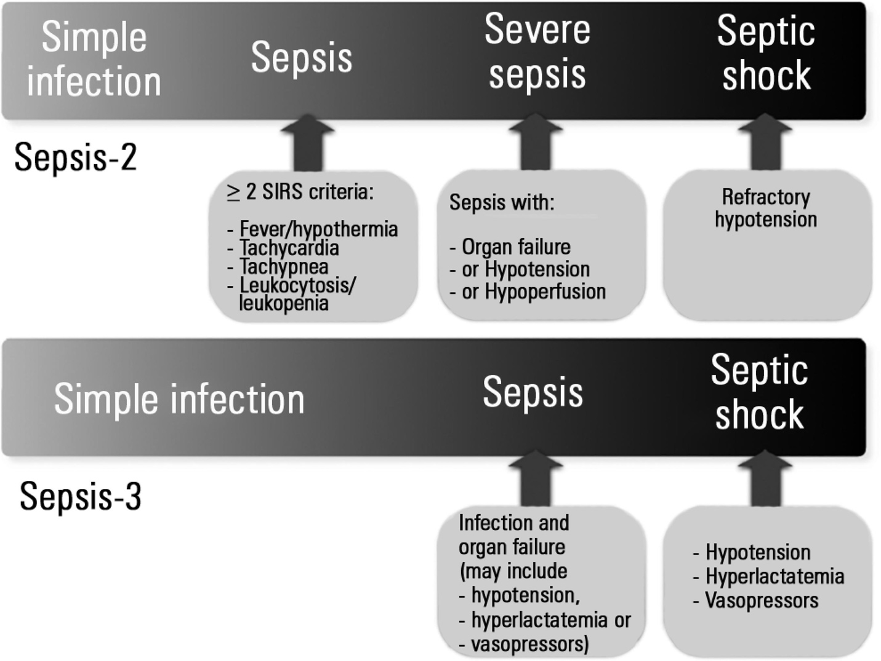

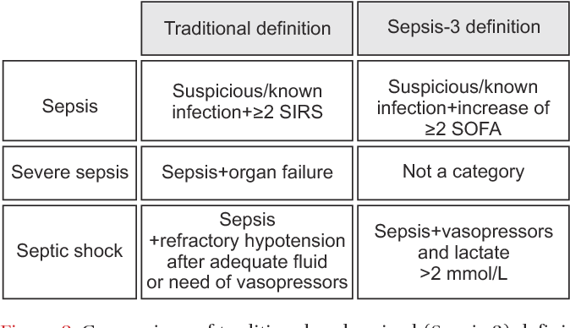
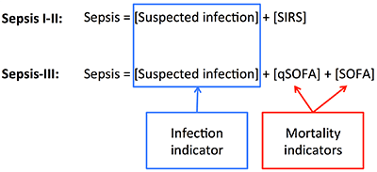
Table 2 Sequential Organ Failure Assessment (SOFA) score⁽⁴⁾
Score | 1 | 2 | 3 | 4
Respiratory system (PaO₂/FiO₂ - mmHg) | < 400 | < 300 | < 200  (and ventilation support) | < 100  (and ventilation support)
Coagulation (platelets x 10³/mm³) | < 150 | < 100 | < 50 | < 20
Liver (bilirubin - mg/dL) | 1.2 - 1.9 | 2.0 - 5.9 | 6.0 - 11.9 | > 12.0
Cardiovascular system (arterial hypotension)* | MAP < 70mmHg | Dopamine ≤ 5 or  dobutamine (any dose) | Dopamine > 5 or  epinephrine ≤ 0.1 or  norepinephrine ≤ 0.1 | Dopamine > 15 or  epinephrine > 0.1. or  norepinephrine > 0.1
Central nervous system (Glasgow Coma Scale) | 13 - 14 | 10 - 12 | 6 - 9 | < 6
Kidneys (creatinine - mg/dL) or urine output - mL/day | 1.2 - 1.9 | 2.0 - 3.4 | 3.5 - 4.9 or  < 500mL/day | > 5.0 or  < 200mL/day
Table 3 Sepsis-3 criteria qSOFA - quick Sequential Organ Failure Assessment.
qSOFA | Septic shock
Respiratory rate ≥ 22/minute  Systolic arterial pressure ≤ 100mmHg  Altered mentation | Arterial hypotension requiring vasopressors to maintain mean arterial pressure ≥ 65mmHg and hyperlactatemia > 18mg/dL (2mmol/L) despite adequate vascular filling
Problem for vet med is that SOFA score has not been validated in our patients, so sepsis 3 guidelines are not fully applicable yet, so sepsis 2 guidelines are still used

Pathophysiology sepsis:

Sepsis
- Clinically:
  - hemodynamic collapse, respiratory failure, thrombocytopenia/DIC, altered glucose control, altered mental status, acute kidney injury, ileus, polymyopathy, adrenal dysfunction, and/or altered liver function.
- On a cellular and subcellular level:
  - alterations and/or dysfunction in immune function/signaling, the endothelium, the intestinal epithelium and microbiota, and the coagulation cascade
Part 1 Immune and inflammatory response
- Initially thought sepsis was uncontrolled inflammatory response, “cytokine storm”
  - Treatment initially failed with solely therapeutic blockade of proinflammatory mediators
- Now more understood that there is complex host response that includes pro-inflammatory (SIRS) and anti-inflammatory cascades (CARS)
  - Concept of an opposing “compensatory anti-inflammatory response syndrome” (CARS), thought to be an adaptive response to excessive proinflammatory process in SIRS and sepsis
  - Typically, most instances of host-defense challenge has appropriate balance of SIRS and CARS
    - Acts to balance host’s need to maintain defense while minimizing self-induced tissue damage
    - This balance is lost in sepsis leading to uncontrolled proinflammatory reaction to infection resulting in organ dysfunction or undesirable compromise of immune system permitting opportunistic infection (“second hit”), or combo of both
- Serum concentrations of both proinflammatory and anti-inflammatory mediators increase early on in sepsis
  - Some concentrations of mediators (like IL-6) predictive of septic morbidity or mortality
- Sepsis also increases apoptosis of lymphocytes, hepatocytes, GI epithelial cells, endothelial cells, but decreased in neutrophils
- Neutrophil function altered with decreased migration of neutrophils to infected tissues and their antimicrobial function.
  - Peritoneal neutrophils potential source of IL-10 which has been seen to suppress inflammatory monocytes in models of polymicrobial sepsis
Initial host defense
- Immune response: concept local vs systemic
  - The immune response to pathogens triggers local reactions that with time, become systemic
  - Locally beneficial host defense mechanisms become detrimental when activated systemically
  - The septic reaction travels via the vascular system to spread inflammation throughout the body leading to organ failure
  - Early infections represent a race between the ability of pathogens to multiply and spread and the hosts' ability to sequester and kill pathogens before they disseminate.
    - This race starts after resident innate immune cells expressing toll like receptors (TLRs) recognize pathogens, leading to local vasodilation, increased vascular permeability, recruitment of neutrophils and monocytes, and local coagulopathy
    - If the inoculum is high, the pathogen evades host defenses, or if the host response is slow to gain control over multiplying pathogens, then both the pathogen and the inflammatory response aimed at pathogen containment extend beyond the local environment, and both systemic infection and systemic inflammation occurs.
- There is always a constant barrage of potentially pathogenic microorganisms
  - Survival depends on physical barrier preventing entry of pathogen and innate immune system that can rapidly induce defensive inflammatory response
  - Innate immune system further interacts with adaptive immune system, based on system of T and B lymphocytes that respond to specific epitopes
- Surface barrier mechanisms and antimicrobial peptides
  - Dermis keratinized epithelium and mucous lining of body cavities discourage pathogenic colonization
  - Innate defenses minimize penetration of body wall by microorganisms with antimicrobial peptides (AMPs) on mucosal surface.
    - AMP’s 3 main groups
      - Digestive enzymes and peptides that disrupt microbial cell membrane
      - Peptides that act as decoys for microbial attachment
      - Peptides that bind essential elements
    - Bactericidal AMPs: Ex: defensins and cathelicidins
      - Bacterial cell walls
        - Lack cholesterol and negatively charged phospholipids
        - Instead rich in anions (basic amino acids) that attract cationic defensins
      - Defensins carpet microbial membrane and institute channel formation
        - Channels lead to transmembrane pore formation, membrane destabilization, and microbial cell death
    - AMPs form part of non-oxidative killing mechanisms within phagolysosomes in cells like neutrophils and macrophages
    - May also be actively secreted onto epithelial surfaces of GI, respiratory, and urinary tract
- Recognition of pathogens: PRRs (TLRs) to PAMPs, MAMPs, and DAMPs
  - 2 factors for innate immune system to respond: presence of receptor against pathogen markers and widespread receptors in the body
  - Receptors expressed on effector cells of immune system, epithelial cells, endothelial cells, myocytes
    - Immune system cells like macrophages, neutrophils, dendritic cells, lymphocytes, natural killer (NK) cells
- Role of immune system in early phases of sepsis
  - Response to infection in two pathways: innate immune system and adaptive immune system
  - Recognizes pathogens by pattern-recognition receptors (PRRs) (through toll-like receptors TLRs and other PRRs)
    - This initiates innate response and regulates adaptive immune response
    - Understanding presence of TLRs has provided new target for therapeutic intervention
  - Innate immune system:
    - Protection in first minutes to hours after infectious challenge
    - TLRs bind to highly conserved structures on microorganisms that are not easily altered by microbes and present on broad groups of organisms
    - Immune cells use different TLRs to detect several features of an organism and based on composite information gained generate a tailored response to invading pathogens.
      - TLRs 1,2,4,5,6,11 present on external plasma membrane
      - TLRs 3,7,8,9 in endosomes
      - TLR 2 recognizes multiple PAMPs such as lipotechoic acid (gram-positive bacteria), peptidoglycan (gram-pos and neg bacteria), lipoproteins (e coli, borrelia burgdorferi, mycoplasma spp) and complete pathogens of clostridium spp, Chlamydophila spp, herpes virus
      - TLR 4 triggers innate immune response as it recognizes LPS from gram-neg bac, various viral protein envelopes, large number of endogenous molecules
    - Activation of TLRs stimulates signaling pathways:
      - increase pro-inflammatory cytokines like tumor necrosis factor (TNF- α), interleukin-1B (IL-1B), and nuclear factor- κB (NF-κB)
      - anti-inflammatory cytokines like interleukin-10 (IL-10)
      - up-regulate microbial killing mechanisms like production of reactive nitrogen species
  - Major targets of these PRRs are known as pathogen-associated molecular patterns (PAMPs)
    - Sometimes renamed as “microbial-associated molecular patterns” (MAMPs) because molecules could be in non-pathogenic and commensal bacteria
    - Recognize carbohydrate or lipid molecules that commonly exist on surface of pathogen
  - PAMPs criteria:
    - Produced by microbial pathogens, not by host
      - Ex: peptidoglycans produced by bacteria by not host eukaryotic cells
      - Able to discriminate automatically as “self” vs “nonself”
    - Generally invariant molecules shared by entire classes of microorganisms
      - Ex lipoarabinomannan is found on cell wall of all mycobacteria
      - Allows retention of few PRRs to recognize vast numbers of potential pathogens
    - Typically structures that are vital to survival or pathogenicity of microorganisms
      - Ex lipopolysaccharide (LPS) in outer membrane of gram-negative bacteria and lipotechoic acid (LTA) in cell membrane of gram-positive bacteria
      - Allows targeting of highly conserved molecules and removes the need for variability in host PRRs
  - DAMPs
    - “Danger-associated molecular patterns”
    - Innate immune system developed DAMPs to detect markers of endogenous cell damage called “alarmins”
    - Recognize patterns associated with injury, derived from necrotic cells and mitochondria
  - Triggering of PAMPs and DAMPs causes multiple positive feedback systems that lead rapidly to global inflammatory response
    - Cytokine/chemokine signaling
    - Release of oxygen species (ROS)
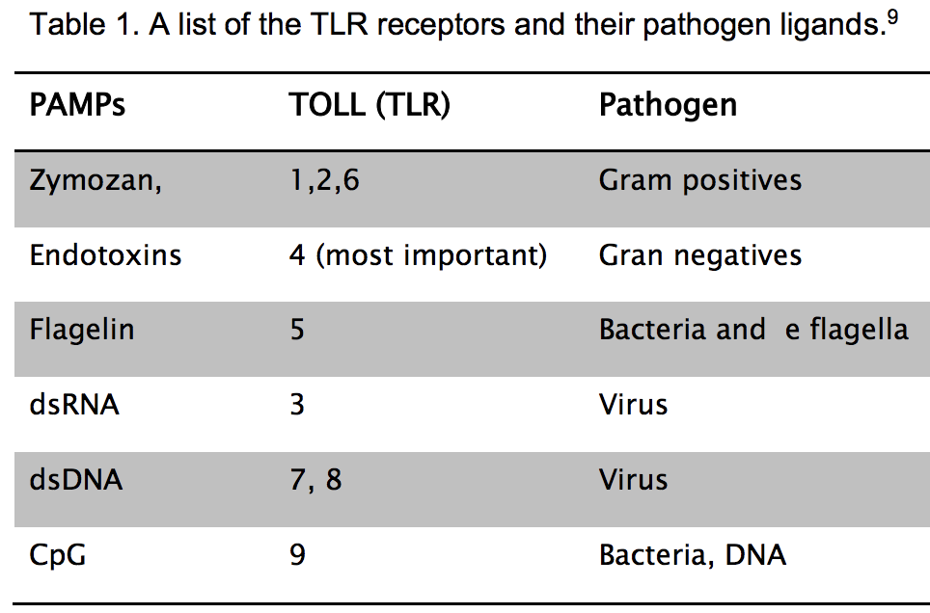

Neutrophils in sepsis and organ failure
- Review:
  - First line of defense, but beneficial and detrimental roles
  - Main cell type involved in acute inflammation
  - Main functions: secretion of molecules, migration and phagocytosis.
  - When infection occurs there is mobilization, marginalization and rolling in the endothelium, and adhesion and transmigration through the wall of the blood vessels with significant changes in their morphology and biology.
  - Dysfunctional neutrophil biology in sepsis will lead to significant changes that will contribute to the development of secondary complications and MODS.
    - Delayed neutrophil apoptosis and prolonged neutrophil response associated with increased organ including ARDS and decreased survival
    - ROS released by neutrophils are part of positive feedback propagation of inflammatory response, shown to cause both endothelial and mitochondrial dysfunction that contributes to multi-organ failure process
- Changes in the neutrophil biology during sepsis:
  - Changes in the neutrophil elasticity.
    - Pro-inflammatory mediators and released bacterial products result in increased leukocyte stiffness
    - Neutrophils become sequestered in the capillary beds (lungs, liver)
    - Reduction of leukocyte movements during sepsis may contribute even more to neutrophil sequestration and vascular occlusion, thus promoting tissue ischemia and dysfunction of various organs.
  - Alterations in neutrophil-endothelial cell and chemotaxis.
    - Profiles of adhesion molecule expression in neutrophils, endothelial cells further promote firm and neutrophil adhesion in the vasculature.
    - Movement to the sites of infection controlled by cytokines and microparticles
  - Deterioration of neutrophil migration
    - Compromised due to excessive release of pro-inflammatory mediators
- Expansion of inflammation by neutrophils
  - Acute phase, neutrophils entering the circulation can spread inflammation in other organs, and leading to damage
  - Late phases, there is a state of immune refractoriness with reasonably high amounts of antiinflammatory cytokines and specific inhibitors of cytokines
  - Lack of maintenance of the balance between excessive inflammation vs anti-inflammatory mechanisms.
  - Systemic neutrophil activation induces the release of NETs into the blood vessels causing endothelial damage, culminating with worsening sepsis and possible death.
    - NETs: (neutrophil extracellular traps) neutrophil’s weapons against bacteria
      - To kill pathogens, neutrophils use strategies such as phagocytosis, degranulation and NETs formation.
      - NETs are webs of DNA coated in antimicrobial proteins that are released into the vasculature during sepsis and contribute to organ damage
      - Released with activation of neutrophils, NETs link and kill microbes, immobilize platelets and erythrocytes triggering DIC

CCM Ch 25
- Role of immune system in early phases of sepsis
  - Adaptive immune system:
    - Amplifies response initiated by innate system with higher degree of specificity
    - Microorganisms stimulate specific cell-mediated and humoral adaptive immune responses
    - Adaptive immune response (humoral and cellular) require days to develop
      - Faster response if re-exposure to same pathogen through memory T and B lymphocytes
    - CD4 T cells divided 2 types: type 1 helper T-cell (Th1) and type 2 helper T-cell (Th2)
      - Factors such as type of organism, site of infection, infection burden affect T cell response.
      - Th1 secrete pro-inflammatory cytokines (TNF- α and IL-1B)
      - Th2 secrete ani-inflammatory cytokines (IL-4 and IL-10)
    - B lymphocyte cells responsible for releasing immunoglobulins in response to microorganisms.
      - Immunoglobulins bind organism-specific antigens and enhance recognition and destruction of other immune cells (natural killer cells and neutrophils)

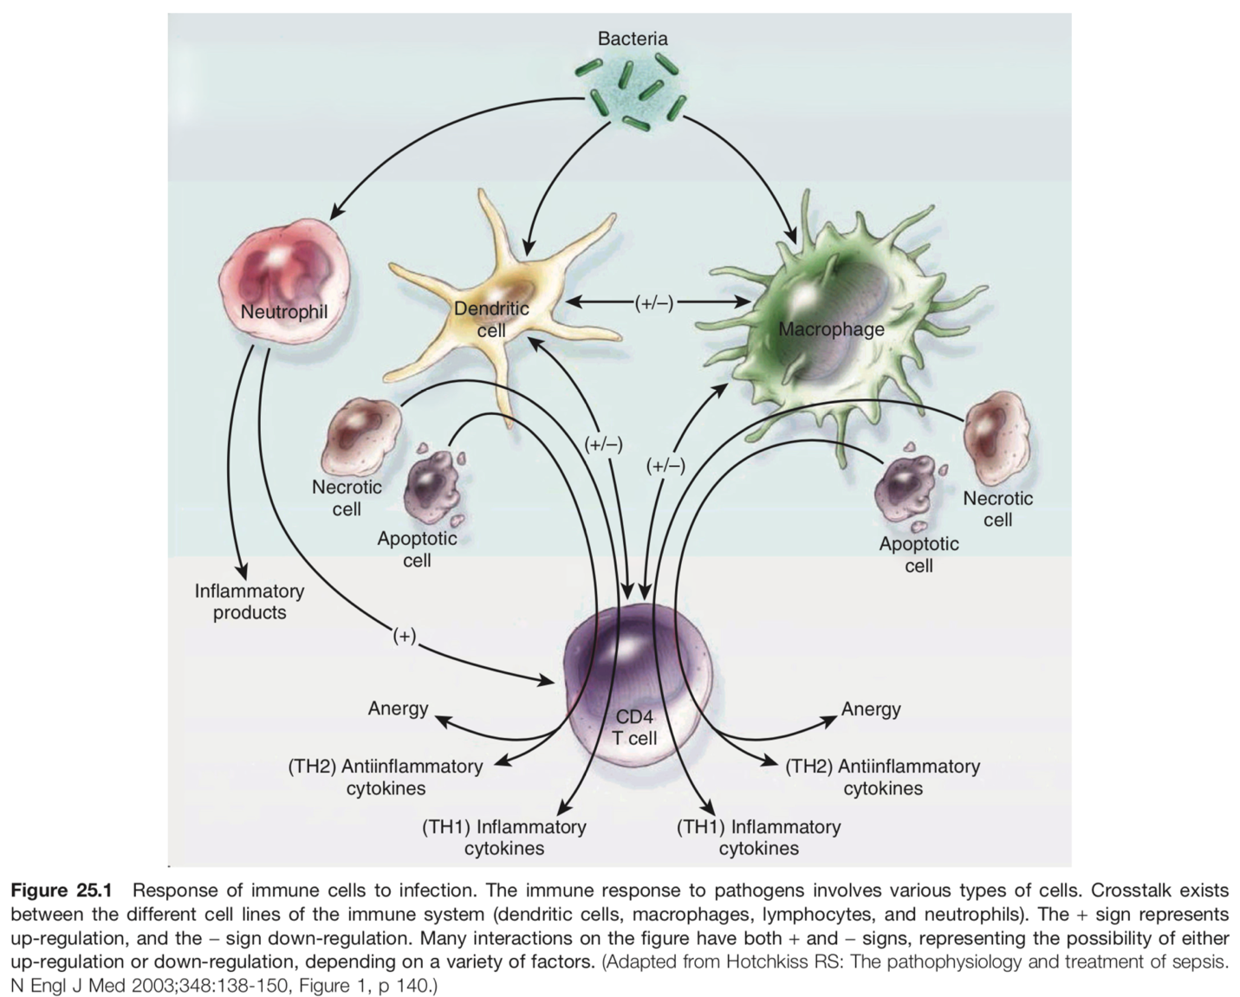
- Role of inflammation
  - Pro-inflammatory cytokines
    - increase in early sepsis
    - overlapping and synergistic effects stimulating further the inflammatory cascade
    - Activates monocytes macrophages and neutrophils
    - Stimulates neutrophil margination
    - Increase gluconeogenesis
    - Clinical signs
      - Fever
      - Hypotension
      - Capillary leakage with decreased intravascular volume
      - Myocardial depression
    - TNF- α
      - interacts with TNF receptor 1 to mediate proinflammatory and apoptotic pathways associated with inflammation
      - interacts with TNF receptor 2 for promotion of tissue repair and angiogenesis
      - TNF- α activation results in transcription of proinflammatory interleukins like IL-1, IL-6, IL-8, IL-12
      - Serum concentrations of TNF- α correlate with death in certain types of human sepsis. Also seen in studies of canine parvovirus, neonatal septicemia in cattle and horses, but not in septic cats
    - IL-1 (alpha form and beta form)
      - Synergistic interaction with TNF- α in “hyperacute” period after innate immune stimulation in sepsis
      - Induce synthesis of adhesion molecules and cytokines by endothelial cells
        - Leukocyte activation
        - Endothelial tethering
        - Transmigration into interstitium
      - Upregulates iNOS and COX2 production
      - Acts as major endogenous pyrogen in fever
      - Increases corticosteroid release via hypothalamic effects
    - IL-6
      - Stimulatory effects upon leukocyte activation and myeloid progenitor cell proliferation
      - Triggers acute phase response
      - Major pyrogen
    - TNF- α, IL-1, IL-6 plasma concentrations increased in sepsis
      - May be predictive of progression to MODS and death
      - Increased serum concentrations of IL-6 and IL-1B correlate with death in naturally occurring sepsis in dogs and cats
  - Anti-inflammatory cytokines
    - Role not fully understood in sepsis, but also increased serum concentrations in sepsis
    - Current thoughts suggest that sepsis-induced multiorgan failure and death may be caused in part by shift to anti-inflammatory phenotype and by apoptosis of key immune cells
      - Shift driven by increased levels of anti-inflammatory cytokines
      - Results from a shift in helper T-cell population (Th1 to Th2)
    - IL-10
      - Inhibits release of TNF- α, IL-1B, IL-6 from monocytes and macrophages
      - Reduces circulating concentrations of IL-1 and TNF- α
      - Increased concentrations associated with increased mortality in septic foals and humans
  - Two additional cytokines critical in sepsis
    - Macrophage migration inhibitory factor (MIF) and high mobility group 1 protein (HMG-1 or HMGB-1)
      - Downstream mediators of inflammation and potential therapeutic targets
    - MIF
      - Produced by anterior pituitary gland
      - Increased concentration in SIRS and sepsis
      - Proinflammatory, induces cytokine production of TNF- α, IL-1, IL-6
      - May delay apoptosis of activated monocytes and macrophages, perpetuating proinflammatory state
      - Serum concentration correlates with mortality
      - Inhibition of MIF appears to be protective
        - Has ability to override anti-inflammatory effects of glucocorticoids, instead glucocorticoids can induce secretion of MIF
    - HMG-1
      - Endogenous protein involved in nuclear DNA stabilization
      - After necrotic or apoptotic cell death, HMG-1 released into circulation and has direct pro-inflammatory actions
      - Potentiates effects of PAMPs and DAMPs upon TLR-2 and TLR-4
      - Circulating concentrations appear to correlate with mortality in canine SIRS patients, but did not predict mortality in 1 study of septic human patients.
  - Acute phase response
    - Triggering of PRRs release large quantities of acute phase proteins (APP) from hepatocytes
    - APP have variety of functions to re-establish homeostasis, assist in pathogen elimination, subdue inflammation
    - Leads to fever, neutrophilia, activation of coagulation and complement cascades, serum iron and zinc binding, gluconeogenesis, muscle catabolism, altered lipid metabolism
    - Induced by TNF- α, IL-1, IL-6
    - Upregulation of APP production leads to decrease in other plasma proteins (negative APP) like albumin, protein C, antithrombin
    - Recent studies identified adiponectin and insulin-like growth factor-1 as negative acute phase proteins in canine model of endotoxemia
    - Other studies looking at APPs serum levels and predictive survival in sepsis on procalcitonin and C-reactive protein (CRP)
      - Procalcitonin does not seem to distinguish inflammatory/infectious/neoplastic diseases
      - CRP also seems sensitive but not specific for inflammation
        - Recent study of SIRS and sepsis in dogs showed correlation between decreasing CRP and recovery from disease, suggesting use as prognostic biomarker in this context

