Disorders of Phosphorus

Functions of P:
- essential role in cellular structure and function
- constituent of structural phospholipids in cell membranes and hydroxyapatite in bone
- component of nucleic acids and phosphoproteins involved in mitochondrial oxidative phosphorylation.
- Part of ATP
- Part of 2,3-diphosphoglycerate (2,3-DPG) that decreases the affinity of hemoglobin for oxygen and facilitates the delivery of oxygen to tissues
- Part of Cyclic adenosine monophosphate (cAMP): intracellular second messenger for many
- polypeptide hormones.
- urinary buffer, and urinary phosphate constitutes the majority of titratable acidity
- participates in intermediary metabolism of protein, fat, and carbohydrate and as a component of glycogen. It stimulates glycolytic enzymes (e.g., hexokinase, phosphofructokinase) and participates in the phosphorylation of many glycolytic intermediates
- Nicotinamide adenine dinucleotide phosphate (NADP) is a coenzyme for important biochemical reactions
- regulates the activity of enzymes such as the glutaminase essential for ammoniagenesis

PHYSICAL CHEMISTRY
Two forms:
- organic (phospholipids and phosphate esters)
- inorganic (orthophosphoric and pyrophosphoric acids) forms in the body. Almost all serum phosphorus is in the form of orthophosphate

Serum P concentrations typically are reported as elemental phosphorus and expressed as milligrams of elemental phosphorus per deciliter of serum.
- One millimole of phosphate contains 31 mg of elemental phosphorus. To convert milligrams per deciliter to millimoles per liter, divide milligrams per deciliter by 3.1.
- clinical laboratories typically measure inorganic phosphate
- 10% to 20% of the inorganic phosphate in serum is protein bound, and the remainder circulates as free anion or is complexed to sodium, magnesium, or calcium.
  - The free and complexed fractions are available for ultrafiltration by the renal glomeruli

BODY STORES AND DISTRIBUTION
- Phosphate is the body’s major intracellular anion, and translocation in and out of the intracellular compartment can rapidly change serum phosphorus concentration
- 80% to 85% of total body phosphate is inorganic hydroxyapatite in bone
- 15% is in soft tissues such as muscle. Most soft tissue phosphorus is organic and can be readily converted to the inorganic form as needed
- The ECF compartment contains less than 1% of total body phosphorus stores

NORMAL SERUM CONCENTRATIONS
- Normal serum P in adult dogs 2.5 to 6.0 mg/dL, higher in dogs younger than 1 year.
  - highest in puppies less than 8 weeks of age (up to 10.8 mg/dL may be considered normal) and gradually decrease into the adult range after 1 year of age (Bone growth and an increase in renal tubular reabsorption of phosphorus mediated by GH presumably contribute to this age effect.)
  - effect of age is less pronounced in cats, immature cats have a tendency for higher serum concentrations.

- Effect of Diet on P concentrations:
  - A carbohydrate meal or infusion (e.g., 5% dextrose) decreases serum phosphorus concentration; phosphate shifts into intracellular fluid as a result of stimulation of glycolysis and formation of phosphorylated glycolytic intermediates in muscle, liver, and adipose cells.
  - Protein intake increases serum P concentration because of the relatively high phosphorus content of protein-rich diets.
- Effect of Acid-base status on P concentration:
  - Respiratory alkalosis stimulates glycolysis (by activating phosphofructokinase) and decreases serum P concentration.
- Measuring serum phosphorus concentration after a 12-hour fast minimizes confounding factors, the magnitude of hypophosphatemia or hyperphosphatemia may be incorrectly assessed if only one serum or plasma sample is analyzed.

- Other factors that affect Serum P concentration:
  - Hyperphosphatemia:
    - Hemolysis: phosphate is present in erythrocytes. canine erythrocytes contain 35 mmol/dL and feline erythrocytes contain 26 mmol/dL. When the red cell is ruptured, P is released.
    - Hyperlipidemia and hyperproteinemia: cause overestimation of serum phosphorus concentration, depending on the methodology used
    - Thrombocytosis and monoclonal gammopathy also may cause spurious increases in serum phosphorus concentration
  - Hypophosphatemia:
    - Icterus and hemolysis were reported to result in artifactual hypophosphatemia in dogs with immune-mediated hemolytic anemia

  - Mannitol and other drugs may interfere with some assay systems, leading to erroneous measured values
- hypophosphatemia in patients without known predisposing factors should prompt consideration of laboratory error.

DIETARY INTAKE
- average P content of commercial pet foods is approximately 1% on a dry matter basis
- Dogs and cats need to ingest 0.5 to 3.0 g of phosphorus per day

INTESTINAL ABSORPTION
- Ingested organic phosphate is hydrolyzed in the gastrointestinal tract, liberating inorganic phosphate for absorption. Net intestinal phosphate absorption: 60% to 70% of the ingested load
- Two mechanisms:
- Passive diffusion
  - principal route and occurs primarily through the paracellular pathway.
- Active mucosal phosphate transport:
  - sodium-dependent, saturable carrier-mediated process.
    - Calcitriol (1,25- dihydroxycholecalciferol) increases active intestinal mucosal phosphate transport
  - this mechanism is probably important only during dietary phosphate deficiency

- Both transport mechanisms function in the duodenum, whereas diffusion is the primary mechanism in the jejunum and ileum.
- Intestinal alkaline phosphatases may facilitate absorption by freeing inorganic phosphate for transport.

Factors that modify absorption:
- alkaline environment: allows for optimal phosphate transport occurs, and HPO4 is the main ionic species transported
- vitamin D deficiency and in malabsorptive states: decrease intestinal phosphate absorption
  - no evidence of a direct effect of PTH on intestinal phosphate absorption, and observed effects are probably mediated by the role of PTH in conversion of 25-Hydroxycholecalciferol to calcitriol.
- High dietary ratios of Ca to P (>3 to 4): may suppress intestinal phosphate absorption, presumably through binding of phosphate by calcium and formation of poorly absorbed calcium phosphate complexes.
  - During phosphate deprivation, the kidneys dramatically reduce phosphate excretion to negligible amounts in fewer than 3 days. Obligatory GI loss continues for at least 3 weeks, but there is a diminution in the amount lost. This GI loss may cause a cumulative negative phosphorus balance during phosphate deprivation.

RENAL HANDLING
- The kidneys adjust tubular reabsorption of filtered phosphate to maintain zero balance.
- 80% to 90% of the filtered phosphate load is reabsorbed by the renal tubules, and renal dysfunction is the most common cause of hyperphosphatemia

- Phosphate crosses the luminal membranes of the proximal renal tubular cells by brush border Na-P cotransporters:
  - Main transport protein in the proximal tubules: type IIa Na-P cotransporter translocates three Na and one divalent P ion across the luminal membrane and thus promotes luminal electronegativity.
  - Luminal entry is the rate-limiting step and the target for physiologic and pathophysiologic mechanisms that alter phosphate reabsorption.
  - High dietary intake of phosphorus decreases proximal tubular reabsorption, whereas low dietary intake can result in nearly 100% proximal tubular reabsorption of phosphate.
- PTH most important regulator of renal phosphate transport: decreases the tubular transport maximum for phosphate reabsorption in the proximal tubule where most phosphate reabsorption occurs.
- No reabsorption occurs in the thin ascending limb or thick ascending limb of Henle’s loop
- P reabsorption is inhibited in the early proximal tubule by volume expansion with saline
Hormones:
- GH increases proximal renal tubular phosphate reabsorption (accounts for the increased serum phosphorus concentrations in younger animals).
- Insulin and thyroxine increase proximal tubular reabsorption of phosphate
- Calcitonin and ANP inhibit proximal tubular phosphate reabsorption
- High doses of ACTH or glucocorticoids increase renal phosphate excretion and may decrease serum phosphorus concentration
Acid-base status and P:
- Acute metabolic acidosis does not affect renal tubular reabsorption of phosphate
- chronic metabolic acidosis results in decreased proximal tubular transport, possibly mediated by glucocorticoids.
- Respiratory acidosis decreases and respiratory alkalosis increases proximal tubular reabsorption of phosphate.

- Volume expansion increases urinary phosphate excretion and causes natriuresis because phosphate is cotransported with sodium in the proximal tubule.
- Phosphatonins: circulating substances that increase renal loss of phosphorus:
  - fibroblast growth factor-23 (FGF-23), secreted frizzled-related protein (sFRP-4), fibroblast growth factor-7 (FGF-7), matrix extracellular phosphoglycoprotein (MEPE) decrease sodium phosphate transporters in PCT
  - FGF-23 and sFRP-4 are believed to also decrease formation of 1–25 dihydroxycholecalciferol.

CLINICAL EFFECTS OF HYPOPHOSPHATEMIA
- decreased erythrocyte concentrations of ATP: increases erythrocyte fragility hemolysis.
  - Reported in hypophosphatemic dogs and cats with DKA and hepatic lipidosis
  - usually is not observed until serum P to 1.0 mg/dL or less.
- reduced erythrocyte 2,3-DPG concentrations: impairs oxygen delivery to tissues.
- Leukocytes have impaired chemotaxis, phagocytosis, and bacterial killing.
  - Linked to sepsis in hypophosphatemic patients receiving total parenteral nutrition.
- Platelet-associated abnormalities: include shortened survival time, impaired clot retraction, megakaryocytosis in the bone marrow, and thrombocytopenia.
- Neuromuscular effects: weakness and pain associated with rhabdomyolysis, as well as anorexia, vomiting, and nausea secondary to intestinal ileus.
- impaired CNS glucose use and ATP production metabolic encephalopathy, wide range of manifestations in people (coma, seizure, confusion, irritability).
- Reversible impairment of cardiac contractility
- Proximal tubular bicarbonate wasting, reduction in titratable acidity, and impaired renal ammoniagenesis.
  - serious acid-base disturbances do not arise in phosphate-deprived dogs
- Bone demineralization via effects of PTH and calcitriol, and release of carbonate from bone may prevent serious metabolic acidosis

CAUSES OF HYPOPHOSPHATEMIA
- Translocation of phosphate from extracellular to intracellular fluid (maldistribution)
  - related to administration of a carbohydrate load (e.g., 5% dextrose infusion); common cause of hypophosphatemia in hospitalized people.
  - Insulin facilitates entry of glucose and phosphate into cells, where glucose is phosphorylated to glycolytic intermediates
- Increased loss (decreased renal reabsorption of phosphate)
  - fractional urinary phosphorus excretion to help determine if renal losses are responsible
- Decreased intake (decreased intestinal absorption of phosphate)

- Malnourished patients receiving TPN susceptible to hypophosphatemia because of the accelerated rate of tissue repair as phosphate is incorporated into new cells and phosphate use during glycolysis.
- Hypophosphatemia as part of the refeeding syndrome
  - more likely inpatients that were more severely emaciated lower initial serum phosphate concentrations
- Respiratory alkalosis causes translocation because it stimulates glycolysis by activating phosphofructokinase
  - Increased intracellular pH may be more important than increased extracellular pH for causing hypophosphatemia in respiratory alkalosis, which could explain why severe hypophosphatemia may occur in people with severe respiratory failure who are mechanically ventilated.
- Diabetic patients risk for hypophosphatemia. They often have total body phosphate deficits because of a loss of muscle mass, urinary phosphate losses, and impaired tissue use of phosphate related to insulin deficiency.

- Administration of large doses of insulin makes hypophosphatemia even more likely in DKA patients. Severe hypophosphatemia has been reported in dogs and cats treated for DKA.
- Increased urinary loss of phosphorus often produces moderate hypophosphatemia in primary hyperparathyroidism, but clinical signs are caused by hypercalcemia
- Hypophosphatemia is seen inconsistently in cats with primary hyperparathyroidism.
- Fanconi syndrome in basenjis is associated with decreased renal fractional reabsorption of phosphate, but serum phosphorus concentrations are normal

- carbonic anhydrase inhibitors may increase renal excretion of phosphate secondary to their effects on proximal tubular sodium reabsorption.
- dietary deficiency: unlikely in animals eating commercial diets with adequate protein content.
- Vomiting and malabsorptive diseases rarely cause hypophosphatemia in dogs or cats
- Postsurgical hypophosphatemia is a well-established problem in people. It is more common and can be particularly severe after hepatic surgery, especially major resection and transplantation. Mechanism: uptake of phosphorus by the regenerating liver, excessive renal losses are now considered to be responsible.
- Low P seen in dogs experimentally intoxicated with xylitol, uncertain whether hypophosphatemia is due to hepatic damage or to other metabolic effects of xylitol.
- Low P previously associated with sepsis and gram-negative infections in people to the extent that some have suggested that it should be a diagnostic tool.
  - believed to occur in these people due to redistribution of phosphorus into body cells. Recently, severe hypophosphatemia (<1 mg/dL) has been reported to be a major risk factor for mortality in these patients

TREATMENT OF HYPOPHOSPHATEMIA
- Prevention is preferred to therapy
- Anticipate potential hypophosphatemia and either administer supplemental phosphorus (e.g., patients receiving TPN or insulin treatment for DKA) or carefully monitor the patient for hypophosphatemia
  - Asymptomatic animals with low serum phosphorus concentrations but without phosphorus depletion and those with serum phosphorus concentrations greater than 1.8 mg/dL and unlikely to decrease any lower (e.g., primary hyperparathyroidism) often do not require phosphate administration.
  - Asymptomatic patients deemed at risk for developing symptomatic hypophosphatemia (e.g., DKA cat with serum phosphorus concentration of 1.6 mg/dL), treatment seems appropriate
    - Over-supplementation can cause hypocalcemia, soft tissue calcification and renal failure
If oral supplementation is suitable, it may be safer and therefore preferable to parenteral supplementation.
- Patients symptomatic because of hypophosphatemia generally need parenteral therapy
- intravenously P may cause hypocalcemia, tetany, soft tissue mineralization, renal failure, or hyperphosphatemia. Therefore, administer small amounts slowly over hours to days and monitoring the patient repeatedly (0.01 to 0.06 mmol/kg/hr and measure P q 6 to 8 hours)
- Theoretically, adding phosphorus to fluids containing calcium may cause precipitation of calcium phosphate, but this appears to depend on relative concentrations of calcium and phosphorus.

HYPERPHOSPHATEMIA
CLINICAL EFFECTS OF HYPERPHOSPHATEMIA
- Increased serum P concentration decreases serum Ca concentration so that the calcium phosphate solubility product ([Ca] x [Pi]) remains constant.
- Hypocalcemia (which may cause tetany) and soft tissue mineralization are the major clinical consequences of hyperphosphatemia.
- If hyperphosphatemia occurs in a hypercalcemic patient systemic calciphylaxis (calcification of organs, including the heart and lungs); can be fatal.

- Acute hyperphosphatemia has been associated with acute renal failure in patients without prior hypercalcemia, and a direct toxic effect of phosphate on renal tubular cells has been hypothesized.
  - In human end-stage renal disease patients, hyperphosphatemia is associated with increased cardiovascular mortality.
- The risk of soft tissue mineralization increases when the [Ca] x [Pi] solubility product exceeds 60 to 70.

CAUSES OF HYPERPHOSPHATEMIA
- decreased renal excretion:
  - main cause of hyperphosphatemia; and chronic renal failure is the most common cause of hyperphosphatemia in adult dogs and cats. CKD causes a progressive decrease in the glomerular filtration rate (GFR), and the filtered load of phosphate decreases as GFR decreases.
  - If phosphorus intake remains constant, phosphorus retention and transient hyperphosphatemia result. However, sustained hyperphosphatemia does not usually develop in early chronic renal failure because there is a compensatory increase in phosphate excretion by remnant nephrons
- increased intake and translocation (less likely)
- Tumor lysis syndrome:
  - hemolymphatic malignancies
  - Myeloblasts and lymphoblasts may contain up to four times as much phosphate as normal cells, and destruction of these cells causes release of phosphate.
  - Patients with lymphosarcoma treated with chemotherapy with or without radiation
- Massive tissue injury with rhabdomyolysis: Subsequent development of acute renal failure related to myoglobinuria further contributes to hyperphosphatemia.
- Hypertonic enema solutions or oral administration of sodium phosphate can increase P
- Intoxication with cholecalciferol-containing rodenticides: Vitamin D increases intestinal absorption of calcium and phosphorus and may produce hyperphosphatemia in addition to hypercalcemia.

TREATMENT OF HYPERPHOSPHATEMIA
- Volume expansion with saline dilutes ECF phosphate and enhances renal phosphate excretion in dehydrated patients.
  - Increasing GFR by volume expansion increases the filtered load of phosphate, and natriuresis impairs proximal tubular phosphate reabsorption.
- Administration of glucose (and insulin if necessary) may temporarily decrease serum phosphorus concentration by promoting phosphorus entry into cells, rarely used
- All sources of phosphorus intake should be curtailed: In the diet, phosphorus restriction is accomplished primarily by protein restriction. As a rule, low-protein diets are also low in phosphorus.
- Calcium salts should not be administered to hyperphosphatemic patients because of the risk of metastatic soft tissue calcification.
- Dialysis is unpredictable because phosphate is a poorly diffusible ion.
- phosphate binders: most effective way to treat hyperphosphatemia
  - prevents ingested and endogenously secreted phosphate from being absorbed.
    - the cation in the binder combines with dietary phosphate, producing insoluble, nonabsorbable phosphate compounds.
  - The most widely used contain aluminum or calcium and hydroxide, carbonate, or acetate
  - 90 to 100 mg/kg/day divided two or three times daily is a reasonable starting point
  - Constipation, common side effect of aluminum-containing phosphate binders.
- Effectiveness is monitored by measuring fasting serum phosphorus concentration. The goal is to maintain the serum phosphorus concentration in the normal range.

DISORDERS OF MAGNESIUM

- 99% of the body’s Mg intracellular, participates in vital behind-the-scenes metabolic activities of the cell

Distribution of Mg
- precise distribution not well understood
  - 1% of the total body Mg located outside the cell in the ECF and that the remaining 99% intracellular stores
  - 67% of body Mg is stored in the bone with calcium and phosphorus, 20% is found in muscle tissue, and 11% in other soft tissues not including muscle
- Exchange between intracellular Mg and the extracellular fluid is difficult to study, but current estimates: 15% of these stores are considered to be exchangeable with the ECF
- Bone Mg is the most labile pool and will be scavenged during a Mg deficit.
- Regulatory control of Mg shifts is complex and multifactorial

- Extracellular Mg is present in three forms (like calcium):
  - ionized or free form (55%) that is believed to constitute the biologically active fraction
  - protein bound form (20% to 30%)
  - complexed form (15% to 25%)
- Mg is only 20% to 30% bound to protein less affected by changes in albumin concentration

- Inside the cell:
  - Mg is complexed to many organic compounds where it plays a pivotal role
  - only about 1% to 2% of the intracellular Mg is present in the ionized or free form.
  - Presumably, Mg also shifts between the free and complexed intracellular forms as well; precise mechanism is not understood

GASTROINTESTINAL HANDLING OF Mg
- Ileum: primary site of absorption, jejunum and colon also contribute
- Two pathways for absorption:
Paracellular movement (unsaturable and passive) of Mg occurs through the tight junctions between epithelial cells.
    - Driving forces are:
- Transepithelial Mg concentration gradient: influenced by the gut intraluminal ionized Mg concentration (chelated or complexed Mg species do not contribute). Total dietary intake of Mg and intake of dietary constituents that influence the amount of Mg that is complexed or chelated may influence the net absorption of Mg
- Transepithelial voltage gradient: formed by salt and water absorption. Created by net movement of salt and water. A small positive intraluminal voltage results in a small force favoring transepithelial cation movement.
- Permeability of the tight junctions to Mg
- Solvent drag created by sodium and water reabsorption will also result in transepithelial movement of Mg and other ions. Water and salt reabsorption from the gut therefore has a significant influence on Mg absorption

Active transcellular route (saturable): pathway not very well studied.
  - Numerous proteins exist in the tight junction that serve as ion channels for Mg
  - Specific Mg ion channels in the gut epithelial tight junctions have not been conclusively identified
  - Paracellin-1: regulate Mg movement through the renal epithelial tight junctions, speculation that a similar protein may exist in the gut as well

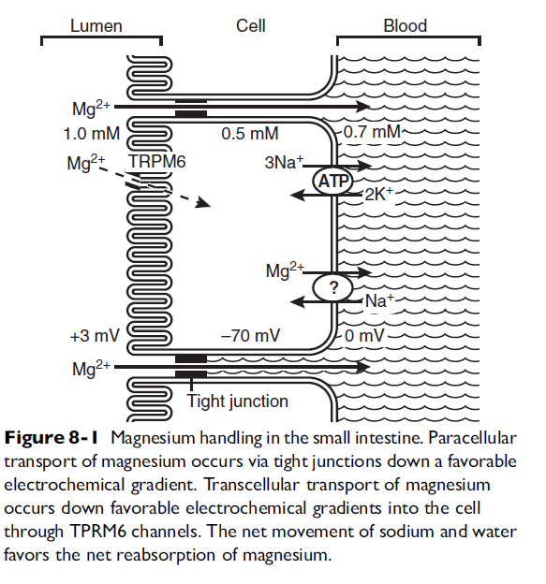

RENAL HANDLING OF Mg
Proximal tubule:
- 80% of total serum Mg is filtered by the glomerulus and enters the proximal tubule
- 10% to 15% of Mg is reabsorbed
  - via passive and unsaturable mechanisms
  - paracellular transport also but the precise mechanism is not known
Loop of Henle:
- site of the majority of Mg absorption from the kidneys
  - Approximately 60% to 70% of filtered Mg is reabsorbed in the cortical thick ascending limb of the loop of Henle
  - The medullary thick ascending limb does not appear to participate in Mg balance
  - paracellular pathway through tight junctions between renal epithelial cells
- Principal forces allowing Mg transport:
  - electropositive luminal environment created by the movement of sodium and chloride from the lumen to the interstitial space
  - In addition, movement through the tight junctions occurs due to “solvent drag” created by the salt and water movement
  - The positive intraluminal charge facilitates movement of Mg (and calcium) from the lumen to the interstitium through a paracellular “pore” or channel
  - Changes in the transepithelial voltage and paracellular permeability to Mg strongly influence Mg absorption
  - Increases in salt movement from the lumen will concurrently elevate the transepithelial electrical potential and facilitate Mg absorption
- PTH, calcitonin, glucagon, antidiuretic hormone, aldosterone, and insulin all act to increase Mg absorption from the lumen
- PGE2, hypokalemia, hypophosphatemia, and acidosis decrease Mg absorption

- Calcium/Mg sensing receptor or cation-sensing receptor (CASR): basolateral extracellular receptor:
  - senses extracellular Ca and Mg concentrations at the basolateral membrane and is coupled to intracellular inhibitory G proteins, which will inhibit and neutralize the effect of other hormonal influences
  - Activation of the CASR in the loop appears to decrease salt absorption (sodium, Mg, and calcium)
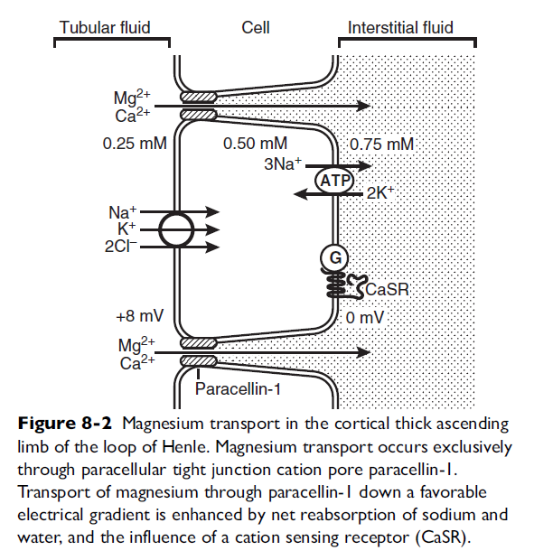

Distal Convoluted tubule:
- does not appear to act as a mass transporter of Mg as the ascending loop does, but instead is the site for many complex influences to determine the final Mg excretion
- reabsorbs approximately 10% to 15% of the filtered Mg
- When necessary it can be very efficient at reabsorbing Mg, reabsorbing as much as 70% to 80% of the Mg that is delivered from the thick ascending limb
- The final urine concentration of Mg is principally determined by this segment
- Reabsorption of Mg in the DCT appears to occur only through active transcellular routes.
- Passive paracellular transport does not appear to occur to any significant degree.
- The transcellular transport of Mg is dependent on favorable transepithelial concentration and voltage gradients
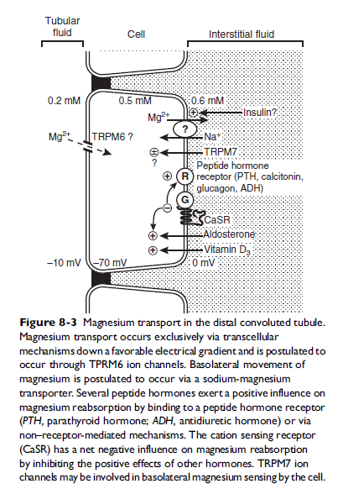
MANIFESTATIONS OF Mg DEFICIENCY
- Seen in canine studies only:
  - Poor growth rates and numerous dermatologic and soft tissue problems: dry brittle hair and nails, peripheral vasodilation and swelling, and splaying of the paws.
  - Neuro signs had a later onset.

Functions of Mg
- Multiple cellular metabolic processes
- Bound to numerous molecules that regulate energy production, storage, and use.
- Vital role in the mitochondria during oxidative phosphorylation and during anaerobic metabolism of glucose
- Participates in synthesis and degradation of DNA, the binding of ribosomes to RNA, adenine nucleotide synthesis, and production of important intracellular second messengers such as cyclic AMP
- cofactor with ATP as the driving force behind intracellular ion pumping activity
  - Na-K ATPase, HCO3 - ATPase, and Ca2-ATPase, all require Mg2-ATP to maintain effective ionic gradients within and outside the cell
Cardiovascular effects:
- Mg plays an important regulatory role in the intracellular cycling of calcium in muscle cells.
- It is a cofactor for the Ca- ATPase that rapidly shunts intracellular calcium back into the sarcoplasmic reticulum after the contraction cycle is complete
- Intracellular and extracellular Mg levels thus play an important role in cardiac excitability, contraction, and conduction through their regulatory effects on calcium movement

Mg and arrhythmias:
- Mg is a cofactor for the ionic pumps that rapidly pump sodium out of the cell, potassium back into the cell, and calcium out of the cell or back into the sarcoplasmic reticulum.
  - Also serves as an important gating mechanism to control the movement of intracellular calcium as described above, and it also acts to prevent the leak of potassium from inside the cell
  - Intracellular calcium overload triggered during myocardial ischemia by mediators such as lysophosphatidylcholine (LPC) has been implicated as an important cause of ventricular arrhythmias that result from ischemic conditions
- Mg may act as an antiarrhythmic agent by limiting intracellular calcium overload in such conditions
Mg and vascular tone:
- Mg appears to control or exert a powerful role in calcium cycling in the smooth muscle of the peripheral vasculature, with higher intracellular concentrations of Mg producing a relaxing or vasodilating effect
- Low concentrations of intracellular Mg appear to have the opposite or vasoconstricting effect. Mg deficiency implicated as a potential contributing cause in the constellation of causes of systemic hypertension
Mg and nervous system:
- Mg depletion leads to an increased neuronal excitability and enhanced neuromuscular transmission, with the opposite effects predominating in states of Mg excess.
- Signs are rare in small animals

Refractory hypokalemia due to hypomagnesemia:
  - During a Mg deficient state, the simultaneous occurrence of intracellular K loss and decreased ability for K to reenter the cell lead to a significant intracellular depletion of K.
    - refractory state of hypokalemia occurs despite aggressive supplementation with potassium and resolves only when the Mg deficit has also been corrected
- mechanisms of Refractory hypokalemia:
  - Mg’s function as a cofactor for most ATPase pumps:
    - Reduced Na-K-ATPase function will lead to a net loss of potassium outside the cell and a net gain of sodium in the cell
  - Mg deficit also decreases the function of the Na-K-Cl cotransport system, thus decreasing potassium reentry into the cell
  - Also, Mg appears to act from both within and outside the cell to prevent potassium leak from the cell through potassium channels and other less well understood mechanisms.
  - Overall, Mg acts to maintain appropriate intracellular potassium stores. In the kidneys, where significant potassium reabsorption occurs through Na-K-ATPase activity and Na-K-Cl cotransport, Mg stimulates and permits normal reabsorption to occur.
    - Depletion of Mg therefore has a permissive effect on intracellular loss, leading to extracellular accumulation of potassium, which is subsequently lost from the body due to ineffective potassium reabsorption mechanisms in the kidneys

Mg DEFICIENCY
- Most commonly, Mg deficiency occurs in hospitalized ill patients due to the combined causes of lack of dietary intake in conjunction with excessive loss through the gastrointestinal track due to diarrhea, or through the kidneys
- Causes of Mg deficiency in veterinary patients have not been as well documented or reported
CAUSES OF HYPOMAGNESEMIA
- Gastrointestinal
  - Reduced intake/starvation/malnutrition
  - Chronic diarrhea
  - Gastric suction
  - Malabsorption syndromes
  - Short bowel syndrome
  - Gastric bypass surgery
  - Colonic neoplasia
  - Renal
  - Diabetes mellitus/diabetic ketoacidosis
  - Diuretics (except potassium-sparing agents)
  - Osmotic agents (including hyperglycemia)
  - Intrinsic renal causes of diuresis
    - Post-obstructive
    - Polyuric acute failure
    - Hyperaldosteronism
    - Hyperthyroidism
  - Concurrent electrolyte disorders
    - Hypokalemia
    - Hypercalcemia/hyperparathyroidism
    - Hypophosphatemia
  - Drugs: Gentamycin, Carbenicillin, Ticarcillin, Cyclosporin and Cisplatin
  - Familial or inherited
- Miscellaneous
  - Excessive loss from Sweat or Lactation
  - Acute myocardial infarction
  - Acute pancreatitis
  - Insulin
  - Catecholamine excess
  - Idiopathic

DIAGNOSIS OF Mg DEFICIT
- No gold standard
  - Total serum Mg commonly measured
  - Ionized serum Mg: Ionized Mg appears to equilibrate rapidly across the cell membrane, thus extracellular ionized Mg may be reflective of intracellular stores.
  - Total serum Mg represents 1% of the body’s Mg stores, and ionized serum Mg represents 0.2% to 0.3% of the total body Mg stores.
Assessment of physiologic Mg handling can be done:
- Assessment of renal Mg handling and testing Mg retention
  - Based on the concept that active renal retention of Mg during total Mg deficit should occur
  - In addition, they assume that renal function and renal Mg handling are adequate and appropriate to the patient’s current status
    - cannot be used in patients with inadequate renal function

PHARMACOLOGIC USES OF Mg
- For most dogs and cats (fed commercial food), dietary Mg deficiency is not a concern
- Hospitalized dogs and cats, particularly those who have been anorexic for several days and in whom excessive gastrointestinal or renal loss of Mg could be occurring
- Ventricular arrhythmias resulting from an overload of intracellular calcium induced by ischemia may benefit from Mg administration
- The safety of administration of Mg salts is great. Doses several-fold outside the normal therapeutic range were required to produce significant adverse effects in a normal anesthetized dog model of Mg administration

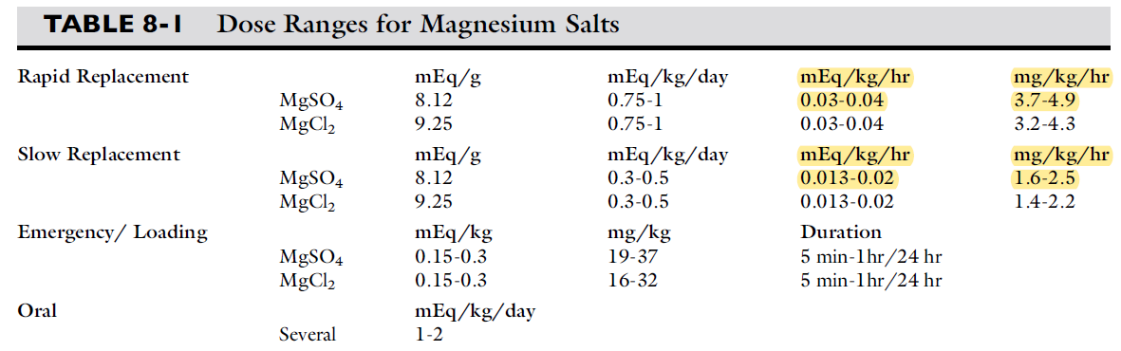

HYPERMAGNESEMIA
- much less clinically significant
- Causes:
  - Renal insufficiency
  - Iatrogenic overdose
  - methylprednisolone

