Neurolocalization, congenital & degenerative malformations (hydrocephalus, chiari-like malformation, A-A lux, Wobblers, Degenerative Myelopathy, Lumbosacral stenosis)

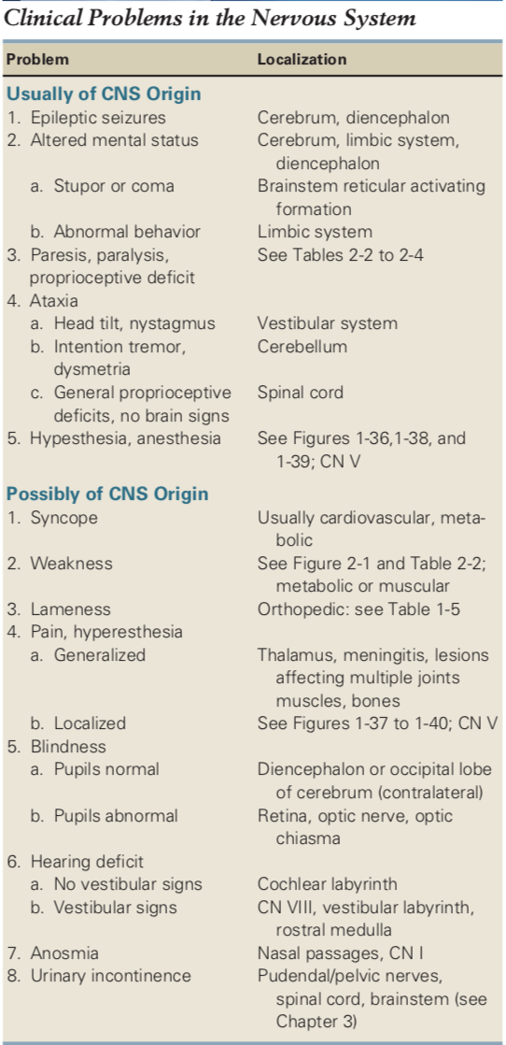

Neurolocalization
- Brain – divided between cerebrum, brain stem, and cerebellum
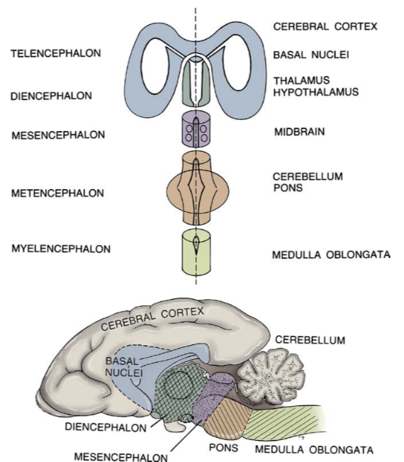
  - Cerebrum
    - Lobes:
      - Frontal lobe – motor area, origin of corticospinal and cortionuclear tracts
      - Parietal lobe – somatosensory area, receives afferent conscious proprioceptive and nociceptive information
      - Temporal lobe – receives input from auditory and vestibular system
      - Occipital lobe – termination of optic tract fibers for visual interpretation
      - Pyriform lobe – termination of olfactory tract axons for perception of smell
    - Descending tracts to limbs (corticospinal tracts) mainly 75% contralateral
    - Conscious proprioception (position sense), tactile sensation, and some nociception (face) are contralateral cerebral hemisphere
    - Clinical signs:
      - behavior change and/or loss of trained habits (urinating/defecating in house)
      - altered mental status (dull, obtunded, stupor, coma)
      - seizure
      - walking in wide circles (toward the lesion), head turn (toward the lesion)
      - head-pressing, staring off into space, getting stuck behind furniture or tight spaces
      - compulsive pacing or wandering aimlessly
      - Contralateral menace/vision deficits and postural reaction deficits
      - Contralateral deficits to facial sensation
      - Structural brain disease (tumors) may have neck pain, so does not mean multifocal or diffuse disease
      - Hemi-inattention or hemineglect syndrome: phenomenon in which patient with structural forebrain lesion ignores input from one-half of environment (contralateral to lesion)
  - Brain stem
    - Diencephalon (thalamus, hypothalamus)
      - Similar clinical signs as cerebral disease
        - Can circle to either side, or alternate
      - Other signs include evidence of endocrine dysfunction (PU/PD), abnormal eating pattern, problems with temperature regulation
      - Large lesions may produce stupor or coma, part of ascending reticular activating system (ARAS) which is responsible for maintain the awake state in animals
    - Clinical signs for brainstem dysfunction midbrain through medulla
      - Severe disturbance of consciousness (stupor/coma) due to impairment of ARAS
      - Gait abnormalities UMN paresis or plegia
        - Can be unilateral or bilateral depending on size of lesion
        - Usually in clinical setting, lesion large enough that signs are bilateral and severe (decerebrate rigidity in brainstem herniation)
    - Midbrain (mesencephalon)
      - Oculomotor nuclei (CN III) and trochlear nuclei (CN IV) located in midbrain.
    - Pons (ventral metencephalon)
      - Motor nucleus of trigeminal nerve (CN V)
      - Major respiratory centers in pons and medulla so abnormal respiratory activity may be apparent with damage to pons
    - Medulla oblongata (myelencephalon)
      - Nuclei of abducent nerve (CN VI), facial nerve (CN VII), glossopharyngeal nerve (IX), vagus nerve (X), accessory nerve (XI), and hypoglossal nerve (XII)
      - Vestibular nuclei (rostral, medial, caudal, lateral) also located in medulla
      - Lesions can cause alterations in consciousness, respiratory disturbance, autonomic dysfunction (heart rate and blood pressure), UMN paresis/plegia

  - Vestibular
- Responsible for maintaining normal body position and coordination
- Divided into two portions
  - Peripheral vestibular system (inner ears, vestibulocochlear nerve)
  - Central vestibular system (brainstem)
  - Vestibular structures in the cerebellum (fastigial nucleus, flocculus, nodulus) and caudal cerebellar peduncle - causes paradoxical central vestibular signs
- Clinical signs
  - Head tilt, circling, falling, rolling toward lesion
  - Nystagmus fast phase away from the lesion
  - May have horner’s syndrome with middle and inner ear lesions

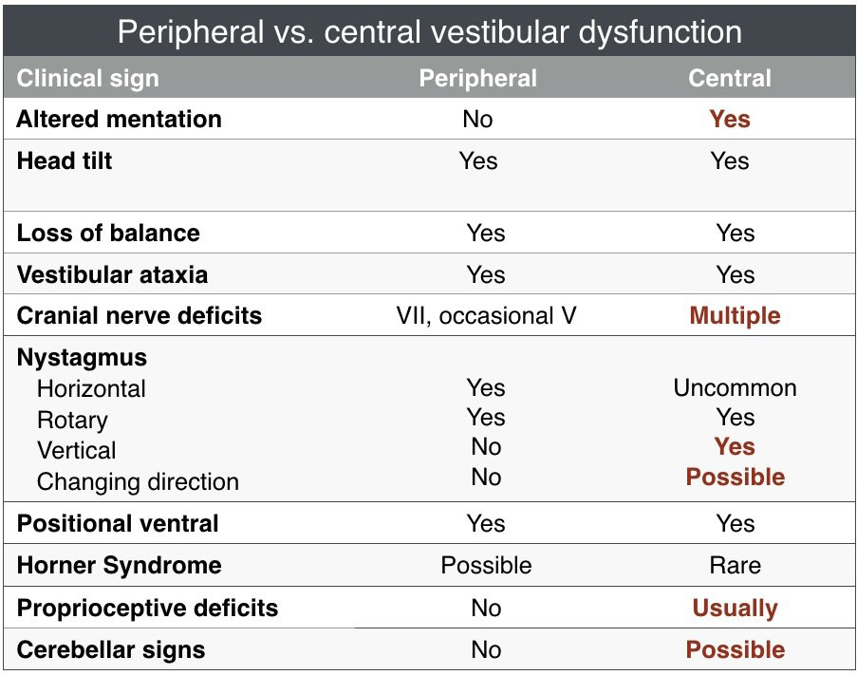

- Paradoxical central vestibular dysfunction
  - Cerebellum or caudal cerebellar peduncle lesion
  - Head signs suggest lesion on one side of the body while the postural reaction deficits indicate the other side
    - Always trust postural reaction deficits, they are always ipsilateral to the lesion in patients with vestibular dysfunction

  - Cerebellum (dorsal metencephalon)
    - Cerebellum coordinates and regulates rate and range of movement by acting as comparatory. It does NOT initiate movement
    - Clinical signs lead to
      - exaggerated movements (hypermetria)
      - truncal ataxia without paresis
      - intention tremors (initiated by voluntary movement) most notable in head region
        - Postural tremors or titubation consists of rocking movements (forward-backward and side-to-side)
      - Ipsilateral postural reaction deficits
      - Occasional ipsilateral absent menace response (with normal vision, palpebral, and no forebrain signs)
      - +/- anisocoria (pupil dilated contralateral to lesion)
      - +/- opisthotonus
    - Direct connection of cerebellum with vestibular system, so evidence of vestibular dysfunction may accompany cerebellar disease
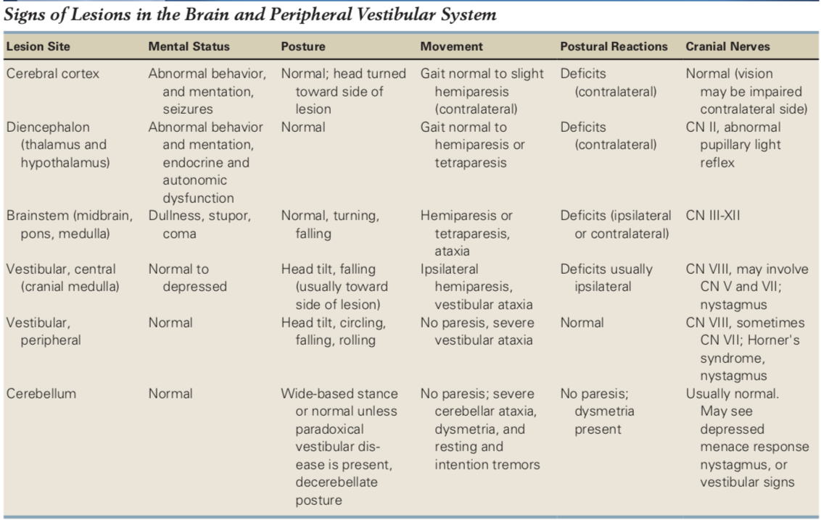

  - Cranial Nerves
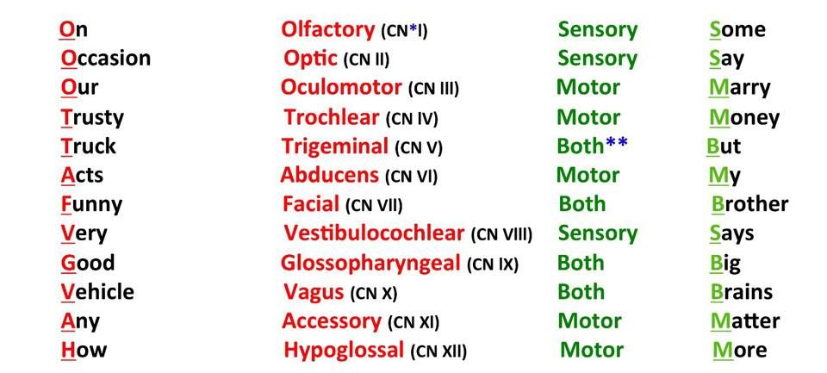
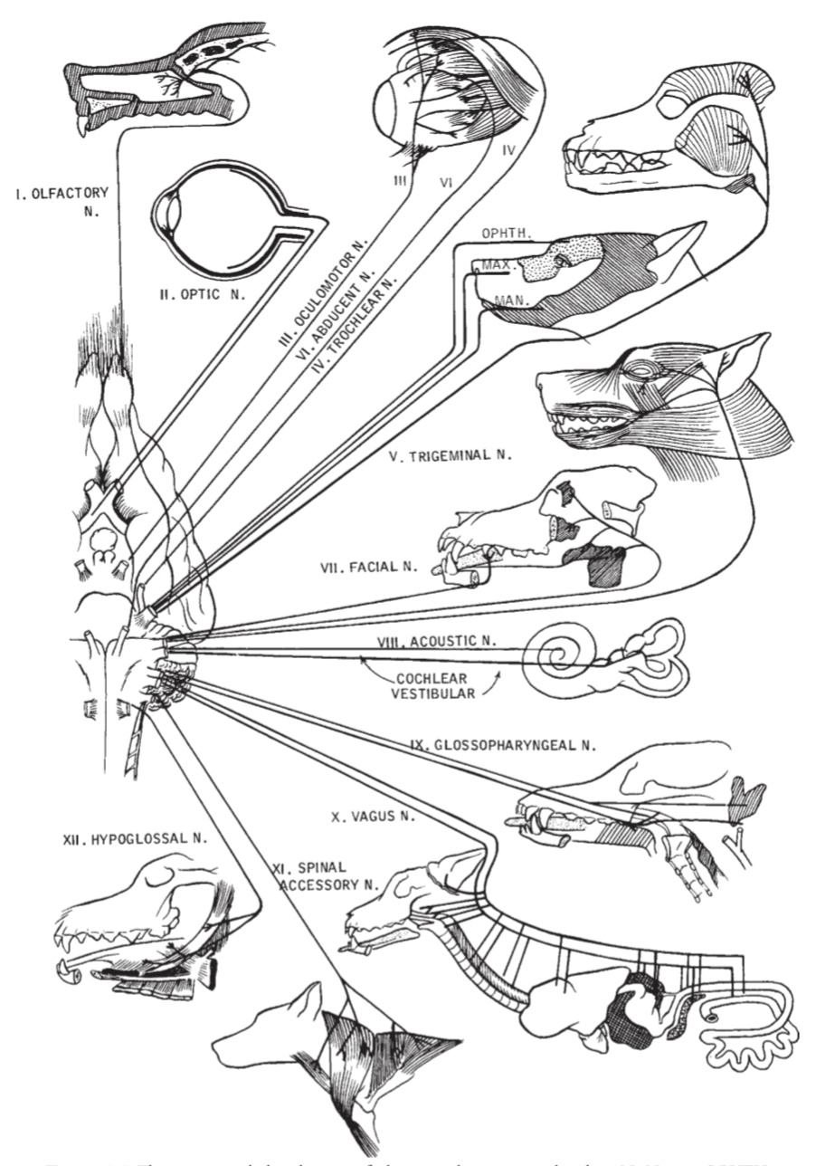

Cranial Nerve Evaluation
I | Smell
II | Menace
III | Pupillary size  PLR direct and consensual
III, IV, VI | Strabismus  Physiological nystagmus  Corneal reflex  Pupil size
V | Palpebral reflex  Corneal reflex  Jaw tone  Lip pinch  Masticatory muscle atrophy
VI | Strabismus  Physiological nystagmus  Corneal reflex
VII | Facial symmetry  Palpebral reflex
VIII | Auditory  Head tilt  Nystagmus
IX, X, XII | Tongue movement  Tongue atrophy
Menace Response:
- visual stimulus – CN II (optic) – contralateral thalamus – contralateral visual cortex of occipital lobe – contralateral motor cortex – contralateral pontine nucleus – ipsilateral cerebellum – facial nucleus – CN VIII (facial) – Blink
- http://vmerc.uga.edu/CranialNerves/mrp.html
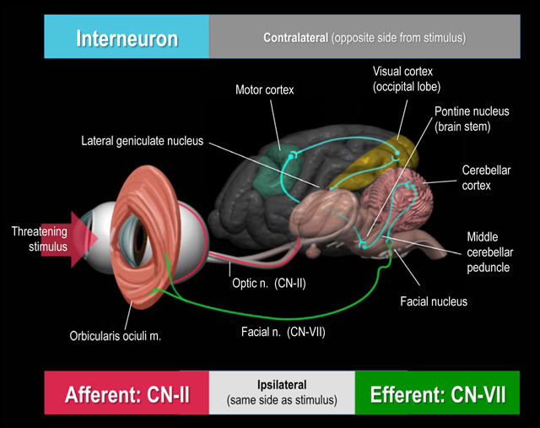

Pupillary Light Reflex:
- Direct: visual stimulus – CN II – contralateral optic tract – contralateral pretectal region – ipsilateral accessory oculomotor nucleus – ipsilateral CN III (oculomotor) – direct miosis
- Consensual: visual stimulus – CN II – ipsilateral optic tract – contralateral accessory oculomotor nucleus – contralateral CN III - consensual miosis
- Pupillary constriction is 50% less than stimulated eye
http://vmerc.uga.edu/CranialNerves/plrp.html

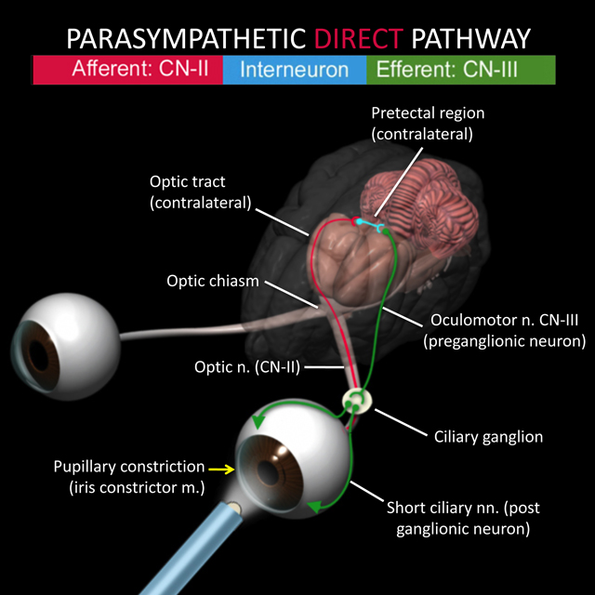
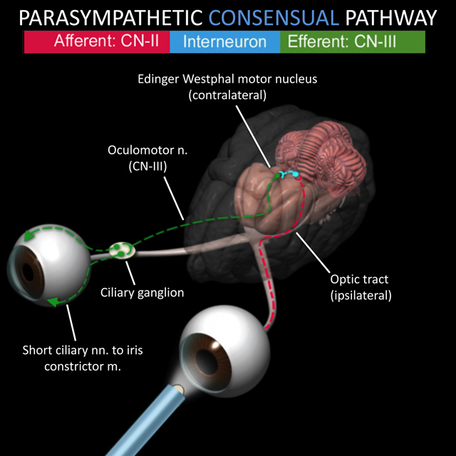

Horner’s syndrome:
- Sympathetic denervation to the eye, any lesion of sympathetic pathway can lead to ipsilateral horner’s
- Upper motor neuron: hypothalamus – brainstem – cervical spinal cord to T1-T3
- Preganglionic or Second order neuron: T1-T3 – ventral roots through cranial thorax (part of vagosympathetic trunk) - cranial cervical ganglion (ventromedial to tympanic bulla)
- Postganglionic or Third order neuron: Cranial cervical ganglion – near (dogs) or through (cats) tympanic bulla – into calvaria – eye
- Clinical signs: drooping of the upper eyelid on the affected side (ptosis), the pupil of the eye on the affected will be constricted (miosis), the eye on the affected side often appears sunken (enophthalmos), +/- elevated third eyelid

  - Upper motor neuron (UMN) vs lower motor neuron (LMN)
    - UMN are neurons of brain that control motor activity of body
      - initiates voluntary movement
      - maintains muscle tone for support against gravity
      - regulates posture
    - stimulate or inhibit neurons that directly innervate muscles (LMN)
    - divided between pyramidal (located in motor area of cerebral cortex) and extrapyramidal (located in brain stem nuclei)
      - extrapyramidal predominant UMN system in dogs and cats
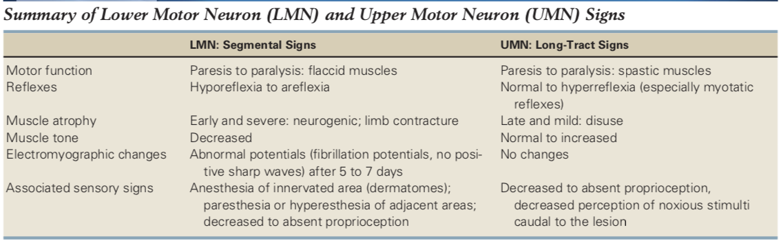

  - Spinal cord
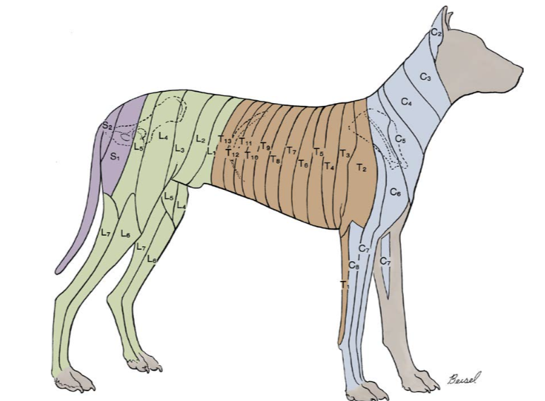

    - C1-C5
      - UMN of all 4 limbs
      - Clinical signs:
        - Weakness, paralysis, and/or ataxia in all 4 limbs, ipsilateral hemi limbs, or only 1 thoracic limb
        - UMN signs in all 4 limbs
          - Normal to exaggerated spinal nerve reflexes
          - Normal withdrawl reflex all 4 limbs
          - Normal to increased muscle tone in affected limbs
        - Cervical vertebral discomfort, muscle spasms, rigidity
        - +/- UMN bladder
        - +/- respiratory difficulty (UMN dysfunction to phrenic and intercostal nerves)
        - +/- horner syndrome (1st order sympathetic neuron)
    - C6-T2
      - Causes signs of LMN dysfunction in the thoracic limbs and UMN in the pelvic limbs
      - May have normal thoracic limbs and abnormal pelvic limbs, especially with compressive spinal cord lesions
        - Pelvic limb spinal tracts are more peripheral than the centrally located LMN cell bodies in the ventral horn of the grey matter
        - Mild to moderate external compression of the spinal cord will compress the pelvic limb tracts first causing UMN signs to the pelvic limbs, while still having normal thoracic limbs
        - As compression worsens, the thoracic limb LMNs are affected leading to LMN signs in the thoracic limbs as well.
        - Cervical discomfort/rigidity can help distinguish C6-T2 signs from a T3-L3 lesion
      - Clinical signs:
        - Weakness, paralysis or ataxia in all 4 limbs, ipsilateral limbs, or only one thoracic limb
        - Decreased withdrawal reflexes in thoracic limbs
        - Normal to exaggerated withdrawal reflexes in pelvic limbs
        - Postural reaction deficits in thoracic and pelvic limbs
        - Early denervation atrophy of thoracic limb(s), late onset disuse muscle atrophy in pelvic limbs
        - +/- Cervical pain, muscle spasms, rigidity
        - +/- Root signature
        - +/- Decreased or absent cutaneous trunci
        - +/- UMN bladder
        - +/- Respiratory difficulty (LMN dysfunction to phrenic and UMN to intercostal nerves)
        - +/- Horner Syndrome (1st order sympathetic neurons)
    - T3-L3
      - UMN pelvic limbs, normal thoracic limbs
      - Clinical signs
        - Spastic weakness, paralysis and ataxia in pelvic limbs
        - Normal to exaggerated spinal nerve reflexes in pelvic limbs
        - Normal withdrawal reflexes in the pelvic limbs
        - Postural reaction deficits in pelvic limbs
        - Late onset disuse muscle atrophy
        - +/- Decreased or absent cutaneous trunci reflex (usually 1-2 vertebrae cranial to cutoff)
        - +/- Paravertebral pain at site of lesion
        - +/- UMN bladder
        - +/- Schiff-Sherrington posture
          - Will have normal postural reactions in the thoracic limbs, while a patient with a C1-C5 lesion will have delayed or absent postural reactions
    - L4-S2
      - LMN pelvic limbs, normal thoracic limbs
        - Flaccid weakness/paralysis and ataxia in pelvic limbs
        - Decreased to absent spinal nerve & withdrawal reflexes in pelvic limbs
        - Postural reaction deficits in pelvic limbs
        - Decreased to absent muscle tone in affected limb(s) or tail
        - Early denervation muscle atrophy
        - +/- Decreased or absent cutaneous trunci reflex
        - +/- Paravertebral pain at site of lesion
        - +/- Root signature
        - +/- LMN bladder
        - +/- Decreased/absent anal tone or dilated anus
        - +/- Urinary or fecal incontinence

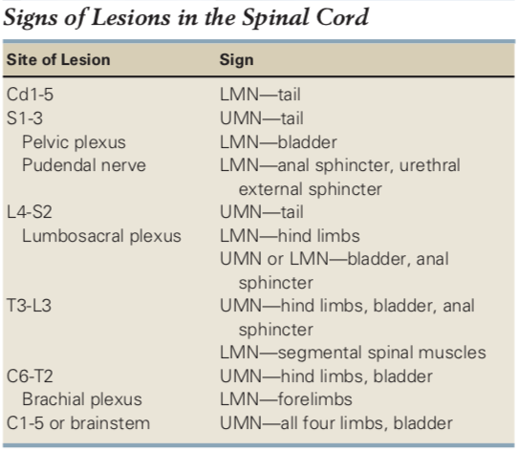
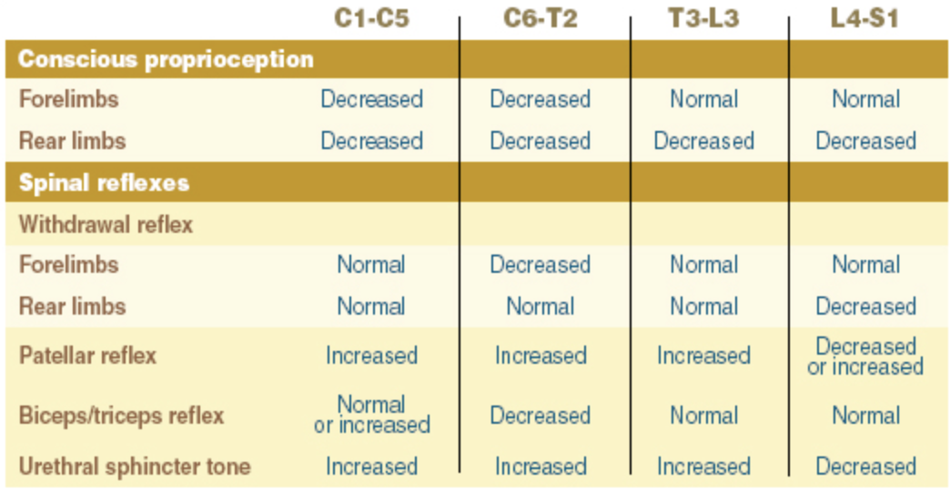
Paresis of one limb and lesion localization
- Monoparesis or monoplegia denotes partial or complete loss of voluntary motor function in one limb due to neurologic lesion
- Peripheral nerve and nerve root compression often initially cause lameness and pain (termed nerve root signature)
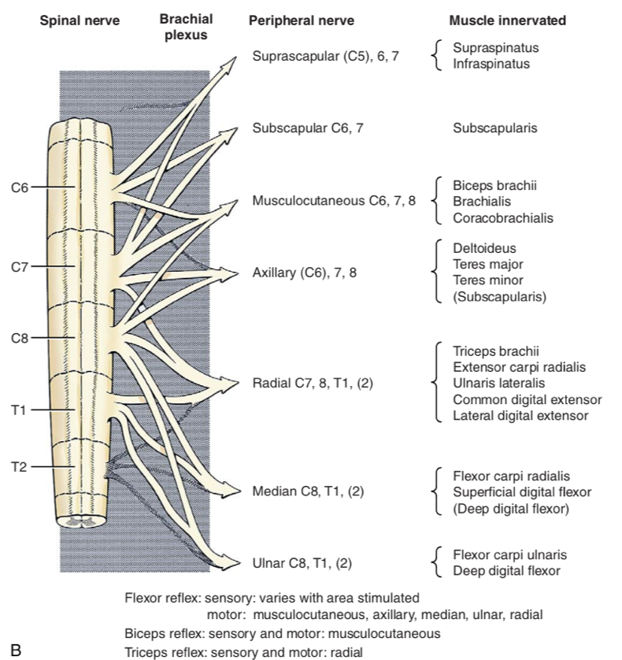

Radial nerve injury: Spinal cord segments C7,C8, T1, (T2)
- Motor function: extension of elbow, carpus, and digits
- Sensory function: cutaneous sensory of dorsal surface of foot and dorsolateral part of antebrachium
- Dysfunction: loss of weight bearing, knuckling of foot, decreased extersor carpi radialis and triceps reflexes, loss of sensation of dorsal surface distal to elbow
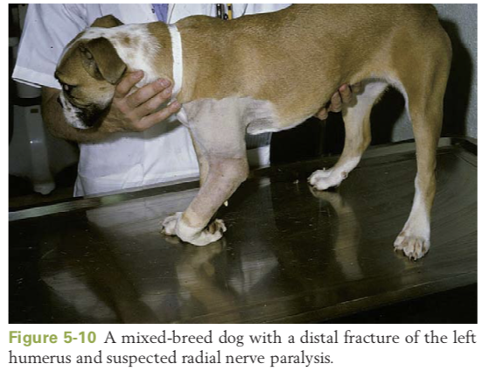
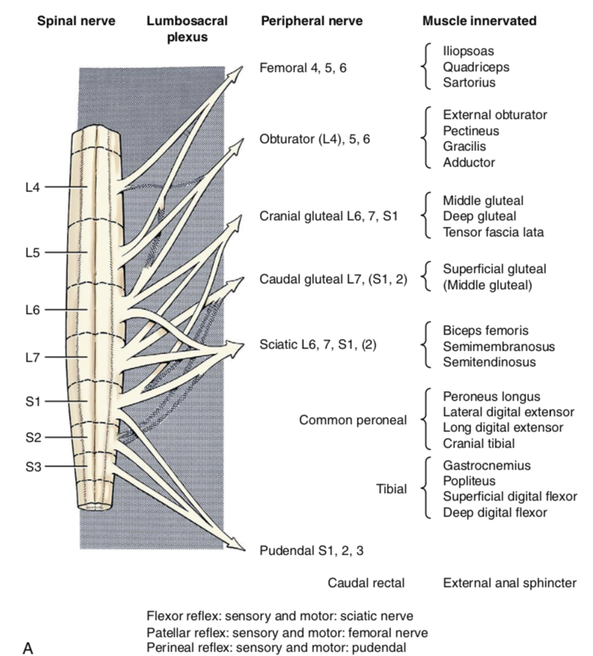

Femoral nerve injury: Spinal segments L4, L5, L6
- Motor function: extension of stifle, flexion of hip
- Sensory function: saphenous branch supplies medial surface of limb and medial digit
- Dysfunction: severe gait dysfunction, no weight bearing, decreased or absent patellar reflex, loss of sensation in medial limb and medial digit

Sciatic nerve injury: Spinal segments L6, L7, S1, (S2)
- Motor function: extension of hip, extension and flexion of stifle (tibial and peroneal branches)
- Sensory Function: caudal and lateral surface of limb distal to stifle
- Dysfunction: Severe gait dysfunction, paw knuckled but weight bearing occurs, hip cannot be extended, hock cannot be flexed or extended, loss of sensation distal to stifle, absent flexor reflex
Hydrocephalus
Pathophysiology:
- Hydrocephalus is the presence of excessive CSF within the brain or cranial cavity.
- CSF flows from the lateral ventricles through interventricular foramina to third ventricle. Then caudally through the mesencephalic aqueduct to the fourth ventricle and into the subarachnoid space through the lateral apertures of the fourth ventricle.
- Most of the absorption occurs through the arachnoid villi in the dorsal sagittal sinus. Absorption also can occur via venous and lymphatic drainage around spinal and cranial nerves.
- Most of the CSF is produced by the choroid plexus in the lateral, third, and fourth ventricles
- Production of CSF is independent of hydrostatic pressure within the ventricles. Instead, dependent on osmotic pressure (used in the treatment of hydrocephalus)
- Most cases of hydrocephalus in veterinary practice are congenital. Usually recognized in the very young animal. The increase in intracranial volume occurs before the sutures of the calvaria have closed, allowing for enlargement of the cranial cavity. In most animal species, the enlargement of the head, the open sutures and persistent fontanelles, and the poor development of the animal may be recognized shortly after birth.
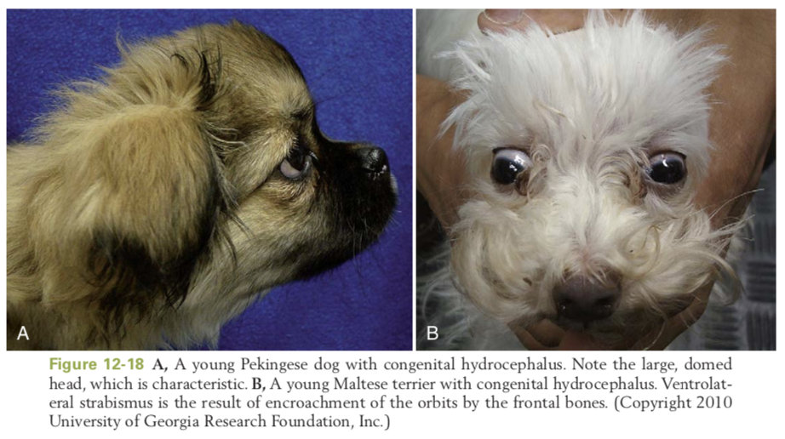
Clinical Signs.
- Affected dogs are usually diagnosed between 2 and 3 months of age, sometimes when they are older.
- Palpation of the skull may reveal the persistent sutures and fontanelles. The prominent frontal areas encroach on the orbits, causing ventrolateral deviation of the eyes
- Puppies and kittens with hydrocephalus usually are smaller and less developed than their littermates, often dull, have episodic behavioral changes such as aggression or confusion, and frequently have seizures.
- Because their mental development is poor, they do not learn as readily as their littermates.
- Visual deficits with normal PLRs are common because of damage to the optic radiation and the occipital cortex.
- Motor function may range from an almost normal gait to severe tetraparesis.
- Occasionally, asymmetric signs may occur.
- Hydrocephalus can lead to abnormal hypothalamic function. Hypodipsic hypernatremia, as a result of pressure atrophy of hypothalamic osmoreceptors, has been observed.
- In animals having reached skeletal maturity, diagnosis via clinical signs harder since the size of the cranial cavity remains normal because the sutures have fused before the increase in ICP. With increase in ICP, the clinical signs develop more rapidly and are more severe. Seizures are a frequent sign in the early stages. Dullness, which may progress to stupor or coma, is common. Because hydrocephalus in the adult is usually secondary to inflammation or a mass, signs of the primary problem may predominate early in the course of the disease. Complete obstruction of the CSF causes a rapidly progressive hydrocephalus, which may cause cerebellar herniation.
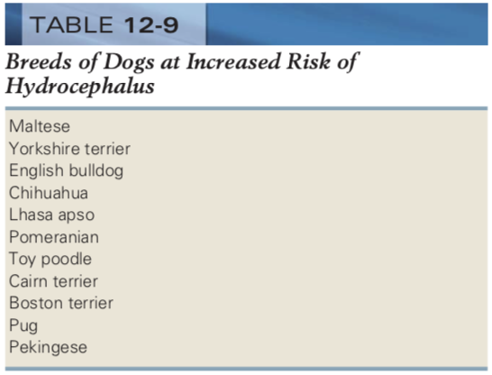
Assessment.
- The presumptive diagnosis of hydrocephalus in the young animal is relatively straightforward if the characteristic signs are present. Behavioral changes or seizures may be the only complaint.
- The definitive diagnosis can be confirmed with imaging procedures.
  - MRI imaging modality of choice, identifies ventricular or subarachnoid dilation and identifies if there is underlying etiology (e.g., mass obstructing CSF flow) or existence of concurrent disease (e.g., meningoencephalitis).
    - In congenital hydrocephalus, MRI discloses enlarged ventricles containing fluid with MRI characteristics consistent with CSF (Figure 12-19). Ventriculomegaly is often confined to the lateral ventricles and may be asymmetric. Secondary parenchymal changes may be observed. Frequently, the periventricular white matter is hyperintense compared with normal white matter on T2W images. Changes in periventricular white matter are more conspicuous on T2W fluid attenuated inversion recovery sequences and likely represent interstitial edema.
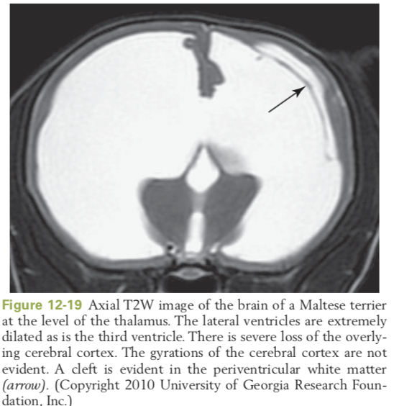
  - CT may also be used in the diagnosis of hydrocephalus, although less sensitive in discrimination of soft tissues
  - Ultrasound in young animals or those with persistent fontanelles
    - US using a persistent fontanelle as an acoustic window can be used in the diagnosis of hydrocephalus.
    - The main benefit of US is no need for sedation or general anesthesia
    - US lacks the sensitivity in discriminating a primary or concurrent disease process, so MRI or CT needs to be performed in affected animals before pursuing therapeutic interventions, especially surgical treatments.
  - Radiography of the head can confirm persistent suture lines and fontanelles. In congenital hydrocephalus, thinning of the calvaria with loss of the normal digitate impressions of the cerebral gyri on the inner surface of the calvaria is absent. The cranial cavity may have a ground-glasslike appearance.
- Analysis of the CSF may be useful for identifying an etiologic diagnosis. Caution should be exercised before performing a CSF collection in animals with suspected increased ICP. Therapeutic measures directed at lowering intracranial pressure should be performed before pursuing a spinal tap. In rare instances, CSF can be obtained by a ventricular tap under general anesthesia.
Treatment. Treatment involves medical, surgical, or combined therapies. Affected animals usually are in one of the following three categories: (1) mild to severe static signs, (2) acute with rapidly progressive signs, and (3) chronic progressive deterioration.
Animals with mild signs that are static may not require treatment. Animals with severe static or acute progressive signs indicate a poor prognosis and the need for intensive treatment aimed at reducing CSF production and vasogenic or interstitial edema. Animals with severe static signs are unlikely to improve.
Medical treatment:
- Hyperosmolar fluids (mannitol or HTS) can be given to reduce CSF production and vasogenic edema in severely affected animals. Hyperosmolar fluids can be repeated as needed every 4 to 6 hours based on clinical signs.
- Furosemide (0.7 mg/kg intravenously given 15 minutes after completion of the mannitol infusion) may be administered to prolong the effect of mannitol.
  - Before administration of hyperosmolar fluids or furosemide, assessment of hydration is necessary. Should not be used in dehydrated animals.
- Corticosteroids also may be administered at an anti-inflammatory dosage (prednisone 0.5 to 1.0 mg/kg)
- Anticonvulsant drugs (i.e., phenobarbital) for seizures if needed
- Acetazolamide, a carbonic anhydrase inhibitor, reduces CSF production. The dosage is 10 mg/kg orally every 6 to 8 hours. Acetazolamide should be used short term. Electrolyte and acid-base status should be monitored. Acetazolamide alone or in combination with corticosteroids or other diuretics can cause metabolic acidosis and hypokalemia.
- Omeprazole as a proton pump inhibitor can be used alone or in combination with other medications to reduce CSF production.
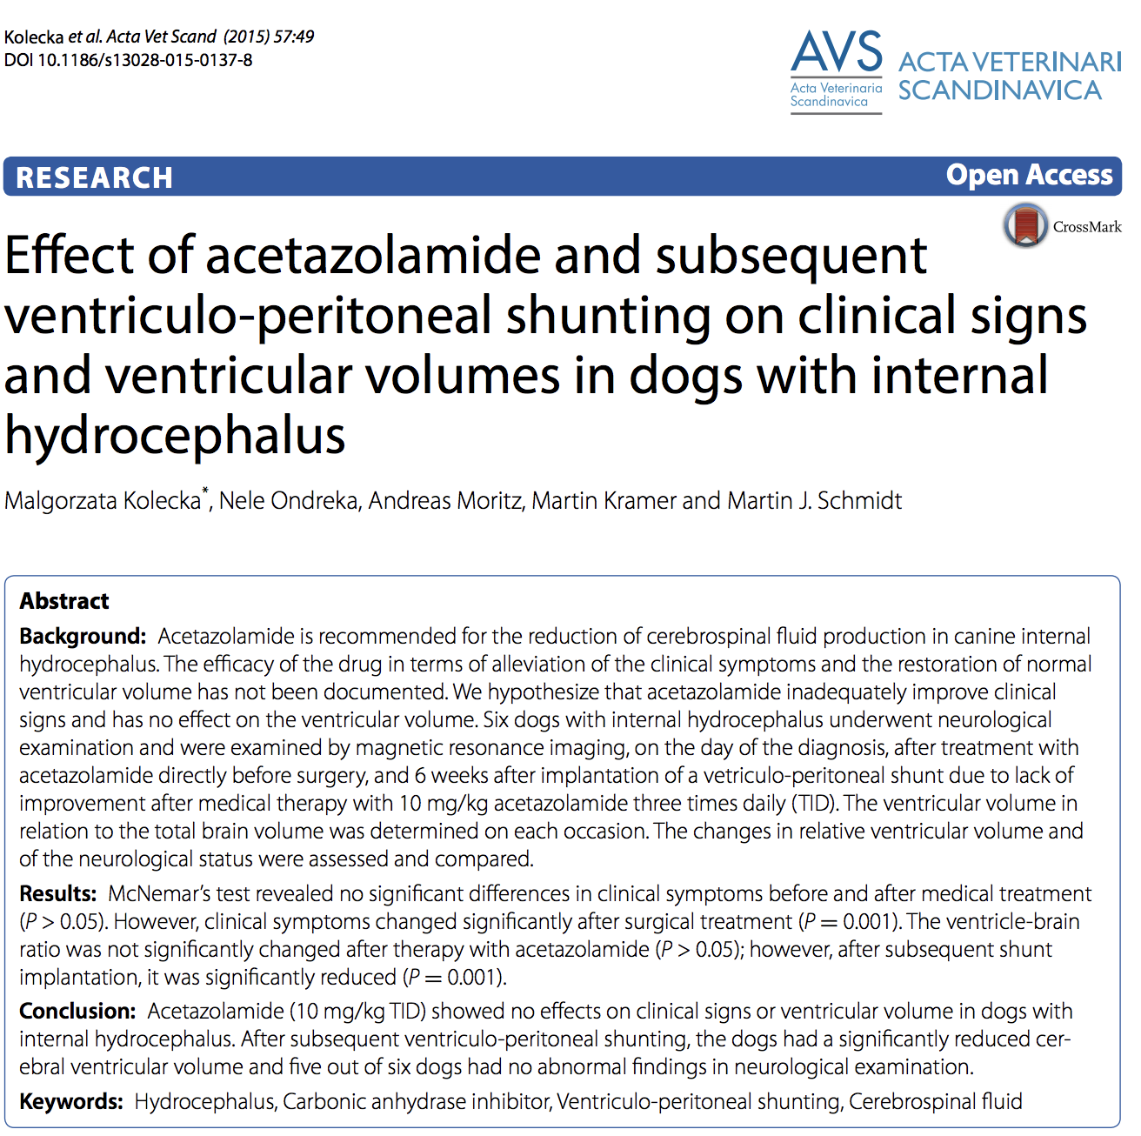
Surgical treatment
- Reserved for animals that require medical therapy to maintain clinical remission yet experience side effects that achieve only partial remission with medical therapy, or that cannot be stabilized medically.
- Entails placement of a CSF drainage device (shunt) that diverts CSF from the lateral ventricle through a one-way pressure valve and reservoir to the peritoneal cavity.
- The major disadvantages of surgery are the expense and the postoperative complications.
- The complications include the need to replace the tubing as the animal grows, and occlusion of the tubes by fibrous tissue, choroid epithelium, or ependyma, and infection.
- The shunts can be very effective for long-term control of clinical signs.

Chiari-like malformation (caudal occipital malformation syndrome) and syringomyelia
Pathogenesis:
- Syringomyelia is a condition characterized by gradual formation of a fluid-filled cavity (syrinx) within the spinal cord.
- In humans, syringomyelia may be caused by several conditions, including abnormalities of the posterior fossa (Chiari malformation).
- In dogs, the observation of similar but not the same exact abnormalities has led to the term Chiari-like malformation (CM). Another term used is caudal occipital malformation syndrome (COMS).
  - Chiari-like malformation is a hereditary condition, first described in the Cavalier King Charles spaniel (CKCS), that can lead to syringohydromyelia.
    - Also named occipital dysplasia and caudal occipital malformation.
      - Occipital dysplasia is a malformation of the occipital bone consisting of a variation in the dorsal extent of the foramen magnum in normal dogs or associated with cranial cervical spinal cord anomaly
    - The anomaly of CM consists of an abnormally small caudal fossa, with secondary herniation of the cerebellar vermis through the foramen magnum and subsequent formation of syringohydromyelia.
- Breed predilection in CKCSs and Brussel Griffon, but other toy and small-breed dogs can be affected.
- In a normal state, pulsatile flow of CSF occurs across the foramen magnum from the intracranial subarachnoid space to the cervical spinal subarachnoid space during systole and reverses flow direction during diastole.
- The pathophysiology of CM may be related to the overcrowding of the caudal fossa obstructing the normal flow of CSF across the foramen magnum, resulting in abnormal pressure dynamics and hydrocephalus. With each arterial pulse, the brain moves back and forth, and the herniated cerebellum is forced caudally. The CSF pressure increases, and CSF is redirected into the perivascular channels along the spinal cord, causing progressive fluid accumulation and syrinx formation.
Clinical Signs
- Clinical signs may involve the forebrain, caudal brainstem, and cervical spinal cord
- Most common is severe cervical spinal pain. May have excessive scratching of the ear, neck, or shoulder, vocalization, and facial rubbing
  - Signs are a reflection of paresthesia or neuropathic pain. The enlarged syrinx is most likely associated with development of the neuropathic pain, owing to damage in the dorsal horn of the gray matter and alterations in neural processing of sensory information
- Signs of C1-C5 lesion (proprioceptive ataxia/UMN paresis) or C6-T2 lesion (LMN paresis of the thoracic limbs and proprioceptive ataxia/UMN paresis of the pelvic limbs)
- Central vestibular and cerebellovestibular may occur with cerebellar and brainstem involvement
- Seizures and other encephalopathic signs due to secondary obstructive hydrocephalus.
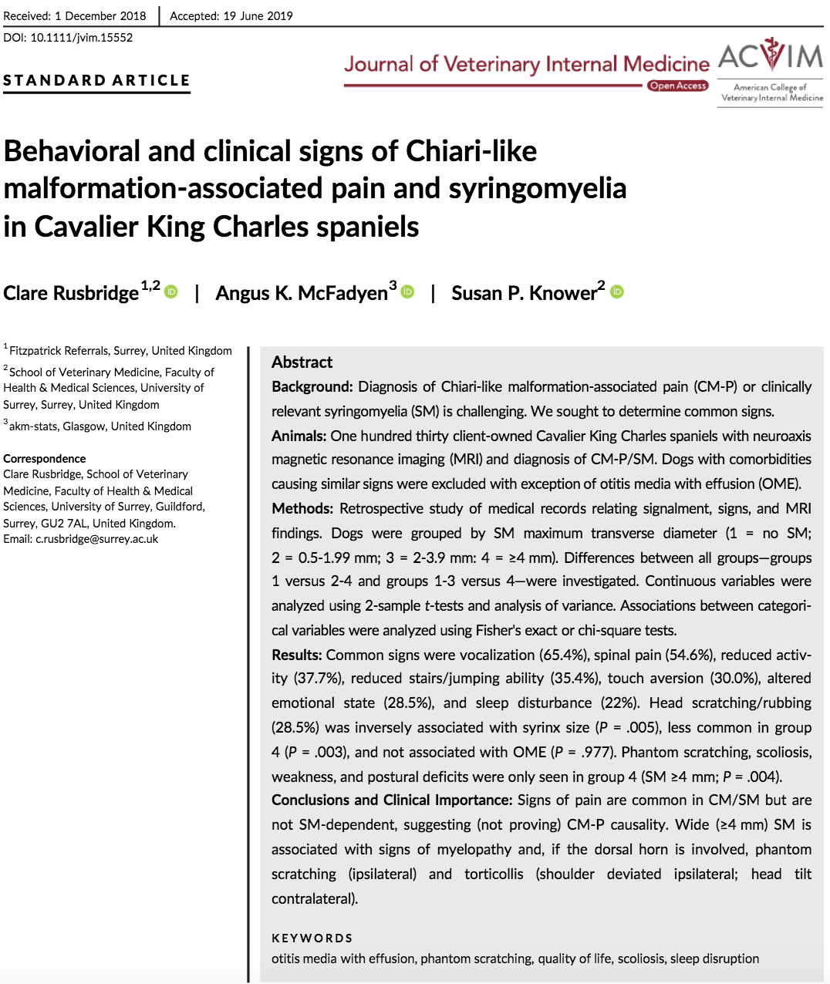
Diagnosis
- Diagnosed by MRI
  - The most useful view is a mid-sagittal image of the caudal aspect of the brain that includes the cervical spinal cord.
  - Typically see attenuation of the dorsal subarachnoid space at the cervicomedullary junction, rostral displacement of the caudal cerebellum by the occipital bone, varying degrees of syringohydromyelia in the cervical spinal cord, obstructive hydrocephalus, and herniation of the caudal cerebellar vermis.
  - Occasionally, a “kinked” appearance of the caudal medulla oblongata
- Ultrasonography of the craniocervical junction can sometimes see cerebellar herniation and syringomyelia but lacks sensitivity.
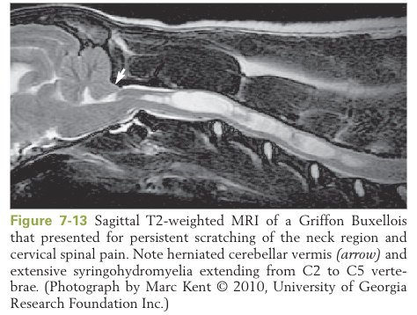
Treatment
- Medical management centered around pain control and decreasing CSF production
  - Pain management: Combination analgesics. Recent studies on gabapentin and pregabalin used to treat neuropathic pain.
  - Decrease CSF production: Acetazolamide and furosemide used to decrease CSF production. Corticosteroids provide antiinflammatory effects and also decrease CSF production.
  - Although medical management may improve clinical signs, it does not prevent further disease progression.
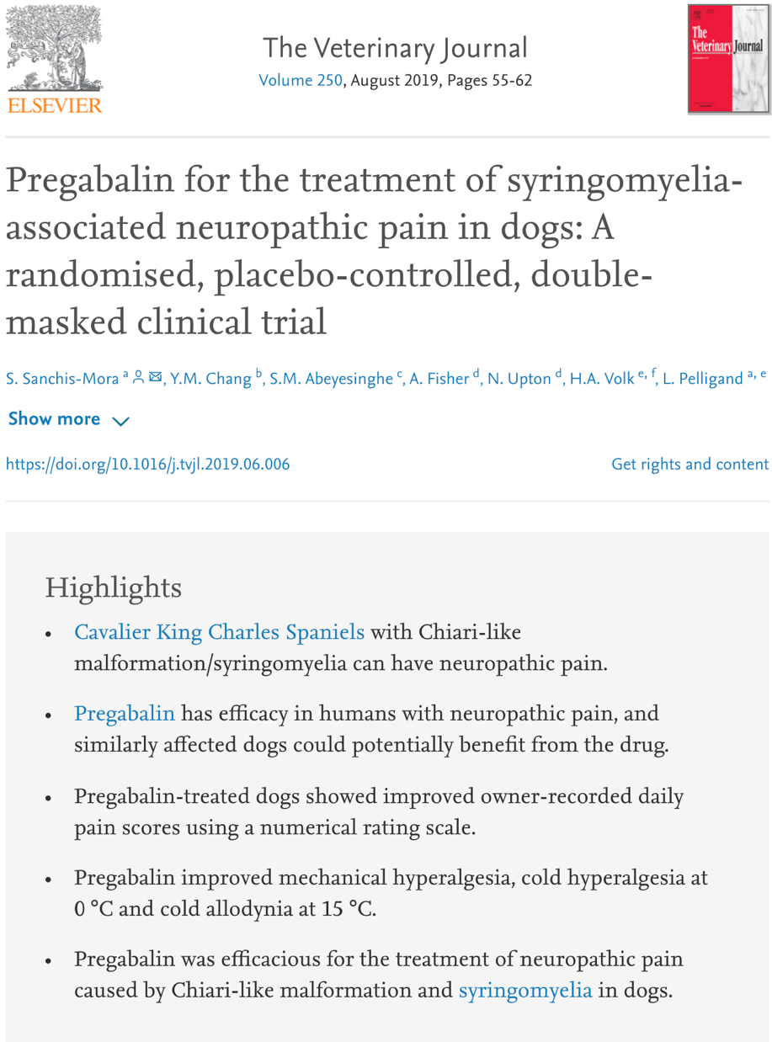
- Surgical management
  - Indicated when analgesics are unable to control the discomfort or when neurologic deficits are present and are unacceptable or progressive
  - Surgery consists of:
    - Decompressing the cerebellum by a suboccipital craniectomy, which enlarges the foramen magnum
    - Dorsal laminectomy of the first or second cervical vertebra
    - Durotomy at the level of the decompression sites and resecting any dural bands that constrict the neural tissue.
  - Decompressive surgery can relieve the pain but may not result in resolution of the syringohydromyelia
  - Even with surgery, the clinical signs may not completely resolve, and recurrence is possible.
    - A recurrence of clinical signs of up to 47% can occur within months to years after surgery
Wobblers (cervical spondylomyelopathy)
Pathophysiology
- Breeds commonly affected include Great Danes, Doberman pinschers, Bernese mountain dogs and other larger breed dogs.
- Neurologic signs develop because of progressive spinal cord compression from surrounding vertebral bony and soft-tissue structures
- Abnormalities of the midcervical to the caudal cervical vertebrae or their articulations (or both) lead to stenosis of vertebral canal
- In dogs, has variable forms which differ between the Doberman pinscher and the giant breeds.
  - Dobermans
    - between 4 and 8 years of age
    - Common pathologic features include hypertrophy of the interarcuate and dorsal longitudinal ligaments and Hansen type II disk protrusion involving the caudal cervical vertebrae
    - Since Hansen type II IVDD is common, the term disk-associated wobbler syndrome (DAWS).
  - Great Danes and other giant breeds
    - typically clinical signs at 2 years of age
    - The pathology includes dorsal and dorsolateral compression secondary to osteoarthrosis of the articular processes and hypertrophy of the joint capsules and interarcuate ligament
    - Any site can be affected, but the C5-6 and C6-7 sites are most common
    - Osteoarthrosis has been considered a form of osteochondrosis dissecans.
Clinical Signs
- Although the cervical spinal cord is compressed, clinical signs usually more severe in pelvic limbs.
- Typically mild pelvic limb proprioceptive ataxia that progresses to tetraparesis
  - Due to compression of ascending proprioceptive pathways.
- With increasing compression, involvement of descending motor pathways causes UMN paresis or paralysis
- May see ataxia and paresis in the thoracic limbs
  - Forcing the dog to wheelbarrow with its head extended so that it cannot see the floor accentuates proprioceptive deficits in the thoracic limbs.
- Cervical spinal pain is usually absent unless the disorder is associated with cervical IVD protrusion.
  - Extension of the neck may cause pain
  - In some animals, trauma may precede the development of acute signs

Diagnosis.
- The diagnosis using various radiographic and cross-sectional imaging using CT and MRI
- X-rays:
  - Changes in shape and/or opacity of the intervertebral disk and/or disk space (more common in the older Doberman pinscher)
  - Changes in shape and/or opacity of the articular facets to sclerosis and exostosis
  - Vertebral displacement (subluxation) (not usually definitive since there is a lot of normal variability)
  - Stenosis of the vertebral canal
  - Malformed or misshapen vertebral bodies (often involving C6 vertebra)
  - Misshapen spinous processes
- Myelography:
  - Identify minor changes in vertebral column architecture, compression by soft tissues (ligamentous structures and disk protrusions), and see whether the lesion is associated with compression of one or multiple sites
  - Myelograms should be made with the neck extended to reveal dynamic soft-tissue or bony compression that may be missed if the neck is imaged only in normal (neutral) position.
  - Dynamic (flexion, extension, and traction) views on myelography or cross-sectional imaging should be performed with caution.
  - Dynamic imaging is mandatory in older Doberman pinschers to exclude disk disease as the primary cause of the neurologic signs.
  - Myelography combined with CT or MRI provide additional information, particularly on the degree of spinal cord atrophy
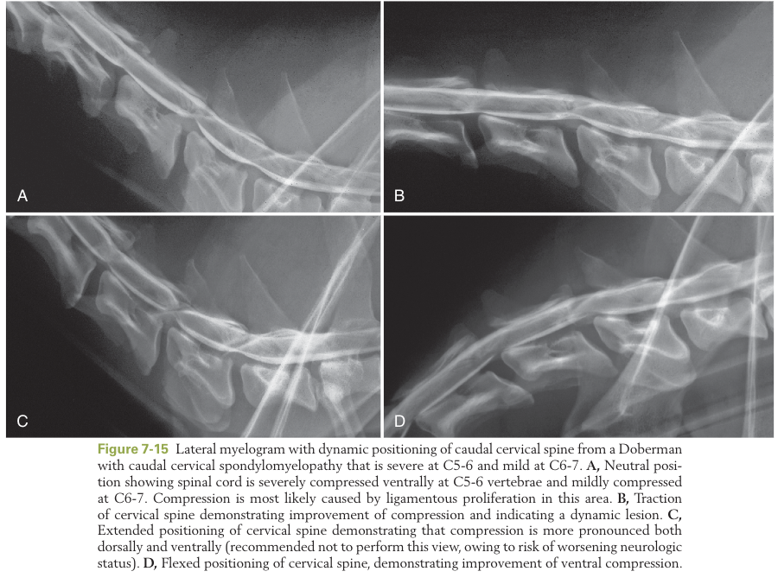
- MRI
  - definitive information for soft-tissue structures causing spinal cord compression, as well as showing evidence of spinal cord pathology
  - Spinal cord hyperintensity on T2-weighted images may suggest gliosis, edema, or syrinx formation
  - The finding of extensive hyperintensity in the grey matter of the spinal cord at the site of compression a poorer prognosis for return of function following surgery
  - Intervertebral disk degeneration associated with CSM and other intervertebral disks causing compressive myelopathy also can be visualized more accurately on MRI

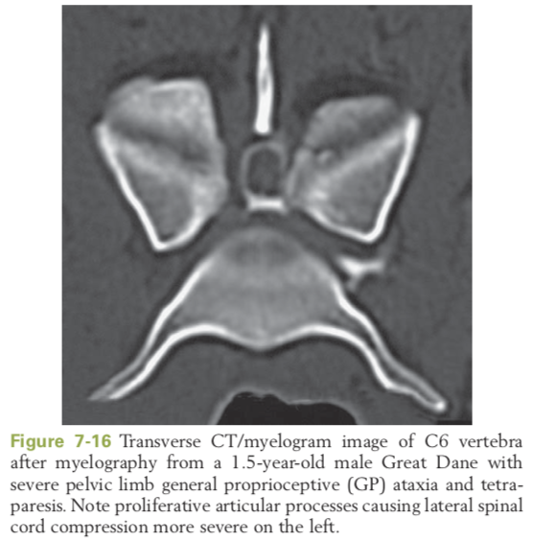
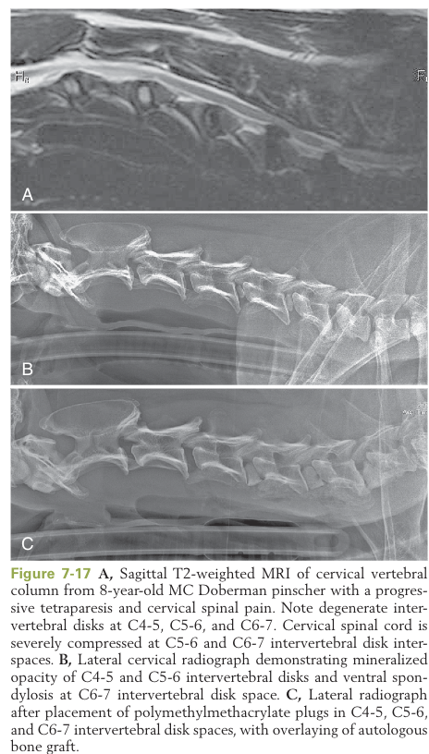

Therapy
- Conservative therapy includes management of pain and strict exercise restriction similar to that involving conservative management of IVD herniation
  - Variable response
  - Can consider short-term corticosteroid for analgesic and anti-inflammatory effects
- A study evaluating treatment of CSM in Dobermans and other breeds found no difference in outcome or survival time between dogs treated conservatively or surgically
- Goals of surgery are to stabilize the vertebrae and decompress the spinal cord.
  - Ventral or dorsal decompression may be indicated, depending on the sites of compression.
  - Distraction- fusion procedures are used in dogs in which the spinal cord compression observed with imaging is relieved by traction of the cervical vertebral column
    - Interbody screws, bone grafts, metallic spacers, polymethylmethacrylate, or implants anchored by polymethylmethacrylate
    - Newer techniques involve locking-plate fixation and inter- body bone grafting
  - Surgical treatment of dogs with multiple lesions is particularly problematic with high morbidity immediately post op if dorsal laminectomy extending over the entire area of involvement is performed
  - Surgical complications include implant failure and collapse of the intervertebral disk space, penetration of implants into the vertebral canal, failure of fusion and worsening of neurologic deficits.
    - distraction techniques can put further stress on adjacent IVD spaces, risking a domino effect whereby the adjacent IVD space becomes affected as a consequence of the abnormal forces applied to it as a result of stabilization.
  - Success rates for various surgical procedures in dogs with dynamic CSM have ranged from 70% to 80% to having a 33% success rate.
- In general, the prognosis for full recovery is poor in tetraplegic dogs and guarded in others.
  - Factors that contribute to poor recovery include:
    - irreparable spinal cord damage
    - failure to provide adequate decompression or stabilization
    - development of compression at sites adjacent to the initial lesions
    - postsurgical complications caused by difficulty in rehabilitating large, recumbent dogs.

Atlantoaxial (AA) luxation
Pathophysiology:
- frequently affects young, small/ toy breed dogs
- AA luxation results from congenital malformation or trauma to the associated bones, joint, and/or supporting ligamentous structures involved in the articulation of the atlas (C1) and axis (C2).
- Seven ossification centers exist during development of the axis and three for the atlas, all centers fuse by approximately 4 months of age
- The normal atlantoaxial articulation allows rotational and lateral movement. The dens projects from the body of the axis and is bound to the ventral arch of the atlas by a strong transverse ligament
  - This attachment prevents flexion between the atlas and the axis
- Hypoplasia or aplasia of the dens causes failure of proper ligamentous development and support
  - Dorsal angulation of the dens is common in affected dogs. Joint instability allows the axis to rotate caudodorsally.
  - The spinal cord is then compressed between the axis and the dorsal arch of the atlas
    - Cervical flexion accentuates the degree of spinal cord compression.
- Luxations caused by a fracture or congenital malformation of the dens tend to produce less severe neurologic signs, because less compression of the spinal cord occurs
- Fractures of the body of the axis produce neurologic signs similar to those of acute traumatic luxation in other regions of the cervical vertebral column.
Clinical Signs:
- The onset of clinical signs can be acute or chronic with a gradual progressive disease course.
  - may be associated with episodic bouts of cervical spinal pain or be static for years, with an acute exacerbation.
- Often the onset of clinical signs coincides with minor trauma such as jumping from furniture (recent case series 5/8 had trauma from another animal (attack or jumped on)
- Consistent with C1-C5 lesion, usually range from cervical spinal pain to severe motor dysfunction with proprioceptive ataxia/UMN tetraparesis or paralysis.
- Rarely, tetraplegia and respiratory compromise/failure may occur.
  - Severe cervical spinal cord injury may disrupt descending reticulospinal pathways for control of respiration, thus necessitating perioperative ventilatory support.
- Because flexing the neck causes severe pain and accentuates motor dysfunction, it should be avoided or done with extreme caution. Extension of the neck must be maintained and flexion of the neck avoided.
  - Very important if the dog is to be sedated or undergo anesthesia, where muscle relaxation may further accentuate instability and lead to greater compression and worsening of clinical signs.
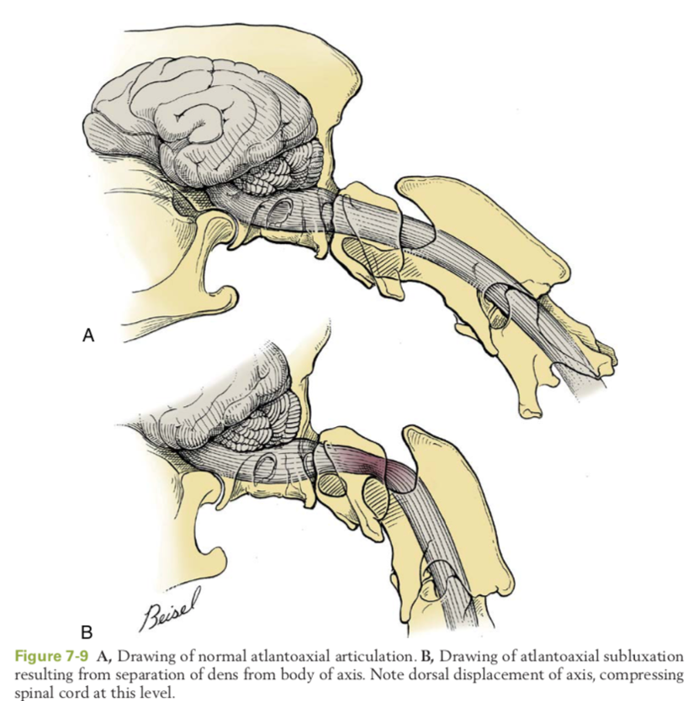
Diagnosis
- Atlantoaxial subluxation must be suspected in all toy or miniature dogs with C1-C5 signs
- Spinal radiography is useful for revealing the C1-2 malalignment (71% 5/7 identified in recent case series)
  - lateral and ventrodorsal views and be taken while the animal is awake
    - anesthesia with loosen muscle tone may increase possibility of neck flexion and severe spinal cord compression
  - If the survey radiographs reveal minor displacement, a definitive diagnosis can be made with radiographs taken with the dog anesthetized just before surgical fixation
- Advanced imaging can provide further insight to other bony and soft-tissue abnormalities
  - CT provides more detailed bone resolution.
  - MRI gives excellent soft-tissue resolution of the neural parenchyma and provides identification of other spinal cord pathologies (e.g., syringo/hydromyelia and myelomalacia) and intra- axial hemorrhage
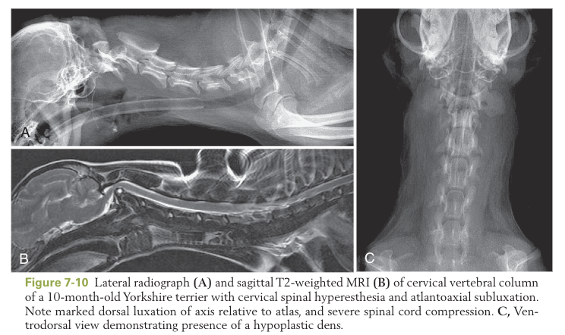
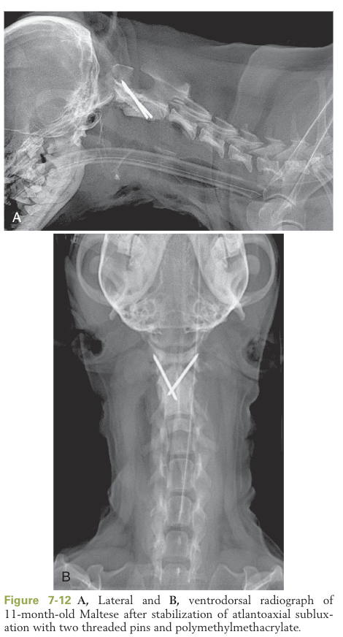
Treatment.
- The goal is joint stabilization and fusion. As a general rule, surgical treatment is the preferred method of therapy for AA subluxation.
- Conservative therapy
  - Exercise restriction with cage rest, external coaptation of the cervical vertebral column and head, pain control.
  - Treatment option for dogs that show clinical signs of cervical spinal pain or minimal neurologic deficits, minimal anatomic malalignment on radiography, or have owners with constraints that prevented surgical options. Also considered temporary for animals with immature bone that is not capable of withstanding implant placement
  - External coaptation by use of cervical spinal splints, noninvasive method
    - Methods of splint placement vary, include dorsal, ventral, circumferential, or soft padded bandage.
    - Must incorporate head and thoracic limbs so as to eliminate flexion
    - External splints are usually maintained for 6 to 8 weeks
    - Bandage changes necessary to ensure adequate immobilization.
    - Complications include inadequate joint stabilization, corneal ulceration, decubitus ulcers, dermatitis, and otitis externa secondary to bandage placement.
      - AA lux patients can also have pharyngeal and laryngeal weakness, predisposing them to aspiration pneumonia, dyspnea, and choking.
  - Owners educated on bandage management and committed to frequent checks.
- Surgical Stabilization
  - Ventral fusion
    - most common type of stabilization procedure
    - Indications include chronic history of clinical signs, relapse of signs from conservative therapy, and bone maturity that is capable of withstanding implant placement.
    - Techniques of fusion of the AA joint include transarticular fixation or multiple implants secured with polymethylmethacrylate.
    - A ventral approach to the cranial cervical vertebral column allows adequate visualization of the AA joint, articular cartilage is removed, joint is reduced and aligned, and screws or pins are placed across the C1-2 joint. A cancellous bone autograft is placed to facilitate bony fusion.
  - Postoperative, recommended that all forms of fixation be supplemented with external coaptation and strict cage confinement for 8 weeks.
  - Main complications are death or implant failure
    - Implant failures from migration, break, or loss of reduction.
    - Postoperative complications include respiratory-related complications: reflex gagging, laryngeal paralysis, tracheal collapse and necrosis, pulmonary edema, pneumonia, respiratory compromise
  - Dorsal wire fixation
    - a loop of wire or suture passed beneath the dorsal arch of C1 and cut and tightened to provide adequate reduction of C1 and C2.
    - Failure rate has been reported as high as 37%.
      - Usually there is breakage of the wire or suture; the spinous process of C2 or the dorsal arch of C1 also may fracture
    - Mortality rate has been reported as 16%
    - Dorsal stabilization techniques do not eliminate rotation and shear forces acting across the joint and are more prone to failure.
    - Complications are usually respiratory failure or cardiac arrest from spinal cord compression during the surgical procedure or after breaking of the wire or suture.
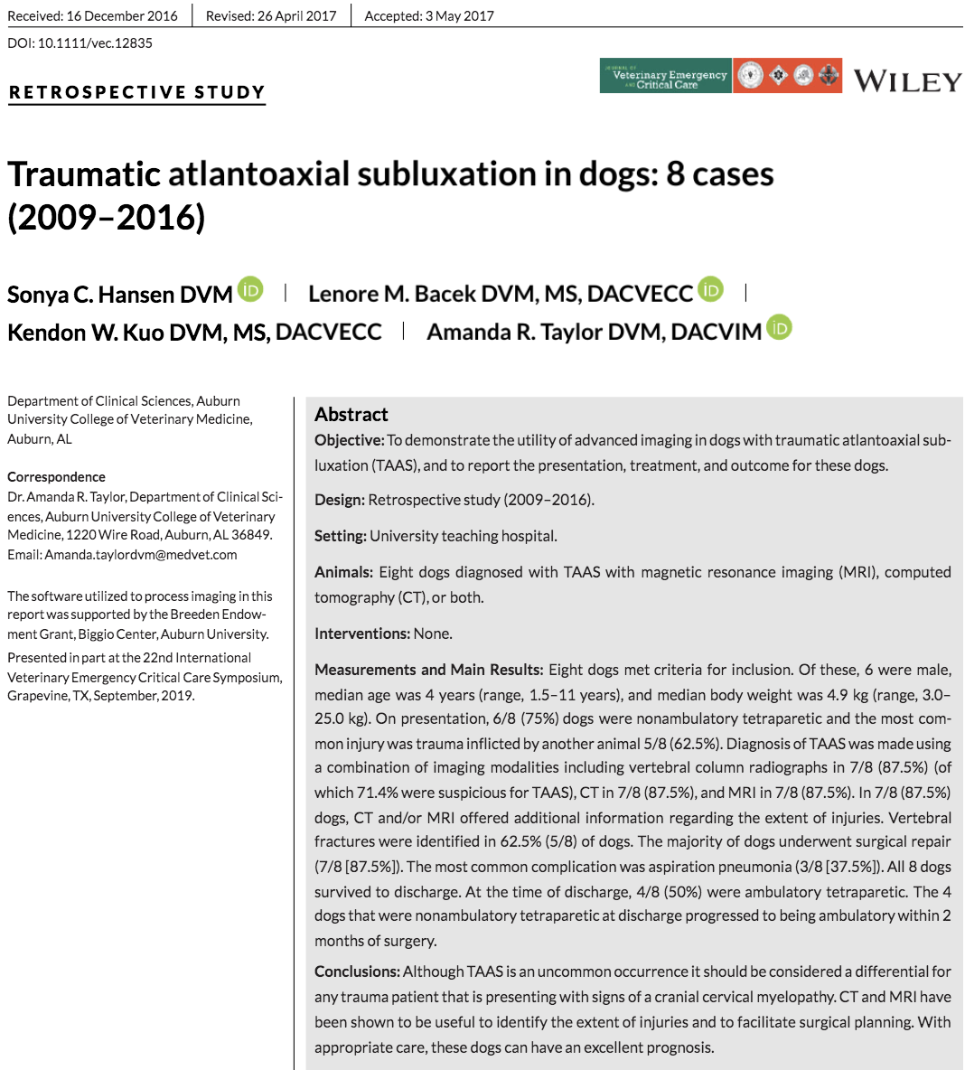
Degenerative Myelopathy
Pathogenesis:
- An insidious, progressive, proprioceptive ataxia and UMN spastic paresis of the pelvic limbs beginning in late adulthood, ultimately leading to LMN signs, paraplegia and necessitating euthanasia
- The disease was termed degenerative myelopathy because of its histopathologic nature as a non- specific degeneration of spinal cord tissue of undetermined cause.
- German shepherd dogs poster children. Also, husky, corgi, cheseapeake bay retriever, Rhodesian ridgeback, and boxers
- Age of onset usually middle age (5 years to older)
- DM consistent with a non- inflammatory axonal degeneration. Lesion distribution involves the spinal cord myelin and axons in all funiculi but affects the midthoracic to caudal thoracic region most extensively.
- The more severely affected dogs show significantly greater axonal degeneration and loss in the thoracic spinal cord segments and progression to the cervical and lumbar spinal cord.
- Intracranial lesions are uncommon.
Clinical signs:
- Mean time for disease duration/progression of 6 months in larger dog breeds.
- Usually progress to nonambulatory paraparesis within 6 to 9 months from onset of clinical signs
  - Pet owners usually elect euthanasia when the dogs can no longer support weight in their pelvic limbs and need walking assistance
  - Smaller breed dogs may be supported for longer due to size
- Early Disease.
  - The earliest clinical signs are proprioceptive ataxia and mild spastic paresis in the pelvic limbs.
  - Worn nails and asymmetric pelvic limb weakness are apparent upon physical examination.
  - Asymmetry of signs at disease onset is frequently reported.
  - T3-L3 signs UMN paresis, normal to increased patellar and withdrawals
- Late Disease
  - clinical signs will progress to LMN paraplegia and ascend to affect the thoracic limbs
    - LMN signs emerge as hyporeflexia of the patellar and withdrawal reflexes, flaccid paralysis, and widespread muscle atrophy beginning in the pelvic limbs as the dogs become nonambulatory.
  - Flaccid tetraplegia occurs in dogs with advanced disease.
  - Cranial nerve signs include swallowing difficulties and inability to bark.
  - Urinary and fecal continence usually latter disease stage with paraplegia.
Diagnosis
- Based on pattern recognition of the progression of clinical signs followed by diagnostic steps to exclude other disorders.
- CSF analysis, electrodiagnostic testing, and spinal cord imaging procedures
- A presumptive diagnosis of DM often is made based on lack of clinically relevant compressive myelopathy as determined by MRI.
  - MRI can identify early intramedullary spinal cord neoplasia and evidence of extradural compressive myelopathy.
  - Can also see IVD herniation, which can confound a diagnosis of DM.
    - Therefore, consider rapidity of disease progression, presence of paraspinal hyperesthesia, and amount of spinal cord compression to account for the severity of the myelopathy to distinguish between them
- CT/myelography can also be used
- CSF analysis can help rule out meningitis
- https://vgl.ucdavis.edu/test/degenerative-myelopathy
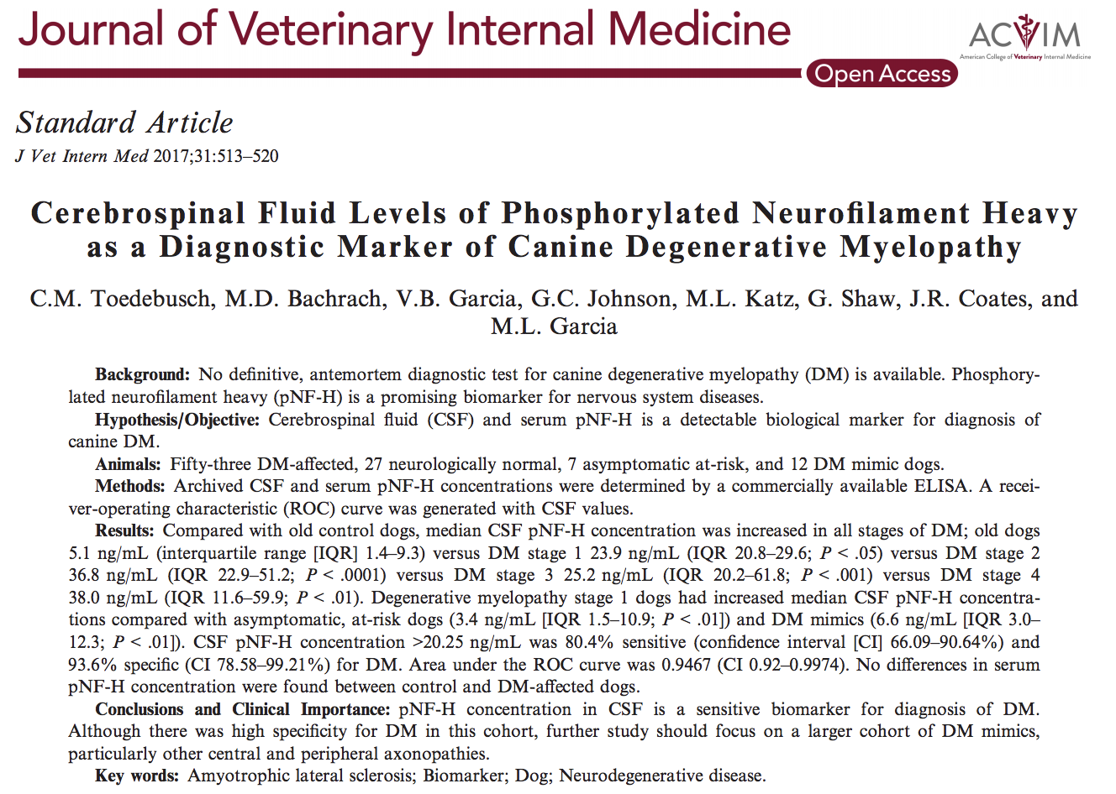
Treatment:
- Although it is hypothesized that DM is an immune-mediated neurodegenerative disease, immunosuppressive therapies using corticosteroids have shown no long-term benefits in halting the progression of DM.
- Dogs that received intensive physiotherapy had significantly longer survival times compared with dogs that received moderate or no physiotherapy. May improve the quality of life for the DM-affected pet and pet owner
Overall the long-term prognosis of DM is poor.

Degenerative Lumbosacral Stenosis (Cauda Equina Syndrome)
- relatively common and has been reported in dogs of various ages and breeds.
- Degenerative lumbosacral stenosis (DLSS) is also seen with increasing frequency in the cat.
- In several studies, middle-aged to older large-breed dogs, such as GSDs, Labrador retrievers, border collies, or crossbreeds were affected more frequently.
- The male:female ratio in GSDs is 2:1
Pathogenesis
- Stenosis of the lumbosacral canal is caused by a combination of anatomic factors causing compression of the cauda equina
- Stresses on the annulus fibrosus lead to proliferative changes and IVD protrusion.
  - This is a Hansen type II IVD degeneration with additional changes in the articulations and vertebral end plates.
- Narrowing of the IVD space causes the intervertebral foramen to be smaller.
- When osteophytes are around the foramen, the L7 spinal nerve is entrapped
- Typically due to congential vertebral abnormality or developmental predisposition
Clinical Signs
- The most common clinical sign caudal lumbar pain.
- May experience difficulty rising, won’t jump, difficulty climbing stairs
  - at this stage the clinical signs easily confused with hip dysplasia or other orthopedic disorders as breeds predisposed to lumbosacral stenosis also predisposed to hip dysplasia and stifle disease
- Recurring lameness of one or both pelvic limbs is common
- Dogs may stand with the pelvic limbs tucked under the caudal abdomen presumably to flex the lumbar vertebral column and lessen nerve root compression.
- Exercise often exacerbates the signs with vascular engorgement within the foramen, and further worsening the nerve compression
- Pelvic limb paresis is unusual unless the condition is advanced.
  - If the disease progresses to paraparesis, the weakness involves the muscles innervated by the sciatic nerve, causing decreased extension of the hock leading to a plantigrade stance.
- Only in the latter disease stage are significant postural reaction deficits present.
- May have paresthesia in the tail or perineal region and may lick or chew the affected area with altered tail carriage.
- Abnormalities in urination and fecal incontinence are commonly associated with clinical signs attributed to compression of the sacral nerves.
  - The anal sphincter may be atonic, and the perineal reflex may be weak or absent.
  - The urinary incontinence is of the LMN type with overflow incontinence. The bladder is flaccid and distended as a result of a poor detrusor reflex. The sphincter tone is still maintained since innervation by the hypogastric nerve remains intact.
- The key to clinical diagnosis is localization of hyperesthesia in the lumbosacral region. More than 90% of affected dogs are in pain. LS pain on palpation or pain on tail extension. By rectal palpation, pressure can be applied to the ventral aspect of the lumbosacral IVD space.
Diagnosis
- Degenerative lumbosacral stenosis must be differentiated from various causes of compression, such as trauma and neoplasia; inflammatory diseases such as discospondylitis and spinal empyema (abscesses); orthopedic diseases, such as arthritis, hip dysplasia, and cranial cruciate disease; and spinal cord diseases, such as degenerative myelopathy and IVDD.
- Survey radiography is useful to rule out other causes of DLSS (e.g., discospondylitis and vertebral neoplasms).
  - Abnormal findings include osteochondrosis of the sacral end plate, transitional vertebrae, spondylosis, subluxation, sclerosis of the end plates, and bony proliferation of the articular processes.
  - Stress radiography (extension and flexion) has been used to identify instability of LS junction.
  - Myelography used to rule out other causes of compressive lesions cranial to L4.
- CT and MRI have the advantage of better bone and soft tissue resolution, respectively.
  - MRI is superior to CT with regard to soft tissue definition of the associated neural and ligamentous tissues. The spinal cord, cerebrospinal fluid, intervertebral disks, ligaments, and nerve roots can be directly visualized. Can provide early recognition of intervertebral disk degeneration.
  - Imaging findings based on CT and MR may be disparate when compared with the severity of clinical signs and predicting the surgical outcome. Should not be used in formulating the prognosis
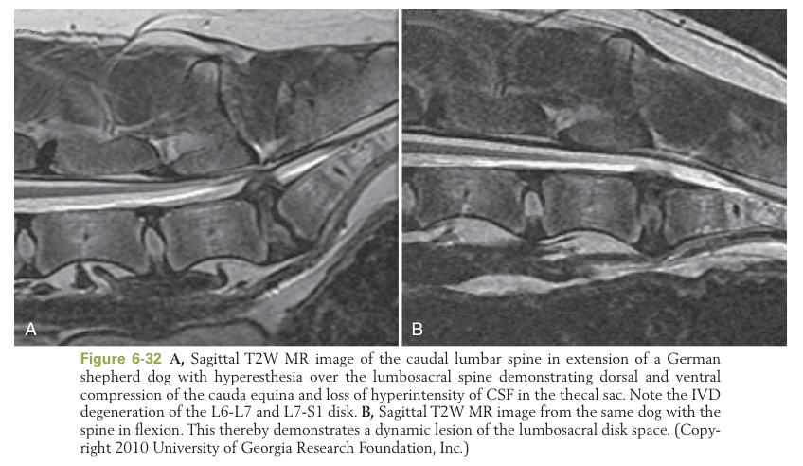
Treatment
- The management based on an evaluation of the severity and duration of the clinical signs.
- Conservative management for the first episode of clinical signs or when the pain is intermittent
  - Confined rest for 4 to 8 weeks and pain management
  - The recovery rate with conservative management is between 24% and 50%.
  - Signs often recur when exercise is resumed.
  - Injection of methylprednisolone sodium acetate injections into the lumbosacral epidural space results in clinical improvement in 79% and complete resolution of signs in 53% of affected dogs
- Surgical management for failure of conservative management, severe pain, and severe neurologic deficits (in particular incontinence)
  - Choices of surgical procedures include dorsal decompression, discectomy, facetectomy, foraminotomy, and fixation-fusion.
  - The dorsal laminectomy procedure allows decompression and visualization of the cauda equina
    - Dorsal laminectomy alone provides relief of pain in most dogs
    - Short-term outcome success using a decompressive laminectomy procedure ranges between 41% to 78%.
  - Postoperative care
    - maintenance of bladder function
    - Exercise restricted for at least 6 weeks
    - Nonsteroidal analgesics
Prognosis:
- Prognosis depends on the severity and duration of signs.
- Dogs with pain as the only sign have an excellent prognosis for complete recovery, although they may experience episodes of discomfort after vigorous exercise.
- Prognosis is fair to good if clinical signs improve with surgery and with early surgical intervention.
  - Recurrence rates for degenerative lumbosacral stenosis vary between 3% and 18% in the working dog.
  - Working dogs that are younger at time of onset and have mild signs have a good prognosis with surgical decompression alone; however, recurrence still may be seen.
- Dogs with severe neurologic deficits, and urinary and fecal incontinence for more than a few weeks before surgery have a guarded to poor prognosis.

