Reminder of definitions:
- Osmolality = concentration of osmotically active particles in a solution, as a function of number of particles (not related to molecular weight, size, shape, or charge). mOsm/kg
- Osmolarity = number of particles of solute per liter of solution. mOsm/L
- How to calculate plasma osmolality? What is normal dog and cat plasma osmolality?
=2 (Na+K) + BUN/2.8 + glucose/18
BUN/2.8 because of unit conversion, same with glucose. Won’t need to unit convert if using SI units
Paper compared formulas, JVECC 2008 James Barr Use of the advanced micro-osmometer model 3300 for determination of a normal osmolality and evaluation of different formulas for calculated osmolarity and osmole gap in adult dogs: Paper recommended above formula or [1.86(Na+K) + BUN/2.8 + glucose/18]/0.93
2013 J Small Animal Practice Comparative accuracy of several published formulae for the estimation of serum osmolality in cats; 2014 JVECC A comparison of the clinical utility of several published formulae for estimate osmlolality of canine serum: formula without potassium same as formula as with potassium, so either is fine. 2 Na + BUN/2.8 + glucose/18
- Tonicity (AKA effect osmolality) = ability of solution to initiate water movement and is dependent on presence of impermeant solutes in solution like glucose and sodium (solutes that cause movement of water because they cannot readily cross cell membranes)
Name two examples impermeant solutes: glucose and sodium

Exact same osmolality calculation except for BUN because BUN mostly permeable
- Diuresis = urine flow greater than normal (>1-2mL/kg/hr)
  - Osmotic diuresis = increase urine flow due to excessive amounts of nonreabsorbed solute within renal tubules
Name two examples that cause this: diabetes mellitus and mannitol administration
  - Water diuresis = increase urine flow due to decreased reabsorption of solute-free water in the collecting ducts
Name to examples that cause this: Polyuria due to psychogenic polydipsia or diabetes insipidus
Renal handling of sodium: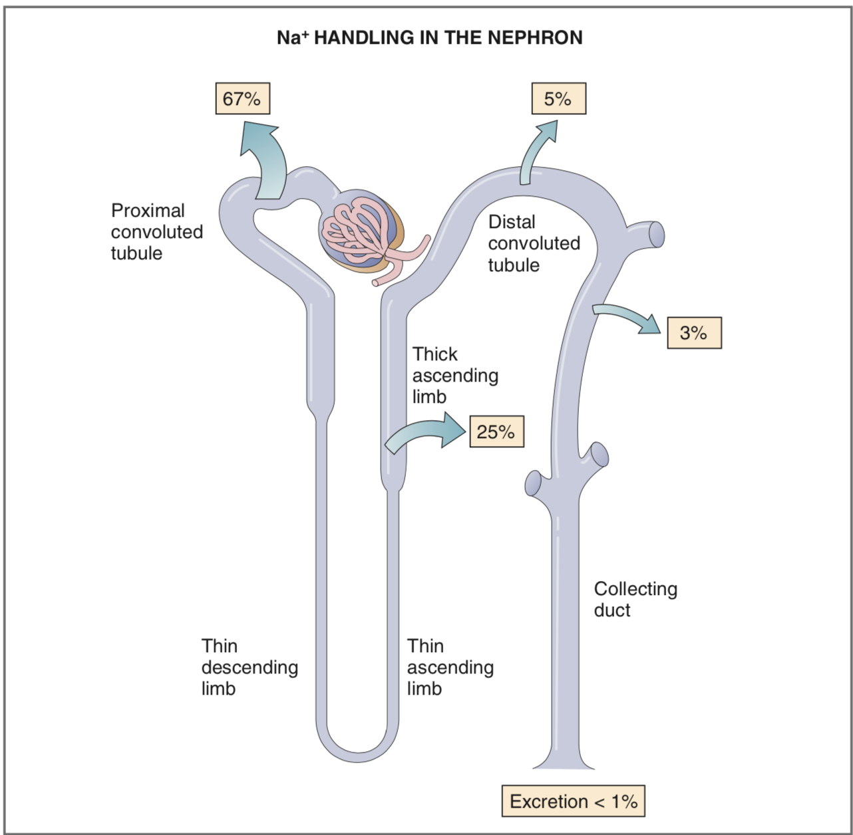
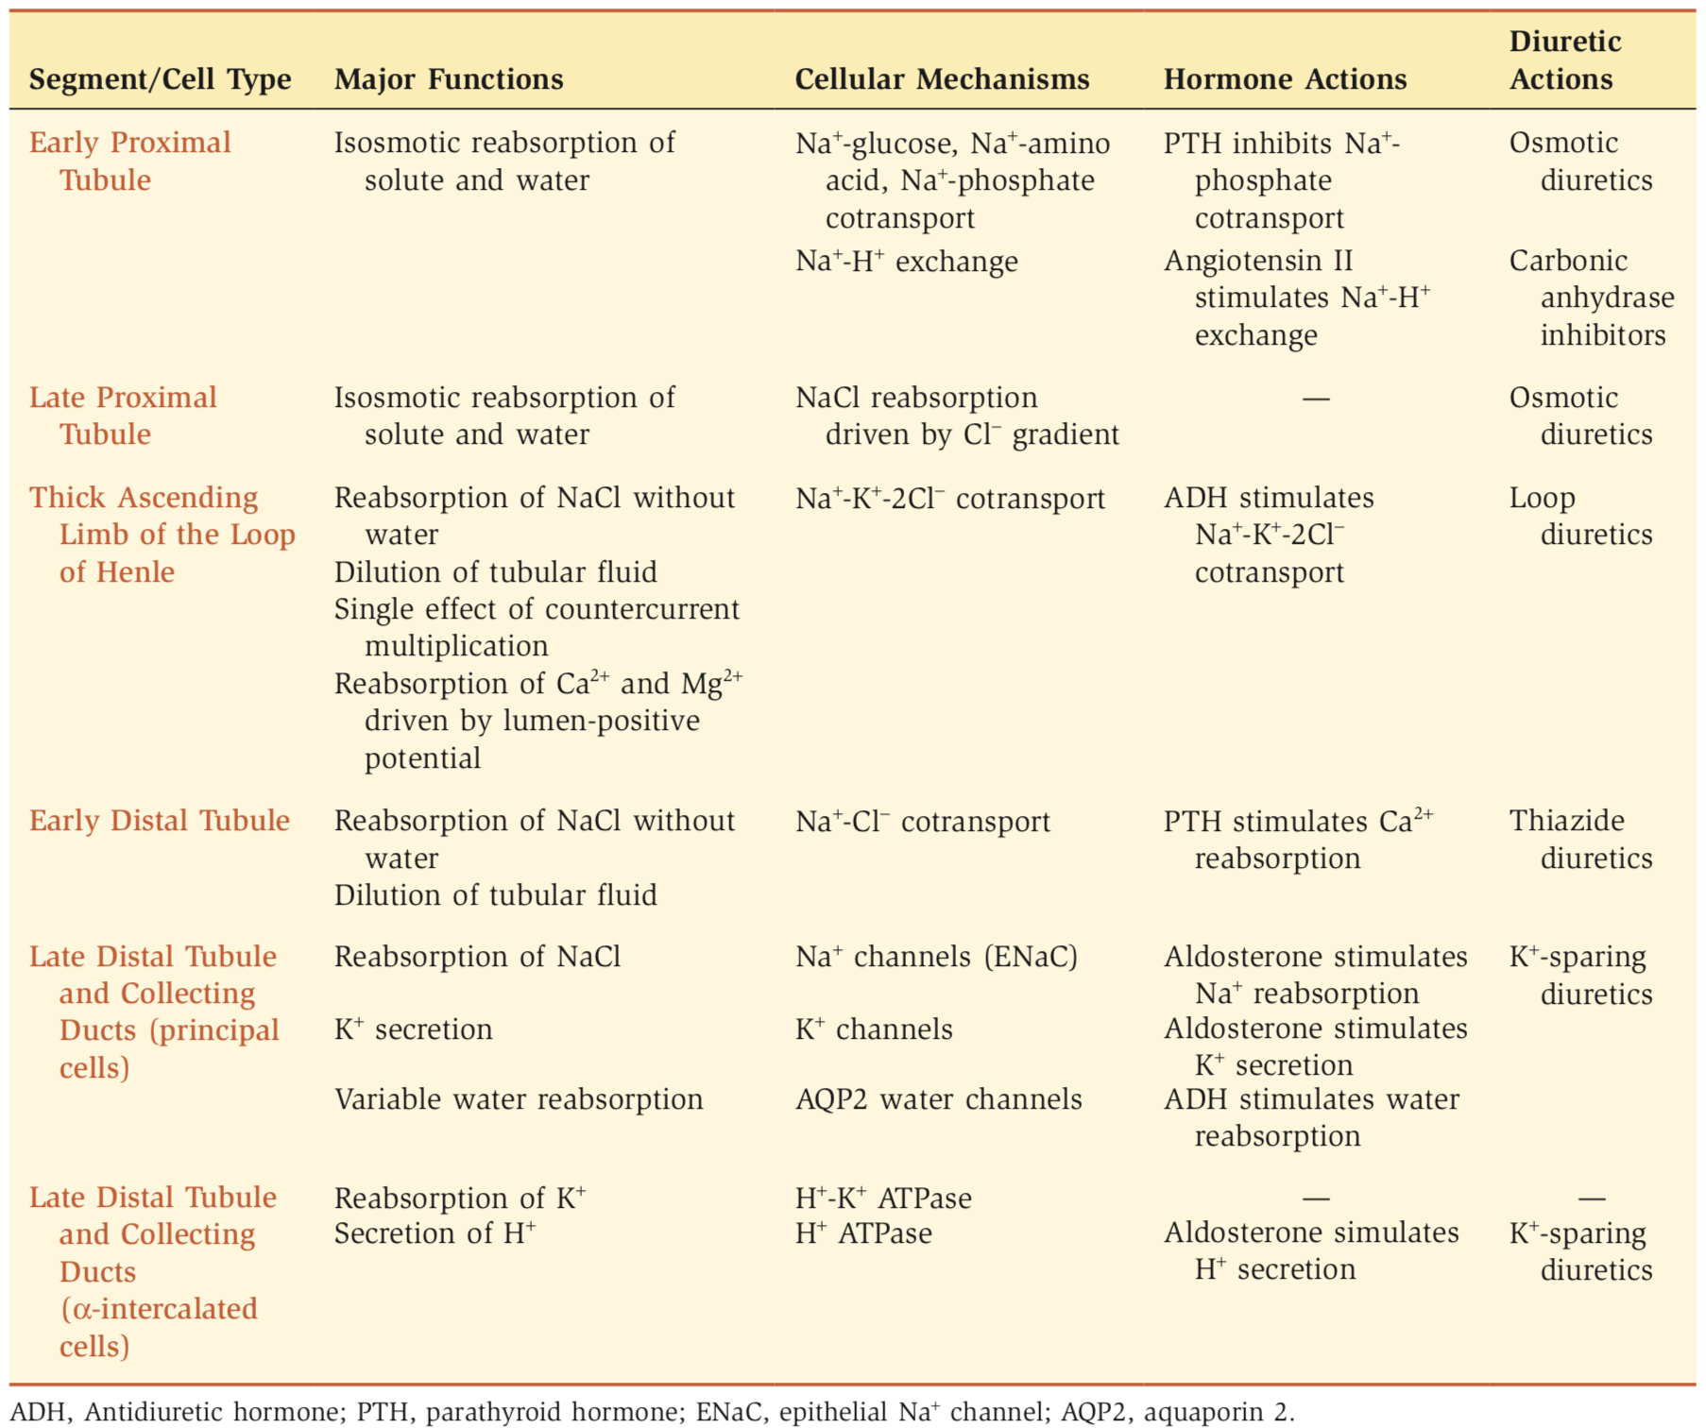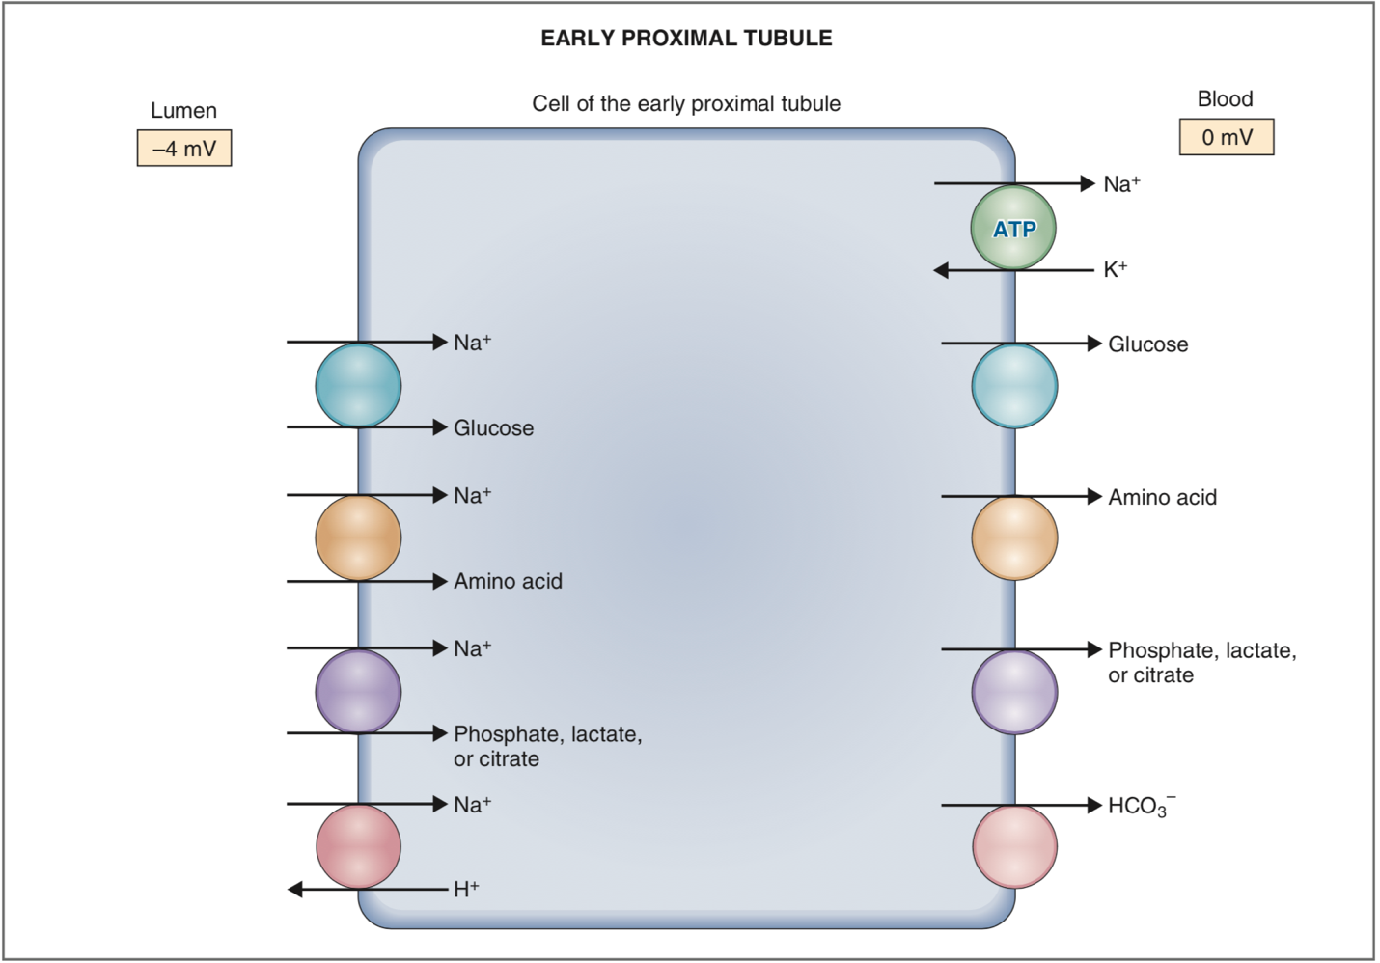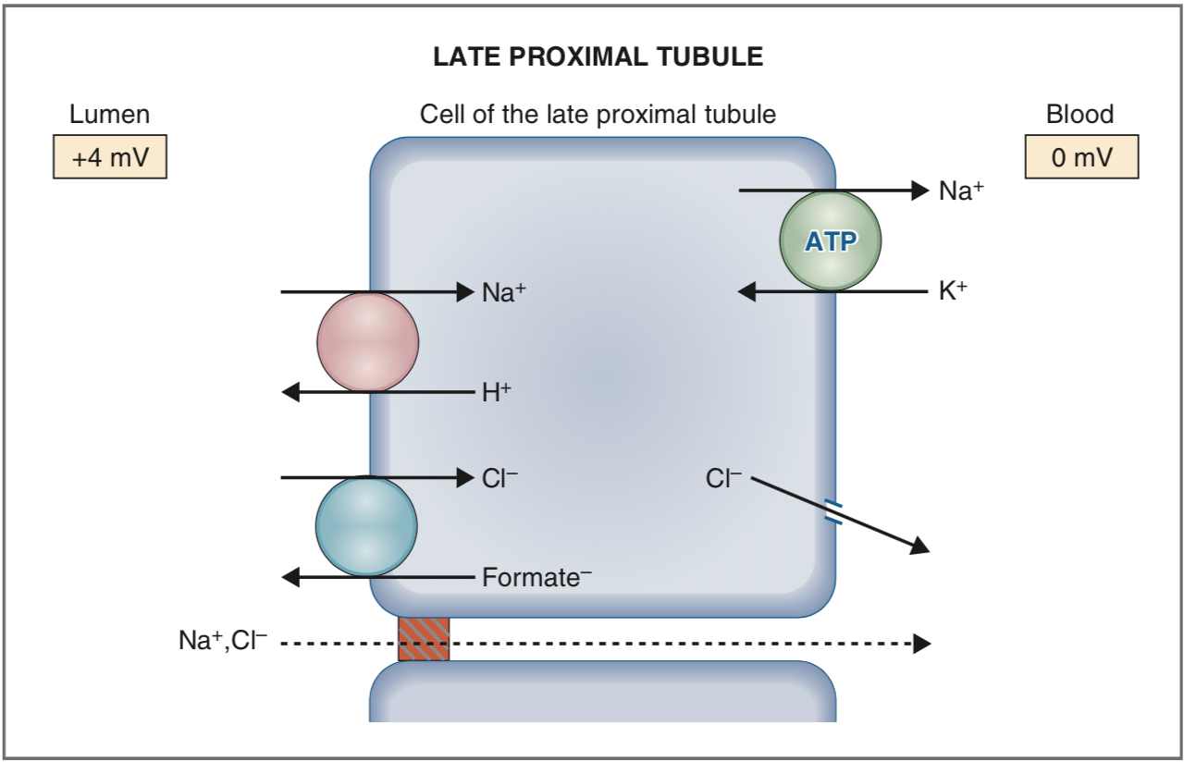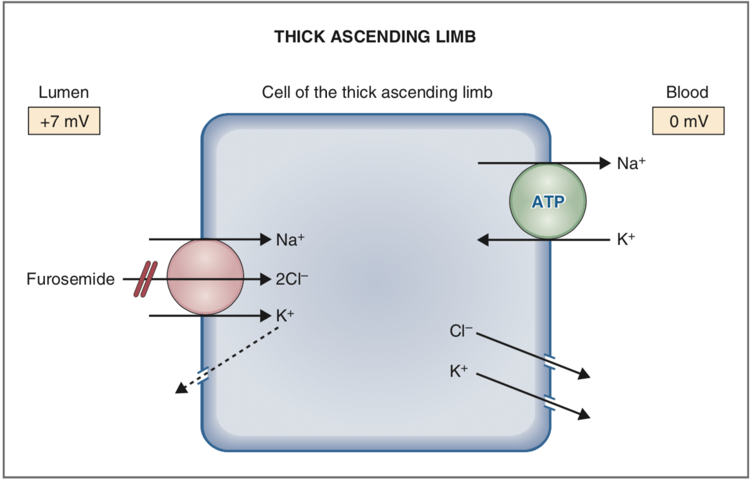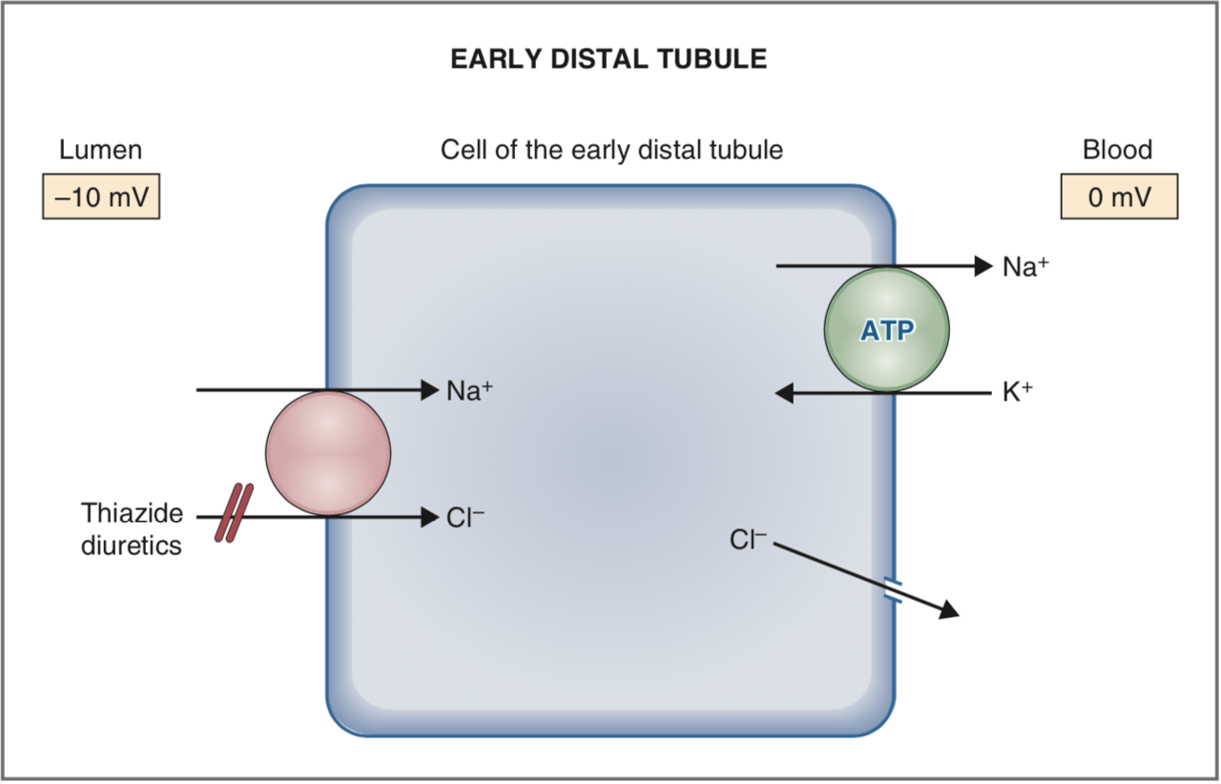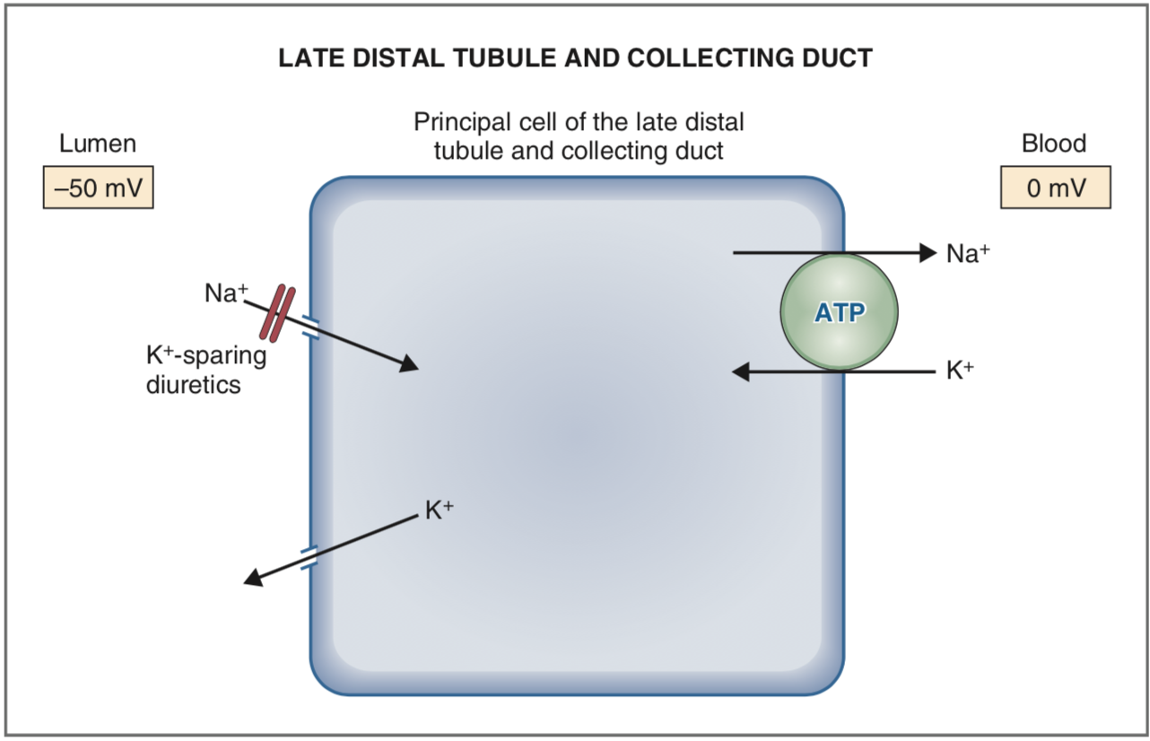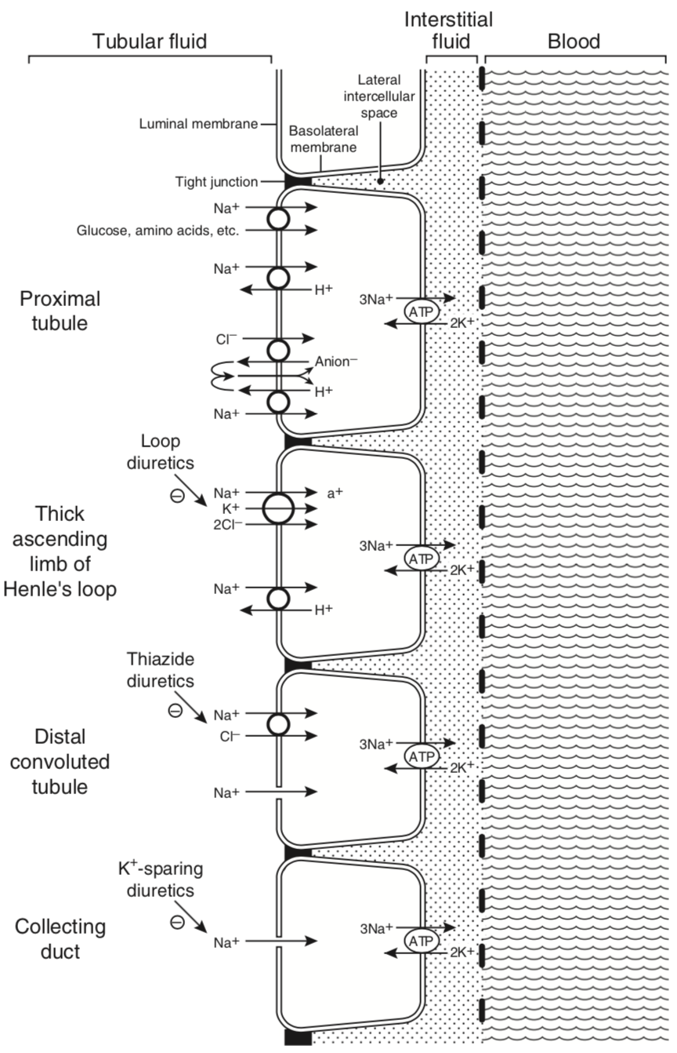
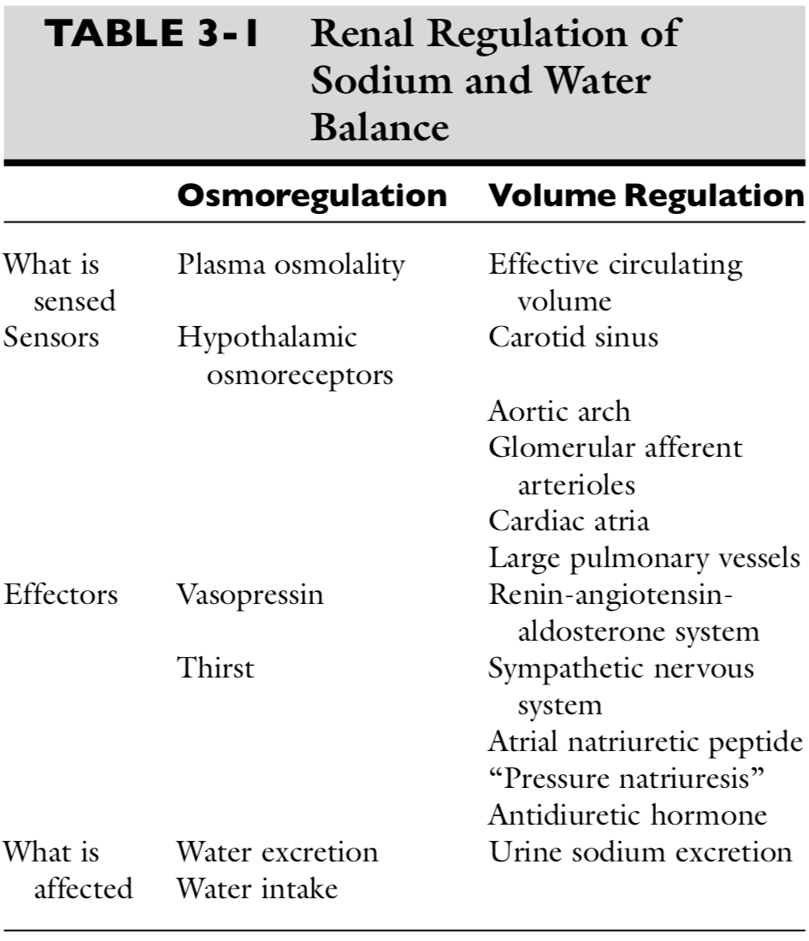

Regulation of sodium:
- Afferent limb of the body’s regulatory system
  - Low-pressure mechanoreceptors (i.e., volume receptors) in the cardiac atria and pulmonary vessels
  - high-pressure baro-receptors (i.e., pressure receptors) in the aortic arch and carotid sinus play a primary role in the body’s ability to sense the adequacy of the circulating volume.
  - Within the kidneys, the juxtaglomerular apparatus responds to changes in perfusion pressure with changes in renin production and release.
  - Less well characterized are receptors in the liver and the central nervous system that may contribute to sodium homeostasis.

- Efferent limb = kidney
  - regulate sodium balance by excreting an amount of sodium each day equal to that ingested.
  - There are several overlapping control mechanisms for regulation of renal handling of sodium. This redundancy serves to protect against sodium imbalance should one control mechanism fail.
  - The two points of control for sodium balance in the kidneys are glomerular filtration and tubular reabsorption.
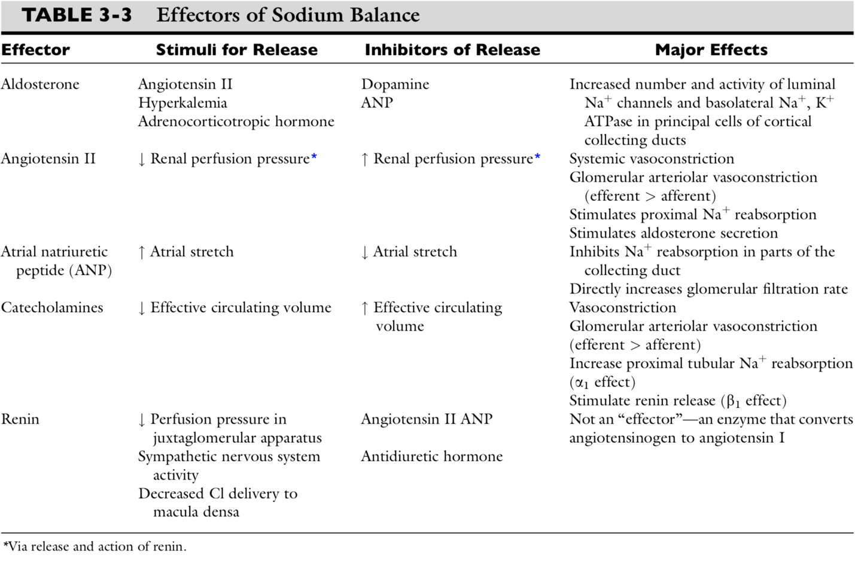
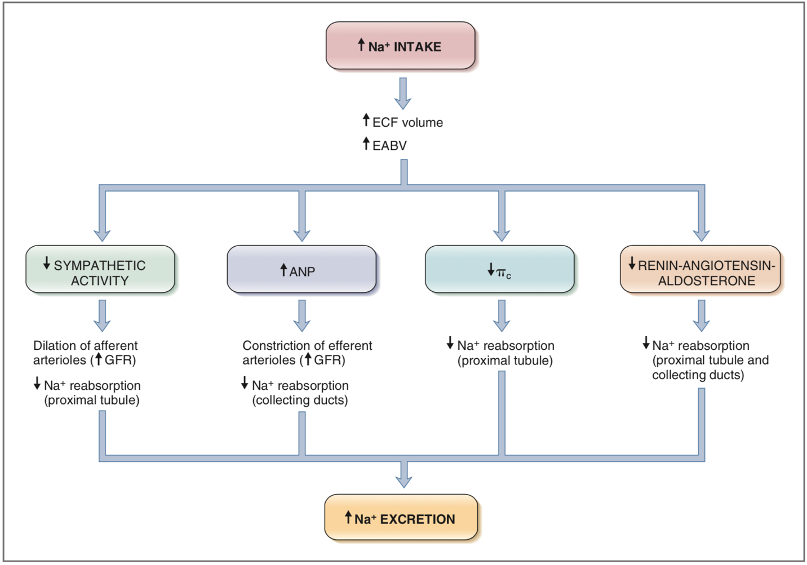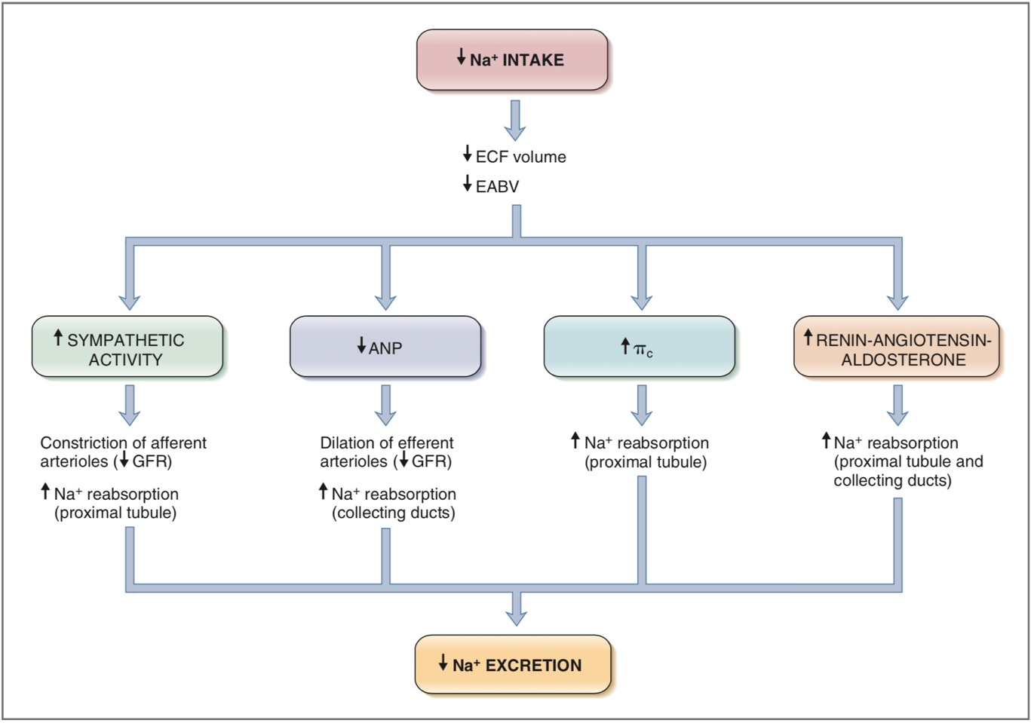
Regulation of water balance:
- The osmolality of ECF and serum sodium concentration are regulated by adjusting water balance.
- Afferent limb (sensors) = osmoreceptors in the hypothalamus
- Efferent limb = Vasopressin (antidiuretic hormone) for water output and thirst for water input
  - ADH release is stimulated when the osmoreceptors shrink in response to plasma hyperosmolality and is inhibited when they swell in response to plasma hypo- osmolality.
Vasopressin (Antidiuretic hormone [ADH])
- Amino acid peptide synthesized in neurons of supraoptic and paraventricular nuclei in hypothalamus, travel down axons of neurons and released into circulation at level of neurohypophysis
- Mechanism of action:
  - Increases reabsorption of water in collecting ducts of kidneys and increase permeability of medullary collecting ducts to urea
  - Vasopressin attaches to V2 receptors on basolateral membranes of principal cells of cortical and medullary collecting ducts
  - Hormone-receptor complex activates Gs regulatory protein causing GDP to GTP replacement and stimulation of adenyl cyclase in cell membrane
  - Formation of cAMP results in activation of protein kinase A, which phosphorylates aquaporin 2 protein found in membranes of subapical vesicles in cytoplasm of principal cells
  - This results in insertion of aquaporin 2 water channels in luminal membranes of principal cells
  - V1a receptors are on vascular smooth muscle, causing vasoconstriction when vasopressin binds
  - V1b receptors are found primarily in hypothalamus where vasopressin binding increases secretion of corticotrophin
- Stimulus
  - Hypertonicity of plasma reaching osmoreceptors of hypothalamus
  - Volume depletion sensed by baroreceptors of left atrium, aortic sinus, and carotid sinuses
  - Nausea/pain/anxiety
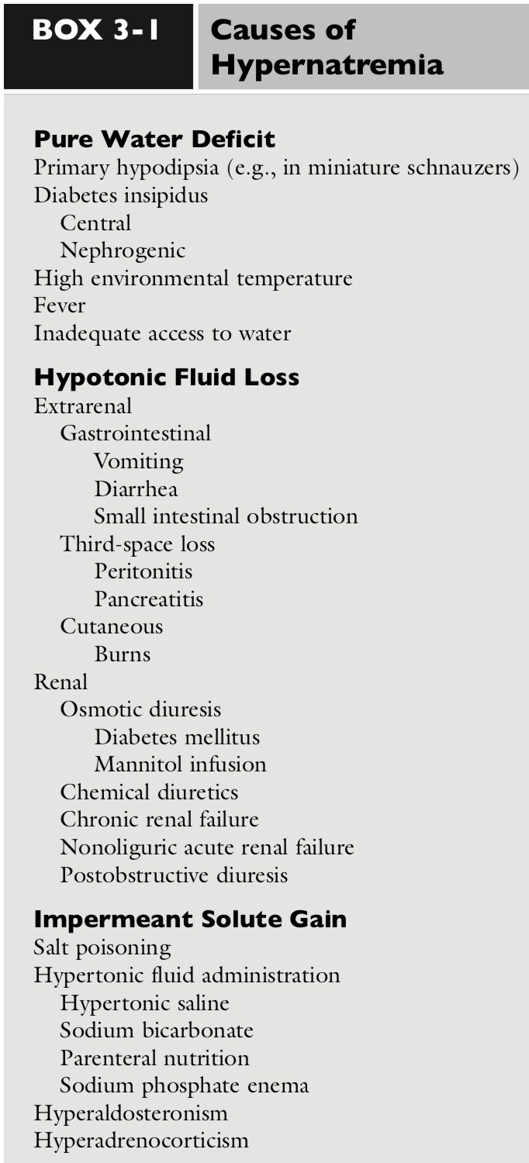
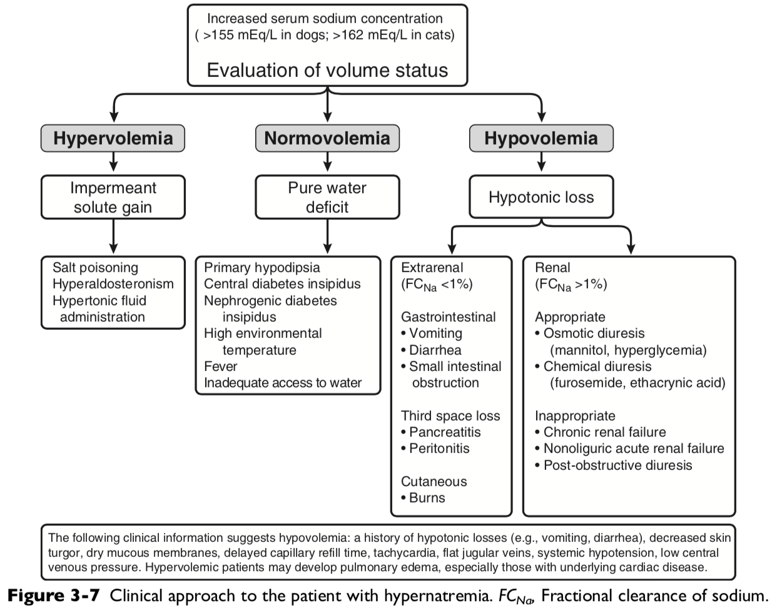
Water deficit = Wt (present) x 0.6 (volume of distribution) x ( [Na(current)/Na (previous/normal/desired)] – 1)
Ex: 10kg dog current serum sodium concentration 170mEq/L, normal 145 mEq/L. what is water deficit? = 10 x 0.6 x ([170/145]-1) = 1.03L over fifty hours = 20.6mL/hr

Correction should be less than 10-12mEq/L per 24 hours (0.4-0.5mEq/L/hr) in chronic or unknown duration
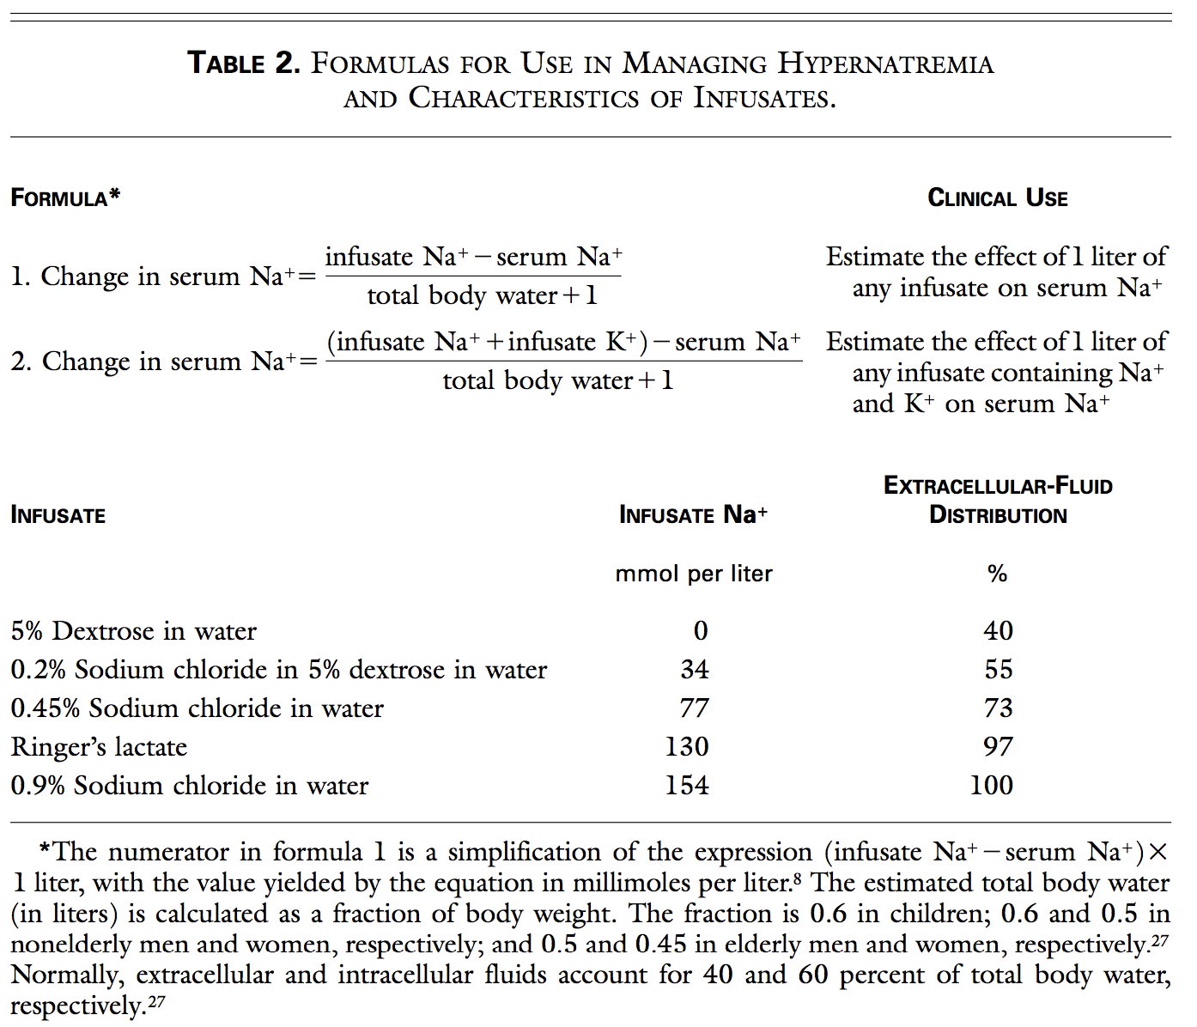
0.6 x BW in people = total body water
Calculate how much D5W a 10kg dog with serum sodium at 170mmol/L would need to decrease serum sodium concentration 25. At what rate would you give it?
The estimated volume of total body water is 6 liters (0.6x10kg). The retention of 1 liter of 5 percent dextrose is estimated to decrease the serum sodium concentration by 24.28 mmol per liter ([0-170]÷ [6+1]=-24.28). To reduce the serum sodium concentration by 25 mmol per liter, no faster than 0.5mmol/L per hour, over a period of fifty, 1.03 liters of 5 percent dextrose will be infused at a rate of 20.6 ml per hour.

Central diabetes insipidus
- Caused by partial of complete lack of vasopressin production and release from neurohypophysis from trauma, neoplasia, or idiopathic.
- Clinical signs: severe PU/PD, hyposthenuric, +/- neurologic signs
- Complete CDI USG 1.001-1.007 with no change with dehydration
- Partial CDI USG 1.002-1.016 to 1.010-1.018 with 5% dehydration
- Treatment:
  - Vasopressin restores medullary hypertonicity and normal urinary concentrating ability
  - desmopressin (DDAVP) structural analogue of vasopressin with more potent antidiurectic effect than vasopressin, but minimal vasopressive effect.
Nephrogenic diabetes insipidus: structural or functional abnormalities interfere with ability of kidneys to concentrate urine
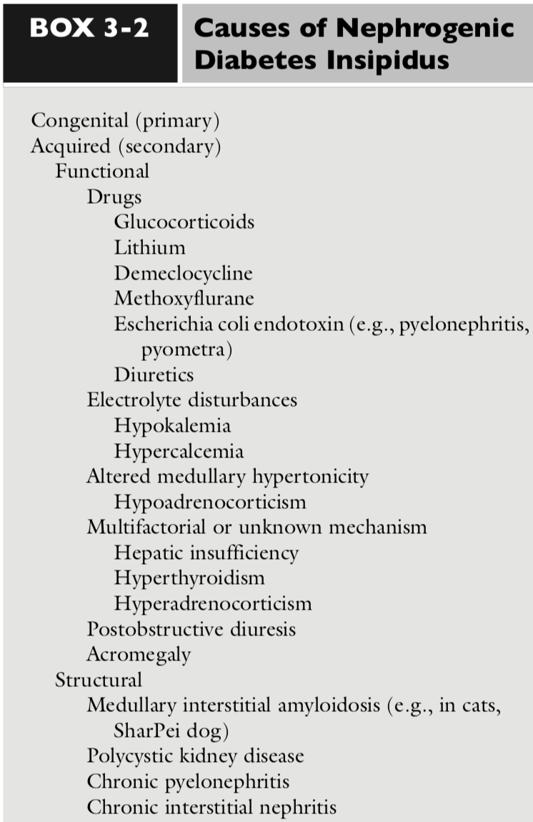

Clinical signs of hypernatremia:
- Neurologic signs related to osmotic movement of water out of brain cells
  - Rapid decrease in brain volume may cause rupture of cerebral vessels and focal hemorrhage
  - Severity of signs related to rapidity of onset of hypernatremia, rather than magnitude
  - Usually seen with serum sodium concentration >170mEq/L
  - If hypernatremia develops slowly, brain adapts to hypertonic state by production of intracellular solutes called osmolytes or idiogenic osmoles
- Anorexia, lethargy, vomiting, muscle weakness, behavioral change, disorientation, ataxia, seizures, coma, and death
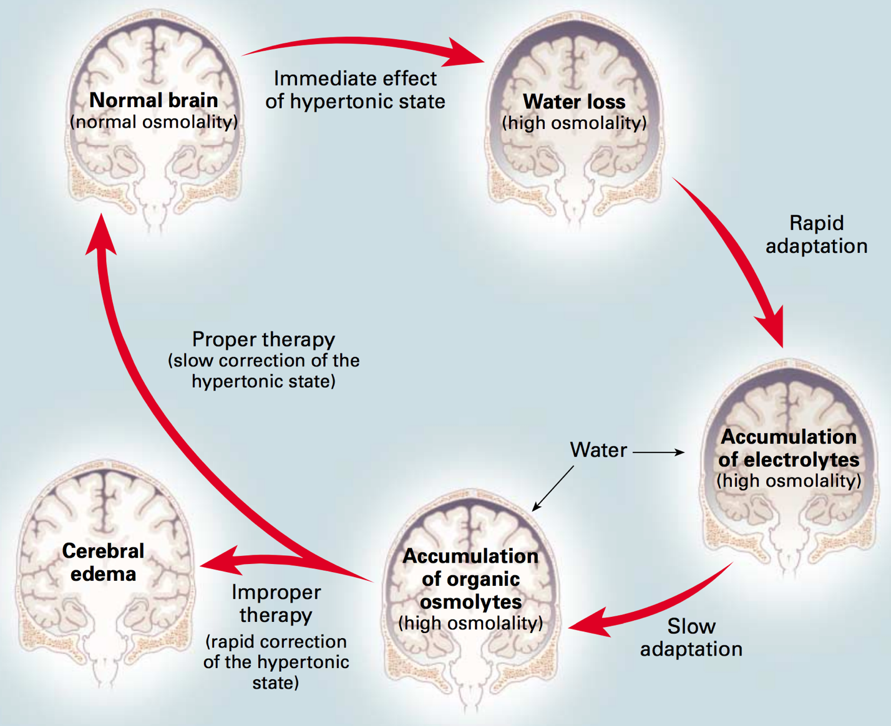
Figure 2. Effects of Hypernatremia on the Brain and Adaptive Responses. Within minutes after the development of hypertonicity, loss of water from brain cells causes shrinkage of the brain and an increase in osmolality. Partial restitution of brain volume occurs within a few hours as electrolytes enter the brain cells (rapid adaptation). The normalization of brain volume is completed within several days as a result of the intracellular accumulation of organic osmolytes (slow adaptation). The high osmolality persists despite the normalization of brain volume. Slow correction of the hypertonic state reestablishes normal brain osmolality without inducing cerebral edema, as the dissipation of accumulated electrolytes and organic osmolytes keeps pace with water repletion. In contrast, rapid correction may result in cerebral edema as water uptake by brain cells outpaces the dissipation of accumulated electrolytes and organic osmolytes. Such overly aggressive therapy carries the risk of serious neurologic impairment due to cerebral edema.

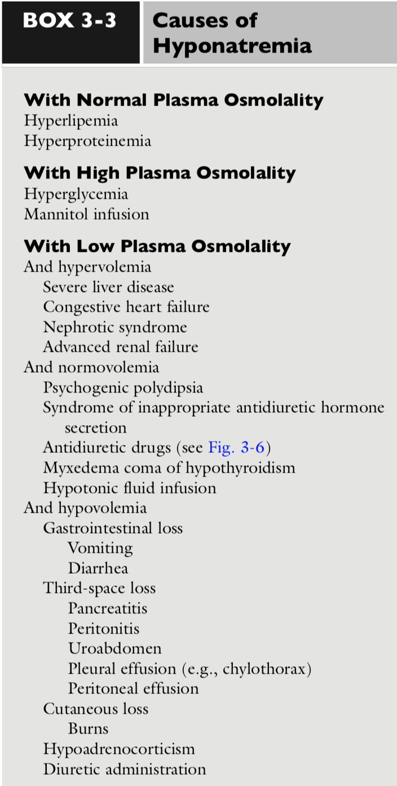
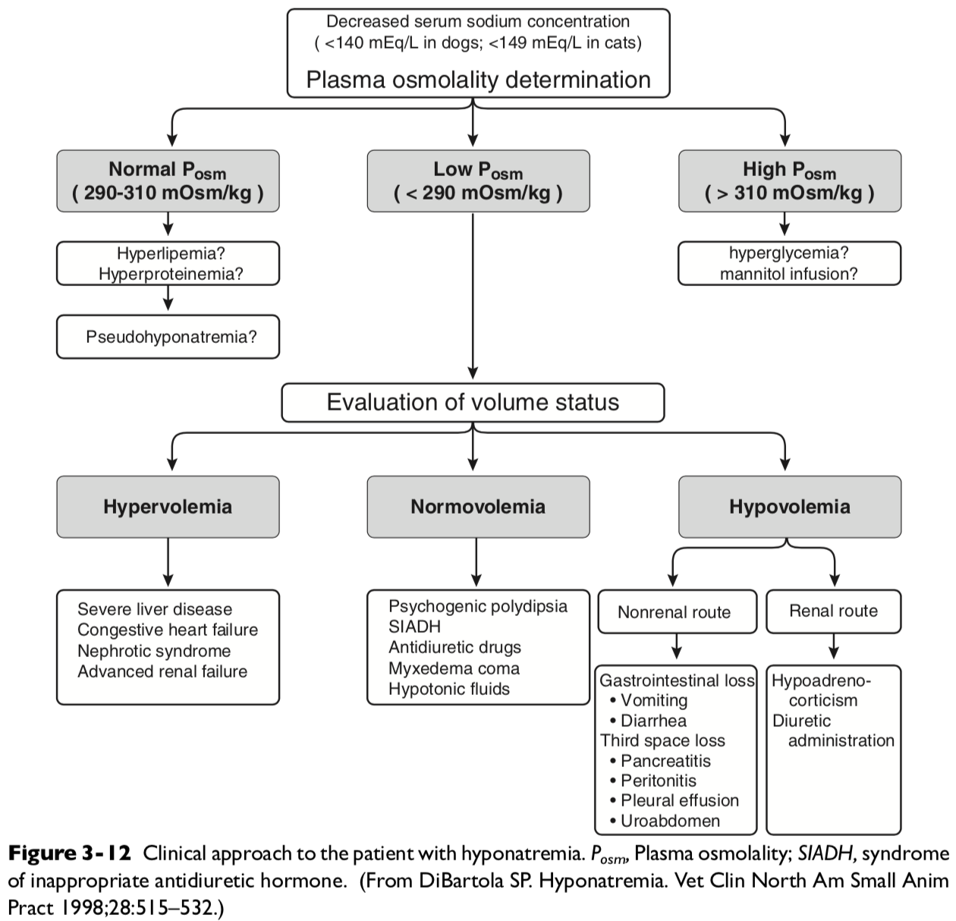
Syndrome of Inappropriate ADH secretion (SIADH)
- Inappropriate vasopressin release in absence of normal osmotic or nonosmotic stiumi
- Rare in dogs, reported in association of dirofilariasis, undifferentiated carcinoma, neoplasia in region of hypothalamus, hydrocephalus, idiopathic
The diagnosis of SIADH must be made by excluding other causes of hyponatremia. The following criteria should be met before establishing a diagnosis of SIADH:
- Hyponatremia with plasma hypoosmolality.
- Inappropriately high urine osmolality in the presence of plasma hypoosmolality. (Urine osmolality is often >300 mOsm/kg in human patients with SIADH. A urine osmolality >100 mOsm/kg should be consid- ered abnormal in a patient with hyponatremia and plasma hypoosmolality. A urine osmolality <100 mOsm/kg would normally be expected as a result of complete suppression of vasopressin release. Urine osmolality is important in distinguishing psychogenic polydipsia and SIADH. Urine is maximally diluted in psychogenic polydipsia but not in SIADH.)
- Normal renal, adrenal, and thyroid function.
- Presence of natriuresis despite hyponatremia and plasma hypoosmolality as a result of mild volume expansion (urine sodium concentration usually >20 mEq/L in human patients).
- No evidence of hypovolemia, which could result in nonosmotic stimulation of vasopressin release.
- No evidence of ascites or edema, which could result in hypervolemic hyponatremia (i.e., no evidence of severe liver disease, congestive heart failure, or nephrotic syndrome).
- Correction of hyponatremia by fluid restriction.
Clinical signs of hyponatremia
- Related to rapidity of onset rather than severity
- Deaths and severe complication seen when acutely decreased Na <120mEq/L or rate greater than 0.5mEq/L/hr.
- Cerebral edema and water intoxication
- Chronic hyponatremia can have no clinical signs due to brain volume adjusted toward normal by loss of potassium and organic osmolytes from cell
- When corrected, potassium and organic osmolytes lost must be restored to cells in brain. If replacement of these solutes do not keep pace with increase in serum sodium, lead to grain dehydration and injury = osmotic demyelination or myelinolysis
- Complications of severe and rapidly evolving hyponatremia include seizures, coma, permanent brain damage, respiratory arrest, brain-stem herniation, and death.
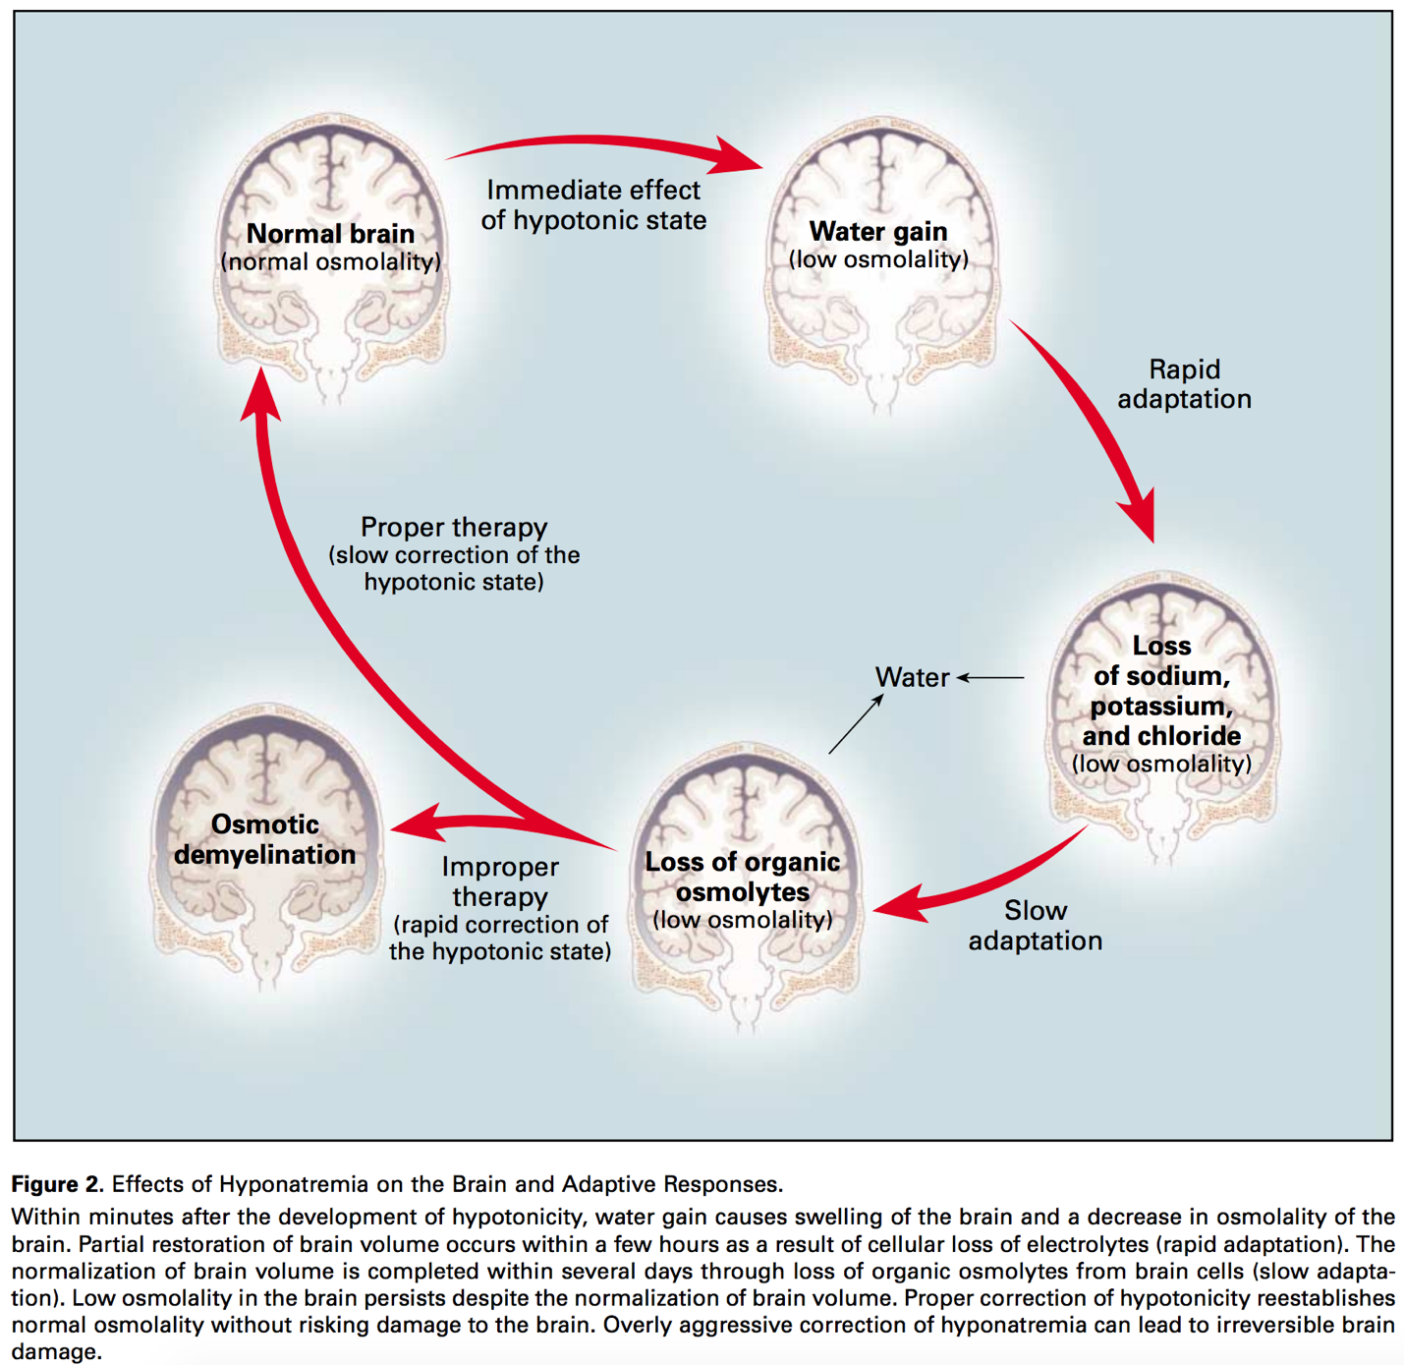
- Shrinkage of the brain triggers demyelination of pontine and extrapontine neurons that can cause neurologic dysfunction, including quadriplegia, pseudobulbar palsy, seizures, coma, and even death. Hepatic failure, potassium depletion, and malnutrition increase the risk of this complication.
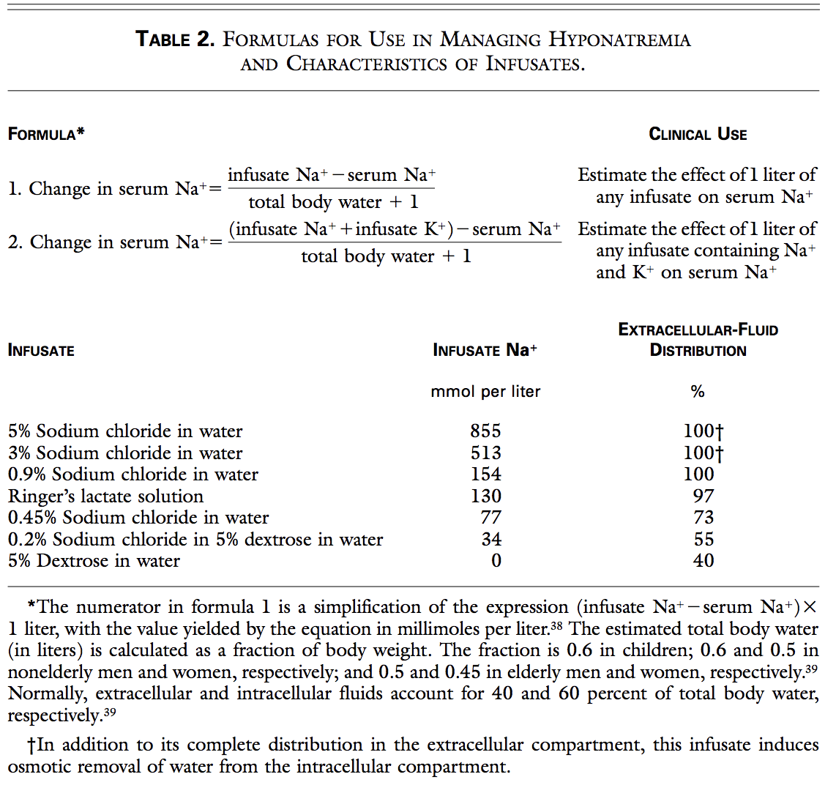
Treatment:
- It was recommended that dogs with asymptomatic chronic hyponatremia be treated by mild water restriction and monitoring of serum sodium concentration.
- Symptomatic dogs with chronic hyponatremia should be treated conservatively at correction rates of less than 10 to 12 mEq/L/ day (0.5 mEq/L/hr).
- Serial monitoring of serum sodium concentration is necessary because the actual rate of correction may not correspond to the calculated rate of correction.
- Correction should be carried out with conventional crystalloid solutions (e.g., lactated Ringer’s solution and 0.9% NaCl) in a volume calculated specifically to replace the patient’s volume deficit.
- Remember that volume repletion in hypovolemic patients abolishes the nonosmotic stimulus for vasopressin release and allows the animal to excrete solute-free water via the kidneys. This in itself tends to correct the hyponatremia. Thus, caution should be exercised even when using conventional crystalloid fluid therapy.
- Water intake should be carefully restricted to a volume less than urine output in normovolemic patients with hyponatremia (e.g., psychogenic polydipsia), or drugs causing an antidiuretic effect should be discontinued if possible.
- Demeclocycline and lithium inhibit vasopressin release and have been used to treat SIADH in humans, but water restriction is probably the safest approach
- In edematous patients, dietary sodium restriction and diuretic therapy should be considered. A 0.9% NaCl solution can be administered concurrently with loop diuretics to effect more rapid correction of hyponatremia in overhydrated symptomatic patients.
- Arginine vasopressin (AVP) receptor antagonists (vaptans) block either V2 receptors (lixivaptan, tolvaptan, satavaptan) or both V2 and V1A receptors (conivaptan). Based on their mechanism of action, these drugs increase free water excretion by the kidneys and effectively normalize serum sodium concentration in patients with non-osmotic release of AVP causing euvolemic (e.g., SIADH) or hypervolemic (e.g., congestive heart failure, liver failure) hyponatremia.
  - Conivaptan is administered as an intravenous bolus in 5% dextrose followed by a constant rate infusion, whereas tolvaptan, lixivaptan, and satavaptan are administered orally.
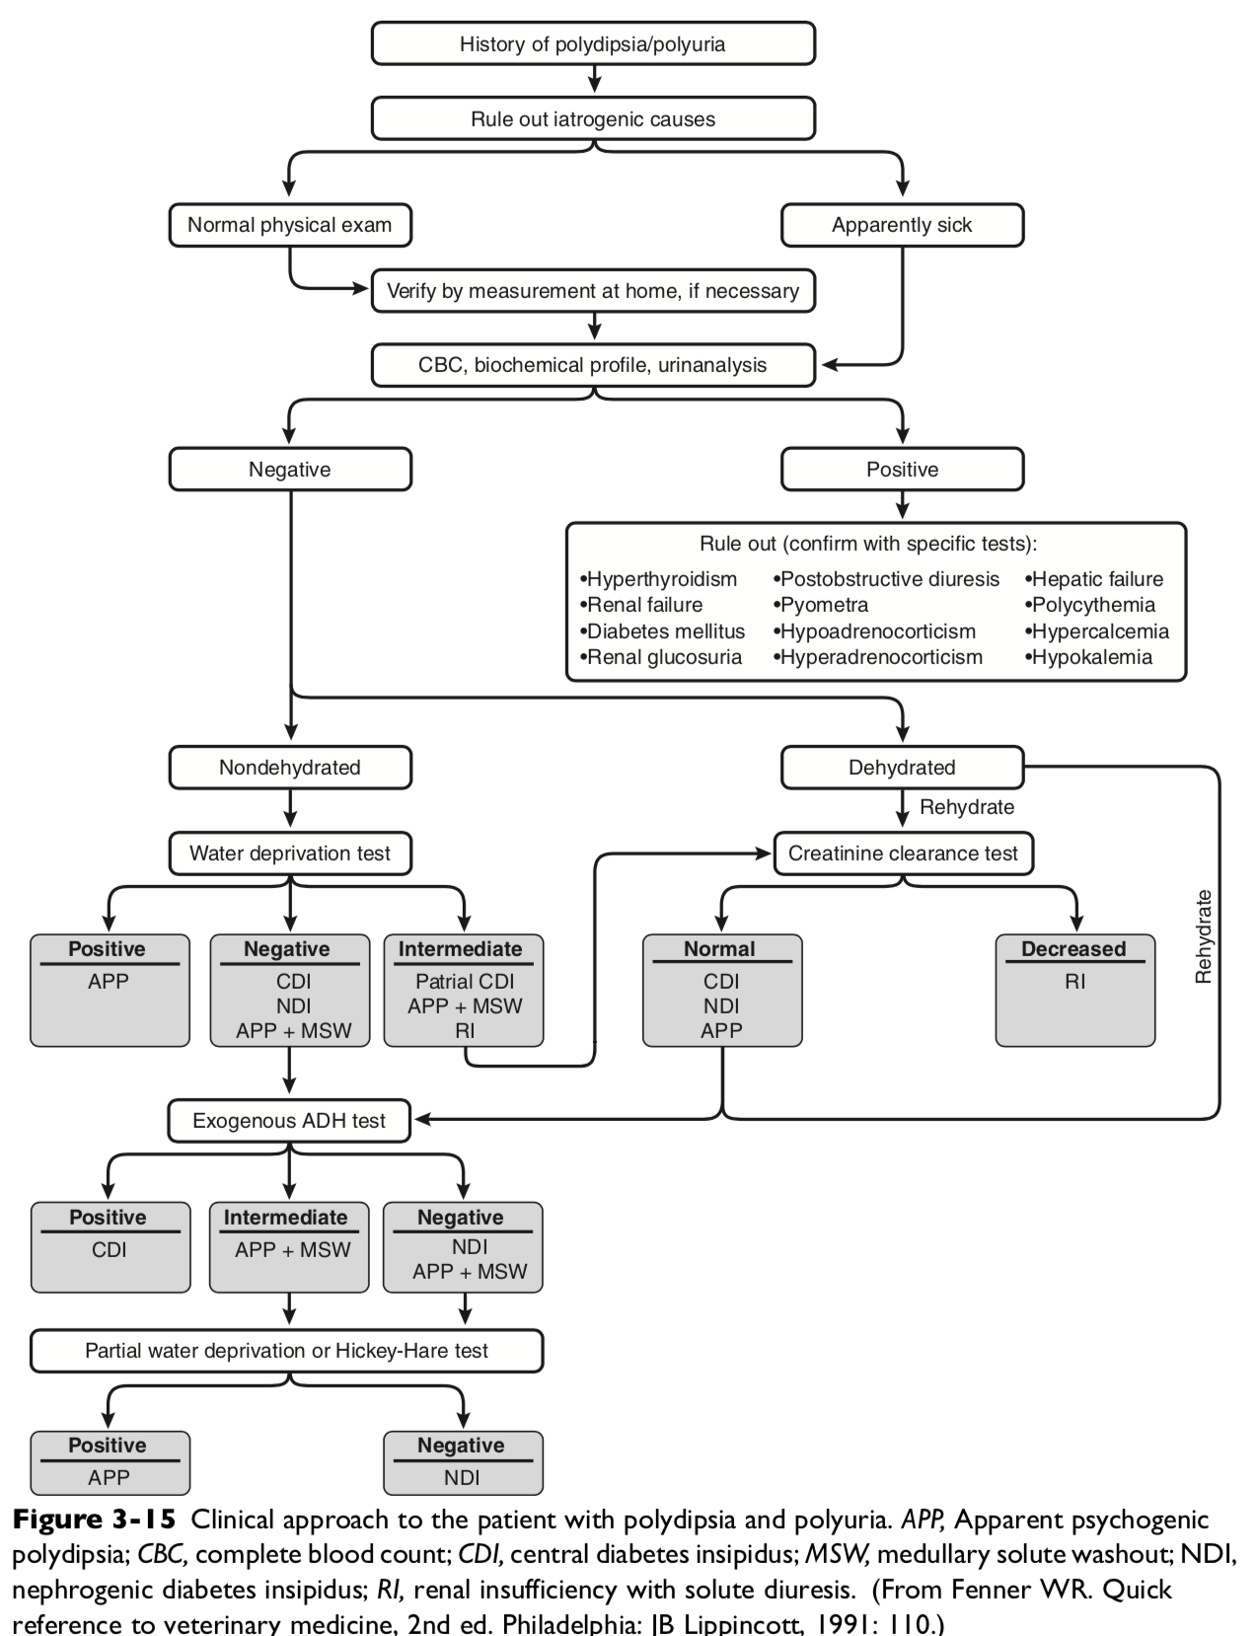

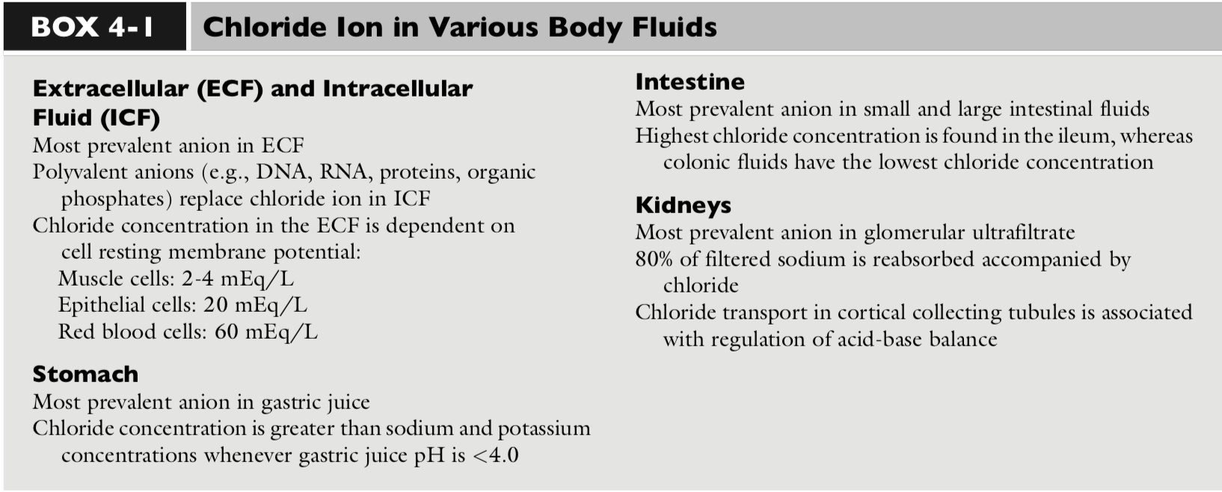
- Chloride constitutes approximately two thirds of the anions in plasma and the remainder of extracellular fluid (ECF). It also is the major anion filtered by the glomeruli and reabsorbed in the renal tubules.
- Chloride is important not only for maintaining osmolality but also actively participates in acid-base regulation.
GI
- Under normal conditions, humans produce 1 to 2 L of gastric juice daily. The sodium concentration ([Na]) and [Cl] of gastric juice is quite variable, ranging from 20 to 100 mEq/L and 120 to 160 mEq/L, respectively.
- In the jejunum, sodium is absorbed actively against small electrochemical gradients and also through relatively large mucosal “pores” in the proximal bowel. Chloride absorption in the jejunum generally follows sodium to maintain electroneutrality. It is believed that chloride reabsorption in the jejunum occurs via the paracellular route in response to the transepithelial potential generated by active sodium transport.
- The ileum is less permeable to ions than the jejunum. Absorption of chloride and secretion of bicarbonate in the ileum are coupled by processes that may involve active transport of one or both ions.
- Colon has highly efficient absorption of sodium and chloride, where 90% of the sodium and chloride entering is reabsorbed. There appears to be no direct or indirect coupling between sodium and chloride or bicarbonate reabsorption in the distal colon. Active chloride reabsorption and bicarbonate secretion occur in the distal colon.
- Chloride also can be secreted in the jejunum, ileum, and colon.

Kidneys
- Chloride reabsorption in the proximal tubule is actively and passively linked to active sodium reabsorption. A formate-chloride exchange mechanism exists in the luminal membrane of proximal tubular cells and is responsible for active chloride reabsorption.
- Reabsorbed chloride returns to the systemic circulation at the basolateral membrane primarily by a potassium chloride (K+- Cl-) cotransporter.
- Of filtered chloride, approximately 50% to 60% is reabsorbed by the proximal convoluted and straight tubules.
- Chloride reabsorption occurs transcellularly in the thick ascending limb of Henle’s loop, leading to the generation of a lumen-positive transepithelial voltage. Sodium is reabsorbed transcellularly or paracellularly, and the transepithelial voltage drives the latter process. Chloride ion delivery is the rate-limiting step in this process, and net sodium chloride (NaCl) transport increases directly with fluid [Cl] concentration. Loop diuretics such as furosemide and bumetanide act in the loop of Henle by competing for the chloride site on the Na-K-2Cl carrier.
- Thiazide diuretics act by inhibiting the Naþ- Cl carrier in the early distal tubule, apparently at the chloride site.
- Little is known about chloride transport in the medullary collecting tubules. In the cortical collecting tubules, however, the paracellular pathway, which is highly conductive for chloride ions, is an important route for reabsorption of chloride by diffusion down an electro- chemical gradient.
- Increased urinary loss of chloride is believed to be associated with hyperadrenocorticism.
Chloride and Acid-base balance
- The acid-base status of plasma is regulated by changing Pco2 in the lungs and SID in the kidneys, the latter being accomplished mainly by differential reabsorption of sodium and chloride ions in the renal tubules.
Metabolic acidosis
- Metabolic acidoses are traditionally divided into hyperchloremic (normal anion gap [AG]) and normochloremic (high AG) based on the AG and [Cl].
  - The AG is the difference between measured cations (sodium and potassium) and measured anions (chloride and bicarbonate).
  - Physiologically, there is no AG because electroneutrality must be maintained and the AG is the difference between the unmeasured anions (UA) and unmeasured cations (UC). The AG is a simplification that is helpful clinically.
- Metabolic acidosis usually results from an increase in the concentration of a strong anion.
  - Strong anions are anions that are completely dissociated at the pH of body fluids (e.g., Cl, lactate, ketoanions).
  - If the strong anion added is chloride, the sum of the measured anions ([Cl] þ [HCO3]) will remain the same, and the AG will not change (so-called hyperchloremic or normal AG acidosis).
  - If the strong anion added is an unmeasured anion (e.g., lactate), [Cl] will remain normal, whereas [HCO3] will decrease. The sum of the measured anions will decrease, thus increasing the AG (so-called normochloremic or high AG acidosis).
Metabolic alkalosis
- Chloride participates in the genesis, maintenance, and correction of metabolic alkalosis because decreases in [Cl] increase SID, causing metabolic alkalosis. The role of chloride is supported by the inverse relationship between chloride and bicarbonate in metabolic alkalosis, the fact that chloride depletion is accompanied by increased plasma [HCO3]
Changes in chloride concentration can result from changes in water balance or can be caused by a gain or loss of chloride. When changes in [Cl] are caused by water balance alterations (i.e., increase or decrease in free water), [Na] also changes. Changes in [Cl] and [Na] are proportional in this setting (e.g., a 10% gain in free water decreases [Cl] and [Na] by 10%). To account for changes in water balance, [Cl] must be evaluated in conjunction with evaluation of changes in [Na]. Therefore, patient [Cl] is “corrected” for changes in [Na] concentration:
