Reminder of definitions:
- Osmolality =
- Osmolarity =
- How to calculate plasma osmolality? What is normal dog and cat plasma osmolality?
- Tonicity (AKA effect osmolality) =
Name two examples impermeant solutes
- Diuresis =
  - Osmotic diuresis =
Name two examples that cause this:
  - Water diuresis =
Name to examples that cause this:

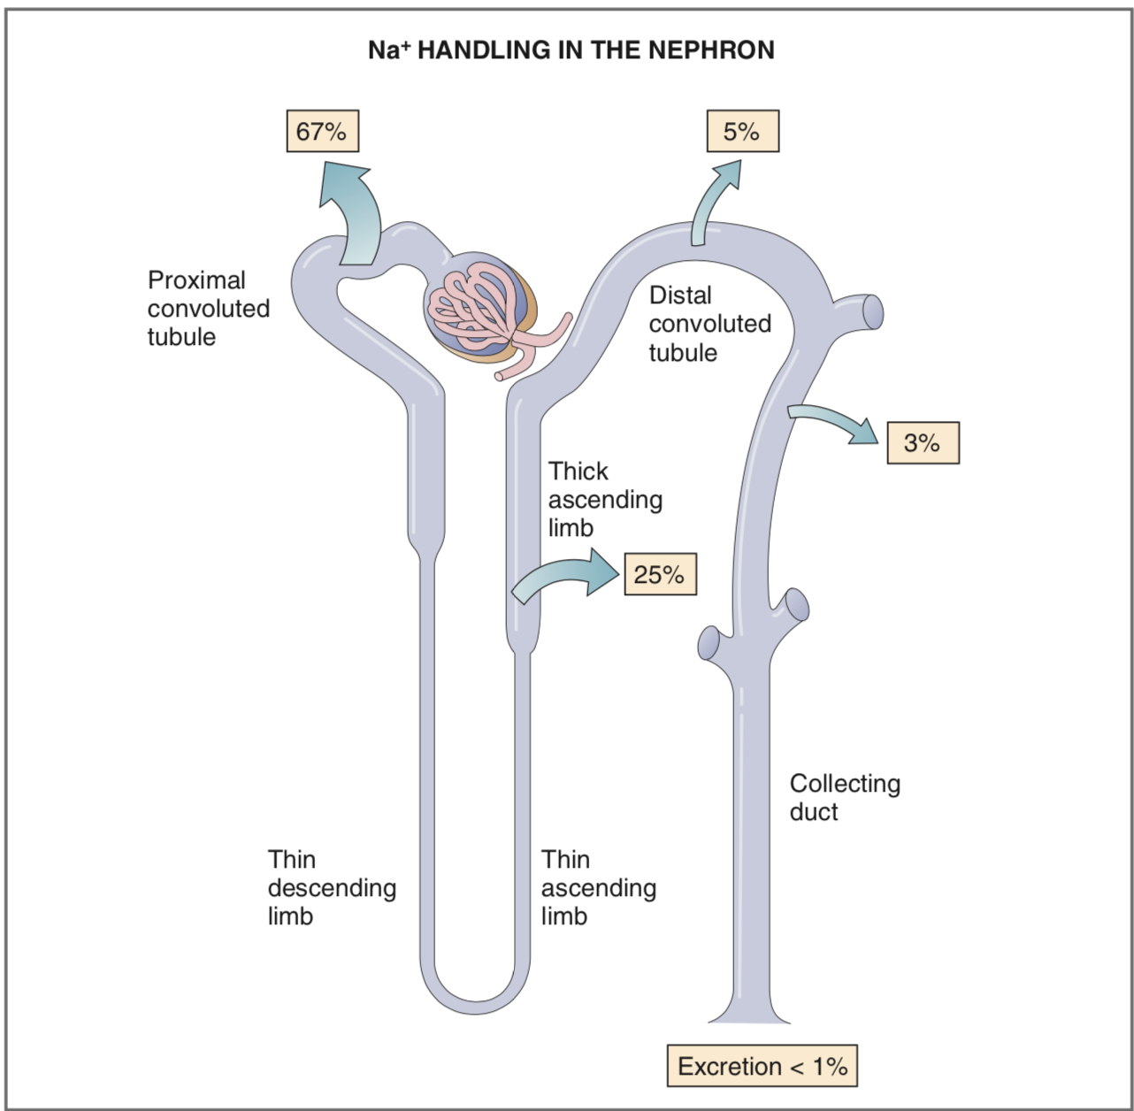

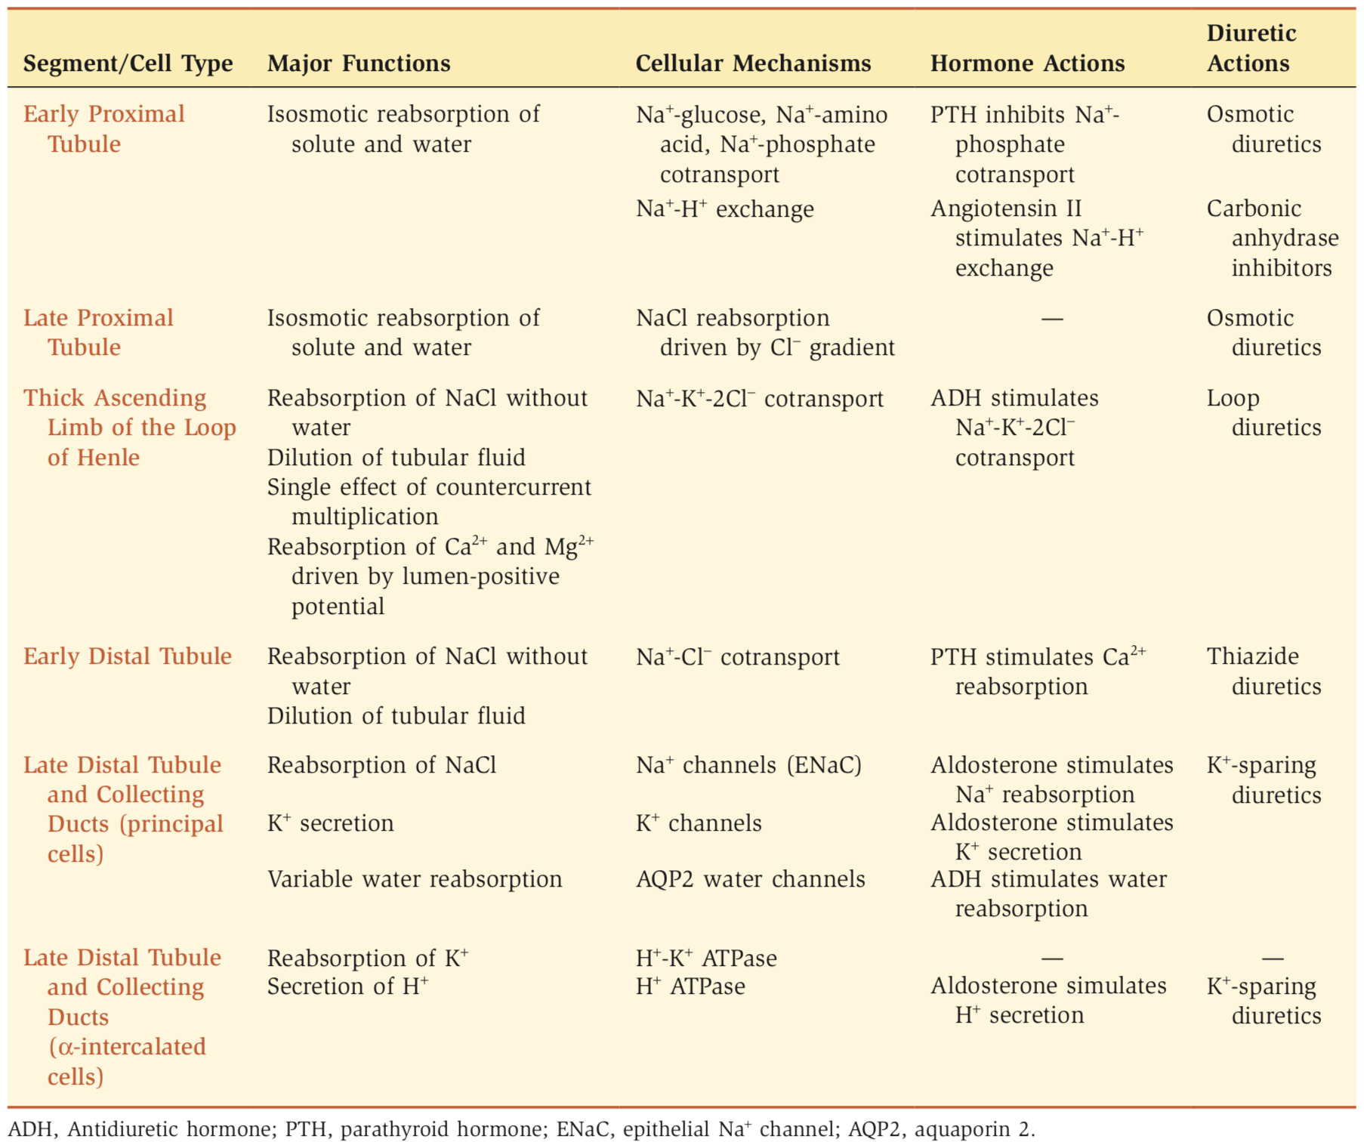
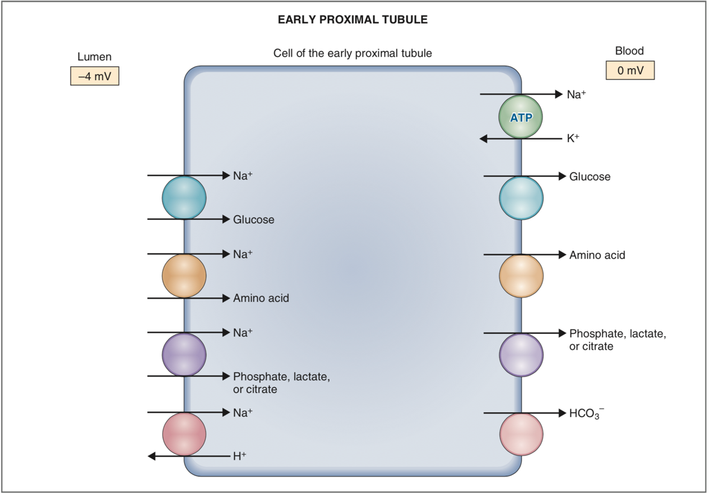
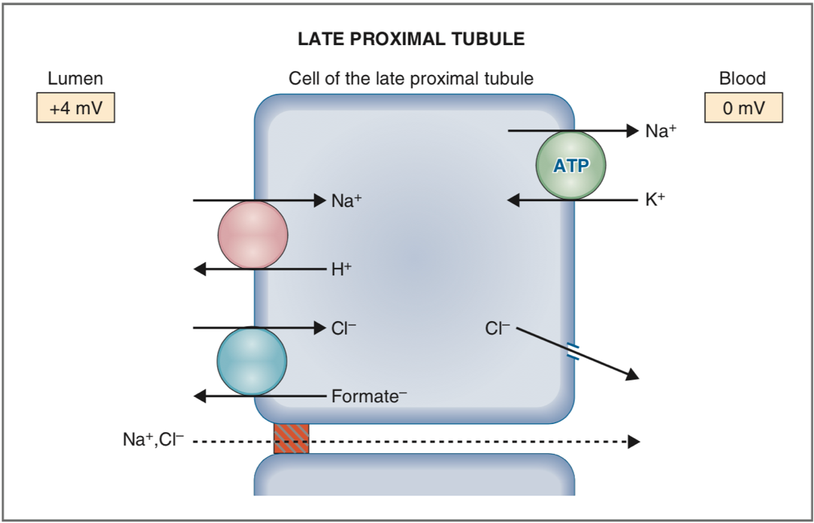
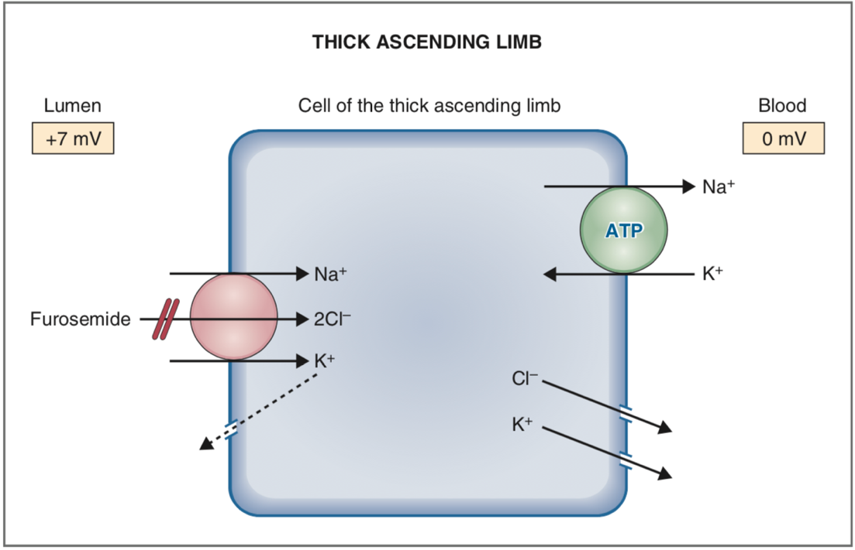
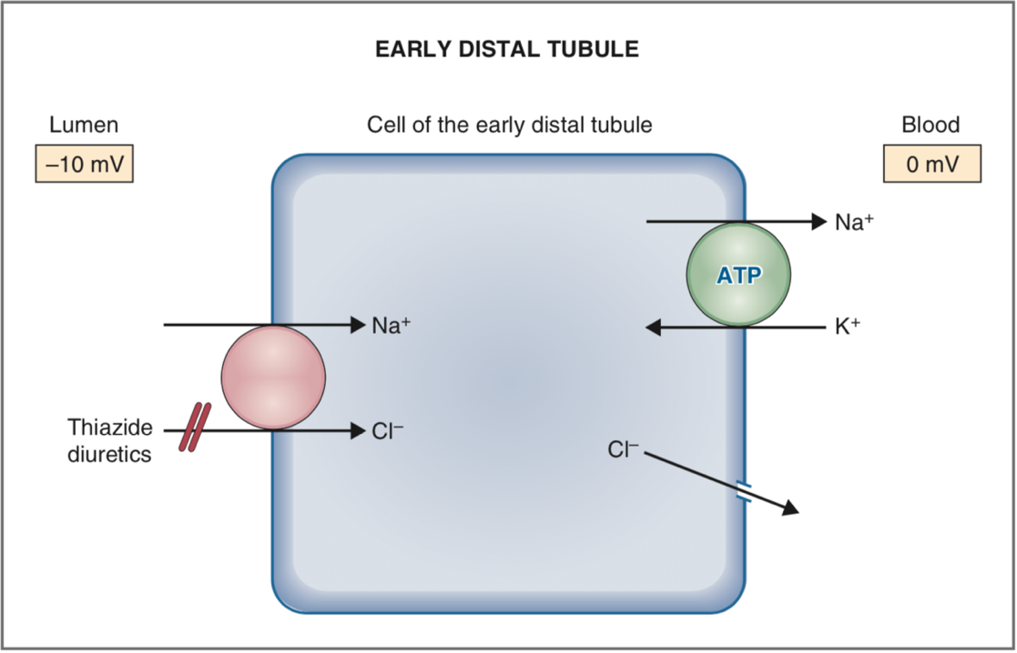
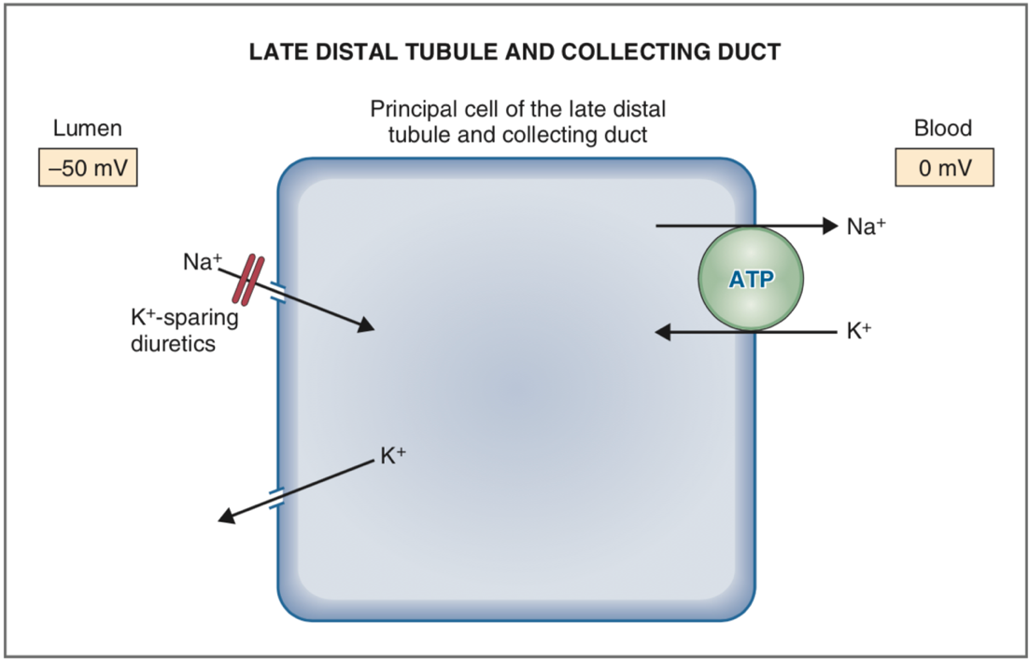

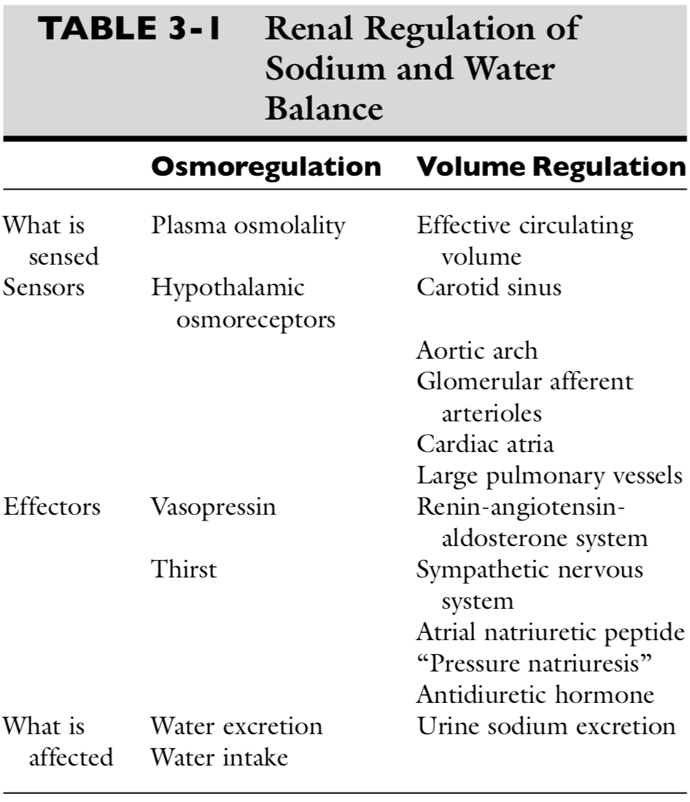

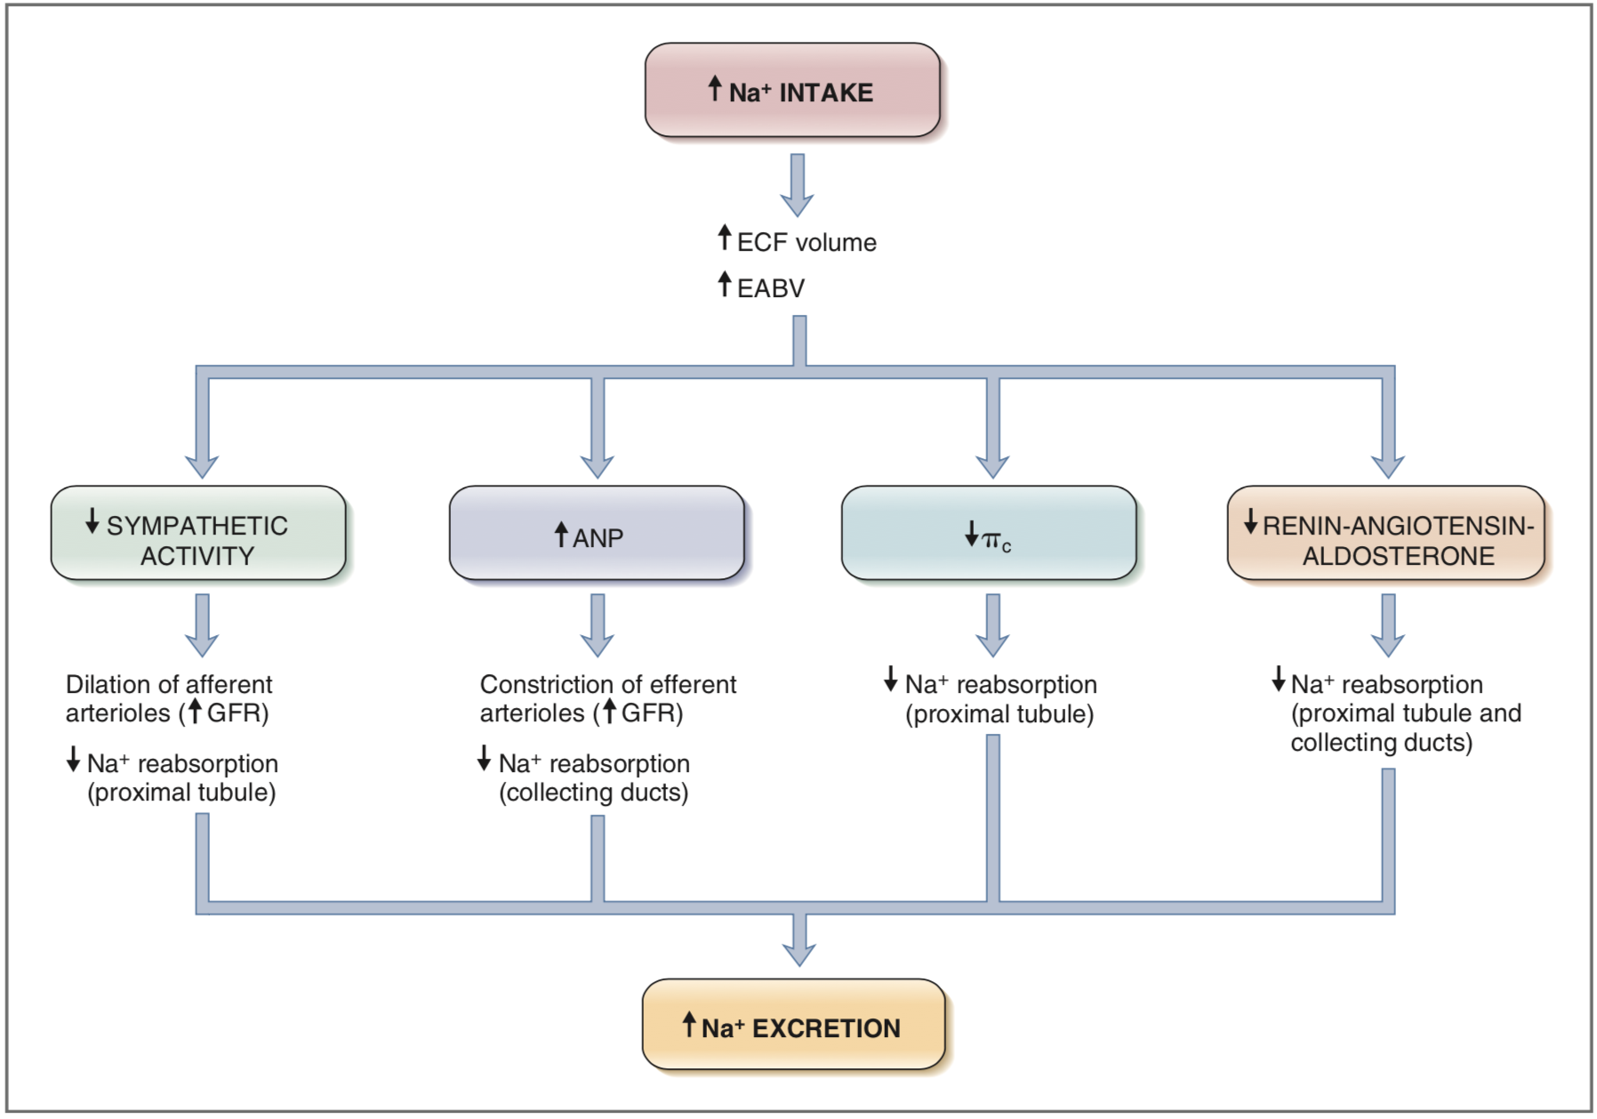

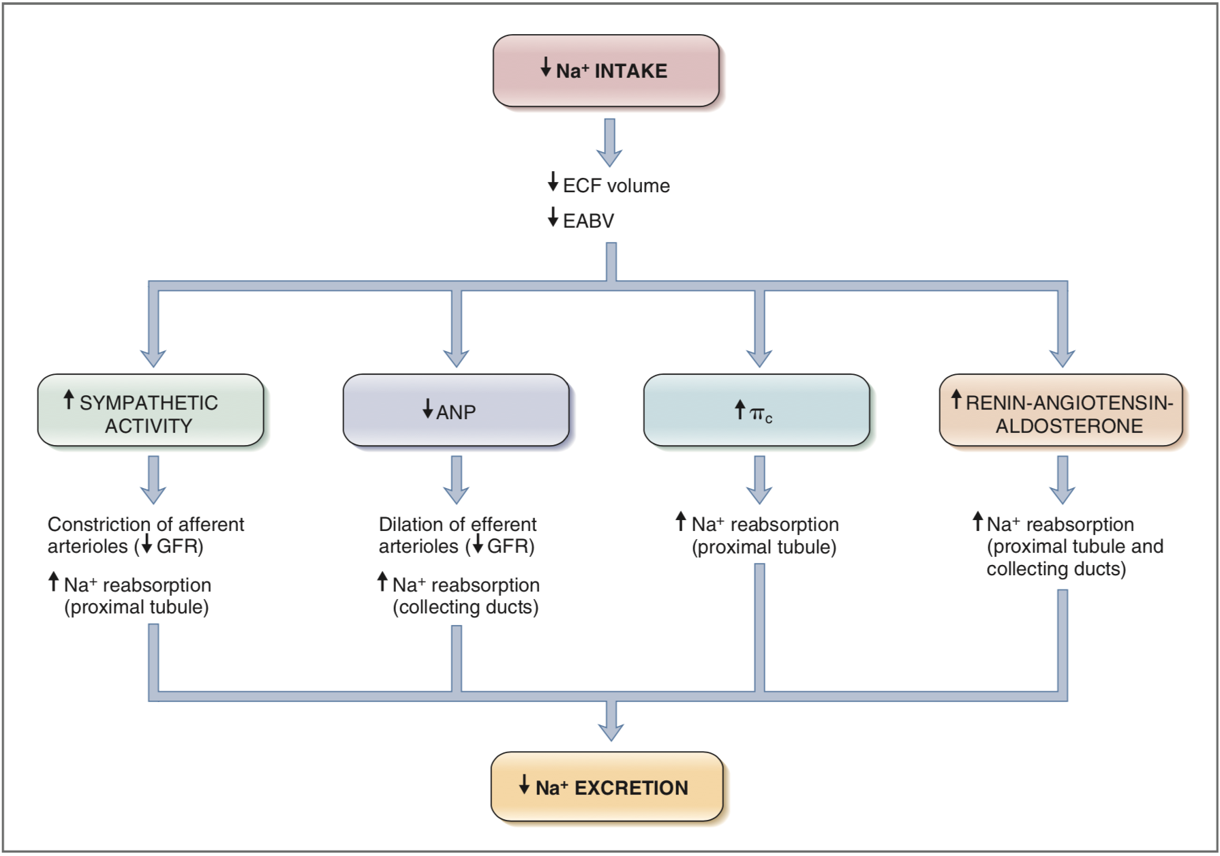

Regulation of water balance:
- The osmolality of ECF and serum sodium concentration are regulated by adjusting water balance.
- Afferent limb (sensors) =
- Efferent limb = _________________ water output and _____________ for water input
  - ____ release is _________ when the osmoreceptors ______ in response to plasma hyperosmolality and is __________ when they _______ in response to plasma hypoosmolality.
Vasopressin (Antidiuretic hormone [ADH])
- Amino acid peptide synthesized in neurons of supraoptic and paraventricular nuclei in hypothalamus, travel down axons of neurons and released into circulation at level of neurohypophysis
- Mechanism of action:
  - Increases reabsorption of water in collecting ducts of kidneys and increase permeability of medullary collecting ducts to urea
  - Vasopressin attaches to V2 receptors on basolateral membranes of principal cells of cortical and medullary collecting ducts
  - Hormone-receptor complex activates Gs regulatory protein causing GDP to GTP replacement and stimulation of adenyl cyclase in cell membrane
  - Formation of cAMP results in activation of protein kinase A, which phosphorylates aquaporin 2 protein found in membranes of subapical vesicles in cytoplasm of principal cells
  - This results in insertion of aquaporin 2 water channels in luminal membranes of principal cells
  - V1a receptors are on vascular smooth muscle, causing vasoconstriction when vasopressin binds
  - V1b receptors are found primarily in hypothalamus where vasopressin binding increases secretion of corticotrophin
- Stimulus
  - Hypertonicity of plasma reaching osmoreceptors of hypothalamus
  - Volume depletion sensed by baroreceptors of left atrium, aortic sinus, and carotid sinuses
  - Nausea/pain/anxiety

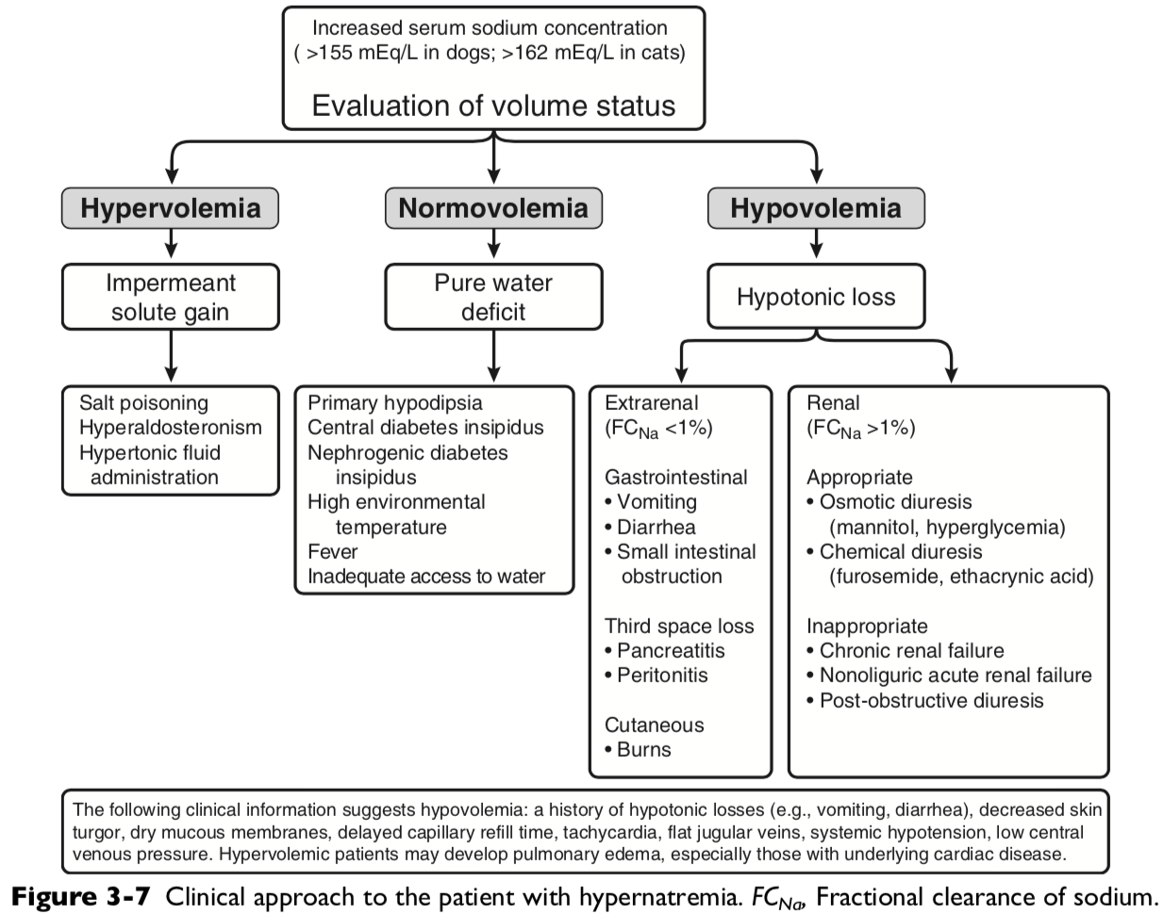

Equation for Water deficit = Wt (present) x ( [Na(current)/Na (previous)] – 1)

Ex: 10kg dog current serum sodium concentration 170mEq/L, normal 145 mEq/L. what is water deficit?
To determine how long to give it over, we want no more than 0.5mEq/L per hour. 170mEq/L-145mEq/L – 25mEq/L divide by 0.5mEq/L/hr = 50hours
= 10 x 0.6 x ([170/145]-1) = 1.03L over fifty hours = 20.6mL/hr

Correction should be less than 10-12mEq/L per 24 hours (0.4-0.5mEq/L/hr) in chronic or unknown duration
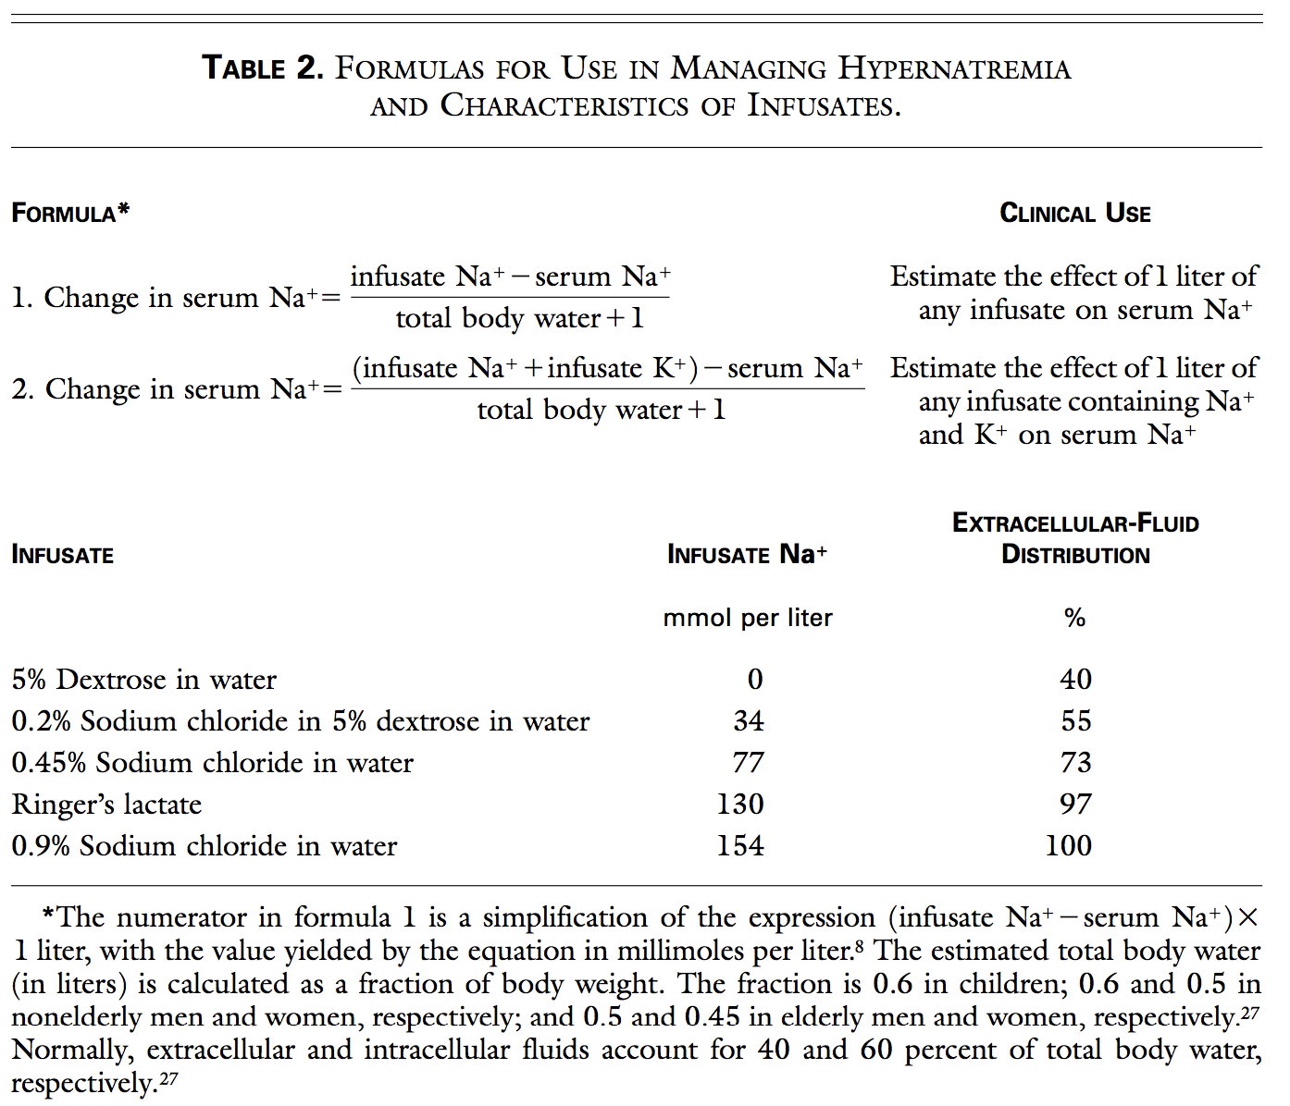
Calculate how much D5W a 10kg dog with serum sodium at 170mmol/L would need to decrease serum sodium concentration 25. At what rate would you give it?
The estimated volume of total body water is 6 liters (0.6x10kg). The retention of 1 liter of 5 percent dextrose is estimated to decrease the serum sodium concentration by 24.28 mmol per liter ([0-170]÷ [6+1]=-24.28). To reduce the serum sodium concentration by 25 mmol per liter, no faster than 0.5mmol/L per hour, over a period of fifty, 1.03 liters of 5 percent dextrose will be infused at a rate of 20.6 ml per hour.

Central diabetes insipidus
- Causes partial or complete lack of vasopressin production and release from neurohypophysis
- ddx: trauma, neoplasia, or idiopathic.
- Clinical signs: severe PU/PD, hyposthenuric, +/- neurologic signs
- Complete CDI USG 1.001-1.007 with no change with dehydration
- Partial CDI USG 1.002-1.016 to 1.010-1.018 with 5% dehydration
- Treatment:
  - Vasopressin restores medullary hypertonicity and normal urinary concentrating ability
  - desmopressin (DDAVP) structural analogue of vasopressin with more potent antidiurectic effect than vasopressin, but minimal vasopressive effect.
Nephrogenic diabetes insipidus: structural or functional abnormalities interfere with ability of kidneys to concentrate urine
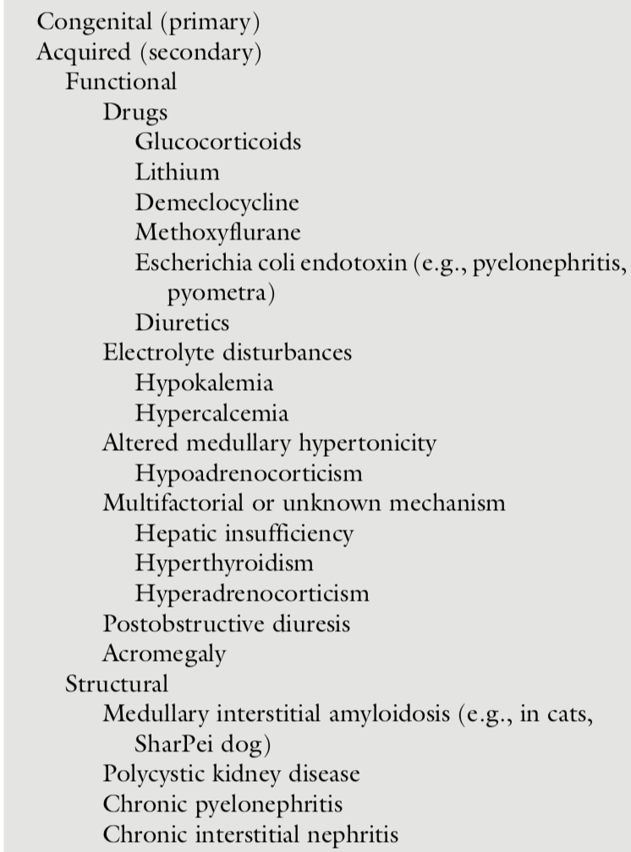

Clinical signs of hypernatremia:
- Neurologic signs related to osmotic movement of water out of brain cells
  - Rapid decrease in brain volume may cause rupture of cerebral vessels and focal hemorrhage
  - Severity of signs related to rapidity of onset of hypernatremia, rather than magnitude
  - Usually seen with serum sodium concentration >170mEq/L
  - If hypernatremia develops slowly, brain adapts to hypertonic state by production of intracellular solutes called osmolytes or idiogenic osmoles
- Anorexia, lethargy, vomiting, muscle weakness, behavioral change, disorientation, ataxia, seizures, coma, and death

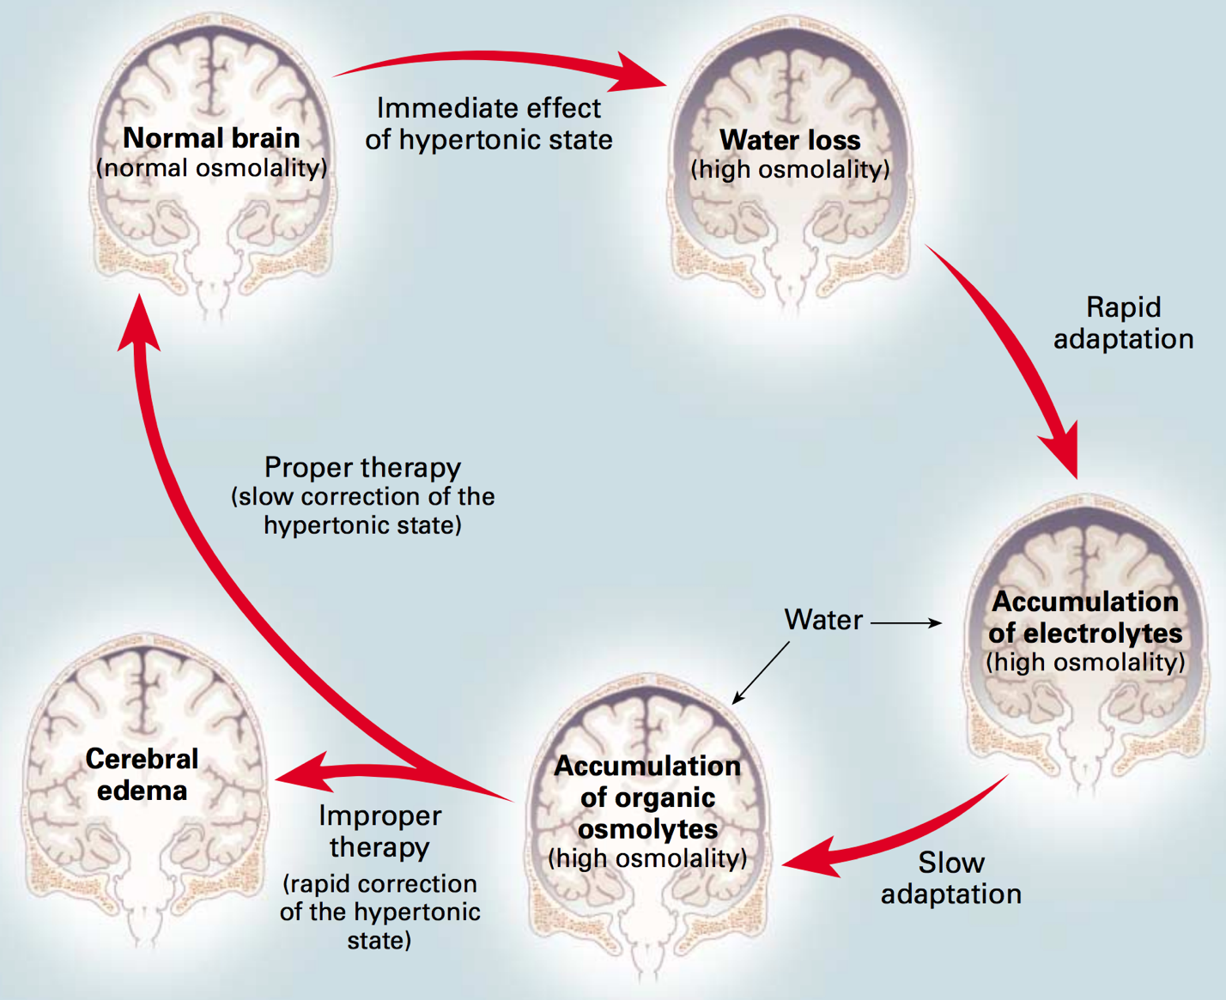
Figure 2. Effects of Hypernatremia on the Brain and Adaptive Responses. Within minutes after the development of hypertonicity, loss of water from brain cells causes shrinkage of the brain and an increase in osmolality. Partial restitution of brain volume occurs within a few hours as electrolytes enter the brain cells (rapid adaptation). The normalization of brain volume is completed within several days as a result of the intracellular accumulation of organic osmolytes (slow adaptation). The high osmolality persists despite the normalization of brain volume. Slow correction of the hypertonic state reestablishes normal brain osmolality without inducing cerebral edema, as the dissipation of accumulated electrolytes and organic osmolytes keeps pace with water repletion. In contrast, rapid correction may result in cerebral edema as water uptake by brain cells outpaces the dissipation of accumulated electrolytes and organic osmolytes. Such overly aggressive therapy carries the risk of serious neurologic impairment due to cerebral edema.
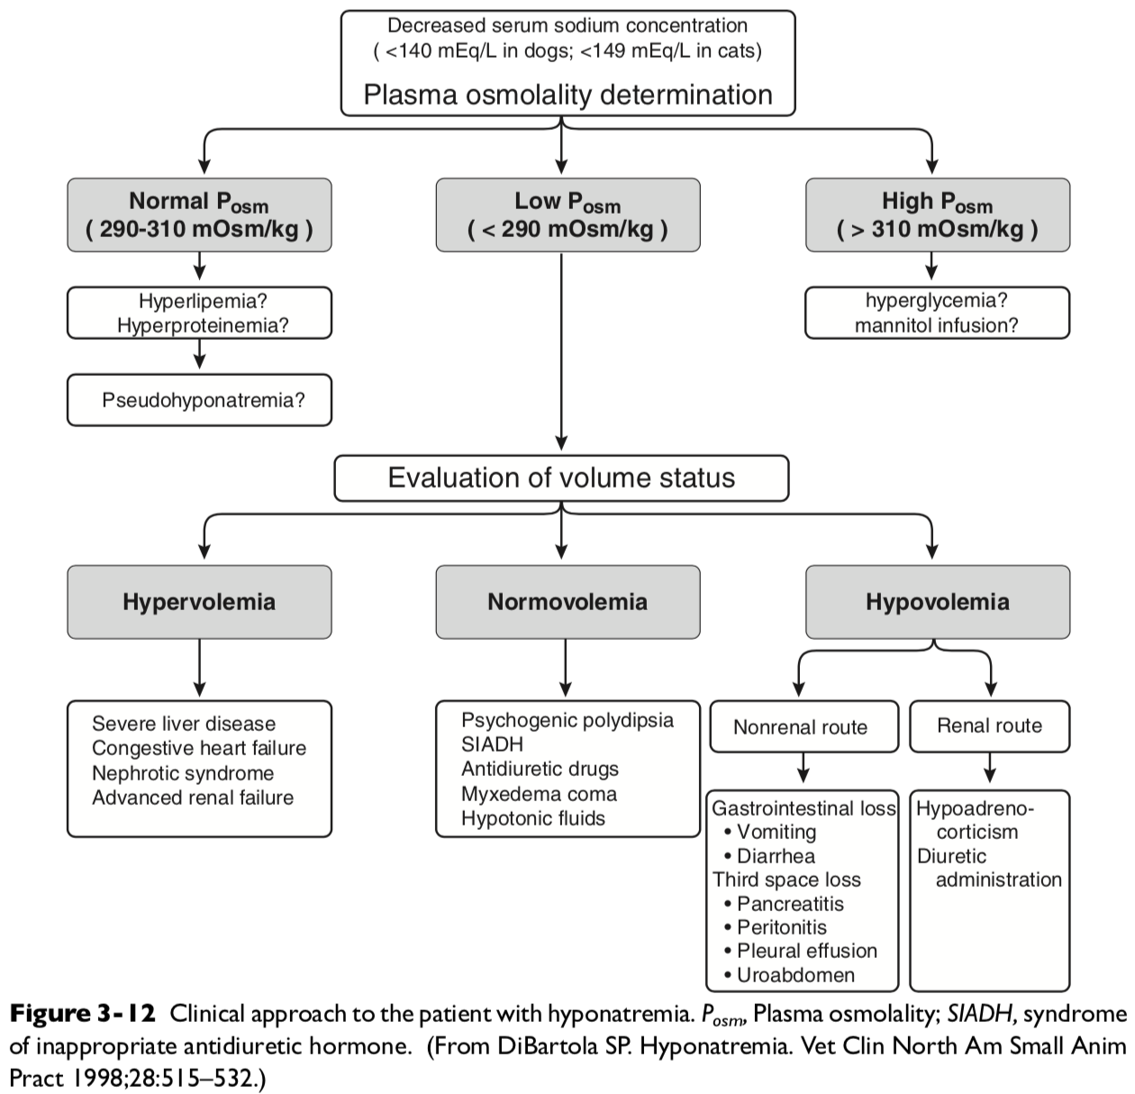

Syndrome of Inappropriate ADH secretion (SIADH)
- Inappropriate vasopressin release in absence of normal osmotic or nonosmotic stiumi
- Rare in dogs, reported in association of dirofilariasis, undifferentiated carcinoma, neoplasia in region of hypothalamus, hydrocephalus, idiopathic
The diagnosis of SIADH must be made by excluding other causes of hyponatremia. The following criteria should be met before establishing a diagnosis of SIADH:
- Hyponatremia with plasma hypoosmolality.
- Inappropriately high urine osmolality in the presence of plasma hypoosmolality. (Urine osmolality is often >300 mOsm/kg in human patients with SIADH. A urine osmolality >100 mOsm/kg should be considered abnormal in a patient with hyponatremia and plasma hypoosmolality. A urine osmolality <100 mOsm/kg would normally be expected as a result of complete suppression of vasopressin release. Urine osmolality is important in distinguishing psychogenic polydipsia and SIADH. Urine is maximally diluted in psychogenic polydipsia but not in SIADH.)
- Normal renal, adrenal, and thyroid function.
- Presence of natriuresis despite hyponatremia and plasma hypoosmolality as a result of mild volume expansion (urine sodium concentration usually >20 mEq/L in human patients).
- No evidence of hypovolemia, which could result in nonosmotic stimulation of vasopressin release.
- No evidence of ascites or edema, which could result in hypervolemic hyponatremia (i.e., no evidence of severe liver disease, congestive heart failure, or nephrotic syndrome).
- Correction of hyponatremia by fluid restriction.
Clinical signs of hyponatremia
- Related to rapidity of onset rather than severity
- Deaths and severe complication seen when acutely decreased Na <120mEq/L or rate greater than 0.5mEq/L/hr.
- Cerebral edema and water intoxication
- Chronic hyponatremia can have no clinical signs due to brain volume adjusted toward normal by loss of potassium and organic osmolytes from cell
- When corrected, potassium and organic osmolytes lost must be restored to cells in brain. If replacement of these solutes do not keep pace with increase in serum sodium, lead to grain dehydration and injury = osmotic demyelination or myelinolysis
- Complications of severe and rapidly evolving hyponatremia include seizures, coma, permanent brain damage, respiratory arrest, brain-stem herniation, and death.
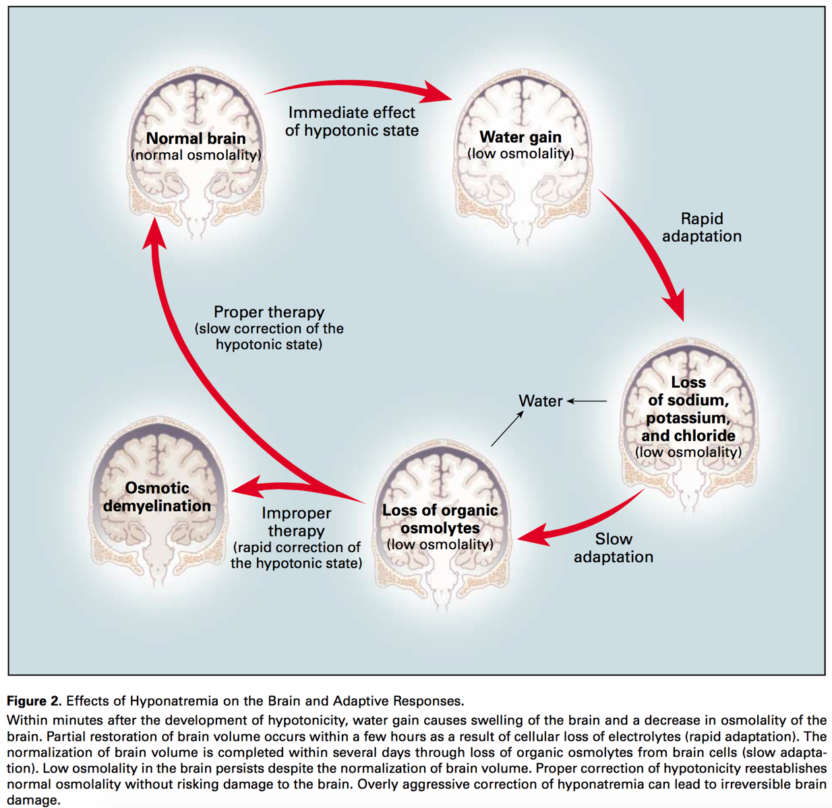
Treatment:
- Asymptomatic chronic hyponatremia be treated by mild water restriction and monitoring of serum sodium concentration.
- Symptomatic dogs with chronic hyponatremia treated conservatively at correction rates of less than 10 to 12 mEq/L/ day (0.5 mEq/L/hr).
- Serial monitoring of serum sodium concentration is necessary because the actual rate of correction may not correspond to the calculated rate of correction.
- Correction should be carried out with conventional crystalloid solutions (e.g., lactated Ringer’s solution and 0.9% NaCl) in a volume calculated specifically to replace the patient’s volume deficit.
- Remember that volume repletion in hypovolemic patients abolishes the nonosmotic stimulus for vasopressin release and allows the animal to excrete solute-free water via the kidneys. This in itself tends to correct the hyponatremia. Thus, caution should be exercised even when using conventional crystalloid fluid therapy.
- Water intake should be carefully restricted to a volume less than urine output in normovolemic patients with hyponatremia (e.g., psychogenic polydipsia), or drugs causing an antidiuretic effect should be discontinued if possible.
- Demeclocycline and lithium inhibit vasopressin release and have been used to treat SIADH in humans, but water restriction is probably the safest approach
- In edematous patients, dietary sodium restriction and diuretic therapy should be considered. A 0.9% NaCl solution can be administered concurrently with loop diuretics to effect more rapid correction of hyponatremia in overhydrated symptomatic patients.
- Arginine vasopressin (AVP) receptor antagonists (vaptans) block either V2 receptors (lixivaptan, tolvaptan, satavaptan) or both V2 and V1A receptors (conivaptan). Based on their mechanism of action, these drugs increase free water excretion by the kidneys and effectively normalize serum sodium concentration in patients with non-osmotic release of AVP causing euvolemic (e.g., SIADH) or hypervolemic (e.g., congestive heart failure, liver failure) hyponatremia.
  - Conivaptan is administered as an intravenous bolus in 5% dextrose followed by a constant rate infusion, whereas tolvaptan, lixivaptan, and satavaptan are administered orally.
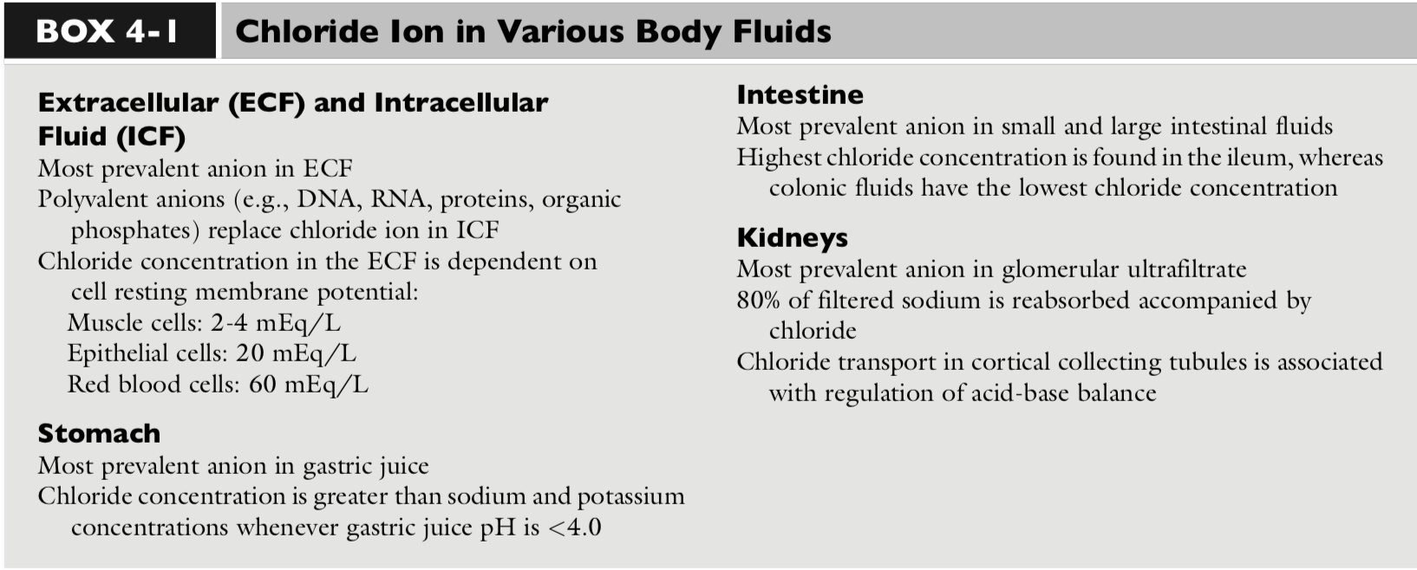

Kidneys
- Proximal tubule: Chloride reabsorption is actively and passively linked to active sodium reabsorption. A formate-chloride exchange mechanism exists in the luminal membrane of proximal tubular cells and is responsible for active chloride reabsorption.
  - Reabsorbed chloride returns to the systemic circulation at the basolateral membrane primarily by a potassium chloride (K+- Cl-) cotransporter.
  - Of filtered chloride, approximately 50% to 60% is reabsorbed by the proximal convoluted and straight tubules.
- Thick ascending limb of Loop of Henle: Chloride reabsorption occurs transcellularly, leading to the generation of a lumen-positive transepithelial voltage. Sodium is reabsorbed transcellularly or paracellularly, and the transepithelial voltage drives the latter process. Chloride ion delivery is the rate-limiting step in this process, and net sodium chloride (NaCl) transport increases directly with fluid [Cl] concentration. Loop diuretics such as furosemide and bumetanide act in the loop of Henle by competing for the chloride site on the Na-K-2Cl carrier.
- Thiazide diuretics act by inhibiting the Naþ- Cl carrier in the early distal tubule, apparently at the chloride site.
- Collecting ducs: Little known in the medullary collecting tubules. In the cortical collecting tubules, chloride reabsorption by the paracellular pathway, which is highly conductive for chloride ions, is an important route by diffusion down an electro- chemical gradient.
- Increased urinary loss of chloride is associated with hyperadrenocorticism.

What are two causes of change in chloride concentration?
Changes in water balance or a gain/loss of chloride. When changes in [Cl] are caused by water balance alterations (i.e., increase or decrease in free water), [Na] also changes. Changes in [Cl] and [Na] are proportional in this setting (e.g., a 10% gain in free water decreases [Cl] and [Na] by 10%). To account for changes in water balance, [Cl] must be evaluated in conjunction with evaluation of changes in [Na]. Therefore, patient [Cl] is “corrected” for changes in [Na] concentration.

Because of that, what is the equation for corrected chloride?
