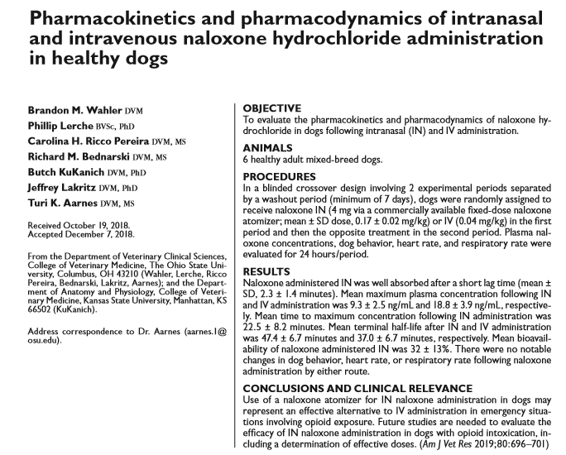
- CPA due to opioid - naloxone at 0.04 mg/kg IV as a reversal agent
- IN naloxone administration described in healthy humans with acceptable efficacy and bioavailability and minimal adverse effects – given as concentrated formulation of naloxone via an atomizer designed for IN administration
- Cross over study where healthy, non narcotized dogs got naloxone IN (4mg via atomizer, fixed dose) or standard dose 0.04mg/kg IV – HR, behavior, RR, plasma concentrations monitored
- No behavior, HR, RR changes
- IN rapidly absorbed, similar half lives, plasma concentration lower likely due to decreased absorption from nasal mucosa
- May be useful in emergency situations
- IV formulation given IN not evaluated, research needed on efficacy when given to dogs with opioid intoxication
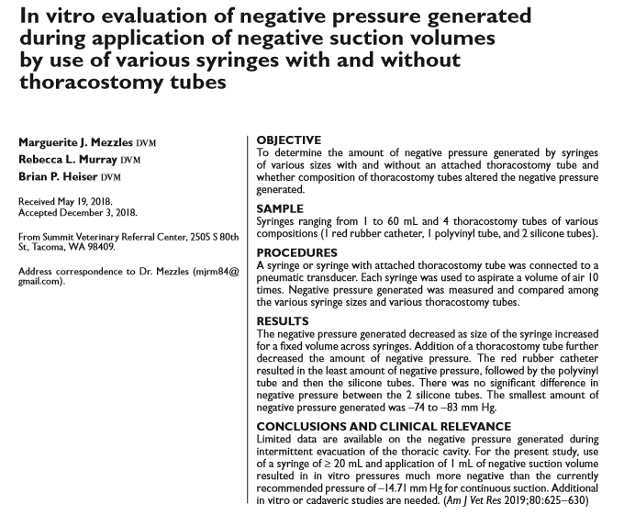
- The normal intrapleural pressure is –3.68 mm Hg (–5 cm H2O)
- Conditions that result in an accumulation of air or fluid in the thoracic cavity cause changes to the intrapleural pressure alteration in respiration, ventilation, perfusion
- Resolve by intermittent evacuation via a thoracostomy tube or continuous suction
- Recommended applied pressure for continuous suction systems is –3.68 to –18.39 mm Hg (–5 to –25 cm H2O) – human literature -14.71 mmHg (-20 cmH2O) standard lower than this = increase chance of reexpansion pulmonary edema
- Limiting amount of negative pressure applied may lower this risk
- No data on how much negative pressure is generated with intermittent suction with syringes
- Results:
  - Unexpected result – negative pressure generated decreased as size of syringe increased (error?)
  - Addition of thoracostomy tube decreased amount of negative suction generated – red rubber created least amount of negative pressure
  - Application of standard 5-10mL negative pressure on a syringe resulted in negative pressures far greater than -14.71mmHg (-20cm H2O recommended)
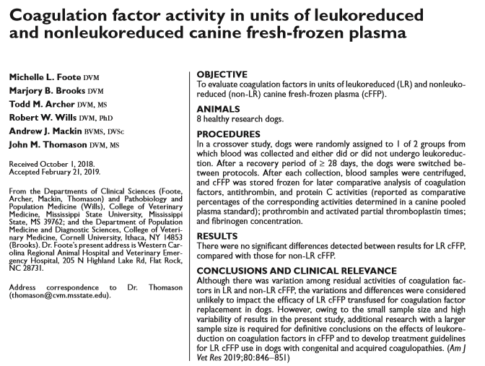
- In humans LR procedures can decrease the residual concentration and function of coagulation factors reducing therapeutic benefit of transfusion product
- LR hFFP has substantially lower concentrations of factors VII, VIII, and XI than non-LR
- LR hFFP has a substantially longer aPTT compared to non-LR though remains w/in ref limits
- Results: canine coagulation factors were not markedly depleted by leukoreduction
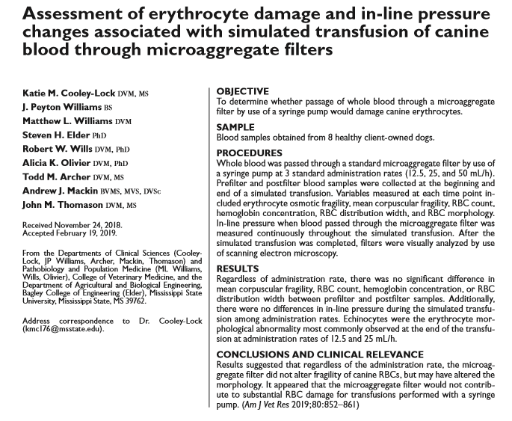
- Objective: determine whether administration of fresh whole blood through a microaggregate filter by use of a syringe pump would alter pressures within the administration line or damage RBCs (shear stress decreasing RBC survival)
- No significant differences were detected for any CBC variables between prefilter and postfilter samples or among administration rates
- Fragility did not differ significantly among administration rates
- There was accumulation of cells and cellular debris on the surface of microaggregate filters during simulated transfusion, but the accumulation did not significantly increase in-line pressure and did not significantly alter erythrocyte morphology and fragility

