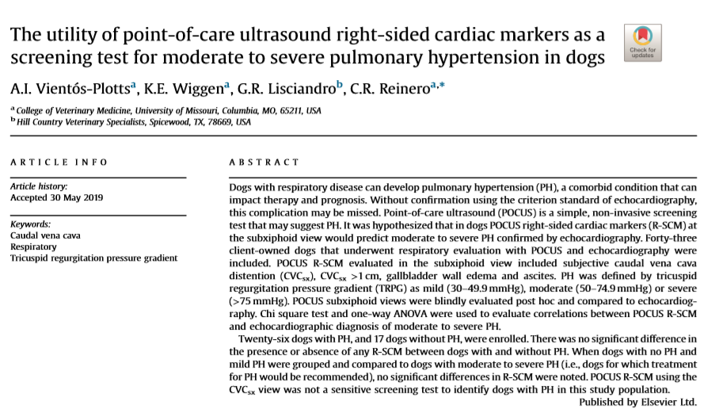

- To determine if right sided cardiac markers in the DH / subxypoid view (subjective CdVC distension, CdVC diameter > 1cm, gallbladder wall edema, ascites) would predict moderate to severe PH (tricuspid regurgitation pressure gradient: 50-75 mmHg -moderate; >75 mmHg severe)

- Results: no difference in dogs with PH vs dogs without PH found; not useful as screening test for dogs is mild, moderate, severe PH vs those without; could not discriminate who would require treatment (moderate-severe PH) vs no treatment (mild PH)

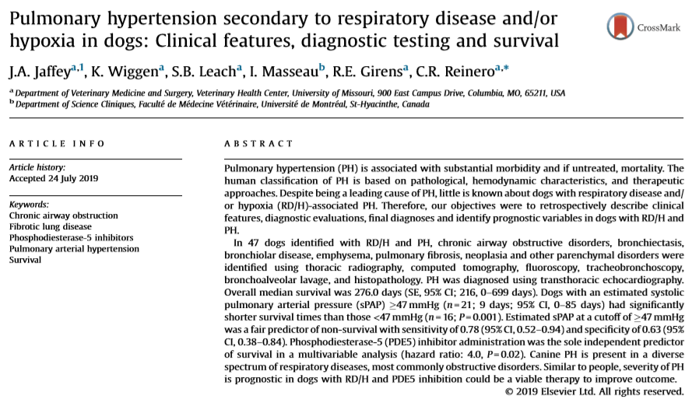
- PH = pulmonary arterial pressure > 30mmHg; can lead to vascular remodeling, R CHF, death
- PH classified into 5 categories: 1) primary PH 2) secondary to left heart disease 3) respiratory disease / hypoxia (RD/H) 4) chronic TE disease 5) unclear/multifactorial
  - Dogs mostly type 2 and 3 (42%, 22% respectively)
  - Often presumptive dx of PH due to RD/H based on exclusion of L heart dz w/o diagnostics to determine underlying etiology
  - Determining if PH is due to restrictive vs obstructive lung disease may impact treatment and prognosis
    - Obstructive: tracheal/MSB collapse, bronchomalacia, BCA, bronchiolar disease, emphysema
    - Restrictive: pulmonary fibrosis, pulmonary neoplasia, pneumonia, uncharacterized parenchymal disease
- Results: dogs with RD/H had at least one clinical sign (cough, resp distress, syncope, wheezing, cyanosis, increased RR/RE, hemoptysis, exercise intolerance)
- Approx 50% had severe PH
- 83% had obstructive airway disease as single pathology
- MST 276 days; PAP > 47mHg had significantly shorter survival time
- Administration of PDE-5i was independent predictor of survival (4x more likely to be alive at any time point compared to dogs who did not receive PDE-5i)

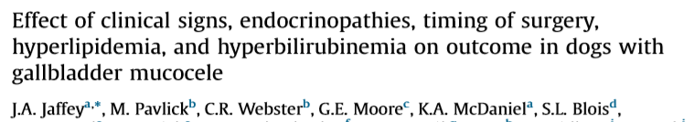
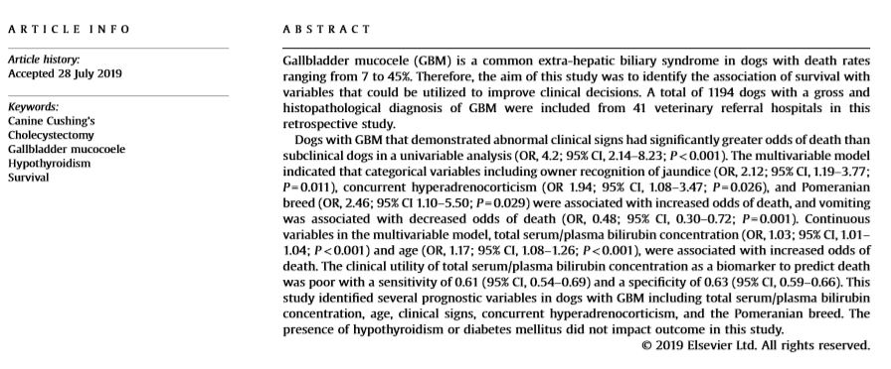
- Objectives: 1) determine if timing of choley after identification of clinical signs was related to survival 2) determine if there was a survival difference in dogs w and w/o signs 3) determine if concurrent HAC, hypoT4, hyperlipidemia impacted survival 4) can Tbili be a prognostic indicator
- 17.6% did not exhibit signs at time of surgery
- 15% in hospital mortality rate
- Factors associated with increased risk of death included clinical signs associated with GBM, owner recognition of icterus, Pomeranian breed, concurrent HAC, increased Tbili
- Tbili by itself was not a good biomarker to predict death
- Timing of recognition of symptoms to choley was not associated with survival

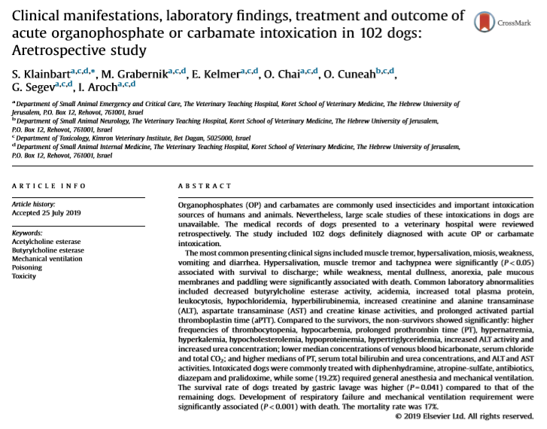
- OPs are phosphoric (H₃PO₄) or thiophosphoric acid (H₃PO₃S) derivatives
- Carbamates are mostly phosphorus-free carbamic acid (NH₂COOH) derivatives
- Both competitively bind to the anionic and esteric sites of acetylcholine esterase (AChE) and butyrylcholine esterase (BuChE) inhibiting them build up of Ach = overstimulation of nicotinic and muscarinic receptors
- Ops bind irreversibly to AChE through a process termed “aging” (necessitating de-novo AChE synthesis)
- Carbamate spontaneously dissociate from binding site (T ½ = 30 – 40 min)
Results:
- The median hospitalization period was 1.8 days
- Common historical and presenting clinical signs included muscle tremors, hypersalivation, miosis, weakness, vomiting and diarrhea
- Presence of weakness, mental dullness, anorexia, pale mucous membranes and paddling
- Mechanical ventilation required in 20% - the need for ventilation was associated with mortality
- Overall mortality rate was 16.7%
- Survival rate in dogs that had gastric lavage was significantly higher

