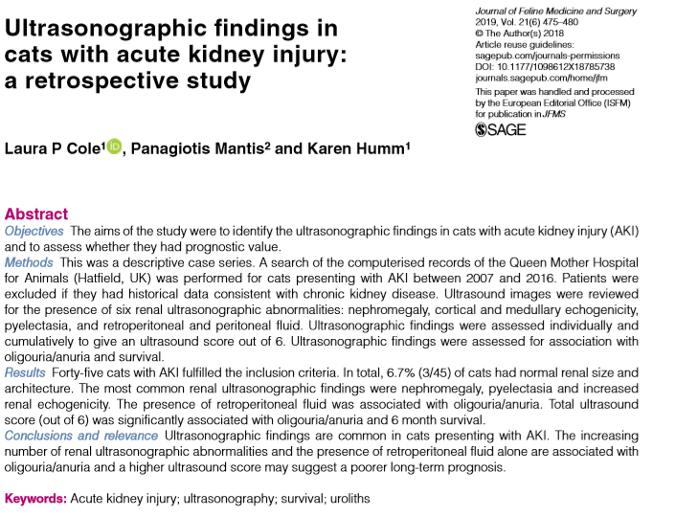
- Published ultrasonographic findings in dogs and cats with AKI include increased renal size, increased cortical echogenicity, the presence of perirenal fluid, medullary rim sign, pyelectasia, increased echogenicity of the perirenal fat and abnormal echogenicity of the urine in the renal pelvis
- Goal of study: identify the ultrasonographic findings in cats with AKI and to assess whether any specific findings had a prognostic value
- Retrospective descriptive case series; AKI based on IRIS guidelines; no history of CKD
- Nephromegaly was present in 68.9% (31/45) - 35.5% had unilateral nephromegaly; pyelectasia was present in 57.8% (26/45) - unilateral in 11.5%, all cats had been on fluid therapy prior to AUS, 75% (3/4) of patients with severe pyelectasia were documented to have uroliths; increased cortical and medullary echogenicity was documented in 40% (18/45) and 51.1% (23/45) respectively
- 42.2% (19/45) survived to discharge and 35.6% (16/45) were alive at 6 months (all that died were euthanized due to their disease)
- No single AUS finding or composite score was correlated with survival to discharge
- There was a statistically significant association between the total ultrasound score and 6 month survival time and presence of oliguria/anuria
- There was a statistically significant association between the presence of retroperitoneal fluid and oliguria/anuria
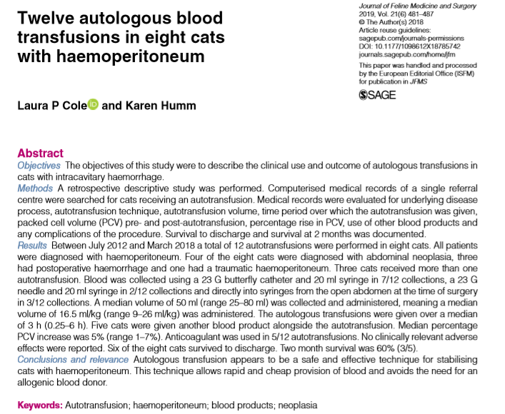

- Goal of study: investigate the frequency and efficacy of feline autotransfusion, as well as describe the reasons for performance of autotranfusion and the methods used (not previously reported in felines)
- Retrospective descriptive study; 8 cats received 12 autotransfusions – 6 type A, 2type B over a 6 year period
- Methods of transfusion: blood was collected using a 23 G butterfly catheter and 20 ml syringe (7/12); a 23 G needle, three-way tap and 20 ml syringe (2/12); and directly into syringes from the open abdomen at the time of surgery (3/12)
- Anticoagulant acid citrate dextrose (ACD-A) was used in 5/12 of the autotransfusions - 0.14 ml of ACD used per 1 ml blood collected, as described in previous studies
- All cases the blood was transfused through an 18 μm blood filter
- Median volume of 50 ml was collected and administered (median volume of 16.5 ml/kg over a median of 3 h; 3 autotransfusions were given in 1 h or less)
- There were no documented reports of urticaria, erythema, increased rectal temperature or other signs of transfusion reaction
- 5/8 cats also received other blood products (FFP, canine blood, feline pRBC, whole blood, oxyglobin)
- Two cats had culture of the abdominal fluid used for autotransfusion – no cytological evidence of bacteria in either sample but one grew enterococcus on culture
- 6/8 cats survived to discharge -no delayed adverse reactions to the autotransfusions were reported in any patient
- Monitoring for post-transfusion hemolysis, coagulopathy and hypocalcemia are recommended post-transfusion

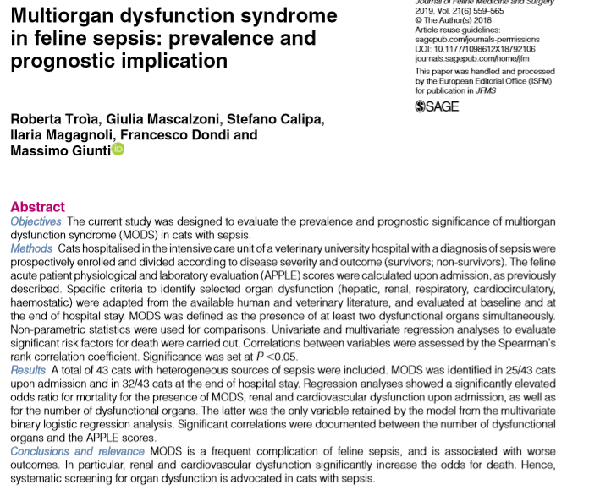
- Frequency and clinical manifestation of sepsis and MODS are less documented in cats
- Biomarkers of feline sepsis - metarubrocytosis, high circulating muscle enzymes (AST, CK), high band neutrophil percentage and elevated serum amyloid A (SAA) concentrations have been investigated though selected organ dysfunctions have been rarely characterized
- Goal of study: investigate and characterize organ dysfunctions and MODS in feline sepsis and determine if occurrence is associated with increased mortality
- Prospective study; include ¾ SIRS criteria + confirmed source of infection; numerous diagnostic tests and lab work performed on admission and APPLE(fast) and APPLE(full) score; organ dysfunction determined based on adaptation from human and canine literature; MODS if >2 organ systems dysfunctional simultaneously
- 43 cats; median age of 5.2yr; major causes of sepsis were pyothorax (13), panleukopenia (11), septic peritonitis (9); others were UTI (3), bacterial cholangiohepatitis (2), endocarditis (1), myocarditis (1), septic arthritis (1), pyelonephritis (1) and ocular abscess (1)
- 26/43 survived
- Lower body temp, higher APPLE(fast) score, lower WBC count, increased volume of fluids given during hospitalization were significantly different for non survivors
- 25/43 had MODS at presentation; 37/43 developed MODS
- The presence of MODS, renal and cardiovascular dysfunction at presentation were significantly associated with increased the risk of death
- The number of dysfunctional organs was associated with a higher APPLE score
- The overall number of dysfunctional organs was the strongest predictor of mortality
