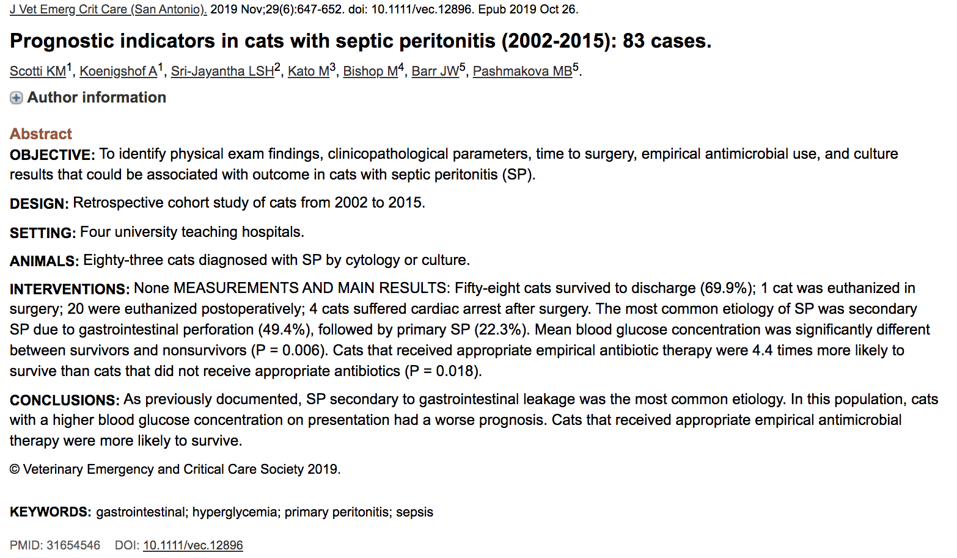

Intro
- GI perforation is the most commonly reported cause of SP in cats, followed by trauma
- Cats can also develop primary SP (no cause identified during exploratory laparotomy)
- Can be mono- or poly- microbial infections
- 60% bacteria cultures are gram positive.
- Previous studies show failure to normalize hypocalcemia and elevated lactate are associated with decreased survival, but no other prognostic indicators have been identified.

Results:
- 83 cases in analysis
- 69.9% survived to discharge
- 41 (~50%) cats had SP due to GI perforation
- 19 (~23%) cats had no identifiable cause for SP
- No difference in survival rate between primary and secondary SP
- 82 (~99%) cats received antimicrobials at presentation
- 70 (~84%) had bacterial culture and sensitivity
- 50 (~60%) were treated with appropriate antimicrobial therapy
- Cats that received appropriate antimicrobials at admission were 4.4 times more likely to survive than cats that did not receive appropriate antimicrobials (80% vs 55% P= 0.018)
- Cats with primary and secondary SP had monomicrobial infections accounting for 28.6% and 30.4%
- Cats with primary and secondary SP had gram negative infections in 55.8% and 56.4% cases resp. and gram positive in 41.9 and 42.7% resp
- No prognostic indicators on CBC
- Chemistry: non-survivors had higher blood glucose admission. Survivors 126.8 +/- 51.94 (7.04 +/-2.88) and non survivors 164.4 +/- 58.42 (9.12 +/- 3.24)
- Not sufficient data for Acute Patient Physiologic and Laboratory Evaluation Scores
- 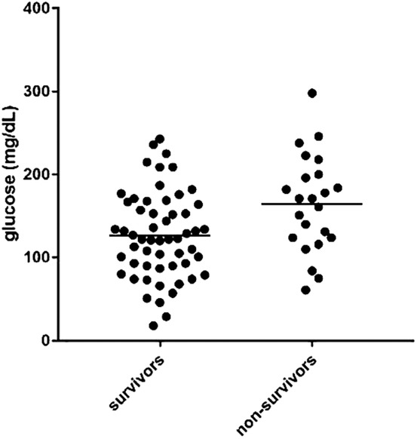
- Discussion – clinical significance? Overlap?
- Too much glucose does bad things: mitochondrial dysfunction, electrolyte abnormalities, platelet activation, osmotic diuresis, dehydration
- Cats have decreased control over hyperglycemia due to decreased activity of hepatic glucokinase (decreased conversion of glucose to glycogen)
- Also associated with increased LOH
- Cats frequently get a stress hyperglycemia in hospital as well.

