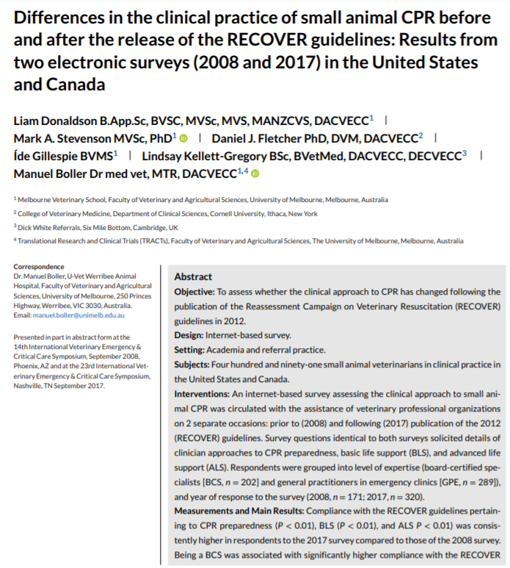
Assessment of 491 veterinarians and their compliance with the RECOVER guidelines in 2008 and 2017. RECOVER was published in 2012.
Performed an internet based survey and assessed details on approaches to CPR preparedness including BLS and ALS
Compliance was higher in the 2017 survey
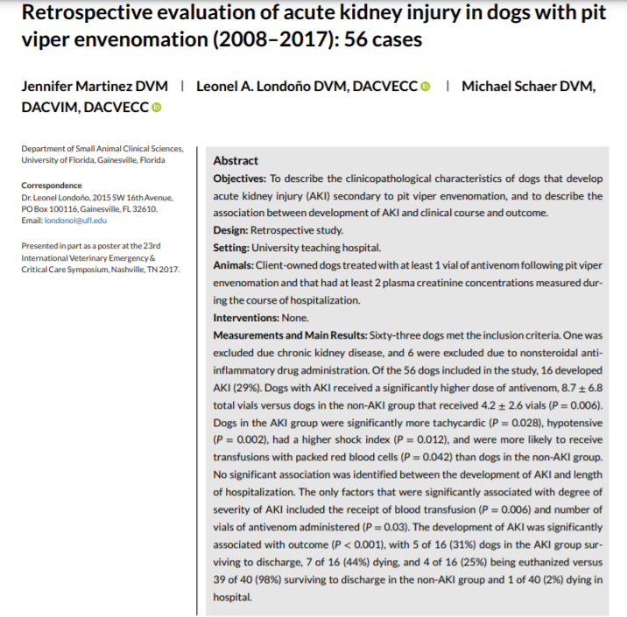
56 cases of client owned dogs that were treated with 1 vial of antivenom and had two plasma creatinine concentrations.
Degree of severity of AKI was associated with receiving blood transfusion and increased numbers of vials of antivenom
Development of AKI significantly associated with outcome.
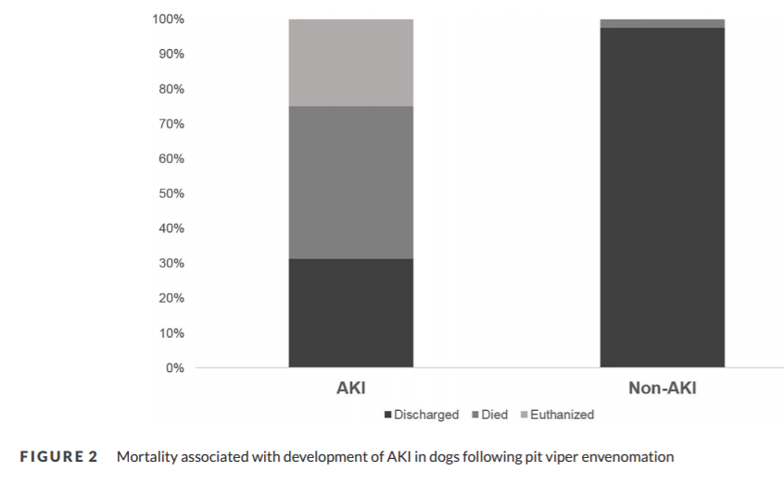
The proposed mechanisms for the development of AKI following snake bite envenomation in people include hemodynamic instability precipitating prerenal AKI, as well as primary renal AKI secondary to the development of rhabdomyolysis and hemolysis causing myoglobinuria and hemoglobinuria, respectively.1
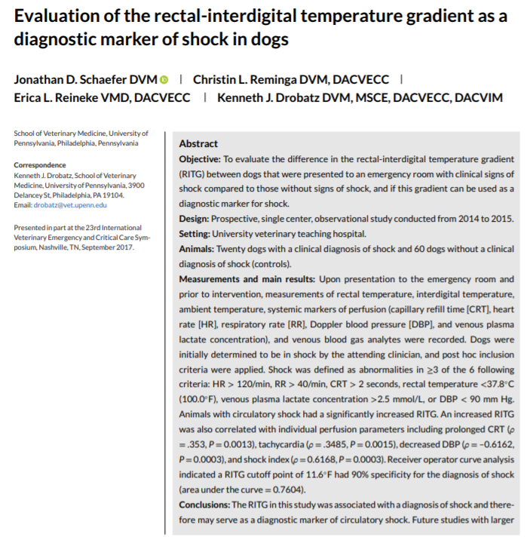
20 dogs with shock, 60 dogs without shock (as controls) Rectal interdigital temperature gradient
RITG of 11.6F was 90% specific for diagnosis of shock!
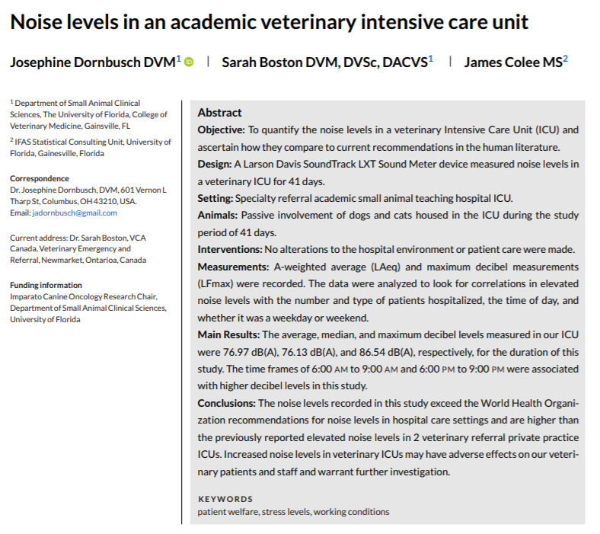
Noise levels in the ICU of specialty referral ICUs were measured for 41 days.
Noise levels were recorded and were noted to be high – specifically higher than the WHO recommends. Also higher than previously reported.
Times that they found to have elevated decibels were 6am, 9am, 6pm, 9pm

