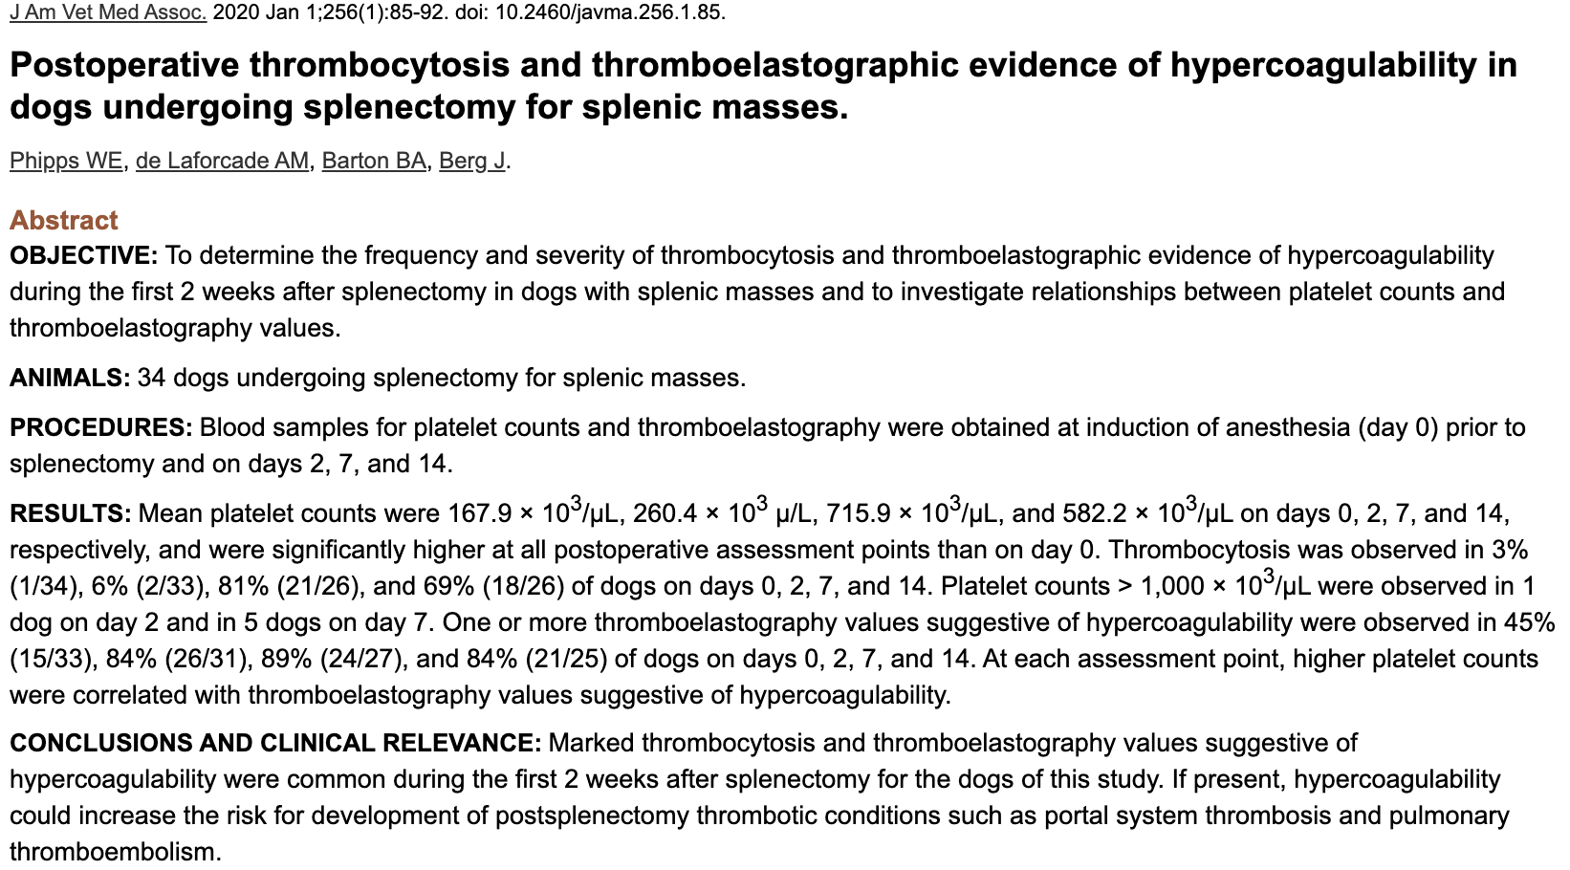

Introduction
- Thromboses of major venous system (portal system thrombosis [PST] or PTE) are important causes of peri-op death
  - Development of PTE or ARDS associated to failure to survive to hospital discharge
  - Dogs who underwent splenectomy had a peri-op mortality rate of 7.6% and most common causes were PST (22% of all death) and PTE (10% of all deaths)
- In people, PST occurs in 5-10% of patients at 2-10 days post-op, peaking at 7-20 days
- Causes of PST unclear but Virchow triad involved (endothelial injury, stasis, hypercoagulability)
  - Loss of filtering function = allow particulate matter and abnormal cells to persist in circulation endothelial damage hypercoagulability
  - Thrombocytosis occur as spleen functions as a reservoir for platelets and usually removes senescent and damaged platelets from circulation, and also reactive thrombocytosis
    - Can contribute to hypercoagulability
    - Mean platelet count higher in splenectomized dogs and the life span was 47% longer splenectomized dogs
- Thromboelastography is superior than routine coagulation testing
  - Dynamic test, able to assess speed and strength of clot formation
  - Limitations: in vitro, affected by low PCV (artefactual increase in total coagulation factor masses)
  - Parameters used to identify hypercoagulability:
    - R= time until initial clot formation
    - K= time to achieve defined level of clot formation
    - MA= measure of fibrin clot
    - G= representation of clot strength and platelet function

Results
- They measured PCV, platelet count, TP, and kaolin-activated TEG ran at anesthetic induction, 2, 7 and 14 days following splenectomy
- Total of 34 dogs enrolled: 50% of dogs had hemoperitoneum at time of sx
  - 33/43 had histopath – 55% malignant, 45% benign
- Platelet count:
  - Significant thrombocytosis seen post-op (day 7*)
  - K-time significantly decreased post-op at day 2, 7*, and 14
- Platelet counts were negatively correlated with K values and positively correlated w/ alpha, MA and G values
- Dogs with hemoperitoneum in general had higher MA and G on day 7 compared to those without, especially those with a malignant splenic mass

Discussion
- Thrombocytosis and TEG evidence of hypercoagulability common in the first 2 weeks following splenectomy
- 65% at pre-op thrombocytopenia, 94% had low to normal at day 2, then thrombocytosis seen in >80% of dogs at day 7
- Hypercoagulability likely driven by multitude of factors
  - Such as size of splenic mass, benign vs malignant, administration of blood products, blood loss, signlament, comorbidities, presence of intra-abdominal hemorrhage
  - Thrombocytosis relatively uncommon in day 0 and 2 but TEG showed hypercoagulability despite that
  - PCV was not significantly different therefore can’t attribute all to anemia
- Limitations:
  - Did not control all clinical variables
  - No limitations on treatment administered peri-operatively (e.g. thromboprophylaxis, blood transfusion, sedative and anesthetic protocols)
  - A lot of missing data
  - Time between sample collection and running sample was not standardized
  - Lack of histopathological diagnosis in all splenic masses

