Endocrine pancreas composed of islets of Langerhans, which are dispersed as “small islands” in a “sea” of exocrine secreting acinar cells. 4 types of cells within these islets:
- Alpha cells-> glucagon
- Beta cells -> insulin
- Delta cells -> somatostatin
- Pancreatic polypeptide (PP) cells -> pancreatic polypeptide

Most common disorder of endocrine pancreas is diabetes mellitus, absolute or relative insulin deficiency due to deficient insulin secretion with concurrent insulin resistance.

Glucose regulation

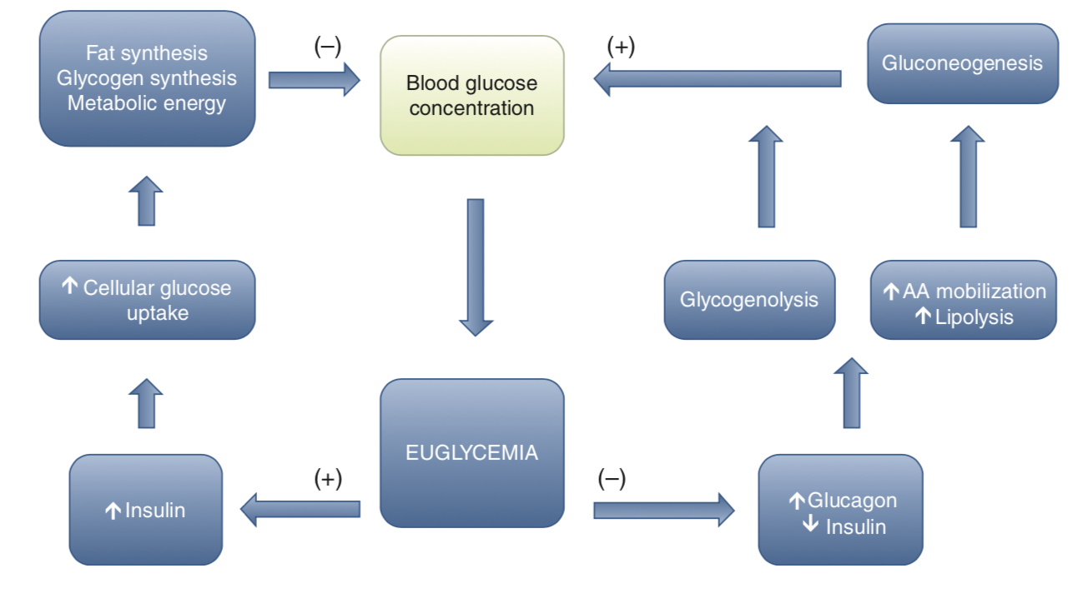
- Glucose available to body via intestinal digestion and absorption of carbs, breakdown of glycogen via glycogenolysis, or production of glucose via gluconeogenesis.
- Glucose mostly stored in liver and skeletal muscle as glycogen
- Remainder of glycose oxidized via glycolysis to form two molecules of pyruvate for each molecule of glucose. Pyruvate converted to acetyl-CoA in mitochondria and utilized in Kreb’s (citric acid) cycle for final energy production
- Alternatively glucose can be converted to fatty acids for fat storage when intake of glucose exceeds demand
- Glucose regulation
  - BG levels increase, insulin is produced by beta-cells of pancreas and released
    - Insulin leads to conversion of glucose to glycogen, storage of amino acids as protein, and storage of fatty acids in adipose tissue
  - BG levels decrease, counterregulatory hormones released
    - Glucagon is produced by alpha-calls of pancreas and stimulates glycogenolysis in liver via cyclic AMP production and subsequent phosphorylation of glycogen phosphylase.
      - Also leads to proteolysis and lipolysis
    - Epinephrine released via sympathetic stimulation of adrenal medulla and serves to potentiate glucagon’s activation of phosphorylase
    - Glycogenlysis sustains body’s glucose demand for only 6-12 hours
    - Gluconeogenesis occurs with prolonged or increased glucose demand, using end-products of glycolysis to form glucose (lactic acid, pyruvate, glycerol, and amino acids)
    - Cortisol mobilizes proteins and adipocytes so amino acids and fatty acids are available for glucose production
    - Cortisol and growth hormone inhibits actions of insulin and potentiates effects of glucagon and epinephrine in the liver

Other causes of hyperglycemia
- Stress hyperglycemia (due to illness, TBI, cats anxiety in hospital) seen due to catecholamine release, which stimulates glucogenolysis and gluconeogenesis as well as inhibits insulin-mediated glycogenesis
- BG in this setting typically 200-400 mg/dL

Classification of DM
- Type 1 diabetes mellitus
  - Most common type in dogs is absolute insulin deficiency
  - Permanent hypoinsulinemia, no increase in endogenous serum insulin concentration following insulin secretagogue administration (glucose/glucagon)
  - Etiologies:
    - 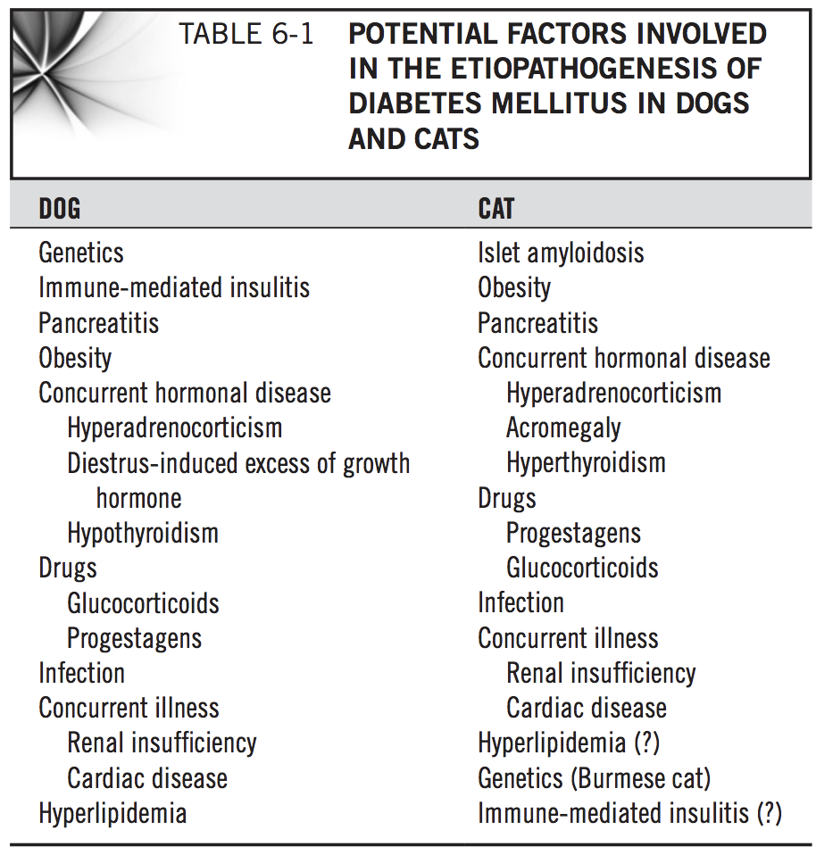
    - Genetics in keeshonds, or immune-mediated component
    - Common histologic abnormalities include reduction in number and size of pancreatic, decrease in numbers of beta cells, and beta cell vacuolation and degeneration.
    - Loss of beta-cell function is irreversible and lifelong insulin therapy mandatory to maintain glycemic control of diabetic state.
    - Other insulin insufficiency may be seen with exocrine pancreatic insufficiency or partial pancreatectomy
  - Type 2 Diabetes Mellitus
    - In humans, type 2 DM is obesity associated characterized by insulin resistance, loss of beta cell function with or without loss of beta cell mass, impaired insulin secretion, and defects in insulin receptor function and insulin receptor signal transduction.
    - Not dependent on insulin to control disease
      - Control through diet, exercise, oral hypoglycemic drugs
      - Termed non-insulin-dependent diabetes mellitus (NIDDM)
    - Insulin may be necessary in some more severe cases
    - Does not typically occur in dogs, but 80% of cats with DM have type II

  - Insulin resistance
    - May result from one of these three
      - Prereceptor problem occurring prior to interaction of insulin with receptor
        - Increased insulin degradation or circulating insulin-binding antibodies
      - at the receptor
        - alteration in insulin receptor binding affinity and concentration and insulin-receptor antibodies
      - Post receptor problem, steps distal to interaction of insulin and its receptor
        - block in insulin signal transduction
      - Receptor and post receptor problems attributable to obesity, circulating acute phase proteins and inflammatory cytokines
        - TNFalpha, IL1, IL6
    - May occur where counterregulatory hormones like cortisol, epinephrine, growth hormone, thyroid hormone, or progesterone is elevated.
      - Epinephrine stimulates glucagon secretion and inhibits insulin release by pancreatic beta-cells
      - High cortisol levels increase hepatic glucose production and stimulate protein catabolism and increased gluconeogenesis
    - Clinical cases occur with cushing’s disease, hypersomatotropism, diestrus, hyperlipidemia, and hypothyroidism
    - Look for concurrent illnesses if difficult to control diabetes (cushing’s in dogs, hypersomatotropism in cats)
    - Drug introduced diabetes may induce insulin resistance (glucocorticoids, progestins)
    - Exerts negative influence on insulin sensitivity at level of insulin receptor or insulin signaling cascade.
    - Results in number of alterations in carbohydrate metabolism leading to insulin resistance, increased hepatic glucose production, impaired peripheral glucose utilization, and relative insulin deficiency.
  - Diabetic remission
    - Uncommon in dogs
      - C-peptide is connecting peptide found in proinsulin molecule, which is secreted into circulation in equimolar concentrations as insulin, thus a marker for functional beta cells.
      - Even with presence of c-peptide in diabetic dogs, still need insulin therapy, suggestive that it is residual beta-cell function with type 1 diabetes mellitus rather than severe form for type 2.
      - Can be seen in older female dogs diagnosed with diabetes during diestrus of pregnancy with increased serum progesterone and growth hormone
        - Dogs diagnosed with diabetic remission following diestrus have high likelihood of developing permanent insulin dependent diabetes during next estrus, so should be spayed as soon as possible after diabetes is diagnosed.
    - In cats, cut off is 4 weeks of normoglycemia
  - Humans and dogs with DM type 1 can have honeymoon period
    - Transient increase in endogenous insulin secretion and reduced insulin dosage requirements during initial weeks to months after diagnosis
    - Shows excellent glycemic control using dosages of insulin considerably less than expected.

- Pathophysiology of DM
  - Relative or absolute deficiency of insulin secretion by beta cells leads to decreased tissue utilization of glucose, amino acids, and fatty acids, accelerated hepatic glycogenolysis and gluconeogenesis, and accumulation of glucose in circulation causing hyperglycemia.
  - 4 classic signs of DM are polyuria, polydipsia, polyphagia, and weight loss, with severity of signs directly related to severity of hyperglycemia
    - As BG increases, ability of renal tubular cells to resorb glucose from glomerular ultrafiltrate is exceeded, resulting in glucosuria
      - Typically dogs when BG >180-220mg/dL
      - Typically cats when BG >200-280mg/dL
    - Glucosuria leads to osmotic diuresis and polyuria, with compensatory polydipsia to prevent dehydration
    - Diminished peripheral tissue utilization of ingested glucose leads to weight loss as body attempts to compensate for perceived “starvation”
    - Polyphagia
      - “Feeding center” in lateral region of hypothalamus and “satiety center” in ventromedial region of hypothalamus
      - Amount of glucose entering calls in satiety center affects feeling of hunger, which is mediated by insulin. With DM, there is then failure of inhibition of feeding center since glucose does not enter satiety cells.
  - Consequence of hyperglycemia
    - Leads to generation of reactive oxygen species and elevated inflammatory markers.
      - Proinflammatory cytokines (TNF-alpha, IL-6 IL-1-beta) contributes to insulin-resistant state
      - TNF-alpha interferes with insulin receptor signaling as well as synthesis and/or translocation of glucose transport GLUT-4 to plasma membrane
      - Presence of inflammatory cytokines and state of insulin resistance leads to lipolysis, increasing release of free fatty acids.
        - Elevated FFAs detrimental to cardiovascular system by increasing catecholamine concentration and mean arterial blood pressure
        - Associated with malignant cardiac dysrhythmia, increased myocardial oxygen consumption, and presence of ischemic stroke
    - Impair leukocyte function and limit phagocytosis, chemotaxis, and bacterial destruction
    - Limits neovascularization and collagen synthesis, restricting body’s ability to generate new healthy tissue at surgical site
    - Increases platelet aggregation and results in prothrombotic state
    - Overproduction of reactive oxygen species results in direct cellular damage, vascular and immune dysfunction
    - NF-kappa-B activation and production of inflammatory cytokines like TNF-alpha, IL-6 and plasminogen activator inhibitor-1 (PAF-1) increase vascular permeability and activates both leukocytes and platelets
- Signalment:
  - Dogs: 5-15 yo, juvenile-onset DM is <1 yo and uncommon
    - Female dogs>male neutered>male intact
    - MBD over pure breed
    - Certain breeds: irish setter, poodle, yorkie, English setter, spitz type breeds (Samoyed, Swedish elkhound)
  - Cats: obese
- History
  - PU/PD, polyphagia, weight loss
    - Urinary accidents in house
  - Sudden blindness from cataract formation
  - Systemic signs of illness with DKA
    - Lethargy, anorexia, vomiting, weakness
  - Identification of concurrent disorders
    - CKD, cushing’s disease (causing carbohydrate intolerance), pancreatitis, bacterial infection (result from carbohydrate intolerance), occult sources of sepsis, recent estrus
- PE:
  - Dogs: nonketotic may be obese but otherwise normal PE, cataracts (anterior uveitis and KCS may also be present)
  - Cats: diabetic neuropathy with rear limb weakness and ataxia

- Diagnosis
  - Fasted hyperglycemia:
    - Portable blood glucose monitoring device
    - Hyperglycemia w/o glucosuria may be caused by other diseases
  - Glucosuria +/- ketonuria:
    - Ketodiastix
    - Glucosuria w/o hyperglycemia supports primary renal glucosuria or other renal tubular disorders and not DM
  - Serum fructosamine: supports presence of sustained hyperglycemia
  - 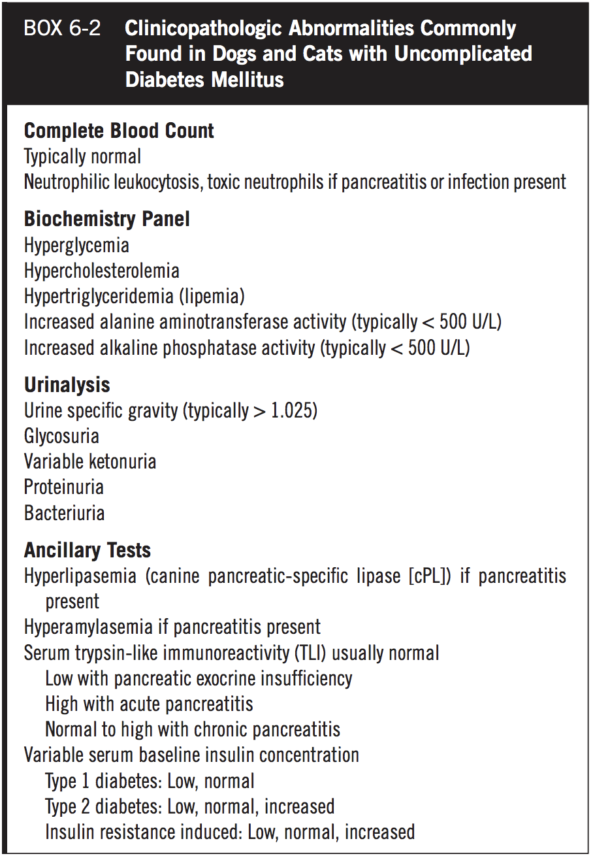
    - Glucosuria of 2% or 4+ on dipstick usually increased USG by 0.008-0.010, so USG <1.020 with this level of glucosuria is suggestive of concurrent PU/PD disorder like CKD or cushings disease
    - ALP> 800 suspicious of concurrent cushing’s disease
    - ALT >600 suspicious of concurrent hepatopathy
    - Elevated T. bili suspicious of concurrent pancreatitis with secondary extrahepatic biliary duct obstruction
    - BUN/creat usually normal in uncomplicated DM, elevation due to primary renal failure or pre-renal azotemia due to dehydration
    - Hypercholesterolemia and hypertriglyceridemia
      - Insulin inhibitor of lipolysis and free fatty acid oxidation
      - With insulin deficiency, lipoprotein lipase activity reduced, hormone-sensitive lipase activated, hepatic production of triglyceride-rich very-low-density lipoprotein (VLDL) increased, clearance of VLDL particles decreased
  - AUS: to evaluated for pancreatitis, adrenomegaly, pyometritis in intact dog, abnormalities affecting liver or urinary tract
    - If AUS not available, can consider cPLI to evaluate for pancreatitis
- 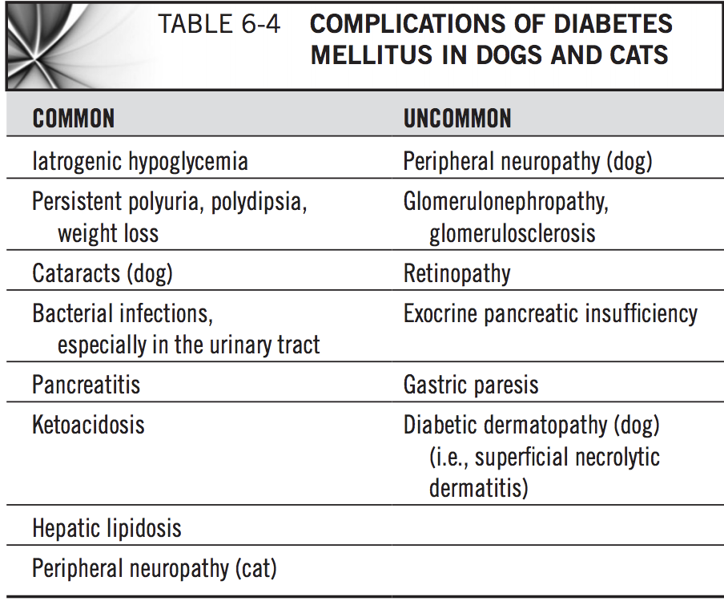
- Treatment DM
  - Goals are to eliminate owner-observed clinical signs and to minimize impact of therapy on owner’s lifestyle
  - Insulin therapy
    - Starting insulin dose usually 0.25u/kg SQ BID (Lente and NPH)
      - Typical dose to attain glucose control 0.5u/kg, range 0.2-1.0u/kg
    - Intermediate acting insulin (neutral protamine hagedorn NPH, lente)
      - NPH (Humulin N, Novolin N) recombinant human insulin
        - Contains fish protein protamine and zinc to delay insulin absorption to prolong duration of insulin effect
      - Lente (vetsulin, caninsulin) purified porcine-source insulin
        - Alterations in zinc content and size of zinc-insulin crystals alter rate of insulin absorption from subcutaneous site of deposition
          - Larger crystals, slower rate of absorption and longer duration of effect
          - Mixture of three parts short acting amorphous zinc insulin and seven parts long acting crystalline zinc insulin
          - Recommends vigorous shaking of insulin vial until homogenous milky suspension prior to withdrawal
    - Long acting insulin (protamine zinc insulin (PZI), insulin glargine, insulin detemir)
      - PZO (Pro-zinc) recombinant human insulin
        - Contains fish protein protamine and zinc to delay insulin absorption to prolong duration of insulin effect
        - Used in cats
      - Insulin glargine (lantus) insulin analogue
      - Insulin detemir (Levemir) insulin analogue
    - U100 insulin preparation = 100units insulin per mL of solution
      - NPH, insulin glargine, insulin detemir
    - U40 insulin preparation = 40 units of insulin per mL of solution
      - Lente (vetsulin) and protamine zinc insulin
    - Insulin pens available for NPH, lente insulin (vetsulin), insulin glargine (Lantus) insulin, and insulin detemir (Levemir)
    - Insulin stored at room temp or in refrigerator, heating or freezing inactivates insulin
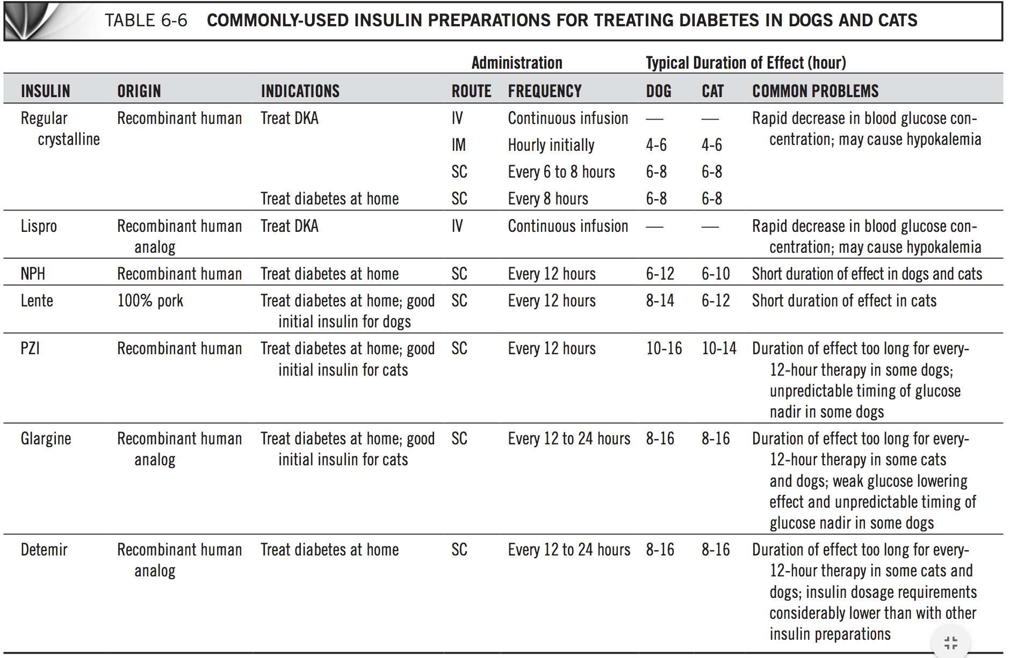
  - Diet modification
    - Correction of obesity most beneficial to improve glycemic control
    - Weight loss diets have higher quantities of fiber and lower fat content to decrease caloric density.
      - Should not be used in thin or emaciated diabetic dogs until control of glycemia and normal body weight obtained
    - Diabetic diets have increased fiber and/or low glycemic index carbohydrates
      - Fiber forms viscous gel and impairs convective transfer of glucose and water to absorptive surface of intestine, slowing intestinal glucose absorption
      - Complications of high fiber diet include excessive frequency of defecation, constipation, soft stools, excessive flatulence, problem with palatability
    - Vet diets for diabetic dogs: Hill’s w/d, Hill’s r/d (obese diabetic dog), Purina DCO, Purina OM (obese diabetic dog), Royal Canin Diabetic
- Monitoring:
  - Good glycemic control supported by improvement of clinical signs (PU/PD/polyphagia)
  - Single BG helpful only if hypoglycemia is identified, supporting insulin overdosage.
    - Increased BG itself can be due to stress/excitement, so unreliable to determine if pet is poorly controlled
  - Serum fructosamine
    - Glycated protein found in blood, from irreversible, non-enzymatic, insulin-independent binding of glucose to serum proteins
    - Marker of average BG during lifespan of protein which is about 2-3 weeks.
    - 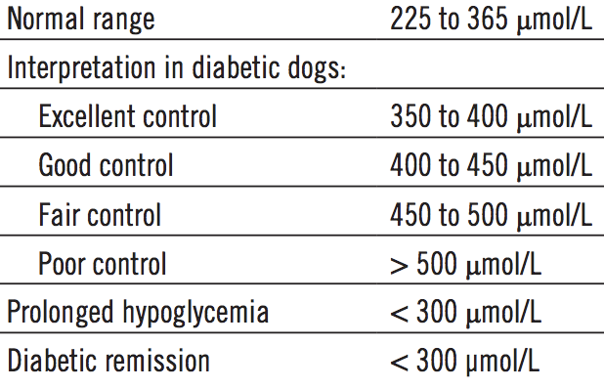
  - Urine glucose monitoring for glucosuria and ketonuria
    - Should not adjust dose based on first morning urine
  - Serial BG curve
    - Able to identify glucose nadir, time of peak of insulin effect, approximate duration of insulin effect, and range of BG concentrations
  - Glucose monitoring devices
    - Hand-held portable blood glucose meter device (PBGM)
      - Ex: AlphaTRAK
      - Results can be higher or lower than reference methodologies
      - HCT <30% can affect accuracy
    - Point of care glucose analyzer
      - Ex: NOVA, gaslyte
    - Continuous glucose monitoring (CGM)
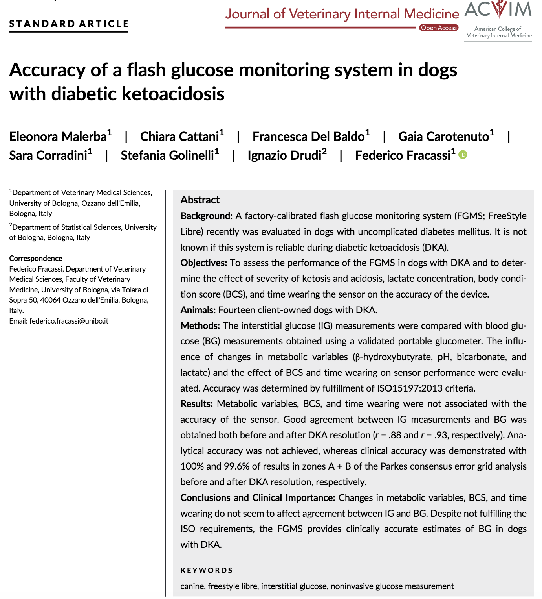
- 1st generation system (Guardian REAL-time) offered only retrospective analysis, glucose concentrations displayed after disconnecting sensor and uploading the data to a computer
- 2nd generation system allowed real-time display, but needed blood collection to calibrate 2-3 times a day
- A novel factory-calibrated flash glucose monitoring system (FGMS, FreeStyleLibre, Abbott, UK) has been licensed for use in people (CE mark, August 2014).
  - The system consists of a small, round, disposable, water-resistant sensor, which continuously measures glucose in the interstitial fluid through a small (5 mm long×0.4 mm wide) filament inserted SC.
  - The FGMS generates information every minute, and the readings are automatically stored in 15-minute intervals for up to 14 days, so no additional calibration needed for 2 weeks.
  - Interstitial glucose concentrations are displayed when the sensor is wirelessly scanned (or “flashed”) with a reader device on demand. The reader device then will display the past 8 hours of glucose information, including current glucose, a trend graph, and a trend arrow that indicates the direction of the patient's current glucose concentration with respect to the previous results.
  - FGMS sensor placed on clipped/clean area dorsal part of neck
    - Sensor has 1 hour initialization
    - Readings between 20-500 mg/dL, beyond that is read as “LO” or “HI”
- IG measurements compared with BG concentration obtained within 10 seconds with PBGM had good clinical accuracy but did not meet ISO 2013 accuracy requirements
  - ISO analytical standards require comparison of BG meter with results of standard reference method. But standard is blood to blood. No standard for blood to different compartment. So ISO criteria may not hold up because there’s no standard of interstitial fluid

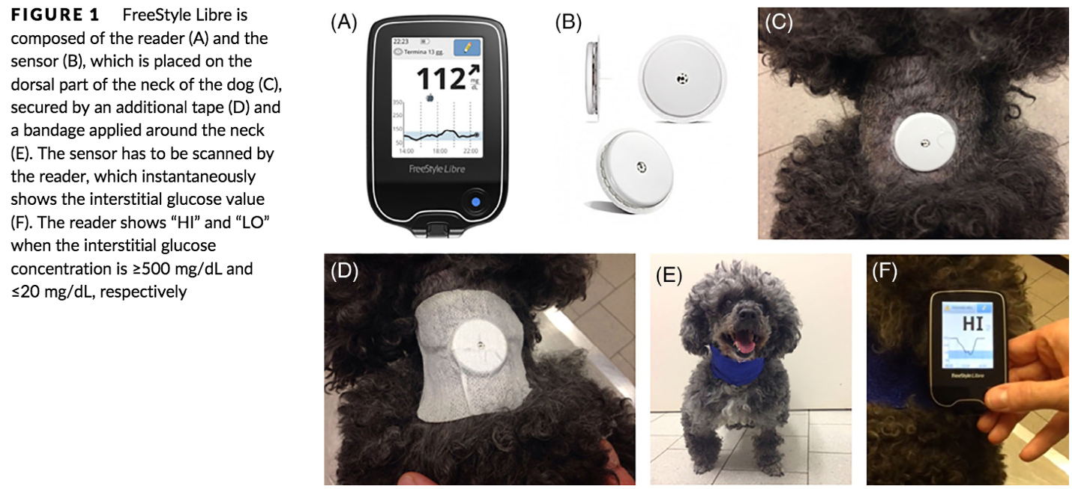

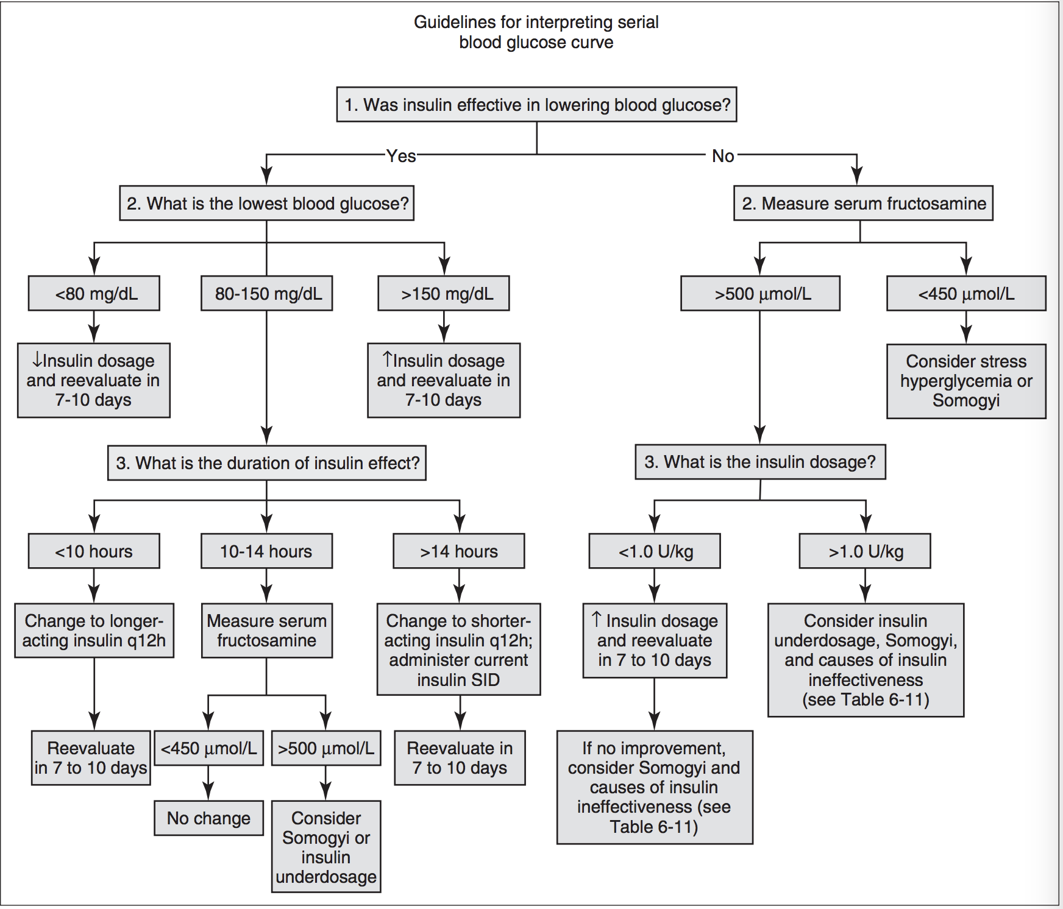

- Somogyi Response
  - Insulin overdose and glucose counterregulation
    - Hypoglycemia from insulin overdose resulting in BG <65mg/dL or when BG rapidly decreases regardless of glucose nadir, stimulates heptic glycogenolysis and secretion of diabetogenic hormones (epinephrine and glucagon)
    - Secretion of diabetogenic hormones during somogyi response may induce insulin resistance which may last 24-72 hours after hypoglycemic episode
    - Results in marked hyperglycemia within 12 hours of glucose counterregulation
    - Diabetic dog unable to dampen rise in BG due to insufficient endogenous insulin and circulating insulin from insulin injection
    - Therefore diagnosis is difficult unless BG curve is done the same day as counterregulation and hypoglycemia is seen, BG curve done the next day will not show hypoglycemia and may show hyperglycemia and dose may be incorrectly increased
- Prognosis:
  - Those that survive first 6 months may maintain good quality of life for longer than 5 years
  - High mortality rate exists for first 6 months due to concurrent life-threatening or uncontrollable disease (DKA, acute pancreatitis, renal failure)

Diabetic Ketoacidosis (DKA)
- Criteria include hyperglycemia, glucosuria, ketonemia/ketonuria, and metabolic acidosis
- Pathogenesis:
  - Insulin deficiency promotes gluconeogenesis and glycogenolysis and reduces cellular utilization of glucose leading to hyperglycemia
  - Hormone-sensitive lipase is stimulated and free fatty acids (FFA) are released from adipocytes to be used as alternative energy source.
  - FFA are metabolized to triglycerides, CO2 + water, or ketone bodies
    - In uncomplicated DM, mostly just triglyceride produced and the small amount of ketones produced are completely metabolized for energy by having acetyl CoA and pyruvate enter kreb’s (citric acid) cycle to form ATP
    - Concurrent physiological stressors release counterregulatory hormones which contribute to glucose production, insulin resistance, protein catabolism, and lipolysis (further increasing circulating FFA available for ketone formation
  - Ketone bodies synthesized from acetyl-coenzyme A (acetyl-CoA), which is product of mitochondrial beta-oxidation of fatty acids.
    - Fatty acids undergo ATP dependent catabolism with breakdown of two carbon fragments at a time and results in acetyl-CoA formation
    - Increased acetyl-CoA formation with decreased activity of kreb’s (citric acid) cycle leads to ketone body synthesis
    - Three ketone bodies synthesized in liver from acetyl-CoA: acetoacetate, beta-hydroxybutyrate, acetone
      - Acetyl-CoA converted to acetoacetate by two metabolic pathways
      - Acetoacetate metabolized to beta-hydroyxbutyrate or acetone
  - DKA occurs when quantity of ketoacids overwhelms metabolic pathways that convert ketones to energy and buffering system that mitigates effects of ketones on acid-base status
    - Acetoacetate and beta-hydroxybutyrate are anions of moderately strong acids
- History and PE:
  - Median dog age DKA 8 years, cats 9 years with wide range from young to old
  - Concurrent disease in 70% DKA dogs and 90% DKA cats
    - Concurrent disease results in increase glucagon, cortisol, or catecholamine concentration and increased risk of DKA
    - In dogs, most common concurrent diseases with DKA are acute pancreatitis, bacterial UTI, and cushing’s disease
    - In cats, most common concurrent disease with DKA are hepatic lipidosis, CKD, acute pancreatitis, bacterial/viral infections, and neoplasia
  - Classic diabetic patient PU/PD/polyphagia/weight loss plus dehydration, hypovolemia, lethargy, mental depression, anorexia, vomiting, diarrhea, weakness, and ketone breath.

Hyperglycemia Hyperosmolar Syndrome (HHS)
- Criteria include severe hyperglycemia >600mg/dL, minimal or absent serum/urine ketones, severe hyperosmolality >350mOsm/kg
- Rare (~5% of dogs with DM)
- Initially thought DKA and HHS were distinctly separate, but becoming more apparent that both diabetic ketoacidosis and hyperosmolar nonketonuric diabetes can occur
- Pathogenesis:
  - Same complications with insulin deficiency as DKA with gluconeogenesis/glycogenolysis and reduced cellular utilization of glucose but ketosis prevented by small quantities of circulating insulin and hepatic glucagon resistance that inhibits lipolysis
  - Primary result is hyperglycemia, progressive osmotic diuresis, marked dehydration, and subsequent decrease in GFR
    - As plasma volume contracts due to dehydration, lower GFR limits renal glucose excretion and leads to rise in BG
  - Measured serum sodium usually decreased or within normal reference range, but “corrected” serum sodium concentration is within normal or increased, contributing to increase in plasma osmolality
  - As plasma osmolality increases, water is drawn out of cerebral neurons, resulting in cerebral dehydration and shrinking
- History and PE:
  - Same classical diabetic findings PU/PD/polyphagia/weight loss
  - Anorexia, lethargy, vomiting, weakness, hypovolemia.
  - May have neurologic signs like circling, pacing, depression to coma, seizures due to hyperosmolality-induced cerebral dehydration.
  - Hyperosmolality may lead to tachypnea and increased respiratory effort, or may develop due to concurrent heart failure which commonly accompanies HHS.

Diagnostics:
- QATS (PCV/TP/glucose/azostix) and VBG
  - Hemodiluted or anemic blood can falsely elevate plasma glucose reading
  - Magnitude of acidemia may be from ketoacidosis, lactic acidosis, uremia, and possibly hyperchloremia
- CBC
  - Dogs: 50% nonregenerative anemia, neutrophilia with left shift, or thrombocytosis
  - Cats: nonregenerative anemia, neutrophilia with left shift, Heinz body formation (correlated with plasma beta-hydroxybutyrate concentration)
- Measure ketones
  - Urine dipstick for acetone and acetoacetate using urine or serum/plasma
  - Ketone meter with blood for beta-hydroxybutyrate
  - Beta-hydroxybutyrate is the dominant ketone body in DKA
    - In people, >3:1 hydroxybutyrate to acetoacetate
  - JVIM 2009 “Evaluation of portable meter to measure ketonemia and comparison with ketonuria for diagnosis of canine ketoacidosis” showed measurement of ketonemia to be more accurate and more effective than measurement of ketonuria
- Degree of hyperosmolality
  - Normal serum osmolality is 290-310 mosm/kg
  - Neurologic signs seen >340mOSm/kg
  - Osmolality = 2 (Na⁺ + K⁺) + (Glucose/18) + (BUN/2.8)
    - Glucose and BUN have to be divided because they are measured in mg/dL while NA/K are mmol/L
  - Modified equation in new emergency textbook: 2 (Na+) + (Glucose/18)
    - Since BUN is ineffective osmole and effects of potassium on osmolality is minimal
- Sodium changes
  - Psuedohyponatremia
    - Hyperglycemia and hyperosmolality exert osmotic force pulling water into extracellular (including vascular) space. Increase in plasma water dilutes sodium and falsely decreases sodium
    - As BG decreases, osmotic gradient lowers, excess water leaves vasculature and interstitium back into intracellular space, causing measured serum sodium to increase
  - Na+(corrected)=1.6×[(measured glucose − normal glucose)/100]+Na+(measured)
  - If BG over 400 = 2.4 ×[(measured glucose − normal glucose)/100]+Na+(measured)
- Potassium, Magnesium, Phosphorus changes
  - Potassium concentration variable on initial presentation
    - 4 things that increase serum potassium on initial presentation
      - Insulin deficiency decreases amount of potassium co-transported into cells
      - Acidemia causes potassium to shift out of cells in exchange for hydrogen ions
      - Severe hyperosmolality leads to shift of potassium out of cells
      - Poor renal perfusion/dysfunction increases potassium
    - 3 things that decrease serum potassium
      - Decreased intake and GI losses
      - Hypovolemia-induced hyperaldosteronism increases renal potassium loss
      - Osmotic diuresis
      - Insulin therapy
        - Insulin induces transport of glucose and potassium into cells
        - As acidemia improves, potassium shifts into cells in exchange for hydrogen
  - Phosphorus
    - Total body phosphorus depletion develops with shifts from intracellular space to extracellular space as a result of hyperglycemia, acidosis, and hypoinsulinemia
      - Excreted out of body from osmotic diuresis
    - Dehydration and decreased phosphorus excretion in later states of disease cause serum phosphorus concentration to be normal to increased
    - Fluid therapy and insulin therapy will P back into cells and utilized for ATP production, causing extracellular and whole body phosphate depletion
    - Hypophosphatemia in DKA associated with hemolysis, seizures, weakness, myocardial depression, and arrhythmias
  - Magnesium
    - Similar mechanism as phosphorus
    - Hypomagnesemia in diabetic humans cause insulin resistance, hypertension, hyperlipidemia, and increase platelet aggregation
    - Not common in dogs with DKA
- Additional tests for concurrent disease include UA/UC, AUS, CXR, adrenal/thyroid axis testing (may need to wait until no longer sick to perform these tests), liver function test, cPLI

Treatment:
- Fluid therapy and insulin therapy most important
  - Fluid therapy with isotonic crystalloids
    - 0.9% NaCl advocated for high sodium concentration but may contribute further to acidosis with high chloride concentration and lack of buffer
    - LRS/p-lyte/NormR have buffer to help with management of acidosis and small amount of potassium
    - Fluid therapy alone without insulin does decrease blood glucose concentration
      - due to reduced insulin resistance by decreasing concentration of counterregulatory hormones, diluting BG, increasing GFR and subsequent urinary excretion of glucose

  - Discussion about volume resuscitating patient and adjust electrolyte deficiencies prior to insulin therapy
    - Early insulin therapy can worsen hypovolemia by rapidly decreasing blood glucose and osmolality which causes water to move out of vascular space
    - Rapid decrease in BG can also contribute to cerebral edema formation, but studies have not shown this to be any significant concern. Instead, inadequate normalization of serum sodium concentration with declining BG had greater impact on effective osmolality and potential neurologic complications
      - JVECC 2006 “Relationship between glucose, sodium and effective osmolality in diabetic dogs and cats”

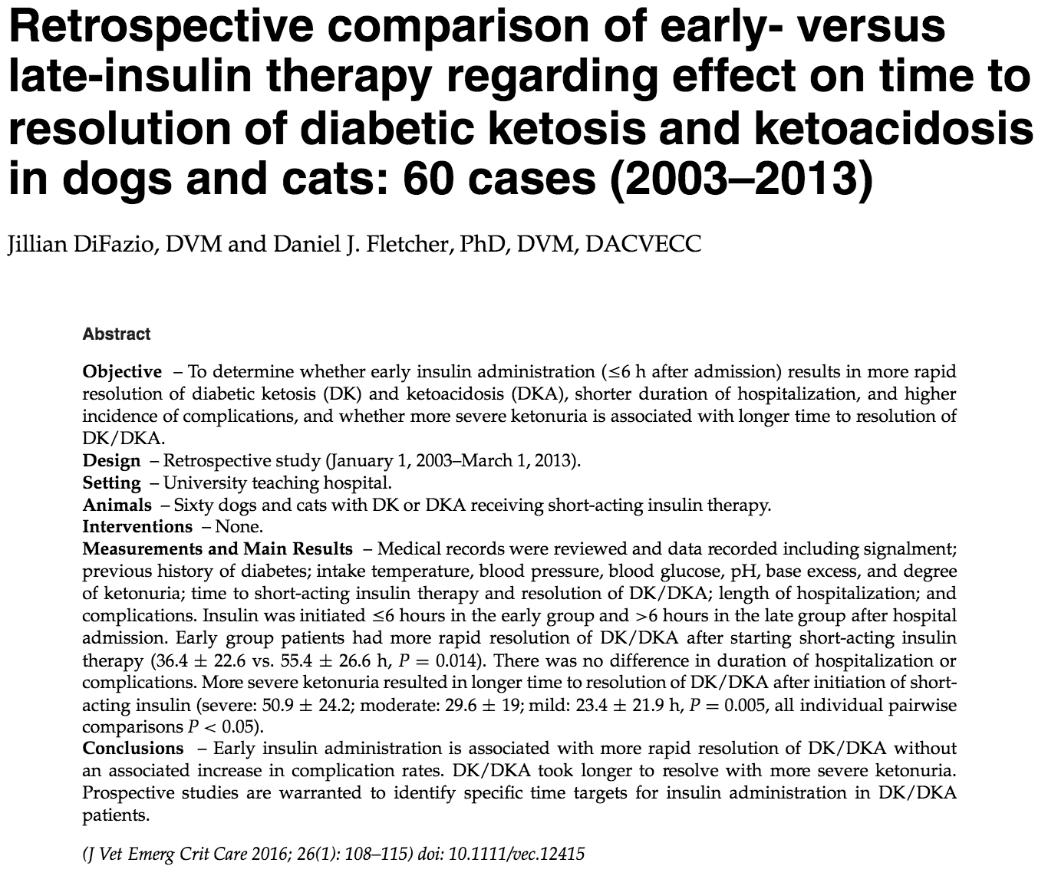
- Study had 60 cases with 49 individual patients, 37 dogs and 12 cats
- Divided between early group (insulin initiated < 6hrs) or late group (initiated >6 hrs)
  - 44 in early group, median 4 hours (range 0-6 hr)
  - 16 in late group, median 8.25 hours (range 7-21 hr)
- DK/DKA resolution was 19 hours earlier in early-insulin group
- No difference in duration of hospitalization or complications
  - Complication rates include electrolyte derangements, hypoglycemia, and neurologic changes
- Current guideline in people is initialing insulin 1 hour after initiating IV fluids

  - Insulin therapy
    - Required to stop ketogenesis, increase ketone body metabolism, decrease gluconeogenesis, and promote glucose utilization
    - Usually short acting regular insulin as intermittent IM or IV CRI
    - Absorption SQ usually poor or unpredictable in dehydrated or hypotensive DKA/HHS patient
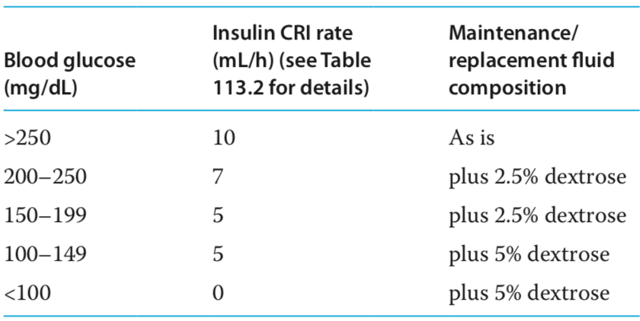

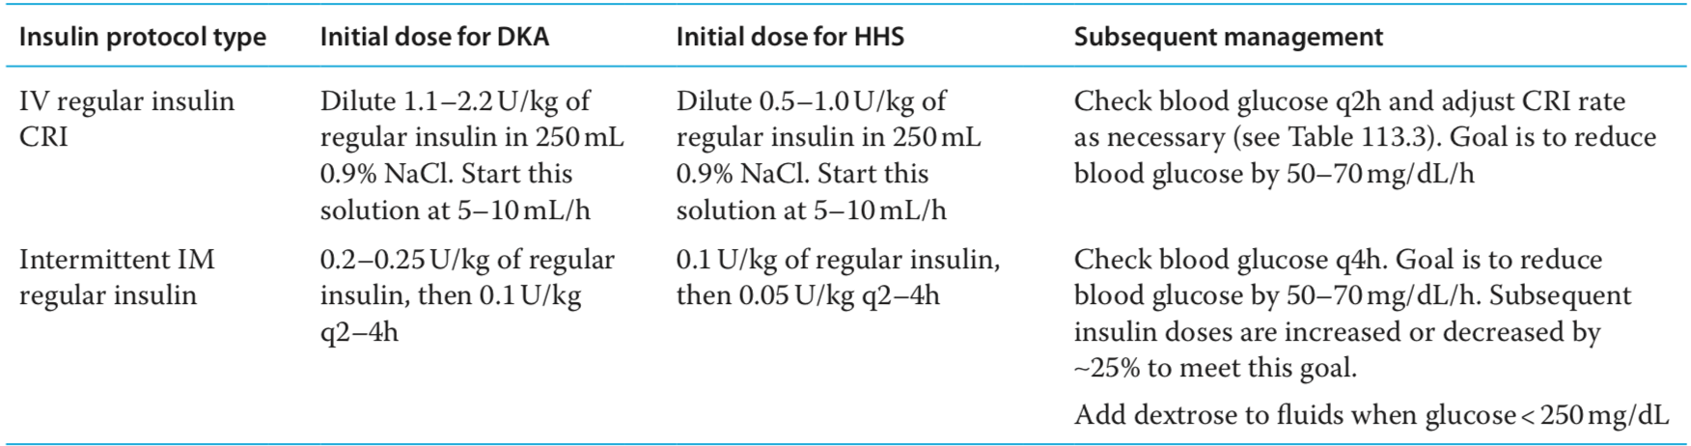
  - Previously reported insulin CRI for cats was 1.1u/kg/day, but study of 29 cats treated with CRI regular insulin for 2.2u/kg/day did not have increased frequency of adverse or neurologic or biochemical effects
    - JVECC 2010 “Comparison of regular insulin infusion doses in critically ill diabetic cats: 29 cases (1999-2007)” Retrospective

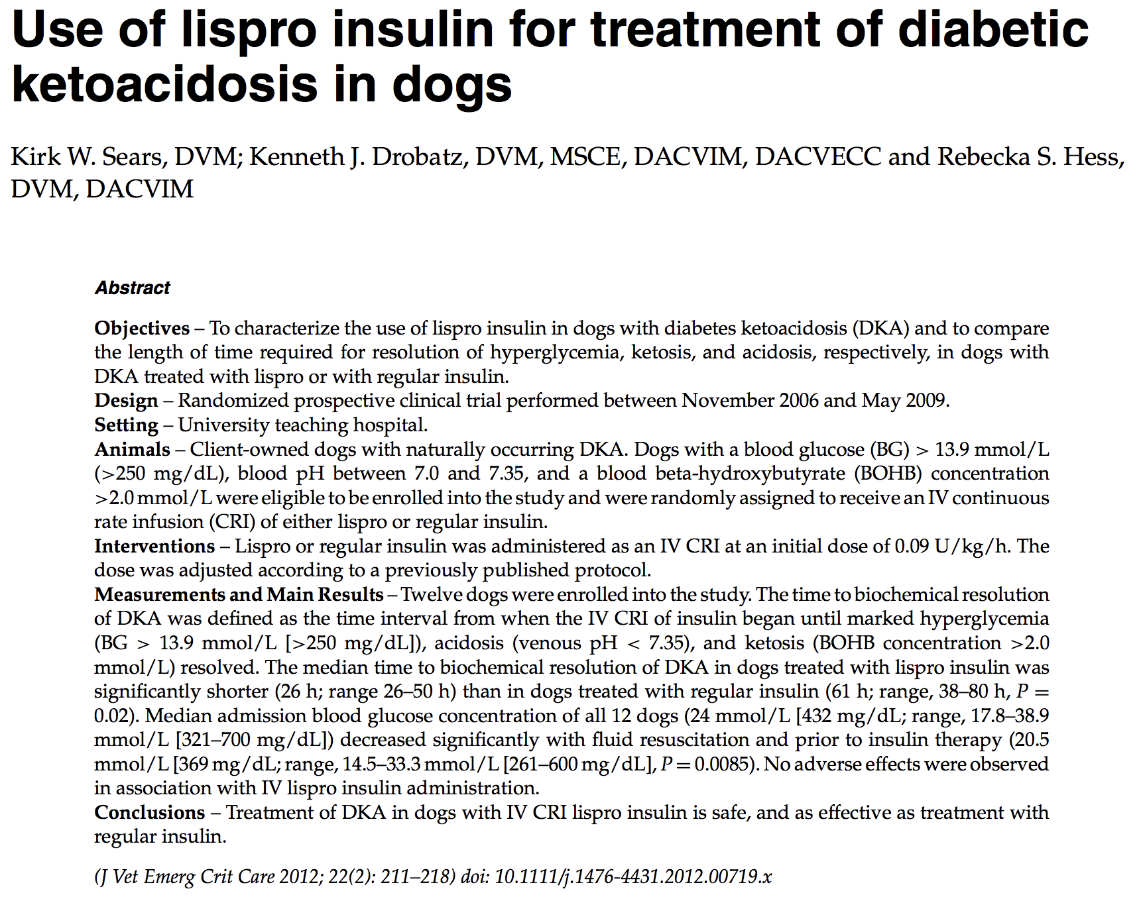

- Treat electrolyte abnormalities
  - Regardless of initial measured blood concentrations, whole body deficits in potassium, magnesium, and phosphorus are present and will worsen with insulin therapy
  - Insulin therapy should be withheld until potassium at least 3.5mEq/L

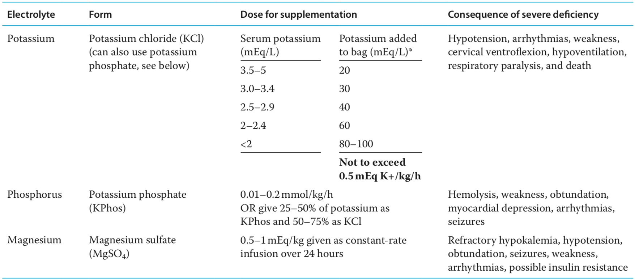
  - KCl can also be given as CRI 0.1-0.5mEq/kg/hr but not exceed 0.5mEq/kg/hr
    - If higher doses required, ECG monitoring should be performed
  - KPhos contains 4.4mEq/mL of potassium and 3mmol/mL of phosphate, usually given as CRI
  - MgSO4 contains 4mEq/mL of magnesium, also usually given as CRI
    - Only given to patients with documented decreased iMg or total Mg
    - Magnesium toxicity signs include vomiting, weakness, generalized flaccid muscle tone, mental dullness, bradycardia, respiratory depression, and hypotension
- Ancillary therapy
  - Concurrent pancreatitis may need pain meds, anti-emetics, gastroprotectants, and nutrition support
  - Concurrent infections common, use of broad spectrum antibiotics usually indicated
  - Treatment of other concurrent diseases
  - Bicarb therapy usually not needed in dogs and cats with DKA as acidemia improves with fluid therapy. However, in people, it is considered if pH remains less than 7.0 after 1 hour fluid therapy.
Prognosis:
- Death and euthanasia rate for DKA 7-30%, HHS 38% dogs 65% cats
- Most DKA survive to discharge (70%)
- Median hospitalization ~5-6 days
- Reoccurrence of DKA in at least 7% dogs and up to 40% cats
- Dogs with concurrent cushing’s less likely to be discharge from hospital
- Improvement of base deficit (response to treatment) associated with outcome, such that each 1mEq/L increase in base deficit yielded 9% increase in likelihood of discharge
- Severity of acidosis is associated with outcome
- These stats from JVIM 2006 “Outcome of Dogs with Diabetic Ketoacidosis: 127 dogs (1993-2003)
- HHS poor outcome associated with abnormal mental status and low venous pH

