ALBUMIN

Structure
Briefly describe the structure of albumin, molecular weight
- Highly flexible, symmetric globular protein
  - 3 homologous domains assembling into heart-shaped protein
  - 584 amino acids in alpha helices, bound together by disulfide bridges
  - Disulfide bridge and ellipsoid shape: Polarized outside, hydrophobic inside
- Molecular weight: 66-69 kDa
- Negatively charged (-19) at physiologic pH

Albumin production
Where is it synthetized? What are the steps
- Primary site: Liver
  - Synthesized as preproalbumin (has N-terminal peptide)
  - N-terminal is cleaved as it is released by rough endoplasmic reticulum proalbumin
  - Proalbumin cleaved in Golgi vesicles secreted as albumin
- Pathway: Produced in hepatocytes hepatic interstitium sinusoids hepatic veins systemic circulation
- Other sites: Mammary glands and skeletal muscle
- Normally work at 1/3 of capacity to produce albumin
- No storage pool

Production is influenced by (4) factors

- Hepatic interstitial oncotic pressure
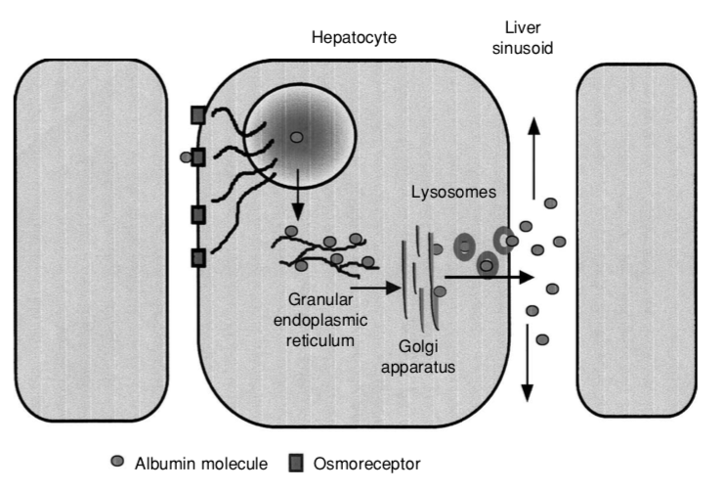
  - Osmoreceptors in hepatic interstitium detect changes in oncotic pressure
  - When onc pressure decreases, albumin synthesis incr; vice versa
    - Hepatic vascular beds have large capillary pore size + protein reflection coefficient of zero = permeable to molecules <620k Da
    - Albumin, globulins, and synthetic colloids can accumulate in the hepatic interstitium affects COP alters albumin synthesis
- Inflammation
  - Negative acute phase protein
  - Can decrease synthesis up to 90%
- Hormonal influences
  - Low ACTH, GH, insulin, testosterone and TH decrease synthesis
- Nutrition
  - Albumin synthesis consumes 6% nitrogen intake

Distribution
Where is it mainly distributed?
- 40% intravascular
- 60% extravascular (mainly interstitium)
  - Skin, muscle, liver, lung, heart, kidneys, and spleen
  - 75-85% of intravascular albumin exchanges w/ interstitial pool every 2-3 days
    - Average at 4%/hr exchange rate
  - Interstitial albumin pool serves as a source to replenish the intravascular pool
- Serum levels therefore do not accurately reflect changes in total body albumin
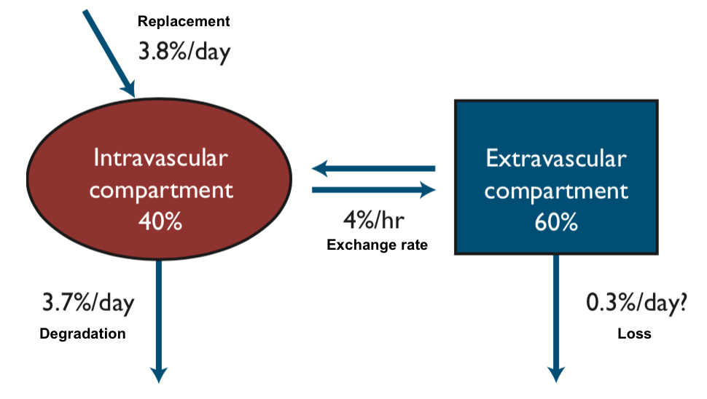

Degradation
How is albumin degraded? Where it is excreted? Average life-span of canine albumin?
- Normal catabolism of albumin occurs in muscle and skin (40-60%)
  - Remaining lost via liver, kidney
  - 10% loss via GIT in healthy animals
- 4% of total body albumin degraded daily at a rate directly related to albumin concentration
- Avg life span is 8 days in dogs

Functions of Albumin (9)
- Maintains colloid osmotic pressure
- Transports and binds substrates
- Functions as an antioxidant
- Contributes to primary and secondary hemostasis
- Buffers extracellular fluid
- Maintains microvascular permeability
- Provides amino acids for protein synthesis
- Assists with immunoprotection
- Aids in wound healing

1) Maintain colloid oncotic pressure
How does albumin exert its COP? (2)
- Albumin accounts for 50-60% total plasma protein, but accounts for 80% of colloid oncotic pressure
  - Relatively small size (69kDa) compared to others (e.g. fibrinogen 624kDa and globulins 160kDa)
- 66% of albumin’s oncotic effect is due to Van’t Hoff’s law: 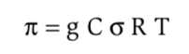
  - Colloid oncotic pressure generated is indirectly proportional to the molecular weight of the particle
  - It converts concentration of particles into pressure
  - π = oncotic pressure
  - g= # of particles per mole in solution (Osm/mol)
  - Ω = reflection coefficient, 1 for albumin
  - R= gas constant (0.082L-atm mol-K)
  - T= absolute temperature in Kelvin
- The remaining is exerted by the Gibbs-Donnan effect: the water-holding property
  - The large -ve charge of albumin causes Na+ and other cations to accumulate around its core
  - The accumulation of ions causes water to follow across a semipermeable capillary endothelial membrane, contributing to the water-holding property of albumin w/in the vascular space
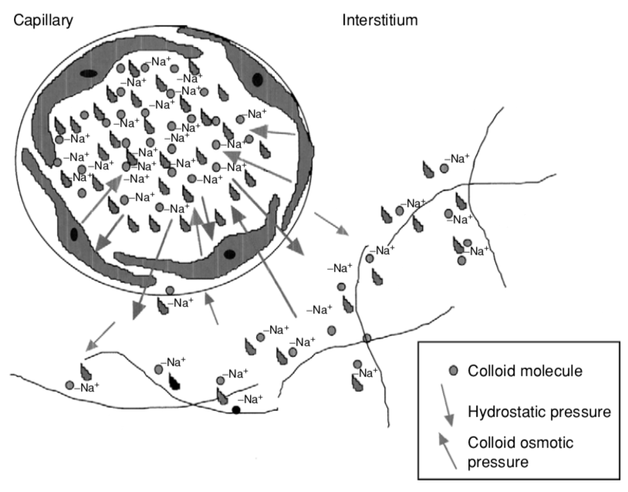

How to measure COP and what are the normal ranges for dogs and cats?
- COP can be measured via a colloid osmometer
  - Uses a semi-permeable membrane to stimulate role of vascular membrane
  - Samples injected into chamber A can equilibrate with reference chamber B (saline)
  - Artificial membrane only allows molecule <30kDa to pass
  - COP of sample causes water & small solutes to move from chamber B to A reduced pressure in chamber B
  - This pressure difference is sensed = COP of sample A
  - Measures effects of both natural and synthetic colloid molecules
- Normal COP
  - Plasma: 14-27 mmHg in dogs, 21-34 mmHg in cats
  - Whole blood: 20-22 mmHg in dogs, 24-28 mmHg in cats
- COP can be altered by severe hemolysis, hypergammaglobulinemia, and hyper- or hypoalbuminemia
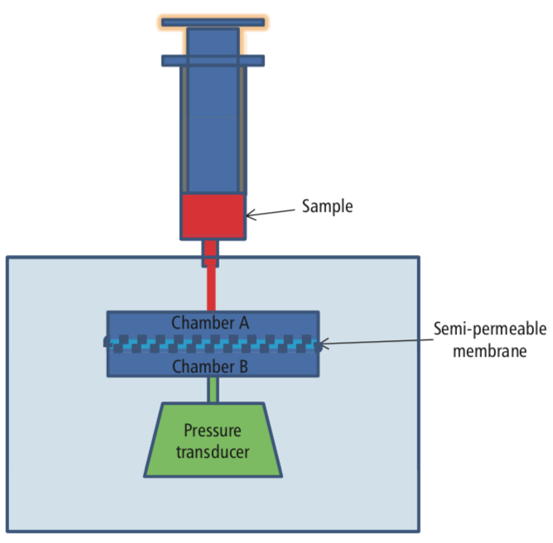

2) Carrier function
- Carrier for insoluble organic substances
  - Bilirubin: unconjugated bilirubin becomes non-toxic when bound to albumin
- Binds to positively charged minerals
- Serve as transport vehicle
- Storage reserve (esp. hydrophobic drugs)
  - NSAID and warfarin compete w/ bilirubin to bind albumin
Name 5 endogenous and 5 exogenous substances carried by albumin
Endogenous
Bilirubin  Calcium  Copper  Cysteine  Fat-soluble vitamins | Fatty acids  Free radicals  Glucocorticoids  Thyroxine (T4)  Tryptophan
Exogenous
Anti-inflammatory | Ibuprofen, salicylic acid, phenylbutazone
Antimicrobial | Cephalosporins, sulfonamides, penicillin, tetracyclines
CNS drugs | Amitriptyline, phenobarbital, chlorpromazine, thiopental, diazepam
Cardiac | Digoxin, furosemide, hydralazine, propranolol
Miscellaneous | Glipizide, warfarin

3) Antioxidant (3)
- Scavenges reactive oxygen species (e.g. iron)
- Protect bound substances from oxidant injury
- Bind free Cu (Cu=oxidant)
4) Role in coagulation (2)
- Binds to arachidonic acid and prevents formation of substances that promote platelet aggregation
- Heparin-like effect by enhancing antithrombin III activity
5) Acid-base
- Strong negative charge contributes to strong ion difference
- Behaves as a weak acid = buffering
6) Maintains microvascular permeability
- Albumin occupies water channels in vessel walls to narrow channels and repel macromolecules
- Albumin carries erythryocyte-derived-sphingosine-1-phosphate (S1P) to the endothelium, which mediates glycocalyx recovery by suppressing MMP activity
7) Protein synthesis
- Catabolism of albumin produces constituent amino acids for protein synthesis
8) Immunoprotection
- Inhibits endothelial cell apoptosis
- Limits activation of inflammatory cytokines
9) Wound healing
- When extravasates to site of inflammation, it carries substrates vital for collagen crosslinking and tissue repair

Other forms of albumin
- Glycated albumin
  - Persistently elevated blood glucose levels result in increased glycosylation
    - Glucose binds irreversibly to free amino acids
    - Glycosylated plasma proteins = fructosamine (80% of albumin)
  - Gives mean glycemia over previous 3 weeks
  - Half-life altered by DM and hypothyroidism (increase fructosamine), insulinoma and hyperthyroidism (decrease fructosamine)
- Ischemia-modified albumin (IMA)
  - Marker of acute myocardial ischemia in people that plays a role in early diagnosis of cardiogenic ischemic disease
    - However, can also be seen increased in severe inflammatory disease
  - Oxidative stress cause alteration of the N-terminal binding site albumin cannot bind to metallic ions measure amount of binding as a marker of oxidative stress

Abnormal albumin levels
Hyperalbuminemia
Causes of hyperalbuminemia (2)
- Physiologic hyperalbuminemia can be seen in volume contraction 2ry to fluid losses (will see concurrent hyperglobulinemia)
- Pathophysiologic
  - Adrenal dysfunction: hyperadrenocorticism
  - Hepatocellular carcinoma: concurrent hyperalbuminemia (>5.3g/dL) and increased in colloidal osmotic pressure
    - Malignant hepatocyte increases albumin production and have decreased negative feedback
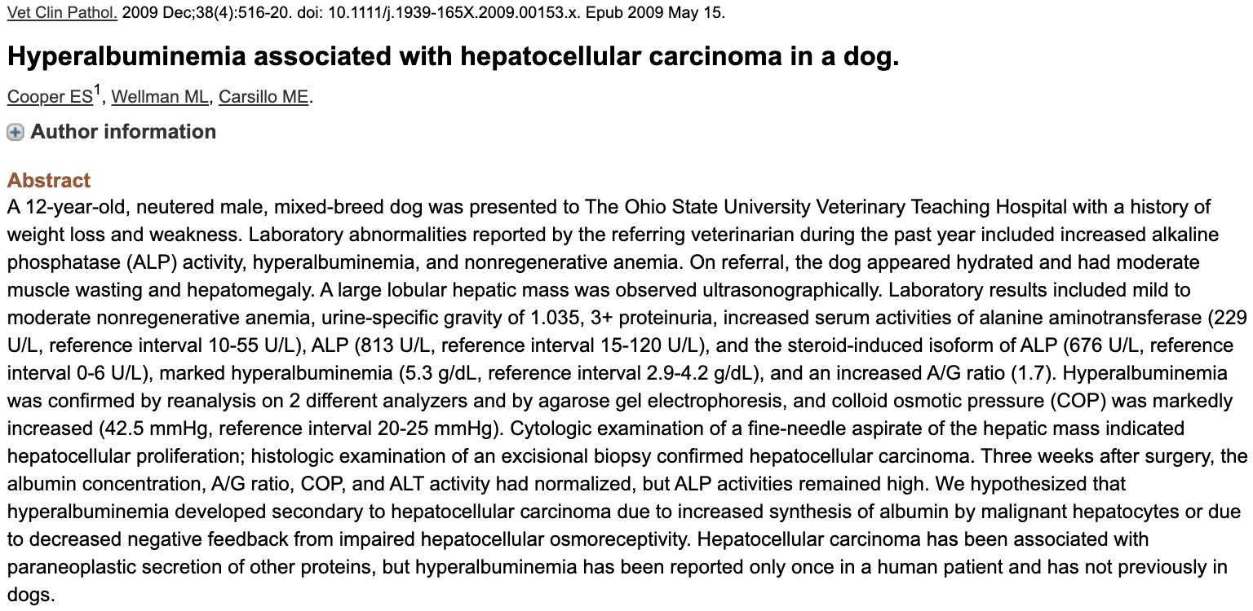

Hypoalbuminemia
Physiologic: Dilution
- Excessive fluid administration
- Excessive fluid retention e.g. anuric/oliguric renal failure, CHF

Pathophysiologic
Decreased production
- SIRS/inflammation
  - Decreased production (negative acute phase)
    - Cytokines shift from amino acids from albumin formation to positive acute phase protein synthesis
    - Will see A:G decreased due to combination of low albumin and high globulins
  - Leakage from vasculature
  - Denaturation of albumin at site of inflammation
  - Degradation of albumin bound to toxins
  - Crystalloid dilution effects
- Malnutrition
  - Can decrease synthesis by 50% within 24 hours
  - Due to insufficient hepatic amino acids
- Synthetic liver failure
  - Occurs when > 75% liver function is loss
  - Concurrent hypocholesterolemia, hypoglycemia, low BUN
- Paraneoplastic
  - Increased oncotic pressure: exerted by immunoglobulins secreted by multiple myelomas (high IgM > IgG) sensed by hepatic baroreceptors cause downregulation of liver production of albumin
Increased loss
- Low albumin + low globulins = severe hemorrhage
- PLN: can occur as nephrotic syndrome (proteinuria, hypoalbuminemia, hypercholesterolemia and peripheral edema); globulin levels are usually maintained
- PLE: albumin and globulins lost concurrently so have normal A:G
- Severe exudative dermatopathies: albumin AND globulins both low

 | Albumin | Globulins | HCT
Hemorrhage | Decrease | Decrease | Decrease
PLN | Decrease | Normal | Normal
PLE | Decrease | Decrease | Normal

Sequestration
- Loss of albumin from intra- to extravascular space
- Most commonly occur in protein-rich effusions e.g. peritonitis, pleuritis, sepsis, vasculitis
- Dilution can result from compensatory mechanisms associated w/ decreased effective circulating volume if fluid accumulation is severe

Hypoalbuminemia in Sepsis
- Multifactorial
  - Decreased production
  - Leakage from vasculature
  - Denaturation of albumin at site of inflammation
  - Degradation of albumin bound to toxic
  - Dilution from crystalloid therapy
- Prognostic indicator?
  - Not in dogs or cats
  - In people, low serum albumin levels (<29.2 g/dL) associated with an increased risk of death in patients with severe sepsis.

Consequences of hypoalbuminemia (5)
- Fluid shift
  - Severe hypoalbuminemia (<1.5 g/dL) extravasation of fluid
  - Fluid accumulates peripherally or w/in body cavities, but less so in the pulmonary interstitium
  - Intravascular plasma volume is lost simultaneously during extravascular fluid accumulation d/t loss of intravascular colloid oncotic pressure
    - Results in inability to retain fluid w/in intravascular compartment
  - Edema can impair healing, nutritional absorption etc.
- Thromboembolic risk
  - ATIII lost concurrently and in excess of procoagulant factors
    - ATIII = similar size to albumin
  - PLN > PLE
  - More likely if albumin < 2 g/dL
  - Risk can’t be predicted on ATIII, serum albumin or UPC values alone (Lennon et al 2013)
- Decreased carrier availability
  - Results in increased free/unbound form increased efficacy and toxicity
  - E.g. NSAIDS – 99% protein bound normally.
    - If there are insufficient albumin, the drug is only 98% bound and the free drug concentration will be doubled
- Acid-base: decreased anion gap
  - Every 1 g/dL decrease in concentration will lead to 4.1 mEq/L decrease in AG
  - AG_{Alb-adjusted} = AG + 4.2 – (3.77 – [alb])
- Wound healing
  - Delayed from interstitial edema formation
  - A risk factor for dehiscence of GI surgical sites in dogs (Ralphs et al 2003, Grimes et al 2011)
    - Possibly increased risk if < 2.5 g/dL
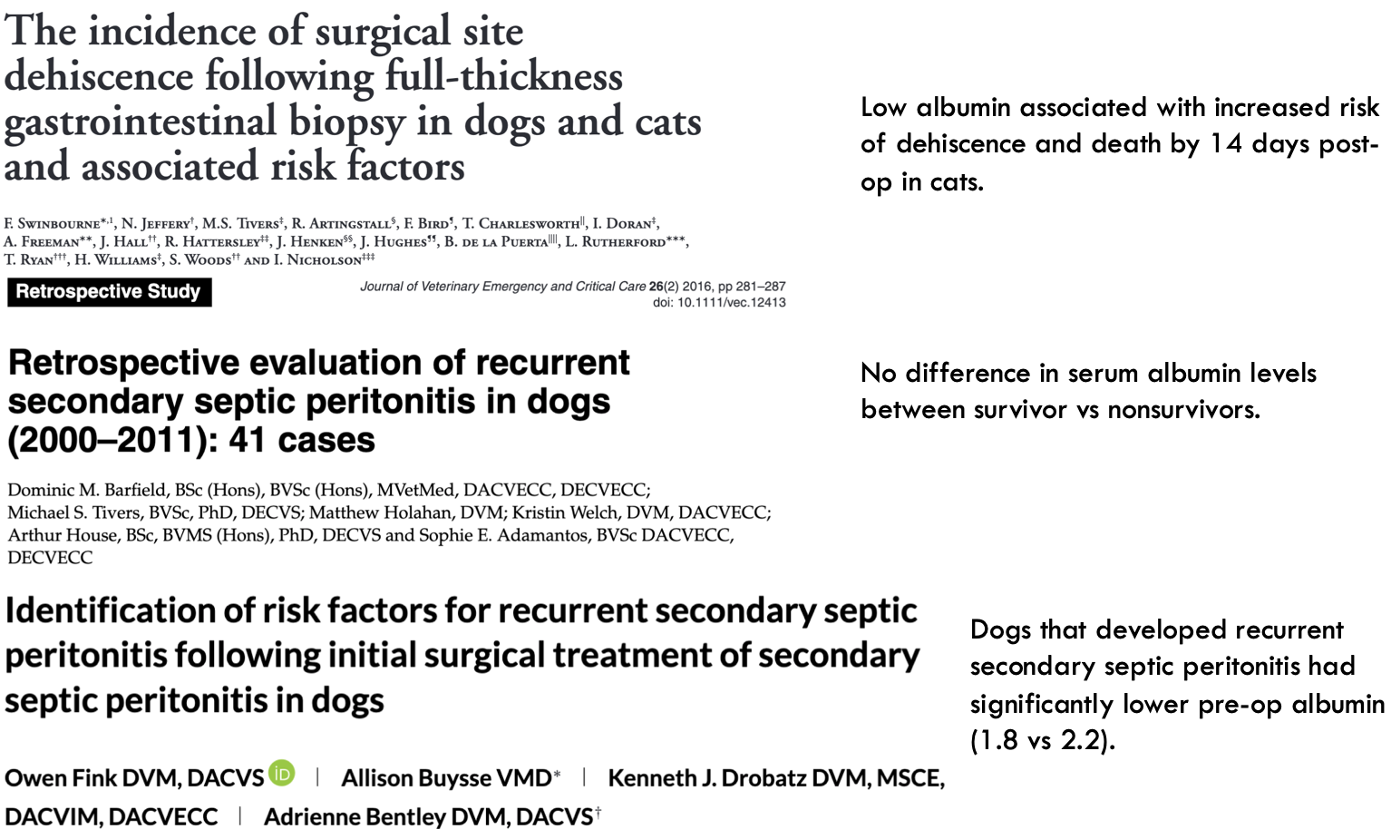

Treatment of Hypoalbuminemia
- Always be directed at treating the cause of the loss/decreased production
- Nutrition is important to provide protein to make new albumin
  - Enteral or parenteral nutrition
  - 18-24 hours of fasting can decr albumin by 50%
- Balanced approach to crystalloid therapy: too little may worsen vasoconstriction and impair O2 delivery, but excessive may worsen protein dilution and further decrease intravascular COP

Fluid options for hypoalbuminemia? (6)

- Crystalloid fluid
  - Pro: Inexpensive, readily available, generally well-tolerated
  - Cons: Short-lived effects, contributes to hemodilution
- Synthetic colloid
  - Pros: Significantly increase COP, inexpensive, readily available, larger molecules size (less likely to be lost in states of increased permeability)
  - Cons: May decrease albumin synthesis and increase catabolism, impair hemostasis, AKI?
- Fresh frozen plasma
  - 22 mL/kg of FFP to raise albumin by 0.5 g/dL
  - Pros: Easily accessible, species-specific, contains coagulation factors
  - Cons: $$, large volume, risk of transfusion rx
- Cryopoor plasma
  - No set formula to raise albumin
  - Pros: Cheaper than FFP, better blood product stewardship
  - Cons: Not readily available, no defined formula to raise albumin, used as CRI, risk of transfusion rx
- Human serum albumin
  - Indicated to increase COP in hypoalbuminemia, volume replacement
  - Pros: Significantly increase COP, unlikely to cause AKI (compared to synthetic colloids), doesn’t impair hemostasis
  - Cons: Expensive, risk of delayed hypersensitivity rx
  - Goal of albumin supplementation
    - To maintain albumin 2.5 +/- 0.5 g/dL or plasma COP = 13-20 mmHg
    - To increase COP without inhibiting albumin synthesis
    - In people they use it for volume expansion
  - Albumin deficit equation: 10 x (2.0 g/dL – patient albumin in g/dL) x BW (kg) x 0.3

Human serum albumin
- SAFE study (2008): Evaluated 4% albumin vs. 0.9% NaCl during fluid resuscitation
  - No difference between groups in terms of mortality
  - Worsened outcomes in traumatic brain injury
    - Suspected due to a secondary increase in ICP
- ALBIOS study (2014): Does 20% albumin to maintain albumin > 3g/dL reduce mortality at 28-days in severe sepsis or septic shock patient?
  - No 28- or 90-day survival benefit
  - Survival benefit at 90d for septic shock (42% vs 48%)
  - More rapid hemodynamic stabilization, reduced pressor requirements
- Surviving sepsis 2018: “We suggest using albumin in addition to crystalloids for initial resuscitation and subsequent intravascular volume replacement in patients with sepsis and septic shock, when patients require substantial amounts of crystalloids (weak recommendation, low quality of evidence).”
- Use of 25% HSA in veterinary medicine
  - Adverse rx
    - Mild acute rx are common
    - Risk of severe, delayed hypersensitivity rx is high
  - Caution esp. when administering it with other blood products
  - Critically ill patients suffer fewer adverse effect?
    - Hypothesis is that they are unable to mount an appropriate response against infusion of a foreign protein
- 5% and 25% concentrations of HSA available
  - 5%= isotonic, COP 20mmHg
  - 25%= hypertonic, COP 200 mmHg will incr intravascular volume 4-5x that of the volume infused

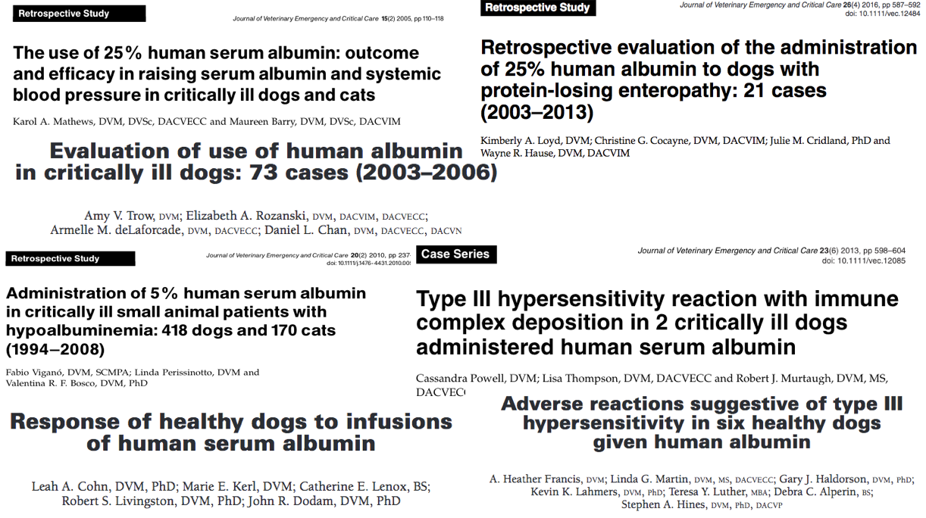

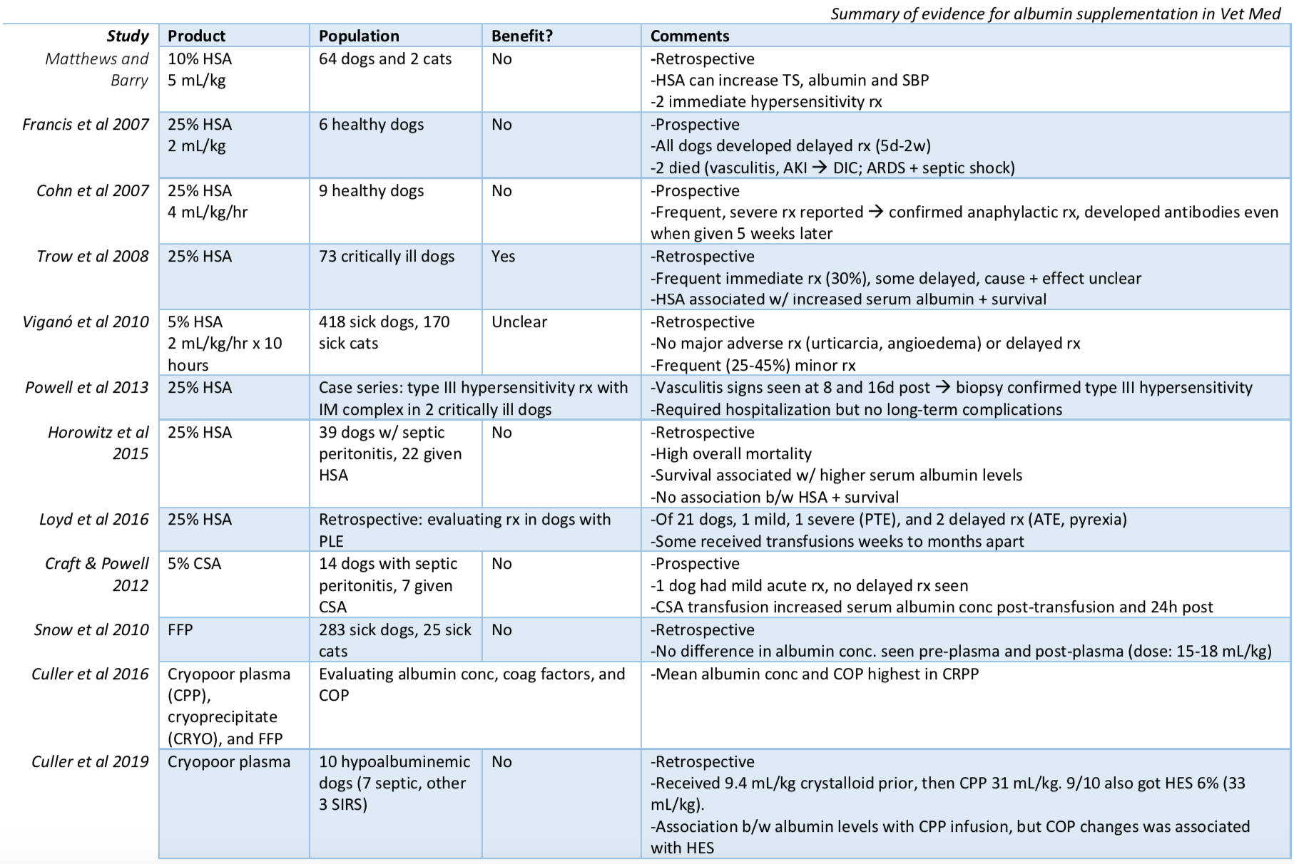

- Canine specific albumin (CSA)
  - Use if
    - Albumin <2 g/dL
    - Septic patients
    - Those w/ vasculitis, SIRS, edematous manifestations
  - Labelled for tx of hypovolemic shock or hypoalbuminemia
  - Pros: Species-specific (non-antigenic), should function like endogenous albumin
  - Cons: Expensive, availability, less data available
  - Reported adverse effects:
    - Vomiting, urticaria, fever
    - Vasodilation, hypotension
    - Rarely anaphylaxis
    - Possible unpublished data of CSA in healthy dog – can cause acute death?
  - Lyophilized form in 5 g vials
    - Collected via plasmapheresis
    - Reconstituted with 0.9% NaCl or D5W to 5, 10, or 16% solution
      - 5% =isotonic
  - Recommended dose (manufacturer): 450 mg/kg to increase albumin by 0.5 g/dL
  - Craft and Powell (2012 JVECC): Evaluated CSA in dogs with SP
    - Compared to CDT, CSA group significantly higher albumin 24 hours after transfusion
    - No difference between groups in COP or DBP
    - No difference in albumin levels between groups at discharge
    - One dog had a mild acute rx
    - No delayed rx seen

