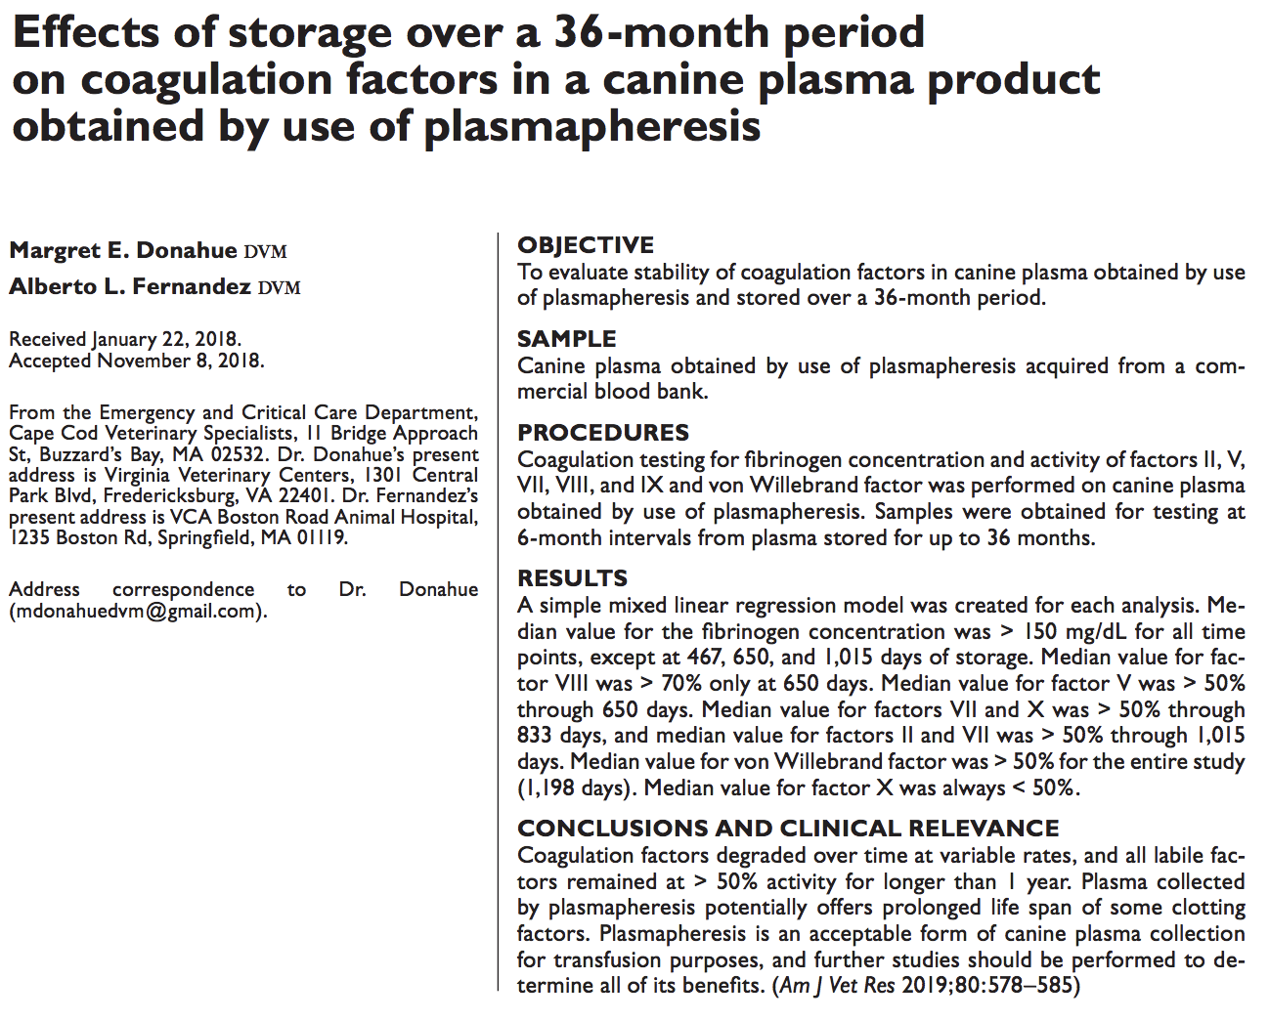

- Traditional FFP is plasma separated from whole blood and frozen within 8 hours. This study looks as plasma collected through plasmapheresis
- Coagulation factors II, V, VII, VIII, IX, von willebrand factor, and fibrinogen concentration are tested at 0mo, 6mo, 12mo, 18mo, 24mo, 30mo, and 36mo.
- In UK/Australia, FFP must have ≥ 70% FVIII activity and > 140mg fibrinogen/dL. Canada ≥52% FVIII activity. US does not have specifications.
- Results were variable. FVIII >70 % only at 18mo but was >50% for first 4 time points up to 24 mo. Fibrinogen concentration >150mg/dL for time 0, 1, 4, 6 but not 2,3,5. Mostly activity was >50% up to at least 1 year.
- Limitations: they did not test the initial sample for amount of coag factors or fibrinogen before it was frozen, so they do not know if variability between time points were due to patient variability at time of blood draw.

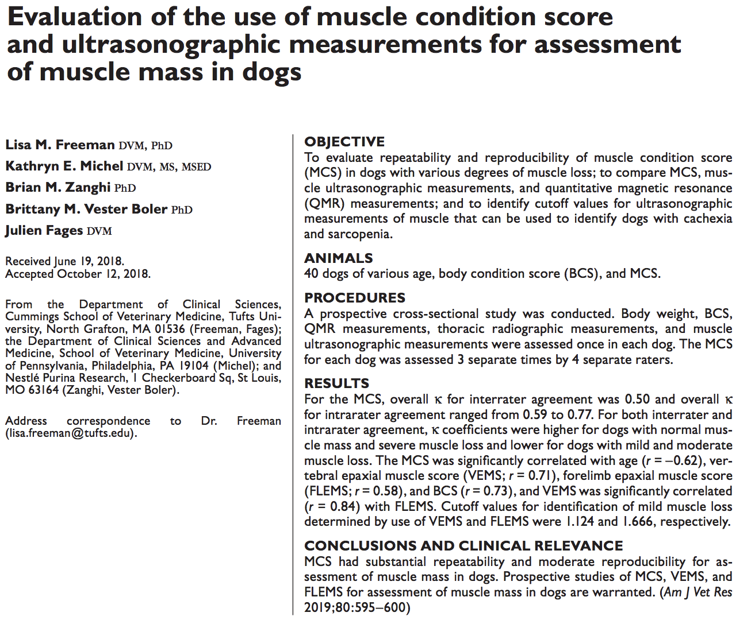
- Because muscle loss is common in animals with chronic disease, acute disease/injury, or aging, early identification enables early effective treatment.
- Looking at 40 dogs for body weight, BCS, MCS, QMR (quantitative MRI), muscle ultrasound measurements (epaxial muscle height), and thoracic radiographic measurement (vertebral epaxial muscle score).
- With MCS, they had 4 investigators evaluated all 40 dogs 3 separate times. There was repeatability but only moderate reproducibility (interrater agreement)
- No significant correlation between MCS and QMR, but suspect due to assessment of different body compartments

Nothing for Vet Journal

