PROJECT MANAGEMENT
https://www.linkedin.com/learning/project-management-foundations
Instructor: Bonny Biafore
These notes are taken from the course’s transcripts, and most of them are verbatim.
Table of Contents
PROJECT MANAGEMENT 1
Chapter 1. GET TO KNOW PROJECT MANAGEMENT 2
What is a project? 2
What is project management? 2
What it takes to be a project manager 2
The project management life cycle 2
Traditional vs agile project management 3
How organizational structure affects projects 3
How organizational culture affects projects 3
Project management software options 4
Chapter 2. FIRST THINGS FIRST 5
Initiate a project 5
Identify project stakeholders 5
Identify the project goal 5
Define project objectives 5
Choose a strategy 5
Gather requirements 5
Identify project deliverables and success criteria 5
Identify project assumptions and risks 5
Prepare a project scope statement 5
Create a project charter 5
Chapter 3. DEVELOP A PROJECT PLAN 6
Project planning overview 6
What is a work breakdown structure? 6
Build a work breakdown structure 6
How to create work packages 6
Estimate time and cost 6
How to choose the best estimate 6
Create a resource management plan 7
Build a project schedule 8
Develop a project budget 8
Identify risks 8
Create a risk management plan 8
Set up a communication plan 9
Develop a quality plan 9
How to set up a change management plan 9
How to plan procurement 9
Processes for procuring resources 9
How to obtain approval to proceed 9
Chapter 4. BUILD A PROJECT SCHEDULE 9
Put tasks in sequence 9
How to assign resources to tasks 10
Learn to use milestones 11
Make a realistic schedule 11
Understand the critical path 11
Understand the critical chain method 11
How to shorten a schedule 12
Document the baseline 12
Chapter 5. OVERVIEW OF AGILE PROJECT MANAGEMENT 12
What is agile project management? 12
The agile project management life cycle 13
Plan an iteration 13
Manage the explore stage 13
Handle the adapt and close stages 13
Chapter 6. WHILE YOU RUN THE PROJECT 14
How to run a project 14
Techniques for communicating effectively 14
Run effective meetings 14
Chapter 7. WORK WITH TEAMS 14
Manage team resources 14
Understand team dynamics 14
How to manage virtual teams 14
How to manage technical teams 14
Chapter 8. MONITOR AND CONTROL PROGRESS AND PERFORMANCE 15
How to gather data 15
How to manage project change 15
Learn how to manage project scope 15
Monitor and control risks 15
Understand earned value analysis 15
Evaluate progress 15
Learn how to solve problems 15
How to get a project back on track 15
Chapter 9. CLOSE A PROJECT 16
Close a project 16
How to obtain customer acceptance 16
Document lessons learned 16
How to prepare a close-out report 16
Learn how to close and transition projects 16

Chapter 1. GET TO KNOW PROJECT MANAGEMENT

What is a project?
A project is a temporary endeavor that has a specific and unique goal, and usually a budget.

What is project management?
Answering a few crucial questions:
- What problem are you solving?
- How are you going to solve this problem?
  - requirements, deliverables, scope
- What’s your plan?
  - work, resources, schedule, processes
- How will you know when you are done?
- Success criteria: quantifiable, measurable results that show that the project is complete
- How well did the project go?
  - This is an important step. What went well? What didn’t? Why? What could we have done better?

What it takes to be a project manager
- Technical
- Business expertise
- Problem solving
- Interpersonal skills
- Strong leadership

The project management life cycle
Five groups of processes that guide a process from beginning to end:
- Initiating: define the project, aim and scope, cost estimate, project stakeholders’ approval to proceed.
- Planning: What are we going to do? How are we going to do it? How will we know when we're done?
- Executing: put plan into action
- Monitoring and controlling: checking what's going on in the project, and how that compares to what you planned.
- Closing process: document project performance
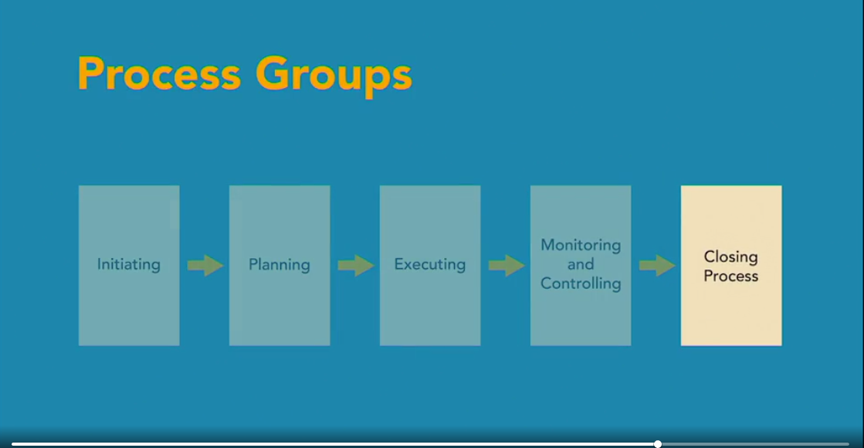

Traditional vs agile project management

- Traditional: processes flow from one to the next, scope and deliverables are clear-cut, works for projects with little uncertainty.
- Agile: processes go through iterations, sometimes called sprints, to deliver partial solutions at regular intervals. The project continues based on customer feedback.

How organizational structure affects projects

- Functional hierarchy: project managers have no authority, a functional manager is in charge.
- Matrix organizations: still functional hierarchies, but more support for projects.
- Projectized organizations: project managers have complete authority over their projects, including the budget.

How organizational culture affects projects
- Does your organization put results ahead of procedures or vice versa? That is, is it better to follow the rules, even if you don't achieve the objective or can you do whatever it takes as long as you deliver the desired results?
- A project's goal is always to achieve its objectives. But it's important to know where the boundaries are in making things happen.

Project management software options
(There are dozens of options, I think we have enough at CUL already - vs.)

Chapter 2. FIRST THINGS FIRST

Initiate a project
- Get commitment to move forward

Identify project stakeholders
- Create a stakeholder analysis spreadsheet, which includes stakeholder name, department, position, interests and objectives, project contribution, and concerns.

Identify the project goal
- The end result the project will deliver; include a problem statement that defines the problem or opportunity. Why do we need to do this (project)?

Define project objectives
- Detailed objectives define the project scope, the approach you choose, and the success criteria you have to meet.

Choose a strategy
- Compare options, evaluate how well each strategy satisfies the project objectives. Is it feasible? Is it risky? Does it fit the organization’s culture?

Gather requirements
- Describe specifically what the project must deliver. Confirm these with stakeholders.

Identify project deliverables and success criteria
- List the end (and, if applicable, intermediate) deliverables and quantifiable success criteria with which to measure them.

Identify project assumptions and risks
- Assumptions: Ask people what they expect and what they envision when they think about the project. Identify risks that could affect the project, so that management can decide whether or not to invest in the project.

Prepare a project scope statement
- Project scope describes the boundaries of the project, what is included in the scope of the project, and just as important, what isn't included – what is out of scope.

Create a project charter
- This document authorizes and publicizes the project. It includes the name of the project, the purpose of the project, a short summary of its goal and objectives, and a project description, which may include things like high-level success criteria, requirements, scope, risks, assumptions, and constraints, a milestone schedule, cost estimate, and list of stakeholders.

Chapter 3. DEVELOP A PROJECT PLAN

Project planning overview
- Break the work down into bite size pieces. Create a list of tasks, decide who's going to do the work, how long each task will take, and how much it will cost.

What is a work breakdown structure?
- A work breakdown structure (WBS) diagram is useful to organize work by dividing up the project into manageable pieces.
- A scheduling diagram shows the progress of the project in terms of a time line.
- The tasks diagram breaks up the project into work parts, consisting of summary tasks, which are then broken down into work packages.
- Summary tasks are the higher-level tasks that summarize work in some way. Work packages are the several detailed tasks that constitute one summary task.
WBS Diagram (from google search) - lots of diagram examples available on-line, based on one’s preference.
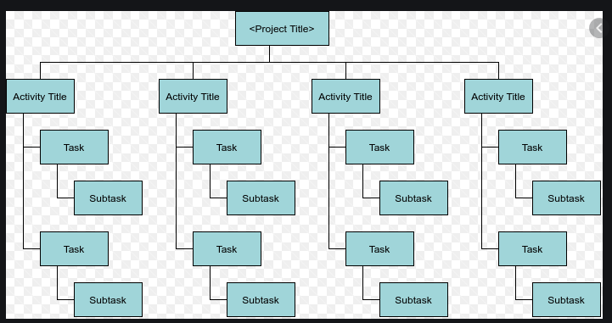

Build a work breakdown structure

- Start at the top level of summary tasks and work your way down.
- As a team, identify the top few levels of summary tasks.
- Break down the summary tasks into smaller sub-tasks. Add time, cost (where applicable), and measurable status to each sub-task.
- At the end, everyone gets back together to review the results.

How to create work packages
- Work package documents describe the work that needs to be done in detail. The level of detail needed in the work package document depends on how familiar the work is and the experience of the person assigned to the task. For example, a work package document might include a detailed description of the work for a less experienced person. For someone more experienced, a checklist of things to do might be enough.
- If the specifics of the work are described somewhere else, you can refer to the other document that contains the information.
- A work package document does more than describe the work, it also identifies how you know the task is complete and whether it was completed correctly.

Estimate time and cost
- Estimating accurately matters because your estimates could determine whether it makes sense to run the project.

How to choose the best estimate
- The answer is about halfway between the average and worst-case values. Based on a Bell Curve, that gives you an 86% probability of your results being less than or equal to that number.
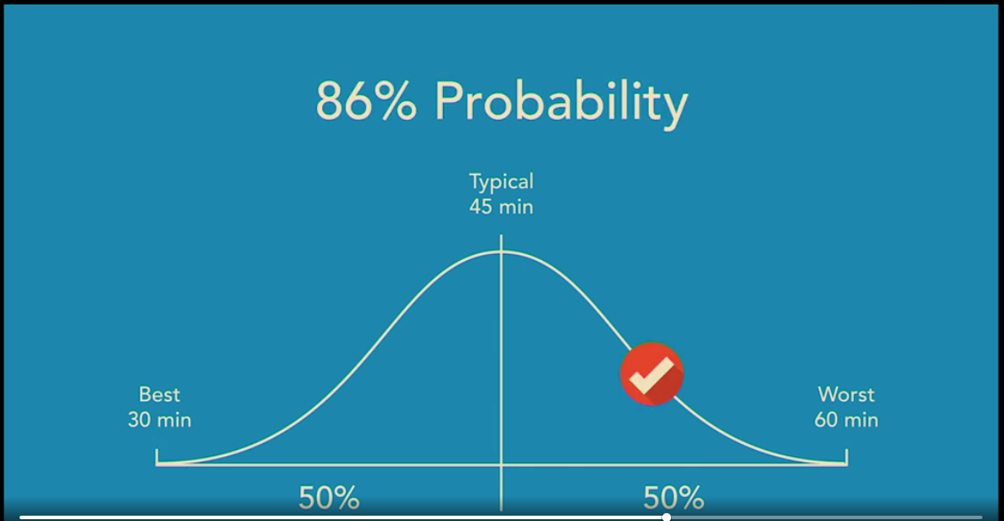

Create a resource management plan

Project roles and responsibilities
- Responsibility matrix: This document spells out who can make or approve decisions, the groups performing work, and which groups need to be consulted or informed about what's going on.
- Project organization chart: It's like a regular org chart, except it shows the hierarchy and reporting structure for people involved with the project. That way, you know who to talk to if you need to escalate a request or a decision.
- Skills matrix: Identify the skills the project requires and how many people you need with those skills.
- Staffing plan: Identify where you plan to get resources. Are they in-house, outsourced, or contracted? When do you need resources? Identify any training they need and document resource-related processes, getting team members on board, handing out assignments, getting status updates, and releasing them from the project when their work is done.

Build a project schedule

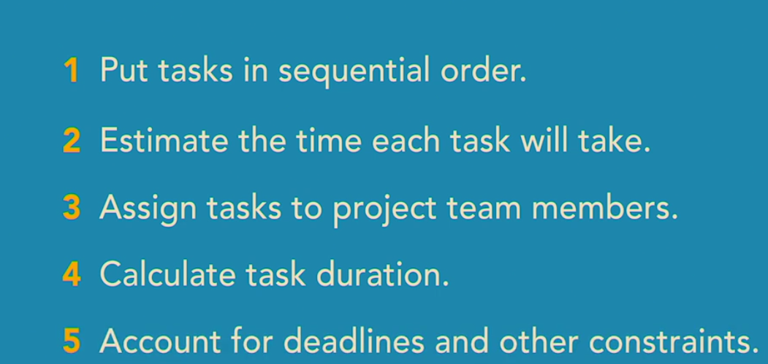

Develop a project budget
- (We mostly deal with time costs - vs.)

Identify risks
- Technology might cost more than you expect, not work the way it's supposed to or not show up when you need it.
- A widely dispersed project team can increase risk.
- Delays due to time-zone differences.
- Miscommunication from different languages or cultures.
- Lack of team work because remote team members haven't developed effective working relationships. Lack of detail like specifics on deliverables, due dates or who will work on your project.
- Limited options like people with rare skills increase risk because you don't have easy alternatives to apply if a problem arises.
Work with everyone on your team to identify risks. You can ask experts for different parts of the project about the risks they foresee. Ask key people in the project what they think and ask other project managers about risks from similar projects.

Create a risk management plan
A risk management plan documents which risks you're going to worry about and how you plan to handle them.
- First, identify which risks warrant managing.
- Start by evaluating how likely they are and how serious their impact would be.
- Rate risks by probability and impact using a scale of one to five, where one is unlikely or not serious, and five is highly likely or extremely serious.
- Then multiply the probability and impact to calculate a risk score. It makes sense to manage risks that are at least fairly likely and serious. That means you need to plan for any risk with a score of nine or more.

Set up a communication plan
- The success of a project depends on good communication. That's why you set up a communication plan, include the right people, and communicate the right information at the right time and in the right way.
- The communication plan helps by spelling out how you're going to communicate with stakeholders to keep them onboard and happy.
- A communication plan helps ensure that people get the information they need in the most effective way.

Develop a quality plan
A quality management plan is your roadmap to meeting objectives. Project quality translates into meeting the customer's requirements and delivering on time and within budget. With deliverables and products, quality also means conforming to specifications.
A quality management plan has three components.
- First, there's the quality standards for deliverables. The goal is to meet the quality standards.
- The second part of the Quality Management Plan, is a Quality Assurance Plan. This spells out the processes you used during the project to ensure that the final results meet the quality standards.
- Finally, you plan for quality control, which means how you measure and monitor quality in the final deliverables. The bottom line is that you examine or measure results to see if they meet the standard set.

How to set up a change management plan
A change management plan helps you add important changes into your project while keeping out the ones that don't make sense.
- First you identify what you want to control like the project scope, requirements, and the schedule. Or perhaps the entire project plan. The versions you control are called baseline documents. The list of project requirements approved by the stakeholders is your baseline.
- If new requirements are suggested, you use your change management process to decide whether or not to add them to the requirements list. You also need a group that reviews change requests and decides whether to approve them. It's called the change review board and it's usually made up of key stakeholders.
- Then you define a change management process. That's what will happen when someone requests a change. The process your organization chooses depends on things like the company culture and project size.

How to plan procurement
- First you identify what you need to purchase. Maybe you need people with specific skills or you need more people than your organization has. Or the project requires products and materials.
- Second, you document your procurement processes. Who handles procurement? Is it the purchasing department, the project or team or a combination of the two? The plan describes criteria for choosing vendors, the selection process, types of contracts you use and how you manage those contracts. Fortunately, you usually don't have to invent all these processes. Most organizations already have procurement processes in place. Talk to your purchasing department or finance group to find out how it's done.
- Third, you describe your make or buy decision process. Basically, how you you decide whether to use in-house products or services, or procure them. To make an informed make or buy decision, it's important to understand your needs. Make sure your requirements are clear and then prioritize them. That way it's easier to pick products that meet your requirements, plus you can resist bells and whistles you don't need. You have to see if a product that meets your needs is available. If it is, evaluate how it matches up with your requirements.
- Before you finalize your decision, consider the pros and cons of making versus buying. If your project is on a tight timeline, buying is probably the right choice.
- The last part of the procurement plan is a list of potential vendors who offer what you need, to purchase. Describe how you researched vendors and contractors and the criteria for developing the list.

Processes for procuring resources
- If team members come from within your organization, procurement might be as simple as telling your in-house team it's time to start your assignments.
- For resources outside your organization, the procurement process has a few more steps: solicitation, evaluation, selection, contracting, and ongoing management.

How to obtain approval to proceed
- Now that you have a plan for the project, you need to get the stakeholders to approve the plan so you can start work. Getting approval is important because you need stakeholders' commitment to make the project a success.
- Schedule a meeting specifically for getting approval. The agenda is straight forward. First, present the project plan to make sure that the stakeholders agree with it. If issues arise, deal with them right then and there.

Chapter 4. BUILD A PROJECT SCHEDULE

Put tasks in sequence
A network diagram shows the sequence of tasks. A task dependency is when one task controls the timing of another. The task in control is called a predecessor, and the one being controlled is the successor. Each task has a start and finish, so there are four types of task dependencies.
- Finish-to-start dependencies are the most common. The finish of one task controls when the other task starts.
- A finish-to-finish dependency means the finish of one task controls the finish of the other.
- Start-to-start means that the start of one activity triggers the start of the other.
- Start-to-finish dependencies don't occur very often. That's a good thing, because they can be confusing. The start of one task triggers the finish of another.
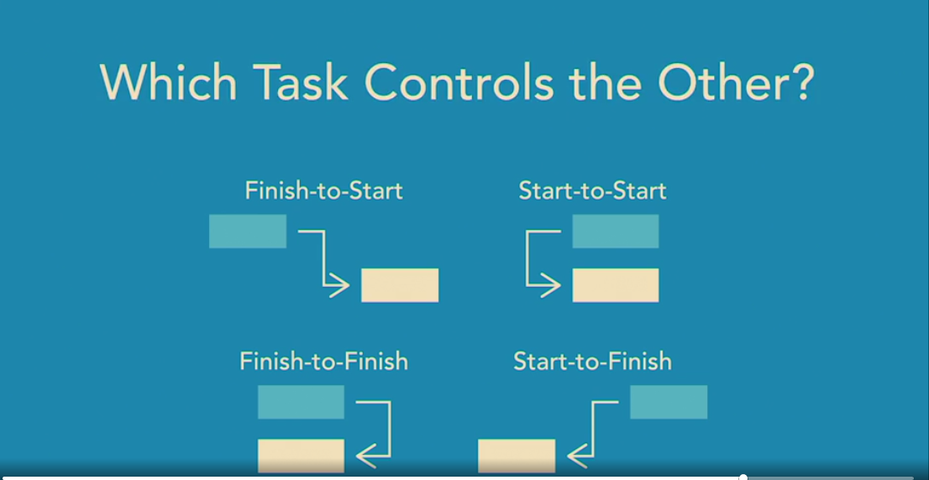

How to assign resources to tasks
The final piece of your scheduling puzzle is how many people work on each task and when they're available. With that info, you can see how long tasks take and when they should occur. You assign resources only to work packages, because they represent work that must be done. Summary tasks roll up work from lower levels, so you don't assign resources to these tasks.

Learn to use milestones
Milestones help indicate progress in a project. 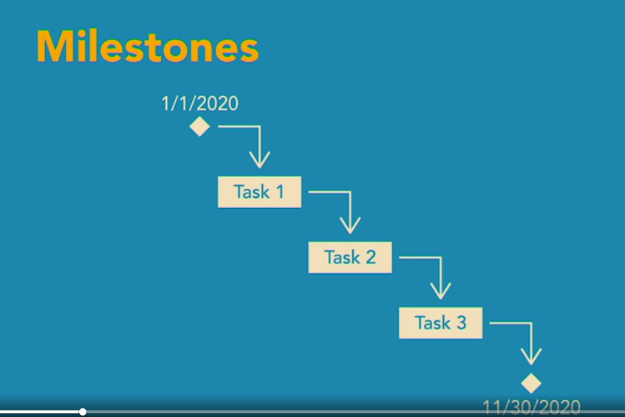

Make a realistic schedule
Estimate task duration based on the hours people work on the project each day. People don't work 100% of their time on project tasks. People don't even work 100% of every workday. Things like staff meetings, paperwork, training, and time off chew up work hours. Even walking across campus uses up work time. So do your best to estimate the number of hours people typically work.

Understand the critical path
The critical path is the longest sequence of tasks in your schedule. Critical tasks can't move without affecting the project finish date. If any of these tasks are delayed, the project finish date moves later in time.
On the other hand, if a task has slack, it can start later without delaying the tasks that come after it. The critical path is the place to look when you want to keep your project on time or deliver it early.

Understand the critical chain method
Critical chain is a slightly different take on the critical path. It can help you deliver your project earlier than you would otherwise, and helps prevent delays in the project finish date.
The critical chain approach uses buffers to give a project breathing room. That way, delays aren't as likely to delay the finish date.
What do these buffers do? They're like adding shared time to the project. Each task doesn't get its own time buffer. Instead, sequences of tasks share a buffer. That way, only the tasks that actually need extra time use some of the buffer.
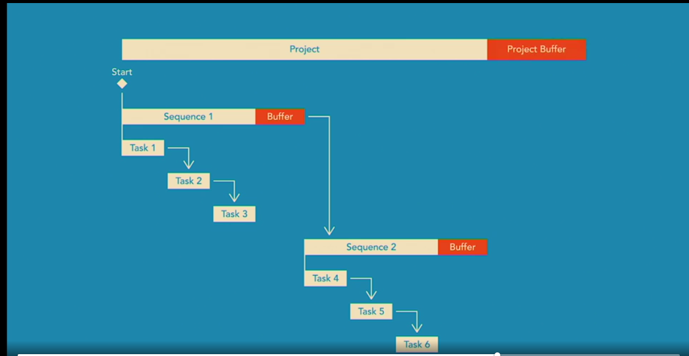

How to shorten a schedule
- Fast-tracking: overlap tasks that normally occur one after the other.
- Crashing: spend additional money to shorten the schedule, like paying for more people or expedited delivery of key materials
- Cut project scope

Document the baseline
- The baseline is a collection of the approved project documents like requirements, the schedule, budget, spread sheets, and more. Basically, everything you want to control with the change management process.
- With baseline documents, you can compare actual project performance to the baseline to see how the project's doing. Because the baseline is controlled by the change management process, any changes to baseline documents show up as change requests.

Chapter 5. OVERVIEW OF AGILE PROJECT MANAGEMENT

What is agile project management?
With Agile, work is performed in time periods called iterations or sprints. The goals of each iteration is to deliver a complete, ready to use feature. Agile places more importance on people and interaction, than processes and tools. For example, people communicate when there's a reason to, not because the weekly team meeting is scheduled. With Agile, your goal is to produce a product not reams of documentation. That doesn't mean no documentation. While the team is building features, documentation is limited to what they need to do their work. Documentation like User Guides are added to the features list. The customer is much more engaged in an Agile project. In Agile, the customer collaborates throughout the development process, which means it's easier to meet their needs. Changes are not only expected, but welcomed. The Agile philosophy views change as a way to provide more value. With Agile, you can shift priorities quickly by adding new features in a later iteration. Agile performs many of the same activities in waterfall project management in a slightly different order. One way to think about it: the waterfall approach defines the scope of the project, and then estimates the time, cost, and quality to deliver that scope. Agile looks at time, cost, and quality as fixed elements. Then you figure out which features you can produce given those constraints.

The agile project management life cycle
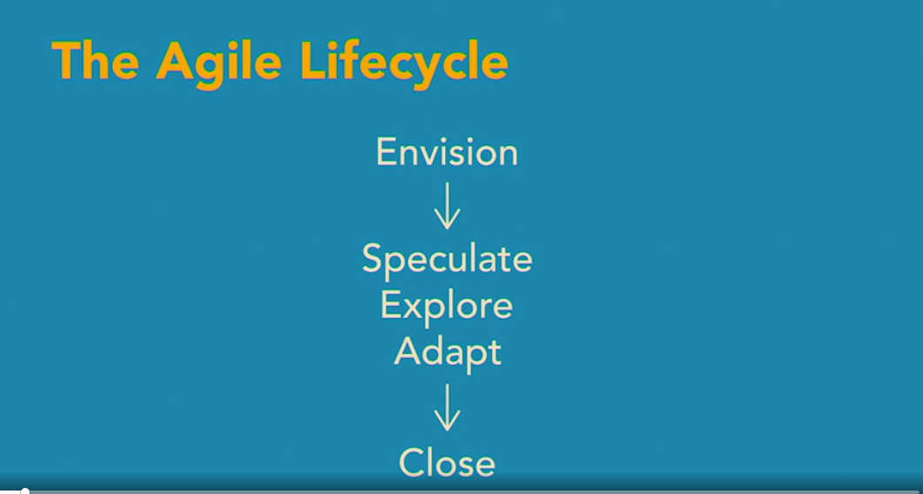
- Envision: Start of your project, when you and the customer envision what you're going to deliver. Define the project goal and objectives, scope, and stakeholders.
- For each iteration, you cycle through the speculate, explore, and adapt stages.
- Speculate: is about planning, except that you plan an iteration, not the entire project.
- Explore stage: Build the iteration's features; peer reviews of features in development; testing.
- Adapt: Act on feedback. Product owner or customer conducts a final review of the iteration's features.
- Close: Produce a final set of lessons learned to use in future projects.

Plan an iteration
- The Speculate stage is when the business and technical teams identify the features to include in the current iteration. A feature is a small function or deliverable that addresses a business need.
- Once the prioritized feature list is approved by the customer or sponsor, you can create the Iteration, Milestone, and Release Plan. This plan outlines all the features, when they're scheduled in the iterations, and when they'll be implemented in the organization. And you're ready to start the Explore stage of the first iteration.
- Each time you start another Speculate stage, you have to reestimate, reevaluate, and reprioritize the features to decide which ones to include in the iteration, like features that weren't completed and are now back in the backlog, or new features that were identified since the original backlog was built, and the next features in the backlog that you want to include.
- The Speculate stage doesn't take long. If your iterations are three weeks long, you might spend a couple of days in the Speculate stage. You start each iteration by planning what will be done.

Manage the explore stage
- This is where the team starts building and implementing features. At this stage, a lot of collaboration occurs between the business and technical folks. The bulk of the effort in the explore stage is working on the features assigned to the current iteration.
- Your main job is to remove obstacles so team members can focus on their work.
- You stop working on features when the iteration is scheduled to end, even if the features aren't done. For example, if your explore stage is four weeks, you stop at four weeks. If features are incomplete, you put the incomplete work into the backlog to address in a future iteration. On the other hand, if the team cranks out the iteration features faster than they estimated, you can start working on another feature from the backlog to fill in the rest of the time.
- The explore stage is mostly about building and implementing features, with short daily meetings to help keep things on track.

Handle the adapt and close stages
- The last stage of an iteration, the adapt stage. As you might expect, you and the team compare what was delivered to what was planned. You talk about what did and didn't work. The team might identify changes to make future iterations run better.
- Take time to review with the customer what's been done, and make sure that the features are working the way they should. At the same time, check that the features produced the business benefits they're supposed to.
- Hold a lessons learned session to share feedback. That way, everyone can brainstorm ways to resolve issues and eliminate obstacles, plus, everyone can improve by taking advantage of the things that went well.
- It's important to get closure at the end of each iteration, and the end of the project. That way, you confirm the success of this and future projects.

Chapter 6. WHILE YOU RUN THE PROJECT

How to run a project

Techniques for communicating effectively
It's about getting a message across so the other person understands it and does something about it.
(We have lots of CUL training about effective communication that contains more details than this brief chapter – vs.)
- First, tell your audience why they should pay attention.
- Second, get to the point. That way, you'll make your point before they lose interest.
- Third, tailor your message to your audience. What's relevant to them?

Run effective meetings
- If you hold a meeting, make it count. The first step to a productive meeting is to know what you're trying to accomplish.

Chapter 7. WORK WITH TEAMS

Manage team resources
- Clearly communicate roles and responsibilities to your team members. You can build your relationships with them by helping them understand what they're responsible for and what you expect of them.
- Give people specific and achievable goals. Team members usually dig deeper to respond to challenges.
- Provide support and help remove obstacles that get in the way. If your people can't resolve issues or remove obstacles, help them in any way you can.
- Provide feedback quickly.
- Handle people problems quickly if they come up. The answer could be as easy as telling someone what they're supposed to do, or explaining the effect they're having on others. It's important to be up-front while at the same time being tactful and respectful.

Understand team dynamics
- Teams grow up through several stages before they're truly productive. One model that describes the typical phases that teams go through is called forming, storming, norming, and performing.
- The first team stages is called forming because the individuals are just starting to form into a team. They aren't sure of their goal as a team, and they don't know who does what. During the forming stage, you as their leader have to clearly define the team's goals and give them direction.
- The second stage is called storming because things with teams usually get worse before they get better. As team members start to work out their relationships with each other, power struggles often occur. Storming teams have difficulty making decisions because of disagreements. The good news is that those disagreements lead to communication, which helps people grow as a team.
- After the storm has passed, you finally have a team. That's the norming stage. The team understands their common goal, and everyone pitches in to be successful.
- Teams in the performing stage know what they're supposed to accomplish, who's supposed to do what, and they often get things done very quickly, all without any help from you. You only have to step in if the team asks.

Chapter 8. MONITOR AND CONTROL PROGRESS AND PERFORMANCE

How to gather data
- The first thing you need to track progress is when tasks actually start. If tasks don't start when they're supposed to, a delay in the project finish could be on the horizon.
- While tasks are underway, get actual work hours or actual duration.
- Progress data tells you where your project stands and whether you need to wrangle your project back on track.

How to manage project change
- Let's say a change request comes in. You assign someone to evaluate the request, add it to the change request log, and submit it to the change review board, along with your recommendation to either approve or reject it.
- If the request is rejected, let the requester know. Make sure no one on the team starts working on it in anticipation of its approval.
- However, if the request is approved, you assign someone to keep an eye on it. That person updates the baseline documents to reflect the change. Maybe new tasks are needed, or the project finish date moves or cost increases.
- The owner of the change request also adds status to the change request log, reports on progress, and shepherds the request through to completion.

Learn how to manage project scope
- The best way to prevent scope creep is to identify scope clearly during planning.
- If the customer is asking for features that are clearly out of scope, point out that they aren't in the scope statement. You can talk to the customer about the schedule and budget changes needed to add to the project scope.
- If the customer doesn't know what they want, consider switching to an agile approach. That way you and the customer will have opportunities to hone the scope over time.

Monitor and control risks
- In the risk management plan, each risk you decided to monitor has an owner assigned. That person's job is to watch their assigned risk and regularly update its status.
- Before a risk occurs, you proactively implement risk responses. That means you take steps to avoid, mitigate or plan contingencies for the risk. Then you watch for signs that high-priority risks are unfolding.
- Also watch for the events that trigger a contingency plan.
- When a risk occurs, launch the response you planned. Then, track the results.
- Finally, regularly report risk status and update the risk log and detail sheet. Upgrade or downgrade risk probability or impact if situations have changed.

Evaluate progress
- When work is underway, you have to look at the schedule and cost to see where the project stands. Variance values show the exact difference between your baseline and current schedule.
- Homing in on problem tasks helps you identify what you need to change to keep your schedule on track. Scheduling programs include tools that provide early warning of delays.
- Once you see where the project stands and identify problems, you'll have the info you need to come up with solutions.

Learn how to solve problems
- First, focus on what's important. Decisions and problem solving can take time and information, which are usually in short supply. So be sure to tackle the important decisions and problems first. You have to learn to ignore what isn't important, no matter how urgent it appears. When a problem arises, ask yourself, is it important? If the answer is no, ignore it.
- Next, make sure you understand what the problem is. Just like when you develop a problem statement for the project.
- Third, evaluate the impact of problems and prioritize the ones with the greatest effect on your project. With problems that have significant and long-lasting effects on your project, it's really important to pick the best solution. For issues like these, evaluate your options like you do with project strategy. On the other hand, sometimes doing nothing at all is the answer. Taking no action on purpose is an action. And it might be an acceptable alternative.
- Finally, ask for help if you need it. Others might identify solutions you wouldn't think of and can help you choose the best alternative. Problem solving is something you get to practice every day.

Chapter 9. CLOSE A PROJECT

Close a project
- You can improve the performance of future projects by identifying what worked well, what didn't, and how things can be done better.

How to obtain customer acceptance
- The project isn't done until the customer says so, but that doesn't mean they can keep asking you to do things.
- During closing, you run acceptance tests to prove that the project is complete. Back in planning, you fleshed out the project deliverables to demonstrate whether the deliverables do what they're supposed to.
- When the acceptance tests are done, hold a brief sign off meeting to get the customer and other key stakeholders to sign the acceptance document. That means they agree that the deliverables are complete and successful

Document lessons learned
- First, schedule time regularly for lessons learned. Don't wait until the end of the project to ask about lessons learned. By then your team members have already forgotten a lot of them.
- One approach is to add lessons learned as a topic in your status meetings. Keep your lessons learned sessions positive and productive. Start with what went right, ask each person for a tip or technique that help them in their work. Like, what saved you the most time recently? Or what was the gnarliest challenge you solved and how did you do it? Then move on to lessons learned from problems people faced.
- Try scheduling meetings without managers to see if people will share information more freely. You might use an anonymous method for submitting lessons learned like a suggestion box. This approach can be helpful for sensitive issues, or when people are afraid to admit mistakes.
- Finally, document lessons learned. You can add them to your project notebook, but you can also set up a knowledge base like a web page with frequently asked questions. That way everyone in your company can learn what your team already knows. Lessons learned give your organization the opportunity to learn and grow with each new project.

How to prepare a close-out report
- A closeout report is like a final status report for a project. It sums up the project results and helps share what you learned with others. Like a news article, start with the highlights, what the project accomplished and whether it was successful.
- Did the project deliver what it was supposed to? Was it on time and within budget?
- If not, what was the main reason why?
- Include information you want to share with others, like significant changes, issues, risks and lessons learned. Say the project didn't deliver the entire scope. In the closeout report, identify the scope that was and wasn't delivered.

Learn how to close and transition projects

