JFMS
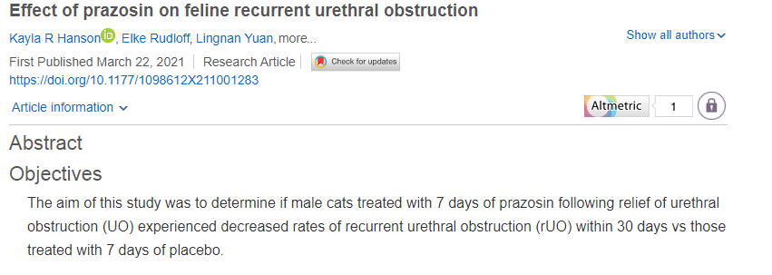
Intro: 93% survival rate, 36% rUO within 17 days, urethral spasm may contribute, 28-37% of the feline urethra has smooth muscle with alpha adrenergic receptors, can use prazosin to block the alpha receptors and allow for relaxation. Goal: look at the rate of rUO in 30 days for cats given prazosin vs placebo.
Methods: prospective, randomized, placebo controlled study, any MN cats that presented over 3 years that presented to the hospital for first time UO. Exclusion criteria: prior medications, prior urinary catheter placement, history of heart disease or hypertension, or cystoliths. All cats were given IVF, methadone, propofol, oxygen and used a 3.5 fr catheter, then placed 3.5 fr red rubber. In place for at least 24 hrs, no greater than 48 hrs. Cats were randomly assigned to the prazosin group (0.5 mg q 12 hrs x 7 days) vs placebo, blinded groups. 30 days later the owners were called to determine if there was a recurrence.
Results: 65 cats completed the study. 16/65 (25%)- rUO. Of the 16 cats, 5 received placebo and 11 received prazosin. Ten of those cats re-obstructed in hospital. No significant difference between the groups.
Discussion: This study actually found a higher rate of recurrence of UO in cats in the prazosin, treatment group (30%) vs cats on placebo (18%)- however this was not statistically significant. Placebo cats had a longer duration of indwelling urinary catheter than prazosin group. Increasing creatinine was associated with rUO and increasing TS was associated with less likely to rUO. This sample size was very small so may not be able to extrapolate this info to a larger population. This medication may not be useful in the treatment of UO cats.

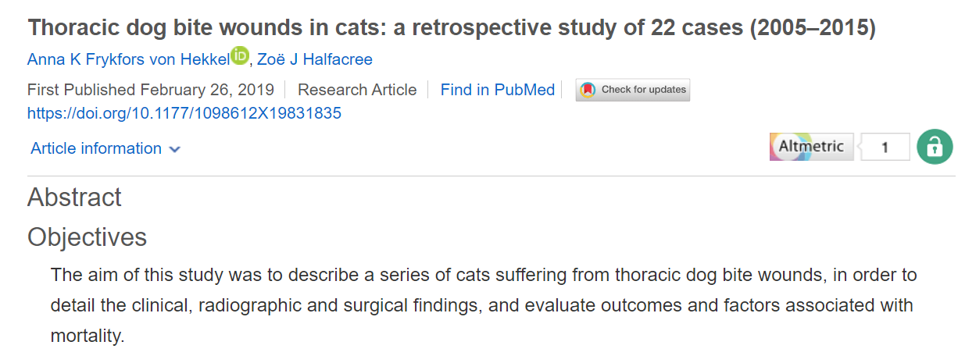

Intro: Common emergency, thoracic bite wounds have a high mortality rate. Commonly have features of crush, avulse, tear and puncture injuries. Extent of injury cannot usually be understood by initial evaluation. High mobility of skin and thoracic wall likely contributes. Even without evidence of skin damage, some cases required lung lobectomy. Aim of the study is to describe the clinical, radiographic, and surgical findings and associations with outcome.
Methods: Retrospective, case search between 2005 and 2015, inclusion- confirmed dog bite thoracic trauma with complete medical records. Tachypnea, and dyspnea were found commonly with pseudo flail chest if paradoxical movement was found prior to radiographic confirmation. Rads= rib fracture, sternal fracture/luxation, pleural effusion, pulmonary contusions, DH, pneumothorax and pneumomediastinum. Surgical findings= wound depth was characterized as- no wound, superficial, deep, or penetrating. Wound management: conservative, local explore, or surgical explore.
Results: 22 cats, Clinical presentation: 4/22 eupneic, 15/22 tachypneic, 12/22 dyspneic (9 cats with both). Wounds: 6/22 no external wounds, 4/20 superficial, 3/20 deep, 8/20 penetrating (2 euthanized and excluded). 9/20 pseudo flail chest. Rads: 18 cats had rads performed, CT in one case, pneumothorax found in 11/18, PC 7/18, pleural effusions, sternal fracture and rib fracture (6/18 each). Presence of greater than 3 lesions was significantly associated with presence of a penetrating wound and need for surgical explore. Not associated with survival or length of hospitalization. Presence of rib fractures was associated with a deep wound. Clin path: VBG in 17 cats, elevated lactate in 9/17, bacteriology on 16/20 cats- positive in 6 cats, most common isolate was E coli and Staph species. Surgery: local explore in 7/20, thoracic explore in 8/20. 11 cats survived to discharge, 3 referred to rdVM. Overall mortality 27% when financial constraints were not taken in account.
Discussion: Sternal and rib fractures associated with deep wounds and thoracic explore. 17/18 cats had radiographic changes on CXR. Majority of cats did not require surgical explore, only 1 that received conservative or wound explore died. Recommend surgical exploration in all pseudo flail chest cases since 7/8 found penetrating injuries on explore that required repair. Surgical exploration is also advantageous to debride and flush to reduce incidence of sepsis/SIRS. Mortality 27%.


Intro:
- Common feline emergency, constipation defined as trouble defecating or decreased frequency vs obstipation which is unable to defecate typically as attempts at treatment.
- Often associated with CKD, DM, and hyperthyroidism, less commonly pelvic fractures, neurologic issues, drugs and megacolon.
- Study aims to look at risk factors associated with this complaint and factors that predict success or failure
Methods:
- Retrospective case control study from 2011- 2017, cats included were discharged from the ER with a diagnosis of constipation or obstipation, and had history and PE that were consistent.
- Used 99 cases randomly selected as controls that were discharged from ER
- Treatment variables included enemas, IV fluids, SQ fluids and oral lactulose
- Treatment success was indication of any bowel movement while in the hospital, manual de-obstipation was not considered an adjunct treatment
Results:
- 251 cats were met criteria, 189 included, Sex not a risk factor, constipated cats were older than controls, proportion of cats fed a dry diet were not higher in the constipated cats group
- Constipated cats had a significantly higher BCS, no other PE findings were significantly different between groups
- Constipated cats were 20X more likely to have constipation in their history, more likely to have DM, IBD/small cell- but not significant
- TS and iCa were higher in constipated cats, hypokalemia as well, only iCa was significant
- 66% received one enema, 24% of those cats received a second one, outcome was recorded in 69%, 53% defecated in hospital, 40% enema as sole treatment. Enema type and volume were similar.
- Cats with a history of constipation were more likely to defecate after enema, cats assessed as painful on abdominal palpation were less likely to defecate, 8% were given buprenex or methadone
Discussion:
- Study was small
- Older cats with higher BCS were more likely to present for constipation
- Obesity can exacerbate neurologic and orthopedic issues which can make posturing to defecate more difficult
- Diet was not significant
- CKD was associated constipated cats, cats with CKD lose more water so it is reabsorbed in the colon which leads to constipation, hypokalemia also alters smooth muscle motility- need more information on whether correcting this electrolyte would make enemas more successful
- Unclear how much opioids cause constipation in cats like in humans- need more info
- Unclear about the helpfulness of adjunctive treatments
- 52% of cats defecated in this study so more research is needed to help determine lifestyle changes and treatment protocols

