Feb 2018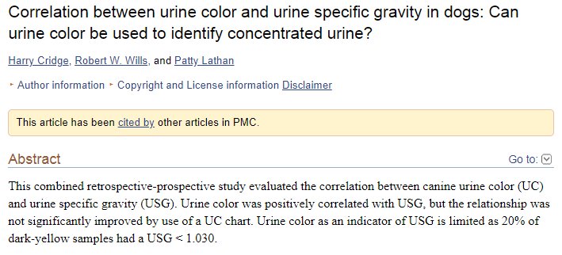

Intro: USG measures the amount of solutes dissolved in the urine, typically >1.030 in a dehydrated canine patient. Typically thought that a darker color is associated with a higher concentration. This relationship has been studied in human extensively and color scales have been useful in different clinical situations. This studied hypothesized that UC would be positively correlated with USG and a color chart as well as UC would be able to predict USG.
Materials and methods: medical records over an 18 month period, 1538 samples, samples with hematuria, bilirubin crystalluria, glucose or protein were exluded since they change the USG. 100 samples were randomly selected. Clear (1), light yellow (2), yellow (3) and dark yellow (4) urine samples were photographed. 95 new urine samples were obtained. Color was assessed using the chart and a routine urinalysis was performed.
Results: UC and USG were positively correlated, the relationship was not significantly affected by using the chart. All samples assigned a 1 had a USG <1.030, 80% samples with a 4 had a USG > or equal to 1.030.
Discussion: UC can be used to estimate USG, UC score of 1 or 2 was unlikely to have a USG > 1.030. Caution should be used since the samples in this study had no major abnormalities.

Jan 2019

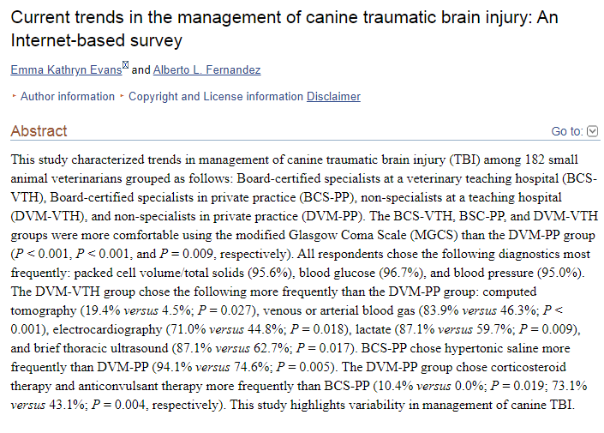
Intro: TBI requires prompt recognition and intervention, MRI in head trauma has shown that intraparenchymal lesions and prognosis are associated but it is often not performed in vet patients, continues to be debate about best treatments for TBI, such as unclear if prophylactic seizure management should be instituted. Internet survey- based study to determine the current diagnostic and treatment strategies commonly employed at veterinary hospitals and hypothesized that it would be heterogenous.
Materials and methods: Internet based survey from June to August 2016, sent to ACVECC and ACVIM list serves, 182 responded. The survey had 24 questions on diagnostic and therapeutic interventions for canine TBI. There were multiple choice and open ended questions, BC specialists from academia and private practice and non specialist in academia and PP.
Results:
- 1-5 patients with TBI monthly were seen, the most common criteria were mentation change, changes to pupil size and symmetry or responsiveness, bradycardia/hypertension. However, external trauma, seizures and changes in ability to ambulate were also cited.
- 73.6% used the MGCS to help determine TBI. BCS vets were more likely to use that scale. 62.6% said the MGCS was moderately useful and the majority of respondents were moderately or very comfortable using the scale. Overall the VTH vets were more comfortable using the scales. DVM in PP were the least comfortable. Among all groups 34.6 % repeated the MGCS fewer than 50% of the time.
- Initial diagnostic testing within 4 hours of admission were PCV/TS, BP and BG. Vets at VTH were more likely to use lactate, TFAST and ECG more than vets at PP. DVM VTH also chose CT and V/ABG over DVM PP. However, DVM PP were more likely to run a CBC/chemistry and CXR.
- Initial therapeutic interventions among all DVMs were mannitol, hypertonic saline, crystalloids, head elevation, opioids and oxygen therapy. BCS PP were more likely to hypertonic saline than DVM PP. 10.4% of DVM PP chose steroids and none of the BCS chose it and 73.1% chose anticonvulsant therapy vs 47.1% BCS PP.
- First line therapy for ICH was chosen based on patient characteristics such as volume status and hemodynamic stability. Mannitol was chosen by 73% and hypertonic was chosen by 73.6%. The respondents also took into consideration the rheological effects, anti-inflammatory effects and properties as hyperosmolar agents. 99.4% said that improvement in mentation or responsiveness guided therapy. They also looked at hemodynamic changes, pupil size and symmetry, seizures, improvement of MGCS, improvement of ventilation parameters and blood work parameters.
- Pathophysiology of secondary brain injury- BCS DVM were more likely to be very familiar with this concept, 63.6% VTH and 66.7% PP vs 38.7% VTH and 14.9% PP.
- Availability and accessibility of guidelines- 54.4% felt very comfortable treating canine TBI, BCS in either group were more comfortable. 68.1% thought there were somewhat clear guidelines and 67.6% thought there were moderately available and accessible.
Discussion:
- BCS were more likely to rely on the MGCS which is a good objective determination of the neuro status after TBI and is the gold standard in human medicine, there is also utility in repeating this scale since it has been shown in veterinary studies to be a useful indicator of prognosis.
- Diagnostics: BP and BG at admission are not prognostic indicators, although high BG may indicate a more severe TBI. Indicators or hypoperfusion or metabolic derangements such as elevated lactate, low HCO3, decreased pH and increased BE were associated with non survival. There was no uniform decision making for diagnostics.
- Neuroimaging was infrequently chosen, in humans CT is the diagnostic of choice within 24 hours of TBI to look for hemorrhage or fractures, MRI is the gold standard after 24 hours. A study in dogs found associations between MRI findings and prognosis.
- CRASH study showed no clinical benefit of steroids in human TBI patients and showed increased early mortality rates.
- In humans seizure prophylaxis is recommended in severe cases, mostly detected on EEG an non convulsive. Need additional info to determine if it is warranted and what drug should e first line.
- Current guidelines in humans do not recommend one hyperosmolar agent over another.
- Highlights the need for a consensus statement regarding treatment of canine TBI.

June 2020
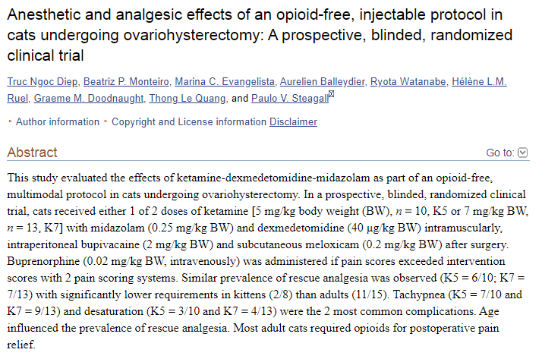
Intro: Opioids and volatile anesthesia are not always available so this study looked at opioid free low volume injectable anesthetic for feline spays with ketamine, midazolam and dexmed and the need for rescue analgesia.
Materials and methods: 35 female cats from a shelter- kittens and adults, randomized blinded clinical trial, any healthy cat >4 months of age with normal PE, history and PCV/TS. Randomly allocated to 1 or 2 treatment groups, one group received 5 mg/kg ketamine or 7 mg/kg ketamine. The investigators that gave the injection were blinded to the treatment. Once in lateral recumbency the cats were intubated and placed on a water blanket then prepped for surgery. ECG, pulse ox, BP and capnography were recorded every 5 minutes and temp was taken at the beginning and end of the procedure. LRS 10 ml/kg was administered. Intraperitoneal bupivacaine was administered. A ketamine bolus was given if not adequate anesthesia (0.5 mg/kg). Antisedan and meloxicam were given after each surgery. Anesthetic complications were tachycardia, bradycardia, hypotension, bradypnea, tachypnea, desat, hypothermia, hypercapnia. Ambu bag or oxygen was administered if hypercapnia or desat occurred. Pain was assessed 1 hour prior to injectable medications and at 0.5, 1,2,3,4,6,8,12 and 24 hours post op. The Glasgow feline composite measure pain scale and the feline grimace scale were used. Sedation was assessed with the dynamic interactive visual analog scale prior to pain assessment. Buprenex was used as a rescue of needed based on the pain scale results.
Results: 23 cats total, none required a ketamine bolus intra op, no difference in anesthesia complications between groups. No sig diff between treatment at any time, but 0.5 and 1 hour recordings were discarded due to continued effects of anesthesia. CMPS scores were higher at 2 and 3 hours in K5 and at 2,3,4 and 6 hours in K7 vs baseline. Grimace were higher in 2,3, 4 and 6 hours in K5 and 2,4 and 6 hours in K7 vs baseline. 13 cats required rescue analgesia- 6 in K5 and 7 in K7. Greater need in cats than kittens and most often given at 2 or 3 hour time point. Positive and significant association between both pain scales used. No sig difference between sedation scores.
Discussion: DKM injectable provided rapid immobilization and smooth induction in all cats, duration and depth of anesthesia was adequate, however almost all adult cats needed an opioid. Almost 1/3 of patients needed oxygen or assisted ventilation so this protocol is not advised if these are no readily available. The 5 mg/kg dose was adequate. Approx 32 minutes of anesthesia time and 16 minutes to recovery after antisedan. Unclear if kittens seem less painful because they show less behaviors consistent with pain, there is less trauma or physiological differences. Both the pains scales were effective and should be used in post op spay assessments. Less sedation effects were also noted in kittens.

