Lit Review December 2020

Oct 2019
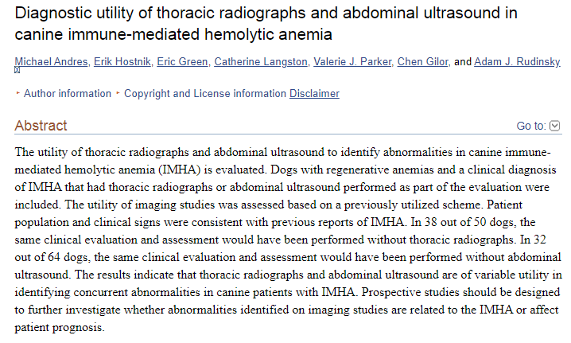
Intro: Most IMHA cases are primary, and most of the diagnostics are costly to look for secondary causes, this study is to evaluate the utility of thoracic x-ray and abdominal ultrasound in IMHA cases based on abnormalities found.
Materials and methods: Medical records from 2005-2015 for animals with regenerative anemia, diagnosis of IMHA based on conventional criteria, CBC/chem/ua and imaging was performed. Imaging was reviewed by a radiologist that was blinded to the diagnosis. Survey to assess if the imaging was useful in case management.
Results: 187 dogs met the diagnostic criteria, 64 dogs met all the criteria, 100% had spherocytes, 75% had nRBCs, 78% had macro and or micro agglutination and 36% had positive Coombs test. 68% had normal thoracic x-rays in 20% of cases the TXR were useful in case management. AUS 25% wnl, 37% were important to case management.
Discussion: 76% of TXR and 50% of AUS when interpreted with clinical case information were not helpful in case management. Gall bladder wall edema was more common than expected. The abnormalities found on either imaging modality were not necessarily associated with the IMHA diagnosis. The overall utility of imaging to determine abnormalities was not high. The decision to recommend these tests should be evaluated on a case by case basis.
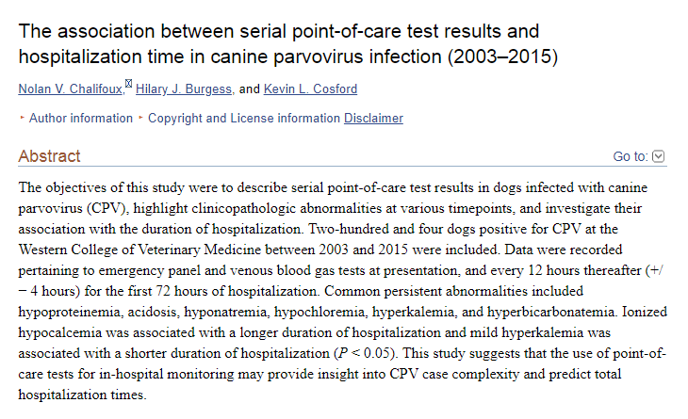
Intro: Importance of looking at the clinicopathologic changes on point of care blood work during hospitalization to monitor disease progression in parvo positive puppies
Materials and methods: Medical records from 2003-2015, dogs included had a positive SNAP parvo test, were hospitalized and the dog survived to discharge, data were recorded for PCV/TS, VBG. BG, lactate, BUN and azo. This was recorded initially and then every 12 hours for 72 hours, 204 dogs total
Results: Common persistent abnormalities identified on EP and VBG results include hypoproteinemia, acidosis, hyponatremia, hypochloremia, hyperkalemia, and hyperbicarbonatemia. Decreased ionized calcium at 24 and 48 hours was associated with longer hospitalization. Mild hyperkalemia at 12, 24 and 36 hours was associated with a shorter length of hospitalization.
Discussion: typical age related changes in puppies were noted on the blood work such as lower PCV/TS for dogs under 1 year of age, lower Na/Cl, higher iCa/K for puppies under 12 weeks. Mild hypercalcemia at presentation was associated with and a shorter hospitalization and was likely due to dehydration and the following readings were likely more accurate. Hyperkalemia was likely due to decreased renal excretion due to dehydration and or hypovolemia as well as GI losses, decreased intake and acidemia.

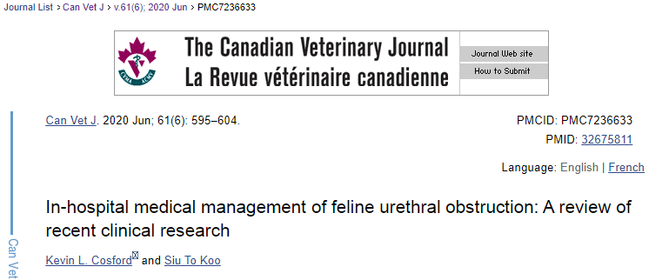
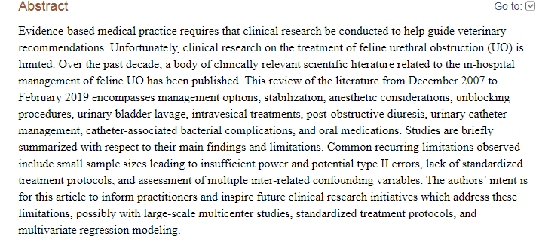
Intro: UO- 54% are idiopathic, 20% urethral plugs, 20% urolithiasis, <5% strictures or neoplasia
Discussion of the major findings in literature from 2007-2019
In hospital vs outpatient: Seitz, 107 client owned cats, 11% inpatient cat re-obstructed and 31% of outpatient, odds were greater that the outpatient group would re-obstruct in 30 days
Winner: inpatient
Non traditional approach without urinary catheter: Cooper, 15 client owned cats, were given sedatives, decompressive cysto, kept in a quiet room and SQ fluids, 11/15 were able to urinate in 72 hours, however 3 developed uroabdomen.
Winner: traditional approach
Type of crystalloid used: LRs vs Saline- saline group had lower pH, HCO3 and BE than the LRS group, another study showed that metabolic disturbances resolved more quickly with the use of Norm R vs saline, neither had an effect on potassium levels
Winner: Norm R/LRS
Fluid overload: FO was defined as respiratory distress from pleural effusion or pulmonary edema, Risk factors were fluid bolus at presentation, development of a heart murmur or gallop sound, No effect on mortality rate
Decompressive cysto: 47 cats, 56% had abdominal effusion on x-ray after cysto, none definitively diagnosed with urinary bladder rupture. DECYST trial showed no major complications after cysto and no major change in length of hospitalization or outcome
Winner: unknown
Anesthetic protocol and coccygeal block: ketamine and diazepam vs propofol, time to standing was shorter with propofol, but no other major differences, not many studies looking at the best protocol. Not enough information regarding the block to determine its usefulness.
Urinary bladder lavage: flush and no flush groups were matched with age, body weight, neuter status, previous blocking history and crystalluria. No impact on in hospital UO recurrence rates, duration of catheterization or hospitalization.
Intravesical treatments: glycosaminoglycans- no change in pain or re-blocking rates in cats that received a glycosaminoglycan bladder infusion. Alkalinized lidocaine infusion- no change in re-obstruction rates.
Post obstructive diuresis: POD = >2 ml/kg/hr, incidence of 46%, another study showed that fluid rate significantly impacted the incidence of POD. POD was also seen more in cats that presented with acidemia.
Indwelling urinary catheter: lower rate of reblocking with a 3.5 fr vs 5 fr catheter at 24 hours, one study showed no association between length of indwelling catheter and reUO and another showed one where longer indwelling catheter was associated with decreased incidence of reUO.
Catheter associated bacterial infections: greater than 3 days of indwelling catheter was associated with bacteriuria. In two studies there were 0 positive cultures from samples obtained at admission and 13% positive after 24 hrs and 33% in 48 hours. Most commonly with E. coli, strep, staph and pasteurella. Current guidelines do not recommend antimicrobial therapy since this is likely transient.
Prazosin: prazosin better than phenoxybenzamine, not better than placebo in reUO rates prior to discharge, 1 month and 6 months. One study showed a shorter length of hospitalization when used.
NSAIDS: no sig difference between groups of demeanor, food intake or painful behavior in cats that received meloxicam and did not

