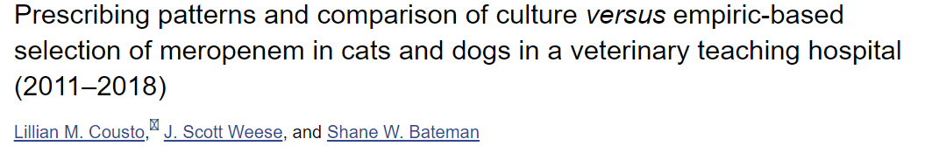
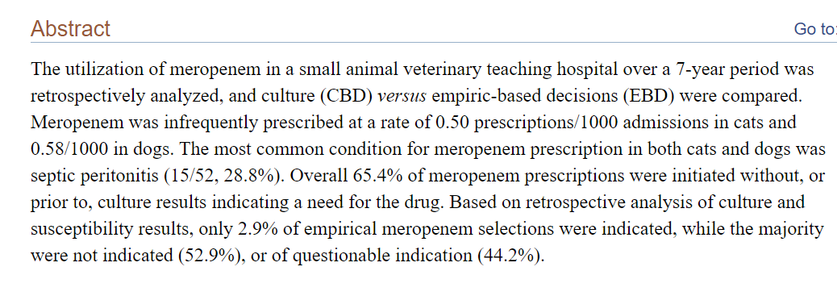
Introduction: Recent increase in prevalence of MDR infections in veterinary medicine and the need to preserve antibiotics for critical illness in humans. Carbapenem that has extended spectrum beta lactamase (ESBL) activity. This causes a greater selection pressure for bacterial resistance (allowing the abx resistant bacteria to survive and multiply) and select for carbapenamase producing bacteria. ACVIM consensus statement on antibiotic usage stating that antibiotic use should be based on culture results when available. The aim of the study was to compare CBD vs EBD and if meropenem was used appropriately.
Materials and methods: Pharmacy records of Ontario Vet College were searched over 7 yrs, from June 2011-2018 for dogs and cats prescribed meropenem and overall abx prescriptions over the same time period. Dose, frequency and duration were noted for each patient as well as other abx used. Recorded as a culture based (CBD) decision or empirically based (EBD)- no culture performed or culture results not yet available. For EBD listed reasons for use, such as worsening of clinical disease, poor response, persistent pyrexia and severity of illness.
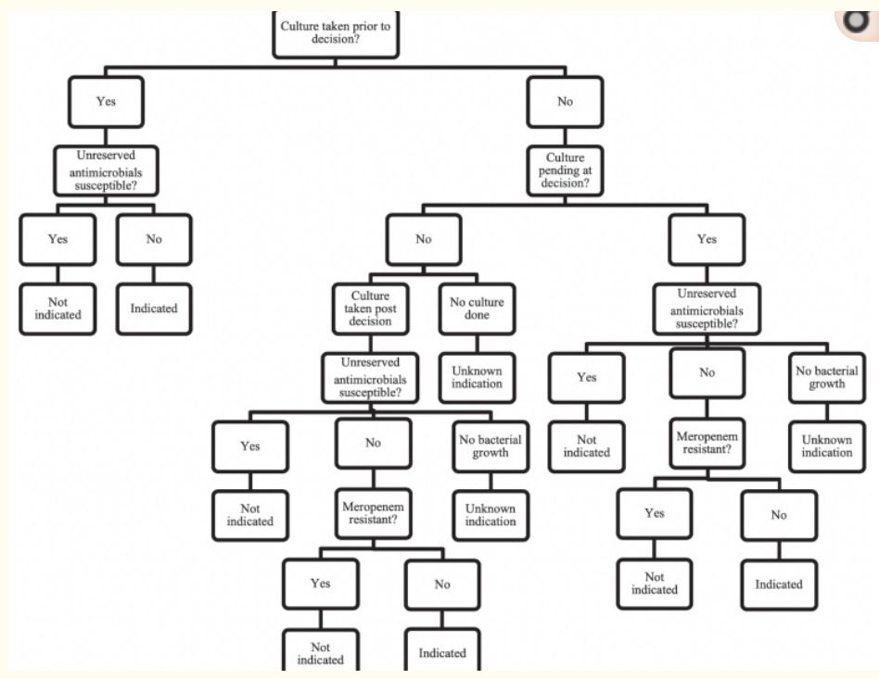

EBD decision tree was made to determine if the prescription was indicated– if culture pending or if not susceptible to another abx or if other abx was contraindicated for that patient. Not indicated if resistant to meropenem or if susceptible to a UA with no contraindications for the patient. If no growth or no culture submitted then indication was deemed unknown.
Unreserved abx were outlined by the hospital as common first or second line drugs such as, penicillin, pot. penicilin, 1st-3rd gen. cephalosporins, TMS, metro, macrolides and fluoroquinolones.
Severity of illness was scored using APPLEfast (The 10‐variable model looking at creatinine, WBC count, albumin, SpO₂, total bilirubin, mentation score, respiratory rate, age, lactate, and presence of free fluid in a body cavity) to predict illness severity. This was done within 24 hrs of admission and length of hospitalization and outcome were also recorded.
Results: Prescribed to 52 animals total, (5/1525 felines) and (47/9968 canines), infrequent (0.5 prescriptions out of 1000 cats and 0.58 out of 1000 dogs admitted)
Septic peritonitis was the most common reason it was prescribed (28%) for dogs and cats- other reasons: dog- abscess, SSI, pyothorax, UTI, pneumonia, suspected infection, parvo, PN, endocarditis, cat- suspect infection and UTI
65.4% prescriptions were based on EBD vs 34.6% CBD, reasons were documented in 74.9% in EBD group.
C/S available for 100% CBD group- results were most commonly MDR E.coli, Enterobacter spp and Enterobacter cloacae. In 38.8% another pathogen was grown which was susceptible to one of the unreserved abx.
EBD group C/S results were available in 91.2% of cases. In 53% meropenem was not indicated (50% had an UA and in 3% it was contraindicated). In 44% unknown indication d/t no culture, no growth, no S results. Only indicated in 1 case of EBD group- E coli aspiration pneumonia.
Patients that were prescribed meropenem had overall higher APPLEfast scores and mortality rates- (higher in EBD group) and the mean days of hospitalization were higher in the CBD group.
Overall 51% mortality rate for patients receiving meropenem. Mortality was higher in the EBD (70%) group than CBD (16.7%).
94.2 % were receiving other abx prior to meropenem administration. 53% did not receive other abx while on M, but the ones that did stayed on the previous abx. De-escalation to a more targeted abx occurred in 90% of surviving patients in the EBD group and 46% of the survivors in the CBD group.
Discussion: Overall it was infrequently prescribed. However often not based on C/S results and with poor justifications. This medication should be prescribed if there is a high suspicion of an MDR infection however that was rarely listed as the reason. Since the EBD group had higher APPLEfast scores and mortality rates, they were most likely considered critical patients which may be why the medication was used for fear of missing a useful intervention. There is a need to develop improved guidelines regarding the use of this category of abx. De-escalation was done appropriately in the EBD group based on C/S results if available which is important since it is associated with decreased mortality in humans. Another concern for use is that the appropriate dose is unknown and no break points have been established. (break point – chosen concentration mg/L of an antibiotic which defines if it is susceptible or resistant to an antibiotic, if the MIC is less than or equal to the BP than it is susceptible).

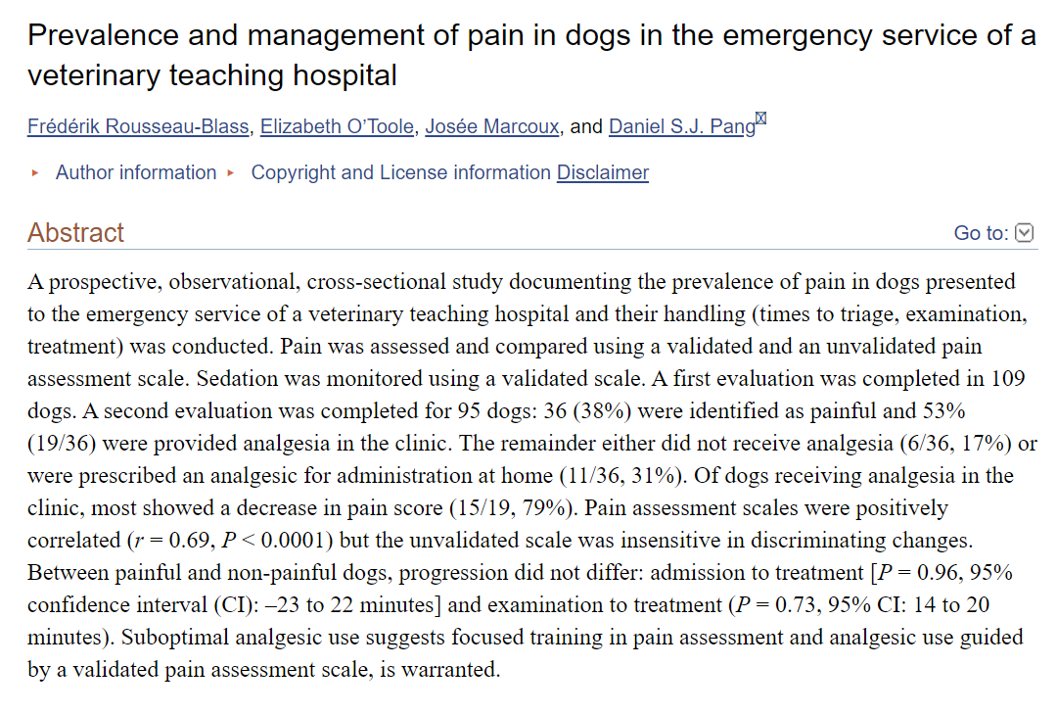
Introduction: Pain is considered the 5th vital sign, difficult to assess pain in veterinary patients, lack of validated pain scales, Glasgow composite measure pain scale short form (CMPS). Most common causes of pain were orthopedic and lacerations/bites. There is a concern for chronic pain development if acute pain is not managed properly. Goals: prevalence of pain in ER, analgesia used, response to pain meds, time from admission to treatment and unvalidated pain scale vs CMPS. Hypothesis: painful dogs would be assessed faster and receive analgesia.
Materials/methods: All dogs admitted to the ER over 36 weekends except critically ill dogs, pet was triaged and then brought to room and allowed to roam for 5 minutes, then an investigator assessed pain based on the CMPS and Colorado Canine Acute Pain scale (CCAPS). A second evaluation was performed after initial plan or prior to discharge. Sedation level also evaluated using a validated scale. Blinding to analgesic treatment was not always possible.
Results: 118 eligible dogs, 9 excluded, complete data set was obtained for 95 dogs, 14 w/o second evaluation- 109 total, 1/3 of the dogs were id as painful on first eval, IVDD most common, of the painful dogs (40) 36 had second evals- half received analgesic in the clinic and 31% received analgesic at home, 17% no pain meds, most frequent pain meds- opiods, NSAIDs, dexmed, gaba. Between the first and second eval pain scale scores decreased in 79% of dogs that received analgesic in clinic and 63% has scores that decreased below the analgesic intervention threshold - < or equal to 5/20. 3 dogs had an increase and 1 dog had no change. Of the 17 dogs that had no analgesic 10 had a decrease in score and 2 had an increase. ¼ dogs initially classified as non painful had an increased score on the second eval. 2 pain scales were positively correlated at first, however the change between the first and second eval were different-25 that’s had a reduction in CMPS, 14 had no change on the CCAPS, 5 dogs with an increase in CMPS showed no change in the CCAPS. Patient handling time- 37 painful dogs and 63 non painful. Time from admission to treatment was not sig different between groups. The time from admission to exam was sig shorter in the non painful group.
Discussion: highlights the importance of pain re-assessment since a population of dogs showed pain even after med administration, discussed the benefits of acute pain management, CCPAS weaker than CMPS for pain progression, time to treatment and evaluation did not differ in the painful or non painful group which is concerning that we are not adequately assessing pain at the triage exam, emphasizes the need to use a validated pain score and be more aware of prompt intervention

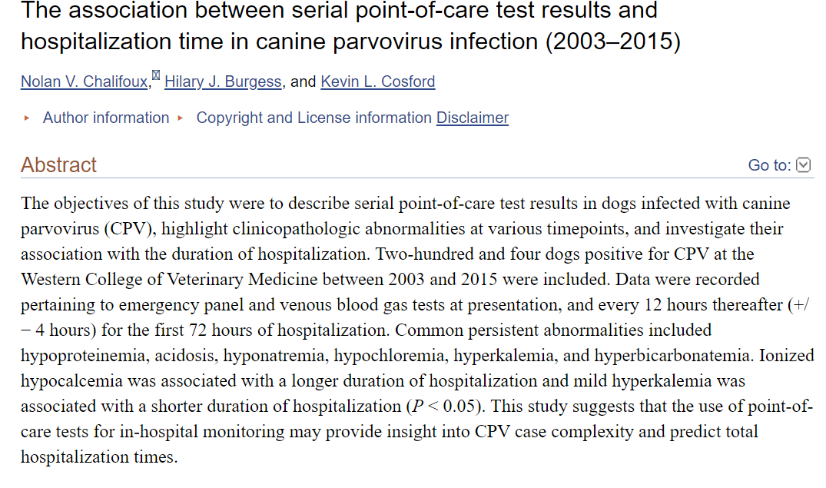
Introduction: Investigate the use of poc blood work with regard to progression of disease for patients while hospitalized for parvo virus infection and the common derangments. See if there is a correlation between changes on blood work and length of hospitalization in patients that survived to discharge.
Materials and methods: Records from 2003-2015 for dogs with a positive snap parvo test. Recorded VBG and PCV/TS, Azo, BUN, BG at admission and then every 12 hrs for the next 72 hrs.
Results: 204 dogs, most < 1 yr, common persistent abnormalities identified on EP and VBG results include hypoproteinemia, acidosis, hyponatremia, hypochloremia, hyperkalemia, and hyperbicarbonatemia, dogs with hypoiCa at the 24hr and 48 hr points had a sig longer duration of hosp compared to dogs without, conversely dogs with hyperiCa or normal iCa had a sig shorter duration of hosp than dogs with hypoiCa. Dogs with mild hyperkalemia at 12, 24 and 36 hrs had a sig shorter median duration of hosp vs dogs with normal or hypokalemia.
Discussion: Dogs <1 yr have a lower PCV/TS, puppies < 12 wks low Na, Cl and high K, iCa which may be the cause of the changes noted in this paper since the reference interval used was for adults dogs, therefore these findings may be due to age and not the underlying disease process. hypoiCa has been associated with longer hospitalization in dogs presenting with trauma, but the pathogenesis is unclear. The hyperkalemia is most likely secondary to decreased renal excretion due to dehydration/hypovolemia (so less circulating volume) and also due to the metabolic acidosis. This may reflect a shorter time to resolution of anorexia, vomiting and diarrhea which is associated with a shorter hosp stay. Since younger puppies tend to have a worse prognoses they do not think the finding was attributed to age alone. Did not have enough data to compare to non survivors and since it is a retrospective the approach was no standardized.

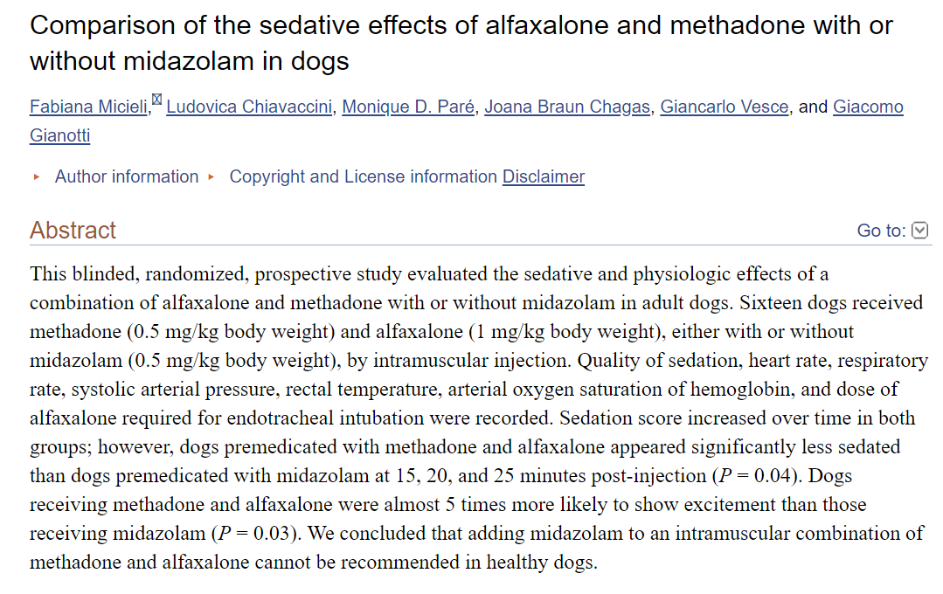
Introduction: The aim was to assess level of sedation, vital parameters and amount of additional alfaxalone needed for induction in dogs sedated with alfaxalone/methadone vs alfaxalone/methadone/midazolam IM. Hypothesis: midazolam would lessen the amt of alfax needed and provide better quality sedation.
Methods/materials: Blinded, randomized, prospective study. 16 client owned healthy adults dogs undergoing elective surgical procedures under GA were enrolled. CBC/chem-nsf. Doses= 1 mg/kg alfax, 0.5 mg/kg midazolam and methadone used a pre-meds, administered in epaxial muscle. Sedation was assessed at 10,15, 20, 25 minutes using a modified numeric sedation scale. HR, RR, SAP via Doppler, digital temp and SPO2 were measured at the same intervals. A single observer was used for all the dogs. A catheter was placed during this time. Adverse events were recorded. Once palpebral and gag were gone the alfaxlone IV was stopped. Intubation occurred. Criteria included- posture, response to clipper sounds, response to clipping, response to restraint and catheter.
Results: No sig diff of baseline vital parameters between groups. For both groups sedation increase over time. However dogs sedated with MMA seemed less sedate at 15, 20 and 20 mins than the group sedated with MA. HR and SAP decreased in both groups. No sig diff in temp or SPO2 between groups. Vitals remained in normal range. 62% MMA dogs showed signs of excitement and only 1 in the MA group which stopped at 10 mins. 5X more likely to show signs of excitement in MMA than MA group. Amount of alfaxalone needed for induction was not stat sig between the two groups.
Discussion: Hypothesis was rejected. When administered alone IM alfax can have undesired side effects like tremors, paddling, etc. Therefore adding a second and third agent was helpful in obtaining a good plane of sedation with less side effects. The excitement from the midazolam could have been potentiated by the alfaxalone or methadone. Dose reduction of induction agent in approx. 64% in premed pets vs non pre med. No side effects after alfaxalone induction in this study. Midazolam when added to dexmed and methadone did decrease the amount of propofol needed and prolonged sedation in a recent study. Limits: sedation scale was not validated for dogs, could not evaluate the total duration of sedation due to GA.

