VAA September 2020
Development of a severity scoring system for acute haemorrhage in anaesthetized domestic cats: the CABSS score
Gareth E Zeiler 1, Andrea Fuller 2, Eva Rioja 3, Peter Kamerman 2, Roxanne K Buck 4, Friederike Pohlin 4, Brighton T Dzikiti 5
Vet Anaesth Analg. 2020 Jul;47(4):499-508. doi: 10.1016/j.vaa.2019.11.008. Epub 2020 Apr 2.I: 10.1016/j.vaa.2019.11.008

Objective: To determine whether physiological, haematological, biochemical or electrolyte variables can predict severe haemorrhage in cats.
Study design: Randomized crossover study whereby each cat underwent mild and severe haemorrhage, with a 2-month period between events.
Animals: A group of six domestic cats aged 21 ± 1 months and weighing 4.9 ± 1.2 kg, mean ± standard deviation.
Methods: Cats were anaesthetized (buprenorphine, alfaxalone, isoflurane in oxygen at a fixed end-tidal concentration of 1.7%) before the haemorrhage event. In total, 34 variables were measured twice (prehaemorrhage and posthaemorrhage). The difference and percent change for each variable were compared between haemorrhage events (paired t test). Significant variables were placed into 13 different ratios (posthaemorrhage value of one variable divided by a posthaemorrhage value of a second variable) and compared (paired t test), and Cohen's d (d) was calculated. Receiver operating characteristic curves were plotted and cut-off values for weak, moderate and strong indicators of severe haemorrhage were obtained.
Results: The blood loss was 4.5 ± 1.1 mL kg-1 and 26.8 ± 5.5 mL kg-1 for mild and severe haemorrhage events, respectively. The most significant variables with large effect sizes were heart rate (HR), systolic arterial blood pressure (SAP), end-tidal carbon dioxide (Pe'CO2), serum albumin, haematocrit and actual bicarbonate ion concentration [HCO3-(act)]. The most robust ratios were: 1) shock index (d = -2.8; HR:SAP); 2) HR:Pe'CO2 (d = -2.9); 3) serum albumin: haematocrit (d = 1.5); and 4) HR:HCO3-(act) (d = -1.6). These ratios were included in the final proposed Cat Acute Bleeding Scoring System (CABSS).
Conclusions: Cats subjected to mild and severe haemorrhage demonstrated statistically and clinically relevant changes whereby four ratios could be created to make up the CABSS. The ratios detected and quantified the presence of severe haemorrhage in anaesthetized cats.

- Most can tolerate loss of 10% of circulating blood volume w/o needing volume resuscitation
- Measurement of blood loss
  - Direct: Counting blood-soaked swabs, in suction canisters, and estimating blood volume on surgical drapes
  - Indirect: Hb and HCT%, TS or albumin measurement – but only useful to assess blood loss after compensatory fluid shifts (2h following acute hemorrhage event)
- Study set out to determine if quantifiable variables that can be used in CABSS to predict acute severe hemorrhage
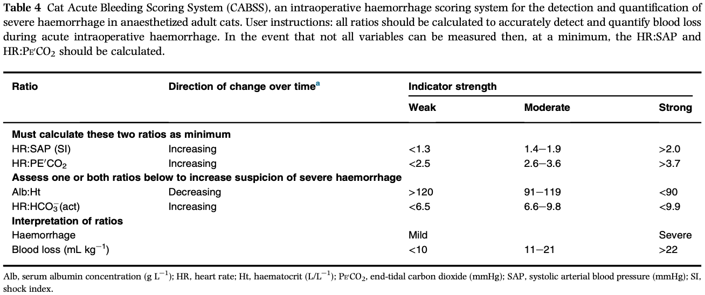
- SI (HR/SBP): To evaluate the need to identify hemorrhage
- HR:PECO2: Decreasing PECO2 suggests decreasing CO
- Serum albumin:HCT ratio reflects act changes w/in intravascular compartment during hemorrhage
- HR:HCO3 ratio reflects the extent of blood loss

Comparison of pulse pressure variation versus echocardiography-derived stroke volume variation for prediction of fluid responsiveness in mechanically ventilated anesthetized dogs
Lucas A Gonçalves 1, Denise A Otsuki 2, Marco Aa Pereira 3, Julio K Nagashima 3, Aline M Ambrosio 3, Denise T Fantoni 3
Vet Anaesth Analg.2020 Jan;47(1):28-37. doi: 10.1016/j.vaa.2019.08.047. Epub 2019 Oct 21.

Objective: To evaluate the ability and accuracy of aortic flow velocity-time integral variation (ΔVTI) and peak aortic velocity variation (ΔVpeak) compared with pulse pressure variation (PPV) to predict fluid responsiveness in mechanically ventilated dogs.
Study design: Prospective clinical study.
Animals: A group of 50 mechanically ventilated dogs with spontaneous hypotension during orthopedic or oncologic surgery.
Methods: Investigations were performed in the surgery room. When mean arterial pressure (MAP) decreased to <65 mmHg, measurements were performed before and after a fluid challenge (lactated Ringer's solution 5 mL kg-1 over 15 minutes). Responders were defined as a change in stroke volume (SV; transesophageal Doppler) ≥15%. Data were analyzed using paired/unpaired t test or Mann-Whitney/Wilcoxon test when appropriate and receiver operating characteristics (ROC) curves; a p value <0.05 was considered statistically significant.
Results: After the fluid challenge, 35 (70%) of 50 dogs were responders with significant increases in SV and decreases in PPV; 15 dogs were nonresponders. ΔVTI and ΔVpeak correlated with a 15% increase in SV. The optimum cut-off value for PPV was 15.6% (sensitivity, 88%; specificity, 100%), for ΔVTI was 10.65% (sensitivity, 65%; specificity, 100%) and for ΔVpeak was 10.15% (sensitivity, 80%; specificity, 100%). The area under the ROC curve for PPV was (0.93 ± 0.08) and for ΔVpeak was (0.89 ± 0.09), before fluid challenge. The gray zone area spread from 6.15% to 15.6% for PPV (18 dogs), 2.45% to 10.65% for ΔVTI (22 dogs) and 0.6% to 10.15% for ΔVpeak (25 dogs).
Conclusions: When using mechanical ventilation, ΔVTI and ΔVpeak predicted fluid responsiveness with the same ability as PPV, based on the area under the ROC curve analysis. However, PPV showed great accuracy demonstrated by a narrower gray zone that included fewer individuals.
Clinical relevance: ΔVTI and ΔVpeak can be used as indices of fluid responsiveness in anesthetized dogs.

- Shift from using static preload indices (e.g. PAOP, CVP, RVEDVI, LVEDA) to using dynamic indices (e.g. fluctuation in peak aortic velocity and velocity-time integral) to evaluate for fluid responsiveness
- Patient who is fluid responsive is on the ascending part of the Frank-Starling curve as an increase in preload will increase their cardiac output
- ΔVpeak and ΔVTI were shown to be reliable for predicting fluid responsiveness in humans and ΔVpeak was more accurate then pulse pressure variation (PPV) for predicting fluid responsiveness in ventilated children
- Study evaluated
  - 1) whether respiratory variations in aortic blood flow velocity reflect preload-dependent changes in SV, thus predicting fluid responsiveness in mechanically ventilated dogs
  - 2) compare diagnostics accuracies of ΔVTI, ΔVpeak and PPV in predicting fluid responsiveness
- All 3 parameters predicted fluid responsiveness
  - PPV cutoff: 15.6%
  - ΔVpeak cutoff 10.15%
  - ΔVTI cutout 10.65%
  - PPV had the best AUC
- ΔVpeak and ΔVTI require trans-esophageal echocardiography which is less available compared to PPV

Development and assessment of a pictorial guide to improve accuracy of visual estimation of blood loss of small animals
Scott H Cumming 1, Fernando Martinez-Taboada 2
Vet Anaesth Analg. 020 May;47(3):301-308. doi: 10.1016/j.vaa.2019.10.007. Epub 2020 Feb 4.

Objective: To investigate the accuracy of visual blood loss estimation from small animals among veterinary staff and final-year veterinary students, and the development and utility of a pictorial guide to improve estimation, in a veterinary hospital.
Study design: Online anonymous voluntary survey.
Methods: A two-part online survey was circulated to voluntary participants at the University Veterinary Teaching Hospital Sydney, The University of Sydney, including students, nurses, interns, residents, general practitioners and specialists. The survey consisted of visual and brief descriptive depictions of blood loss scenarios involving small animals, principally including images of common surgical items and receptacles containing a bloodlike substance. Each participant estimated the blood volume (in millilitres) for each scenario two times, initially [Pre-Guide (PGD)] and then with the aid of a pictorial guide [With-Guide (WGD)]. The pictorial guide used similar images labelled with corresponding volumes. Data were analysed for normality with the Shapiro-Wilk test, corrected to absolute error and compared for statistical significance using the Wilcoxon signed-rank test or the Kruskal-Wallis test as appropriate (p < 0.05).
Results: A total of 59 participants provided 288 responses. The raw median PGD error was -16 mL (range -105 to 443 mL), indicating a tendency towards underestimation of the actual volume. The WGD median error was 18 mL (range -91 to 191 mL), indicating a tendency towards overestimation when using a pictorial guide (p < 0.0001). Data corrected to absolute error showed a PGD median error of 34 mL (range 0-443 mL) and WGD median error of 23 mL (range 0-191 mL; p < 0.0001). There were differences between the participant roles in the PGD phase but not when using the pictorial guide.
Conclusions: and clinical relevance Participants generally underestimated surgical blood loss, with a wide variation, when visually estimating scenarios involving small animals. A pictorial guide improved estimation by reducing the absolute median error and narrowing the range.

- Importance?
  - Underestimation hypovolemic shock, reduced DO2, and incr risk of mortality/morbidity
  - Overestimation unnecessary blood transfusion (waste resources), incur risk of recipient, incr mortality in humans & animals
- Previous studies evaluated gravimetric and colorimetric measurement of blood loss which had inherent limitations owing to evaporation error, intra-op utility and timely execution
- Investigate degree of accuracy when estimating blood loss by observation utilizing a pictorial guide to reduce the error in estimation
Pictorial guide
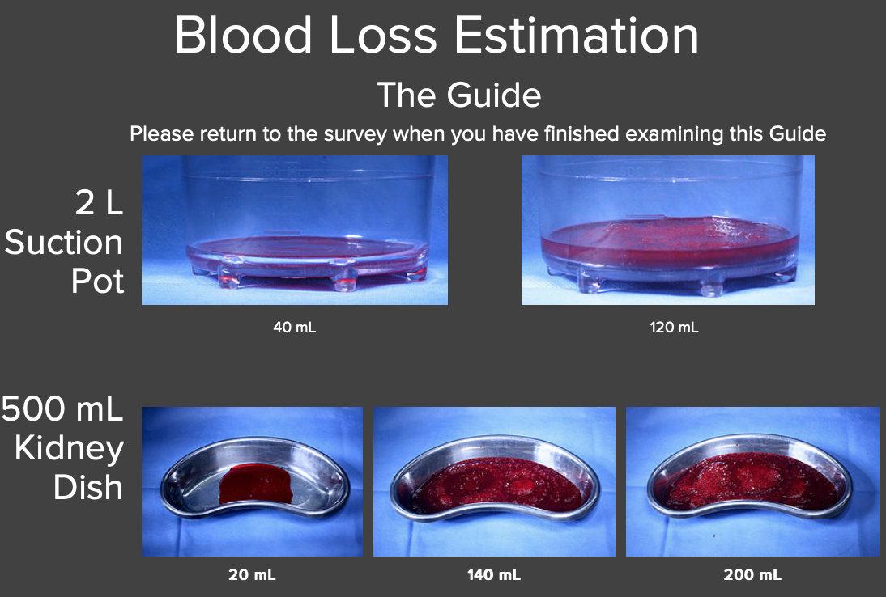
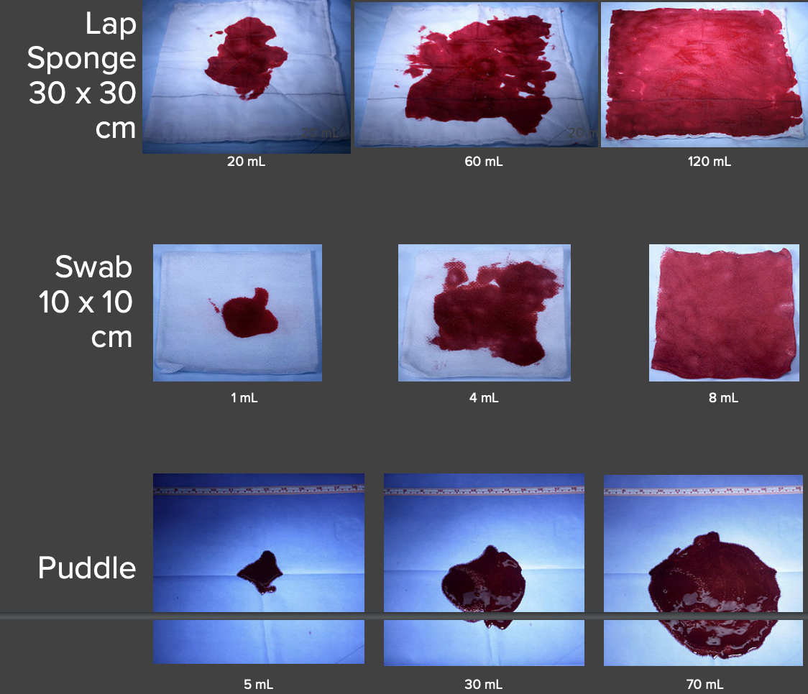
- Everyone underestimates the blood volume with visual assessment which is in agreement w/ previous medical literature
  - Larger volume of blood = greater magnitude of underestimation
  - Smaller volume of blood = great magnitude of overestimation
- Residents/residency trained and interns were more accurate than specialist or GPs to estimate blood loss
- The use of a pictorial guide allowed respondents to estimate volume more effectively

Summarized introduction section - This is what you should present along with results/discussion 3. Summarized results/discussion section -- this section should only include the pertinent results/discussion points from the paper that you deem relevant.

