Comparative Performance of Pulmonary Ultrasound, Chest Radiograph, and CT Among Patients With Acute Respiratory Failure.

David M Tierney, Joshua S Huelster, Josh D Overgaard, Michael B Plunkett, Lori L Boland, Catherine A St Hill, Vincent K Agboto, Claire S Smith, Bryce F Mikel, Brynn E Weise, Katelyn E Madigan, Ameet P Doshi, and Roman R Melamed.

OBJECTIVES: The study goal was to concurrently evaluate agreement of a 9-point pulmonary ultrasound protocol and portable chest radiograph with chest CT for localization of pathology to the correct lung and also to specific anatomic lobes among a diverse group of intubated patients with acute respiratory failure.
DESIGN: Prospective cohort study.
SETTING: Medical, surgical, and neurologic ICUs at a 670-bed urban teaching hospital.
PATIENTS: Intubated adults with acute respiratory failure having chest CT and portable chest radiograph performed within 24 hours of intubation.
INTERVENTIONS: A 9-point pulmonary ultrasound examination performed at the time of intubation.
MEASUREMENTS AND MAIN RESULTS: Sixty-seven patients had pulmonary ultrasound, portable chest radiograph, and chest CT performed within 24 hours of intubation. Overall agreement of pulmonary ultrasound and portable chest radiograph findings with correlating lobe ("lobe-specific" agreement) on CT was 87% versus 62% (p < 0.001), respectively. Relaxing the agreement definition to a matching CT finding being present anywhere within the correct lung ("lung-specific" agreement), not necessarily the specific mapped lobe, showed improved agreement for both pulmonary ultrasound and portable chest radiograph respectively (right lung: 92.5% vs 65.7%; p < 0.001 and left lung: 83.6% vs 71.6%; p = 0.097). The highest lobe-specific agreement was for the finding of atelectasis/consolidation for both pulmonary ultrasound and portable chest radiograph (96% and 73%, respectively). The lowest lobe-specific agreement for pulmonary ultrasound was normal lung (79%) and interstitial process for portable chest radiograph (29%). Lobe-specific agreement differed most between pulmonary ultrasound and portable chest radiograph for interstitial findings (86% vs 29%, respectively). Pulmonary ultrasound had the lowest agreement with CT for findings in the left lower lobe (82.1%). Pleural effusion agreement also differed between pulmonary ultrasound and portable chest radiograph (right: 99% vs 87%; p = 0.009 and left: 99% vs 85%; p = 0.004).
CONCLUSIONS: A clinical, 9-point pulmonary ultrasound protocol strongly agreed with specific CT findings when analyzed by both lung- and lobe-specific location among a diverse population of mechanically ventilated patients with acute respiratory failure; in this regard, pulmonary ultrasound significantly outperformed portable chest radiograph.
Critical Care Medicine, 2020 vol. 48 (2) pp. 151-157.

http://eutils.ncbi.nlm.nih.gov/entrez/eutils/elink.fcgi?dbfrom=pubmed&id=31939782&retmode=ref&cmd=prlinks

Introduction/ Background:
- ARF is a common reason for ICU admission and is associated with a high mortality
- Portable chest rads lack the sensitivity and specificity of CT, but are sometimes preferred due to speed, lower cost, reduced radiation exposure, and no need for patient transport
- Pulmonary ultrasound has the same convenience as portable chest rads, and per previous literature approaches the accuracy of CT for pneumonia, interstitial processes, acute respiratory distress syndrome, pleural effusion and pneumothorax
- Pulmonary ultrasound also allows for regular reassessment to look for progression or improvement of disease
- Ultrasound technique:
  - 9 anatomical locations
  - categorized as normal (A-lines and lung sliding), B lines (B1 to B3), atelectasis/ consolidation, and/or pleural effusion
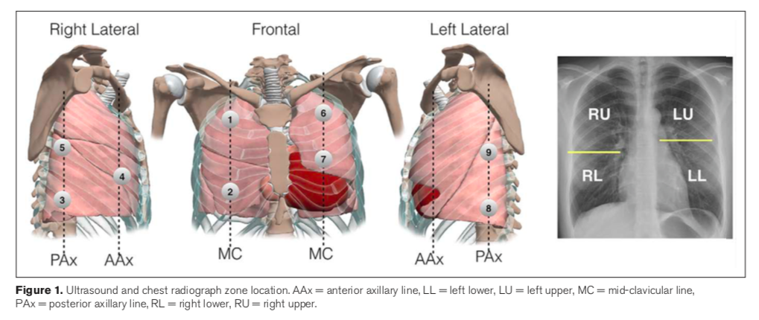

- Study objective: concurrently evaluate the accuracy of both pulmonary ultrasound and chest rads with CT, for both agreement of findings and localization of disease

Results
- 67 patients met inclusion criteria
  - Diverse population of ICU patients
  - Patient that underwent pulmonary ultrasound at the time of intubation, followed but portable CXR and chest CT within the subsequent 24 hours
  - Most common diagnoses: pneumonia (30%), aspiration, cardiac arrest, sepsis, CHF and ARDS
  - Median P:F ratio 214
- Pulmonary ultrasound consistently had better agreement with CT than CXR, which was most prominent for interstitial findings. It was also better at localization. (See Table 3)
- Lobe-specific agreement the worst in left lower lobe (82%)
- Pulmonary ultrasound misdiagnosed in four cases (compared to CT): metastatic pleural nodules, bullous emphysema, superior/anterior right upper lobe mass, posterior left lobe consolidation

Discussion
- This study supports the existing literature demonstrating the agreement between CT and pulmonary ultrasound
- Demonstrates localizing ability of pulmonary ultrasound, which is clinically useful in making specific diagnosis
- Lung ultrasound outperformed CXR, particularly for interstitial disease
- Study limitations:
  - Not truly blinded
  - Requirement of CT and CXR within 24 hours may have introduced bias for sicker patients, which may impact generalizability of results
  - Duration of time between imaging modalities may have affected results

Take-home message: Pulmonary ultrasound outperforms chest x-rays in both identification of pulmonary pathology and lobar localization in ICU patients with acute respiratory failure. Pulmonary ultrasound is a convenient, inexpensive, and a risk-reducing imaging modality that may be used as an adjunct or replacement for CXR or CT. There are potential scenarios where pulmonary ultrasound may have limitations compared to CT.

