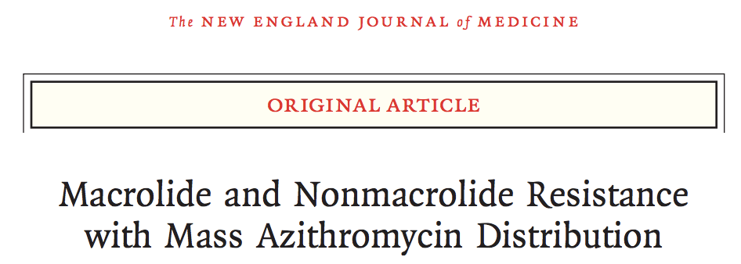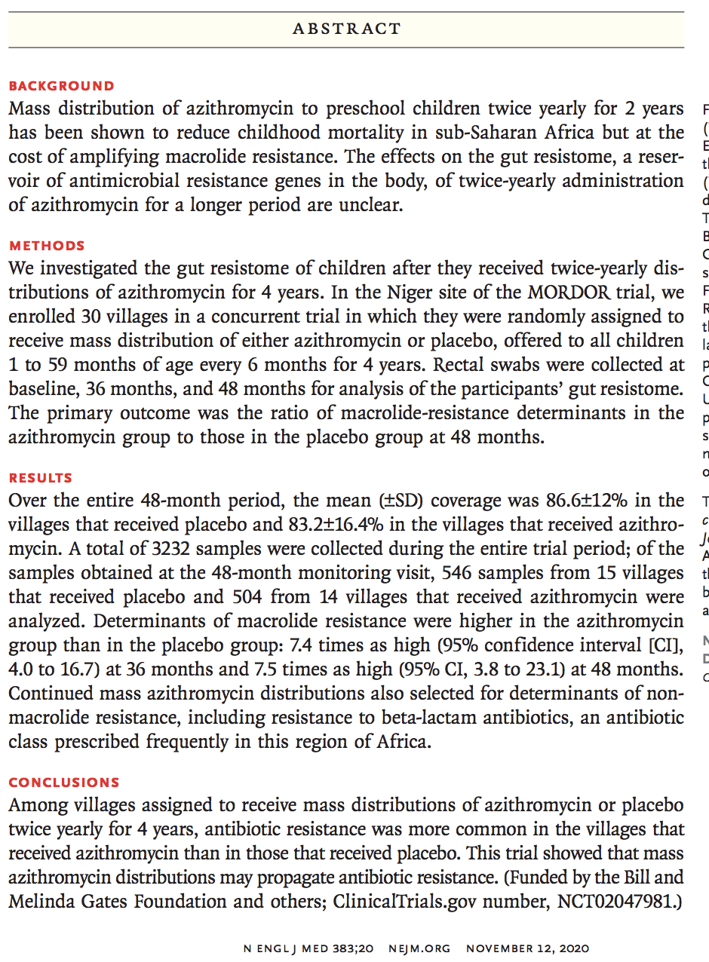
- In people, mass distribution of oral azithromycin twice a year has showed decreased child mortality between age 1-5 yo looking at 2 year period
- Same time though, shows macrolide resistance to streptococcus pneumoniae in nasopharynx as well as macrolide resistance in gut
- This study looked at longer term (4 years) twice a year administration with effect on gut resistome, reservoir of antimicrobial-resistance genes in the body
- Mass distribution of azithromycin twice a year to 30 villages in Niger for children between 1-5 years old for 4 hours vs placebo
- Looked at rectal swab for gut resistome (machine sequencing for antibiotic resistance-gene)

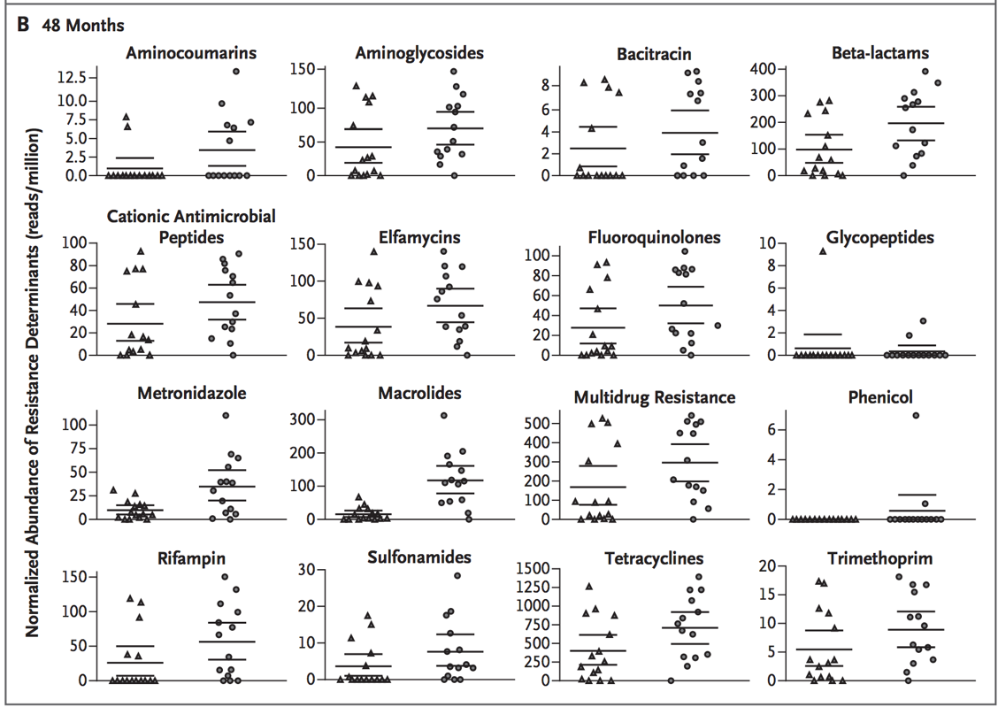
- Results: saw increase in macrolide resistance determinants in the gut at 36 mo and 48 mo for azithromycin group.
- Most interesting was increase in nonmacrolide resistance with mass azithromycin distribution, most notably in aminoglycocides, beta-lactams, trimethoprim, metronidazole
- Although azithromycin preferentially reduces susceptible pathogens, such as campylobacter species, it may also affect the abundance of other species in the gut. Thus, under the selection pressure of azithromycin, not only are gut bacteria harboring macrolideresistance determinants potentially selected for, but bacteria carrying nonmacrolide-resistance determinants may also be selected for sometimes if they reside in the same bacterial lineages
- Limitations: samples from children of whole village, did not take down information of symptomatic infectious illness, so cannot make clinical inferences. Rural setting, so hard to make generalizations to other population.
