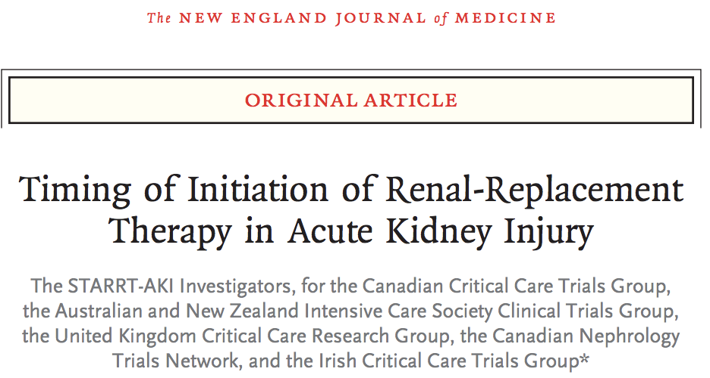
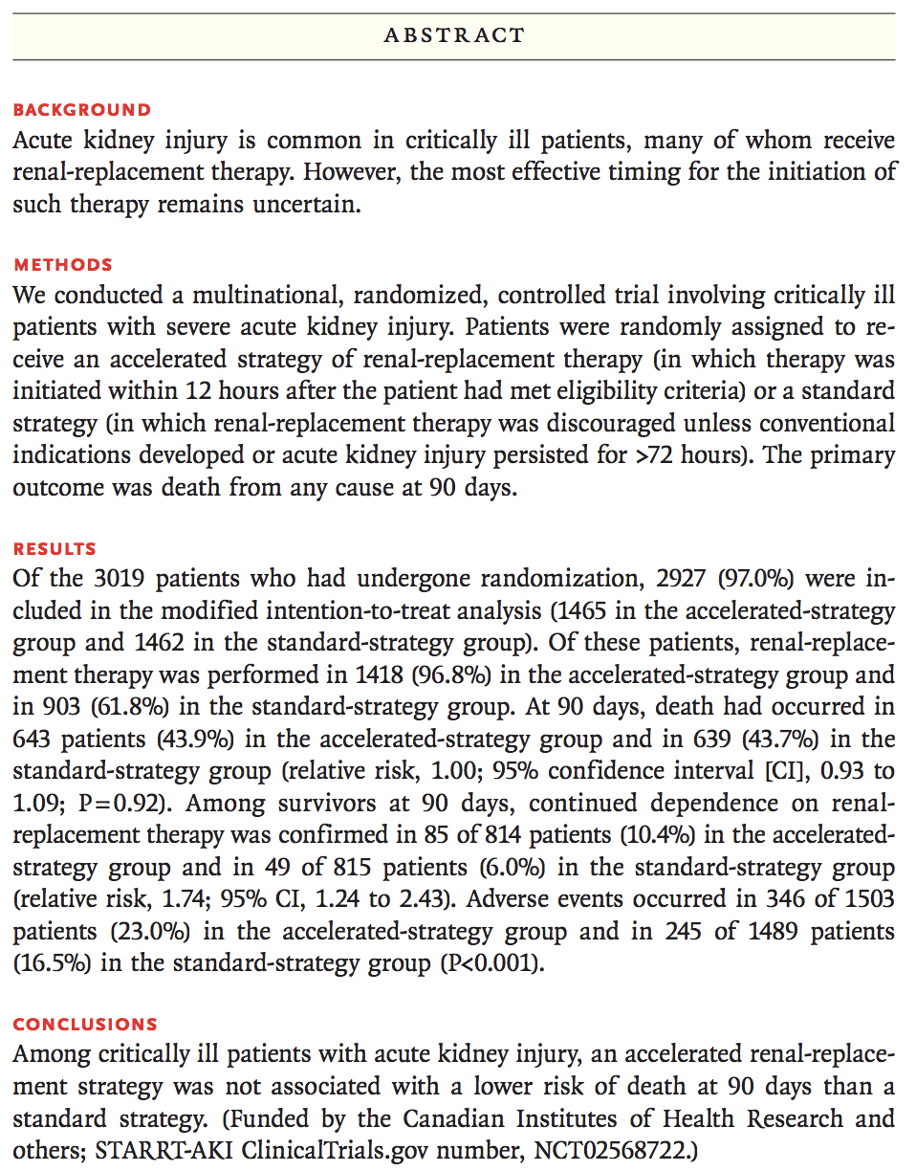
Background: STARRT-AKI trial = Standard vs Accelerated Initiation of Renal-Replacement Therapy in Acute Kidney Injucry
- Multinational, randomized, open-label, controlled trial
- Compares effect of accelerated initiation of renal-replacement therapy vs standard initiation in critically ill patients with AKI
- Hypothesis: accelerated strategy for renal-replacement therapy would result in lower risk of death from any cause at 90 days that standard strategy
- Benefits of renal-replacement therapy:
  - Treat fluid disturbances, mitigate fluid accumulation
  - Treat major metabolic disorders of acidosis, hyperkalemia, and uremia

Methods:
- Adults >18yo admitted to ICU with kidney dysfuction defined as creat >1.13mg/dl in women >1.47mg/dL in men and severe acute kidney injury categorized as stage 2 or 3 of KDIGO classification
- Randomized in 1:1 ratio to receive accelerated or standard initiation of renal-replacement therapy using centralized web-based platform
- In accelerated group: start renal-replacement ASAP and within 12 hours after patient has met full eligibility criteria
- In standard group: discouraged from initiating unless development of K>7mmol/L, pH <7.2 or bicarb <12, severe respiratory failure PF ratio <200, or persistent AKI >72 hours after randomization
- Primary outcome was death of any cause at 90 day after randomization
- Secondary outcome at 90 day include dependence on renal-replacement therapy, composite of death or dependence of R-R T, and major adverse kidney event

Results:
- After removing ineligible or nonconsent, of 2927 patients, 1465 in accelerated strategy group 1462 in standard strategy group
- 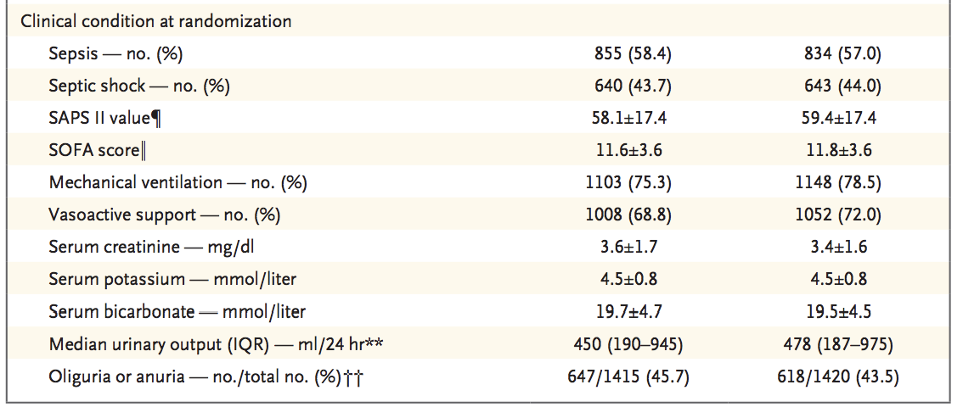
- Primary outcome: Death at 90 days Accelerated 643 (43.9%), standard 639 (43.7%)
- Secondary outcome:
  - Continued dependence on renal-replacement therapy 85 of 814 (10.4% )in accelerated, 48 of 815 (6.0%) in standard
  - Patients in accelerated group had shorter ICU stay, but no difference in number of ventilator-free days, vasoactive free days or ICU-free days at 28 days

Discussion:
- Accelerated did not have lower risk of death at 90 days than standard
- Therefore, those that do not have overt complications of AKI may not benefit from immediate renal-replacement therapy

