March 2021 Lit Review: JVIM
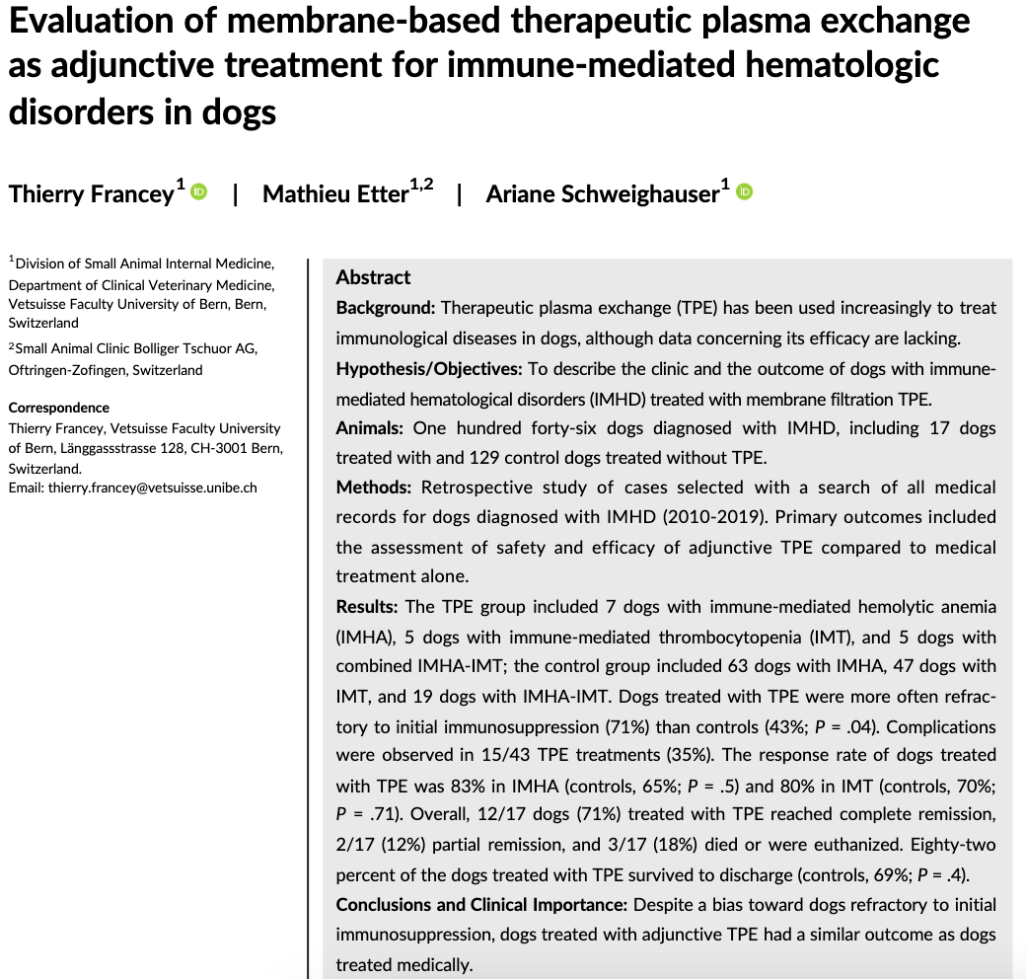
- 2 main types: membrane-based (mTPE) and centrifugational, both providing continuous-flow techniques have largely replaced the older intermittent manual centrifugation procedures
  - Centrifugation technique allows higher plasma extraction fraction than filtration technique lower access blood flow rate, shorter procedure time, and lower risk of citrate accumulation
- Benefits:
  - Ability to rapidly remove plasma anti-erythrocyte or anti-platelet autoantibodies, circulating immune complexes, and activated complement components w/o myelosuppression
  - Indirect modulation of cellular immunity (improved T-suppressor cell function and shift of the T-helper cell response from Th2 to Th1)
- IMHA defined based on ACVIM criteria and ITP based on Plt <100k/uL, DIC ruled out by PT/PTT/fibrinogen activity
- mTPE offered to dogs considered refractory to medical immunosuppression or affected w/ severe uncontrolled dz
  - Refractory = nonresponsive to 7 days of at least 2 immunosuppressant and severe dz (needing blood products b/c of ongoing hemolysis or bleeding)
- Response to mTPE categorized as partial (HCT to 0.25-0.39 and plt count 50-149k/uL), full (HCT>0.4 and plt count >150k/uL), or failure to response (<0.25 or <50k/uL)
- 7 IMHA dogs, 5 ITP dogs and 5 Evan’s dogs
- Results
  - Dogs w/ mTPE: hospitalized for longer, did not have clinically relevant hemorrhage, 35% had complications (none life threatening)
    - Main complication was laryngeal edema associated w/ FFP administration, suspected d/t rx to plasma as responded to anti-histamine and steroids
  - mTPE resulted in complete remission in 12/17 (71%), 2/17 (12%) partial), and 3/17 (18%) died/euthed due to lack of response
  - Survival 82% w/ mTPE versus 69% w/o mTPE but overall not significantly difference b/w group at 30 and 90 days
- Discussion; Despite a bias toward dogs refractory to initial immunosuppression, dogs treated w/ mTPE had a similar outcome as dogs treated medically.

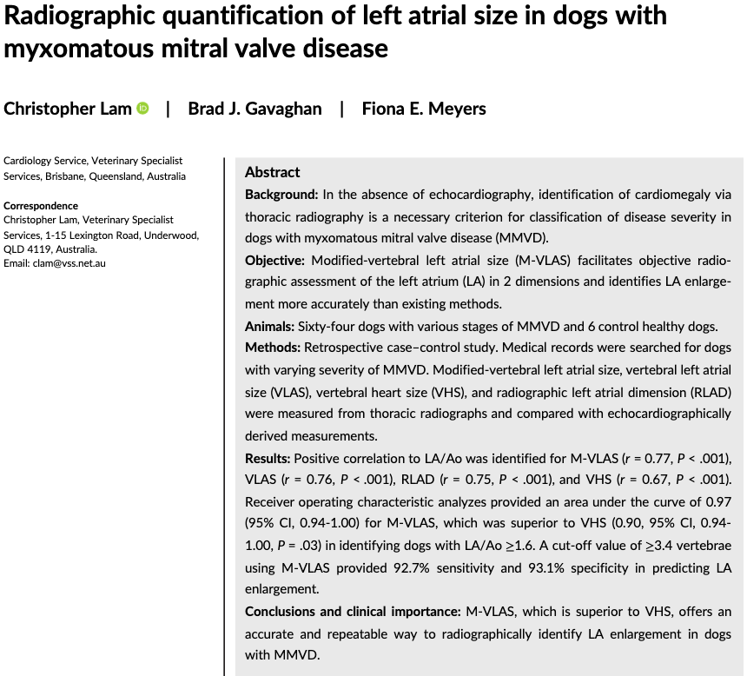
- MMVD = most commonly acquired cardiac dz
- L-sided cardiac remodeling occurs when eccentric capacity is reached, rise in LAP creates incr in pulmonary capillary pressure pulmonary edema, congestion, i.e. L-CHF
  - LAE therefore a precursor to CHF and a prognostic indicator for MMVD dogs
- Echo is recommended but not affordable to every dog therefore ACVIM recommends using VHS and vertebral left atrial size (VLAS) to identify dogs w/ stage B2 MMVD
  - Limitations: Breed-associated variations, interobserver variability, influence of the resp and cardiac cycle
  - VLAS >2.5 is 87% Sp and 67% Sn in predicting LA/Ao > 1.6
  - RLAD of >1.8 vertebrate is 93.5% specific and 98.6% sensitive in identifying the same LA/Ao
- Study to evaluate the accuracy of VLAS, VHS and RLAD at identifying LAE in dogs w/ MMVD and to compare a modified VLAS to see if it is superior
- Study population
  - Included dogs <20kg with 2/3v TXR and echo w/in 24h. Excluded if they were <1yo, had acute chordae tendinae rupture, or concurrent cardiac dz
  - Control dogs were <20kg, no HM, no cardiac abnormalities one cho and had 2v TXR taken w/in 24h
- Measurements obtained from RLat inspiratory TXR
- Modified-VLAS: Caliper from center of the most ventral aspect of the carina extending to the intersection b/w the most caudal aspect of LA + dorsal border of CdVC (YELLOW)
  - 2nd dimension obtained by placing digital caliper at the most distal LA border and extended to perpendicularly intersect w/ the first line (RED)
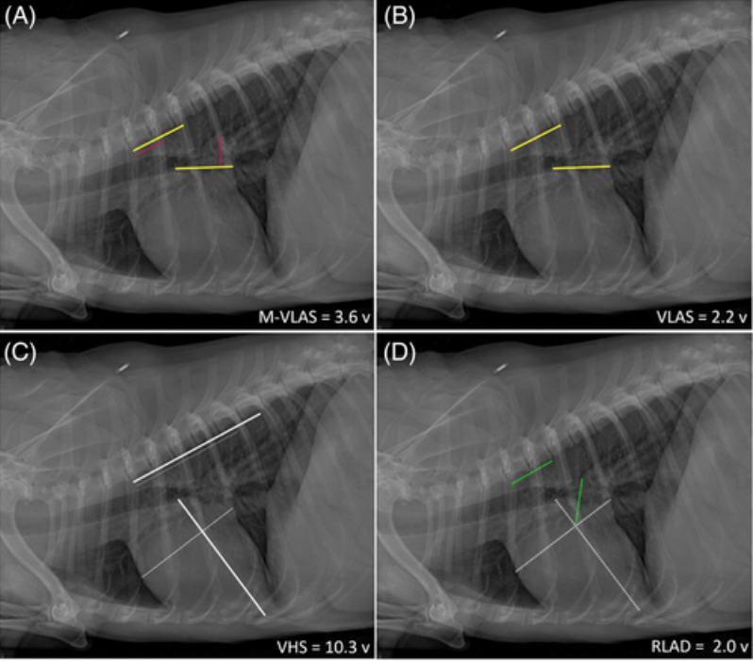
- All methods measure from the cranial edge of T4 extending caudally, parallel to the vertebral column
- RESULTS:
  - M-VLAS, VLAS, VHS, RLAD, LA/Ao, and LVIDdN were all higher in dogs in stage B2 and C MMVD compared to control or B1
  - No diff b/w stage B1 and control
  - La/Ao positively correlated w/ M-VLAS, VLAS, and RLAD
  - M-VLAS cut off of >3.4 vertebrae was 93% Sn and 93% Sp in detecting LAE (defined as LA/Ao >1.6)
  - VLAS cut off >2.4 was 81% Sn and 97% Sp
  - RLAD cut off >1.7 was 100% Sn and 72% Sp
- Discussion: M-VLAS superior to VHS in identifying LAE
  - M-VLAS is a more specific LA measurement versus VHS being a measurement of global cardiac size
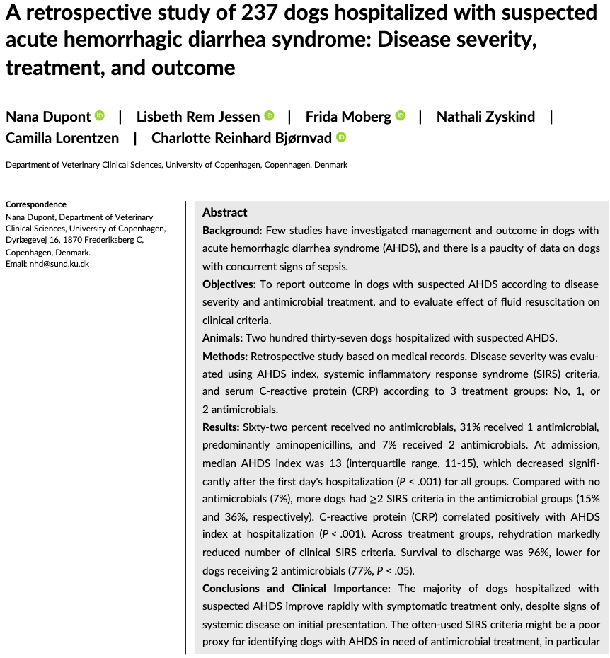
- AHDS due to necrosis of the intestinal mucosal lining
- C. perfringens NetE and NetF toxins may play a role in pathogenesis but exact underlying etiology is unknown
- Previously ABX was routinely recommended d/t potentially incr risk of bacterial translocation & subsequent sepsis
- However, despite this, recent studies don’t support the routine use of ABX in dogs w/ AHDS
- ABX is only indicated in dogs w/ AHDS if the dog is bacteremic, shows signs of sepsis or if there’s an inadequate response to tx
- Aim of study to report disease severity (measured by AHDS index, clinical + hematologic markers of inflammation) and outcome according to an ABX tx regime in dogs w/ suspected AHDS
- Dogs w/ suspected AHDS improved markedly solely w/ supportive care and survived to discharge w/o needing ABX
- CRP correlated w/ AHDS index but didn’t correlate to days hospitalized and not useful to guide ABX

