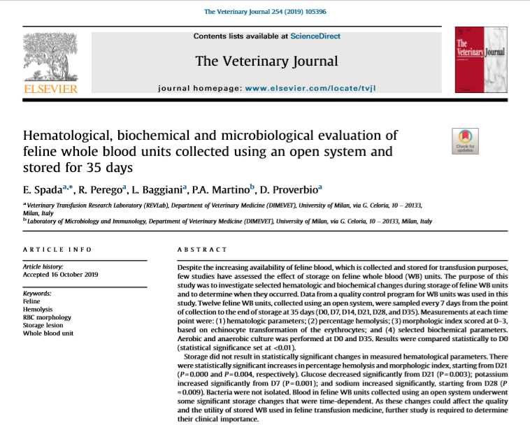
- Feline blood collection volume is too small for standard 450 mL human closed-collection systems open or semi-closed collection systems used (anticoagulant must be added before collection)
- Blood usually collected into a syringe through a butterfly catheter and transferred aseptically to a 50–150 mL transfer-pack container and sealed to prevent bacterial contamination small volume collected (approx. 50–60 mL) poses challenges for separation of the whole blood into components WB is commonly used
- Feline WB units are usually stored for 21
- By convention, efficacy and safety measured by hemolysis <1% at the end of the approved storage period
- Study goals were to look at storage lesions for feline WB Day 0-35 (generally accepted max shelf life) and changes with respect to time since collection
- More important changes - increased hemolysis and echinocyte transformation
- Significant increase in hemolysis from D21 onwards (P < 0.0001); storage time and hemolysis were positively correlated
- Glucose decreased significantly from D21 onwards (P = 0.003). Na increased significantly at D28 (P = 0.009). Significant increases K+ occurred from D7 (P = 0.001). Unlikely to be clinically significant.
- No aerobic and anaerobic bacteria were cultured
- WB unit stored for >3 weeks should be evaluated for hemolysis as an indicator of its viability. However, results do not support the practice of disposing of units after >3 weeks, as almost half of the feline WB units studied had acceptable hemolysis values for up to 5 weeks of storage
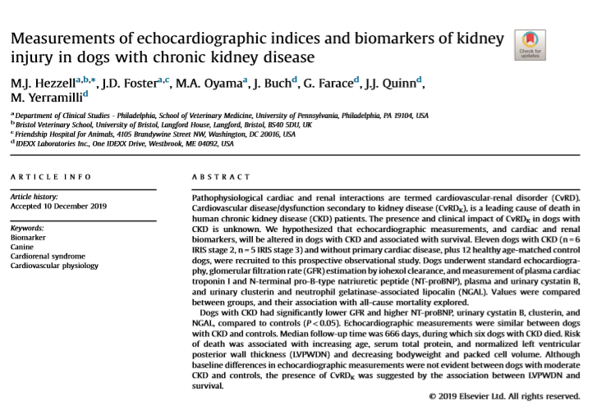

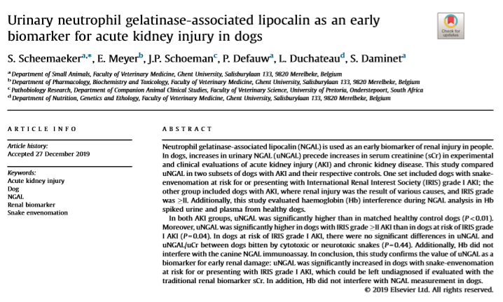

- Neutrophil gelatinase-associated lipocalin (NGAL) - early renal biomarker for AKI and CKD
- NGAL is found in neutrophils, renal tubuli and other tissues
- Kidney damage leads to lower reabsorption of NGAL at the proximal tubulus and/or higher expression of NGAL mRNA at the tubuli = increased urinary NGAL
- Serum creatinine is insensitive and non-specific - results in delayed recognition of renal disease need for novel renal damage biomarkers like NGAL to facilitate earlier detection and intervention of renal injury
- Study goal: compare NGAL between healthy dogs, dogs in IRIS grade ≥II AKI (various causes), and At Risk AKI grade I dogs (snake envenomation), and effect of hemoglobin on NGAL measurement using Hb spiked urine and plasma from healthy dogs
- Results/discussion:
  - Almost all samples of the IRIS grade ≥II AKI study group had mild/moderate proteinuria and hematuria, with significant proteinuria and inactive sediment in two dogs and severe hematuria in
  - Median sCr values for the IRIS grade ≥ II AKI study group was 644.5 μmol/L (7.29 mg/dL)) which was significantly higher than the sCr values (median 88.0 μmol/L 1.0 mg/dL) in the At Risk IRIS grade I AKI group (P < 0.001)
  - Within the IRIS grade ≥ II AKI substudy the median USG values differed significantly between the affected dogs and controls (P < 0.001) USG AKI >II – 1.014
  - IRIS grade ≥ II AKI study group had significantly higher median uNGAL and uNGAL/uCr values than the At Risk IRIS grade I AKI study group
  - Significant difference in uNGAL and uNGAL/uCr values between both AKI study groups and their respective controls
  - ROC curve - detection of dogs at risk for or with AKI using uNGAL showed that 2.69 ng/mL was the optimal cut-off value (sensitivity 100%, specificity 88%)
  - ROC uNGAL/uCr two cut-off values (1.35 ng/mg and 2.08 ng/mg) were comparable, with a sensitivity and specificity of 95% and 77%, and 93% and 85%, respectively
  - For AKI study groups together - no significant correlation between uNGAL and uNGAL/uCr, and IRIS grade
  - Study demonstrated significantly higher uNGAL concentrations in the At Risk IRIS grade I AKI study group when compared control groups; sCr did not differ between groups
  - ROC analysis showed high sensitivity and specificity values for uNGAL and uNGAL/uCr making it a good tool to detect dogs at risk for or with AKI – values are similar to or higher than sensitivity and specificity of the standard renal biomarker sCr, and SDMA suggesting uNGAL is a superior biomarker
  - uNGAL higher in AKI > II group compared to At Risk IRIS grade I = more pronounced renal inflammation and local stress in the kidneys with increasing IRIS grade, resulting in a more pronounced renal tubular damage.
  - Study was able to confirm that uNGAL is more sensitive than the routine functional biomarker sCr
  - Use of uNGAL value was more reliable than the use of uNGAL/uCr value in the diagnosis of AKI
  - Presence of Hb did not interfere with the measurement of NGAL

