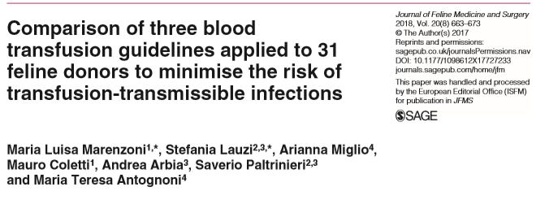
Background:
- With the increasing need for feline blood donors an appropriate screening system is needed to identify risk factors and characteristics of “low risk” donors to help prevent transfusion transmissible infections (TTI)
- Several guidelines (GLs) are used for testing protocols in veterinary medicine. GLs are generally developed according to the circumstances and needs of each country. GLs may differ in some aspects, such as the microorganism to be screened or the screening methods used.
Study:
- Italian GL applied to 31 feline candidate blood donors voluntarily enrolled over a 1 year period.
- GL tests from Europe and US not currently utilized in Italy’s screening process were also included.
- Based on Italian, European and American GLs: hemoplasmas, feline leukemia virus (FeLV), feline immunodeficiency virus (FIV), Anaplasma phagocytophilum, Ehrlichia species, Bartonella species, Babesia species, Theileria species, Cytauxzoon species, Leishmania donovani sensu lato and feline coronavirus (FCoV), were screened.
- Rapid antigen and serological tests and biomolecular investigations (PCR) were used.
- Several PCR protocols for haemoplasma and FeLV DNA were compared – nest PCR always more sensitive
- Found that some of the enrolled cats, while clinically healthy, had risk factors for harboring TTIs.
  - Results for FIV and FeLV infections were negative using rapid tests however when tested with the most sensitive PCR protocol – 1 cat tested positive for FeLV provirus
  - 4/31 (12.9%) of cats were PCR positive for hemoplasma DNA positive despite a normal blood smear
    - All the PCR protocols identified the positive cats but the nested PCR was 10-fold more sensitive
  - Five cats were positive for FCoV antibodies using a more sensitive PCR test
Conclusions:
- The inclusion of tests to screen microorganisms in other GLs caught diseases that otherwise would not have been identified through their (Italian) GL alone.
- Authors recommend biomolecular methods should be used to identify proviral FeLV DNA and hemoplasma.
- Also recommend appropriate recruitment protocols currently not considered in GLs (life style questions, travel) and educational courses for owners.
- The cost and time of the screening procedures may be reduced if appropriate tests are selected.

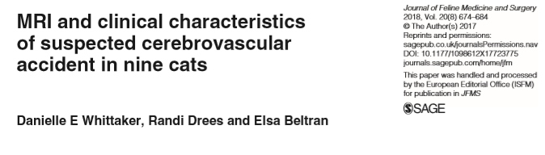
Background:
- Cerebrovascular accidents (CVAs) are defined as a disruption in cerebral blood supply leading to neurological dysfunction and are classically associated with clinical signs that are peracute in onset and non-progressive after 24 h.
- Cerebrovascular disease is the subject of multiple reviews in canine patients it has rarely been reported in the cat.
- MRI characteristics of CVAs in dogs are well described, but in cats they are limited to a single report of two cases of rostral cerebellar infarction.
- There are species-specific adaptations in cerebral blood supply.
- Aim of study is to report the MRI features, clinical characteristics (inclusive of concurrent systemic disease), and short- and long-term outcome of CVAs in the feline population
Study:
- Cats presenting to a single referral hospital (Queen Mother Hospital for Animals, Royal Veterinary College) between January 2005 and September 2016 with acute onset, non-progressive (after 24 h) intracranial signs were retrospectively reviewed.
- Cats that presented within 48 h of onset of clinical signs, had full physical and neurological examinations and underwent MRI within 72 h of presentation were included.
  - n = 9
- Reviewers defined infarcts according to location
Results/Conclusions:
- When CVA occur in cats they are most commonly located caudal to the tentorium, and particularly, the cerebellum.
- In all cases clinical signs reflected neurological dysfunction and varied dependent on the location of the CVA.
  - Middle cerebral artery and caudal cerebral artery exhibited signs of forebrain dysfunction
  - Rostral and caudal cerebellar arteries exhibited signs of cerebellar dysfunction
  - Basilar artery exhibited signs of brainstem dysfunction
- CVAs in cats occur in the same vascular territories as in dogs and have similar MRI features.
- Concurrent systemic disease was common (8/9 cats – 4 HCM, 2 pulmonary masses, 1 hyperthyroid diagnosed and treated 1 yr prior to CVA)
  - A cat presenting with signs consistent with a CVA warrants a full systemic investigation.
- Short term survival was favorable (8/9 cats survived 48hr to hospital discharge); information on only 2/7 cats 5-10 weeks after discharge was available (one had complete recovery, the other had good recovery with some persistent neurologic signs – head tilt, vestibular ataxia)

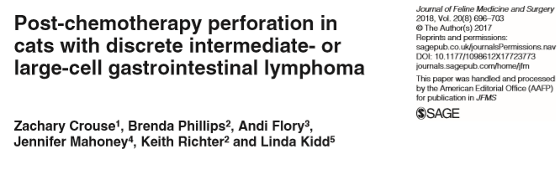
Background:
- Gastrointestinal (GI) perforation is a well described complication of GI lymphoma in people, commonly occurring within days of initiation of chemotherapy.
- There are no studies documenting the prevalence of GI perforation in cats with intermediate- or large-cell GI lymphoma or whether it is associated with induction of chemotherapy.
- The objectives of this study were to document the prevalence and timing of post-chemotherapy perforation in cats with discrete GI masses caused by intermediate- or large-cell lymphoma.
- Authors hypothesized that tumor size, suppurative inflammation within the mass at the time of diagnosis and presence of hypoproteinemia would be associated with perforation.
Study:
- Retrospective: records reviewed June 2006 and May 2012 Veterinary Specialty Hospital San Diego and the Veterinary Specialty Hospital North County. December 2007 and May 2015 Angell Animal Medical Center
- Cats with a diagnosis of intermediate- or large-cell lymphoma based on cytologic or histopathologic examination of a mass lesion of the GI tract and treated with chemotherapy were identified. If the mass was surgically excised, the case was excluded.
- A clinical diagnosis of GI perforation was made using ultrasound findings and analysis of abdominal fluid.
- 23 cats with intermediate- (n = 3) or large-cell (n = 20) lymphoma were included.
  - 18 cats were treated with a COP or CHOP based chemotherapy
  - 3 cats received prednisolone at a cytotoxic dose (1.2–1.9 mg/kg/day)
  - 2 cats were treated with oral lomustine (10 mg/cat or 34–43 mg/m2) and either subcutaneous methylprednisolone acetate (4.2 mg/kg every 14 days) or oral prednisolone (2.9 mg/kg/day).
  - 11 received L-asparaginase as an adjunct to treatment or a rescue therapy during their treatment.
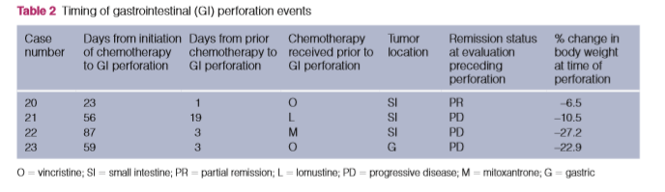
  - 2 treated with a CHOP-based protocol received intravenous (IV) mitoxantrone (6 mg/m2) as a rescue therapy in addition to the standard protocol.
Results/Conclusions:
- GI perforation was confirmed in 4/23 cats (17%), and occurred at 23, 56, 59 and 87 days after induction of chemotherapy.
- Perforation occurred 1 day after receiving vincristine, 19 days after receiving lomustine, 3 days after receiving mitoxantrone and 3 days after receiving vincristine.
- The median time to perforation after induction of chemotherapy was 57.5 days (range 23–87 days).
- It is unlikely that apoptosis and cell death associated with induction of chemotherapy caused GI perforation in these cats.
- However, GI perforation occurred 1–3 days after a recent chemotherapy treatment or after the introduction of a novel chemotherapy drug as a rescue therapy in 3 of 4 cats.
  - a combination of tumor cell death and progressive disease may have contributed to GI perforation.
- There was no association between tumor size, the presence of hypoproteinemia or suppurative inflammation within the mass at the time of diagnosis and subsequent perforation.
- Magnitude of weight loss (>5%) within 15–28 days of induction of chemo was found to be significantly associated with perforation.

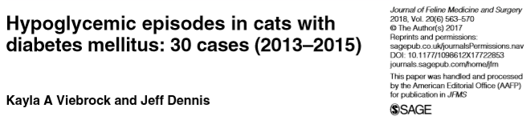
Background:
- Hypoglycemia is also a significant concern when pursuing insulin therapy in cats with diabetes mellitus.
  - In a quality-of-life study, >50% of diabetic cat owners worried that a hypoglycemic episode might occur and 35% of owners indicated hypoglycemic episodes could possibly be occurring in their cats.
  - Investigational studies have found that asymptomatic hypoglycemia is common in cats on insulin therapy.
- As recommendations for treating DM and the types in insulin has changed over the last 25 years, and as clinicians may be using more intensive treatment protocols to help patients achieve diabetic remission, this study wanted to:
  - 1) review the characteristics of diabetic cats receiving insulin therapy presenting to a specialty and emergency center for clinical signs attributed to hypoglycemia and
  - 2) identify the factors that may have contributed to the hypoglycemic episode, the patient’s clinical signs and laboratory findings, and the response of hypoglycemic cats to therapy.
Study:
- Prospective study
- 28 cats were presented a specialty and emergency facility a total of 30 times for symptomatic hypoglycemia between March 2013 and Dec 2015. (hypoBG defined as <65mg/dL).
- Cats categorized into:
  - Mentally dull, weak, ataxic but responsive (n= 14) at presentation
  - Stupor or coma (n= 15)
  - Normal (n=1)
  - BG ‘low’ < 20mg/dL subcategorized (n= 10 with stupor/coma; n=4 dull, weak, ataxic)
- 13 on glargine, 10 on protamine zinc insulin, 6 NPH, 1 porcine insulin; all cats dosed 2x daily
- Median dose was 0.8 U/kg (range 0.2–1.8 U/kg)
- 7 cats (23%) had had their insulin dose increased within 3 months of their initial presentation, 3 cats (10%) had had their dose decreased. 2 cats presented twice during the study period - insulin dose had been decreased from an average 1.2 U/kg to 0.6 U/kg per dose prior to the second presentation. 6 had a previous hypoglycemic event prior to study.
Conclusions:
- 16/30 cases attributed hypoglycemic event to reduced ingestion or subsequent vomiting of a meal after insulin had been administered or the accidental double-dosing of insulin.
- Cause of hypoglycemia unknown in 14/30 cases.
- 18/30 cats has resolved signs within 2 hrs
- 13/14 dull, weak, ataxic cats had neurologic improvement in 12 hours and complete resolution w/in 48hr
- 9/15 stupor/coma cats had improvement at 12hr and were discharged within 96 hours; 6 others were euthanized for lack of improvement
- 10 cats had concurrent illness – this may have been a cause of change of insulin requirement
- If neurologic improvement was seen within 12 hours of treatment, the more likely the cat was to recover despite mental status or glucose level at presentation.

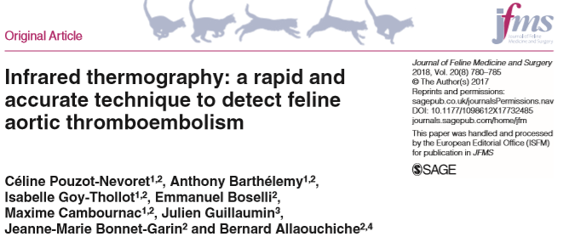
Background:
- Thermography is a painless, non-invasive, non- ionizing diagnostic imaging technique that records the cutaneous thermal patterns generated by the emission of surface heat.
  - Has been used in dogs for the diagnosis of femoral arterial thrombosis, mammary tumor, thoracolumbar disc disease, and cranial cruciate ligament rupture.
  - In humans, is an accurate imaging technique for diagnosis of ATE in infants and deep venous thrombosis in adults.
- The purpose of this study was to evaluate the diagnostic accuracy of infrared thermography as a new diagnostic tool for FATE cats.
Study:
- Prospective study between June 2015 and April 2017 for cats admitted to ICU for acute hind limb paralysis
  - FATE (n=10) diagnosed via ultrasound
  - Control (n= ) paralysis not related to ischemic process, diagnosed by XR, CT, MRI, CSF
- Thermal imaging was performed on all FATE and control cats (3 views taken – all 4 limbs, ipsilateral forelimb/hindlimb view right and left side)
- The maximum (Tmax), minimum (Tmin) and average (Tav) temperatures were determined for each of the four limbs within a hand-drawn region of interest on the dorsal limb extremity.
- Temperature differences between Tmax, Tmin and Tav of forelimb (non-affected) and hindlimb (affected) were calculated between: (1) ΔT – the forelimb with the highest temperature and the hindlimb with the highest temperature; (2) δT – the forelimb with the lowest temperature and the hindlimb with the lowest temperature;; (3) RightΔT – the right forelimb and the right hindlimb; (4) LeftΔT – the left forelimb and the left hindlimb
Results/Conclusion:
- A difference of at least 2.4 degree Celsius between the ipsilateral non-affected and affected limbs had 100% specificity and PPV for detecting FATE
  - This temperature difference may be too low to detect on PE but can be picked up on thermography
- Due to small population size, a larger pool is needed for confirmation.
- Thermography may be a promising non invasive diagnostic tool for FATE.

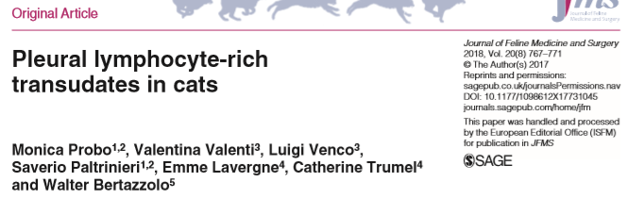
Background:
- The classification of effusions as transudates, modified transudates and exudates is traditionally based on measurement of protein concentration, specific gravity and total nucleated cell counts, in order to characterize them as transudates, modified transudates and exudates.
- Non-chylous lymphorrhagic effusions are transudate forms due to leakage of lymph, but do not contain chylomicrons, and therefore do not show the classical milky aspect of true chylous effusion.
  - lymphocyte-rich transudate (LRT) might represent an alternative and more appropriate designation for these kind of effusions
- One of the most common causes of pleural effusion in cats is an increased hydrostatic pressure of the vascular or lymphatic system often caused by congestive heart failure (CHF).
- The aim of this study was to retrospectively investigate the clinical features and etiology of feline pleural LRTs, and to assess the association between this condition and heart diseases in the cat.
Study:
- Retrospective, 2013-2016
- All transudative effusions with a predominance of lymphocytes on cytology that were considered non- chylous based on visual appearance were included. Pleural effusions classified as neoplastic, exudates or chylous were excluded.
- Only cats that received a complete clinical examination, thoracic radiography and echocardiography were included - diagnosis and classification of cardiac disease was primarily based on echocardiography criteria
- 33 effusion samples met the criteria
  - Triglyceride and cholesterol concentration were available for 19 cases and was consistent with non chylous effusion
  - Lymphocytes comprised >80% of all nucleated cells in 20/33 cases, 60–79% in 8/34 cases and <60% in five cases.
Results/Conclusions:
- 23/33 cases (69.7%) had a concurrent cardiac disease; 9/23 had intra-thoracic mass/neoplasia; 1/23 developed LRT secondary to previous pyothorax
- Authors propose that when a clear lymphatic origin of pleural fluid cannot be demonstrated (chyle), lymphocyte rich transudate (LRT) might be considered a better name for these kinds of effusions rather than “non-chylous lymphorrhagic effusions.”
- The presence of a pleural lymphocyte-rich transudate in a cat should prompt the search for cardiac disease or intrathoracic neoplasia.
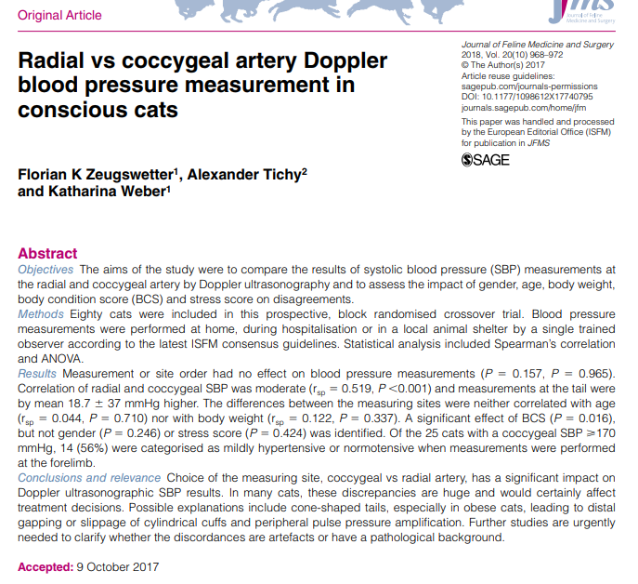
- Replicated findings in two other studies – site of BP measurement (radial vs coccygeal a.) impacted the SBP results using Doppler syphgmomamanometry
- Mean SBP measurements were only moderately correlated (r=0.519)
- Readings on tail were on average 18.7mmHg higher than on forelimb
- Discrepancies in SBP were significantly greater in cats with a BCS > 4 (5 pt scale)
- 14/25 cats that were categorized as hypertensive based on SBP obtained from coccygeal a. were categorized as mildly hypertensive to normotensive with radial a. measurement
  - if sole result of coccygeal measurement was used this would have impacted treatment decisions (i.e initiation of anti-hypertensive medication)
- Differences attributed to cuff shape / fit, difference in peripheral pulse pressure at different body sites, BCS
- Authors recommend documenting BP measurement site and interpret them with caution.
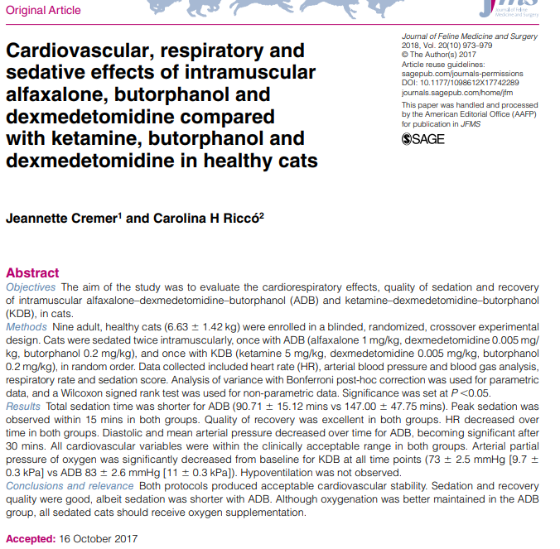

- Adequate sedation achieved with both protocols
- Sedation time with alfaxalone was significantly shorter
- No differences in the two groups were observed with respect to quality of sedation, recovery and cardiovascular effects
- Hypoxemia occurred more frequently in the ketamine group was but was also observed in a few cats in the alfaxalone group however hypoventilation was not observed – attributed to V/Q mismatch from atelectasis from positioning
- All sedated cats should receive supplemental oxygen
In conclusion, there is evidence that Small Jaw and Impact
LigaSures can be reused for a limited number of cycles with-
out deterioration of the vascular seal quality, but they should
be immediately discarded as soon as any intraoperative evi-
dence of formation of a failed vascular seal is identified.
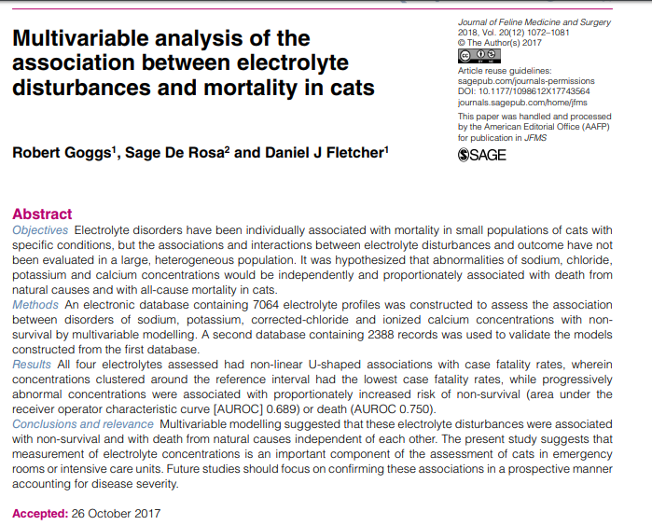
- Study looked to analyze the association between electrolyte abnormalities and mortality outcome in cats
- There were prominent non-linear ‘U’ shaped relationships between electrolyte concentrations and case fatality rates for all four electrolytes assessed (Na, K, Cl – corrected, iCa)
- Patients with electrolyte concentrations close to the median value (within reference intervals) had low case fatality rates, while patients with abnormal concentrations had increased case fatality rates proportionate to the degree of abnormality
- Patients with more than one disturbance in either direction are at greater risk of a poor outcome irrespective of the combination of electrolyte disturbances present
- The strength of the association between death and electrolyte abnormalities suggests such disturbances should be taken seriously and that clinicians should take steps to identify and manage the underlying diseases

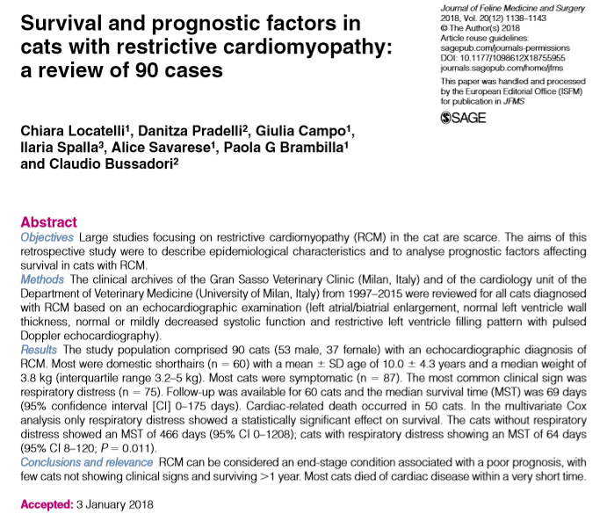
- MST was 69 days with cardiac related death in 83%
- Respiratory distress showed a statistically significant effect on survival - without respiratory distress showed a MST of 466 days (very rare), with respiratory distress MST of 64 days (range in other studies 1-4 mo)
- RCM is almost exclusively diagnosed at a late stage when cats are referred after the development of clinical signs
- Long-term prognosis is poor
- RCM was the second most commonly diagnosed CM in cats in this population - 10 year prevalence of 15% in all cats with CM
- Heart murmur was rarely identified in cats with RCM – consistent with lack of a heart murmur is not a useful screening tool in cats

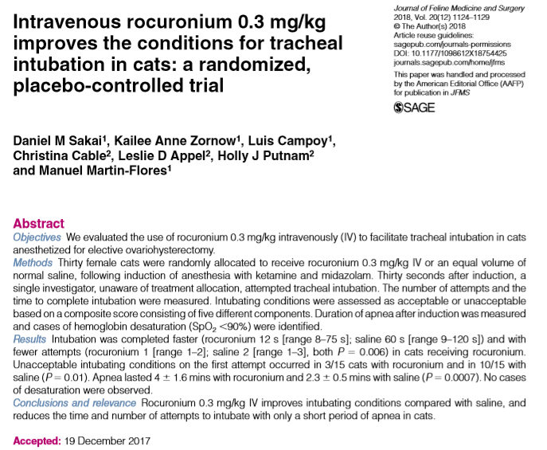
- Neuromuscular blocking agents (NMBAs) are commonly used to facilitate tracheal intubation in people - improves the quality of intubation and reduces the incidence of trauma
- Non-depolarizing NMBAs at the doses commonly used almost invariably result in apnea of long duration – oxygen desaturation, PPV necessary
- Study looked to evaluate low dose rocuronium (0.3 mg/kg IV) for ease of intubation
- Number of attempts to intubate and the time to intubate were significantly less in cats receiving rocuronium
- PPV was administered for significantly longer time (~4 min) for cats receiving rocuronium to those receiving saline control (~2min)
- PPV was required for all 15 cats receiving rocuronium and 7/15 cats receiving saline
- No cases of hypoxemia (SpO2 <90%) was observed
- No cases of residual neuromuscular block were seen in recovery (all cats had rocuronium reversed with edrophonium after return of spontaneous ventilation during surgery – helps decreases the occurrence of residual muscular weakness during emergence from general anesthesia)

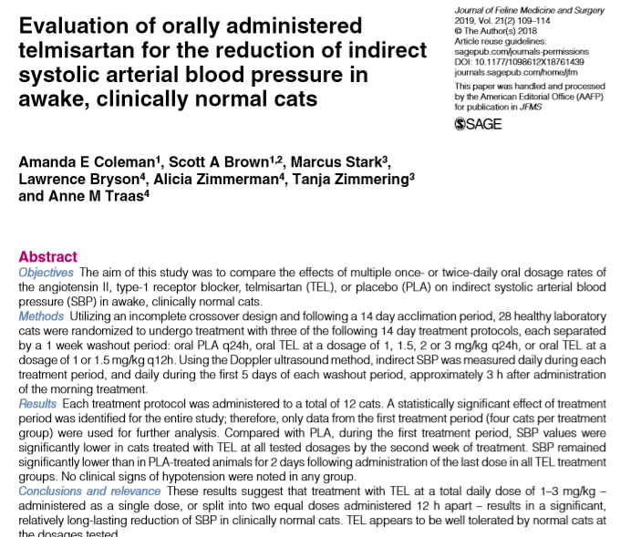

- Benazapril has not been shown to improve survival benefit and lacks efficacy as an anti hypertensive agent in cats
- Telmisartan has been found to have antiproteinuric effects non-inferior to benazepril however antihypertensive efficacy has not been evaluated
- This study looked at BP effects of Telmisartan in healthy cats at different doses and dosing intervals compared to placebo
- After week 1, the 1mg/kg/day and 1.5mg/kg/day did not significantly drop BP but other doses/intervals did
- By week 2 all doses and intervals resulted in statistically significant decreases in BP compared to placebo/baseline (25-37mmHg range decrease)
- Greatest reduction in week 1 with >2mg/kg/day doses
- Testing in hypertensive cats needed; duration of BP control not tested in this study

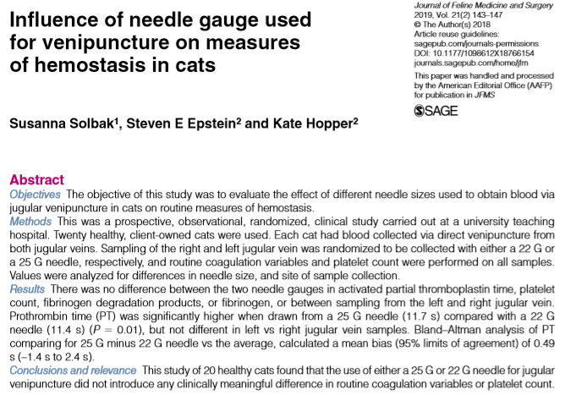
- Smaller diameter needle exerts higher shear forces as blood is collected can activate both platelets and coagulation factors coagulation variables and platelet count may be altered
- Humans - platelet count but not PT or aPTT has been shown to differ with varying needle sizes; dogs no differences with 21, 21, 25g needles
- Cat platelets have greater aggregability in response to shear stress- will various needle sizes will affect tests of hemostasis in cats (22 vs 25g)?
- No difference between the two needle gauges for platelet count, proportion of samples with platelet clumping, aPTT, FDPs or fibrinogen, PT

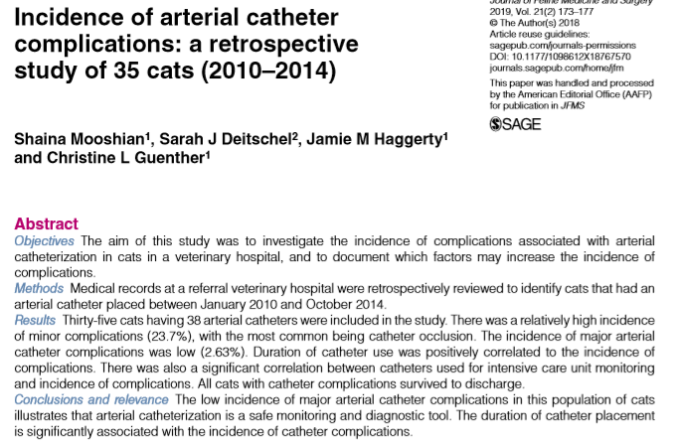
- Minor complications were noted for nine arterial catheters (n = 9/38; 23.7%) of which all were catheter occlusion
- One major complication was noted, with one cat suffering ischemic injury secondary to a coccygeal arterial catheter resulting in tail amputation (1/38; 2.6%)

Reviews (Jan 2019):
- HYPERTENSIVE OCULAR DISEASE IN CATS A guide to fundic lesions to facilitate early diagnosis
- ACUTE PAIN IN CATS Recent advances in clinical assessment

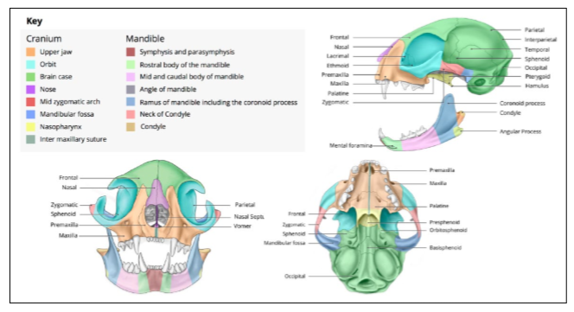
Journal Feline Medicine & Surgery – Feb 14 – April 4 2019
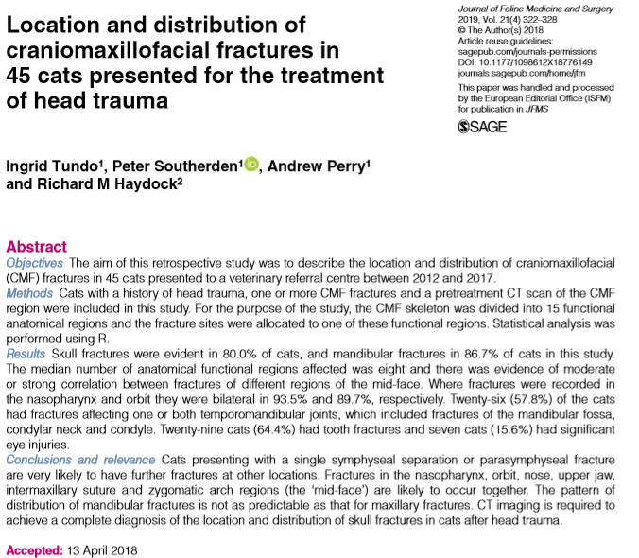
- Can result from HBC, fight, or a fall from a height (high-rise syndrome)
- PE insufficient to accurately classify maxillofacial injuries
- CT imaging superior to XR - incidence and distribution of facial fractures may help develop an understanding of the most appropriate diagnostic and treatment options for these patients
- Retrospective study - describes the location, distribution, fracture pattern, and correlation of the with functional regions and associated ophthalmic and dental injuries in 45 cats
- RESULTS:
  - HBC most common injury causing fracture
  - 80.0% of cats in study had skull fractures (with 81% being bilateral) and 86.7% had mandibular fractures (18% bilateral)
  - Medium 8 fractures per cat
  - Skull fracture - fractures to the ‘mid-face’ region were most common (nasopharynx (68.9%), orbit (68.9%), nose (51.1%), upper jaw (51.1%), intermaxillary suture (44.4%) and zygomatic arch (33.3%))
    - Fractures in these region likely to be bilateral and occur together
  - If a cat had a mandibular symphyseal or parasymphyseal fracture there was an 84.6% chance of another mandibular fracture and a 73.1% chance of a fracture in the skull
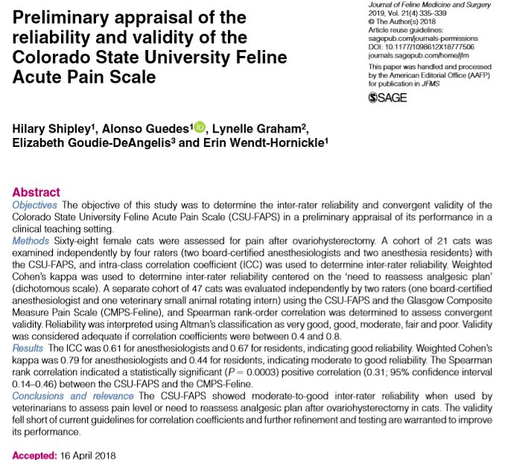

- Uncontrolled pain is detrimental - QOL, increases in cortisol and catecholamines predispose to tissue edema, ischemia, hyperglycemia, infection and impaired wound healing
- Behavioral signs of acute pain in cats: depression, immobility, remaining in a hunched position with the head down, guarding behaviors, attempting to escape, squinting of the eyes, hissing, growling, and resistance to palpation or handling
  - May also appear very similar to signs of distress = overlooked
- Current study: assess the inter-rater reliability and convergent validity of the CSU-Feline Acute Pain Score in a clinical/teaching setting
- RESULTS:
  - CSU-FAPS was simple to use
  - Moderate to good inter-rater reliability when used by veterinarians with advanced training in anesthesia (residents and anesthesiologists)
  - The convergent validity of the scale fell short of current guidelines for correlation coefficient (Glascow Composite Measure Pain Score – Feline was criterion)
  - Refinement of the scale could be beneficial to increase consistency of results
- Relatively reliable but not valid measure

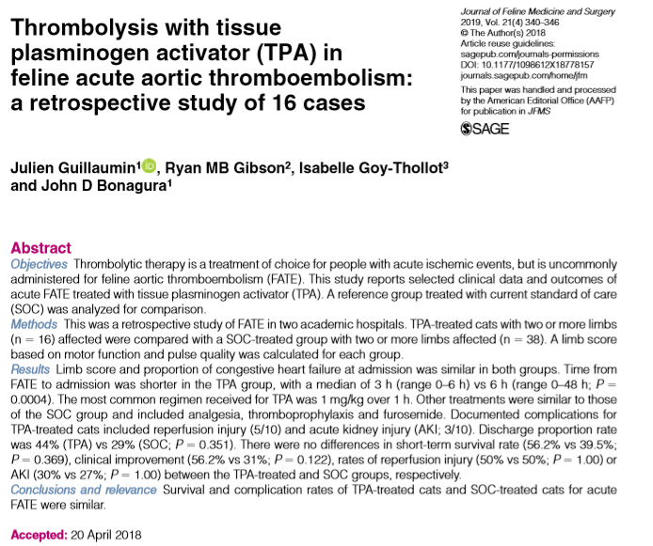
- Prognosis for FATE is poor - euthanasia as high as 90% in some reports
- Current standard treatments = analgesia and thromboprophylaxis - the prognosis is still guarded (survival with treatment 27–45%)
- Humans, mortality and functional outcome improved if tPA given within 6 hours of acute ischemic event
- Veterinary medicine - thrombolysis in FATE has been considered unrewarding (lack of efficacy, risks of reperfusion injury (RI) with hyperkalemia)
- Retrospective study: report clinical data and outcomes associated with the early use and short-term infusion of TPA in FATE vs SOC without TPA (10 year period)
- RESULTS:
  - TPA given within 3 hours of presentation (though significant difference in time to presentation between TPA and SOC group)
  - Euthanasia rate vs spontaneous death was similar in both groups (55.55% for TPA-treated vs 66.7% in SOC)
  - Short-term (48 h) survival proportion were not different between groups (56.25% in the TPA-treated vs 39.5% SOC)
  - 4/7 cats in TPA ground had recurrence of FATE (median time 106 days)
  - SOC group - 25% and 50% developed AKI and RI - not statistically different to the TPA-treated group
  - TPA group – 7/16 had motor function improvement w/in 12 hours of treatment (none in SOC group did not (no significance noted)
  - Overall underpowered – differences may not have been detected
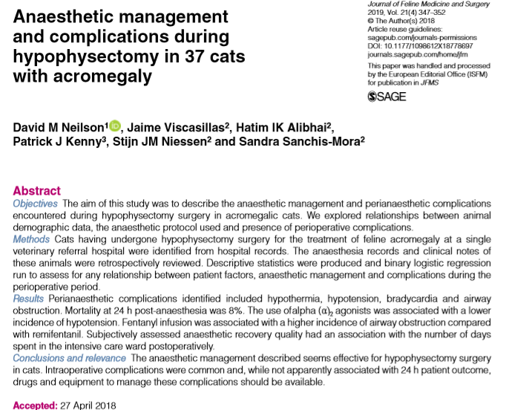
- Hypersomatotropism - growth hormone-secreting pituitary gland adenoma
- Though typically slow-growing, neurological disease is possible
- Traditionally treated with radiation though more surgeons are performing hypophysectomies
- Retrospective study: describe the anesthetic management and complications encountered during hypophysectomy surgeries, assess the relationship between complications and the anesthesia protocol used, and the impact and presence of complications on the perioperative outcome
- RESULTS:
  - Ax management consisted of methadone +/- midazolam, alpha 2 agonist, alfaxalone, acepromazine as premed; propofol or alfaxalone +/- midaz to induce; sevo or iso for maintenance with fentanyl or remifentanil; insulin CRI; hydrocortisone CRI; desmopressin conjunctival; buprenorphine post op
  - Cats that did not receive an α2 agonist were more likely to suffer hypotension during the anesthetic period
  - Cats that received a CRI of remifentanil were less likely to suffer airway complications than cats that received fentanyl infusion
  - Interestingly cats with recovery described as ‘abnormal’ were discharged quicker from the ICU compared with cats with a recovery quality described as ‘unremarkable’
  - Intraoperative complications: hypothermia, bradycardia, hypotension and airway obstruction
  - 3/38 (8%) died within 24 hours of anesthetic recovery
  - Median time in ICU post-op was 6.8 days +/- 3.8
  - Mortality rate lower than previous studies

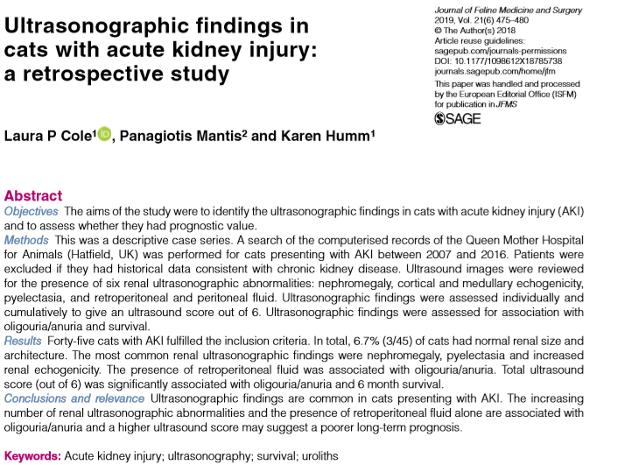
- Published ultrasonographic findings in dogs and cats with AKI include increased renal size, increased cortical echogenicity, the presence of perirenal fluid, medullary rim sign, pyelectasia, increased echogenicity of the perirenal fat and abnormal echogenicity of the urine in the renal pelvis
- Goal of study: identify the ultrasonographic findings in cats with AKI and to assess whether any specific findings had a prognostic value
- Retrospective descriptive case series; AKI based on IRIS guidelines; no history of CKD
- Nephromegaly was present in 68.9% (31/45) - 35.5% had unilateral nephromegaly; pyelectasia was present in 57.8% (26/45) - unilateral in 11.5%, all cats had been on fluid therapy prior to AUS, 75% (3/4) of patients with severe pyelectasia were documented to have uroliths; increased cortical and medullary echogenicity was documented in 40% (18/45) and 51.1% (23/45) respectively
- 42.2% (19/45) survived to discharge and 35.6% (16/45) were alive at 6 months (all that died were euthanized due to their disease)
- No single AUS finding or composite score was correlated with survival to discharge
- There was a statistically significant association between the total ultrasound score and 6 month survival time and presence of oliguria/anuria
- There was a statistically significant association between the presence of retroperitoneal fluid and oliguria/anuria
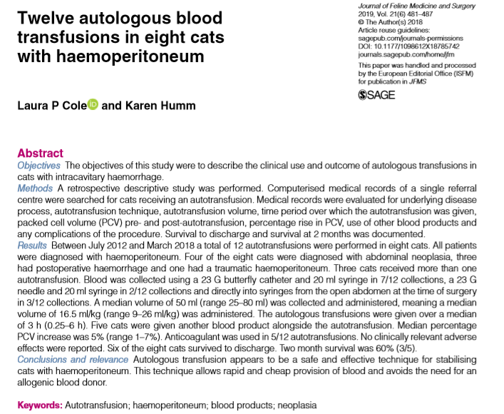

- Goal of study: investigate the frequency and efficacy of feline autotransfusion, as well as describe the reasons for performance of autotranfusion and the methods used (not previously reported in felines)
- Retrospective descriptive study; 8 cats received 12 autotransfusions – 6 type A, 2type B over a 6 year period
- Methods of transfusion: blood was collected using a 23 G butterfly catheter and 20 ml syringe (7/12); a 23 G needle, three-way tap and 20 ml syringe (2/12); and directly into syringes from the open abdomen at the time of surgery (3/12)
- Anticoagulant acid citrate dextrose (ACD-A) was used in 5/12 of the autotransfusions - 0.14 ml of ACD used per 1 ml blood collected, as described in previous studies
- All cases the blood was transfused through an 18 μm blood filter
- Median volume of 50 ml was collected and administered (median volume of 16.5 ml/kg over a median of 3 h; 3 autotransfusions were given in 1 h or less)
- There were no documented reports of urticaria, erythema, increased rectal temperature or other signs of transfusion reaction
- 5/8 cats also received other blood products (FFP, canine blood, feline pRBC, whole blood, oxyglobin)
- Two cats had culture of the abdominal fluid used for autotransfusion – no cytological evidence of bacteria in either sample but one grew enterococcus on culture
- 6/8 cats survived to discharge -no delayed adverse reactions to the autotransfusions were reported in any patient
- Monitoring for post-transfusion hemolysis, coagulopathy and hypocalcemia are recommended post-transfusion

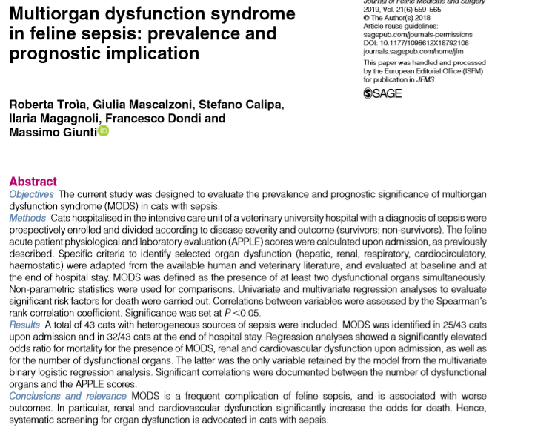
- Frequency and clinical manifestation of sepsis and MODS are less documented in cats
- Biomarkers of feline sepsis - metarubrocytosis, high circulating muscle enzymes (AST, CK), high band neutrophil percentage and elevated serum amyloid A (SAA) concentrations have been investigated though selected organ dysfunctions have been rarely characterized
- Goal of study: investigate and characterize organ dysfunctions and MODS in feline sepsis and determine if occurrence is associated with increased mortality
- Prospective study; include ¾ SIRS criteria + confirmed source of infection; numerous diagnostic tests and lab work performed on admission and APPLE(fast) and APPLE(full) score; organ dysfunction determined based on adaptation from human and canine literature; MODS if >2 organ systems dysfunctional simultaneously
- 43 cats; median age of 5.2yr; major causes of sepsis were pyothorax (13), panleukopenia (11), septic peritonitis (9); others were UTI (3), bacterial cholangiohepatitis (2), endocarditis (1), myocarditis (1), septic arthritis (1), pyelonephritis (1) and ocular abscess (1)
- 26/43 survived
- Lower body temp, higher APPLE(fast) score, lower WBC count, increased volume of fluids given during hospitalization were significantly different for non survivors
- 25/43 had MODS at presentation; 37/43 developed MODS
- The presence of MODS, renal and cardiovascular dysfunction at presentation were significantly associated with increased the risk of death
- The number of dysfunctional organs was associated with a higher APPLE score
- The overall number of dysfunctional organs was the strongest predictor of mortality
