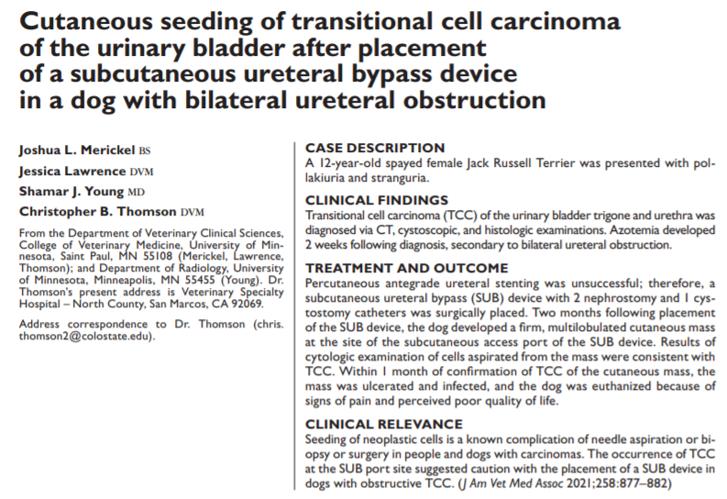
- TCC obstruction at the UVJ – stents could not be placed
- Owner elected for SUB
- 58 days after SUB placement a large, multilobulated, firm, fixed SQ mass was identified at the site of the SUB shunting port and extended toward the inguinal region; CT revealed it was infiltrative and invaded the body wall aspirated as TCC
- TCC accounts for 75% of LUT tumors in dogs 10% of dogs with TCC reportedly had mets to skin (direct extension from bladder tumor, hematogenous and lymphatic spread, seeding during partial cystectomy, seeding from cysto)
- This care seeding could have occurred during aspiration and flushing sessions, tracking along the SUB device, urine leakage and seeding during surgery (thought to be less likely due to location of mass – not on ventral midline), inflammatory microenvironment around the SUB devise encouraging hematogenous or lymphatic dissemination and inflammation causing an environment to favor mets
- As TCC are highly exfoliative – the risk of seeding should be considered when choosing treatment options
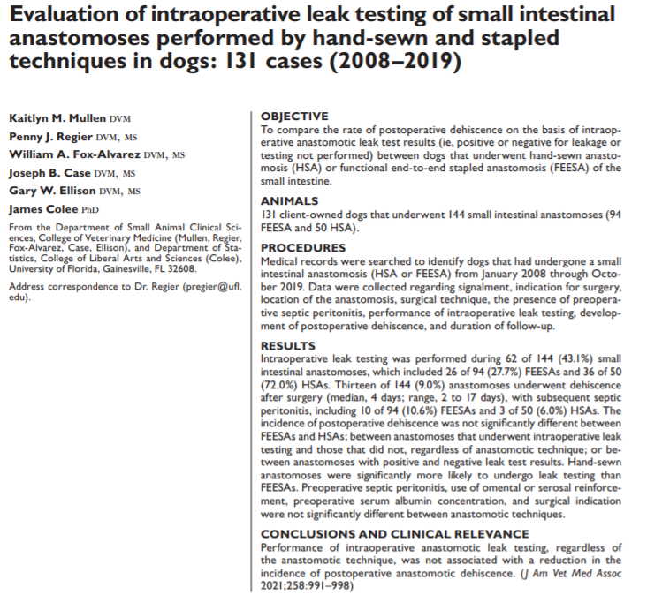
- Intestinal dehiscence rate reported to be as high as 28% - risk factors – septic peritonitis, hypoAlb (<2.5), FB obstruction, intra-op hypotension
- Leak testing evaluates acute integrity of the surgical repair
- Little information on leak testing -aside from intestinal biopsies surgical removal or FB or R&A are more completes and may need a different method of being tested
- Study goals: look post-op dehiscence rates based on intraoperative leak testing compared between hand sewn vs stapled R&A of the SI
Results:
- 144 R&As performed – 94 stapled, 50 handsewn
- Leak testing was performed in 43% of the stapled R&As and 72% of the handsewn – handsewn significantly more likely to be tested
- Leak testing not performed in 57% in total
- Those that were tested, 8% had positive leakage – 11.5% of stapled, 5.5% of handsewn – not significant
- 9% (13/144) had dehiscence (median 4 days) – 10.6% of stapled, 6% of handsewn (difference not significant)
- Pre-op septic peritonitis nor albumin level was associated with dehiscence
- Dehiscence occurred in 8% (5/62) R&A that underwent leak testing; 9.8% (8/82) of those not tested dehisced – not significant
- No relationship between intraoperative R&A leak testing and reduction in postop dehiscence
- No difference in positive leak test or postop dehiscence between stapled and handsewn
- Authors recommend novice surgeons to continue to leak test as a way to eliminate poor surgical technique

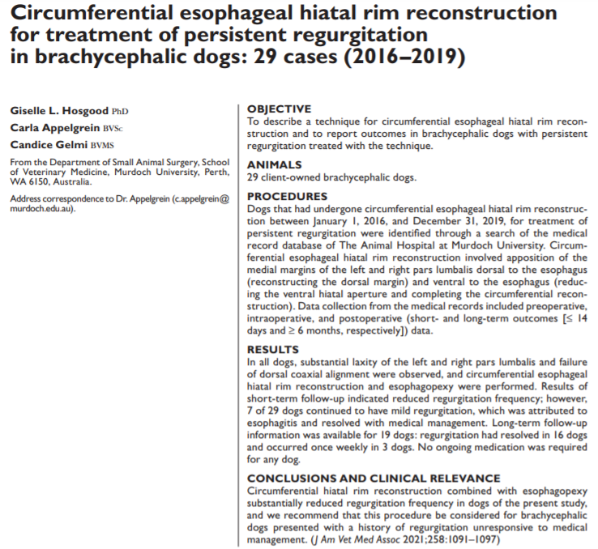
- GERD and regurg are common in brachycephalic dogs
- Causes of reflux are multifactorial and not completely understood – factors can include sliding hiatal hernia, reduced gastroesophageal junction pressure, esophagitis, obesity, increased distensibility of the gastroesophageal junction, prolonged esophageal clearance, delayed gastric emptying
- Brachycephalic breed – sliding hiatal hernia common
- Laxity of the crural muscles may be reason
- Purpose of report is to describe a new surgical technique that circumferentially reconstructs the gastroesophageal hiatal rim to help dogs with persistent regurgitation unresponsive to medical management and report outcomes
Results:
- 29 dogs included
- All dogs had lax phrenicoesophageal ligament and enlarged esophageal hiatus, as well as substantial laxity in the left and right pars lumbalis and failure of the coaxial alignment of the pars lumbalis dorsal to the esophagus
- All dogs had circumferential hiatal reconstruction and esophagopexy – no dogs developed pneumothorax
- All dogs discharged with omeprazole and metoclopramide
- 14 day follow up – 7/29 had intermittent regurg that resolved by follow up, 22 had no vomiting or regurg after discharge
- Long term follow up for 19 dogs – 16/19 never had signs of regurg after surgery, 3 regurg about once weekly, none received long term medication

