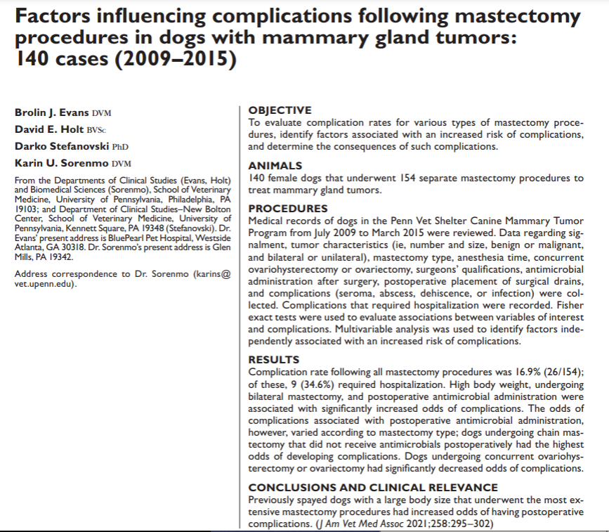
Intro:
- Mammary gland tumors most common tumor type amount sexually intact females (50-70%) – hormone dependent, incidence increases with age
- Mets associated with fatal outcome
- Surgical excision dependent on extent of disease (lumpectomy radical mastectomy); prophylactic removal of affected glands not recommended in dogs as it is in cats
- Study: determine complication rate of various mastectomy procedures, peri and post operative factors associated with complications, severity of complications and their consequences
Methods
- Retrospective
- Data regarding signalment, tumor characteristics (ie, number and size, benign or malignant, and bilateral or unilateral), mastectomy type, anesthesia time, concurrent OHE/OVH, surgeons’ qualifications, antimicrobial, administration after surgery, postoperative placement of surgical drains, complications (seroma, abscess, dehiscence, or infection), and complications needing hospitalization were recorded
Results
- 140 dogs underwent 154 surgeries (14 on two occasions)
- 33% mixed breed
- 69 of the masses were malignant CA > sarcoma) and 85 were benign
- 87% of surgeries involved the caudal abdomen/inguinal mammary glands; 51.3% had bilateral tumors
- Regional mastectomy performed in 48.7%; 72.1% spayed concurrently
- 16.9% suffered complications (26 dogs) – seroma, abscess, dehiscence, infection
  - 40.7% of dogs with chain mastectomies had complications
- Median time to complication 13.9 days
- Factors associated with complications: type of surgical procedure (bilateral mastectomy), bilateral involvement, administration of abx postoperatively, placement of drains, caudal location of tumor, having more than one tumor; increasing bodyweight
- 34.6% of dogs with complications required hospitalization; 7/9 required repeat surgical intervention
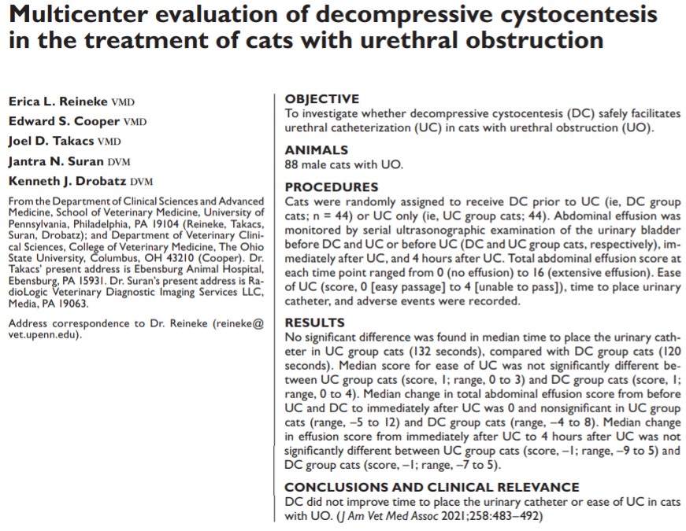
Intro:
- Decompressive cysto prior to unblocking: relieves pain, decreases renal back pressure, improved urinary bladder wall perfusion, facilitates retrograde urohydropulsion and placement of a urinary catheter by lowering intraluminal urinary bladder pressures, UA/UPC/UC
- Possible complications: urine leakage into peritoneum, urinary bladder rupture, risk for hemorrhage, potential to delay unblocking, increased client cost, lack of evidence to show benefit
- Previous retrospective: no survival disadvantage or benefit, no complications; 50% of cats had loss of serosal detail consistent with effusion
- Previous prospective: 8/15 cats had evidence of effusion in caudal abdomen following decompressive cysto
- Is effusion due to urine leakage or due to increases intraluminal hydrostatic pressure and inflammation (bladder sweat)
- 3rd prospective: 15/45 cats had evidence of effusion prior to DC; 7 developed effusion post DC but no clinically relevant uroabdomen
- Study goals: investigate whether DC facilitates urethral catheterization and evaluate safety of DC in these cats
Materials/Methods:
- Randomized, blinded, controlled study – Penn, Ohio
- DC + UC vs UC only compared
- AUS performed prior to DC/UC vs UC, immediately after UC, 4 hours later
Results/Discussion:
- 88 cats included – 44 each group
- Ease of UC placement not different between groups, no difference in urethral spasm, time of catheter placement, PCV/pH/TP/iCa/BUN/K/Cr, or duration of hospitalization
- 1 cat in UC only group develop uroperitoneum after UC; no uroperitoneum in DC group
- 62/67 (93%) of cats had pericystic effusion prior to UC; effusion score was not different between groups
  - Effusion likely due to increased intravesicular pressures resulting in lymphatic obstruction, inflammation associated with cystitis, transudation of urine through bladder wall
- 40% developed increase in total abdominal effusion score following UC
- Effusion score not different between groups immediately post-UC or at 4hr, but total score was higher in DC group at the 4 hour mark (greater effusion at the caudal bladder site)
- 91% of cats survived to discharge; 8 euthanized (5 DC; 3 UC)
- 9% rUO in hospital, not different between groups
- No evidence for or against DC – may be useful when there are unavoidable delays to UC

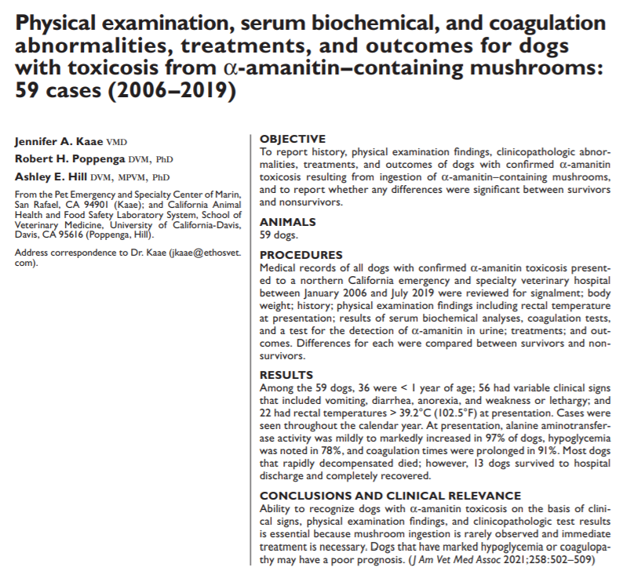
Intro:
- Liver failure after ingestion of certain mushrooms
- Primary hepatotoxins are amantins – alpha-amanitin is most toxic; found in 38 species of mushrooms including Amanita, Galerina, Lepiota
  - Death cap (Amanita phalloides) most common
    - Found alongside planted trees (oak trees on west coast; pine trees on east coast), naturalized in California
    - Cap is green to yellow but can vary
  - 1 mushroom can contain 15mg a-amanitin – LD50 in dogs is 0.5mg/kg
- Amantins rapidly absorbed from small intestines by Na dependent bile acid transporter portal vein liver taken up by OATP bile transporter
- Inhibit RNA polymerase leading to deficient intracellular protein synthesis and hepatocellular death; intestinal cells and renal cells also affected renally excreted within 48 hours
- Should be considered in all ALF dogs
- Study goals: described clinical, clin path abnormalities, treatment, outcomes in dogs with confirmed a-amanitin toxicosis and compare factors of survivors from nonsurvivors
Methods/materials
- Retrospective
- A-amanitin confirmed by detection of toxin in specimens submitted – urine (liquid chromatography-mass spec), vomitus, bile, renal tissue (post-mortem)
- Patient date, time of year
Results/discussion
- 59 cases
- Most dogs less < 1yr
- 95% presented for vomiting, weakness, anorexia, lethargy, diarrhea
  - Clinical course: latency period of 6-24 hours after ingestion; GI phase – v/d/cramping can last 12-24 hours; 36-48 hours after ingestion is convalescent phase with no signs; then liver and renal failure phase – CNS dysfunction (HE, cerebral edema)
- 39% had twitches, tremors, seizures, obtundation due to severe hypoBG
- All presented within 36 hours of onset of signs – 10% treated as outpatients for suspected GE but returned 12-24 hours later for progressive clinical signs
- All dogs assessed to be quiet, depressed, obtunded
- Only 4 owners (7%) saw dog with mushroom in mouth within 24 hours of presentation
- 47% of cases were in the summer
- All dogs had increased ALT (many out of range); 81% hypoBG initially 95% ultimately had hypoBG
  - hypoBG worse in nonsurvivors than survivors
  - a-amanitin depletes hepatic glycogen stores, may also induce insulin release
- All dogs developed prolonged PT/aPTT during hospitalization
- A-amanitin was detected in urine in 57 cases
- 15% euthanized on presentation after ALF diagnosed
- Treatment varied and included IVF, GI protectant, liver protectants, FFP, Vit K
  - Decontamination is important – a-amanitin undergoes EH recirculation charcoal, cholestyramine; percutaneous GB drainage, ostreotide; hemoperfusion does not remove toxin
  - Lactulose does not work well in acute ALF, HE (humans); cerebral edema common
  - Silybin inhibits OATP transporter for a-amanitin into hepatocytes – protective if given IV within 5 hours of ingestion
- 26% survived (13 dogs) – hospitalized 1-5 days
  - Had higher BG during hospitalization, less prolongation of PT/aPTT, trace a-amanitin in urine
  - ALT not associated with survival and should not be used in decision-making
- Euthanized – due to poor response to treatment, grave prognosis due to declining mental status, financial constraints

