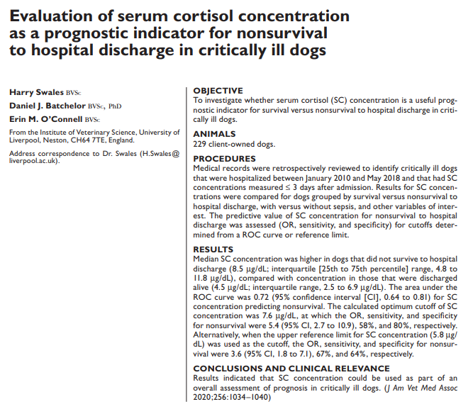
Intro:
- Humans: serum cortisol concentration increase during the acute phase of illness; less investigated in veterinary medicine though high SC levels associated with nonsurvival in parvo and acute Babesia infection and experimental S aureus pneumonia
  - Increased activity of HPA due to catecholamine release, proinflammatory cytokines, non adrenal dependent steroidogenesis; may also be due to reduced cortisol binding proteins and cortisol metabolism
- Study: can SC be a prognostic indicator for nonsurvival versus survival to discharge in critically ill dogs?
Methods:
- Retrospective
- Dogs admitted to ICU with cortisol measured within 3 days of admission Jan 2010 to May 2018; classified as septic or not
Results:
- 229 dogs included; 184 survived; overall mortality was 20%
- No difference in survival for those classified as septic vs nonseptic
- Median SC level was 5.0mcg/dL (RI 2.0-5.8)
- 42% had SC > 5.8mcg/dL; proportion of dogs with high SC was significantly greater for nonsurvivors
- Median SC was significantly higher for nonsurvivors (8.5mcg/dL vs 4.5mcg/dL)
- 1.11 increase in odds of nonsurvival for every 1mcg/dL increase in SC concentration
- Median SC was significantly higher in dogs with sepsis (9.2mcg/dL) than those without sepsis (4.5mcg/dL)
- SC of 7.6mcg/dL – 5.4 odds of nonsurvival, Se 58%, Sn 80%

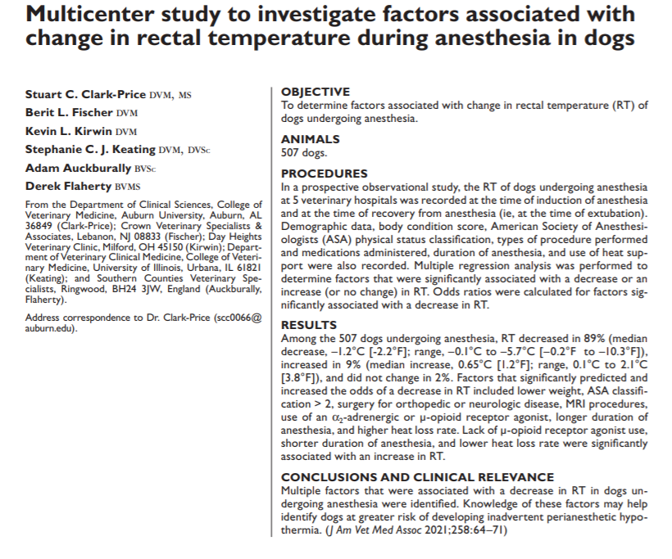
Intro:
- Unintentional loss of body heat during anesthesia (IPH – inadvertent perioperative hypothermia) defined as rectal temp < 101.3 is common
- Hypothermia can result in increased morbidity / mortality - disrupted physiologic enzymatic function, impaired pharmacodynamics of drugs, surgical site infection/dehiscence, blood loss / coagulopathy, cardiac dysrhythmia, prolonged recovery, increased duration of hospitalization
- Factors causing hypothermia include sedative, opioids, surface area of exposed skin, sweating, lack of warming devices, use of local anesthetics
- Study: determine risk factors associated with change in rectal temp during Ax (age, weight, body condition, type of procedure, administration of sedatives/opioids, type of induction agent used, duration of anesthesia, use of thermal support techniques
Methods:
- 5 veterinary facilities
- RT recorded within 2 minutes of Ax induction and again after extubation
- 507 data sheets (1/dog) analyzed
Results
- 89% had temp decreased (median -1.2C / 2.2F), 11% had temp increase or no change (median +0.65C / 1.2F) during Ax
- Body weight, ASA status, procedure performed, administration of alpha2 agonist, use of opioid, duration of anesthesia and rate of heat loss were significantly associated to decrease in RT
- Lack of opioid use, duration of anesthesia and heat loss rate were associated with positive.no change in RT
- Dogs <12kg had greater -ΔRT than 12-24kg, ASA status 2 or 3 had greater -ΔRT than ASA 1, dogs that received an alpha2 or full mu opioid had greater -ΔRT than those who didn’t, surgery >/= 60 min had greater -ΔRT than those with <30 Ax time
- Dogs <6kg (higher SA to mass), ASA 3 or 4, undergoing orthopedic or neurologic surgery or MRI, if received an alpha2 or full mu opioid, had Ax > 60min had a higher likelihood of having -ΔRT
- Age, BCS, induction agent and type of warming did not have an impact on ΔRT

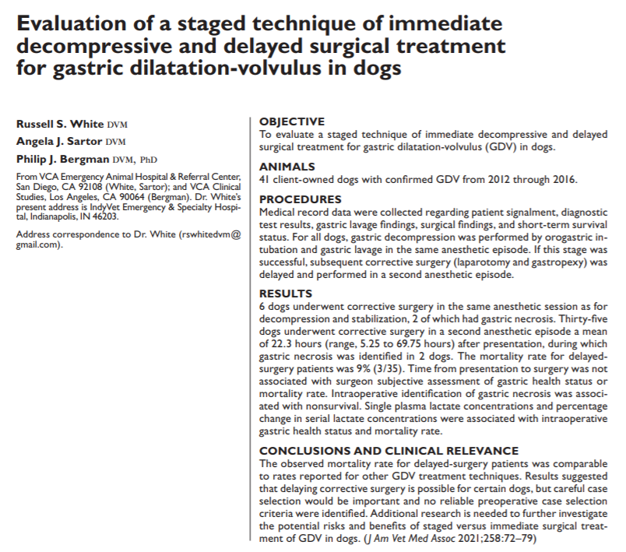
Intro:
- GDV: leads to obstructive shock/reduced venous return, cardiac arrhythmias, myocardial dysfunction, increased intraabdominal pressure decreasing total thoracic volume and poor lung inflation; lactic acidosis, gastric necrosis, thrombosis, DIC
- Greater risk for morbidity and mortality the longer it is left untreated; surgery is definitive treatment (decompression, de rotation, inspection of gastric tissue, pexy)
- Some research indicates that immediate surgery is not the best for every patient; VCA in San Diego treat GDV in staged approach with 2 anesthesia events first to resolve gastric dilatation by passing orogastric tube followed by recovery then anesthesia again later to inspect and stabilize stomach
  - Staging allows treatment of shock state / stabilization prior to corrective surgery
- Study: evaluate staged technique and compare short term outcomes to traditional management; hypothesis = staged treatment would yield outcomes and mortality rates similar to OR BETTER than traditional approach
Methods
- Retrospective medical record review of dogs with confirmed GDV and surgery Jan 2012-Dec 2016 at VCA San Diego
  - Dx GDV based on imaging, surgery report, treatment sheets/lab reports
  - Euth prior to surgery were not included
- Surgical treatment delayed if 2 anesthetic events were performed; immediate if one anesthetic event
- Decompression/stabilization protocol: rapid IVF bolus, anesthesia induction, orogastric tube placement and gastric lavage +/- trocharization; abx; AXR after to determine size and position of the stomach
  - If decompression was successful, dogs allowed to recover and provided medical stabilization for several hours until ex lap; constant monitoring to include gastric girth
  - If concern for sepsis/gastric necrosis, if decompression could not be achieved, or if stabilization could not be achieved immediate surgery was recommended
- Surgery protocol
  - If able to recover from anesthesia after decompression/stabilization – ex lap performed in the morning following hospital admission or delayed longer based on discretion of attending clinician/owner
  - Gastric rotation recorded as normal or abnormal, gastric health classified as mild, moderate bruising, necrotic
- No control group – if stabilization failed and not able to recover, this served as control?? How long to given to “recover”?
Results
- 41 dogs included; mean age 7.1yo
- GSD, Standard Poodle, Lab, Dane most common
- No demographic differences
- 6/41 (15%) underwent corrective surgery under same anesthetic session – 3 could not pass OG tube, 1 CPA during lavage, hemorrhagic gastric contents/concern for necrosis, owner request for immediate surgery
- Mean time to surgery for remaining 35 dogs was 22.3 hours (range 5.25-69.75)
- Time to surgery not associated with gastric health at time of surgery or survival to discharge
- 75% did not have evidence of gastric hemorrhage during lavage; 25% did – hemorrhage not associated with gastric health status at ex lap or survival to discharge
- 21/35 delayed surgery dogs had abnormal stomach position after decompression – still delayed
  - 20/35 (57%) had normal stomach position at time of surgery – 29% had normal rafsand normal sx; 26% had abnormal post lavage rads but normal position at sx; 11% had normal rads but torsed at sx; 34% continued to have abnormal position (45% abnormal)
- Abnormal stomach position at ex lap was associated with worse gastric health
- Mean lactate at presentation was 3.7mmol/L – higher values significantly associated with worse gastric status at ex lap, with hemorrhagic gastric contents, and nonsurvival
- Non survivors had higher lactate concentration (mean 7.3 – range 2.7-11.1) compared to survivors (3.2 – range 1.2-7.8)
- Serial lactate only measured in 22 dogs
- Larger percentages of lactate decrease (AKA clearance) were associated with better gastric health status and higher likelihood of survival to discharge
- 36/41 (88%) survived to discharge
  - 4/6 (67%) that underwent immediate surgery survived to discharge; 32/35 (91%) of staged dogs survived to discharge
- Gastric health significantly associated with survival – all with mild bruising survived, 11/12 moderate bruising survived (1 had concurrent colonic torsion with necrosis); all 4 dogs with gastric necrosis were euthanized (2 delayed, 2 immediate)
  - Immediate group: 1 dog suffered CPA, the other had gastric necrosis
  - Delayed group: 1 dog stabilization challenging, gastric position abnormal - surgery 11 hours after presentation and the other stable, the other had “low lactate (2.7) measured once,” was quieter than normal, and abnormal gastric position after lavage surgery 15 hours later 80% gastric necrosis
- 3/41 (7%) developed post-op regurg, 2/41 (5%) developed aspiration pneumonia – not significant between the groups
- Longer time to surgery was significantly associated with longer hospitalization and cost
- Conclusion: successful decompression and stabilization may allow for delayed surgical correction of GDV in select cases, though no pre-operative variables were identified to predict who might tolerate and benefit from staged treatment or if gastric necrosis was present
- This staged protocol might be useful in situations where owners are reluctant to pursue or are unable to afford immediate surgery, immediate surgery cannot be performed, or transfer from one hospital to another is needed

