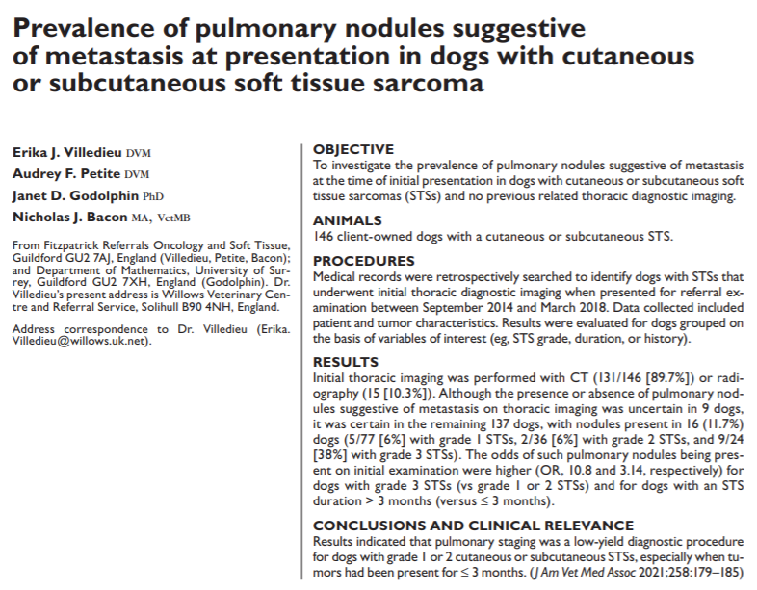
Intro:
- STS – tumors of mesenchymal cells and arise from cutaneous or SQ tissue; account for 9-20% cutaneous or SQ malignant neoplasms in dogs; less common visceral origin
- Large collective group – fibrosarcoma, perivascular wall tumors, NST (nonplexus derived), myxosarcoma, liposarcoma, rhabdomyosarcoma, leiomyo, fibrous malignant histiocytoma
- HSA, synovial cell sarcoma, GIST, oral fibrosarcoma, NST – excluded due to differences in individual or biological behavior
- Management: wide surgical excision – incomplete or high grade = higher chance of local recurrence (7-75%)
- Metastatic potential: 0-44%; high grade = higher chance of mets
- Common met sites: pulmonary and SQ sites; LN uncommon
- Thoracic imaging for staging prior to removal is standard; CT more sensitive than CXR
- Study: investigate prevalence of pulmonary nodules at presentation in dogs with cutaneous or SQ STS and to see if related to tumor characteristics
Methods:
- Retrospective – histology Dx of STS and thoracic imaging compared
- Data collected for location of STS, size, how long present, tumor history, recurrence, thoracic imaging modality, # pulmonary nodules and size, STS type and grade
Results/Discussion
- 146 met include criteria
- Median age 9.3yr; most common breed – Lab
- Most common location – limbs > trunk, head/neck; most 1-cm and grade 1
- Most dogs had CT (89.7%) - nodules identified in 16/137 dogs (11.7%)
  - No comment on how many dogs had nodules identified on CXR vs CT
- Significantly higher pulm nodule prevalence in dogs with grade 3 STS
  - Grade 3 – 9/24 (38%) had mets
  - Grade 2 – 2/36 (6%)
  - Grade 1 – 5/77 (6%)
- Regression analysis: odds of pulm mets significantly higher for dogs with grade 3 STS and if mass was present for greater than 3 months
- Presence of mets at time of referral – 11.7% authors conclude diagnostic yield of thoracic imaging is low, especially for dogs with grade 2 STS present for < 3m
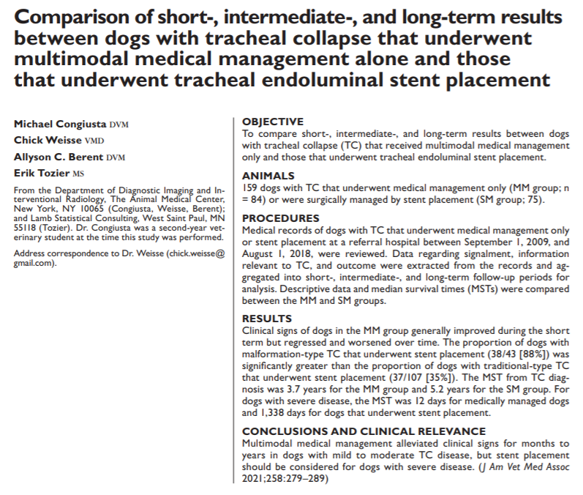
Intro:
- TC: tracheal chondromalacia, weakened / redundant dorsal tracheal membrane, tracheal ring malformation labored breathing, coughing, airway obstruction
- Classified into 2 types:
  - Traditional-type: progressive chondromalacia and laxity of the trachealis dorsal muscle leading to dynamic airway collapse
  - Malformation-type: static form of focal obstruction of tracheal lumen at the thoracic inlet due to tracheal rings that become invaginated and resemble a ‘W’ rather than a ‘C’
- Failure to respond to medical management – may benefit from stent placement (though comes with risk of complications) difficult to know who will not respond to medical management
- Study: compare short, intermediate, long term results for dogs with TC that underwent medical management and those that had stent placement
Methods:
- All dogs with TC evaluated by IR at AMC – retrospective evaluation
- Compared data of patients treated medically vs stented
- Clinical severity score (owner questionnaire, not validated) completed at all visits – evaluate severity of honking/raspy breathing, cough, dyspnea (0-10 – 10 being intractable/persistent)
Results
- 185 dogs included – 110 (59%) had medical management (ultimately only 84 included in ongoing analysis) and 75 (41%) had stent placed + medical management
- Median age 8.8yr, most commonly Yorkies and Poms – did not differ b/w MM and SM groups
- 70/84 had traditional TC; 5/84 malformation TC; 9 not determined
- Many had cardiovascular disease as well
- Short term follow up (first 45 days) - MM
  - Most common meds – antitussives, steroids, anxiolytics/sedatives, abx
  - No dogs died during short term follow up
- Intermediate term (day 46-180) - MM
  - Most common medications the same – though abx use was less
  - Cough, raspy breathing, dyspnea improved for many or stayed static
  - 1 dog died during this period
- Long term (>180 after baseline) - MM
  - Medications the same
  - Honking, cough, dyspnea worsened for some but improved in others
  - 22% underwent emergency exam during this period of time
  - 48 dogs died in long term period
- Final evaluation - MM
  - Final eval occurred at median of 743 days
  - Medication unchanged
  - 10% had developed pneumonia and 25% needed emergency evaluation
- Outcome and MST
  - 58% on MM group died - 43% of those unlikely to be related to TC
  - MST 1,124 days from baseline (3.1yr)
    - Factors associated with shorter MST - >8.8 yo, cardiac disease, emergency examination during intermediate follow up period, diagnosis of pneumonia in intermediate follow up period
  - Clinical severity of disease associated with MST (more severe signs at baseline, shorter MST)
    - 0 severe score – 1363d MST vs 3 severe scores – 55d MST
      - Severe score = >8 (on the 1-10 scale for raspy breathing, cough, dyspnea categories)
- SM vs MM
  - Significantly higher proportion of dogs with malformation type TC had stenting as compared to medical management
  - Dogs with MTC significantly more likely to have a stent than dogs with TTC
  - MST after stent placement was 1,005 days and did not differ significantly based on clinical severity scores at baseline
  - Dogs with MM had longer MST than dogs with SM/stent (1363d vs 1005d)
  - SM group had more severe clinical signs
  - When MM dogs with severe signs at final evaluation were compared to equally severe SM dogs – MST for MM dogs was significantly less (12d vs 1338d) severe clinical signs at diagnosis would have a better outcome if they underwent stent placement as soon as possible
- Medical management can help alleviate signs for a period of time, however they often become progressive and potentially life threatening
- Stent placement should be considered in dogs with severe signs

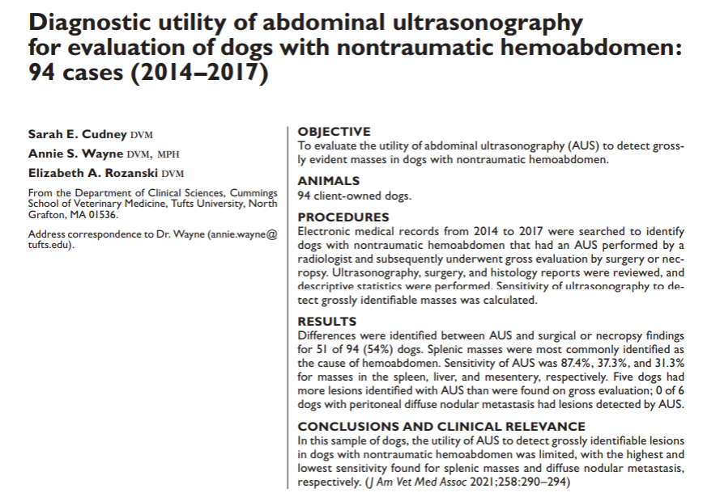
Intro:
- Most common cause for nontraumatic hemoab: ruptured abdominal mass originating from spleen
- 76-80% malignant, 63-70% HSA, 63-90% are splenic in origin
- Other tumor types: mesothelioma, melanoma, lymphoma, splenic carcinoma, poorly differentiated sarcoma, pheo, adrenocortical adenoma, etc
- AUS and CXR recommended prior to surgery – look for origin of mass, mets, anything that could complicate surgery (megaesophagus, pneumonia, etc)
- Study: evaluate utility of AUS for detection of lesions identified grossly during surgery/necropsy
Methods:
- Retrospective; reviewed AUS images and results of surgical explore or necropsy
Results:
- 94 cases included; median age 9.9y; Labs, Goldens, GSDs most common
- Grossly: 69% had multiple lesions in >1 structure
  - Splenic masses most common (93%); hepatic (63%); mesenteric (17%); diffuse nodular (6%)
- AUS: splenic mass identified in 87%; hepatic 44%; mesenteric 13%; no diffuse nodular mets identified
- Differences in AUS and gross findings in 54% of cases (51/94)
  - Masses identified on AUS but not seen grossly (false pos)
  - Masses absent on AUS but found grossly (false neg)
- AUS was 87.4% sensitive for detecting splenic lesions
- AUS was 37.3% sensitive for detecting hepatic lesions
  - 20/39 had lesions grossly not seen on AUS; 17/39 had more seen grossly than on AUS; 2/39 had no gross hepatic lesions that were seen on AUS
- AUS was 31.3% sensitive for detecting mesenteric lesions
  - 8 dogs had lesions found grossly but not on AUS, 3 had more lesions found grossly than seen on AUS, 4 did not have gross lesions that were thought to have been seen on AUS (clot?)
- AUS did not detect diffuse nodular metastasis that was detected grossly in 4 dogs
- Histo:
  - 72% malignant; 28% benign
  - Multifocal lesions found in 69%
    - 11/24 dogs with benign hemoab had multifocal lesions! (most were multifocal hematomas)
    - 53% with multifocal lesions grossly had mets on histo
  - HSA most common malignant (58%)
  - No all splenic lesions were HSA, but all with HSA had splenic lesions
  - Multifocal lesions (78%) and mets in 50% in dogs with HSA
- CXR only performed in 9/94 cases – mets seen in 5/9
Discussion:
- Sensitivity of AUS for detecting splenic lesions was 87.4% but substantially less for detecting lesions in the liver or mesentery or nodular - consider this in discussions with owners
- AUS may be discordant with gross findings
- If a splenic mass can be identified on AFAST – is a full AUS needed as sensitivity of detecting other lesions is low?

