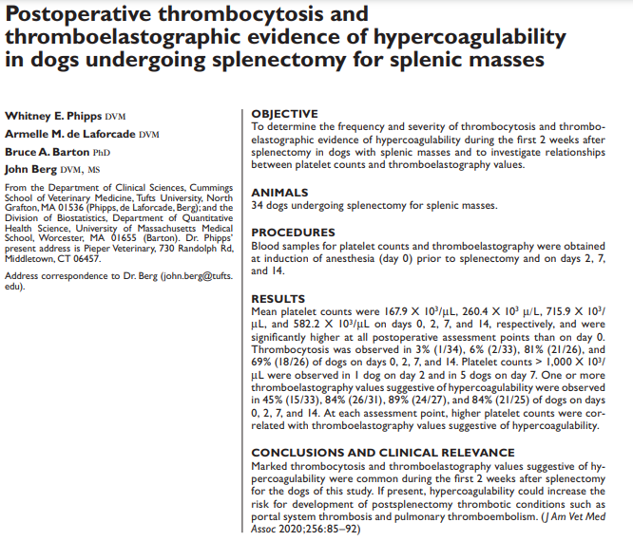
Intro:
- Reported perioperative mortality rates associated with splenectomy for splenic masses are 7.6-33%
- Venous thrombosis are important causes of postoperative death; especially portal thrombosis and PTE Virchow’s triad
- Thrombocytosis is frequent sequela of splenectomy in humans (loss of reservoir) – peak at 7-20d post op and can last for months risk factor for poral thrombosis
- Platelet life spans are increased after splenectomy (not removed from circulation)
- Consumptive thrombocytopenia prior to surgery may be stimulus for reactive increase in platelet production
- Objective: determine frequency and severity of thrombocytosis and thromboelastographic evidence of hypercoagulability during first 2 weeks after splenectomy in dogs with splenic masses
- Secondary objective: elevate relationships between platelet counts and TEG parameters (collected on day 0, 2, 7, 14)
Results/discussion:
- 34 dogs; median age 11yo
- 50% had hemoperitoneum at the time of surgery; 59% had other procedures performed at time of surgery aside from splenectomy (gastropexy, partial liver lobectomy, liver biopsies, gastrotomy, etc)
- 55% of masses were malignant (15/18 HSA)
  - 6/15 HSA had gross metastasis to other organs identified in surgery
- TEG performed on all scheduled days for 26/34 dogs
- Mean platelet counts were significantly higher post-op than on day 0; 65% thrombocytopenic on day 0
- K value lower at all assessment points, and other TEG values higher at all assessment points after day 0 hypercoagulable
- Thrombocytosis (by day 7) and hypercoagulability common during the first 2 weeks after splenectomy for splenic mass
- Early hypercoagulability (low K) unlikely to be platelet dependent, though increase MA and G later (day 7, 14) suggests thrombocytosis plays a role in hypercoagulability
- Implications of findings unclear as no combo of TEG findings have identified to reliably indicate hypercoagulability in dogs and no relationship between TEG findings and the development of thrombosis has been identified in dogs (though it has in humans)
- Taka-away: be cognizant of the potential for hypercoagulability for at least 2 weeks in post op period, know that platelet counts can be elevated for at least 2 weeks in the post op period

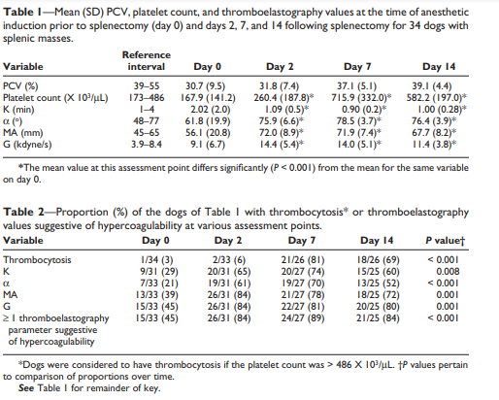
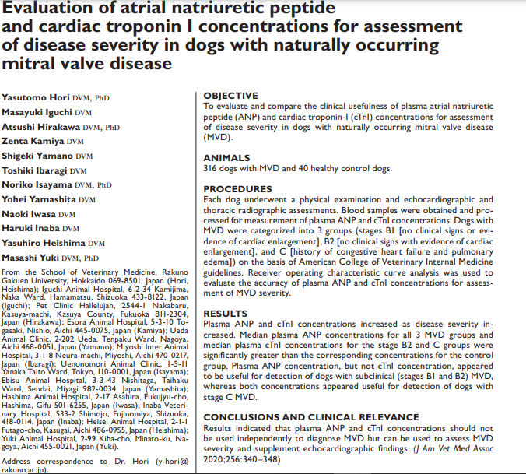
Intro:
- MMVD induces volume overload LV eccentric hypertrophy LAE CHF poor prognosis
- ANP/BNP made in heart, released into circulation due to atrial/ventricular stretch
- Cardiac troponin: 3 subunits T, C, I that are released due to cardiac myocyte damage
- Objective: evaluable and compare clinical usefulness of plasma ANP and cTnI concentrations for assessment of disease severity in dogs with MMVD
Results/Discussion:
- 316 dogs with MMVD and 40 healthy controls; 45% were B1, 32% B2, 23% C
- 52% were receiving medications for cardiac disease
- ANP concentrations significantly higher in stage B1, B2, C than healthy control dogs; ANP concentrations in B2 and C significantly higher than B1
- cTnI significantly higher in C than others; B2 significantly higher than B1 and control
- ANP / cTnI concentration cut-offs:
  - 112.9pg/mL / 0.089ng/mL for detecting B1 or worse
  - 184.2 / 0.139 for detecting B2 or worse
  - 277.8 / 0.163 for detecting C
  - Healthy dogs 61.9 / 0.058
- ROC curves indicated ANP concentration was better than cTni for detecting dogs in the earliest stages of MMVD (B1, B2); but ability to discern for advanced stage (C) was the same

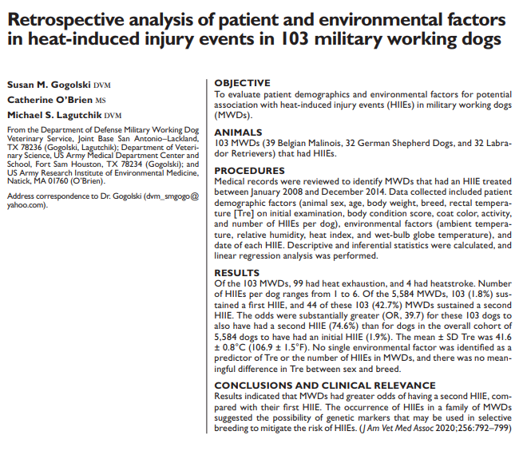
Intro:
- >70% of heat lost is by radiation and convection (dogs); as ambient temp reaches core body temp heat is primary last by evaporation (panting) and becomes less efficient with increasing humidity
- Working/sporting dogs can have temp > 107.6F (42C) with no adverse effects; MWD handlers do not monitor rectal temp for indication of heat stress and instead rely on panting efforts (uncontrolled, how much lips are retracted, increased airway sounds) and for changes in behavior
- Objective: evaluate patient demographics and environmental factors for potential association with heat induced injury and MWD; hypothesized both would be correlated with rectal temp and can predict heat injury

Results:
- 103 dogs had heat induced injuries in a 7 year period out of 5,584 working dogs at that base during the same time period
  - 99 heat exhaustion, 4 heat stroke
- Relative humidity > 50% is the greatest risk factor for developing heat induced injury
- The odds of of a MWD having a second heat induced injury (75%) was much greater than the odd of having a first injury (2%)
  - 43% of dogs (44/103) had >1 heat injury event
- An entire family of MWD had >1 heat induced injury event suggesting a genetic component of heat intolerance
- No breed (GDF, LAB, MAL) or sex differences were found overall, however MAL with heat injury had more instances of rectal temps > 109F (42.8C)
- No environmental factors were predictive of rectal temperature and heat induced injury

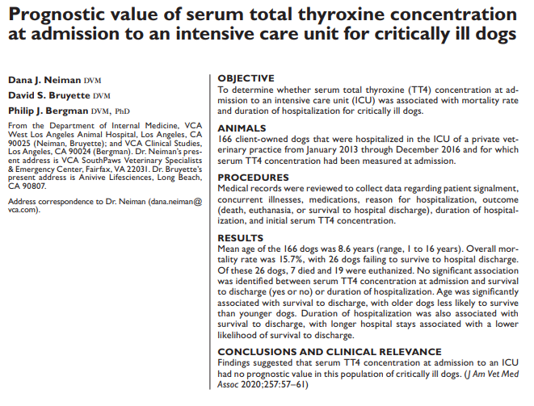
Intro:
- Nonthyroidal illness syndrome – alteration in circulating thyroid hormone concentrations in euthyroid, ill patients
- MOA: low secretion of TSH, low synthesis of TT4, low thyroid gland-binding proteins, low thyroid gland binding affinity, serum protein binding inhibitors, inhibition of deiodination of T4 to T3 in peripheral tissues
  - Physiologic adaption to decrease cellular metabolism during illness
- Humans: relationship between thyroid hormone status and outcome most common, low T3, low/normal T4, high rT3, normal TSH with more severe illness decrease in TT4, fT4
- Dogs: magnitude of thyroid concentration found to be related to severity of illness but not category of disease
  - TT4 low commonly; variable changes in T3, fT4, TSH
  - Difficult to examine the relationship between thyroid hormone concentration and disease severity
- Objective: determine whether serum TT4, which can be easily measured, at admission can be used as a prognostic indicator and if is associated with mortality rate in critically ill dogs, independent of underlying cause
- Secondary objective: determine whether serum TT4 concentration at admission was related to the duration of hospitalization
- Hypothesis: lower TT4 values at admission would be associated with higher mortality rate and longer hospitalization

Results/Discussion:
- 166 cases included, retrospectively
  - Included: hospitalized in the ICU at 2 highest levels, TT4 collected
  - Excluded: <1yo, sighthounds, previous thyroid disease, medication in the last 3 mo that could alter HPT axis, incomplete records
  - Categorized: trauma, respiratory disease, GI disease, repro disease, neoplasia, hematologic disease, cardiovascular disease, urinary disease, hepatic disease, misc
- 84.3% (140/166) survived to discharge; mean duration of hospitalization 3.3 +/- 2.2 days (2.2+/- 1.3 for nonsurvivors)
- Mean TT4 at admission was 1.0 +/- 0.5mcg/dL; 41.6% lower than reference range
- No significant difference in serum TT4 at admission b/w survivors and non-survivors, between dogs that died (7) or euthanized (19), or for duration of hospitalization (P=0.19); offered no prognostic value
- Dogs treated for cardiovascular disease, GI, misc disease, neoplasia had significantly higher TT4 than those treated for hematologic disease
- Older dogs significantly less likely to survive
- **Longer hospitalization was associated with increased chance of survival to discharge (p=0.11?) – abstract says decreased likelihood?? **

