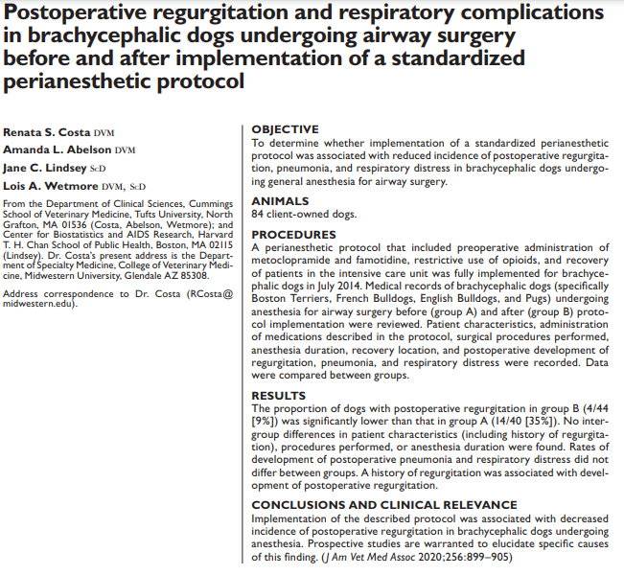
Intro

- Brachycephalic dogs at risk for post op complications (regurg, aspiration, resp distress) d/t stenotic nares, elongated soft palate, redundant pharyngeal folds, hypoplastic trachea increased resp effort and negative intrathoracic pressure vomiting, regurgitation
- 97% brachycephalic dogs have esophageal, gastric, duodenal abnormalities also predispose to risk of aspiration pneumonia with GI signs
- GA, stress of being in hospital, opioids may contribute to post-operative regurgitation
  - Opioids and sedative use may cause decrease in LES tone regurg/reflux, vomiting
  - Ax – decreased awareness and decreased ability to protect airway
  - Post-operative discomfort, continued regurg esoph stricture, resp distress
- Higher chance of regurg in brachycephalic dogs than other breeds
- Standardized peri anesthetic protocol to decrease key Ax complications created study’s goal was to compare post-op regurg, aspiration pneumonia, resp distress in BC dogs (EBD, BT, FBD, Pugs) prior to and after implementation of protocol
Methods/Materials
- Metoclopramide, famotidine given to all EBD, BT, FBD, Pugs
  - No history GI signs: metoclopramide 0.5mg/kg SQ and famotidine 1mg/kg IV or SQ at time of premed
  - History of GI signs: oral medications as dosed above given PO for 1 week prior to surgery (if elective procedure)
- Opioids avoided if possible – ketamine, lidocaine used instead (for airway surgery patients only); opioids used if surgery other than or in addition to airway surgery was to be performed
- DexSP 0.15mg/kg was given prior to first surgical incision when airway surgery was performed (so long as not contraindicated)
- Recovered in IUC
- Sedation given PRN
- High flow nasal oxygen PRN for those in distress
- Teams prepared for intubation, temp trach if needed
- Cases from July 2011 – Dec 2013 (pre protocol) compared to July 2014 – Dec 2016 (post protocol)

Results/Discussion
- 40 in pre group; 44 in post group
- No demographic differences between groups; no difference in surgeries performed or anesthetic time
- In addition to BOAS surgery, patients may also have been neutered, OHE, ophtho surgery, mass removal, BAL, etc
- Opioids administered significantly less frequently in post group as compared to pre group
- Pre group significantly less likely to have received metoclopramide and famotidine prior to surgery and less likely to have recovered in ICU
- Post-op regurg significantly less likely in post protocol group (9% vs 35%)
  - Those who regurgitated (in either group) were more likely to have history of regurg
- 13/18 dogs that developed regurg did so > 6 hours after extubation
- No difference found in aspiration pneumonia or resp distress
  - 3/84 total cases of pneumonia (2 in pre, 1 in post) – 3% overall, consistent with previous studies
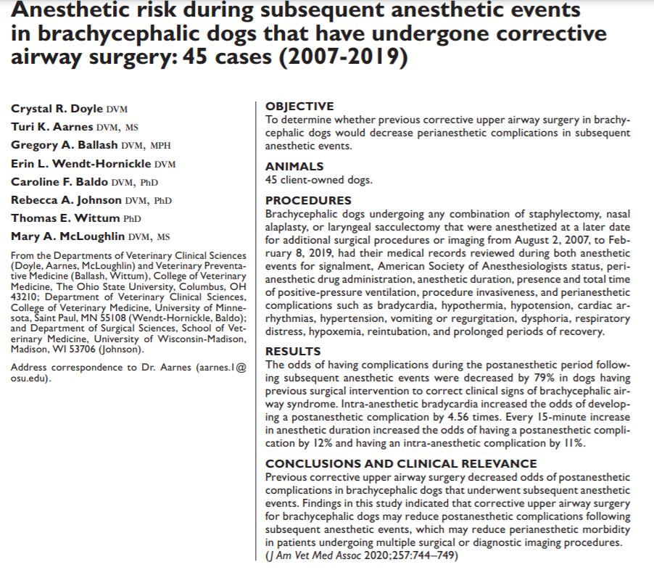
Intro
- BAOS: stenotic nares, elongated and thickened soft palate, aberrant nasal conchae, tracheal hypoplasia negative inspiratory pressure can lead to everted laryngeal saccules, laryngeal collapse, bronchial collapse
- Breeds: EBD, FBD, Pugs, BT, CKCS, Shih Tzu, Pekingese
- Clinical signs: increased resp noise, snoring, stridor, dyspnea, exercise intolerance, collapse, vomiting, regurg, sleep-disordered breathing
- 2x as likely to have perianesthetic complications in post-Ax period
- 1.57x more likely to have intra-Ax complications
- 4.33x more likely yo have post-Ax complications (regurg, vomiting, aspiration, prolonged recovery, stertor – aspiration pneumonia most common complication)
- Upper airway surgery (nasal aplasty, staphylectomy, laryngeal sacculectomy) results in >85% of patients having improvement
- Study: does upper airway surgery decrease chance of perianesthetic complications when undergoing future anesthetic events

Methods/Materials
- Retrospective; 2007-2019; Wisconsin, Ohio State, Minnesota
- Brachycephalic dogs that had airway surgery and then subsequent anesthetic procedure – grouped as non-invasive, minimally invasive, invasive
- Demographic data, surgery performed, drugs administered, anesthetic variables/complications, perianesthetic complications recorded

Results/Discussion
- 45 dogs included (EBD, FBD, Pug most common breeds) – 99 total anesthetic events
- 51% of dogs had postanesthetic complications at time of first surgery (resp distress, prolonged time to extubation, hypoxemia, regurgitation) – oxygen support or reintubation most common; 2 needed temp trach
- Subsequent anesthesia 26% (14/54 Ax events) post-Ax complication; only 3 needed oxygen and none needed re-intubation or tempt trach
- Hypotension was most common intra-Ax complication
- Factors associated with post-Ax complications: intra-Ax bradycardia and Ax duration
- Dogs with intra-Ax bradycardia 4.56x more likely to have post-Ax complication
- For every 15-min increase in Ax time, dogs had 11% greater odds of developing post-Ax complication
- Dogs that had BOAS corrective surgery had 79% decreased odds of having subsequent post-Ax complication

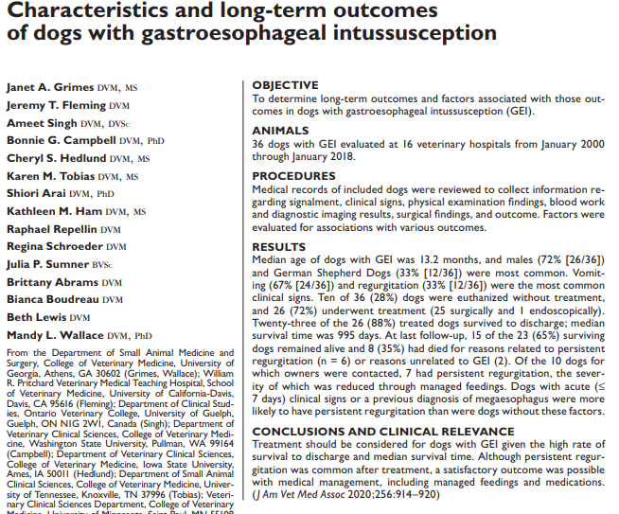

Into
- Gastroesophageal intussusception – uncommon; differs from hiatal hernia as gastroesophageal junction remains in normal anatomic position
- Most reported cases are in dogs <6mo and males are overrepresented
- GSD most common breed reported
- Clinical signs: dyspnea, regurg, vomiting (acute or chronic or acute-on-chronic)
- No specific underlying causes identified – however esophageal abnormality (megaesophagus, dysmotility disorders, laxity of esophageal hiatus) may predispose gastric invagination into the esophagus
- Dx: made through CXR/AXR soft tissue mass within the caudal portion of the esophagus and no evidence of the stomach within the cranial abdomen
  - Megaesophagus and aspiration pneumonia or common concurrent findings
  - Endoscopy can also Dx
- Treatment: reduction of intussusception with left sided (fundus of the stomach intussuscepts into the esophagus) or bilateral gastropexy to prevent recurrence
  - Surgery most common, but endoscopic reduction has also been performed with placement of PEG tube for gastropexy
- Largest report on GEI – 95% of dogs died or euthanized, many did not undergo surgical treatment
- Study: determine long term outcomes and risk factors for those outcomes in dogs treated surgically

Materials/methods
- Data collected by quiring members of Society of Veterinary Soft Tissue Surgery (pull records from 2000-2018)

Results/discussion
- 36 dogs from 16 veterinary hospitals identified
- Median age at initial evaluation 13.2 months; 72% male; 33% GSD, 17% mix breed, 14% Great Dane; 6% EBD
- Most common signs at evaluation was vomiting (67%), regurg (33%), anorexia (28%), hematemesis (25%)
- 69% classified as acute; 22% chronic; 8% acute on chronic
- 36% had documented megaesophagus prior to evaluation for GEI
- Most common PE: poor body condition, dehydration, lethargy/depression, tachypnea, dyspnea
- 88% of radiographs consistent with GEI; aspiration pneumonia present in 33%
- 69% (25/36) had abdominal explore – other organs involved in intussusception included spleen, duodenum, pancreas
- Of those with records – all had left sided gastropexy and 64% also had right sided gastropexy; G tube placed on left side in 36%
- Endoscopic reduction was attempted in 6/7 dogs – only 1 was successful
- Outcomes
  - Short term
    - 10/36 dogs (28%) euthanized without treatment due to concerns for poor prognosis and finances
    - 26 dogs had GEI corrected; 88% survived to discharge – 27% (6/22) had regurg in the post op period
  - Long term
    - Median survival was 995 days
    - No recurrence of GEI reported
    - 6 of the dogs that died by end of study period had signs related to continued megaesophagus, regurgitation and/or aspiration pneumonia (MST 663 days)
    - 10/15 surviving dogs had persistent regurgitation
    - Of those available for contact, 6/7 owners felt they were happy with the outcome of the procedure even though dog continued to regurgitate
- Duration of clinical signs prior to initial evaluation was significantly associated with persistent regurg at last follow up – dogs with SHORTER duration of clinical signs were more likely to have persistent regurgitation
- Chronic signs = less likely to have megaesophagus
- Documented megaesophagus = more likely to regurgitate
- Feeding strategies may need to be implemented to reduce change of regurg/aspiration – Bailey chair, other elevated feeding, adjusting food consistency, medications, etc needed long term

