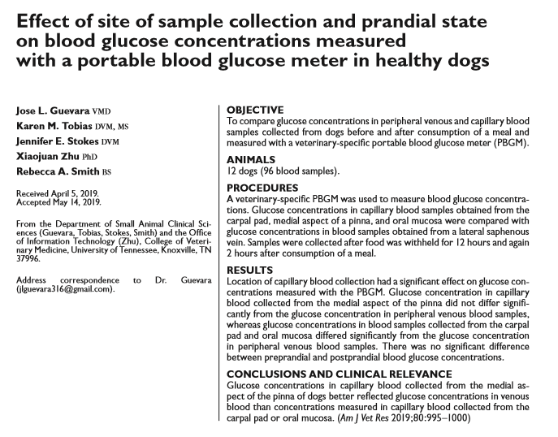
- Goal of study: compare glucose concentrations measured with a veterinary-specific portable BG monitor in capillary and peripheral venous blood samples of healthy dogs and to determine whether those concentrations were affected by the prandial state
- No significant difference between the mean preprandial and postprandial BG
- Collection site had a significant effect on BG - glucose concentrations in capillary blood samples collected from the oral mucosa and carpal pad did not differ significantly from each other, but both differed significantly from the glucose concentration in the venous blood sample
- BG samples obtained from the medial aspect of the pinna did not differ significantly from the venous blood sample, but they differed significantly from the samples obtained from the oral mucosa and the carpal pad
- Take away: use venous sample or capillary sample from medial pinna

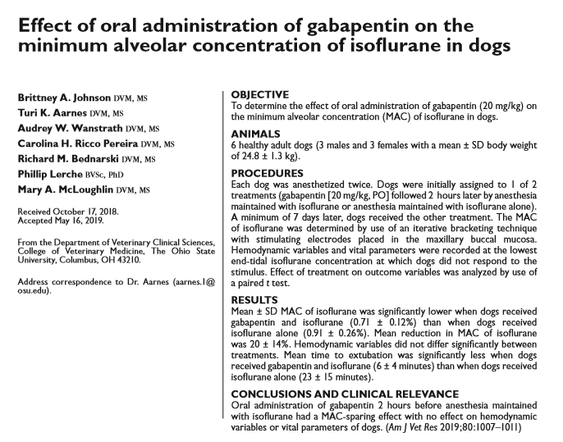
- Oral administration of gabapentin before the induction of anesthesia has been used preemptively to relieve postoperative pain, reduce postoperative vomiting and nausea, reduce requirements of rescue opioid analgesics, and reduce emergence delirium in humans

- Mean ± SD MAC of isoflurane was significantly lower after administration of gabapentin and isoflurane (0.71 ± 0.12%) than after administration of isoflurane alone (0.91 ± 0.26%),
- Mean ± SD time to extubation was significantly less after treatment with gabapentin and isoflurane (6 ± 4 minutes) than after treatment with isoflurane alone (23 ± 15 minutes)
- No effect on hemodynamic status
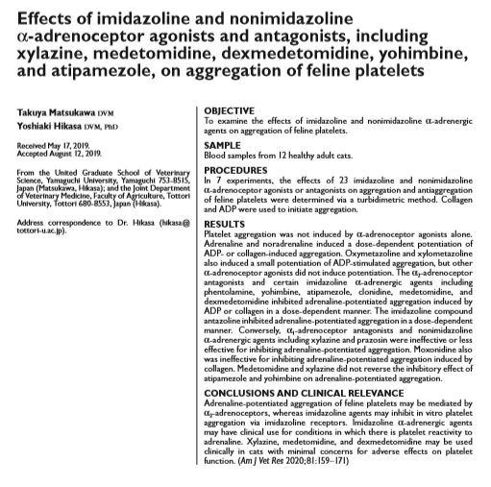
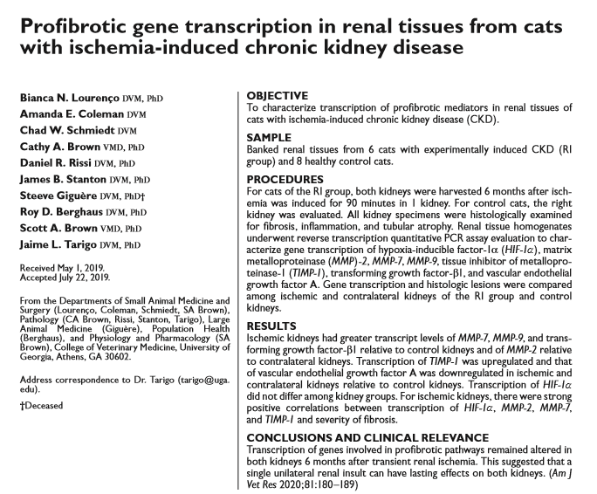

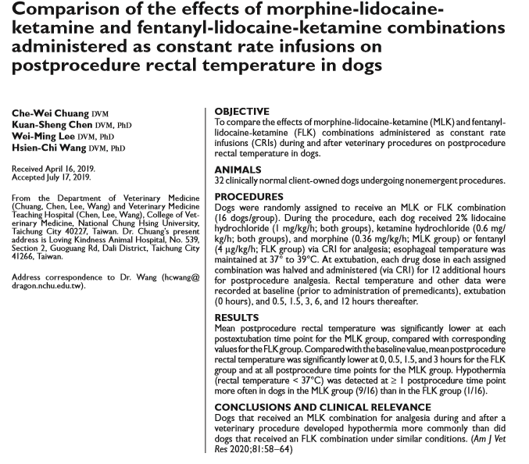
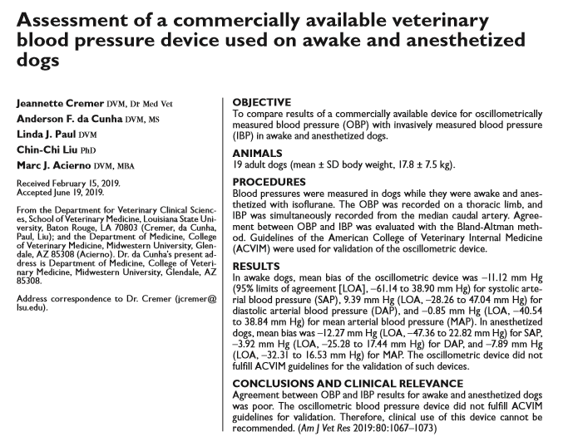
- Oscillometric device = CONTEC08A-VET LCD, Contec Medical Systems

