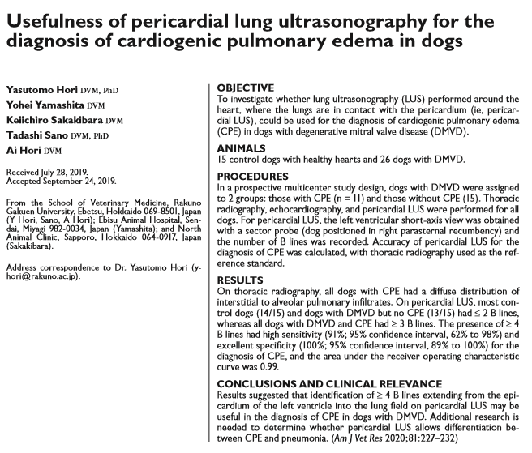
- LUS typically performed to evaluate lung parenchyma at periphery near pleura (look for B-lines)
- Study wanted to evaluate the use of LUS performed around the heart where the lung makes contact with the pericardium (pericardial LUS) in diagnosis of CPE (i.e. B lines at pericardium)
- Healthy dogs (cardiac disease free) were compared to dogs with MMVD stage B2 or greater
- CXR, echo, pericardial LUS performed on all dogs; pro-BNP also obtained
- pLUS was performed with a 7.5- to 12-MHz sector probe with the dog positioned R lat. LV at the level of the papillary muscle was visualized in the right parasternal short-axis view. Depth was adjusted such that the 3- to 5-cm lung region beneath the heart was visible. B lines were defined as hyperechoic, narrow-based reverberation artifacts originating from the epicardium of the LV and spreading to the bottom edge of the screen. The maximum number of B lines was recorded as 0, 1, 2, 3, ≥ 4, or confluent.
- 41 dogs included; 26 with MMVD 11 with CPE/CHF
- Results:
  - Control dogs and dogs with DMVD but no CPE had ≤ 2 B lines from the epicardium; dogs with DMVD and CPE had a high prevalence of confluent B lines
  - An optimal cutoff value of 4 B lines resulted in sensitivity 91% and specificity 100% (AUC 0.99) to discriminate between dogs with CPE and those without; ≥ 4 B lines was significantly (P < 0.001) more common in dogs with CPE
  - AUC for pericardial LUS to diagnose CPE at the optimal cutoff value (4 B lines) was significantly greater than the AUCs for VHS, LA:Ao, LVIDDn, proBNP at their optimal cutoff values
